|  |  |
| --- | --- |
|  |  |
|  |  |

./



FIRE ALARM SYSTEM (F.A.S)

BY Gurram Manikanta

Version Number:1.0

Team Members :01

Team No:

Module: Model Based System Engineering

Table of Contents

1.0 Introduction : 3

2.0 REQUIREMENTS 4

**2.1 SWOT ANALYSIS** 4

**2.2 COMPONENTS USED IN FIRE ALARM** 4

**2.3 4W’S AND 1H** 5

**2.4 TABLE OF REQUIREMENTS** 8

2.4.1 HIGH LEVEL REQUIREMENTS 8

2.4.2 LOW LEVEL REQUIREMENTS 8

3.0 Architecture 9

**3.1 Structural Diagram** 9

**3.2 Behavioral Diagram** 10

**3.3 Behavioral Diagram** 11

4.0 Simulation 12

|  |  |  |  |  |  |
| --- | --- | --- | --- | --- | --- |
| **Ver.Rel. No.** | **Release Date** | **Prepared. By** | **Reviewed By** | **Approved By** | **Remarks/Revision Details** |
|  |  |  |  |  |  |
|  |  |  |  |  |  |
|  |  |  |  |  |  |
|  |  |  |  |  |  |
|  |  |  |  |  |  |

# 

**Document History**

# 1.0 Introduction :

In this project, we are going to create a fire alert system using ATMEGA8 microcontroller and fire sensor. Fire sensors can be of any type, here fire sensor play a vital role we have different types of fire alarms

we can use any one with respect to your project here i am using LM35 a temperature sensor when temperature level exceed the actual level fire sensor sent signal to

microcontroller then buzzer rings after that we reset the buzzer using and fire sensor using reset button, we can use this in real time environments like hospitals schools and shopping malls etc..

we are going to install the fire sensor on the servo motor. The survey will rotate the 180 degree pendulum. With the fire sensor mounted on it, we get 270+ degree fire sensing vision. The survey will continue to rotate, thus providing a complete room fire alert system. We can add smoke sensors to the system for more accuracy. With it we can achieve high accuracy.

# 2.0 REQUIREMENTS

## **2.1 SWOT ANALYSIS**

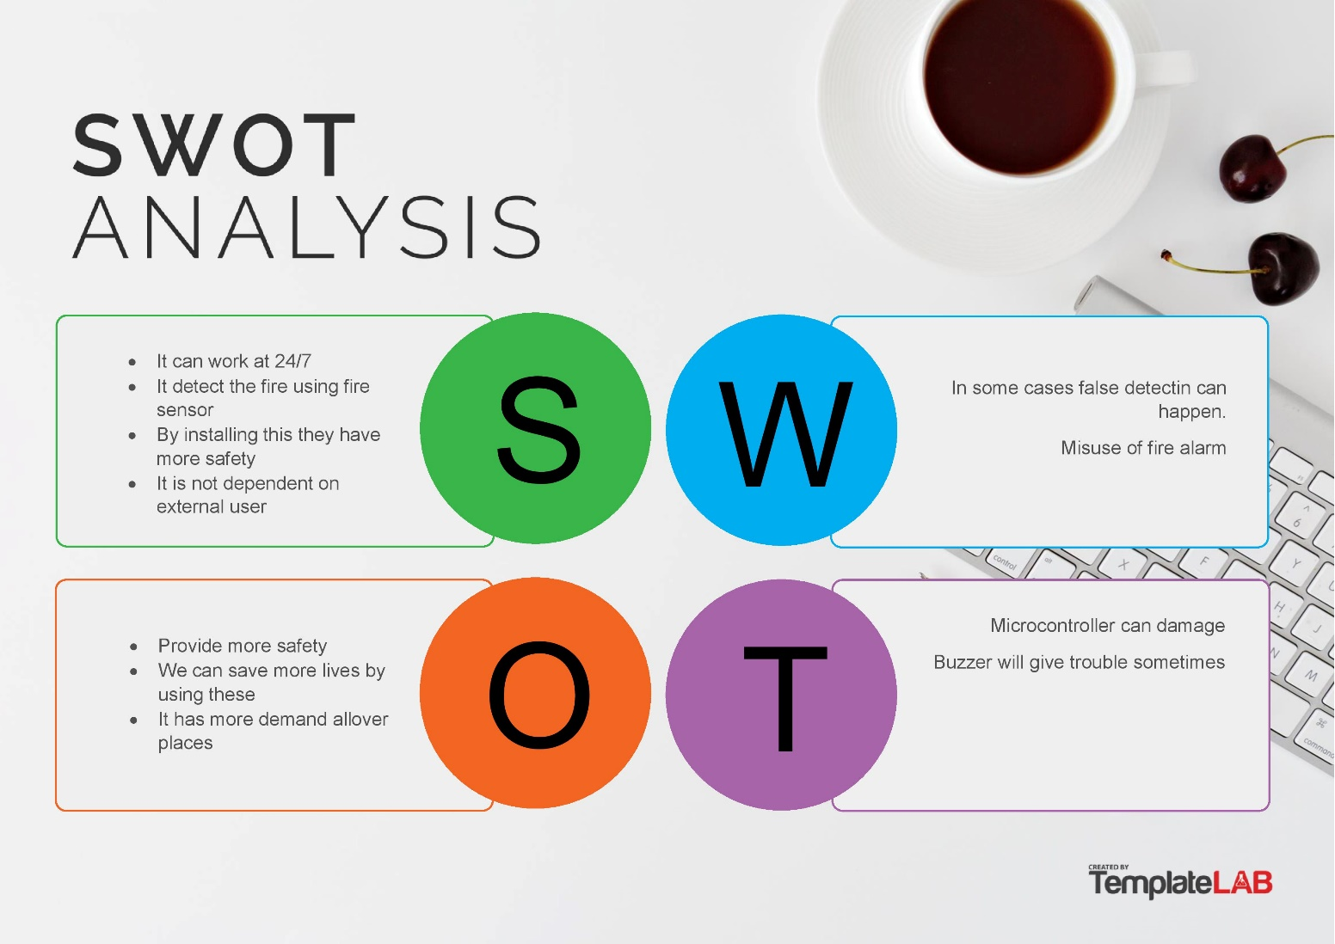

## **2.2 COMPONENTS USED IN FIRE ALARM**

power supply

* it is used give power supply to circuit

Servo motor (

* it have connected with fire sensor it rotate according to temperature

Pressure

ATMEGA328

* it is used to control the all circuit and send commands and operate

Buzzer

BUZZER

* Buzzer is used to make sound and it a output to the circuit Button

* it is used to set and reset buzzer

10KΩ resistor, 1KΩ resistor, 220Ω resistor, 100nF capacitor.

Fire Sensor

The fire extinguisher works by detecting smoke or heat. These devices respond to the presence of smoke or extreme temperatures with fire. After activating the device, it will send a signal to the alarm system to perform a programmed response for that zone.

## **2.3 4W’S AND 1H**

Where

* Fire alarm system is use this in real time environments like hospitals

schools and shopping malls etc..

When

* Fire alarm is activated when it temperature level exceed to normal level it buzzer is activated

* buzzer is activated through micro controller atmega8

What

* fire alarm system using microcontroller Atmega8 and fire sensor, here fire sensor play a vital role

Who

* Fire alarm system is use this in real time environments like hospitals

schools and shopping malls they are used this

How

* Fire alarm is independent device it not dependent on external user it work on micro controller

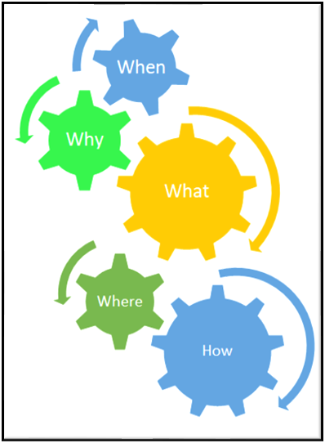

## **2.4 TABLE OF REQUIREMENTS**

### 2.4.1 HIGH LEVEL REQUIREMENTS

|  |  |
| --- | --- |
| HLR ID | High level Requirements |
| HLR1 | It shall be sense the fire |
| HLR2 | It shall be make sound when fire senses |
| HLR3 | It shall have reset button to reset buzzer |
| HLR4 | It shall have ADC to sense analog signals |

### 2.4.2 LOW LEVEL REQUIREMENTS

|  |  |  |  |
| --- | --- | --- | --- |
| ID | Low Level Requirements for HLR1 | ID | Low Level Requirements for HLR2 |
| LLR1 | It shall have Fire sensor | LLR1 | It shall have a buzzer to connect |
| LLR2 | It shall have ADC | LLR2 | It shall have a sensor to connect |

|  |  |  |  |
| --- | --- | --- | --- |
| ID | Low Level Requirements for HLR3 | ID | Low Level Requirements for HLR4 |
| LLR1 | It shall reset button manually | LLR1 | It shall have interrupt |
| LLR2 | Reset button is connect buzzer | LLR2 | It have ADC to convert signals |

# 3.0 Architecture

## **3.1 Structural Diagram**

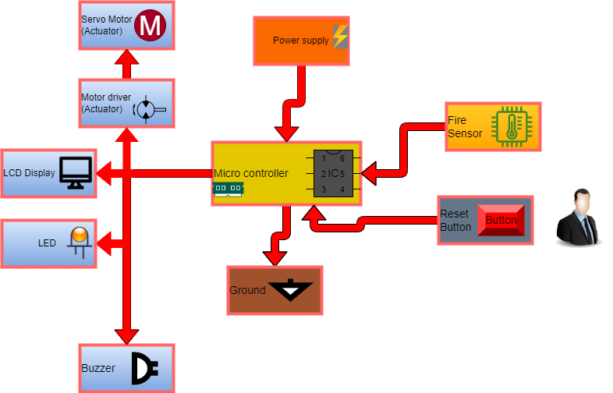

## **3.2 Behavioral Diagram**

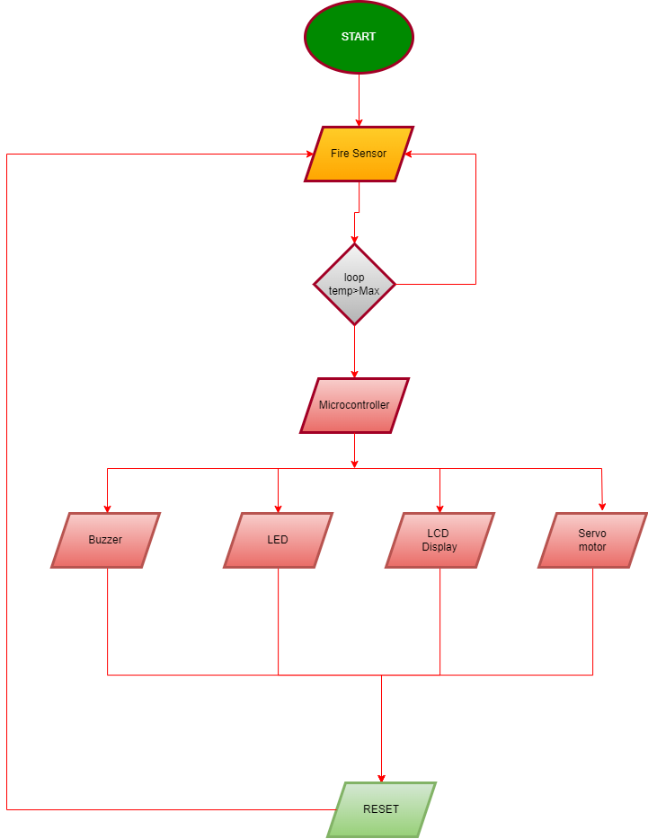

## **3.3 Behavioral Diagram**

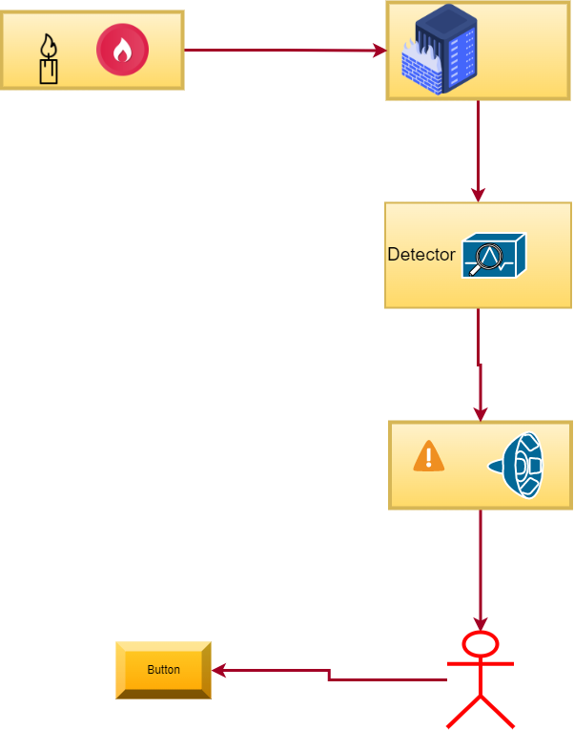

# 4.0 Test cases

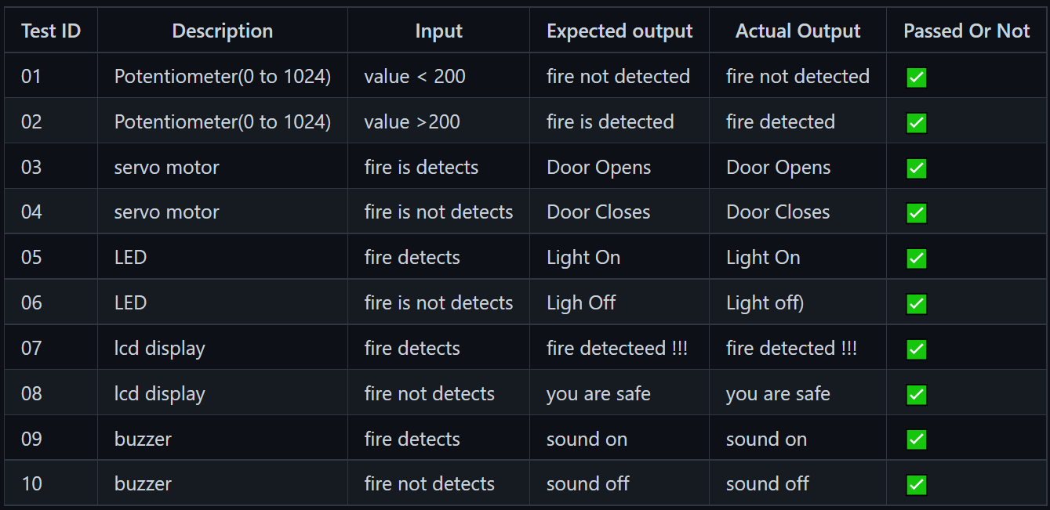

# 5.0 Simulation

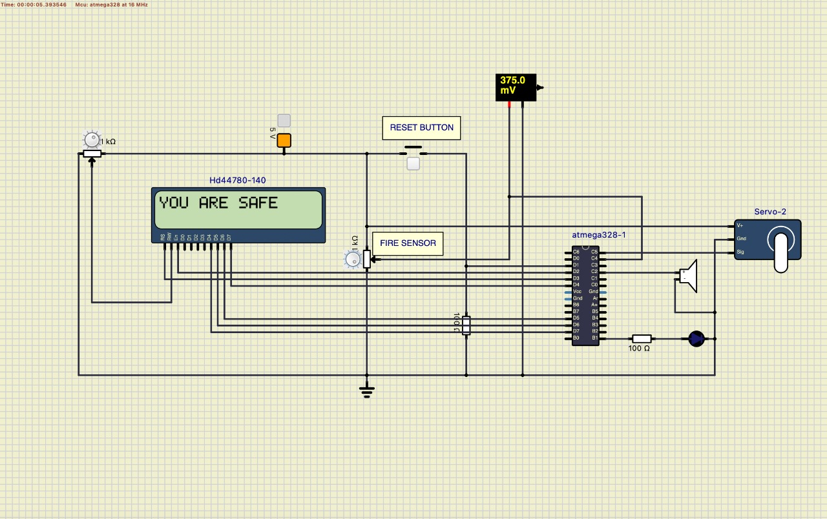

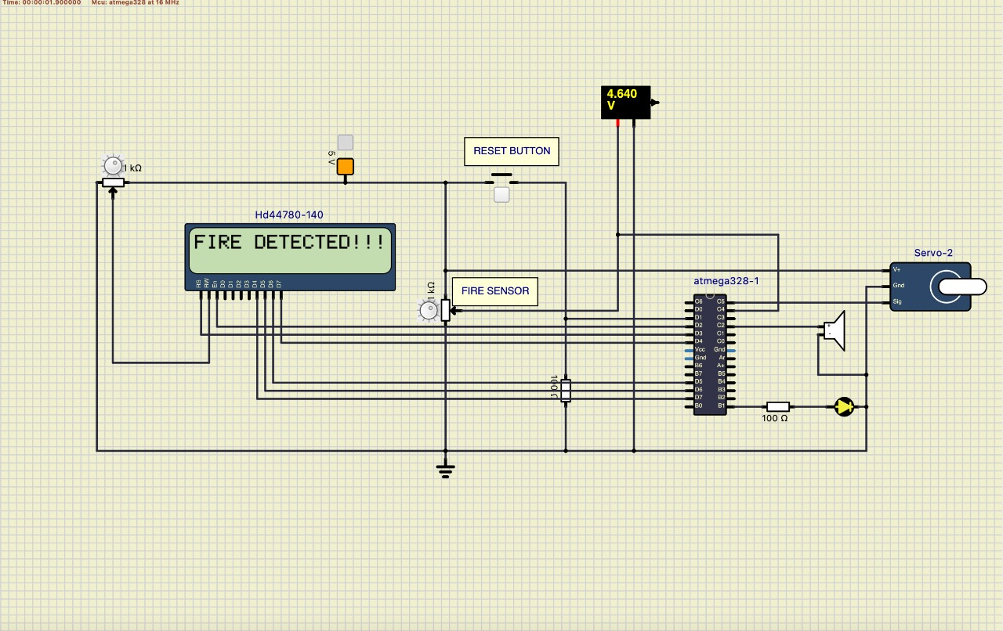

[https://youtu.be/AUkeZzn_j1s](https://youtu.be/AUkeZzn_j1s#)

<https://www.youtube.com/watch?v=AUkeZzn_j1s&t=1s>