**Name : J.M.V.SAI MANIKANTA**

**ROLL NO :CB.EN.U4CSE17327**

**SPM ASSIGNMENT**

**Gantt Chart :**

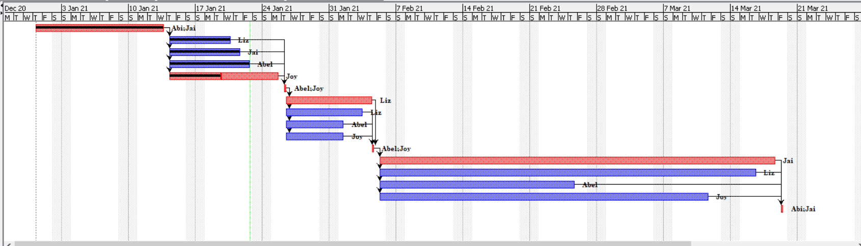

**Critical Path :**

**A -> E -> F -> G -> K -> L -> P**

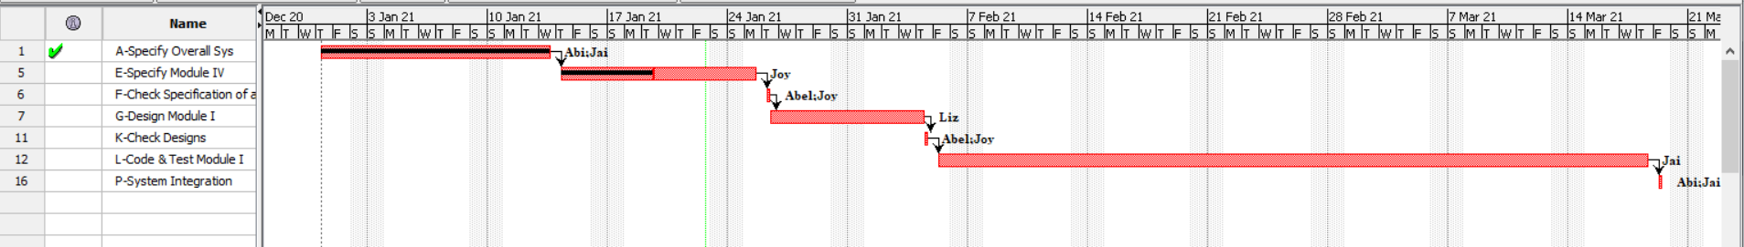

**Resource Histogram :**

**Jai:**

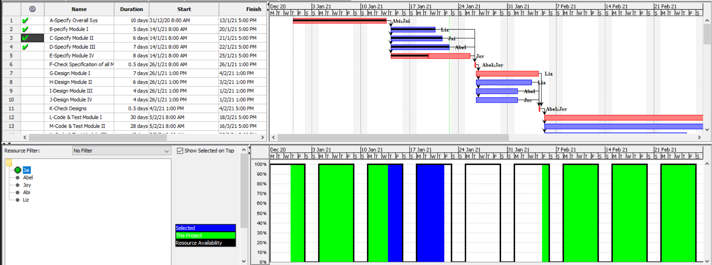

**Abel :**

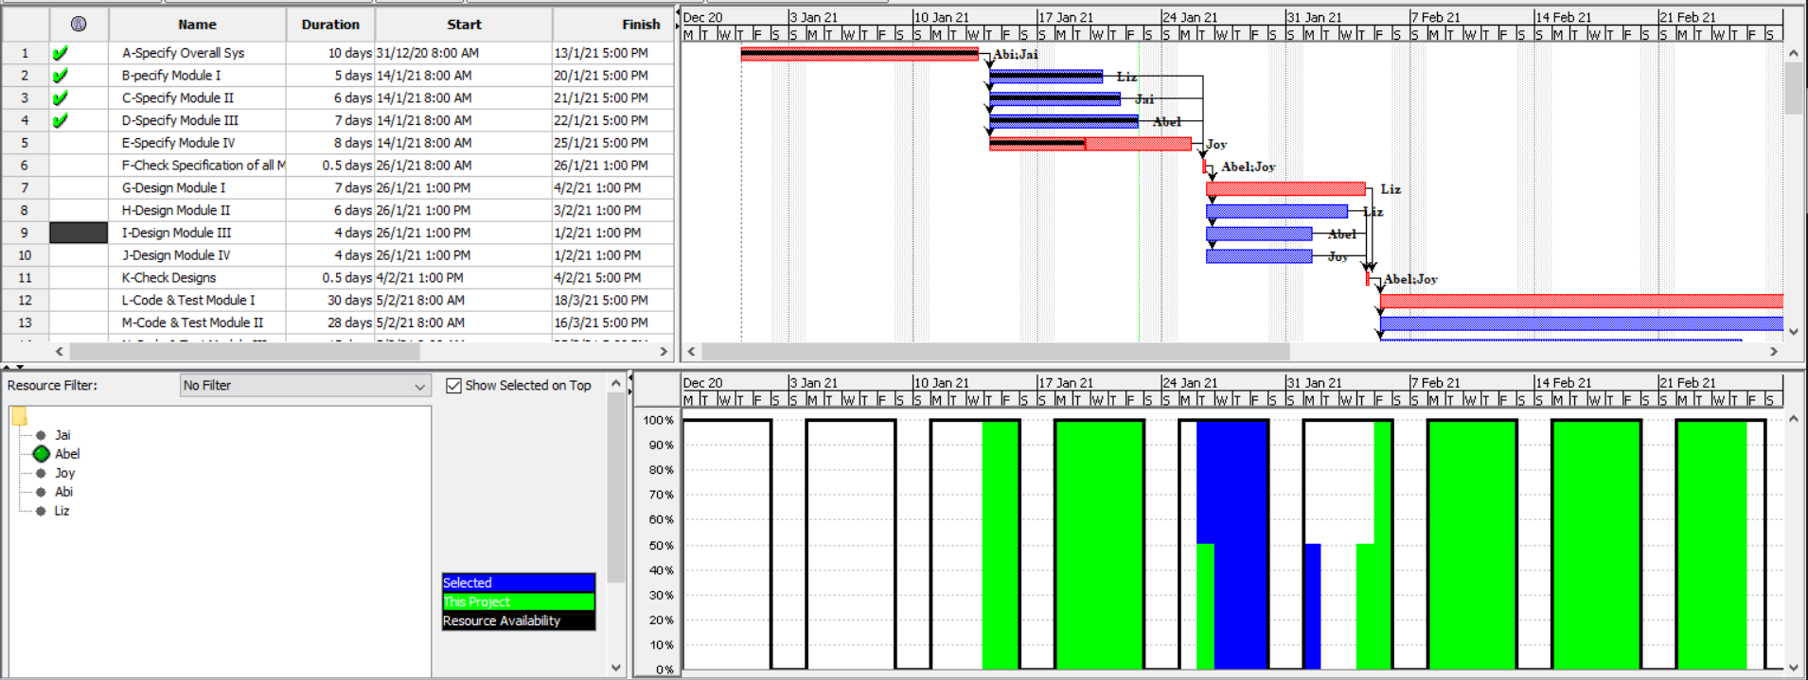

**Joy:**

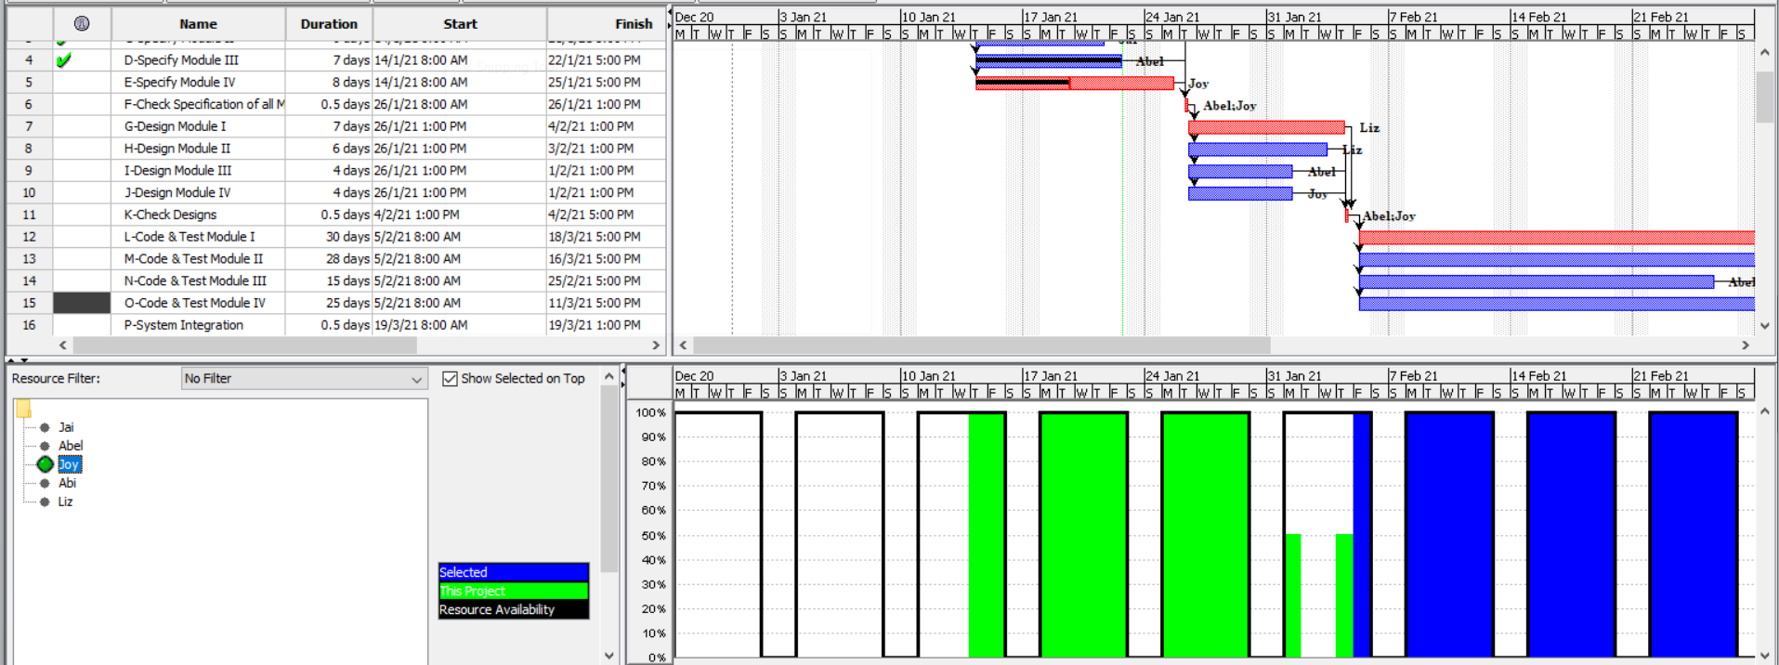

**Abi:**

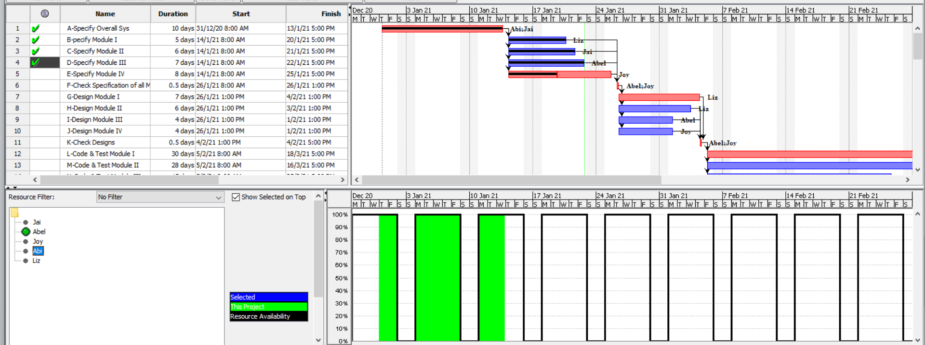

**Liz:**

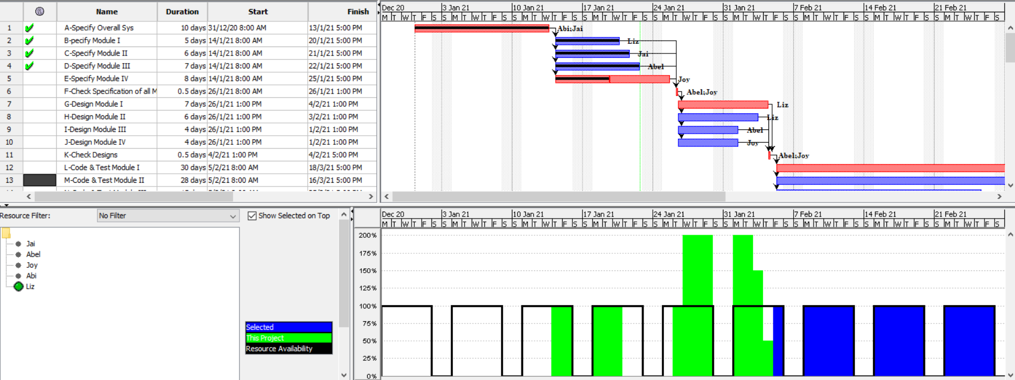

**Jai & Abi :**

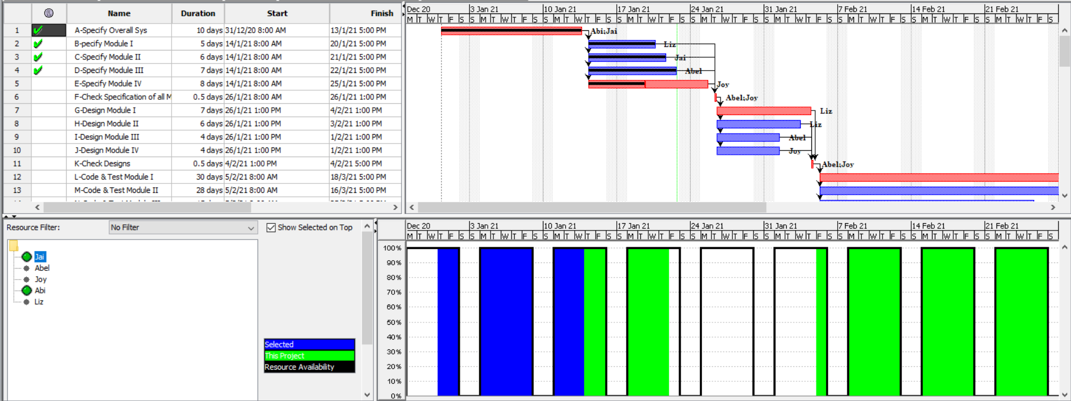

**Resource Allocation :**

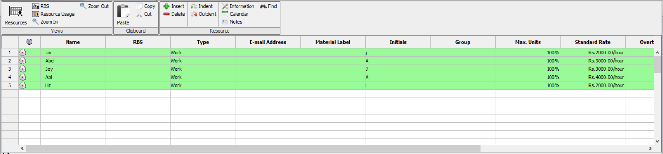

**Earned Value Analysis with planned value (BCWS), earned value (BCWP), actual cost (ACWP), Cost Variance (CV), Cost Performance Indicator (CPI) :**

