**Assignment -2 lab**

**Name:** V.Jaya Vamshhi

**Roll No:** CB.EN.U4CSE17367

Q1)

<!DOCTYPE html>

<html>

<head>

<style>

table{

  border: 3px solid rgb(255, 0, 0);

}

th,td{

  border: 1px solid rgb(255, 0, 0);

}

</style>

</head>

<body>

<table>

  <tr>

    <th><strong>Nested Table 1</strong>

        <br>

        <strong>Column 1      Column 2</strong>

        <p>our First Table Nested Within</p></th>

    <th>

        <strong>Nested Table 1</strong>

        <ul>

            <li>List Object 1</li>

            <li>List Object 2</li>

            <li>List Object 3</li>

            </ul>

    </th>

  </tr>

  <tr>

    <th>        <strong>Nested Table 1</strong>

        <p><a href="https://www.google.com/">Nested Table</a> Demo Continued</p></th>

    <th>

        <h><strong>Nested Table 4</strong></h>

        <div id="image">

            <img src="work2.png" alt="Italian Trulli">

        </div>

    </th>

  </tr>

</table>

</body>

</html>

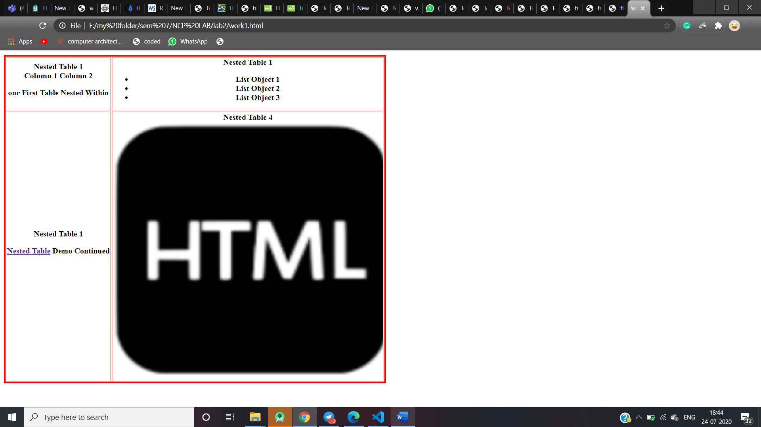

Q2) <style type="text/css">

    .tg  {border-collapse:collapse;border-spacing:0;}

    .tg td{border-color:black;border-style:solid;border-width:1px;font-family:Arial, sans-serif;font-size:14px;

      overflow:hidden;padding:10px 5px;word-break:normal;}

    .tg th{border-color:black;border-style:solid;border-width:1px;font-family:Arial, sans-serif;font-size:14px;

      font-weight:normal;overflow:hidden;padding:10px 5px;word-break:normal;}

    .tg .tg-36ox{border-color:inherit;color:#fe0000;text-align:left;vertical-align:top}

    .tg .tg-sg5v{border-color:inherit;font-size:100%;text-align:left;vertical-align:top}

    .tg .tg-fpwh{background-color:#32cb00;border-color:inherit;text-align:center;vertical-align:top}

    .tg .tg-ik58{background-color:#ffcb2f;border-color:inherit;text-align:left;vertical-align:top}

    .tg .tg-0pky{border-color:inherit;text-align:left;vertical-align:top}

    .tg .tg-i1q2{background-color:#34cdf9;border-color:inherit;text-align:left;vertical-align:top}

    </style>

    <table class="tg">

    <thead>

      <tr>

        <th class="tg-fpwh" colspan="12">Online Timetable Slots</th>

      </tr>

    </thead>

    <tbody>

      <tr>

        <td class="tg-ik58">Dept</td>

        <td class="tg-ik58">CSE</td>

        <td class="tg-ik58">Semester</td>

        <td class="tg-ik58">VII</td>

        <td class="tg-ik58">Class</td>

        <td class="tg-ik58">Btech.CSE</td>

        <td class="tg-ik58">Section</td>

        <td class="tg-ik58">D</td>

        <td class="tg-ik58">ClassAdvisor</td>

        <td class="tg-ik58">Mrs. Prathilothamai<br>Mr. A K Sumesh</td>

        <td class="tg-ik58">Emailid</td>

      </tr>

      <tr>

        <td class="tg-0pky" rowspan="2">Time/Day</td>

        <td class="tg-0pky">Slot1</td>

        <td class="tg-0pky">Slot2</td>

        <td class="tg-0pky">Slot3</td>

        <td class="tg-0pky">Slot4</td>

        <td class="tg-i1q2" rowspan="8">Lunch<br>Break</td>

        <td class="tg-0pky">Slot 5</td>

        <td class="tg-0pky">Slot 6</td>

        <td class="tg-0pky">Slot 7</td>

        <td class="tg-0pky">Slot 8</td>

        <td class="tg-36ox">Slot 9</td>

      </tr>

      <tr>

        <td class="tg-0pky">9-10</td>

        <td class="tg-0pky">10-11</td>

        <td class="tg-0pky">11-12</td>

        <td class="tg-0pky">12-1</td>

        <td class="tg-0pky">14-15</td>

        <td class="tg-0pky">15-16</td>

        <td class="tg-0pky">16-17</td>

        <td class="tg-0pky">17-18</td>

        <td class="tg-36ox">18-19</td>

      </tr>

      <tr>

        <td class="tg-0pky">Monday</td>

        <td class="tg-0pky">15CSE402<br>Structure and Interpretations<br>Computer Programs<br>Dr. Ragesh Krishnan K</td>

        <td class="tg-0pky"></td>

        <td class="tg-0pky"></td>

        <td class="tg-0pky"></td>

        <td class="tg-sg5v" colspan="2">Elective 5 Lab<br>Faculty 1<br>Faculty 2<br>Faculty 3<br>Elective 5A Lab<br>Faculty 4 <br>Faculty 5<br>Faculty 6</td>

        <td class="tg-0pky"></td>

        <td class="tg-0pky"></td>

        <td class="tg-36ox">Discussion</td>

      </tr>

      <tr>

        <td class="tg-0pky">Tuesday</td>

        <td class="tg-0pky">15CSE401<br>MLDM<br>Mr Manu Madhavan</td>

        <td class="tg-0pky">Elective 5 Lab<br>Faculty 1<br>Faculty 2<br>Faculty 3<br>Elective 5A Lab<br>Faculty 4 <br>Faculty 5<br>Faculty 6</td>

        <td class="tg-0pky"></td>

        <td class="tg-0pky">Elective 5 Lab<br>Faculty 1<br>Faculty 2<br>Faculty 3<br>Elective 5A Lab<br>Faculty 4 <br>Faculty 5<br>Faculty 6</td>

        <td class="tg-0pky"></td>

        <td class="tg-0pky"></td>

        <td class="tg-0pky"></td>

        <td class="tg-0pky"></td>

        <td class="tg-36ox">Discussion</td>

      </tr>

      <tr>

        <td class="tg-0pky">Wednesday</td>

        <td class="tg-0pky">Elective 5 Lab<br>Faculty 1<br>Faculty 2<br>Faculty 3<br>Elective 5A Lab<br>Faculty 4 <br>Faculty 5<br>Faculty 6</td>

        <td class="tg-0pky">15CSE401<br>MLDM<br>Mr Manu Madhavan</td>

        <td class="tg-0pky"></td>

        <td class="tg-0pky">15CSE402<br>Structure and Interpretations<br>Computer Programs<br>Dr. Ragesh Krishnan K</td>

        <td class="tg-0pky" colspan="2">Elective 5 Lab<br>Faculty 1<br>Faculty 2<br>Faculty 3<br>Elective 5A Lab<br>Faculty 4 <br>Faculty 5<br>Faculty 6</td>

      <td class="tg-0pky"></td>

      <td class="tg-0pky"></td>

      <td class="tg-36ox">Discussion</td>

    </tr>

    <tr>

      <td class="tg-0pky">Thursday</td>

      <td class="tg-0pky">Elective 5 Lab<br>Faculty 1<br>Faculty 2<br>Faculty 3<br>Elective 5A Lab<br>Faculty 4 <br>Faculty 5<br>Faculty 6</td>

      <td class="tg-0pky"></td>

      <td class="tg-0pky">Soft Skills</td>

      <td class="tg-0pky">15CSE376<br>NCP<br>Dr. Arun Kumar</td>

      <td class="tg-0pky"></td>

      <td class="tg-0pky"></td>

      <td class="tg-0pky"></td>

      <td class="tg-0pky"></td>

      <td class="tg-36ox">Discussion</td>

    </tr>

    <tr>

      <td class="tg-0pky">Friday</td>

      <td class="tg-0pky">15CSE376<br>NCP<br>Dr. Arun Kumar</td>

      <td class="tg-0pky">Elective 5 Lab<br>Faculty 1<br>Faculty 2<br>Faculty 3<br>Elective 5A Lab<br>Faculty 4 <br>Faculty 5<br>Faculty 6</td>

      <td class="tg-0pky"></td>

      <td class="tg-0pky">15CSE402<br>Structure and Interpretations<br>Computer Programs<br>Dr. Ragesh Krishnan K</td>

      <td class="tg-0pky" colspan="2">Elective 5 Lab<br>Faculty 1<br>Faculty 2<br>Faculty 3<br>Elective 5A Lab<br>Faculty 4 <br>Faculty 5<br>Faculty 6</td>

      <td class="tg-0pky"></td>

      <td class="tg-0pky"></td>

      <td class="tg-36ox">Discussion</td>

    </tr>

    <tr>

      <td class="tg-0pky">Saturday</td>

      <td class="tg-0pky">15CSE402<br>Structure and Interpretations<br>Computer Programs<br>Dr. Ragesh Krishnan K</td>

      <td class="tg-0pky"></td>

      <td class="tg-0pky">Elective 5 Lab<br>Faculty 1<br>Faculty 2<br>Faculty 3<br>Elective 5A Lab<br>Faculty 4 <br>Faculty 5<br>Faculty 6</td>

      <td class="tg-0pky">15CSE401<br>MLDM<br>Mr Manu Madhavan</td>

      <td class="tg-0pky"></td>

      <td class="tg-0pky"></td>

      <td class="tg-0pky"></td>

      <td class="tg-0pky"></td>

      <td class="tg-36ox">Discussion</td>

    </tr>

  </tbody>

  </table>

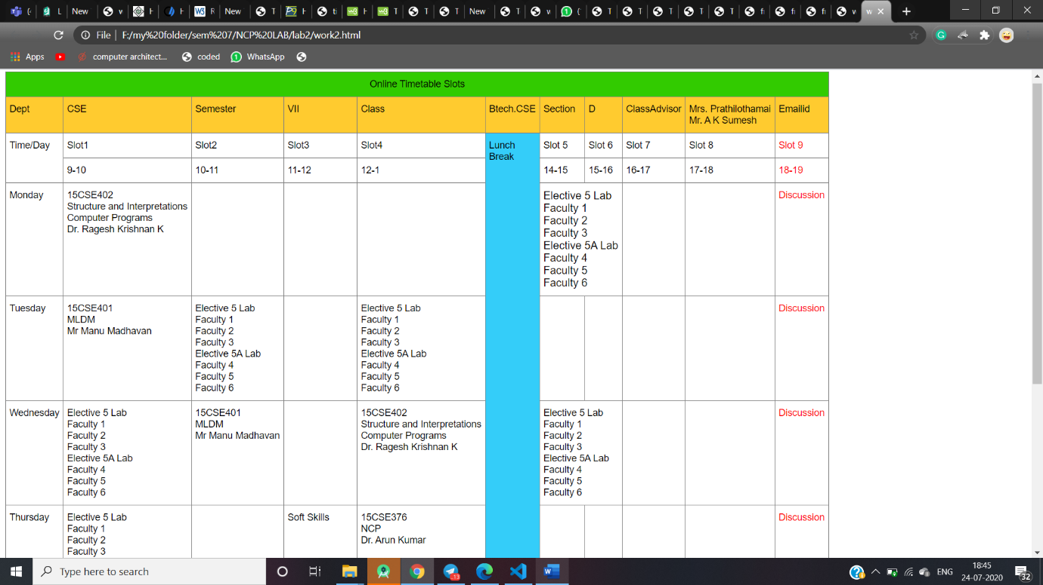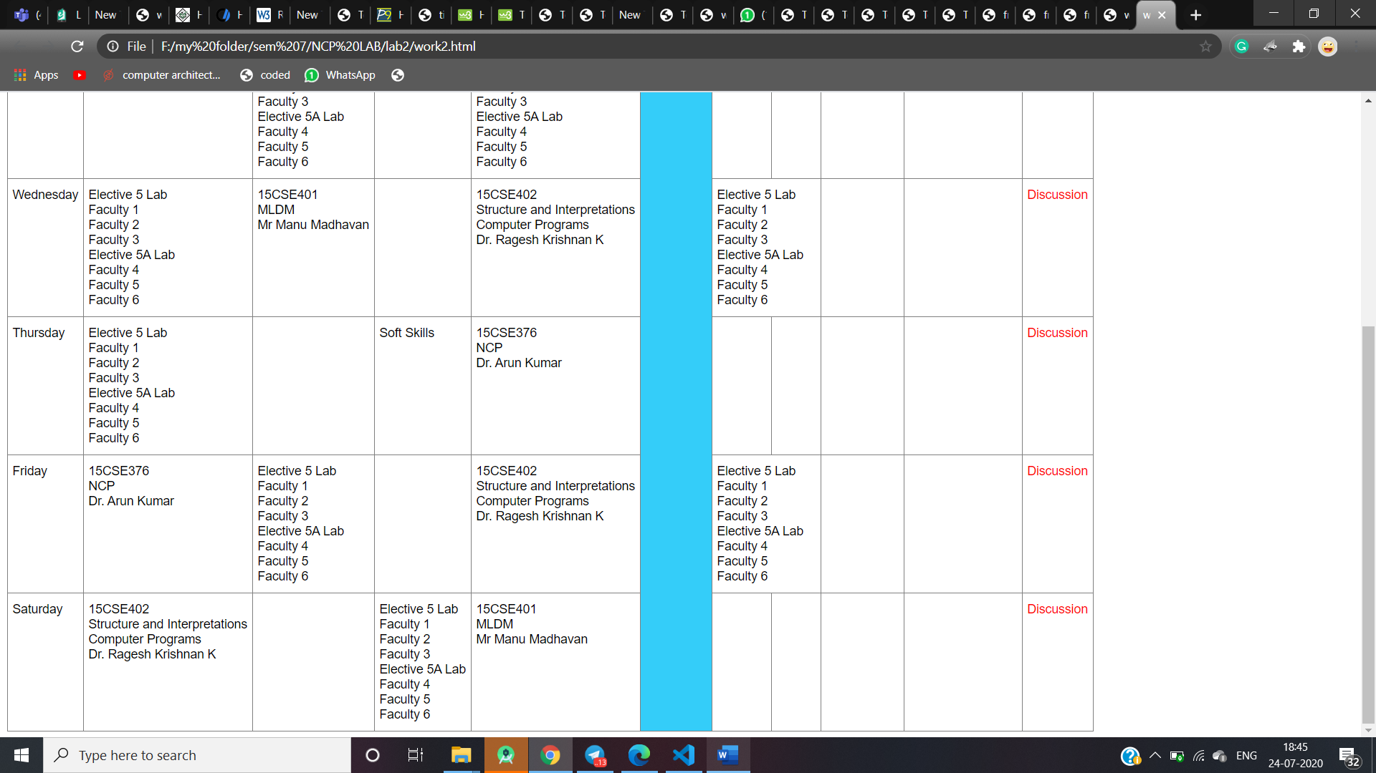

Q3)

Main)

<html>

    <body>

        <p>click on it to watch it closer</p>

        <img src="computer.jpg" alt="rect" usemap="#rectangle">

        <map name="rectangle">

            <area shape="rect" coords="118,78,252,169" alt="sub1" href="printer.html">

            <area shape="rect" coords="253,190,333,250" alt="sub1" href="speaker.html">

            <area shape="rect" coords="275,45,442,166" alt="sub1" href="monitor.html">

            <area shape="rect" coords="445,66,535,199" alt="sub1" href="CPU.html">

            <area shape="rect" coords="352,210,590,226" alt="sub1" href="keyboard.html">

            <area shape="rect" coords="558,232,500,258" alt="sub1" href="mouse.html">

        </map>

    </body>

</html>

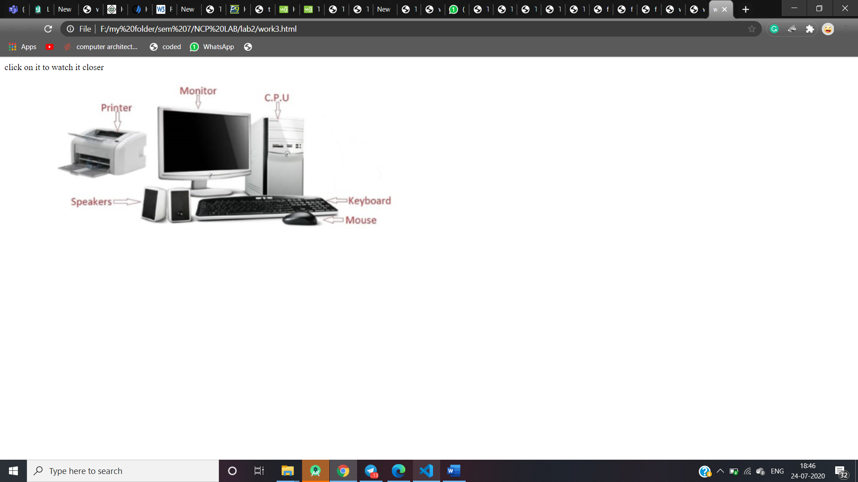

Same printer,scanner,keyboard,mouse,speaker

<!DOCTYPE html>

<html>

<body>

<h1>PRINTER</h1>

<h2>A printer is an output device that prints paper documents. This includes text documents, images, or a combination of both. The two most common types of printers are inkjet and laser printers. Inkjet printers are commonly used by consumers, while laser printers are a typical choice for businesses</h2>

</body>

</html>

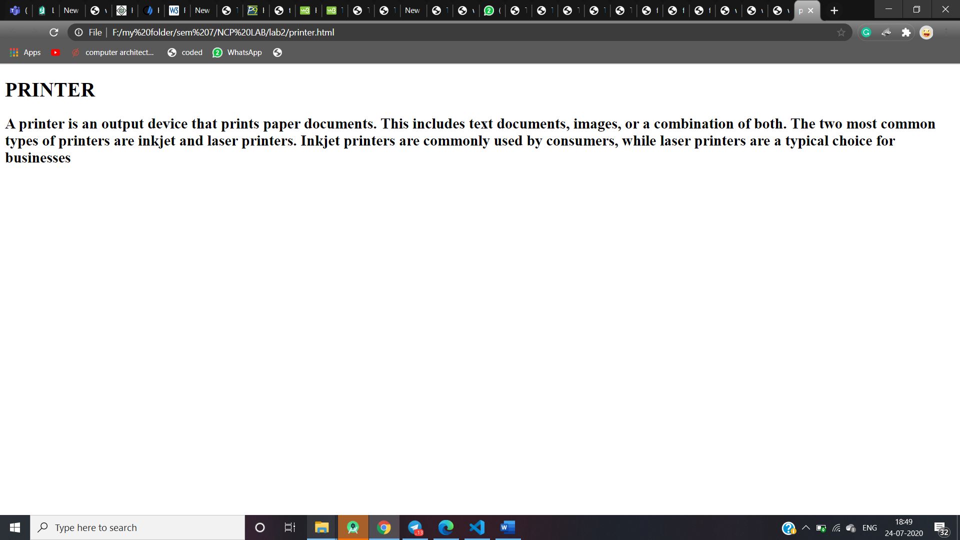

Q4)

Main)

<html>

<head><title>frames</title>

</head>

<frameset rows="5%,5%,8%,20%">

<frame src="part1.html"/>

<frame src="part2.html"/>

<frame src="part3.html"/>

<frame src="part4.html">

</frameset>

</html>

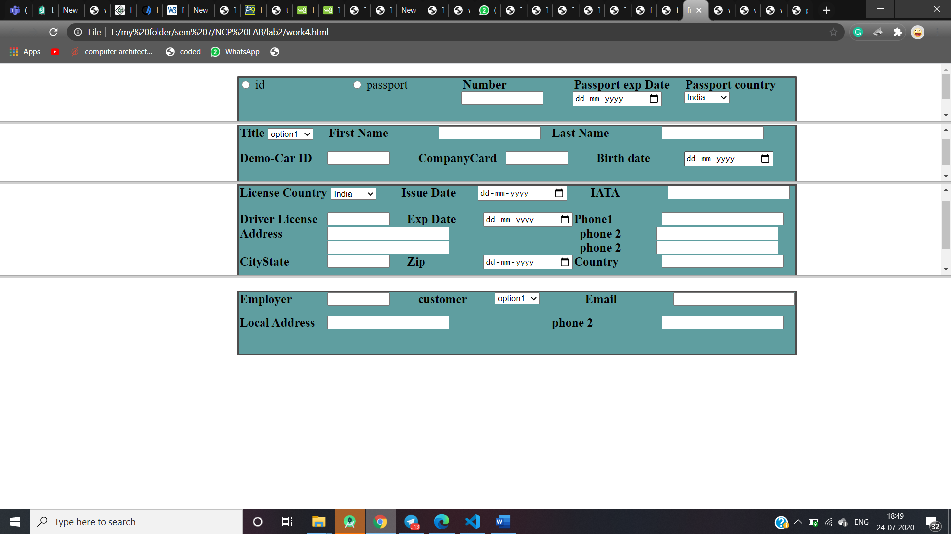

Part1)

<!DOCTYPE HTML>

<html>

    <head>

     <title>Template</title>

     <style>

         body

         {

            padding-left:250px;

         }

         #line

         {

             color:black;

             font-size:25px;

             margin: 0px;

             padding-left:0px;

         }

         label

         {

            font-size:20px;

            margin: 2px;

            padding-bottom:50px;

            padding-top:50px;

         }

         #jayaform1

         {

             width: 900px;

             background-color: cadetblue;

             border:2px solid rgb(78, 76, 76);

             border-radius:1px;

             height: 90px;

             margin: 20px 20px 20px 125px;

         }

         .column {

            float: left;

            width: 20%;

            padding: 0px;

        }

        .row::after {

            content: "";

            clear: both;

            display: table;

        }

        .column1{

            float: left;

            width: 16%;

            padding: 0px;

        }

        .column2{

            float: left;

            width: 14%;

            padding: 0px;

        }

        .column4{

            float: left;

            width: 29%;

            padding: 0px;

        }

     </style>

    </head>

    <body>

<form>

    <div id="jayaform1">

        <div class="row">

            <div class="column">

                <input type="radio" id="male" name="gender" value="male">

                <label for="male">id</label><br>

            </div>

            <div class="column">

                <input type="radio" id="male" name="gender" value="male">

                <label for="male">passport</label><br>

            </div>

            <div class="column">

                <label><strong>Number</strong></label>

                <input name="vam" type="text" name=first  size="15"/>

            </div>

            <div class="column">

                <label><strong>Passport exp Date</strong></label>

                <input name="vam" type="date" name=first/>

            </div>

            <div class="column">

                <label><strong>Passport country</strong></label>

                <br>

                <select id="mySelect" class="mdb-select md-form">

                    <option value="apple">India</option>

                    <option value="orange">America</option>

                    <option value="pineapple">London</option>

                    <option value="banana">Canada</option>

                  </select>

                </div>

            </div>

</form>

    </body>

</html>

Part2)

<!DOCTYPE HTML>

<html>

    <head>

     <title>Template</title>

     <style>

         body

         {

            padding-left:250px;

         }

         #line

         {

             color:black;

             font-size:25px;

             margin: 0px;

             padding-left:0px;

         }

         label

         {

            font-size:20px;

            margin: 2px;

            padding-bottom:50px;

            padding-top:50px;

         }

         #jayaform1

         {

             width: 900px;

             background-color: cadetblue;

             border:2px solid rgb(78, 76, 76);

             border-radius:0px;

             height: 90px;

             margin: 20px 20px 20px 125px;

         }

         .column {

            padding-top:50px;

            float: left;

            width: 20%;

            padding: 0px;

        }

        .row::after {

            content: "";

            clear: both;

            display: table;

        }

        .column1{

            float: left;

            width: 16%;

            padding: 0px;

        }

        .column2{

            float: left;

            width: 14%;

            padding: 0px;

        }

        .column4{

            float: left;

            width: 29%;

            padding: 0px;

        }

     </style>

    </head>

    <body>

<form>

    <div id="jayaform1">

            <div class="row">

                <div class="column1">

                    <label><strong>Title</strong></label>

                    <select id="mySelect" class="mdb-select md-form">

                        <option value="apple">option1</option>

                        <option value="orange">America</option>

                        <option value="pineapple">London</option>

                        <option value="banana">Canada</option>

                      </select>

                    </div>

                    <div class="column">

                        <label><strong>First Name</strong></label>

                    </div>

                    <div class="column">

                        <input name="vam" type="text" name=first/>

                    </div>

                    <div class="column">

                        <label><strong>Last Name</strong></label>

                    </div>

                    <div class="column">

                        <input name="vam" type="text" name=first/>

                    </div>

                </div>

                <br>

                <div class="row">

                    <div class="column1">

                        <label><strong>Demo-Car ID</strong></label>

                    </div>

                    <div class="column1">

                        <input name="vam" type="text" name=first size="10"/>

                    </div>

                        <div class="column1">

                            <label><strong>CompanyCard</strong></label>

                        </div>

                        <div class="column1">

                            <input name="vam" type="text" name=first size="10"/>

                        </div>

                        <div class="column1">

                            <label><strong>Birth date</strong></label>

                        </div>

                        <div class="column1">

                            <input name="vam" type="date" name=first/>

                        </div>

                    </div>

</form>

    </body>

</html>

Part3)

<!DOCTYPE HTML>

<html>

    <head>

     <title>Template</title>

     <style>

         body

         {

            padding-left:250px;

         }

         #line

         {

             color:black;

             font-size:25px;

             margin: 0px;

             padding-left:0px;

         }

         label

         {

            font-size:20px;

            margin: 2px;

            padding-bottom:50px;

            padding-top:50px;

         }

         #jayaform1

         {

             width: 900px;

             background-color: cadetblue;

             border:2px solid rgb(78, 76, 76);

             border-radius:0px;

             height: 170px;

             margin: 20px 20px 20px 125px;

         }

         .column {

            float: left;

            width: 20%;

            padding: 0px;

        }

        .row::after {

            content: "";

            clear: both;

            display: table;

        }

        .column1{

            float: left;

            width: 16%;

            padding: 0px;

        }

        .column2{

            float: left;

            width: 14%;

            padding: 0px;

        }

        .column4{

            float: left;

            width: 29%;

            padding: 0px;

        }

        .column5{

            float: left;

            width: 45%;

            padding: 0px;

        }

     </style>

    </head>

    <body>

<form>

    <div id="jayaform1">

                <div class="row">

                    <div class="column4">

                        <label><strong>License Country</strong></label>

                        <select id="mySelect" class="mdb-select md-form">

                            <option value="apple">India</option>

                            <option value="orange">America</option>

                            <option value="pineapple">London</option>

                            <option value="banana">Canada</option>

                          </select>

                        </div>

                        <div class="column2">

                            <label><strong>Issue Date</strong></label>

                        </div>

                        <div class="column">

                            <input name="vam" type="date" name=first/>

                        </div>

                        <div class="column2">

                            <label><strong>IATA</strong></label>

                        </div>

                        <div class="column2">

                            <input name="vam" type="text" name=first size="25"/>

                        </div>

                    </div>

                    <br>

                    <div class="row">

                        <div class="column1">

                            <label><strong>Driver License</strong></label>

                        </div>

                        <div class="column2">

                            <input name="vam" type="text" name=first size="10"/>

                        </div>

                            <div class="column2">

                                <label><strong>Exp Date</strong></label>

                            </div>

                            <div class="column1">

                                <input name="vam" type="Date" name=first/>

                            </div>

                            <div class="column1">

                                <label><strong>Phone1</strong></label>

                            </div>

                            <div class="column2">

                                <input name="vam" type="text" name=first size="25"/>

                            </div>

                        </div>

                        <div class="row">

                            <div class="column1">

                                <label><strong>Address</strong></label>

                            </div>

                            <div class="column5">

                                <input name="vam" type="text" name=first size="25"/>

                            </div>

                                <div class="column2">

                                    <label><strong>phone 2</strong></label>

                                </div>

                                <div class="column1">

                                    <input name="vam" type="text" name=first size="25"/>

                                </div>

                            </div>

                            <div class="row">

                                <div class="column1">

                                    <label><strong>   </strong></label>

                                </div>

                                <div class="column5">

                                    <input name="vam" type="text" name=first size="25"/>

                                </div>

                                    <div class="column2">

                                        <label><strong>phone 2</strong></label>

                                    </div>

                                    <div class="column1">

                                        <input name="vam" type="text" name=first size="25"/>

                                    </div>

                                </div>

                            <div class="row">

                                <div class="column1">

                                    <label><strong>CityState</strong></label>

                                </div>

                                <div class="column2">

                                    <input name="vam" type="text" name=first size="10"/>

                                </div>

                                    <div class="column2">

                                        <label><strong>Zip</strong></label>

                                    </div>

                                    <div class="column1">

                                        <input name="vam" type="Date" name=first/>

                                    </div>

                                    <div class="column1">

                                        <label><strong>Country</strong></label>

                                    </div>

                                    <div class="column2">

                                        <input name="vam" type="text" name=first size="25"/>

                                    </div>

                                </div>

</form>

    </body>

</html>

Part4)

<!DOCTYPE HTML>

<html>

    <head>

     <title>Template</title>

     <style>

         body

         {

            padding-left:250px;

         }

         #line

         {

             color:black;

             font-size:25px;

             margin: 0px;

             padding-left:0px;

         }

         label

         {

            font-size:20px;

            margin: 2px;

            padding-bottom:50px;

            padding-top:50px;

         }

         #jayaform1

         {

             width: 900px;

             background-color: cadetblue;

             border:2px solid rgb(78, 76, 76);

             border-radius:0px;

             height: 100px;

             margin: 20px 20px 20px 125px;

         }

         .column {

            float: left;

            width: 20%;

            padding: 0px;

        }

        .row::after {

            content: "";

            clear: both;

            display: table;

        }

        .column1{

            float: left;

            width: 16%;

            padding: 0px;

        }

        .column2{

            float: left;

            width: 14%;

            padding: 0px;

        }

        .column4{

            float: left;

            width: 29%;

            padding: 0px;

        }

        .column5{

            float: left;

            width: 40%;

            padding: 0px;

        }

     </style>

    </head>

    <body>

<form>

    <div id="jayaform1">

        <div class="row">

            <div class="column1">

                <label><strong> Employer</strong></label>

            </div>

            <div class="column1">

                <input name="vam" type="text" name=first size="10"/>

            </div>

                <div class="column2">

                    <label><strong>customer</strong></label>

                    </div>

                    <div class="column1">

                        <select id="mySelect" class="mdb-select md-form">

                            <option value="online">option1</option>

                            <option value="orange">America</option>

                            <option value="pineapple">London</option>

                            <option value="banana">Canada</option>

                          </select>

                    </div>

                <div class="column1">

                    <label><strong>Email</strong></label>

                </div>

                <div class="column2">

                    <input name="vam" type="text" name=first size="25"/>

                </div>

            </div>

            <p> </p>

                                <div class="row">

                                    <div class="column1">

                                        <label><strong>Local Address</strong></label>

                                    </div>

                                    <div class="column5">

                                        <input name="vam" type="text" name=first size="25"/>

                                    </div>

                                        <div class="column">

                                            <label><strong>phone 2</strong></label>

                                        </div>

                                        <div class="column1">

                                            <input name="vam" type="text" name=first size="25"/>

                                        </div>

                                    </div>

</form>

    </body>

</html>