SyteLine Prospect-to-Cash AI Assistant
Embedding the Chatbot in SyteLine WebClient
Integration requirements and questions for the SyteLine team

Item | Detail
Document version | 1.0 — for review
Date | 24 September 2026
Prepared by | Chatbot development team
Prepared for | SyteLine technical / administration team
Environment | SyteLine WebClient, configuration AIDEMO
Action requested | Please fill the "Answer" column in Section 9 and the "Provided" column in Section 10

1. Purpose
We are building an AI assistant for the SyteLine Prospect-to-Cash process (lead, opportunity, estimate, customer order, credit, shipment, invoice, payment). The assistant is working today as a standalone web page with test data. The next step is to place it inside SyteLine WebClient so users can use it while they work.
This document explains how the assistant will work inside SyteLine and lists the information, APIs and access we need from the SyteLine team to build it.

2. What we want to achieve
- One login only. After logging in to SyteLine, the user can use the assistant with no second login.
- Floating chat button. A small round chat button in the bottom-right corner of every form.
- Side panel. Clicking the button opens the assistant as a panel on the right side of the screen; the form stays usable.
- Knows the screen. The assistant knows which form, field and record the user is on.
- Follows SyteLine permissions. The assistant knows what the user may see and do, and never shows more.
- Screen-level help. The user can ask "Which form am I on?", "What can I do here?", "What does this field mean?".
Main security rule
SyteLine stays in charge of security. The chatbot has no login of its own and never uses a super-user account to read business data. All data requests use the logged-in user's own SyteLine session, so SyteLine itself allows or refuses them. The chatbot reads the user's permissions only to explain them and to hide options the user cannot use — it can never give more access than SyteLine does.

3. How it will work
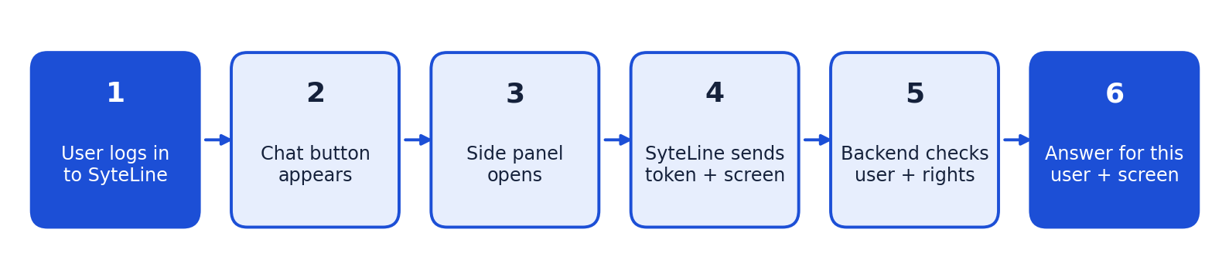
Step | What happens | Who provides it
1. Login | User logs in to SyteLine WebClient as today. | SyteLine (no change)
2. Chat button | A small launcher script loaded with WebClient adds a floating chat button to every form. | SyteLine team enables; chatbot team writes the script
3. Side panel | User clicks the button; the assistant opens as a panel on the right. It stays open when the user changes form. | Chatbot team
4. Token + screen | WebClient passes a short-lived session token and the screen context (form, field, record, site). It sends an update each time the user moves. | SyteLine team (how) + chatbot team (listener)
5. Check user | Chatbot backend validates the token with SyteLine, gets the real user, groups, site and permissions, and caches them for a few minutes. | SyteLine APIs + chatbot team
6. Answer | Help comes from the knowledge base; live values come from SyteLine APIs called with the user's own token; restricted content is refused. | Chatbot team

4. What the user will see
This is the common layout for assistants inside business applications: a round button waits in the corner; clicking it opens a panel about 380–420 px wide on the right. The panel header always shows the form and record the assistant is answering for.
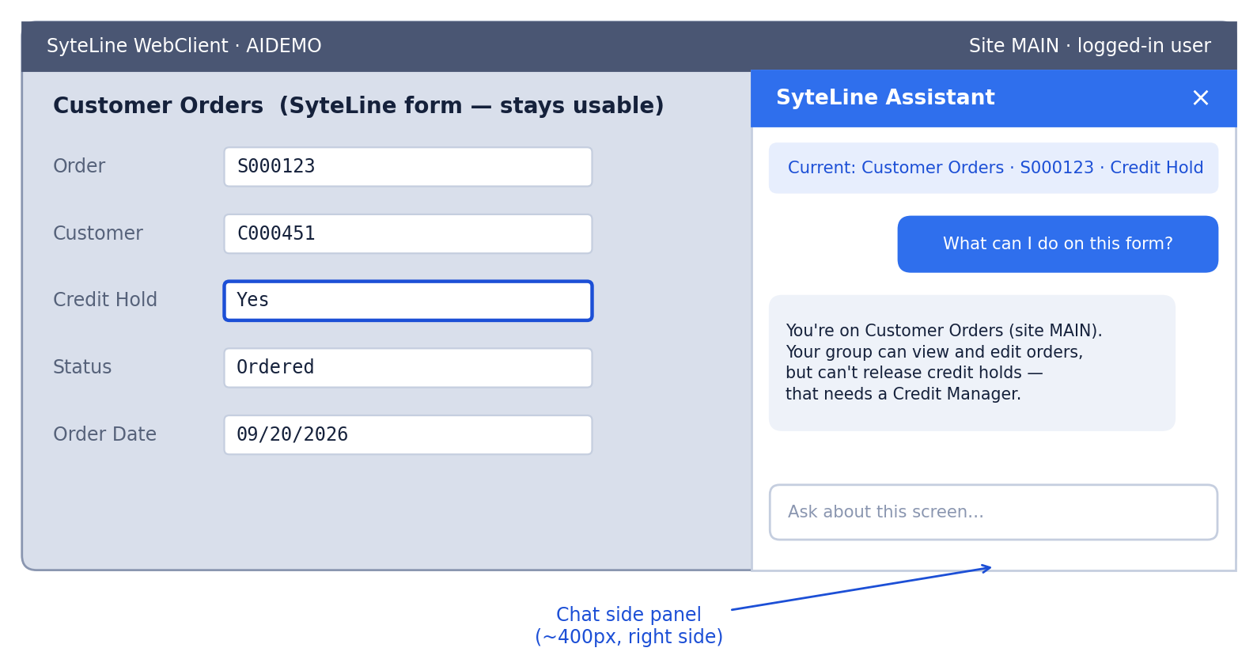
Figure: mock-up with example values.
- Panel can be closed and reopened; the conversation is kept.
- Panel remembers open/closed state while the user moves between forms.
- Works in the same light/dark blue theme as the current chatbot.

5. Screen-level questions the user can ask
User asks | Where the answer comes from | Status
"Which form am I in?" | Screen context sent by WebClient (form name, caption, site). | Needs context API
"What are my permissions here?" / "Can I delete this?" | User's group and user authorizations for this form and its IDO. | Needs permission API
"How do I work with this form?" | Knowledge base for this form; steps the user is not allowed to do are left out. | Knowledge base ready
"What does this field mean?" | Active field from the screen context + field catalogue in the knowledge base. | Field catalogue ready
"Why is this order on hold?" / "What is this customer's balance?" | Live SyteLine data for the selected record, read with the user's own token. | Needs data APIs
"What is the next form?" / "Open the invoice for this order" | Process knowledge + a WebClient command to open a form with a filter. | Needs navigation API

6. Security and permission design
- Identity from SyteLine only. The user is taken from the validated SyteLine token — never from anything the browser claims.
- User's own session for data. Business data is read with the user's own token, so SyteLine enforces form, IDO, field and row security.
- Permissions cached briefly. Permissions are cached (Redis) for about 5 minutes to keep answers fast; the time can be changed.
- Security gate on every message. Prompt-injection, data-exfiltration and privilege-escalation attempts are blocked and logged.
- Read-only for the POC. The assistant does not create, change, release or approve anything.
- Private history. Each user sees only their own conversations (stored in PostgreSQL).

7. What is already built
The full chatbot pipeline already runs against test (mock) SyteLine data. Each mock sits behind one small adapter, so your answers replace only the adapter — nothing else changes.
Piece | Today | Will be replaced by
Who the user is | Mock — test users picked in a panel | User from the validated SyteLine session
Session check | Mock — any token accepted | Token validated against SyteLine
Permissions | Mock — fixed table per group, Redis cache | User and group authorizations from SyteLine
Current form / field / record | Mock — typed into a test panel | Context messages from WebClient
Live business data | Not connected — replies "not available yet" | Approved IDO / REST calls with the user's token
Knowledge search, AI answers, security gate, conversation history | Working | No change

8. Proposed screen-context message
Sent from WebClient to the chat panel when the panel opens and whenever the user changes form, record or field. The user identity always comes from the validated token, never from this message.
{
"type": "ptc.context",
"configuration": "AIDEMO",
"site": "MAIN",
"form": { "name": "CustomerOrders", "caption": "Customer Orders" },
"field": { "name": "CreditHold", "label": "Credit Hold" },
"record": { "ido": "SLCos", "keys": { "CoNum": "S000123" } },
"language": "en-US",
"sessionToken": "<short-lived SyteLine token>"
}

Note: form, IDO and property names are examples. Please confirm the real names in this environment.

9. Questions for the SyteLine team
Priority: Blocker = integration cannot start without it; Needed = required before go-live; Later = can be answered during Phase 4. Blocker rows are shaded. Please write answers in the last column.

A. Showing the chatbot inside WebClient
ID | Question | Why we need it | Priority | Answer (SyteLine team)
A1 | What is the supported way to add our own JavaScript and a floating button to every WebClient form (global script, form script, Mongoose web component, custom master page, or other)? | To show the chat button after login without changing each form. | Blocker
A2 | Can WebClient load a page from our server in a side panel / iframe? Which Content-Security-Policy, X-Frame-Options or allowed-origin settings must change? | The chat panel is served by our backend. | Needed
A3 | Is this the classic WebClient only, or is Infor OS / Ming.le also available? If yes, can we use a Ming.le Context App or Utility App panel instead? | Ming.le has a built-in right-side app panel and context messages. | Needed
A4 | Which WebClient / Mongoose version is AIDEMO running? Is the TEST environment the same version? | Features and scripting APIs differ by version. | Needed

B. Login and session (no second login)
ID | Question | Why we need it | Priority | Answer (SyteLine team)
B1 | How can the chat panel get a token for the logged-in user's current session, and how long is it valid? | The user must not log in twice. | Blocker
B2 | How does our backend validate that token and get the user id, configuration and site from it? Which endpoint or IDO should we call? | To know who the user really is. | Blocker
B3 | Is authentication done with the Mongoose IDO REST token, the Infor ION API gateway (OAuth2 / .ionapi file), or SSO / Infor Federation Services? | Decides how our backend signs its API calls. | Needed
B4 | What happens to the token on logout or session timeout? Can the panel be notified? | The panel must close or lock when the session ends. | Needed

C. User, groups and site
ID | Question | Why we need it | Priority | Answer (SyteLine team)
C1 | Which IDO / API returns the user's authorization groups (e.g. the IDO behind the Users and Groups forms such as MGCore.UserGroupMaps — please confirm the name)? | Permissions are given by group. | Needed
C2 | How do we get the sites a user may access and the site they are currently working in? | Answers and data must match the user's site. | Needed
C3 | Is there a user profile we can read (display name, language, default site, role)? | Personalised, correctly worded answers. | Later

D. Permissions
ID | Question | Why we need it | Priority | Answer (SyteLine team)
D1 | Which IDO / API returns a user's effective form permissions (Read, Insert, Update, Delete, Execute), combining group and individual user authorizations? | To answer "what can I do on this form?" correctly. | Blocker
D2 | How do we read IDO-level and property / field-level permissions, including fields that are hidden or read-only for the user? | Never show or explain data the user cannot see. | Needed
D3 | Are there row-level rules (by site, warehouse, customer, salesperson) that limit which records a user may see? How are they enforced? | Record-level answers must respect them. | Needed
D4 | If our backend calls IDO REST with the user's own token, does SyteLine enforce all of the above automatically? | Our preferred design: SyteLine enforces, chatbot explains. | Needed
D5 | How quickly must a permission change take effect in the chatbot? (We plan a 5-minute cache.) | Sets our cache time. | Later

E. Current screen context
ID | Question | Why we need it | Priority | Answer (SyteLine team)
E1 | In WebClient scripting, how do we read the active form name and caption, the focused field, and the selected record's key values? | For screen-level answers. | Blocker
E2 | Which events fire when the user changes form, record or field, so we can send context updates? | Keeps the chatbot in sync with the screen. | Needed
E3 | How do we find the IDO a form is bound to (e.g. Customer Orders -> SLCos) and the IDO property behind a field? | To fetch live data for the selected record. | Needed
E4 | Can a WebClient script send messages to our panel (e.g. window.postMessage)? Which origin should we accept? | Secure page-to-panel communication. | Needed

F. Business data (live values)
ID | Question | Why we need it | Priority | Answer (SyteLine team)
F1 | Which integration method is approved: Mongoose IDO REST (v2), Infor ION API, or IDO .NET client? What is the base URL for AIDEMO? | All live-data calls. | Needed
F2 | Which Prospect-to-Cash IDOs and properties are approved for read access (customers, customer orders and lines, estimates, shipments, A/R invoices, payments)? Please send exact names. | Live balances, order status, invoices. | Needed
F3 | Are there custom IDOs or methods for credit status, overdue invoices or order status we should use? | Use your business logic, not raw tables. | Later
F4 | Are there rate limits, row limits or peak-hour restrictions for API calls? | Protect SyteLine performance. | Later
F5 | Please confirm the POC is read-only. Which operations (create, update, release, approve) may be allowed later? | Scope of chatbot actions. | Needed

G. Navigation
ID | Question | Why we need it | Priority | Answer (SyteLine team)
G1 | Can a script or URL open a WebClient form with a filter (e.g. open Customer Orders for order S000123)? What is the syntax? | For "open the invoice for this order". | Later
G2 | Can a form be opened in the same window / as a new tab inside WebClient? | Smooth user experience. | Later

H. Environment, access and compliance
ID | Question | Why we need it | Priority | Answer (SyteLine team)
H1 | Can our backend server reach the SyteLine API servers over the network (firewall, VPN, allowed IPs)? | Backend must call SyteLine. | Needed
H2 | Can we get test users in different groups (Sales Rep, AR Clerk, Credit Manager, no access)? | To prove permissions work before go-live. | Needed
H3 | Are help documents / knowledge articles also restricted by module or form access? | Filter help answers per user. | Later
H4 | What audit logging and data-retention rules apply to chat history and questions about customer data? | Compliance for stored conversations. | Needed
H5 | Who is our technical contact, and is there a TEST / UAT configuration we can use before AIDEMO? | Safe testing and fast answers. | Needed

10. Items to provide — checklist
Item | Used for | Priority | Provided? (Y/N) | Notes
A way to load our script and side panel in WebClient | Floating button and chat panel after login | Must have
Session-token access from WebClient + a validation endpoint | No second login; real user identity | Must have
API base URL and auth method (IDO REST token or ION API .ionapi credentials) | All SyteLine calls | Must have
IDO names: users, groups, user-group map, form / IDO authorizations, user sites | Permissions and "what can I do here" | Must have
Form-scripting events / properties for active form, field and record | Screen-level answers | Must have
Form -> IDO and field -> property mapping for Prospect-to-Cash forms | Field help; live data for the selected record | Must have
Test users per group and a TEST configuration | Prove permissions before go-live | Must have
Network access; CSP / iframe / CORS settings | Panel loads; backend reaches SyteLine | Must have
Approved Prospect-to-Cash IDOs and properties (read-only) | Live values: balance, order status, invoices | Phase 4
Form-open-with-filter syntax | "Open this record" navigation | Phase 4
Your SOPs, form guides and screenshots | Better, site-specific help answers | Nice to have

11. Next steps and responsibilities
# | Action | Owner
1 | Answer the Blocker questions: A1, B1, B2, D1, E1 | SyteLine team
2 | Provide API access, test users and IDO names (Section 10) | SyteLine team
3 | Review the screen-context message format (Section 8) | SyteLine team
4 | Build the compact side-panel version of the chat page | Chatbot team
5 | Build the launcher script (floating button, open/close, context listener) | Chatbot team
6 | Replace mock session / permission adapters with real SyteLine calls | Chatbot team
7 | Add screen-help answers: which form, my permissions, this field | Chatbot team
8 | Enable the script / component in the TEST configuration | SyteLine team
9 | Joint permission testing with each test user | Both teams
10 | Security review and rollout to AIDEMO | Both teams

12. Contacts and sign-off
Role | Name | Email / phone | Date
SyteLine technical contact
SyteLine security / admin
Chatbot team lead
Business owner (Prospect-to-Cash)

