SyteLine Prospect-to-Cash AI Assistant
API Requirements and RBAC
Which SyteLine APIs the chatbot needs, why each one is needed — explained step by step with examples — and how SyteLine permissions (RBAC) apply to every call

Item | Detail
Document version | 1.0 — for review
Date | 25 September 2026
Prepared by | Chatbot development team
Prepared for | SyteLine technical and security team
Environment | SyteLine WebClient, configuration AIDEMO
Related documents | SyteLine_Chatbot_Integration_Requirements.docx · SyteLine_RBAC_Permission_Requirements.docx
Action requested | Confirm each API in the "Please confirm" tables and tick the checklist in section 6

1. Summary
The chatbot needs seven groups of SyteLine APIs. Almost all business data in SyteLine is read through one standard service — the Mongoose IDO Request Service — so most items below are really "which IDOs and properties the chatbot may read". Request formats shown are the usual Mongoose REST form and are illustrative: the SyteLine team must confirm the exact endpoints and names for this version.
The one rule that makes RBAC work
Every business-data call is made with the logged-in user's own token — never a shared admin account. SyteLine then applies that user's permissions to every call automatically, and the chatbot can never show more than the user could see in SyteLine.

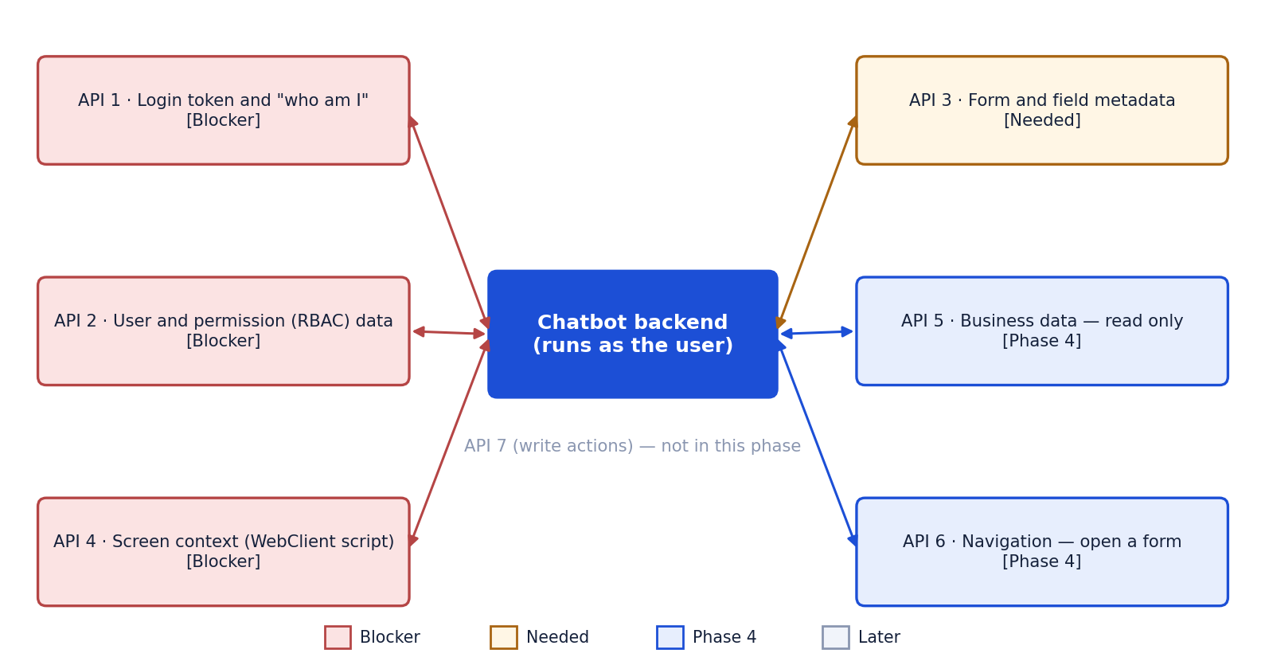
API | Why we need it (one line) | Example question | RBAC by SyteLine? | Priority
1. Login token and "who am I" | The user must not log in a second time — the chatbot has to reuse the SyteLine login. | Priya (Sales Rep) opens the chat after logging in to SyteLine | Yes | Blocker
2. User and permission (RBAC) data | To answer "What can I do on this form?" exactly as SyteLine is configured. | Can I release the credit hold on this order? | This IS the RBAC data | Blocker
3. Form and field metadata | To link what is on screen to the data behind it. | What does this field mean? | Mostly not sensitive | Needed
4. Screen context (WebClient script) | Users ask about "this order", "this field", "this screen" — the chatbot must know what "this" is. | Why can't I ship this? | No | Blocker
5. Business data — read only | To answer questions about real records: status, holds, balances, due dates. | Why is order S000123 on hold? | YES, fully | Phase 4
6. Navigation — open a form | Users want to go straight to the right screen after the answer ("open the invoice for this order"). | Open the invoices for this customer | Yes | Phase 4
7. Write actions — NOT in this phase | Not needed now: the proof of concept is read-only. Asked only to plan future phases. | Create an order for C000451 | When enabled later, SyteLine enforces Insert/Update/Execute rights per user | Later

2. Each API explained step by step
Every API below follows the same layout: what it is, why we need it, a worked example with each step, an illustrative request, what goes wrong without it, how RBAC applies, and what the SyteLine team should confirm.

API 1 — Login token and "who am I" [Blocker]
What it is
A way for the chat panel to receive the logged-in user's short-lived SyteLine session token, and an endpoint the chatbot backend calls to validate that token and learn who the user is.
Why we need it
- The user must not log in a second time — the chatbot has to reuse the SyteLine login.
- The chatbot must know the REAL user (not a name typed in the browser) before it answers anything.
- Every later API call carries this token, so SyteLine applies that user's permissions automatically.
Step-by-step example: Priya (Sales Rep) opens the chat after logging in to SyteLine
Step | What happens | Who / which API
1 | Priya logs in to SyteLine WebClient as usual. | SyteLine
2 | She clicks the chat button; WebClient passes her session token to the chat panel. | WebClient → panel
3 | The panel sends her first question with the token to the chatbot backend. | Panel → backend
4 | The backend calls "who am I" with the token. | Backend → API 1
5 | SyteLine answers: user priya.s, configuration AIDEMO, site MAIN. | API 1 → backend
6 | The chatbot now answers as Priya, with Priya's rights — no second login. | Chatbot

Illustrative request and response (to be confirmed)
GET /IDORequestService/ido/token/AIDEMO (or ION API OAuth2 token)
→ { "Token": "b/XdI6I..." }
Validate / who am I (endpoint to be confirmed)
→ { "user": "priya.s", "configuration": "AIDEMO", "site": "MAIN" }

Without this API
The user would need a separate chatbot login, or the chatbot would have to trust whatever name the browser sends — a serious security hole.
How RBAC applies
Yes — the token IS the user. Every call made with it gets exactly that user's rights.
SyteLine team — please confirm
Please confirm | Answer (SyteLine team)
How does the chat panel get the token from the WebClient session?
Which endpoint validates it and returns user / configuration / site?
Token lifetime, and what happens on logout or timeout?
Mongoose IDO REST token, or ION API gateway (.ionapi OAuth2)?

API 2 — User and permission (RBAC) data [Blocker]
What it is
Read access to the security records: the user, their authorization groups, the object authorizations (privileges on forms and IDOs) for the user and their groups, their sites and licensed modules.
Why we need it
- To answer "What can I do on this form?" exactly as SyteLine is configured.
- To avoid suggesting forms, steps or actions the user is not allowed to use.
- To guard the parts SyteLine cannot see — the chatbot's own help content.
Step-by-step example: Priya asks "Can I release the credit hold on this order?"
Step | What happens | Who / which API
1 | The chatbot knows the user is priya.s (API 1). | Chatbot
2 | It reads her groups: SALES_REP. | Backend → API 2
3 | It reads SALES_REP's authorizations: Customer Orders = Read/Update; Credit Hold release = not granted. | Backend → API 2
4 | Result is cached for a few minutes, so the next question is instant. | Chatbot (Redis)
5 | Answer: "You can view and edit this order, but releasing a credit hold needs a Credit Manager." | Chatbot

Illustrative request and response (to be confirmed)
GET /IDORequestService/ido/load/MGCore.UserGroupMaps
?properties=UserName,GroupName&filter=UserName='priya.s'
→ [ { "UserName": "priya.s", "GroupName": "SALES_REP" } ]
GET /IDORequestService/ido/load/<object authorizations IDO>
?filter=GroupName='SALES_REP'
→ [ { "Object": "CustomerOrders", "Read": 1, "Update": 1, "Delete": 0 }, ... ]
(IDO names are examples — please confirm)

Without this API
The chatbot could not explain permissions and might tell a user to do something SyteLine will refuse.
How RBAC applies
This IS the RBAC data. It is read only to explain and to hide options — the real enforcement is still SyteLine itself on every data call (API 5).
SyteLine team — please confirm
Please confirm | Answer (SyteLine team)
Exact IDO names for users, groups, user-group map, object authorizations, sites, licenses.
Can a user read their own permissions, or is a read-only service account needed?
Rules: group vs user precedence, several groups, deny, Super User.
Is there one call that returns effective permissions?

API 3 — Form and field metadata [Needed]
What it is
Which IDO each form uses (Customer Orders → SLCos) and the property list of an IDO (field name, label, type).
Why we need it
- To link what is on screen to the data behind it.
- To explain a field using its real SyteLine label.
- To request exactly the fields needed — never whole records.
Step-by-step example: Priya is in the Credit Hold field and asks "What does this field mean?"
Step | What happens | Who / which API
1 | Screen context (API 4) says: form CustomerOrders, field CreditHold. | WebClient → panel
2 | The chatbot looks up the form's IDO: SLCos. | Backend → API 3
3 | It reads SLCos property info: CreditHold = "Credit Hold", flag. | Backend → API 3
4 | It combines the label with the knowledge base article on credit holds. | Chatbot
5 | Answer: "Credit Hold marks this order as blocked from shipping until credit is released…" | Chatbot

Illustrative request and response (to be confirmed)
GET /IDORequestService/ido/info/SLCos
→ { "Properties": [ { "Name": "CoNum", "Label": "Order" },
{ "Name": "CreditHold", "Label": "Credit Hold" }, ... ] }

Without this API
The chatbot would not know which data sits behind a screen or field, so screen-level answers would be vague.
How RBAC applies
Mostly not sensitive. The chatbot still hides fields the user is not allowed to see (from API 2).
SyteLine team — please confirm
Please confirm | Answer (SyteLine team)
How to get the form → IDO mapping for Prospect-to-Cash forms?
Is /ido/info available, or another metadata call?

API 4 — Screen context (WebClient script) [Blocker]
What it is
Not a REST API: a supported WebClient script/event that tells the chat panel the current form, focused field, selected record key and site — and sends an update whenever the user moves.
Why we need it
- Users ask about "this order", "this field", "this screen" — the chatbot must know what "this" is.
- Without it, every question needs the user to type IDs and form names.
Step-by-step example: Priya has order S000123 open and asks "Why can't I ship this?"
Step | What happens | Who / which API
1 | WebClient event fires: form CustomerOrders, record CoNum = S000123, site MAIN. | WebClient script
2 | The script posts this to the chat panel (window.postMessage). | WebClient → panel
3 | The panel sends it with the question to the backend. | Panel → backend
4 | "this" is resolved to order S000123 — no need to ask which order. | Chatbot

Illustrative request and response (to be confirmed)
{ "type": "ptc.context", "configuration": "AIDEMO", "site": "MAIN",
"form": { "name": "CustomerOrders", "caption": "Customer Orders" },
"field": { "name": "CreditHold" },
"record": { "ido": "SLCos", "keys": { "CoNum": "S000123" } } }

Without this API
The chatbot cannot answer screen-level questions and has to ask "which order?" every time.
How RBAC applies
No — it is NOT a security source. It only says what is open; identity comes from API 1 and rights from API 2 / SyteLine.
SyteLine team — please confirm
Please confirm | Answer (SyteLine team)
Supported way to read active form, field and record in WebClient scripting?
Which events fire when form / record / field change?
Can the script postMessage to our panel, and from which origin?

API 5 — Business data — read only [Phase 4]
What it is
Read access (load collection / invoke method) to the approved Prospect-to-Cash IDOs: customers, customer orders and lines, estimates/quotes, credit, shipments, A/R invoices and payments — always called with the user's own token.
Why we need it
- To answer questions about real records: status, holds, balances, due dates.
- Documents explain HOW things work; only live data says what is TRUE right now for this record.
Step-by-step example: Priya asks "Why is order S000123 on hold?"
Step | What happens | Who / which API
1 | Chatbot reads order S000123 with Priya's token: CreditHold = Yes, customer C000451. | Backend → API 5
2 | It reads customer C000451 with Priya's token: credit limit 50,000; balance 62,300. | Backend → API 5
3 | It combines the facts with the credit-hold article from the knowledge base. | Chatbot
4 | Answer: "S000123 is on hold because C000451 is over its credit limit (62,300 vs 50,000). A Credit Manager can release it." | Chatbot

Illustrative request and response (to be confirmed)
GET /IDORequestService/ido/load/SLCos
?properties=CoNum,CustNum,Stat,CreditHold&filter=CoNum='S000123'
→ [ { "CoNum": "S000123", "CustNum": "C000451", "Stat": "O", "CreditHold": 1 } ]
POST /IDORequestService/ido/invoke/<IDO>?method=<credit or aging method> (if provided)

Without this API
The chatbot can only explain processes in general; it cannot say anything about a specific order, customer or invoice.
How RBAC applies
YES, fully — because the call runs as Priya. If she cannot see credit fields or another salesperson's customer, SyteLine returns nothing, and the chatbot has nothing to reveal.
SyteLine team — please confirm
Please confirm | Answer (SyteLine team)
Approved IDOs and properties for each Prospect-to-Cash area (exact names).
Any custom methods for credit status, aging, order status?
Rate limits / record caps; confirm read-only for the POC.

API 6 — Navigation — open a form [Phase 4]
What it is
A WebClient command or URL that opens a form, optionally filtered to one record.
Why we need it
- Users want to go straight to the right screen after the answer ("open the invoice for this order").
Step-by-step example: Priya asks "Open the invoices for this customer"
Step | What happens | Who / which API
1 | Chatbot checks Priya can open the invoice form (API 2). | Chatbot
2 | It sends the open-form command with filter CustNum = C000451 to WebClient. | Panel → WebClient
3 | WebClient opens the form; SyteLine still checks her access. | SyteLine

Illustrative request and response (to be confirmed)
(to be provided by the SyteLine team) e.g. an open-form command with a filter:
open form "ARInvoices" where CustNum = 'C000451'

Without this API
The chatbot can only tell users which form to open; they navigate by hand.
How RBAC applies
Yes — SyteLine will not open a form the user has no access to.
SyteLine team — please confirm
Please confirm | Answer (SyteLine team)
Syntax to open a form with a filter from a script or URL.
Same window or new tab?

API 7 — Write actions — NOT in this phase [Later]
What it is
Create / update / release / approve (ido/update, ido/invoke). Listed only so the boundary is clear.
Why we need it
- Not needed now: the proof of concept is read-only. Asked only to plan future phases.
Step-by-step example: Priya asks "Create an order for C000451"
Step | What happens | Who / which API
1 | The chatbot recognises it as an action. | Chatbot
2 | It replies that actions are not available in this version — nothing is created. | Chatbot

Illustrative request and response (to be confirmed)
Not called in the proof of concept.

Without this API
No impact now.
How RBAC applies
When enabled later, SyteLine enforces Insert/Update/Execute rights per user.
SyteLine team — please confirm
Please confirm | Answer (SyteLine team)
Which write operations (if any) may be allowed later, and with which approvals?

3. End to end: how the APIs work together
Example: Priya (Sales Rep) has order S000123 open and asks "Why is order S000123 on hold?"
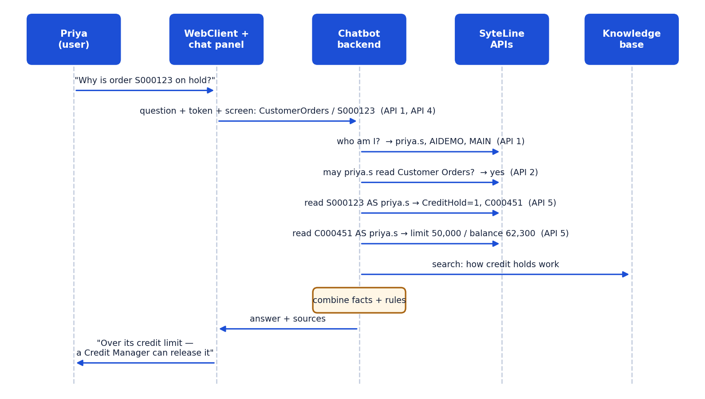
# | Step | API
1 | Priya asks in the chat panel while order S000123 is open. | —
2 | The panel sends the question, her session token and the screen context. | API 1 + API 4
3 | The backend validates the token: priya.s, AIDEMO, MAIN. | API 1
4 | It checks she may read Customer Orders (cached for a few minutes). | API 2
5 | It reads the order AS Priya: CreditHold = Yes, customer C000451. | API 5
6 | It reads the customer AS Priya: over the credit limit. | API 5
7 | It searches the knowledge base for how credit holds work. | Chatbot knowledge base
8 | It writes the answer from these facts only, with sources. | Chatbot

4. How RBAC works across the APIs
Layer | Who enforces | What it protects
1. SyteLine — the real lock | SyteLine, on every IDO call made with the user's token | Forms, IDOs, fields and records the user may not see — refused or left out
2. Chatbot — explainer and gatekeeper | Chatbot permission resolver, using API 2 data | Explaining "what can I do", hiding options, guarding the chatbot's own knowledge answers

Same question, two users: "What is the credit limit of customer C000451?"
User | What SyteLine returns (API 5, as the user) | Chatbot answer
Credit Manager | Credit limit 50,000 | "The credit limit of C000451 is 50,000."
Sales Rep without credit-field access | Credit fields hidden / not returned | "You don't have access to credit limit information. Please contact your credit team." — never guesses

Where RBAC could leak — and the protection
Risk | Protection
A shared admin account used for data calls | Never allowed: business data is always read with the user's own token
Rules checked only in the WebClient screen, not the API | SyteLine team lists them (RBAC doc D2); chatbot adds the checks
Business rules outside RBAC (e.g. credit-hold release) | Listed by SyteLine team (RBAC doc D3); chatbot checks before "you can…"
Stale permissions in the cache | Cache time agreed with SyteLine team (RBAC doc E1), default 5 minutes
Knowledge answers visible to everyone | Chatbot-side filter by module/form (RBAC doc E4)
Chat history seen by another user | Already built: history locked to the user in PostgreSQL
Screen context faked by the browser | Context never decides identity or rights — only API 1 and SyteLine do

5. Priority and order of delivery
Order | APIs | What it unlocks
1st — blockers | API 1 Login token · API 2 Permissions · API 4 Screen context | Real user, real permissions, "which form am I on / what can I do here"
2nd | API 3 Metadata · API 5 Business data (read) | Answers about specific orders, customers, invoices
3rd | API 6 Navigation | "Open this form / record"
Later | API 7 Write actions | Only after the read-only proof of concept is approved

6. Checklist — please tick
Item to provide | For API | Provided? (Y/N) | Notes / file name
Way to pass the session token to the panel + validation endpoint | 1
API base URL and auth method (IDO REST token or ION API .ionapi) | 1, 2, 3, 5
Security IDO names + sample responses; read-only service account if needed | 2
Form → IDO and field → property mapping for Prospect-to-Cash forms | 3
Supported WebClient script/events for form, field, record context | 4
Approved Prospect-to-Cash IDOs + properties (read-only), custom methods | 5
Open-form-with-filter syntax | 6
Test users per role in a TEST configuration | All
Network access from the chatbot server; CORS / CSP / iframe settings | All

7. Contacts and sign-off
Role | Name | Email / phone | Date
SyteLine technical contact
SyteLine security administrator
Chatbot team lead

