SyteLine Prospect-to-Cash AI Assistant
Technical Specification
Architecture, request flow, retrieval, security, data and development history — end to end

Item | Detail
Document version | 1.0
Date | 24 September 2026
System version | Git commit 501db05 (main) + documentation updates
Status | Phases 1–3 complete; Phase 2 on mock SyteLine adapters; Phases 4–6 partly done
Repository | github.com/manikantakavala1998/sytline_chatbot_T
Audience | Developers, architects, reviewers and the SyteLine technical team

Contents
How it works — the complete flowchart (start here)
1. Introduction
2. System overview
3. Architecture and deployment
4. Request lifecycle (pin to pin)
5. Trusted boundary: session, context, permissions
6. LangGraph orchestration
7. Knowledge and retrieval
8. Answer generation
9. Conversation history (PostgreSQL)
10. API specification
11. Frontend
12. Security design
13. Logging and observability
14. Configuration
15. Testing and verification
16. Build, run and operate
17. Development history — how it was built
18. Architecture decisions
19. Known limitations and roadmap
Appendix A. Project file map
Appendix B. Glossary

How it works — the complete flowchart
This one page shows everything that happens from the moment a user types a question until the answer appears. Blue boxes are processing steps, orange diamonds are decisions, and the boxes on the side are the ways a request can finish early. The numbers match the explanation on the next page and the detailed chapters later in this document.
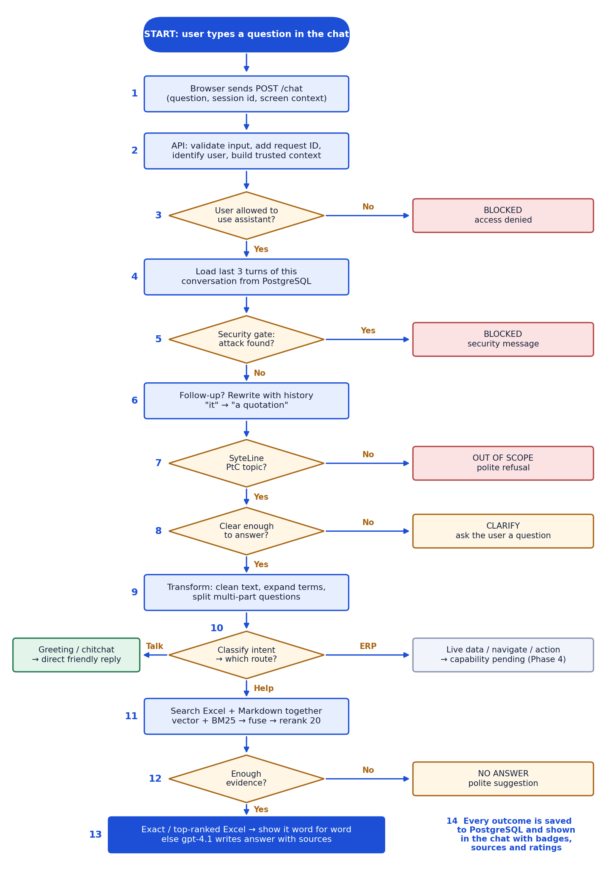
Figure 0 — End-to-end flow of one chat message.

The flowchart explained, step by step
# | Step | What happens, in plain words | Chapter
1 | Send | The chat page sends the question, the conversation id and the current screen (site, module, form) to the server. | 11
2 | Identify | The server checks the input, gives the request a tracking id, finds out who the user is from their session and builds a trusted context. No AI is involved here. | 5
3 | Allowed? | The permission resolver checks the user may use the assistant at all. If not, the request stops as BLOCKED. | 5
4 | Remember | The last 3 questions and answers of this conversation are loaded from PostgreSQL. | 9
5 | Security | The message is checked for 8 kinds of attack (prompt injection, password requests, data dumps…), including hidden/encoded ones. Attacks stop here and are never searched or sent to the answer model. | 6.2
6 | Follow-up | If the message refers back ("how do I convert it?"), it is rewritten into a full question using the history. | 6.3
7 | Scope | Off-topic, general knowledge and other-ERP questions get a polite out-of-scope reply. | 6.4
8 | Clear? | If a record, customer or topic is missing, the assistant asks one clarifying question instead of guessing. | 6.5
9 | Transform | The question is cleaned: greeting and polite words removed for searching, abbreviations expanded (SO → customer order), multi-part questions split. | 6.6
10 | Route | The intent is classified and code (not the AI) decides the route: friendly direct reply, knowledge answer, or "not connected yet" for live ERP data, navigation and actions. | 6.7
11 | Search | Excel Q&A and Markdown are searched together: 10 candidates from each (meaning + keywords), then one reranker scores all 20 on the same scale. | 7
12 | Evidence? | If nothing relevant enough is found, the assistant says so politely and suggests what to ask — it never guesses. | 7.4
13 | Answer | If an approved Excel answer is an exact match (or scores ≥ 0.90 and is ranked first), it is shown word for word. Otherwise gpt-4.1 writes the answer only from the found text, with sources. | 7.5, 8
14 | Save + show | Question and answer are saved to PostgreSQL; the chat shows the answer with a route badge, sources, copy and 👍/👎 buttons. | 9, 11

Before any question: how the system starts
When the server starts, it reads all knowledge files, turns them into vectors and builds the search indexes. This is also how content is updated: edit a file and restart.
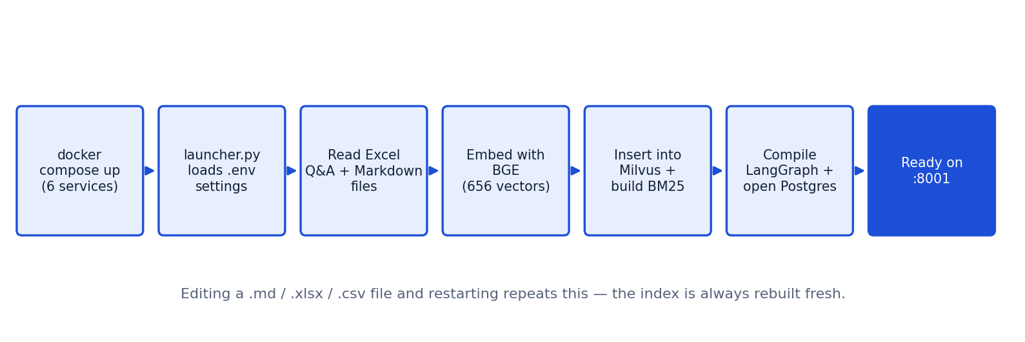
Figure 0b — Startup and knowledge ingestion.

1. Introduction

1.1 Purpose
This document specifies how the SyteLine Prospect-to-Cash AI Assistant is built: its architecture, every step a chat message passes through, the retrieval and answer logic, security controls, data stores, APIs, configuration, testing, and the history of how the system was developed. It is detailed enough for a new developer to run, change and extend the system.

1.2 Scope
- In scope: help and knowledge answers for the Prospect-to-Cash process (prospect → payment), security gating, classification and routing, conversation history, the web chat UI.
- Recognised but not yet connected: live ERP data, navigation and actions (SyteLine connector, Phase 4).
- Out of scope for the POC: any write to SyteLine (create, update, release, approve).

1.3 Reference documents
Document | Content
SyteLine_Prospect_to_Cash_AI_Chatbot_MASTER_PROMPT.md | Authoritative requirements (sections §1–§77)
REPLICA_BUILD_PROMPT.md | Proven RAG pattern the engine is modelled on
ARCHITECTURE_DECISIONS.md | 10 recorded decisions and open SyteLine questions
BUILD_ROADMAP.md | 8-phase build plan and status
PHASE_3_ORCHESTRATION.md | Node-by-node orchestration contract
PROJECT_FILE_GUIDE.md | Purpose of every file in the repository
SyteLine_Chatbot_Integration_Requirements.docx | Questions and APIs needed from the SyteLine team
Prospect_to_Cash_Modules_and_Data_Preparation_Guide.docx | Module guide and content preparation

2. System overview
The assistant answers SyteLine Prospect-to-Cash questions inside a chat window. Every message is checked for attacks, kept in scope, clarified if vague, understood in the context of the conversation, classified, and routed to the right handler. Help questions are answered from a curated knowledge base (Markdown articles + Excel Q&A) using hybrid search and a grounded LLM answer with citations.

2.1 Key capabilities
Capability | Implementation
Security-first input gate | 8 attack categories, obfuscation decoding, regex + LLM, fail-closed
Scope control | 5-label scope classifier collapsing to in/out of scope
Ambiguity handling | A0–A7 labels, UI/record context substitution, clarification questions
Conversation memory | PostgreSQL history; follow-up questions rewritten to standalone questions
Hierarchical classification | 16 intents, 13 complexity types, 5 emotion levels, 11 routes
Code-enforced routing | Route decided by policy code from the intent, never by the model alone
Unified knowledge search | Excel + Markdown in one Milvus collection, vector + BM25 + RRF + cross-encoder
Grounded answers | gpt-4.1 answers only from retrieved context, with source citations
Permissions | Per-route permission checks, Redis-cached (mock SyteLine groups today)
Conversational | Greetings echoed, chitchat, multi-question messages, polite tone
Observability | Request-ID-correlated structured events to terminal and rotating log file

2.2 Technology stack
Layer | Technology | Version / model
Language | Python | 3.12
Web framework | FastAPI + Uvicorn | latest (requirements.txt)
Orchestration | LangGraph StateGraph | latest
Validation | Pydantic v2 + pydantic-settings | v2
Vector database | Milvus standalone (+ etcd, MinIO), Attu UI | milvusdb/milvus v2.3.0
Keyword search | rank-bm25 (BM25Okapi) | —
Embeddings | sentence-transformers | BAAI/bge-base-en-v1.5 (768-dim)
Reranker | sentence-transformers CrossEncoder | cross-encoder/ms-marco-MiniLM-L-6-v2
LLM (answers) | OpenAI Chat Completions | gpt-4.1, temperature 0.1, max 500 tokens
LLM (orchestration) | OpenAI Chat Completions, JSON mode | gpt-4.1-mini, temperature 0, 12 s timeout
Permission cache | Redis | redis:7-alpine
Conversation history | PostgreSQL + psycopg 3 + psycopg-pool | postgres:16-alpine
Frontend | Plain HTML / CSS / JavaScript (no build step) | —
Data files | Markdown, Excel (pandas/openpyxl), CSV | —
Tests | pytest | 78 tests
Containers | Docker Compose (project ptc-chatbot) | 6 services

3. Architecture and deployment
The system is layered. Each layer only talks to the one below it; the trusted boundary sits in ordinary application code before any model is involved, so no prompt can change who the user is or what they may do.
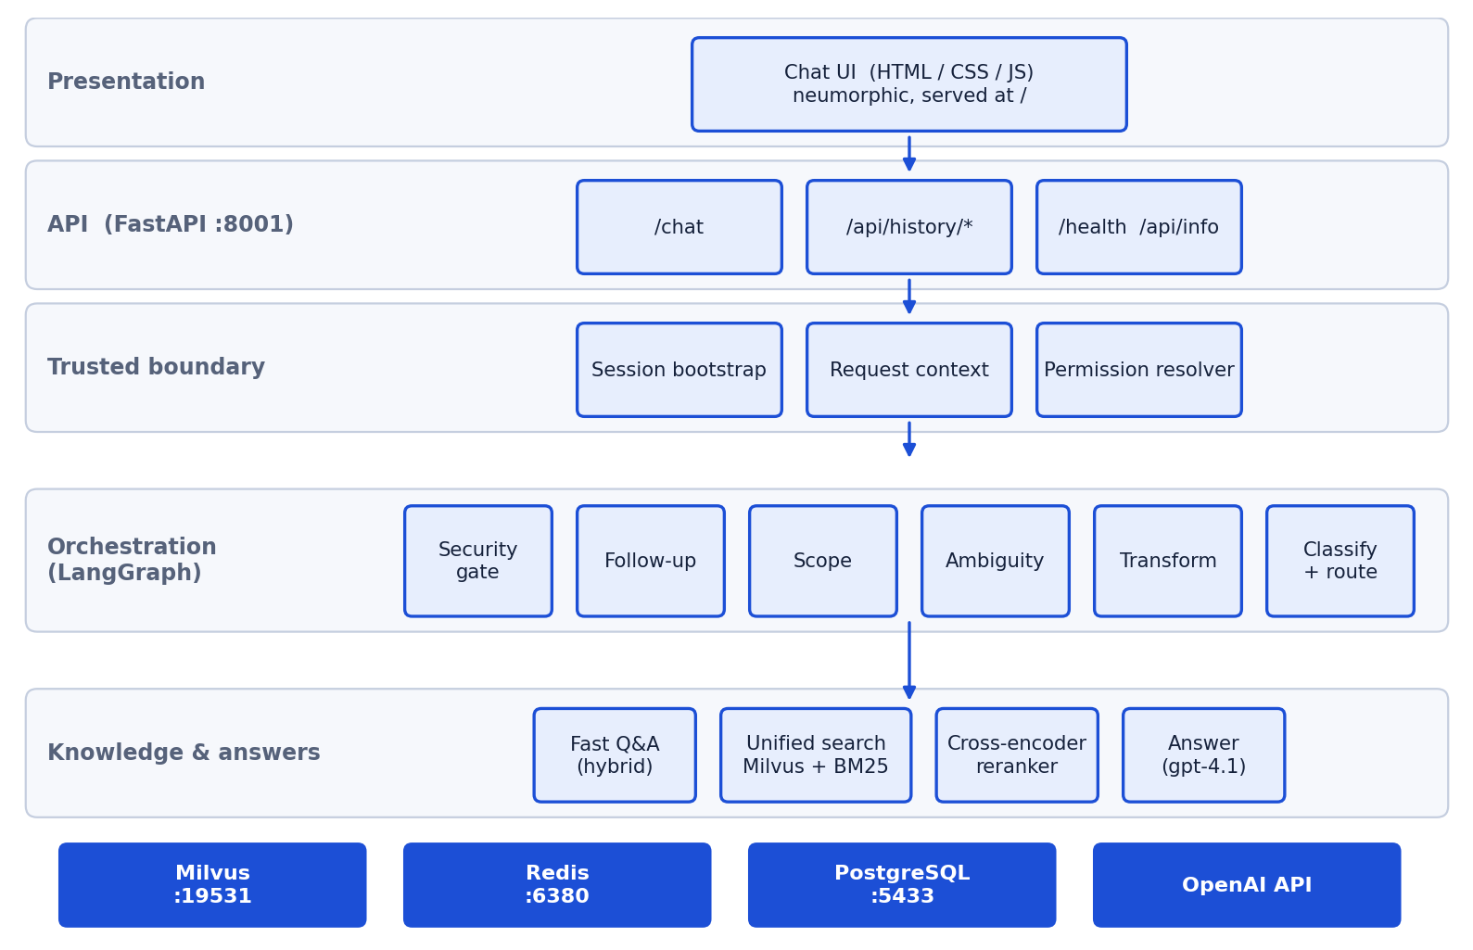
Figure 1 — Layered architecture and backing services.

3.1 Deployment (Docker Compose)
All infrastructure runs in the project's own containers with non-default host ports, so it never collides with other projects on the same machine.
Container | Image | Host port | Purpose
ptc-milvus | milvusdb/milvus:v2.3.0 | 19531 (client), 19092 (health) | Vector database
ptc-etcd | quay.io/coreos/etcd:v3.5.5 | internal | Milvus metadata
ptc-minio | minio/minio (2023-03-20) | 19000 / 19001 | Milvus object storage
ptc-attu | zilliz/attu:latest | 3001 | Web UI to browse vectors
ptc-redis | redis:7-alpine | 6380 | Permission cache (AOF, 256 MB LRU)
ptc-postgres | postgres:16-alpine | 5433 | Conversation history
App (host process) | python launcher.py → uvicorn | 8001 | API + chat UI

3.2 Startup sequence
# | Step | Where
1 | Load settings from .env; fail immediately if OPENAI_API_KEY is missing | config.py
2 | Load Excel Q&A (APPROVED + active rows) and build the Fast Q&A index (BM25 + embeddings) | qa/retriever.py
3 | Check Milvus is reachable (3 s socket check), drop and recreate collection ptc_knowledge | rag/milvus_store.py
4 | Chunk all Markdown files; embed chunks and every Excel question/variation; insert + flush (656 vectors) | rag/retriever.py
5 | Build BM25 indexes per source (excel, markdown) | rag/retriever.py
6 | Compile the LangGraph workflow (routing errors fail at startup, not on the first user) | orchestration/graph.py
7 | Open PostgreSQL pool and create tables if missing (fail-soft) | history/store.py
8 | Log startup_ready and accept requests; mount the chat UI at / | main.py

4. Request lifecycle (pin to pin)
This section follows one chat message from the browser to the answer. Figure 2 shows the LangGraph part; the table lists every step with the file and function that performs it.
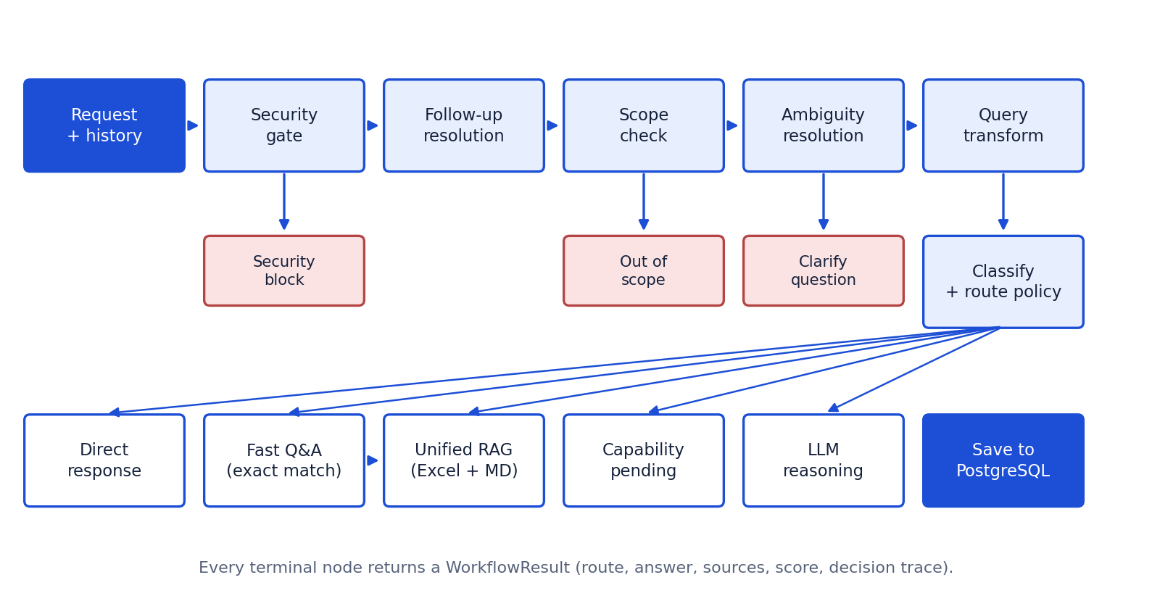
Figure 2 — LangGraph workflow: sequential gates, early exits, code-enforced route execution.
# | Step | What happens | File / function
1 | Browser | User sends a message; UI posts {query, session_id, simulated_group, context} to /chat | script.js · sendQuery()
2 | Middleware | Assign X-Request-ID, log http_request_started, time the request | main.py · request_event_logging
3 | Validation | Pydantic validates: query 1–1000 chars, session_id pattern ^[A-Za-z0-9_-]{1,80}$ | api/models.py · ChatRequest
4 | Session bootstrap | Validate session token, resolve the SyteLine user and groups (mock) | security/bootstrap.py
5 | Request context | Build trusted context: user, configuration, site, form/field, record | context/manager.py
6 | Base permission | READ on 'assistant' — deny ends the request as BLOCKED | authorization/resolver.py
7 | Load history | Last 3 answered turns for this session and user (BLOCKED turns skipped) | routes.py · _load_history
8 | Security gate | Normalize, decode URL/base64, regex categories, LLM for suspicious text | security/input_gate.py
9 | Follow-up resolution | Rewrite 'how do I convert it?' → 'How do I convert a quotation?' | classification/followup.py
10 | Scope check | 5 labels → in scope / out of scope | classification/scope.py
11 | Ambiguity | A0–A7; substitute UI/record references; else clarifying question | classification/ambiguity.py
12 | Transformation | Normalize, strip greeting/polite opener, spelling, glossary expansion, split questions | classification/query_transformer.py
13 | Classification | Heuristic + LLM classifier; route policy enforced in code | classification/router.py
14 | Route execution | Direct response · Fast Q&A · unified RAG · capability pending | orchestration/graph.py
15 | Retrieval + answer | Unified Excel + Markdown search, rerank, evidence gate, gpt-4.1 answer | rag/retriever.py, answer_service.py
16 | Save history | Store question, answer, route, sources, score, trace; return message_id | history/store.py · save_exchange
17 | Response | ChatResponse JSON; UI renders bubble, route badge, sources, rating buttons | routes.py · script.js

5. Trusted boundary: session, context, permissions
Identity, context and base authorization are resolved in plain code before the graph runs (decision #5). Models never receive the session token and cannot change a permission outcome.

5.1 Session bootstrap (mock adapter)
- validate_session(token): any non-empty token is valid today; missing token → BLOCKED(invalid_session).
- get_logged_in_user(simulated_group): mock groups SALES_REP (default), AR_CLERK, NO_ACCESS; user_id = demo.<group>.
- Configuration AIDEMO, site MAIN. Only session_context.py changes when the real SyteLine session API is provided.

5.2 Permission resolver
Aspect | Behaviour
Operations | READ / EXECUTE / INSERT / UPDATE / DELETE against a resource
Resources today | assistant (base access), qa (Excel answers), markdown_rag (document answers)
Mock data | SALES_REP and AR_CLERK: READ on all three; NO_ACCESS: nothing (demonstrates a real deny)
Cache | Redis key perm:<user>:<operation>:<resource>, TTL 30 seconds
Failure mode | Redis down → resolve fresh every time (fail-open on the cache only, never on the decision)
Where checked | API boundary (assistant) + again inside Fast Q&A and RAG nodes (qa, markdown_rag)

6. LangGraph orchestration
ChatOrchestrator compiles a StateGraph over ChatWorkflowState. Nodes return partial state updates; conditional edges implement early exits. Every terminal node returns a WorkflowResult.

6.1 Workflow state
Field | Type | Set by
request_id, context, user | str, RequestContext, SyteLineUser | API
query / original_query | str | API; query replaced by the follow-up rewrite
history, followup_resolved | list[Turn], bool | API / follow-up node
security, scope, ambiguity | SecurityResult, ScopeResult, AmbiguityResult | gate nodes
transformed | QueryTransformResult | transformation node
classification, selected_route | QueryClassification, RouteLabel | classification / route nodes
qa_candidate | (qa_id, match score) | Fast Q&A node → RAG node
result | WorkflowResult | terminal nodes

6.2 Security gate
Label | Examples of what is caught
SEC_PROMPT_INJECTION | "ignore previous instructions", "reveal the system prompt", jailbreak / developer mode
SEC_PERMISSION_BYPASS | "bypass permissions", "pretend I am admin", "show hidden fields"
SEC_SOCIAL_ENGINEERING | "act as administrator", "urgent — skip approval"
SEC_OBFUSCATED_ATTACK | Attacks hidden in URL-encoding or base64
SEC_TOOL_ABUSE | "call an unapproved IDO / hidden API", "invent a tool call"
SEC_DATA_EXFILTRATION | "dump all customer records", "bulk export"
SEC_CREDENTIAL_REQUEST | "show me the password / API key / session token"
SEC_MALICIOUS_INSTRUCTION | "delete all records", "erase the audit logs"
SEC_SAFE | Everything else, including legitimate security help ("how do permissions work?")

- Layer 1 — normalize: Unicode NFKC, whitespace; analyse the original plus URL-decoded and bounded base64-decoded variants.
- Layer 2 — rules: category regexes → block locally with confidence 0.99; never sent to any model.
- Layer 3 — semantic: only suspicious-but-unmatched text goes to gpt-4.1-mini (JSON label, confidence, reason).
- Fail-closed: if the classifier errors, suspicious text is blocked (confidence 0.6, signal fail_closed).

6.3 Follow-up resolution
Runs only when there is history AND the message looks like a follow-up: a reference word (it, this, that, they, next, one…), a continuation ("and…", "what about…", "why") or ≤ 4 words. Small talk (thanks, ok, good morning) is never rewritten. gpt-4.1-mini receives the last 3 turns (answers trimmed to 600 chars) and returns {"standalone": …}. Output over 1,000 chars, empty or unchanged text is ignored; any error keeps the original message.

6.4 Scope
Label | Result | Detection
SYTELINE_RELATED | in scope | Business glossary terms, greetings/chitchat, LLM
OFF_TOPIC | out of scope | LLM
GENERAL_KNOWLEDGE | out of scope | Regex for general trivia/coding/weather-type questions, LLM
COMPETITOR_OTHER_ERP | out of scope | Regex: SAP, Oracle EBS/ERP, NetSuite, Dynamics 365, Epicor, Odoo
IRRELEVANT | out of scope | LLM

6.5 Ambiguity
Label | Trigger | Outcome
A0_CLEAR | Nothing ambiguous; references replaced from UI/record context | continue
A1_MISSING_TOPIC | Bare "what?", "help", "do it" | ask for the topic
A2_MISSING_DETAIL | Balance / credit status / overdue without a customer | ask for the customer
A3_CONTRADICTORY | Conflicting actions (create + delete) | ask for one action
A4_VERSION_RECENCY | "latest version / documentation" | ask which version
A5_REFERENTIAL_AMBIGUITY | "this record" with no selected record | ask to select or give the id
A6_MULTIPLE_ENTITY_MATCH | Several ids joined by "or" | ask which one
A7_UNANSWERABLE | "I don't know which order" | ask to select the record

6.6 Query transformation
Step | Example
Unicode / whitespace normalization | “Invoice” → "Invoice"
Leading greeting removed (kept for the reply) | "Good morning, what is a quote?" → "what is a quote?" + greeting good_morning
Polite opener removed (search text only) | "Could you please tell me how…" → "how…"
Spelling normalization | common SyteLine term misspellings
Process synonyms | lifecycle / life cycle / journey → process
Glossary expansion | "SO" → also searches "customer order", "sales order"
Entity extraction | record ids, modules, forms
Decomposition | "What is X and how do I Y?" → two sub-questions, each searched separately

6.7 Classification and route policy
A deterministic heuristic classifier always runs first. Greetings and chitchat stop there (no paid call). Otherwise gpt-4.1-mini returns a JSON classification restricted to the enum values; on any failure the heuristic result is used. Validators repair common model quirks (null operation → READ; list entity → joined string). The route is then overwritten by policy code:
Intent | Enforced route | Today
GREETING, CHITCHAT, FEEDBACK, COMPLAINT | DIRECT_RESPONSE | Canned replies; greeting echoed
HELP_GENERIC (DIRECT complexity) | FAST_QA | Exact match → verbatim; else unified RAG
HELP_SCREEN, HELP_FIELD, HELP_PROCESS, TROUBLESHOOTING, SECURITY_HELP, UNKNOWN | MARKDOWN_RAG | Unified RAG
LIVE_DATA | LIVE_DATA | CAPABILITY_PENDING (Phase 4)
NAVIGATION | NAVIGATION | CAPABILITY_PENDING (Phase 4)
ACTION | ACTION (tool_candidate cleared) | CAPABILITY_PENDING — never executes writes
MIXED | RAG_IDO | CAPABILITY_PENDING (Phase 4)
ANALYSIS | LLM_REASONING | Reasoning over retrieved knowledge

Also classified for telemetry and future tone control: complexity (13 labels: DIRECT, SYNONYM_VARIATION, CONTEXT_SHIFT, CONCEPT_MAPPING, CONSTRAINT_BASED, NEGATIVE_EXCEPTION, PROCESS_WORKFLOW, HYPOTHETICAL, REVERSE_LOGIC, MULTI_PART, COMPARISON, ROOT_CAUSE, CALCULATION) and emotion (F0 normal, F1 confused, F2 complaint, F3 frustrated, F4 persistent).

7. Knowledge and retrieval

7.1 Knowledge sources
Source | Location | Volume | Processing
Markdown knowledge base | data/knowledge/prospect_to_cash/*.md | 18 files → 128 chunks | Split on headings; sections > 1,200 chars split again; < 20 chars dropped; keywords extracted
Excel Q&A | data/qa/prospect_to_cash/*.xlsx (qa_master + question_variations) | 132 rows × 4 wordings = 528 vectors | Only APPROVED + active rows; placeholder 'PTC Training Guide' rows excluded
Business glossary | data/metadata/business_glossary.csv | 15 terms | Synonym / abbreviation query expansion

The 132 Excel rows were generated by scripts/build_qa_from_knowledge.py: gpt-4.1 (temperature 0, JSON) drafts up to 2 Q&A pairs + 3 variations per section ≥ 200 chars, and a grounding gate keeps only answers with ≥ 85 % of content words present in the source section (21 drafts dropped). Rows are marked APPROVED with approved_by = "AUTO-DERIVED — pending SME review".

7.2 Embeddings
- Model BAAI/bge-base-en-v1.5, 768 dimensions, L2-normalized (cosine = inner product). Loaded once, thread-safe.
- Queries get the instruction prefix "Represent this sentence for searching relevant passages: "; passages do not (the asymmetry fixed early confusion between "order line" and "customer order").
- Excel rows embed only the question wording (never the answer); Markdown chunks embed their text + context path.

7.3 Milvus collection ptc_knowledge
One collection for both sources, explicit schema (dynamic fields off, so Attu shows real columns), AUTOINDEX with inner-product metric, flushed after insert. Rebuilt on every startup.
Field | Type | Content
id (PK) | VARCHAR(120) | credit-1 (Markdown) or KB-0001::q0 (Excel wording 0)
vector | FLOAT_VECTOR(768) | BGE embedding
source_type | VARCHAR(20) | markdown | excel — used as a search filter
chunk_id | VARCHAR(120) | Chunk id, or the Q&A id all wordings share
source_file | VARCHAR(300) | credit.md / credit.xlsx
level | VARCHAR(120) | Module (file stem)
full_context_path | VARCHAR(1000) | Heading path, or the canonical question
qa_id | VARCHAR(50) | KB-xxxx (empty for Markdown)
question | VARCHAR(1000) | The wording this vector came from (Excel)
text | VARCHAR(16000) | Chunk text, or the Excel answer
chunk_index / total_chunks | INT64 | Position within file, or wording n of N

7.4 Unified search algorithm
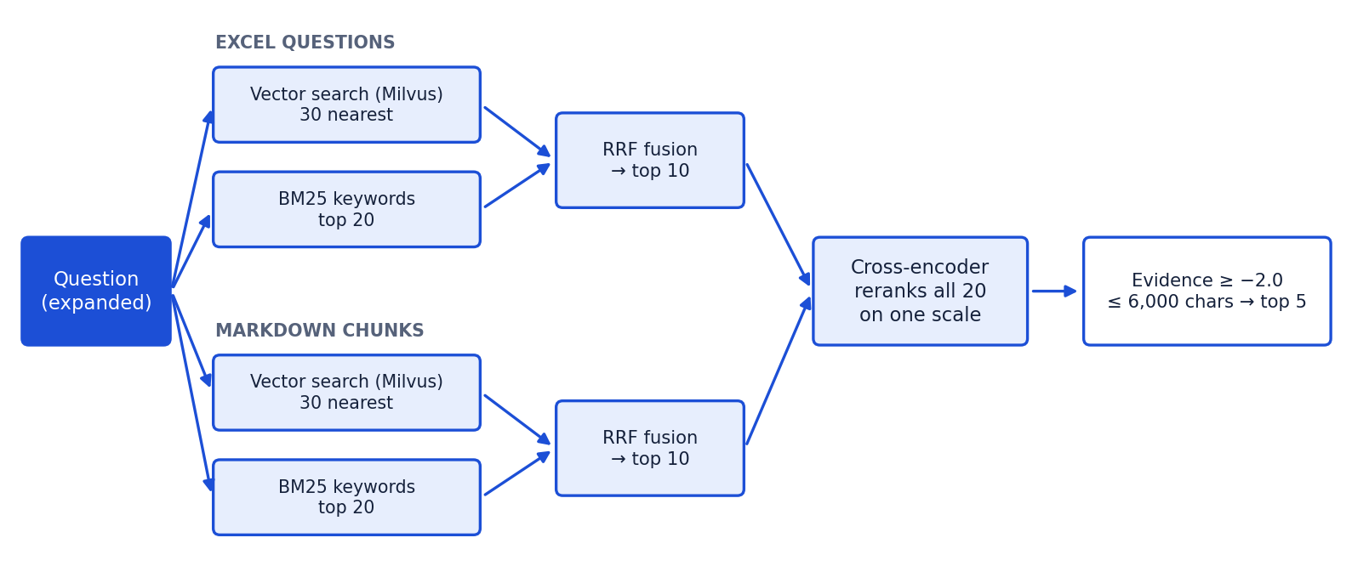
Figure 3 — Per-source candidate generation, one shared reranker.
Stage | Detail | Constant
Vector search | Milvus search filtered by source_type, 30 hits, best score per chunk_id | CANDIDATES_PER_SOURCE × 3
Keyword search | BM25Okapi per source over text + keywords, top 20 with score > 0 | CANDIDATES_PER_SOURCE × 2
Fusion | Reciprocal Rank Fusion: Σ 1 / (60 + rank) | RRF_K = 60
Candidates | Top 10 per source → 20 total | CANDIDATES_PER_SOURCE = 10
Rerank | Cross-encoder scores all 20 (query, text) pairs on one scale | max_length 512
Guaranteed include | Nearest vector ≥ 0.80 is appended if reranking pushed it out | GUARANTEED_INCLUDE_VECTOR_SCORE = 0.80
Evidence gate | Best reranker logit must be ≥ −2.0, else NO_ANSWER | EVIDENCE_THRESHOLD = −2.0
Context budget | Top 5 kept, total ≤ 6,000 chars (multi-question: ≤ 9,000, round-robin) | TOP_K_RERANKED = 5

7.5 When the Excel answer is shown word for word
The Fast Q&A index scores each Excel row with hybrid = 0.4 × BM25 (normalized) + 0.6 × embedding similarity, over the question and all variations. The curated answer is returned verbatim only when:
- Exact match: the normalized question equals the question or a variation (score 1.0), single question — answered immediately (answer_source = excel_exact_match); or
- Two signals agree: single question, match score ≥ 0.90 AND the reranker ranks that same row #1 of all 20 candidates (answer_source = excel_verbatim).
Otherwise gpt-4.1 writes the answer from the strongest Excel and Markdown evidence together. The 0.90 rule came from measurement: correct matches scored 0.95–1.00, wrong near-misses 0.88–0.89 ("What is a customer order?" hitting the order-line row).

8. Answer generation
Aspect | Specification
Model | gpt-4.1, temperature 0.1, max_tokens 500
Context format | [Source: file — heading path] + chunk text, separated by ---
Grounding rules | Answer only from retrieved context; never invent steps, field names or numbers; say so if missing
Style rules | Concise, numbered lists for steps, no mention of "the context", polite and professional
Question sent | The rewritten question (follow-up resolved, greeting removed, user's own wording)
Greeting echo | "Good morning! …" prefixed when the user opened with a greeting
No evidence | NO_ANSWER with a courteous suggestion of what to ask instead
Response metadata | sources (file citations), score, decision_trace incl. answer_source and best score per source

9. Conversation history (PostgreSQL)
Decision #10. History is durable, per user, and used for follow-up questions. Tables are created on startup; the store is fail-soft (chat works without memory if Postgres is down).
Table.column | Type | Notes
chat_sessions.session_id | TEXT PK | Client-generated id, validated by pattern
chat_sessions.user_id | TEXT | Trusted owner from the session bootstrap; index (user_id, updated_at DESC)
chat_sessions.title / created_at / updated_at | TEXT / TIMESTAMPTZ | Title = first question (60 chars)
chat_messages.message_id | BIGSERIAL PK | Returned to the UI for ratings
chat_messages.session_id | TEXT FK | ON DELETE CASCADE; index (session_id, message_id)
chat_messages.role | TEXT | CHECK user | assistant
chat_messages.content / resolved_query | TEXT | Message text; follow-up rewrite (user rows)
chat_messages.route / source / sources / score | TEXT / JSONB / REAL | How the answer was produced
chat_messages.decision_trace | JSONB | Safe labels only
chat_messages.rating | SMALLINT | CHECK −1 | 1 (👎 / 👍)
chat_messages.request_id / created_at | TEXT / TIMESTAMPTZ | Correlates with the log file

- Every query filters by user_id: another user cannot read, write into, rate or delete a conversation, even with its id.
- recent_turns() skips BLOCKED and ERROR turns so rejected text is never fed back to a model.
- Connection pool: psycopg_pool, 1–5 connections, 3 s connect timeout.

10. API specification
Method + path | Purpose | Notes
POST /chat | Ask a question | Body: query, session_id?, session_token?, simulated_group?, context?
GET /api/history/sessions | List the user's conversations | ?include_messages=true; max 50
GET /api/history/sessions/{id} | Messages of one conversation | 404 if not owned
DELETE /api/history/sessions/{id} | Delete one conversation | {deleted: bool}
DELETE /api/history/sessions | Delete all of the user's conversations | {deleted: count}
PUT /api/history/messages/{id}/rating | Rate an answer | Body {rating: up | down | null}
GET /health | Liveness | {status: ok}
GET /api/info | Name, phase, models
GET / | Chat UI (static files) | Mounted after the API router

History endpoints return 503 when Postgres is unavailable and 401 for an invalid session. They take simulated_group / session_token as query parameters (mock identity) until the real session exists.

10.1 /chat request and response
POST /chat
{ "query": "how do I convert it?", "session_id": "session_1727170000_ab12cd",
"simulated_group": "SALES_REP",
"context": { "site": "MAIN", "module": "Sales", "form": "Estimates",
"field": null, "record_type": null, "record_id": null } }
200 OK
{ "route": "MARKDOWN_RAG_RESPONSE",
"answer": "To convert a quotation into a customer order: 1. ...",
"sources": ["quotation.md — Accept, revise, or decline a quote", "..."],
"score": 3.41, "message_id": 42,
"resolved_query": "How do I convert a quotation into a customer order?",
"context": { "user_id": "demo.sales_rep", "site": "MAIN", ... },
"decision_trace": { "security": "SEC_SAFE", "scope": "SYTELINE_RELATED",
"ambiguity": "A0_CLEAR", "intent": "HELP_PROCESS", "complexity": "PROCESS_WORKFLOW",
"emotion": "F0_NORMAL", "selected_route": "MARKDOWN_RAG",
"answer_source": "generated_from_excel_and_markdown",
"history_turns_used": 1, "followup_resolved": true, "transformations": [...] } }

Route value | Meaning
FAST_QA_RESPONSE | Curated Excel answer shown verbatim
MARKDOWN_RAG_RESPONSE | Generated from Excel + Markdown evidence
DIRECT_RESPONSE | Greeting / chitchat / feedback reply
CLARIFY | A clarifying question was asked
NO_ANSWER | Not enough evidence; polite suggestion returned
OUT_OF_SCOPE | Not a SyteLine Prospect-to-Cash question
BLOCKED | Security block, invalid session, or permission denied
CAPABILITY_PENDING | Live data / navigation / action recognised; connector not built yet

11. Frontend
Plain HTML/CSS/JS in frontend/chatbot/, served by FastAPI at / (relative /chat path, so host and port can never drift). Neumorphic white design with a blue gradient for the header, buttons and user bubbles; light and dark themes; responsive from phone to wide desktop.
Feature | Detail
Conversations sidebar | Loaded from /api/history; search; grouped Today / Yesterday / Previous 7 days / Older; delete, clear all
Composer | Auto-growing textarea, Enter sends, Shift+Enter new line, live counter (warns at 900 / 1000)
Answer bubble | Route badge, time, intent → route note, copy button, 👍/👎 (saved to Postgres), sources + score
Follow-ups | "🔗 Understood as: …" note under answers to rewritten questions
Errors | Connection error shown as a danger bubble with a Retry button
Context simulator | Group (SALES_REP / AR_CLERK / NO_ACCESS), site, module, form — stands in for the SyteLine context bridge
Local storage | ptc_chat_sessions, ptc_active_session_id (cache/fallback), ptc_simulated_context, ptc_theme
Accessibility | Keyboard support, Esc closes panels, reduced-motion support, ARIA labels

12. Security design
Control | How it is enforced
No second login / trusted identity | User comes only from the session bootstrap; never from the client or a model
Least privilege | Base assistant permission + per-route permission checks (qa, markdown_rag)
Input attacks | Security gate before any retrieval or generation; fail-closed on classifier errors
Model boundaries | Models receive no tokens; routes are enforced by code; ACTION never executes (read-only POC)
Grounding | Answers only from retrieved context; evidence gate; no answer when evidence is weak
History isolation | All history SQL filtered by trusted user_id; blocked turns never reused
Input limits | Query ≤ 1,000 chars; session_id pattern; Pydantic validation on every request
Secrets | OpenAI key and SyteLine credentials only in .env (git-ignored); never logged
Logging privacy | Logs contain labels, ids, counts and timings — no raw questions, answers, prompts or tokens

13. Logging and observability
logger.py writes the same structured events to the terminal and logs/chatbot.log (rotated at 5 MB, 3 backups, git-ignored). Every event carries the request_id, which the API also returns in the X-Request-ID header, so one request can be traced end to end.
Area | Events
Lifecycle | startup_begin, startup_ingestion_begin, startup_orchestration_ready, history_store_ready / unavailable, startup_ready, shutdown_complete
HTTP | http_request_started, http_request_completed (status, elapsed_ms), http_request_failed
Boundary | chat_received, security_bootstrap_*, request_context_built, permission_resolved / cache_hit, chat_blocked
Orchestration | security gate result, followup_resolution_completed, scope, ambiguity_resolution_completed, query_transformation_completed, query_classification_completed, orchestration_route_selected
Retrieval | fast_qa_search_started / completed, unified search scores per source, answer generation
Outcome | orchestration_completed, chat_response_ready, history_saved, orchestration_blocked / out_of_scope / clarification_requested / capability_pending

14. Configuration
Settings are loaded from .env by pydantic-settings (config.py); .env.example documents every key.
Variable | Default | Purpose
OPENAI_API_KEY | (required) | Startup fails if missing or blank
PRIMARY_LLM / ORCHESTRATOR_MODEL | gpt-4.1 / gpt-4.1-mini | Answer model / classifier + follow-up model
ORCHESTRATOR_LLM_ENABLED / _TIMEOUT_SECONDS | true / 12 | Switch LLM classification off; per-call timeout
TEMPERATURE / MAX_TOKENS | 0.1 / 500 | Answer generation
EMBEDDING_MODEL / EMBEDDING_DIM | BAAI/bge-base-en-v1.5 / 768 | Embeddings
API_HOST / API_PORT | 0.0.0.0 / 8001 | Web server
REDIS_HOST / PORT / DB | localhost / 6380 / 0 | Permission cache
MILVUS_URI | http://localhost:19531 | Or a file path for Milvus Lite
POSTGRES_HOST / PORT / DB / USER / PASSWORD | localhost / 5433 / ptc_chat / ptc / local-dev | Conversation history
HISTORY_TURNS_FOR_CONTEXT | 3 | Earlier turns used for follow-ups

15. Testing and verification
Suite | Tests | Covers
tests/test_phase3_orchestration.py | 63 | Security categories + obfuscation, legitimate security help, 5 scope labels, ambiguity, transformation (greetings, polite openers, synonyms, decomposition), classification + route policy, graph branches, classifier payload quirks
tests/test_conversation_history.py | 13 | Follow-up detection and rewriting (LLM faked), fail-safe paths, Postgres store: blocked turns skipped, per-user isolation
tests/test_knowledge_base.py | 2 | Placeholder Q&A rows never loaded; knowledge base integrity

Tests disable network model calls so they are fast and repeatable (78 passed in ≈10 s). Postgres tests skip automatically if the container is down.
Live verification (running system) | Result
20-question regression: greetings, chitchat, RAG, multi-question, cross-module, out of scope, pending, blocked | 20 / 20
Confidence test: when Excel is verbatim vs generated (invoice, estimate vs quote, credit hold, lifecycle…) | 12 / 12
Follow-up conversations (4 conversations, 12 turns) | Rewrites correct; small talk untouched
History isolation with a second user (read, delete, rate, write-into) | All refused
LLM classifier failures in log after validator fix | 0

16. Build, run and operate
# 1. one-time setup
pip install -r requirements.txt
copy .env.example .env # then put the real OPENAI_API_KEY in .env
# 2. start infrastructure (Milvus, etcd, MinIO, Attu, Redis, PostgreSQL)
docker compose up -d # wait until `docker ps` shows healthy
# 3. start the app (builds all indexes at startup)
python launcher.py # UI: http://localhost:8001
# Attu: http://localhost:3001 (Milvus 19530 inside Docker)
# 4. tests
python -m pytest -q
# 5. regenerate Excel Q&A from the knowledge base (replaces the .xlsx files)
python -m scripts.build_qa_from_knowledge
# inspect history
docker exec -it ptc-postgres psql -U ptc -d ptc_chat

- Content update: edit .md / .xlsx / .csv, restart the app — the Milvus collection is dropped and rebuilt.
- Health: GET /health; logs/chatbot.log; Attu for vectors; psql for history.

17. Development history — how it was built
The system was built phase by phase from the master prompt's 54-step build order, stopping at a tested milestone after each phase. Where the flowchart diagrams and the written master prompt disagreed, the conflict was recorded and decided explicitly (section 18).

Phase 1 — Foundation
- Repository skeleton, settings with fail-fast validation, FastAPI app, launcher.
- Replica-style RAG engine: Excel Q&A schema and Fast Q&A retriever (exact → BM25 → embeddings → hybrid → evidence gate).
- Markdown ingestion and heading-aware chunking; BGE embeddings; Milvus; BM25 + vector + RRF; cross-encoder rerank; evidence check; grounded answer service with citations.
- Dedicated Docker stack (ptc-* containers, non-default ports) replacing a shared Milvus from another project.
- First neumorphic chat UI served by the same app (relative /chat path avoids the replica's port-mismatch bug).

Phase 2 — Identity, context and permissions (integration-ready mocks)
- Security bootstrap: no chatbot login; missing session rejected, never treated as guest.
- Request context (configuration, site, form, field, record) and the frontend Context Simulator.
- Dynamic permission resolver with Redis cache and a mock group table that demonstrates a real deny.
- Every SyteLine dependency isolated in one adapter so real APIs replace mocks without touching callers.

Phase 3 — Security, classification and routing
- Hierarchical taxonomy; layered security gate with obfuscation decoding and fail-closed semantic check.
- 5-label scope, context-first ambiguity resolver (A0–A7), selective query transformation.
- LLM router with allowlisted JSON output, deterministic fallback, and code-enforced route policy.
- Typed LangGraph workflow; Phase-4 routes recognised and terminated as CAPABILITY_PENDING.
- Structured, request-ID-correlated logging; knowledge base expanded to 18 module articles.

Enhancements after Phase 3
- Conversational quality: greeting echo, wider wellbeing detection, polite prompt, polite-opener and synonym handling.
- Multi-question messages searched per sub-question and merged round-robin.
- Unified Excel + Markdown index (replica pattern) with the two-signal verbatim rule; 132 grounded KB rows generated.
- Milvus explicit schema + flush so Attu shows real data; conversation history in PostgreSQL; follow-up resolution.
- UI refresh to an industrial neumorphic design: history search/groups, retry, character counter, dark mode.
- Integration requirements and data-preparation documents for the SyteLine team and business users.

17.1 Problems found and how they were solved
Problem | Root cause | Fix
"hi" returned "No match found" | Greetings went through Q&A/RAG | Deterministic DIRECT_RESPONSE route (decision #8)
Short phrases confused (order line vs customer order) | Query instruction prefix missing on one side | BGE prefix on queries only
23 classifier failures in the log | LLM returned null operation / list entity | Pydantic validators repair the payload
"Good morning, what is…" retrieved nothing (score 2.89 → −0.98) | Greeting text polluted the search | Strip leading greeting, echo it in the reply
"Invoice lifecycle" had no evidence | Word not used in the knowledge base | Rewrite lifecycle/journey → process
"Could you please tell me…" failed retrieval | Polite words dominated the query | Remove polite openers from search text only
Two-part questions answered only one part | One combined search, dominant topic won | Search each sub-question, merge round-robin
"Goodbye" answered as wellbeing | "farewell" contains "well" | Ordered keyword mapping
Wrong Excel rows at 0.88–0.89 | Single 0.80 threshold with 132 similar rows | Exact match or ≥ 0.90 AND reranker #1
Exact variation ranked low | Reranker saw only the canonical question | Exact matches answered first; variations in chunk text
Placeholder Q&A contradicted the knowledge base | Hand-typed starter rows | Excluded; regenerated grounded rows from the .md files
Attu showed 0 rows, only id/vector | Dynamic fields, no flush | Explicit schema + flush after insert
"How do I convert it?" asked for clarification | No conversation memory | Postgres history + follow-up resolution before scope

18. Architecture decisions
# | Decision
1 | SLM generates simple answers by default, LLM handles complex reasoning (target; OpenAI used until Phase 7)
2 | Ambiguity resolution runs before intent classification
3 | 5-category scope classification collapsing to a binary gate
4 | Fast Q&A and Markdown RAG kept as distinct routes (thresholds later superseded by #9)
5 | Session, context and base authorization live in code before LangGraph
6 | Phase-4 routes recognised now, answered as CAPABILITY_PENDING
7 | Layered local security + LLM for inconclusive input, fail-closed, until the security SLM exists
8 | Greetings and chitchat are a deterministic terminal route
9 | Excel and Markdown share one index; curated answer verbatim only when two signals agree
10 | Conversation history in PostgreSQL; follow-ups resolved before scope

19. Known limitations and roadmap
Area | Limitation today | Planned
SyteLine identity & permissions | Mock adapters | Real session + authorization APIs (awaiting SyteLine team)
Live data, navigation, actions | CAPABILITY_PENDING | Phase 4 connector, IDO security gateway, tool registry
Answer validation | Grounding by prompt + evidence gate only | Phase 5: hallucination / permission validation
Tone and escalation | Emotion detected but not used; no tickets | Phase 5: tone manager, support and security escalation
Query techniques | No HyDE / multi-query generation | Add for hard queries
Knowledge content | "What comes next" sections thin; 132 Excel rows need SME review | Business review per the data-preparation guide
Audit & monitoring | Log file + Postgres history | Phase 6: audit model, dashboards, alerts, retention
Models | OpenAI for routing and security semantics | Phase 7: trained SLM router, shadow → canary → production
Embedding in SyteLine | Standalone page | Floating button + side panel in WebClient (integration document)

Appendix A. Project file map
Path | Responsibility
launcher.py | Starts uvicorn with the app
backend/app/main.py | App, lifespan startup/shutdown, request-ID middleware, static UI
backend/app/config.py | Settings from .env
backend/app/api/models.py, routes.py | Request/response models; /chat and /api/history endpoints
backend/app/security/bootstrap.py, input_gate.py | Session bootstrap; security gate
backend/app/integrations/syteline/session_context.py | SyteLine adapter (mock)
backend/app/authorization/resolver.py | Permission resolver + Redis cache
backend/app/context/manager.py | Trusted request context
backend/app/classification/taxonomy.py | All labels and result contracts
backend/app/classification/followup.py | Follow-up resolution
backend/app/classification/scope.py, ambiguity.py | Scope classifier; ambiguity resolver
backend/app/classification/query_transformer.py, router.py | Transformation; classification + route policy
backend/app/orchestration/state.py, graph.py | Workflow state; LangGraph nodes and edges
backend/app/qa/loader.py, glossary.py, retriever.py | Excel loading; glossary expansion; Fast Q&A hybrid search
backend/app/rag/markdown_processor.py | Heading-aware chunking
backend/app/rag/milvus_store.py | Milvus schema, insert, filtered search
backend/app/rag/retriever.py | Unified Excel + Markdown search
backend/app/rag/reranker.py, models/embeddings.py | Cross-encoder; BGE embeddings
backend/app/rag/answer_service.py | Grounded answer generation
backend/app/history/store.py | PostgreSQL conversation history
backend/app/utils/logger.py | Structured, rotating logging
frontend/chatbot/index.html, style.css, script.js | Chat UI
scripts/build_qa_from_knowledge.py | Generate grounded Excel Q&A from the knowledge base
scripts/generate_sample_qa.py | Excel column definitions (original sample generator)
tests/*.py | Automated tests
data/knowledge, data/qa, data/metadata | Knowledge base, Excel Q&A, glossary
docker-compose.yml, requirements.txt, .env.example | Infrastructure, dependencies, configuration template

Appendix B. Glossary
Term | Meaning
RAG | Retrieval-Augmented Generation — search the knowledge first, then let the LLM answer only from what was found
Embedding / vector | A list of numbers representing the meaning of a text; similar meanings have similar vectors
BM25 | Classic keyword-ranking algorithm (exact word matches)
RRF | Reciprocal Rank Fusion — merges two ranked lists by summing 1 / (k + rank)
Cross-encoder / reranker | Model that reads the question and a passage together and scores relevance precisely
LangGraph | Library for building a step-by-step AI workflow as a graph of nodes and edges
IDO | Intelligent Data Object — SyteLine's business-object API layer
SLM | Small Language Model — a compact trained model planned to replace some LLM calls
POC | Proof of concept — the current read-only scope
SME | Subject-matter expert — business user who confirms content

