SyteLine Prospect-to-Cash AI Assistant
RBAC Permission Requirements
Questions and information needed from the SyteLine team so the chatbot follows every user's SyteLine permissions

Item | Detail
Document version | 1.0 — for review
Date | 25 September 2026
Prepared by | Chatbot development team
Prepared for | SyteLine technical / security administration team
Environment | SyteLine WebClient, configuration AIDEMO (TEST configuration requested)
Related document | SyteLine_Chatbot_Integration_Requirements.docx (embedding, login, screen context)
Action requested | Fill the Answer column (section 4), the Provided column (section 5) and the test-user matrix (section 6)

1. Purpose
The chatbot answers Prospect-to-Cash questions inside SyteLine. Before it can show live data or tell a user what they can do on a screen, it must follow that user's SyteLine role-based access control (RBAC) exactly: forms, IDOs, fields, records, sites and business-rule permissions. This document lists what we need to know and receive from the SyteLine team to do that correctly.
Main rule: SyteLine stays in charge of security
The chatbot does not keep its own copy of permissions and never uses a super-user account to read business data. It reads each user's permissions from SyteLine only to explain them and hide options the user cannot use, and it reads data with the user's own session so SyteLine enforces every rule. The chatbot can never give more access than SyteLine does.

2. How the chatbot will use permissions
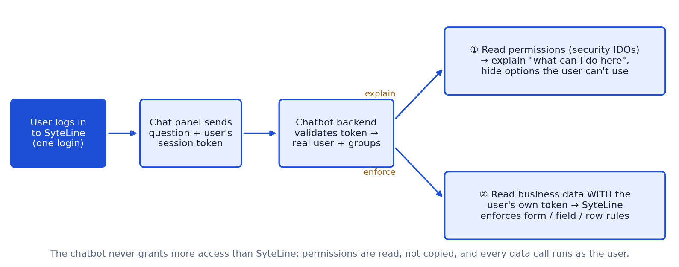
Use | Example | Source
Explain the user's access | "You can view and edit Customer Orders, but releasing a credit hold needs a Credit Manager." | Security IDOs (section 4-B)
Hide what the user can't use | Don't suggest opening a form the user has no access to | Form / IDO authorizations
Protect data | Never show a hidden field, another site's record or another salesperson's customer | SyteLine enforcement with the user's token (4-C, 4-D)
Refuse safely | "You don't have access to invoices. Please contact your administrator." | Effective permissions

3. What is already built
The permission logic is built and running against mock data, behind one adapter that your answers will replace — no other part of the chatbot changes.
Piece | Today (mock) | Will be replaced by
User identity | Test users chosen in a panel (SALES_REP, AR_CLERK, NO_ACCESS) | User from the validated SyteLine session
Permission data | Fixed table per group | Users, groups and authorizations read from SyteLine
Permission checks | Base assistant access + per-feature checks, Redis cache | Same checks, real data (cache time per E1)
Data access | Knowledge base only; live data not connected | IDO calls with the user's own token

4. Questions for the SyteLine team
Priority: Blocker = integration cannot start without it; Needed = required before go-live; Later = can follow. Blocker rows are shaded. Please write answers in the last column (or attach documents and note the name).

A. Security model — how permissions work in your SyteLine
ID | Question | Why we need it | Priority | Answer (SyteLine team)
A1 | Is access granted through authorization groups only, or also directly to individual users? If both exist for the same object, which one wins? | To calculate each user's effective permission correctly. | Blocker
A2 | When a user belongs to several groups, are permissions combined (any group allows = allowed), or does a deny in one group win? | Same object can be allowed by one group and denied by another. | Blocker
A3 | Which privileges exist and on which object types? (e.g. Read, Insert, Update, Delete, Execute, Edit on forms, IDOs, IDO methods, properties/fields, form components) | Defines what "can I do this?" means for each object. | Needed
A4 | How do Super User / administrator roles work, and exactly what do they bypass? | Super users must be handled explicitly, never guessed. | Needed
A5 | Can license modules remove access to a form even when the group allows it? How do we read a user's licensed modules? | Otherwise the chatbot may offer forms the user cannot open. | Needed

B. Reading permissions through the API
ID | Question | Why we need it | Priority | Answer (SyteLine team)
B1 | Which IDOs / APIs return the logged-in user, their groups and their object authorizations? (e.g. the IDOs behind the Users, Groups and Object Authorizations forms, such as MGCore.UserNames / MGCore.UserGroupMaps — please confirm exact names) | The core data the permission resolver reads. | Blocker
B2 | Can a normal user read their own permissions, or do we need a read-only service account for security metadata? If a service account, which account and exactly what access? | Decides how the backend is allowed to read security data. | Needed
B3 | Is there one call that returns effective permissions ("what can user X do on form Y"), or must we combine user and group records ourselves? | A SyteLine-computed answer is safer than our own calculation. | Needed
B4 | How do we map each form to its IDO and each field to its IDO property (e.g. Customer Orders → SLCos)? | Links screen permissions to the data behind them. | Needed
B5 | Please share a sample API response for one test user (users, groups, authorizations). | Lets us build and test the adapter before live access. | Needed

C. Field-level and record-level security
ID | Question | Why we need it | Priority | Answer (SyteLine team)
C1 | Can individual fields be hidden or read-only for some users (e.g. cost, margin, credit limit)? Where is it configured and how do we read it? | The chatbot must never show or explain hidden fields. | Blocker
C2 | Are users limited to certain records — by site, warehouse, salesperson, territory, customer? How is it enforced (IDO filters, custom code, site access)? | The chatbot must never reveal other people's records. | Blocker
C3 | Which sites / entities can each user access, and how do we get the site they are currently working in? | Answers and data must match the user's site. | Needed
C4 | Is any data masking used for sensitive fields? | Masked values must stay masked in answers. | Later

D. Enforcement
ID | Question | Why we need it | Priority | Answer (SyteLine team)
D1 | If our backend calls IDO REST with the logged-in user's own token, does SyteLine enforce form, IDO, field and row security automatically? | Our preferred design: SyteLine enforces, the chatbot explains. | Blocker
D2 | Are any checks done only in the WebClient UI and not in the API/IDO layer? | Those checks would not protect API calls; we must add them. | Needed
D3 | Which business-rule permissions exist outside RBAC (e.g. who may release a credit hold, approve discounts, override prices)? Where are they stored? | To answer "can I do X?" correctly. | Needed
D4 | Is the chatbot proof of concept strictly read-only? Which write operations (if any) may be allowed later, and with which approvals? | Scope of future actions. | Needed

E. Changes, caching and audit
ID | Question | Why we need it | Priority | Answer (SyteLine team)
E1 | How quickly must a permission change take effect in the chatbot? We plan a 5-minute cache — acceptable? | Sets the cache time. | Needed
E2 | Can we be notified when permissions change, or should we re-read them at every login/session? | Avoids serving stale permissions. | Later
E3 | What must we log about permission checks and denials, and how long must logs be kept? | Compliance and audit. | Needed
E4 | Should help documents / knowledge articles also be limited by module or form access? | Filter help answers per user. | Later

F. Testing
ID | Question | Why we need it | Priority | Answer (SyteLine team)
F1 | Can we get test users for each role (see the matrix in section 6) in a TEST configuration before AIDEMO? | Prove permissions work before go-live. | Blocker
F2 | Can you export the authorizations of each test group (forms, IDOs, privileges)? | To compare the chatbot's answers with the real settings. | Needed

5. Items to provide — checklist
Item | Used for | Priority | Provided? (Y/N) | Notes / file name
Security IDO / API names + sample responses | Read users, groups, authorizations | Must have
Rules document: group vs user, several groups, deny, Super User, licenses | Calculate effective permissions correctly | Must have
Form → IDO → property mapping for Prospect-to-Cash forms | Link screen permissions to data | Must have
Field-level and record-level security rules | Never show hidden fields or others' records | Must have
Business-rule permissions list (credit release, approvals, price override) | Answer "can I do X?" correctly | Must have
Read-only service account (if needed) + API base URL + auth method | Call the security IDOs | Must have
Test users per role + TEST configuration | Prove it works before go-live | Must have
Export of the test groups' authorizations | Check expected vs actual | Needed
Audit / retention policy for permission logs | Compliance | Needed

6. Test users — please fill
One test user per role in the TEST configuration. Write the privileges using R = Read, I = Insert, U = Update, D = Delete, X = Execute, — = no access. Add rows for any other role you use.
Role | SyteLine user ID | Groups | Sites | Customer Orders | Estimates / Quotes | Customers | Credit hold release | Invoices | Payments | Hidden fields / row limits
Sales Representative
Customer Service
Credit Manager
AR Clerk
Read-only / Viewer
No access

7. Next steps
# | Action | Owner
1 | Answer the Blocker questions: A1, A2, B1, C1, C2, D1, F1 | SyteLine team
2 | Provide the checklist items (section 5) and test users (section 6) | SyteLine team
3 | Build the real permission adapter replacing the mock data | Chatbot team
4 | Add "what can I do on this form?" answers from real permissions | Chatbot team
5 | Joint test with every test user; compare with the authorization export | Both teams
6 | Security review and sign-off before AIDEMO rollout | Both teams

8. Contacts and sign-off
Role | Name | Email / phone | Date
SyteLine security administrator
SyteLine technical contact
Chatbot team lead
Business owner (Prospect-to-Cash)

