Manikantan

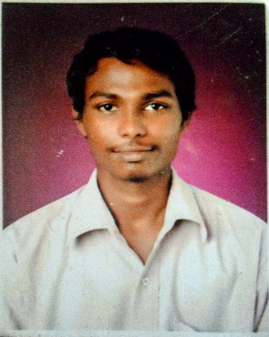

*Near Ayyappa Temple,Koorikatta,Panambur,*

*Mangalore-575010.*

*+918122106340; +918904087189.*

*Dj.kantan11@gmail.com*

Objective

|  |
| --- |
| To work in a challenging environment demandingall my skills and adapt myself in different fields forthe development of the organization withimpressive performance.  ` |

Skills

|  |  |
| --- | --- |
| Web Development - | **HTML5,CSS,JS,Bootstrap,PHP**. |
| .Net Framework - | **ASP.NET,C#.NET,VB.NET .** |
| Other Languages - | **Java,C,C++ .** |
| Database - | **SQL,MYSQL,MongoDB.** |
| IDE - | **Visual Studio,NetBeans,Eclipse,Intellij,WebStorm.** |

Education

|  |  |  |  |  |  |
| --- | --- | --- | --- | --- | --- |
| MCA | [2016-2018]  **KIT-Kalaignar Karunanidhi Institute of Technology,Coimbatore.**  **\*76%(Till 4th Semester)** |  |  |  |  |
| BCA | [2012-2015] **SDM College of Business Management, Mangalore.**  Passed Out with **80.61%** |  |  |  |  |
| PUC | [2010-2012]  **Canara PU College, Mangalore.**  Passed Out with **71%** |  |  |  |  |
| SSLC | [2010] **GHS Baikampady, Mangalore.**  Passed Out with **75.65%** |  |  |  |  |

Other Qualifications

|  |  |
| --- | --- |
| Short Term Course | **Personality Development** [**A** GRADE].  **Business Management** [**A** GRADE] |

Certifications

**HTML5 APPLICATION DEVELOPMENT FUNDUMENTALS [**Microsoft Technology Associate**].**

**SPEECH ANXIETY AND COMMUNICATION SKILLS [**East Michigan University**].**

**VIRTUALIZATION FOR BEGGINNERS [**VMWARE**]**

Other Skills

|  |  |
| --- | --- |
| Software - | **Adobe Phot oshop, Adobe Illustrator, Adobe Lightroom, Adobe Dream Weaver,**  **Sony Vegas, FL Studio, Corel Draw.** |

Leadership

Event Manager **Codezilla, SYGMA-2013** (State Level Fest Conducted By SDMCBM ).

Judge **Web Designing, Mini SYGMA 2016**(Inter Class Fest Conducted By SCAN SDMCBM).

Linguistic Abilities

* **Tamil** [**R**ead-**W**rite-**S**peak].
* **Kannada** [**R**ead-**W**rite-**S**peak].
* **Tulu** [**S**peak].
* **English** [**R**ead-**W**rite-**S**peak].
* **Hindi** [**R**ead-**W**rite-**S**peak].

Area of Interest

* Graphic Design
* MEAN Stack
* Digital Painting
* Photography

Personal Details

|  |  |
| --- | --- |
| Name | **Manikantan** |
| D.O.B | **27-11-1994** |
| Gender | **Male** |
| Blood Group | **A+** |
| Address | **Near Ayyappa Temple, koorikatta, Panambur,Mangalore-10** |

DeclarationI hereby declare that the information furnished above is true and correct to the best of my knowledge and belief.

PLACE: ________________ DATE : (Manikantan)