V4L2
By
Manikanta

Contents

1.Video Encoder flow & Decooder flow

2.What is RGB

3.what is yUV
a.Types of YUV
b.Chroma Subsampling

4.Compression

5.Bitstrream & bitstream format
a.Example of H264

6.Video container formats

7.Meta Data

8.Pixel

9.Aspect ratio

10.Interlaced and progressive scanning

11.I frame ,P frame , B frame

12.High FPS videodev

13.Timelapse Video

14.Down scalling and Up scalling

15.Macro block

16.V4L2

17.Transcoding

18.FFMPEG and How to install

19.How to run and capture the log for appplication

20.Reference links

Video Encoder flow:

camera HW (BAYER format) --> camera ISP (BAYER -> RGB -> YUV) --> Video Encoder (YUV -> bitstream standard formats H264, H265) --> File (H264 -> mp4)

Video Decoder flow:

File (mp4 -> H264) --> Video Decoder (H264 -> YUV) --> Display(YUV -> RGB) -->(RGB) Display HW

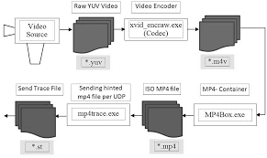

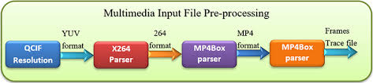

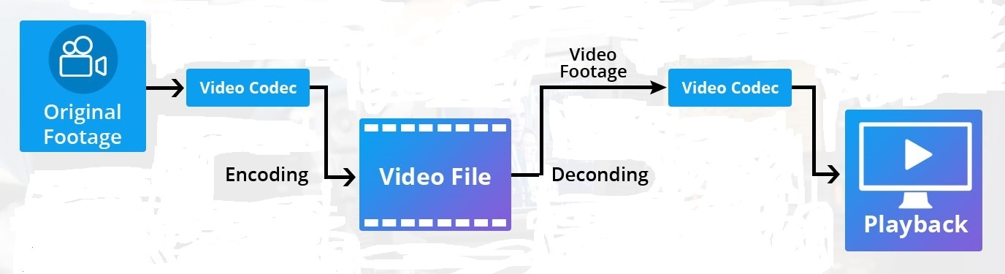

Source links:
https://www.youtube.com/watch?v=sisvOeZItb0
https://www.youtube.com/watch?v=GhWki9a7s18
https://www.youtube.com/watch?v=2cbXxyr0DCY&feature=youtu.be

What is RGB?

The RGB color model is an additive color model in which red, green, and blue light are added together in various ways to reproduce a broad array of colors. The name of the model comes from the initials of the three additive primary colors, red, green, and blue.
In this model, the colors red (R), green (G) and blue (B) are added together at different intensities to produce millions of different colors on modern video display screens.
Levels of R, G, and B can each range from 0 to 100 percent of full intensity.
Each level is represented by the range of decimal numbers from 0 to 255 (256 levels for each color) and 0 is taken to be black,255 is taken to be white.
Equivalent to the range of binary numbers from 00000000 to 11111111, or hexadecimal 00 to FF.
The total number of available colors is 256 x 256 x 256, or 16,777,216 possible colors.
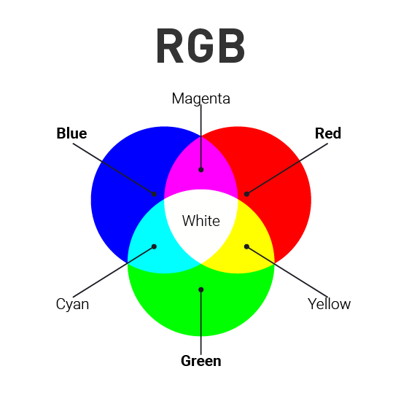

Source links:
https://en.wikipedia.org/wiki/RGB_color_model
https://www.youtube.com/watch?v=DZMvH4D3U2A
https://techterms.com/definition/rgb

What is YUV ?

YUV is a color encoding system typically used as part of a color image pipeline. It encodes a color image or video taking human perception into account
The Y′UV model defines a color space in terms of one luma component (Y′) and two chrominance components, called U (blue projection) and V (red projection) respectively
Many of our color camera models support the transmission of images in a YUV color encoding scheme. This scheme assigns both brightness and color values to each pixel. In YUV, ‘Y’ represents the brightness, or ‘luma’ value, and ‘UV’ represents the color, or ‘chroma’ values. In contrast, the values of the RGB encoding scheme represent the intensities of red, green and blue channels in each pixel.

Types of YUV ?

Each unique Y, U and V value comprises 8 bits, or one byte, of data. Where supported, our color camera models allow YUV transmission in 24-, 16-, and 12-bit per pixel (bpp) format. In 16 and 12 bpp formats, the U and V color values are shared between pixels, which frees bandwidth and may increase frame rate. Known as “chroma subsampling,” this technique takes into account the human eye’s greater sensitivity to variations in brightness than in color.

chroma subsampling

the U and V color values are shared between pixels, which frees bandwidth and may increase frame rate. Known as “chroma subsampling,”

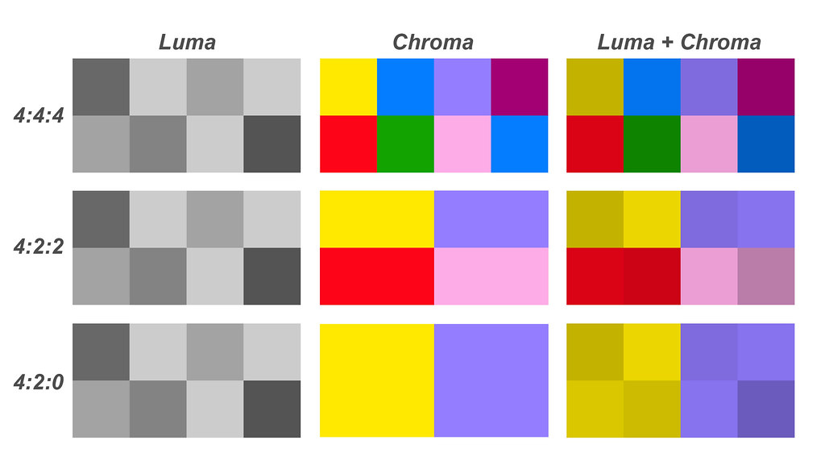

YUV444 Data Format

The YUV444 data format transmits 24 bits per pixel. Each pixel is assigned unique Y, U and V values—1 byte for each value, making it the most straightforward format to understand.

The bytes are ordered in the image in the following manner, where Y, U, V represent a single byte of color or brightness value, and 0, 1, 2… represent the pixel numbers associated with those values:

U0 Y0 V0 U1 Y1 V1 U2 Y2 V2…
This order results in the following data structure for each pixel:
Pixel Number Pixel Values
0 U0Y0V0
1 U1Y1V1
2 U2Y2V2
... ...

YUV422 Data Format

The YUV422 data format shares U and V values between two pixels. As a result, these values are transmitted to the PC image buffer only once for every two pixels, resulting in an average transmission rate of 16 bits per pixel.

The bytes are ordered in the image in the following manner:

U0 Y0 V0 Y1 U2 Y2 V2 Y3 U4 Y4 V4…

This order results in the following data structure for each pixel:
Pixel Number Pixel Values
0 0Y0V0
1 U0Y1V0
2 U2Y2V2
3 U2Y3V2
4 U4Y4V4
... ...

YUV420Data Format

The YUV420 format shares U and V values between four pixels, resulting in an average transmission rate of 12 bits per pixel.

The image bytes are ordered in the following manner:

U0 Y0 Y1 V0 Y2 Y3 U4 Y4 Y5 V4 Y6 Y7…

This order results in the following data structure for each pixel:
Pixel Number Pixel Value
0 U0Y0V0
1 U0Y1V0
2 U0Y2V0
3 U0Y3V0
4 U4Y4V4
5 U4Y5V4
6 U4Y6V4
7 U4Y7V4

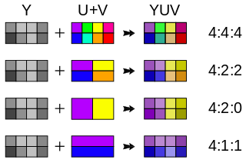

Source links:
https://en.wikipedia.org/wiki/YUV
https://www.youtube.com/watch?v=fkz2-JVaYDk
https://www.youtube.com/watch?v=yinOtVTWJFY
https://www.youtube.com/watch?v=Vt1Q6McYmOc

Compression:

In signal processing, data compression, source coding, or bit-rate reduction is the process of encoding information using fewer bits than the original representation.

To get the smaller size with same quality we need compression.
RGB >>YUV444 Conversion
YUV444 >>YUV420 Chrome
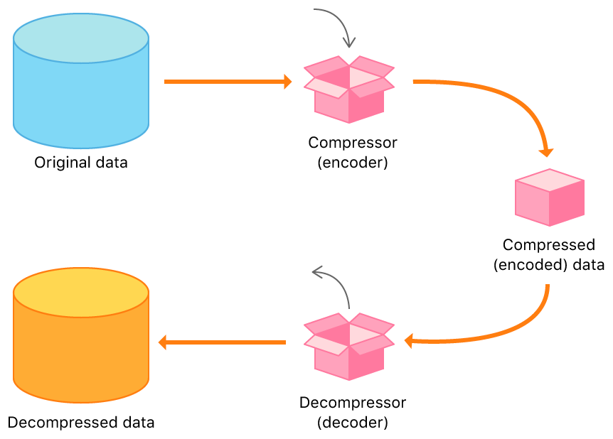
Subsampling
YUV>> H264 This is specific to standard

Source links:
https://www.techopedia.com/definition/18460/video-compression
https://www.haivision.com/resources/streaming-video-definitions/compression/

Bitstream:

A bitstream (or bit stream), also known as binary sequence, is a sequence of bits.
A bytestream is a sequence of bytes. Typically, each byte is an 8-bit quantity, and so the term octet stream is sometimes used interchangeably. An octet may be encoded as a sequence of 8 bits in multiple different ways (see bit numbering) so there is no unique and direct translation between bytestreams and bitstreams.

A bitstream format is the format of the data found in a stream of bits used in a digital communication or data storage application. The term typically refers to the data format of the output of an encoder, or the data format of the input to a decoder when using data compression.

Video Encoder (YUV -> bitstream standard formats H.264, H.265)
Video Decoder (H.264 -> YUV)

Bitstream formats:

H.261,H.262,H.263,H.264 / AVC,H.265 / HEVC,H.266 / VVC,DV
VC-1,VC-2,VC-3,VC-5,VP3,VP6,VP7,VP8,VP9,AV1.
H.264(advanced video coding)
it is proprietary code.
It uses low bit rate than H.265.

H.265(high efffiency video coding)
it is proprietary code.
we can get 50% smaller size of file than H.264.
For live streaming it is better than H.264,but we need more hardware resource than H.264.

VP8:
It is open source/google
We can get smaller file size than H.264.

VP9:
open source by google
we can get 50% smaller size than VP8
It uses webm and IVF containers.

Example:

H.264 is an industry standard for video compression, the process of converting digital video into a format that takes up less capacity when it is stored or transmitted.

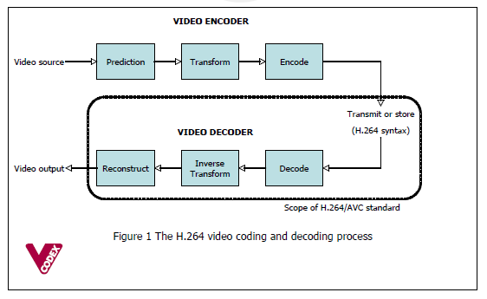

Encoder processes
The H.264/AVC standard was first published in 2003. It builds on the concepts of earlier standards such as MPEG-2 and MPEG-4 Visual and oﬀers the potential for better compression eﬃciency (i.e. better-quality compressed video) and greater flexibility in compressing, transmitting and storing video.

An H.264 video encoder carries out prediction, transform and encoding processes (see Figure ) to produce a compressed H.264 bitstream. An H.264 video decoder carries out the complementary processes of decoding, inverse transform and reconstruction to produce a decoded video sequence.

Transform and quantization
A block of residual samples is transformed using a 4x4 or 8x8 integer transform, an approximate form of the Discrete Cosine Transform (DCT). The transform outputs a set of coeﬃcients, each of which is a weighting value for a standard basis pattern. When combined, the weighted basis patterns re-create the block of residual samples. Figure 4 shows how the inverse DCT creates an image block by weighting each basis pattern according to a coeﬃcient value and ombining the weighted basis patterns.
The output of the transform, a block of transform coeﬃcients, is quantized, i.e. each coeﬃcient is divided by an integer value. Quantization reduces the precision of the transform coeﬃcients according to a quantization parameter (QP). Typically, the result is a block in which most or all of the coeﬃcients are zero, with a few non-zero coeﬃcients. Setting QP to a high value means that more coeﬃcients are set to zero, resulting in high compression at the expense of poor decoded image quality. Setting QP to a low value means that more non-zero coeﬃcients remain after quantization, resulting in better decoded image quality but lower compression.
Bitstream encoding
The video coding process produces a number of values that must be encoded to form the compressed bitstream. These values include:
- quantized transform coeﬃcients
- information to enable the decoder to re-create the prediction
- information about the structure of the compressed data and the compression tools used during encoding
- information about the complete video sequence.
These values and parameters (syntax elements) are converted into binary codes using variable length coding and/or arithmetic coding. Each of these encoding methods produces an eﬃcient, compact binary representation of the information. The encoded bitstream can then be stored and/or transmitted.

Decoder processes
Bitstream decoding
A video decoder receives the compressed H.264 bitstream, decodes each of the syntax elements and extracts the information described above (quantized transform coeﬃcients, prediction information, etc). This information is then used to reverse the coding process and recreate a sequence of video images.
Rescaling and inverse transform
The quantized transform coeﬃcients are re-scaled. Each coeﬃcient is multiplied b an integer value to restore its original scale2. An inverse transform combines the standard basis patterns, eighted by the re- scaled coeﬃcients, to re-create each block of residual data. These blocks are combined together to form a residual macroblock.
Reconstruction
For each macroblock, the decoder forms an identical prediction to the one created by the encoder. The decoder adds the prediction to the decoded residual to reconstruct a decoded macroblock which can then be displayed as part of a video frame.

H.264(advanced video coding)

It uses low bit rate than H.265.
The decoder operates with a sequence of bits received in a specific format. The binary stream is structured and divided into packets. On the upper level, there is separation of the stream on NAL-packets.
NAL stands for Network Abstraction Layer.

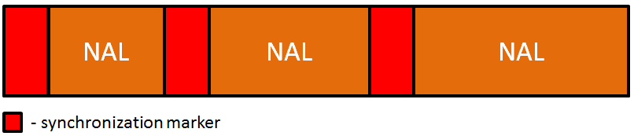
Fig: Stream separation on NAL packets.

NAL-type defines what data structure is represented by current NAL-packet. It can be slice, or parameter set, or filler and so on.
The first byte of a NAL-packet is a header that contains information about the type of packet

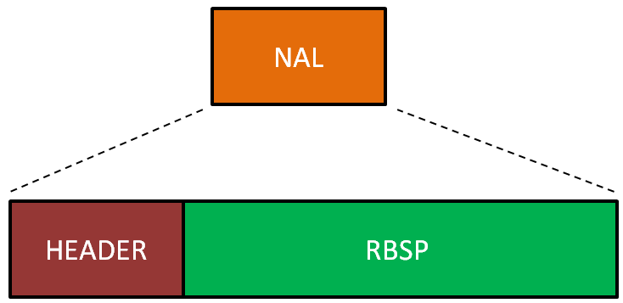
Fig: NAL structure

NAL-packet identified as RBSP (Raw Byte Sequence Payload). RBSP describes a row of bits specified order of SODB (String Of Data Bits).
According to the ITU-T specification if SODB empty (zero bits in length), RBSP is also empty.
The first byte of RBSP (most significant, far left) contains the eight bits SODB; next byte of RBSP shall contain the following eight SODB and so on, until there is less than eight bits SODB. This is followed by a stop-bits and equalizing bit

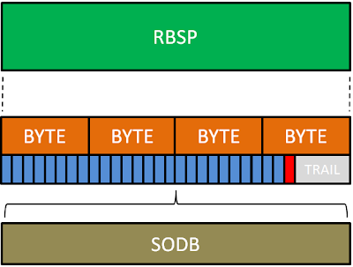

Fig: Raw Byte Sequence Payload (RBSP)

Any coded image contains slices, which in turn are divided into macroblocks. Most often, one encoded image corresponds to one slice. Also, one image can have multiple slices.
The slices are divided into the following types:

The slices are divided into the following types:
Type | Description
0 | P-slice. Consists of P-macroblocks (each macro block is predicted using one reference frame) and / or I-macroblocks.
1 | B-slice. Consists of B-macroblocks (each macroblock is predicted using one or two reference frames) and / or I-macroblocks.
2 | I-slice. Contains only I-macroblocks. Each macroblock is predicted from previously coded blocks of the same slice.
3 | SP-slice. Consists of P and / or I-macroblocks and lets you switch between encoded streams.
4 | SI-slice. It consists of a special type of SI-macroblocks and lets you switch between encoded streams.
5 | P-slice.
6 | B-slice.
7 | I-slice.
8 | SP-slice.
9 | SI-slice.

Table :Slice types

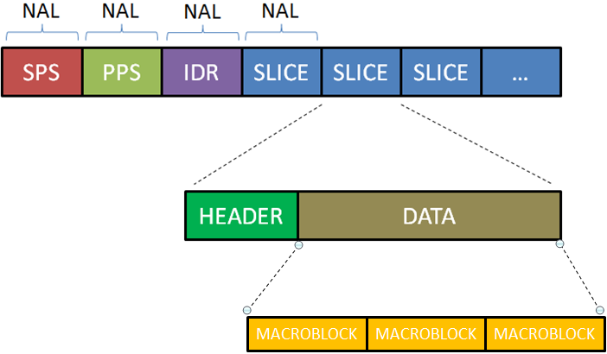
Fig: Detailed H.264 stream

Source link:
https://www.vcodex.com/an-overview-of-h264-advanced-video-coding/

Video Container formats:

Video containers bundle and store all elements of a video into one package. Elements include the video and audio streams, subtitles, video metadata, codec and more.

Each video container type is compatible with certain video codecs. Your video editing software should only allow you to choose compatible pairings, but try to plan what codec and container you want to use ahead of time, to avoid running into issues when you go to render your final video.
Common Video Containers

It can also be called a file extension since they are often seen as file names, such as AVI, MOV, or MP4. While AVI and MOV
3GP,3G2,ASF,AVI,DMF,EVO,F4V,FLV,MP4,PS,TS,MXF,M2TS,Video file.

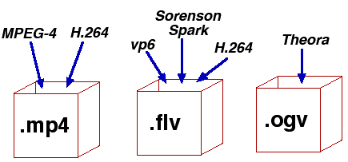

Source links:
https://en.wikipedia.org/wiki/Container_format_(computing)
https://en.wikipedia.org/wiki/Comparison_of_video_container_formats
https://www.headendinfo.com/video-container/

Metadata

Metadata is "data that provides information about other data". In other words, it is "data about data."
If we take one file,It contain information like:
type: video/audio
format: h264, h265
fps: 30 --> Frames per second
Resolution:1280x720=WidthxHeight

How to install Mediainfo for ubuntu

sudo apt-get update -y
sudo apt-get install -y mediainfo

Display information about a video file
$ mediainfo birds.

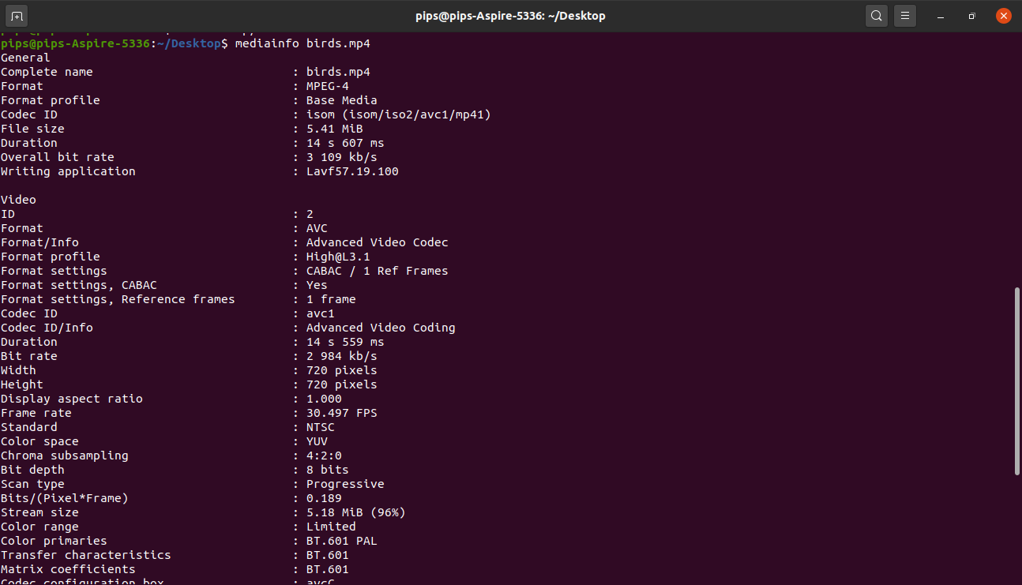

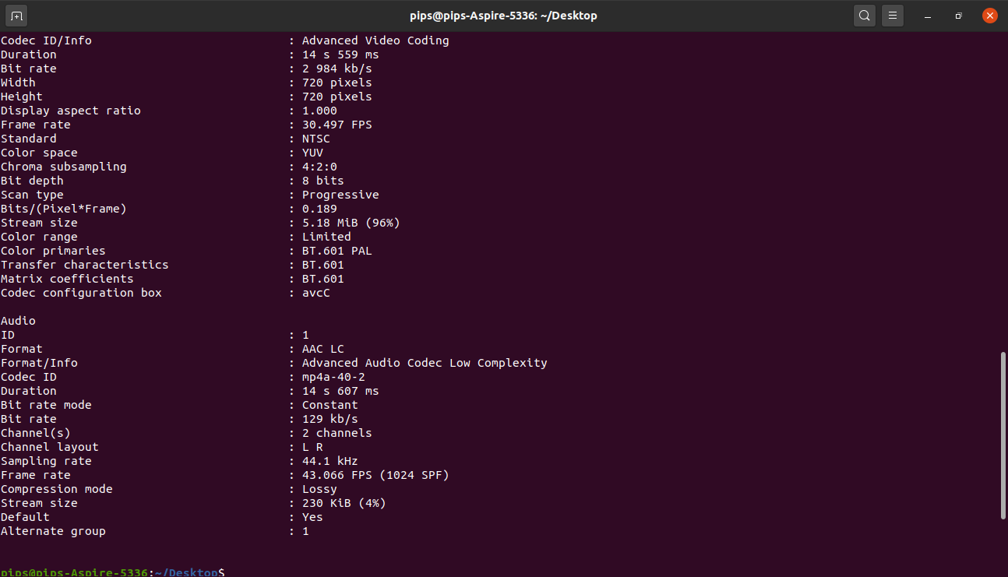

Source links:
http://manpages.ubuntu.com/manpages/bionic/man1/mediainfo.1.html
https://zoomadmin.com/HowToInstall/UbuntuPackage/mediainfo

What is Pixel?
Pixel is the small single component of a digital image.
A pixel is represented by a dot (or) square on a computer monitor display screen, the quantity and size and color combination of pixels will varies with display resolution.
For example,a computer with a display resolution of 1280X768 will produce a maximum of 98,3040 pixels on a display screen.
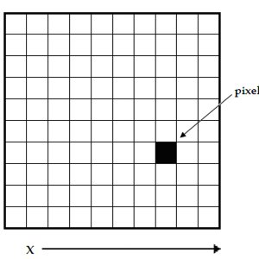

Source links:
https://en.wikipedia.org/wiki/Pixel
https://www.youtube.com/watch?v=FC4l3aqFdIA
https://www.youtube.com/watch?v=wsFROq2jVSQ

What is Video Frame?

Frame is the one of the many still images which compose the complete moving picture.
Video frames were represenated as analog waveforms in which varying voltages represented the intensity of light in an raster scan across the screen.

Frame rates refer to the number of times images are flashed on a screen during a given second to give the illusion of movement.
- Traditional film, such as the classic movies in the movie theater, was shot at 24 frames per second.
- Television, on the other hand, was shot at 30 frames per second

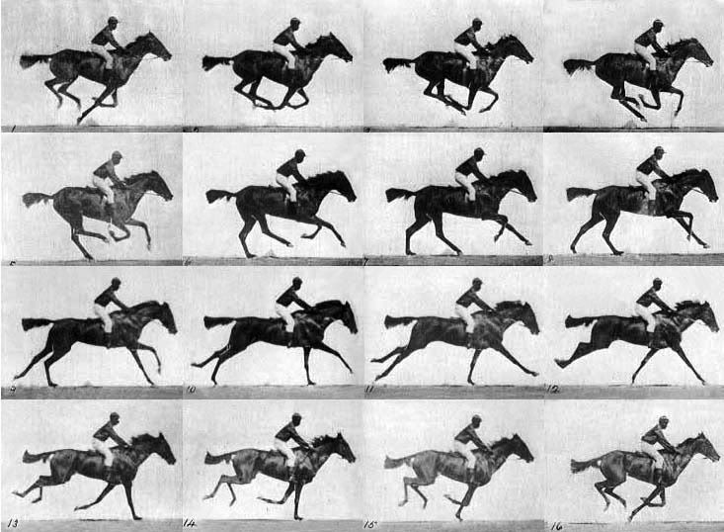

Source links:
https://medium.com/hd-pro/understanding-frame-rate-in-video-7adb1c3a7ea5

What is Aspect ratio?

The term Aspect Ratio refers to the width of a picture (or screen) in relation to its height. Ratios are expressed in the form "width x height". For example, a 4x3 ratio means the picture is 4 units wide by 3 units high. Alternatively a colon may be used (e.g. 4:3 or 16:9) or a ratio to the number 1 (e.g. 1.33:1 or 1.78:1).
Note that the actual physical size of the picture is irrelevant — aspect ratio refers only to the relationship between width and height.
The three most common aspect ratios are shown below. There are many variations in addition to these but most video and film production uses one of these formats.
4:3(1.33:1) 16:9 (1.78:1) 18:9(2:1) 21:9(2.33:1)
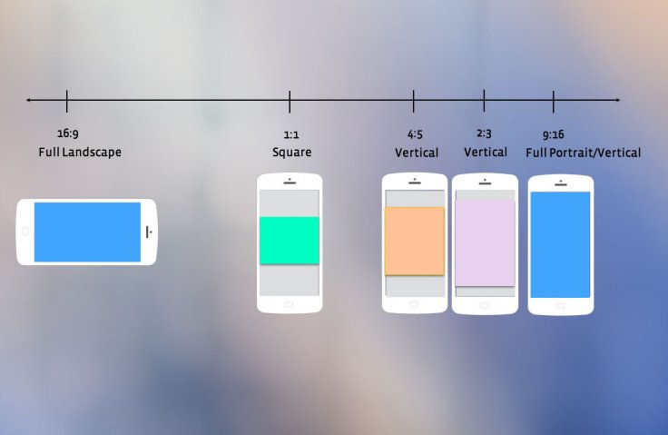
720p is height in order to get resolution we multiply with aspect ratio
720x16/9=1280
720p and aspect ratio 16:9 we get resolutin 1280x720p

width=height X aspect ratio
1280=720 x 16/9
Source links:
https://en.wikipedia.org/wiki/Aspect_ratio
https://www.youtube.com/watch?v=E-dUveGINTg

720p, 480p, 1080p -> What is P ?
1080i --> What is I ?

Progressive Video: Video sources that are listed with the letter p are called progressive scan signals. Examples of this would be 480p, 720p or 1080p. Progressive scan video content displays both the even and odd scan lines (the entire video frame)
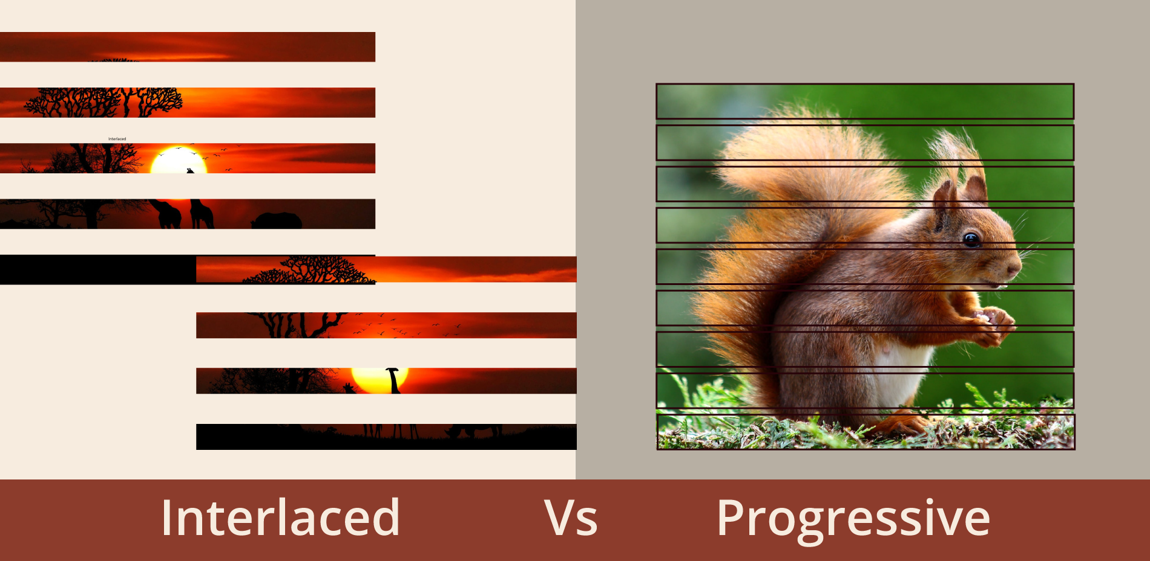
Interlaced Video: Video sources that are listed with the letter i are called interlaced. An example of this would be 480i or 1080i. Interlaced video displays even and odd scan lines as separate fields. The even scan lines are drawn on the screen, then the odd scan lines are drawn on the screen. Two of these even and odd scan line fields make up one video frame.

What is I frame?
Intra coded frame
It constructed from itself only and it is used as a reference for other frames
It never constructed from other frames.

What is P frame?
Predictive frame
It is constructed from previous i and p frames.
It contains previous frame changes.
It can construct from another P-frame.

What is B frame?
Bi-directional predictive frame.
It is constructed from past and future frames.
It is not constructed from another B-frame means never used as a reference.
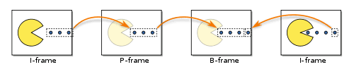

In video coding, a group of pictures, or GOP structure, specifies the order in which intra- and inter-frames are arranged.
The GOP is a collection of successive pictures within a coded video stream.
Each coded video stream consists of successive GOPs, from which the visible frames are generated.

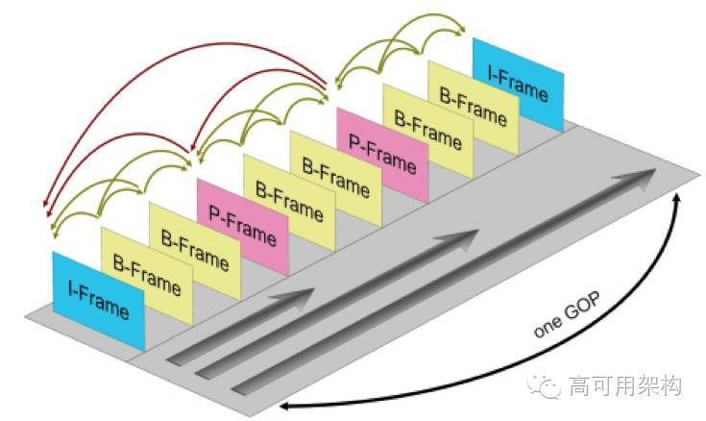
Fig:I and B and P frames in a video

Source links:
https://www.youtube.com/watch?v=H_o5h5SK_70
https://www.youtube.com/watch?v=ZJXczn_jPLQ
https://medium.com/hd-pro/progressive-vs-interlaced-e18e2924800e

High Quality video (480p, 720p, 1080p, 2160p, UHD, Full HD). How many types are the resolutions.

Resolution means the no.of pixels per unit of area.
- 720p = 1280 x 720 - is usually known as HD or "HD Ready" resolution
- 1080p = 1920 x 1080 - is usually known as FHD or "Full HD" resolution
- 1440p = 2560 x 1440 - is commonly known as QHD or Quad HD resolution, and it is typically seen on gaming monitors and on high-end smartphones. 1440p is four times the resolution of 720p HD or "HD ready." To make things even more confusing, many premium smartphones feature a so-called 2960x1440 Quad HD+ resolution, which still fits into 1440p.
- 4K or 2160p = 3840 x 2160 - is commonly known as 4K, UHD or Ultra HD resolution. It is a huge display resolution, and it is found on premium TVs and computer monitors. 2160p is called 4K because the width is close to 4000 pixels. In other words, it offers four times the pixels of 1080p FHD or "Full HD."
- 8K or 4320p = 7680 x 4320 - is known as 8K and it offers 16 times more pixels than the regular 1080p FHD or "Full HD" resolution. For now, you see 8K only on expensive TVs from Samsung and LG. However, you can test whether your computer can render such a large amount of data using this 8K video sample:
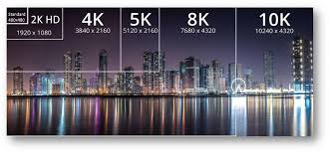

Source links:
https://www.youtube.com/watch?v=aIygY9Kv3bA
https://en.wikipedia.org/wiki/Display_resolution

What is High FPS video ?

In motion picture technology—either film or video—high frame rate (HFR) refers to higher frame rates than typical prior practice. The frame rate for motion picture film cameras was typically 24 frames per second (fps) with multiple flashes on each frame during projection to prevent flicker.

======== Normal Video ===========
720p@30fps --> 1280x720 @ 30 fps
If Total video length = 1 min consider video length of 1min i.e 60sec
1 min => 60 secs
30 fps
1 sec => 30 frames 30fps means 1sec=30frames
1 frame => 1/30 => 33 msecs 1 frame will take 0.033 i.e 33msec
60 secs ==> 1800 frames 60 sec 60x30=1800frames
Example: Decoder (H264 -> YUV)
1800 frames should be processed in 1 min
======== High FPS Video =============
720p@120 fps
Total video length = 1 min
1 min => 60 secs
120 fps
1 sec = 120 frames
1 frame => 1/120 = 8.33 mSecs
60 secs => 7200 frames
720p@30fps speed play ==> 4 mins
7200 frames @ 30 fps ==> 4 mins

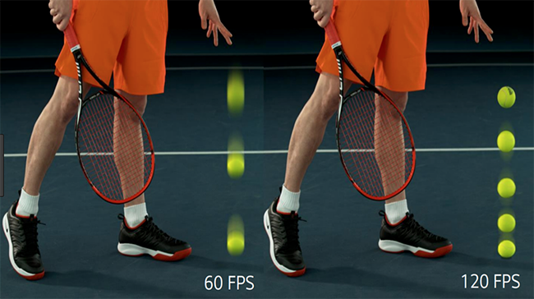
Q.What is timelapse video ?

Time-lapse photography is a technique whereby the frequency at which frames are captured is much more spread out than the frequency used to view the sequence. When played at normal speed, time appears to be moving faster and thus lapsing.
In timelapse the frequency at which film frames are captured is much more spread out than the frequency used to view the sequence.
when played at normal speed,time appears to be moving faster and thus lapsing

======== Time Lapse Video ===========
720p@30fps --> 1280x720 @ 30 fps
day 1: Everyday morning 11AM => 1 frame
.
.
.
.
day 600 : 1 frame
600 frames@30fps
Source link:
https://www.youtube.com/watch?v=AHrCI9eSJGQ

Hardware Video decoder/encoder?
Hardware encoders/decoders are dedicated processors that use a designed algorithm to encode/decode.

Sofware Video Decoder/encoder?
Software encoder/decoders are programs that run on laptop/desktop computer

FFmpeg

Down scaling

We can watch a high-resolution video on a smaller resolution screen.
For example, if you want to watch a video with a 4K resolution on a 720p resolution, that video is shown at 720p resolution, because that is all that your screen can offer.
if the video you want to watch has a higher resolution than that of your device resolution capacity, your device converts the video's resolution to one that fits the resolution of your device,
this is called downsampling.

Up scaling

We can watch a low-resolution video on a high resolution device.
upscaling means 720p video content you can see it in full screen mode on a 1080p device.

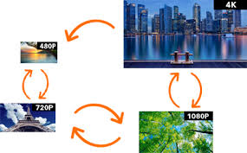

Macro block?

We break up or partition a frame into rectangular areas known as slices or tiles and each tile can be broken down into further into square units known as macro blocks or coding tree units.
Codec will process one macro block at a time,These macro blocks splitted into quarters and quartes again to process.

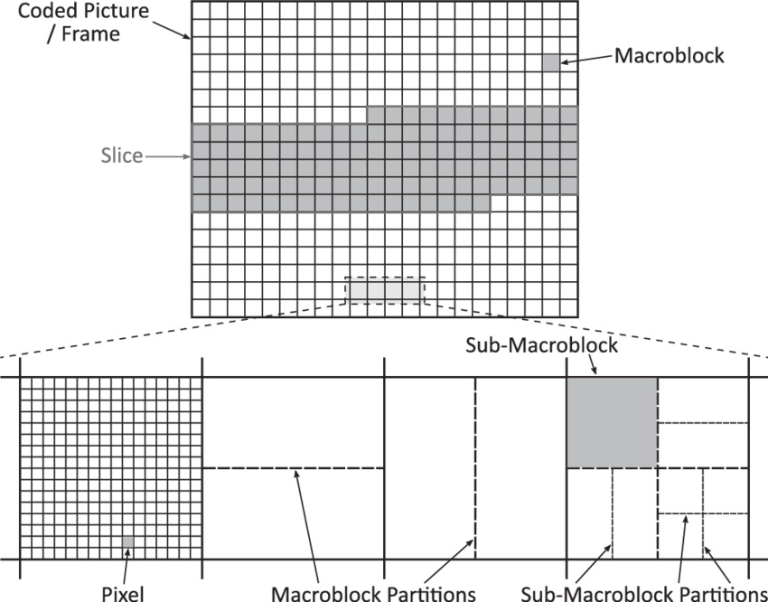

What is AV sync (Audio Video Sync)? When AV sync issue can come?
Audio-to-video synchronization (AV synchronization, also known as lip sync, or by the lack of it: lip-sync error, lip flap) refers to the relative timing of audio (sound) and video (image) parts during creation and post-production (mixing), transmission, reception and play-back processing.
when it will occur:
If video is slower than the audio/audio is slower than video,time difference between audio and video.
No sound in a video issue?
No sound in a video issue means video will play without audio.
Means in the container format may be audio file is missed .

ffprobe?
ffprobe gathers information from multimedia streams and prints it in human- and machine-readable fashion.For example it can be used to check the format of the container used by a multimedia stream and the format and type of each media stream contained in it.
ffmpeg?
ffmpeg is one such software platform especially for multimedia files. With the help of its expanded libraries we can convert, edit, repair, format any video format. It is basically a command line tool which uses commands to work on audio and video formats.
Instalation of ffmpeg
sudo apt update
sudo apt install ffmpeg
Basic conversion
When converting audio and video files with ffmpeg, you do not have to specify the input and output formats. The input file format is auto-detected, and the output format is guessed from the file extension.
- Convert a video file from mp4 to yuv
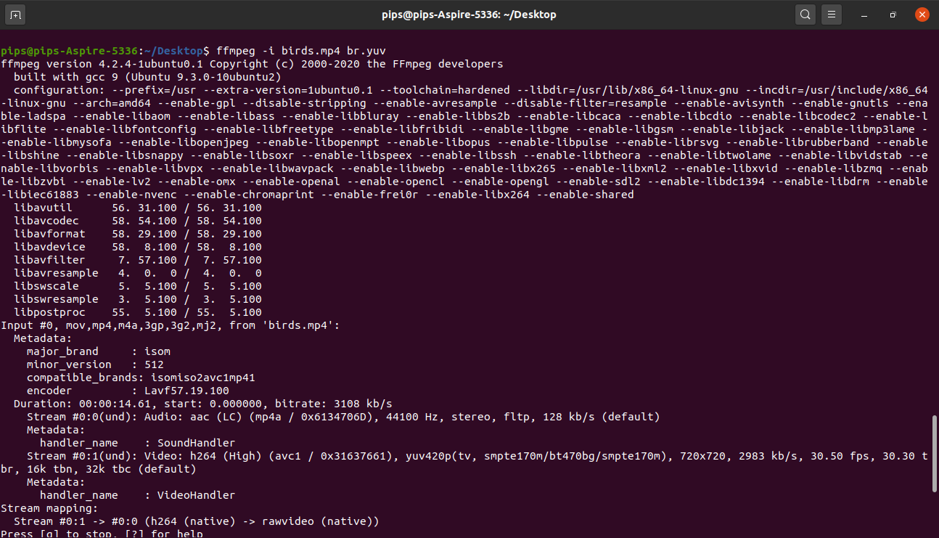
ffmpeg -i input.mp4 output.yuv

- Convert an video file from mp4 to h264:
ffmpeg -i input.mp4 output.h264

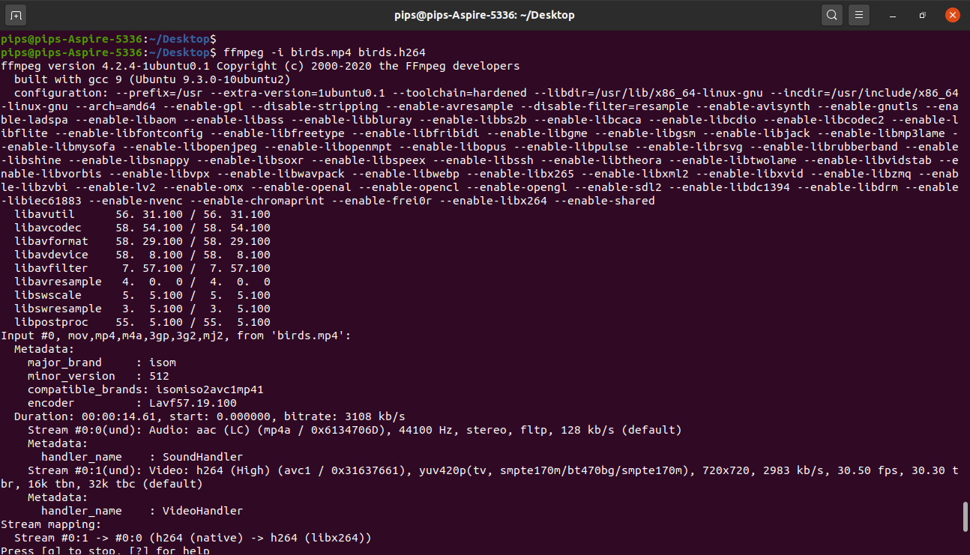

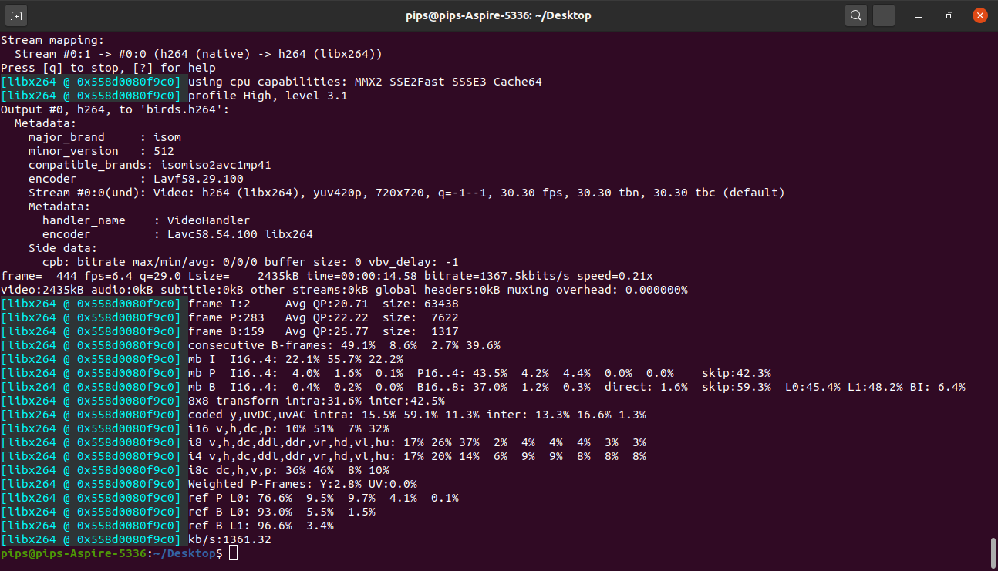

- Convert an video file from mp4 to h265:
ffmpeg -i input.mp4 output.h265
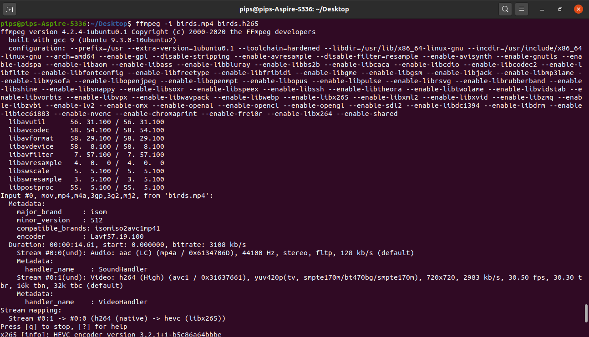

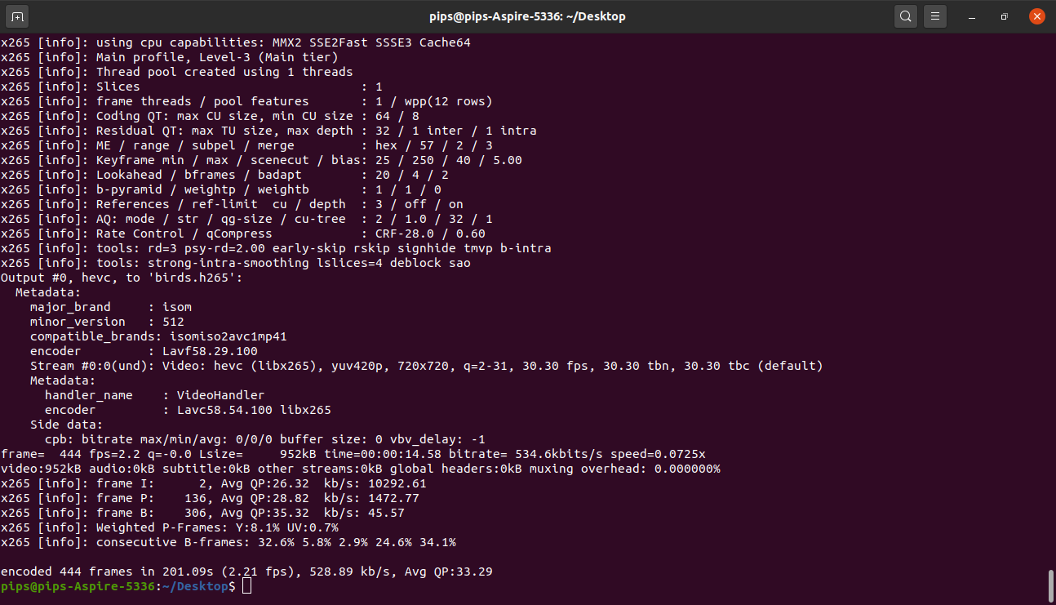

- Convert an video file from h265 to yuv:
ffmpeg -i input.h265 output.yuv
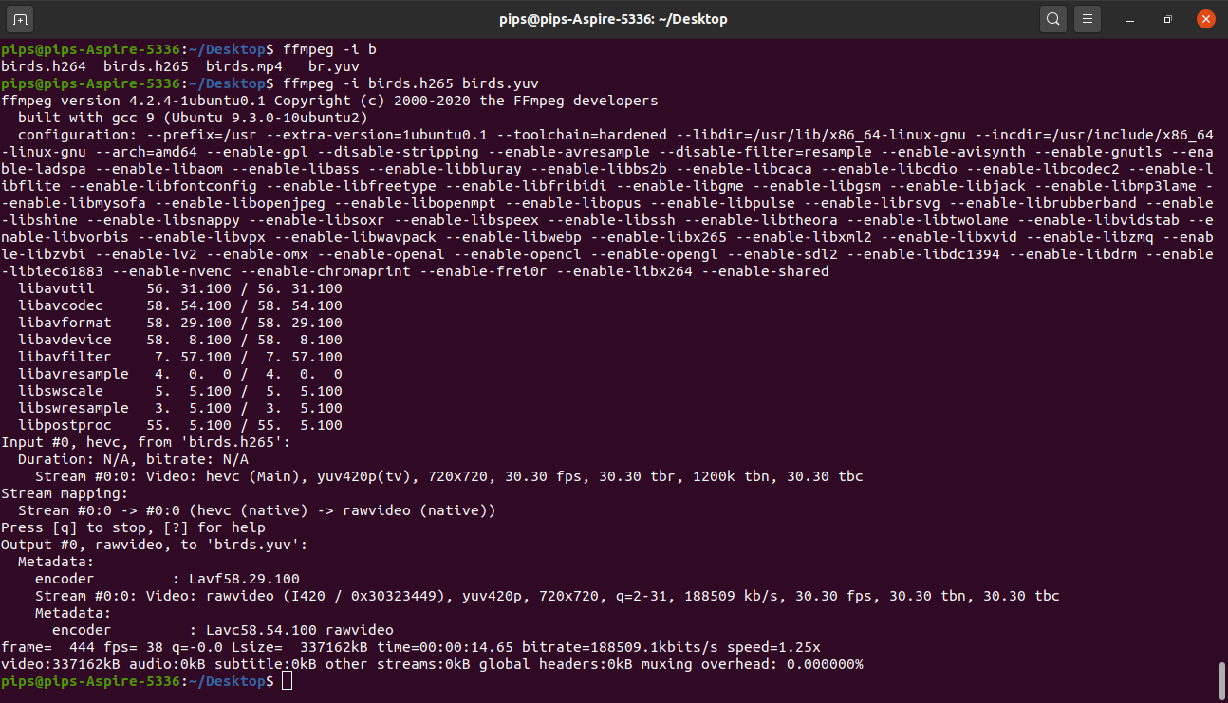

Source links:
https://linuxize.com/post/how-to-install-ffmpeg-on-ubuntu-18-04/
https://opensource.com/article/17/6/ffmpeg-convert-media-file-formats
https://stackoverflow.com/questions/45972119/how-to-convert-mp4-to-yuv-file-using-ffmpeg

V4L2:
Video4Linux is a collection of device drivers and an API for supporting realtime video capture on Linux systems. It supports many USB webcams, TV tuners, and related devices, standardizing their output, so programmers can easily add video support to their applications that use the V4L framework.
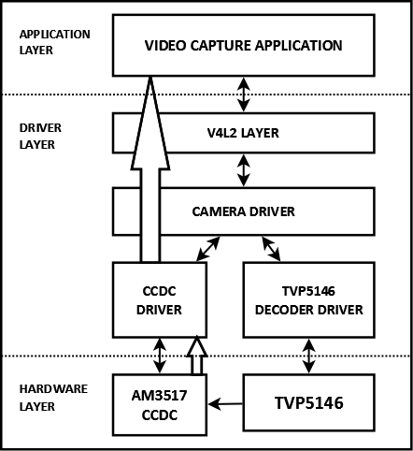

Programming a V4L2 device consists of these steps:
- Opening the device
- Changing device properties, selecting a video and audio input, video standard, picture brightness a. o.
- Negotiating a data format
- Negotiating an input/output method
- The actual input/output loop
- Closing the device
V4L2 drivers are implemented as kernel modules, loaded manually by the system administrator or automatically when a device is first discovered. The driver modules plug into the “videodev” kernel module. It provides helper functions and a common application interface specified in this document.
Each driver thus loaded registers one or more device nodes with major number 81 and a minor number between 0 and 255. Minor numbers are allocated dynamically unless the kernel is compiled with the kernel option CONFIG_VIDEO_FIXED_MINOR_RANGES. In that case minor numbers are allocated in ranges depending on the device node type (video, radio, etc.).

Common implementation of a v4l2 application:
To open and close V4L2 devices applications use the open() and close() function, respectively. Devices are programmed using the ioctl() function
The ioctl VIDIOC_QUERYCAP ioctl is available to check if the kernel device is compatible with this specification, and to query the functions and I/O methods supported by the device.
All V4L2 drivers must support ioctl VIDIOC_QUERYCAP. Applications should always call this ioctl after opening the device.
Other features can be queried by calling the respective ioctl, for example ioctl VIDIOC_ENUMINPUT to learn about the number, types and names of video connectors on the device.
Apart of the generic format negotiation functions a special ioctl( ioctl VIDIOC_ENUM_FMT) to enumerate all image formats supported by video capture, overlay or output devices is available.
Ioctl VIDIOC_REQBUFS ,this ioctl is used to inform the device about your buffers:how are you going to allocate them and how many are there and this will allow the device to write buffer data correctly(mmap is used to map the buffers)
Ioctl VIDIOC_QUERYBUF can be used to give the amount of memory it needs,allocate it and the status of a buffer at any time after buffers have been allocated with the ioctl VIDIOC_REQBUFS ioctl.
Applications call the ioctl VIDIOC_QBUF to en-queue an empty (capturing) or filled (output) buffer in the driver's incoming queue. The semantics depend on the selected I/O method.
To start the applications call the VIDIOC_STREAMON ioctl.
To de-queue a buffer applications use the VIDIOC_DQBUF ioctl.
Buffers remain locked until de-queued, until the VIDIOC_STREAMOFF ioctl or VIDIOC_REQBUFS ioctl is called, or until the device is closed
To stop the applications call the VIDIOC_STREAMOFF ioctl, after buffers will free and it calls the device close function.

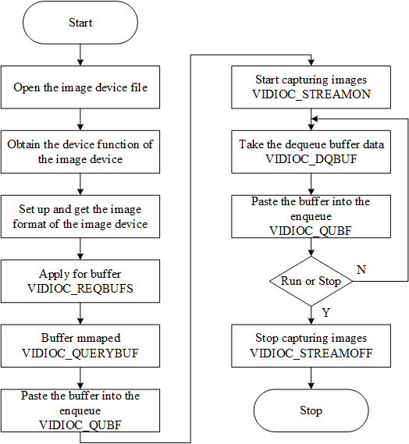

1.VIDIOC_QUERYCAP - Query device capabilities

int ioctl(int fd, VIDIOC_QUERYCAP, struct v4l2_capability *argp)

fd
File descriptor returned by open().
argp

All V4L2 devices support the VIDIOC_QUERYCAP ioctl. It is used to identify kernel devices compatible with this specification and to obtain information about driver and hardware capabilities. The ioctl takes a pointer to a struct v4l2_capability which is filled by the driver. When the driver is not compatible with this specification the ioctl returns an EINVAL error code.

2.VIDIOC_G_FMT - VIDIOC_S_FMT - VIDIOC_TRY_FMT - Get or set the data format, try a format

int ioctl(int fd, VIDIOC_G_FMT, struct v4l2_format *argp)
int ioctl(int fd, VIDIOC_S_FMT, struct v4l2_format *argp)
int ioctl(int fd, VIDIOC_TRY_FMT, struct v4l2_format *argp)

fd
File descriptor returned by open().
argp
Pointer to struct v4l2_format.

These ioctls are used to negotiate the format of data (typically image format) exchanged between driver and application.

3.VIDIOC_G_FMT - VIDIOC_S_FMT - VIDIOC_TRY_FMT - Get or set the data format, try a format
int ioctl(int fd, VIDIOC_G_FMT, struct v4l2_format *argp)
int ioctl(int fd, VIDIOC_S_FMT, struct v4l2_format *argp)
int ioctl(int fd, VIDIOC_TRY_FMT, struct v4l2_format *argp)
fd File descriptor returned by open().
argp Pointer to struct v4l2_format.
These ioctls are used to negotiate the format of data (typically image format) exchanged between driver and application.
4.VIDIOC_QUERYBUF - Query the status of a buffer

int ioctl(int fd, VIDIOC_QUERYBUF, struct v4l2_buffer *argp)

fd File descriptor returned by open().
argp

This ioctl is part of the streaming I/O method. It can be used to query the status of a buffer at any time after buffers have been allocated with the ioctl VIDIOC_REQBUFS ioctl.
5.VIDIOC_QBUF - VIDIOC_DQBUF - Exchange a buffer with the driver

int ioctl(int fd, VIDIOC_QBUF, struct v4l2_buffer *argp)
int ioctl(int fd, VIDIOC_DQBUF, struct v4l2_buffer *argp)

fd
File descriptor returned by open().
argp
Pointer to struct v4l2_buffer.

Applications call the VIDIOC_QBUF ioctl to enqueue an empty (capturing) or filled (output) buffer in the driver's incoming queue. The semantics depend on the selected I/O method.

6.IDIOC_STREAMON - VIDIOC_STREAMOFF - Start or stop streaming I/O

int ioctl(int fd, VIDIOC_STREAMON, const int *argp)
int ioctl(int fd, VIDIOC_STREAMOFF, const int *argp)

fd
File descriptor returned by open().
argp

The VIDIOC_STREAMON and VIDIOC_STREAMOFF ioctl start and stop the capture or output process during streaming

https://www.kernel.org/doc/html/v4.9/media/uapi/v4l/v4l2.html
Transcoding:
Transcoding is the process of converting an audio or video file from one encoding format to another in order to increase the number of compatible target devices a media file can be played on.

Video upscale:
640x480 ==> 1280x720

input.mp4
input.h264 --> input.yuv 480p 640x480
input_up.yuv 720p 1280x720 --> input_up.h264 720p

Output plane &Capture plane

O/p plane Decoder] Capture Plane
dev/video0

O/p plane [Encoder] Capture Plane
dev/video1

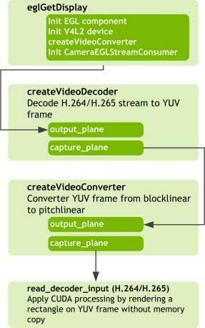

qbuf --> Queuing the buffers, send empty buffers
dqbuf --> Retreiving the buffers, receive ack of buffer

Decoder H264 -> YUV

ibuf1 obuf1
ibuf2 obuf2
ibuf3 obuf3
ibuf4 obuf4

sibuf [Decoder] obuf

qbuf_ibuf (Queuing the buffers)
qbuf_obuf (send empty buffers)
dqbuf_ibuf (receive ack of buffer)
dqbuf_obuf (Retreiving the buffers)

How to run and capture the log for appplication:

1.below is script file to run my application and save below one in .sh format

echo ""
sudo dmesg -C
sudo sh -c 'echo "3" >> /sys/class/video4linux/video0/dev_debug'
sudo sh -c 'echo "3" >> /sys/module/videobuf2_v4l2/parameters/debug'
sudo sh -c 'echo "3" >> /sys/module/videobuf2_common/parameters/debug'
./yavta -F /dev/video0 --capture=10
echo ""
echo ""
sudo dmesg

2.After open the command line terminal type chmod 777 filename.sh

3.finally Run script file using command ./filename.sh |tee destfilename.txt

Below is log for my application destfilename.txt

###video_open##ioctl(dev->fd, VIDIOC_QUERYCAP, &cap);
Device /dev/video0 opened: 1.3M HD WebCam: 1.3M HD WebCam (usb-0000:00:1d.7-4).
//open camera device and querying the capabilites i.e hardware specific information like name of camera and type
##video_get_format### ioctl(dev->fd, VIDIOC_G_FMT, &fmt);
Video format: YUYV (56595559) 640x480
//VIDIOC_G_FMT get format of the video
##video_alloc_buffers### ioctl(dev->fd, VIDIOC_REQBUFS, &rb);
8 buffers requested.
//Requesting how many buffers you want here dev is struct device
{
int fd;
enum v4l2_buf_type type;
enum v4l2_memory memtype;
unsigned int nbufs;
struct buffer *buffers;

unsigned int width;
unsigned int height;
unsigned int bytesperline;
unsigned int imagesize;

void *pattern;

}dev; and rb is struct v4l2_requestbuffers variable

struct v4l2_requestbuffers {
__u32 count;
__u32 type; /* enum v4l2_buf_type */
__u32 memory; /* enum v4l2_memory */
__u32 capabilities;
__u32 reserved[1];
};//

###video_alloc_buffers## ioctl(dev->fd, VIDIOC_QUERYBUF, &buf);
length: 614400 offset: 0
Buffer 0 mapped at address 0x7f1bc6d99000.
//Query buff is used to map the buffer to address here the arguments pass to ioctl are struct device and struct v4l2_buffer
struct v4l2_buffer {
__u32 index;
__u32 type;
__u32 bytesused;
__u32 flags;
__u32 field;
#ifdef __KERNEL__
struct __kernel_v4l2_timeval timestamp;
#else
struct timeval timestamp;
#endif
struct v4l2_timecode timecode;
__u32 sequence;

/* memory location */
__u32 memory;
union {
__u32 offset;
unsigned long userptr;
struct v4l2_plane *planes;
__s32 fd;
} m;
__u32 length;
__u32 reserved2;
union {
__s32 request_fd;
__u32 reserved;
};
};
//https://elixir.bootlin.com/linux/latest/source/include/uapi/linux/videodev2.h#L1021
###video_alloc_buffers## ioctl(dev->fd, VIDIOC_QUERYBUF, &buf);
length: 614400 offset: 614400
Buffer 1 mapped at address 0x7f1bc6d03000.
###video_alloc_buffers## ioctl(dev->fd, VIDIOC_QUERYBUF, &buf);
length: 614400 offset: 1228800
Buffer 2 mapped at address 0x7f1bc6c6d000.
###video_alloc_buffers## ioctl(dev->fd, VIDIOC_QUERYBUF, &buf);
length: 614400 offset: 1843200
Buffer 3 mapped at address 0x7f1bc6bd7000.
###video_alloc_buffers## ioctl(dev->fd, VIDIOC_QUERYBUF, &buf);
length: 614400 offset: 2457600
Buffer 4 mapped at address 0x7f1bc6b41000.
###video_alloc_buffers## ioctl(dev->fd, VIDIOC_QUERYBUF, &buf);
length: 614400 offset: 3072000
Buffer 5 mapped at address 0x7f1bc6aab000.
###video_alloc_buffers## ioctl(dev->fd, VIDIOC_QUERYBUF, &buf);
length: 614400 offset: 3686400
Buffer 6 mapped at address 0x7f1bc6a15000.
###video_alloc_buffers## ioctl(dev->fd, VIDIOC_QUERYBUF, &buf);
length: 614400 offset: 4300800
Buffer 7 mapped at address 0x7f1bc697f000.
//Queuing the buffers into input queue
##video_queue_buffer### ioctl(dev->fd, VIDIOC_QBUF, &buf);
##video_queue_buffer### ioctl(dev->fd, VIDIOC_QBUF, &buf);
##video_queue_buffer### ioctl(dev->fd, VIDIOC_QBUF, &buf);
##video_queue_buffer### ioctl(dev->fd, VIDIOC_QBUF, &buf);
##video_queue_buffer### ioctl(dev->fd, VIDIOC_QBUF, &buf);
##video_queue_buffer### ioctl(dev->fd, VIDIOC_QBUF, &buf);
##video_queue_buffer### ioctl(dev->fd, VIDIOC_QBUF, &buf);
##video_queue_buffer### ioctl(dev->fd, VIDIOC_QBUF, &buf);
//video steam on is enabled and ready for capture
###video_enable## ioctl(dev->fd, enable ? VIDIOC_STREAMON : VIDIOC_STREAMOFF, &type);
##video_do_capture### ioctl(dev->fd, VIDIOC_DQBUF, &buf);
0 (0) [-] 0 614400 bytes 3336.819305 1600320932.753823
//video qbuf means sending eampty buffer to capture plane
//video dqbuf retriving buffer form capture plane
##video_queue_buffer### ioctl(dev->fd, VIDIOC_QBUF, &buf);
##video_do_capture### ioctl(dev->fd, VIDIOC_DQBUF, &buf);
1 (1) [-] 1 614400 bytes 3337.439256 1600320932.789763
##video_queue_buffer### ioctl(dev->fd, VIDIOC_QBUF, &buf);
##video_do_capture### ioctl(dev->fd, VIDIOC_DQBUF, &buf);
2 (2) [-] 2 614400 bytes 3337.475249 1600320932.829761
##video_do_capture### ioctl(dev->fd, VIDIOC_DQBUF, &buf);
3 (3) [-] 3 614400 bytes 3337.515246 1600320932.869760
##video_queue_buffer### ioctl(dev->fd, VIDIOC_QBUF, &buf);
##video_do_capture### ioctl(dev->fd, VIDIOC_DQBUF, &buf);
4 (4) [-] 4 614400 bytes 3337.555243 1600320932.909762
##video_queue_buffer### ioctl(dev->fd, VIDIOC_QBUF, &buf);
##video_do_capture### ioctl(dev->fd, VIDIOC_DQBUF, &buf);
5 (5) [-] 5 614400 bytes 3337.595241 1600320932.949759
##video_queue_buffer### ioctl(dev->fd, VIDIOC_QBUF, &buf);
##video_do_capture### ioctl(dev->fd, VIDIOC_DQBUF, &buf);
6 (6) [-] 6 614400 bytes 3337.635239 1600320932.989757
##video_queue_buffer### ioctl(dev->fd, VIDIOC_QBUF, &buf);
##video_do_capture### ioctl(dev->fd, VIDIOC_DQBUF, &buf);
7 (7) [-] 7 614400 bytes 3337.675238 1600320933.037794
##video_queue_buffer### ioctl(dev->fd, VIDIOC_QBUF, &buf);
##video_do_capture### ioctl(dev->fd, VIDIOC_DQBUF, &buf);
8 (0) [-] 8 614400 bytes 3337.723240 1600320933.089755
##video_queue_buffer### ioctl(dev->fd, VIDIOC_QBUF, &buf);
##video_do_capture### ioctl(dev->fd, VIDIOC_DQBUF, &buf);
9 (1) [-] 9 614400 bytes 3337.775231 1600320933.137787
##video_queue_buffer### ioctl(dev->fd, VIDIOC_QBUF, &buf);
//streamoff for video disable
###video_enable## ioctl(dev->fd, enable ? VIDIOC_STREAMON : VIDIOC_STREAMOFF, &type);
Captured 9 frames in 0.384952 seconds (23.379538 fps, 15960431.430412 B/s).
##video_free_buffers### ioctl(dev->fd, VIDIOC_REQBUFS, &rb);
//requsting 8 buffers are released
8 buffers released.

[ 3336.803262] video0: VIDIOC_QUERYCAP: driver=uvcvideo, card=1.3M HD WebCam: 1.3M HD WebCam, bus=usb-0000:00:1d.7-4, version=0x0005042c, capabilities=0x84a00001, device_caps=0x04200001
[ 3336.803280] video0: VIDIOC_G_FMT: type=vid-cap, width=640, height=480, pixelformat=YUYV, field=none, bytesperline=1280, sizeimage=614400, colorspace=8, flags=0x0, ycbcr_enc=0, quantization=0, xfer_func=0
[ 3336.803502] videobuf2_common: __setup_offsets: buffer 0, plane 0 offset 0x00000000
[ 3336.803830] videobuf2_common: __setup_offsets: buffer 1, plane 0 offset 0x00096000
[ 3336.804096] videobuf2_common: __setup_offsets: buffer 2, plane 0 offset 0x0012c000
[ 3336.804397] videobuf2_common: __setup_offsets: buffer 3, plane 0 offset 0x001c2000
[ 3336.804699] videobuf2_common: __setup_offsets: buffer 4, plane 0 offset 0x00258000
[ 3336.804991] videobuf2_common: __setup_offsets: buffer 5, plane 0 offset 0x002ee000
[ 3336.805287] videobuf2_common: __setup_offsets: buffer 6, plane 0 offset 0x00384000
[ 3336.805586] videobuf2_common: __setup_offsets: buffer 7, plane 0 offset 0x0041a000
[ 3336.805588] videobuf2_common: __vb2_queue_alloc: allocated 8 buffers, 1 plane(s) each
[ 3336.805591] video0: VIDIOC_REQBUFS: count=8, type=vid-cap, memory=mmap
[ 3336.805625] video0: VIDIOC_QUERYBUF: 00:00:00.00000000 index=0, type=vid-cap, request_fd=0, flags=0x00012000, field=any, sequence=0, memory=mmap, bytesused=0, offset/userptr=0x0, length=614400
[ 3336.805633] timecode=00:00:00 type=0, flags=0x00000000, frames=0, userbits=0x00000000
[ 3336.805695] videobuf2_common: vb2_mmap: buffer 0, plane 0 successfully mapped
[ 3336.805704] video0: VIDIOC_QUERYBUF: 00:00:00.00000000 index=1, type=vid-cap, request_fd=0, flags=0x00012000, field=any, sequence=0, memory=mmap, bytesused=0, offset/userptr=0x96000, length=614400
[ 3336.805709] timecode=00:00:00 type=0, flags=0x00000000, frames=0, userbits=0x00000000
[ 3336.805730] videobuf2_common: vb2_mmap: buffer 1, plane 0 successfully mapped
[ 3336.805734] video0: VIDIOC_QUERYBUF: 00:00:00.00000000 index=2, type=vid-cap, request_fd=0, flags=0x00012000, field=any, sequence=0, memory=mmap, bytesused=0, offset/userptr=0x12c000, length=614400
[ 3336.805739] timecode=00:00:00 type=0, flags=0x00000000, frames=0, userbits=0x00000000
[ 3336.805761] videobuf2_common: vb2_mmap: buffer 2, plane 0 successfully mapped
[ 3336.805764] video0: VIDIOC_QUERYBUF: 00:00:00.00000000 index=3, type=vid-cap, request_fd=0, flags=0x00012000, field=any, sequence=0, memory=mmap, bytesused=0, offset/userptr=0x1c2000, length=614400
[ 3336.805769] timecode=00:00:00 type=0, flags=0x00000000, frames=0, userbits=0x00000000
[ 3336.805793] videobuf2_common: vb2_mmap: buffer 3, plane 0 successfully mapped
[ 3336.805797] video0: VIDIOC_QUERYBUF: 00:00:00.00000000 index=4, type=vid-cap, request_fd=0, flags=0x00012000, field=any, sequence=0, memory=mmap, bytesused=0, offset/userptr=0x258000, length=614400
[ 3336.805802] timecode=00:00:00 type=0, flags=0x00000000, frames=0, userbits=0x00000000
[ 3336.805823] videobuf2_common: vb2_mmap: buffer 4, plane 0 successfully mapped
[ 3336.805826] video0: VIDIOC_QUERYBUF: 00:00:00.00000000 index=5, type=vid-cap, request_fd=0, flags=0x00012000, field=any, sequence=0, memory=mmap, bytesused=0, offset/userptr=0x2ee000, length=614400
[ 3336.805831] timecode=00:00:00 type=0, flags=0x00000000, frames=0, userbits=0x00000000
[ 3336.805852] videobuf2_common: vb2_mmap: buffer 5, plane 0 successfully mapped
[ 3336.805856] video0: VIDIOC_QUERYBUF: 00:00:00.00000000 index=6, type=vid-cap, request_fd=0, flags=0x00012000, field=any, sequence=0, memory=mmap, bytesused=0, offset/userptr=0x384000, length=614400
[ 3336.805861] timecode=00:00:00 type=0, flags=0x00000000, frames=0, userbits=0x00000000
[ 3336.805880] videobuf2_common: vb2_mmap: buffer 6, plane 0 successfully mapped
[ 3336.805883] video0: VIDIOC_QUERYBUF: 00:00:00.00000000 index=7, type=vid-cap, request_fd=0, flags=0x00012000, field=any, sequence=0, memory=mmap, bytesused=0, offset/userptr=0x41a000, length=614400
[ 3336.805888] timecode=00:00:00 type=0, flags=0x00000000, frames=0, userbits=0x00000000
[ 3336.805908] videobuf2_common: vb2_mmap: buffer 7, plane 0 successfully mapped
[ 3336.806258] videobuf2_common: vb2_core_qbuf: qbuf of buffer 0 succeeded
[ 3336.806566] videobuf2_common: vb2_core_qbuf: qbuf of buffer 1 succeeded
[ 3336.806876] videobuf2_common: vb2_core_qbuf: qbuf of buffer 2 succeeded
[ 3336.807820] videobuf2_common: vb2_core_qbuf: qbuf of buffer 3 succeeded
[ 3336.808097] videobuf2_common: vb2_core_qbuf: qbuf of buffer 4 succeeded
[ 3336.808407] videobuf2_common: vb2_core_qbuf: qbuf of buffer 5 succeeded
[ 3336.808726] videobuf2_common: vb2_core_qbuf: qbuf of buffer 6 succeeded
[ 3336.809043] videobuf2_common: vb2_core_qbuf: qbuf of buffer 7 succeeded
[ 3336.814594] videobuf2_common: vb2_core_streamon: successful
[ 3336.814599] video0: VIDIOC_STREAMON: type=vid-cap
[ 3336.814616] videobuf2_common: __vb2_wait_for_done_vb: will sleep waiting for buffers
[ 3337.439641] videobuf2_common: vb2_core_dqbuf: returning done buffer
[ 3337.439646] videobuf2_common: vb2_core_dqbuf: dqbuf of buffer 0, with state 0
[ 3337.443893] videobuf2_common: vb2_core_qbuf: qbuf of buffer 0 succeeded
[ 3337.443900] videobuf2_common: __vb2_wait_for_done_vb: will sleep waiting for buffers
[ 3337.475594] videobuf2_common: vb2_core_dqbuf: returning done buffer
[ 3337.475599] videobuf2_common: vb2_core_dqbuf: dqbuf of buffer 1, with state 0
[ 3337.476570] videobuf2_common: vb2_core_qbuf: qbuf of buffer 1 succeeded
[ 3337.476576] videobuf2_common: __vb2_wait_for_done_vb: will sleep waiting for buffers
[ 3337.515592] videobuf2_common: vb2_core_dqbuf: returning done buffer
[ 3337.515597] videobuf2_common: vb2_core_dqbuf: dqbuf of buffer 2, with state 0
[ 3337.516451] videobuf2_common: __vb2_wait_for_done_vb: will sleep waiting for buffers
[ 3337.555591] videobuf2_common: vb2_core_dqbuf: returning done buffer
[ 3337.555597] videobuf2_common: vb2_core_dqbuf: dqbuf of buffer 3, with state 0
[ 3337.556584] videobuf2_common: vb2_core_qbuf: qbuf of buffer 3 succeeded
[ 3337.556591] videobuf2_common: __vb2_wait_for_done_vb: will sleep waiting for buffers
[ 3337.595592] videobuf2_common: vb2_core_dqbuf: returning done buffer
[ 3337.595597] videobuf2_common: vb2_core_dqbuf: dqbuf of buffer 4, with state 0
[ 3337.596589] videobuf2_common: vb2_core_qbuf: qbuf of buffer 4 succeeded
[ 3337.596596] videobuf2_common: __vb2_wait_for_done_vb: will sleep waiting for buffers
[ 3337.635589] videobuf2_common: vb2_core_dqbuf: returning done buffer
[ 3337.635594] videobuf2_common: vb2_core_dqbuf: dqbuf of buffer 5, with state 0
[ 3337.636577] videobuf2_common: vb2_core_qbuf: qbuf of buffer 5 succeeded
[ 3337.636584] videobuf2_common: __vb2_wait_for_done_vb: will sleep waiting for buffers
[ 3337.675587] videobuf2_common: vb2_core_dqbuf: returning done buffer
[ 3337.675593] videobuf2_common: vb2_core_dqbuf: dqbuf of buffer 6, with state 0
[ 3337.676576] videobuf2_common: vb2_core_qbuf: qbuf of buffer 6 succeeded
[ 3337.676583] videobuf2_common: __vb2_wait_for_done_vb: will sleep waiting for buffers
[ 3337.723625] videobuf2_common: vb2_core_dqbuf: returning done buffer
[ 3337.723630] videobuf2_common: vb2_core_dqbuf: dqbuf of buffer 7, with state 0
[ 3337.724617] videobuf2_common: vb2_core_qbuf: qbuf of buffer 7 succeeded
[ 3337.724624] videobuf2_common: __vb2_wait_for_done_vb: will sleep waiting for buffers
[ 3337.775585] videobuf2_common: vb2_core_dqbuf: returning done buffer
[ 3337.775591] videobuf2_common: vb2_core_dqbuf: dqbuf of buffer 0, with state 0
[ 3337.776601] videobuf2_common: vb2_core_qbuf: qbuf of buffer 0 succeeded
[ 3337.776607] videobuf2_common: __vb2_wait_for_done_vb: will sleep waiting for buffers
[ 3337.823617] videobuf2_common: vb2_core_dqbuf: returning done buffer
[ 3337.823622] videobuf2_common: vb2_core_dqbuf: dqbuf of buffer 1, with state 0
[ 3337.824614] videobuf2_common: vb2_core_qbuf: qbuf of buffer 1 succeeded
[ 3337.855701] videobuf2_common: vb2_core_streamoff: successful
[ 3337.855706] video0: VIDIOC_STREAMOFF: type=vid-cap
[ 3337.856023] videobuf2_common: __vb2_buf_mem_free: freed plane 0 of buffer 0
[ 3337.856056] videobuf2_common: __vb2_buf_mem_free: freed plane 0 of buffer 1
[ 3337.856089] videobuf2_common: __vb2_buf_mem_free: freed plane 0 of buffer 2
[ 3337.856115] videobuf2_common: __vb2_buf_mem_free: freed plane 0 of buffer 3
[ 3337.856136] videobuf2_common: __vb2_buf_mem_free: freed plane 0 of buffer 4
[ 3337.856154] videobuf2_common: __vb2_buf_mem_free: freed plane 0 of buffer 5
[ 3337.856172] videobuf2_common: __vb2_buf_mem_free: freed plane 0 of buffer 6
[ 3337.856193] videobuf2_common: __vb2_buf_mem_free: freed plane 0 of buffer

Reference links

https://www.kernel.org/doc/html/v4.9/media/uapi/v4l/v4l2.html
https://www.vcodex.com/an-overview-of-h264-advanced-video-coding/
https://www.youtube.com/watch?v=AHrCI9eSJGQ
https://www.youtube.com/watch?v=sisvOeZItb0
https://www.youtube.com/watch?v=GhWki9a7s18

https://en.wikipedia.org/wiki/RGB_color_model
https://www.youtube.com/watch?v=DZMvH4D3U2A
https://techterms.com/definition/rgb
https://en.wikipedia.org/wiki/RGB_color_model
https://www.youtube.com/watch?v=DZMvH4D3U2A
https://techterms.com/definition/rgb
https://www.techopedia.com/definition/18460/video-compression

https://www.vcodex.com/an-overview-of-h264-advanced-video-coding/

https://en.wikipedia.org/wiki/Comparison_of_video_container_formats
https://www.headendinfo.com/video-container/
http://manpages.ubuntu.com/manpages/bionic/man1/mediainfo.1.html
https://zoomadmin.com/HowToInstall/UbuntuPackage/mediainfo
https://en.wikipedia.org/wiki/Pixel
https://www.youtube.com/watch?v=FC4l3aqFdIA
https://www.youtube.com/watch?v=wsFROq2jVSQ
https://medium.com/hd-pro/understanding-frame-rate-in-video-7adb1c3a7ea5
https://en.wikipedia.org/wiki/Aspect_ratio
https://www.youtube.com/watch?v=E-dUveGINTg
https://www.youtube.com/watch?v=H_o5h5SK_70
https://www.youtube.com/watch?v=ZJXczn_jPLQ
https://medium.com/hd-pro/progressive-vs-interlaced-e18e2924800e
https://www.youtube.com/watch?v=aIygY9Kv3bA

https://linuxize.com/post/how-to-install-ffmpeg-on-ubuntu-18-04/
https://opensource.com/article/17/6/ffmpeg-convert-media-file-formats
https://stackoverflow.com/questions/45972119/how-to-convert-mp4-to-yuv-file-using-ffmpeg
https://www.youtube.com/watch?v=2cbXxyr0DCY&feature=youtu.be
https://en.wikipedia.org/wiki/Display_resolution
https://en.wikipedia.org/wiki/Display_resolution
https://en.wikipedia.org/wiki/Container_format_(computing)
https://www.haivision.com/resources/streaming-video-definitions/compression/

