**Report for Plastic Waste Management**

**System Website**



**23rd April 2024**

**K22MP**

**Roll No : 19**

**Manikanta Reddy**

Prepared for

Continuous Assessment 3

Submitted to

**Akash Pundir**

**DECLARATION**

I hereby declare that the project work entitled “Plastic Waste

Management System website” submitted to the LOVELY PROFESSIONAL UNIVERSITY is a record of an original work done by me under the guidance of “**Akash Pundir**”, and this project work is submitted in the partial fulfilment of the requirements for the award of the degree of BACHELOR OF TECHNOLOGY IN COMPUTER SCIENCE.

Manikanta Reddy

Reg No :- 12216264

**Table of Contents**

**Introduction............................................................................................................1**

1.1 Purpose.................................................................................................................

1.2 Scope...................................................................................................................

1.3 Definitions, Acronyms, and Abbreviations.......................................................

1.4 Overview.............................................................................................................. **General Description...............................................................................................2**

2.1 Product Perspective..............................................................................................

2.2 Product Functions.................................................................................................

2.3 User Characteristics.............................................................................................

2.4 General Constraints.............................................................................................

2.5 Assumptions and Dependencies.........................................................................

**Specific Requirements.............................................................................................3 3.1 External Interface Requirements..........................................................................3**

3.1.1 User Interfaces.............................................................................................

3.1.2 Hardware Interfaces.....................................................................................

3.1.3 Software Interfaces......................................................................................

3.1.4 Communications Interfaces..........................................................................

**3.2 Functional Requirements......................................................................................4**

3.2.1 User Registration.........................................................................................4

3.2.2 Waste Collection Request Submission.......................................................

3.2.3 Recycling Program Information.....................................................................

3.2.4 Administrative Tools....................................................................................

**3.5 Non-Functional Requirements.............................................................................5**

3.5.1 Performance.................................................................................................

3.5.2 Reliability....................................................................................................

3.5.3 Availability...................................................................................................

3.5.4 Security.......................................................................................................

3.5.5 Maintainability.............................................................................................

3.5.6 Portability....................................................................................................

**3.7 Design Constraints.............................................................................................**

**3.9 Other Requirements............................................................................................ Objective of Project...................................................................................................6**

4.1 Efficient Waste Management.................................................................................

4.2 Environmental Impact...............................................................................

**SYSTEM IMPLEMENTATION.........................................................................................7**

5.1 HTML Structure.................................................................................

5.2 CSS Styling.................................................................................

5.3 JavaScript Functionality.................................................................................

5.4 JavaScript Functionality.................................................................................

**Analysis Models......................................................................................................8**

6.1 Data Flow Diagrams (DFD).................................................................................

**GitHub Link............................................................................................................**

# ABSTRACT

The combination of HTML, CSS, JavaScript, and Bootstrap offers a robust framework for building user-friendly web applications. In this project, we developed a Plastic Waste Management System website using these technologies. The aim was to create a platform that facilitates efficient management of plastic waste while promoting environmental sustainability**.**

# LIST OF FIGURES

Home Page

Campaign Page

Gallery Page

Blog Page

Contact Page

# Introduction

**1.1 Purpose:**

The purpose of this Software Requirements Specification (SRS) is to outline the requirements for the development of a Plastic Waste Management System website using HTML, CSS, JavaScript, and Bootstrap. It serves as a guide for software engineers and developers in designing and implementing the system.

**1.2 Scope:**

This document identifies the scope of the Plastic Waste Management System website, including its functionalities, user interactions, and technical requirements. It outlines what the software product will and will not do, along with its intended application.

**1.3 Definitions, Acronyms, and Abbreviations:**

This section provides definitions of terms, acronyms, and abbreviations used throughout the SRS document.

**1.4 Overview:**

The overview section describes the organization of the SRS document and provides a summary of its contents.

# General Description

**2.1 Product Perspective:**

The Plastic Waste Management System website is a standalone web application designed to facilitate the management of plastic waste. It provides users with tools to submit waste collection requests, access recycling program information, and participate in recycling initiatives.

**2.2 Product Functions:**

The website will include features such as user registration, waste collection request submission, recycling program information, and administrative tools for managing user accounts and waste collection activities.

**2.3 User Characteristics:**

Users of the system include individuals interested in managing their plastic waste and administrators responsible for managing the website.

**2.4 General Constraints:**

The design of the website should prioritize user experience, accessibility, and responsiveness across different devices and browsers.

**2.5 Assumptions and Dependencies:**

Assumptions include the availability of modern web browsers and internet connectivity for users to access the website.

# Specific Requirements

**3.1 External Interface Requirements**

**3.1.1 User Interfaces:**

The website will feature a user-friendly interface with intuitive navigation and interactive elements.

**3.1.2 Hardware Interfaces:**

No specific hardware interfaces are required.

**3.1.3 Software Interfaces:**

Integration with a backend database system for data storage and processing.

**3.1.4 Communications Interfaces:**

The website will use HTTP/HTTPS protocols for communication between the client and server.

**3.2 Functional Requirements**

**3.2.1 User Registration:**

Users can create accounts by providing basic information such as name, email, and password.

Account activation via email verification.

**3.2.2 Waste Collection Request Submission:**

Users can submit requests for waste collection by providing their location and preferred collection date.

Option to include additional details or special instructions.

**3.2.3 Recycling Program Information:**

Information on local recycling programs, including drop-off locations and accepted materials.

Educational resources on plastic waste management and recycling.

**3.2.4 Administrative Tools:**

Administrator dashboard for managing user accounts and waste collection activities.

Approval/rejection of collection requests.

Reporting on waste collection activities.

**3.5 Non-Functional Requirements**

**3.5.1 Performance:**

The website should load quickly and respond promptly to user interactions.

**3.5.2 Reliability:**

The system should be available with minimal downtime.

**3.5.3 Availability:**

The website should be accessible to users at all times.

**3.5.4 Security:**

Encryption of sensitive user data.

Secure authentication mechanisms.

**3.5.5 Maintainability:**

Easy maintenance and updates to the system.

**3.5.6 Portability:**

Compatibility with different devices and browsers.

**3.7 Design Constraints:**

Compliance with web accessibility standards.

Support for screen readers and keyboard navigation.

**3.9 Other Requirements:**

Compliance with data protection regulations (e.g., GDPR).

Comprehensive documentation for system installation and maintenance.

# Objective of Project

**4.1 Efficient Waste Management :**

Develop a digital platform for efficiently managing plastic waste, including waste collection scheduling and recycling information dissemination.

**4.2 Environmental Impact :**

Reduce the environmental impact of plastic pollution by promoting responsible waste disposal practices and facilitating recycling efforts.

# Images of the output

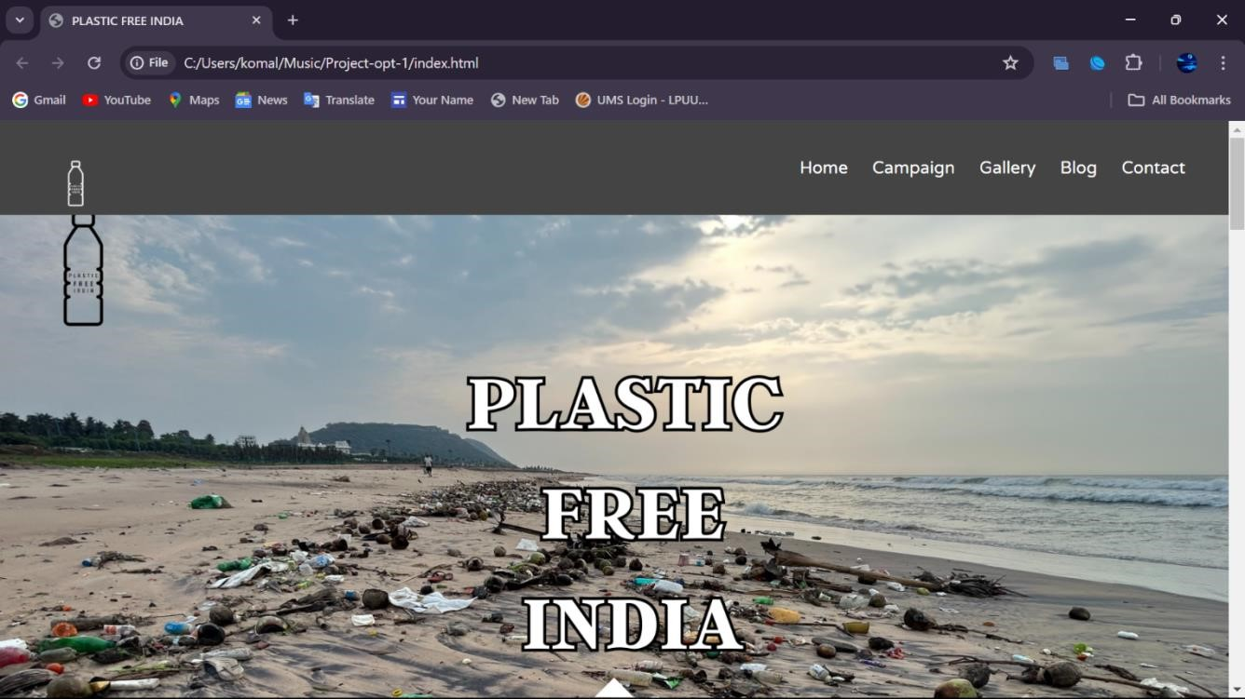

→The above image is the Home page of my website Plastic Free India.

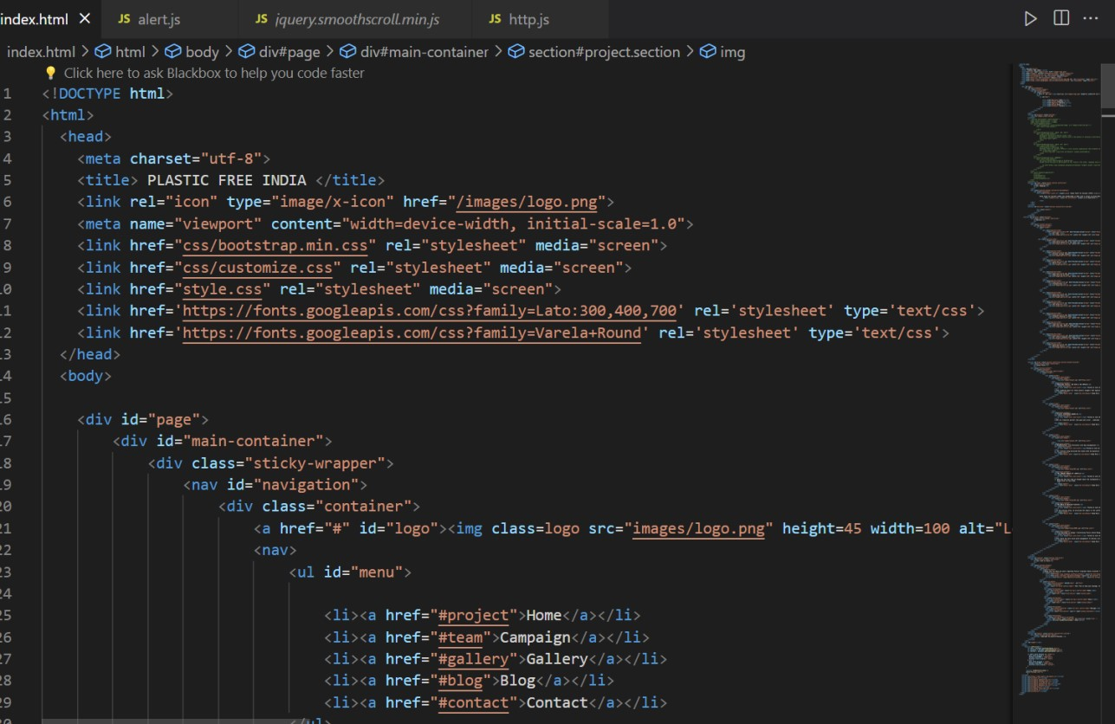

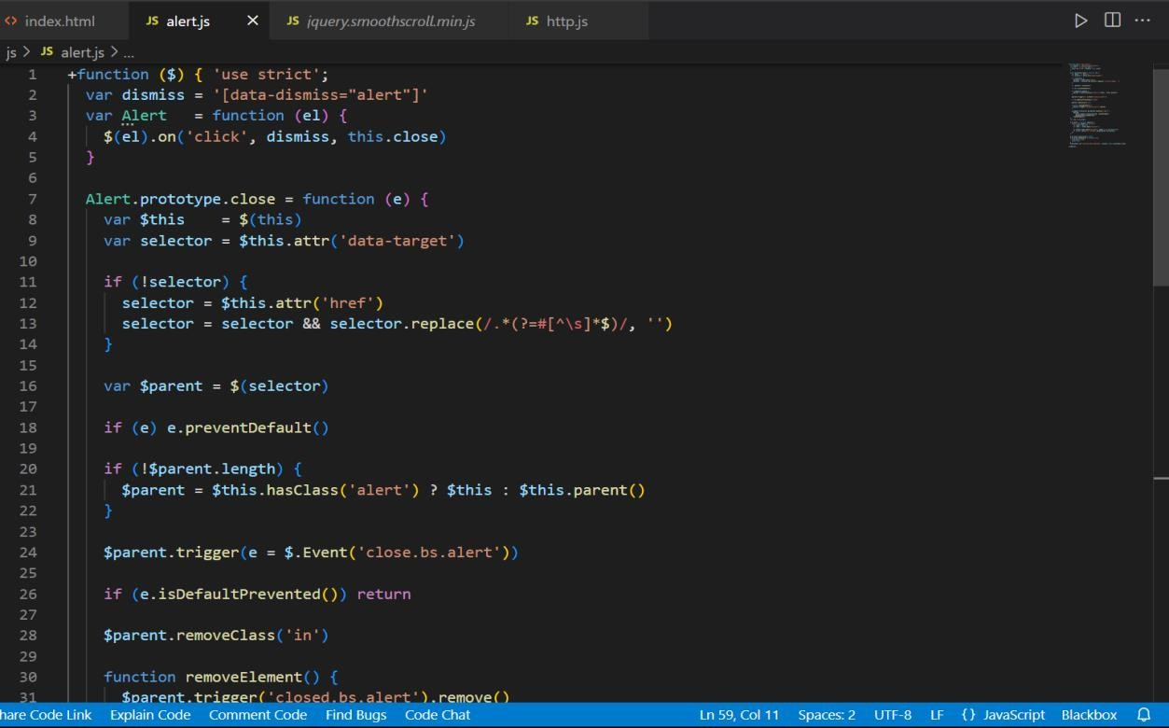

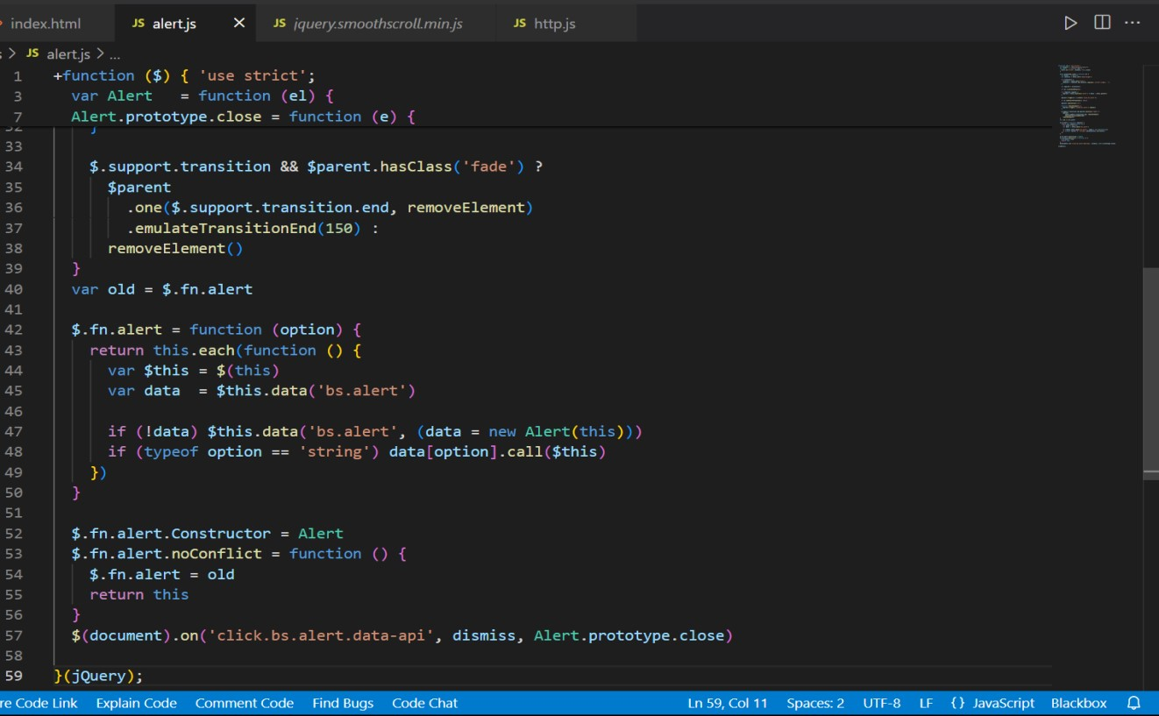

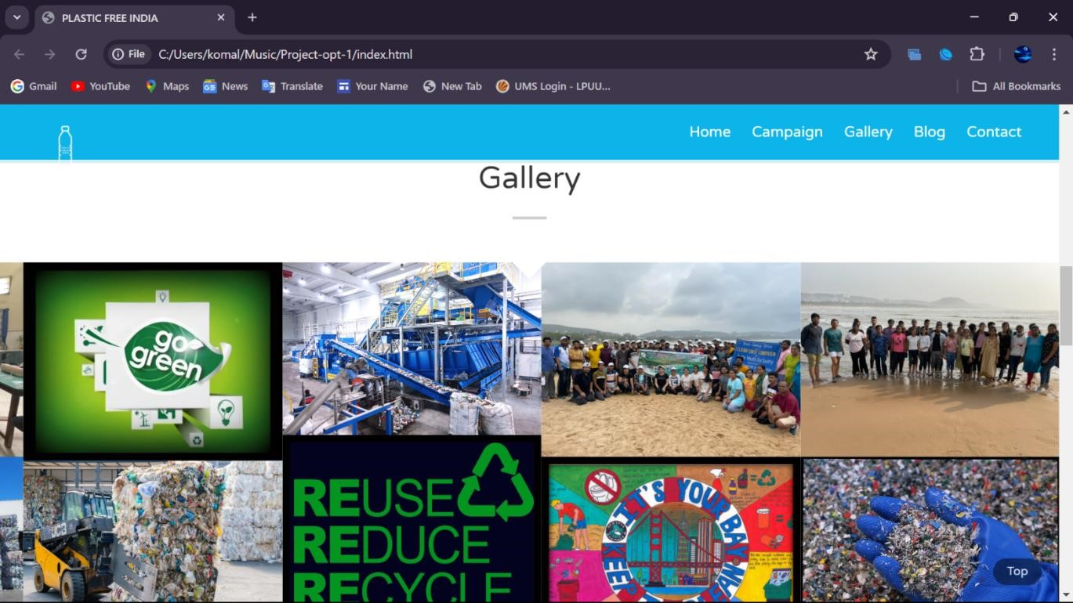

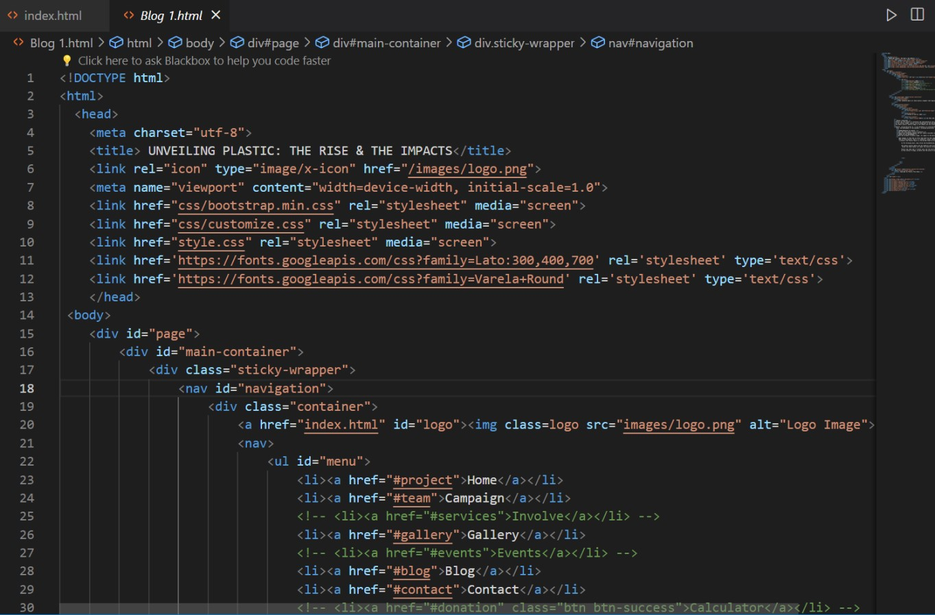

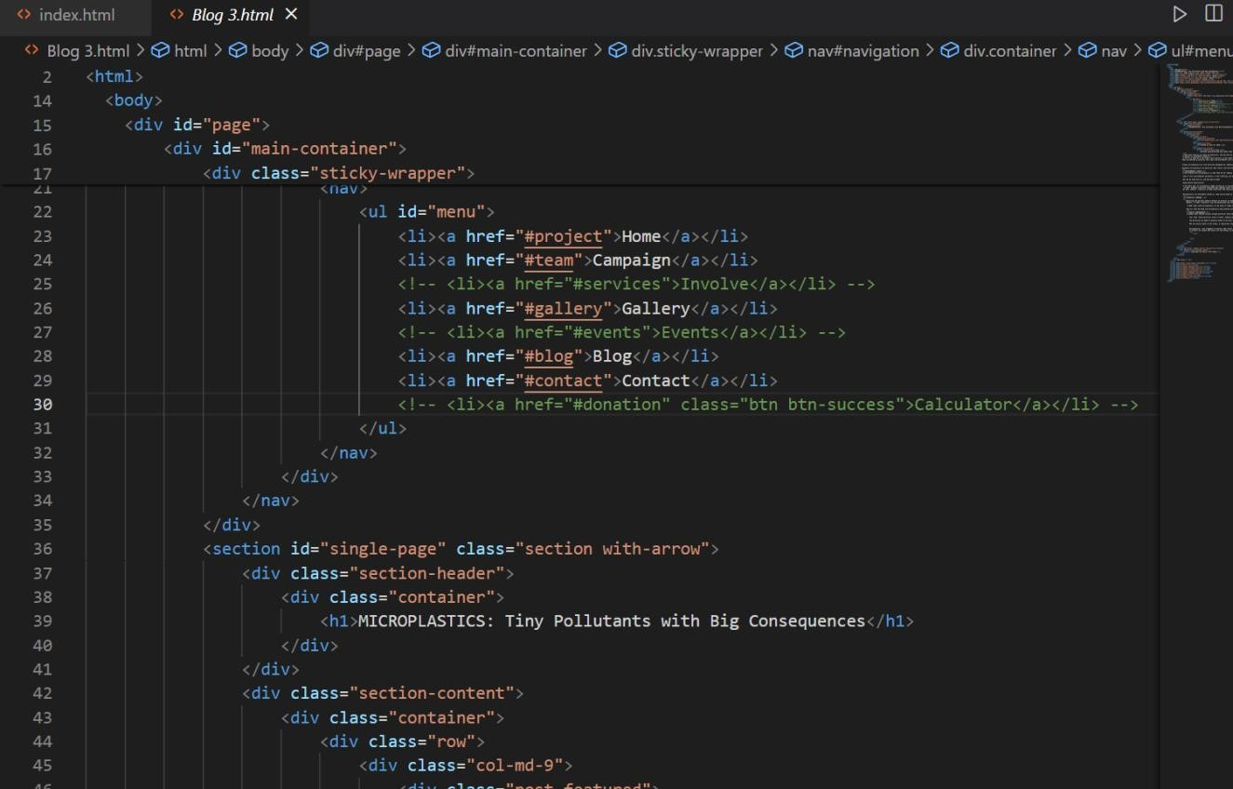

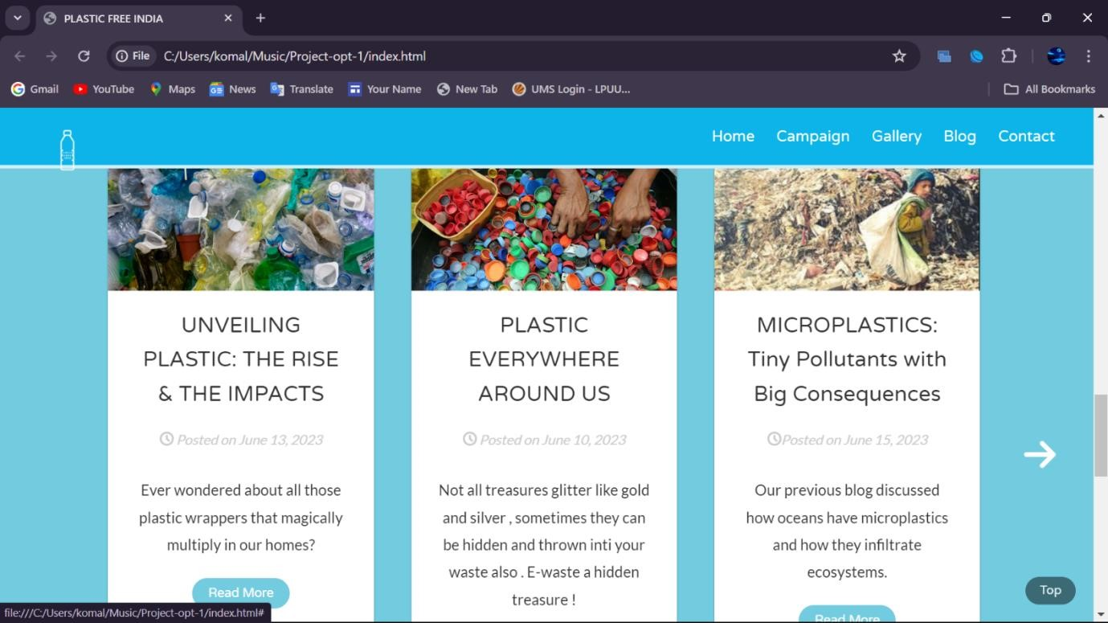

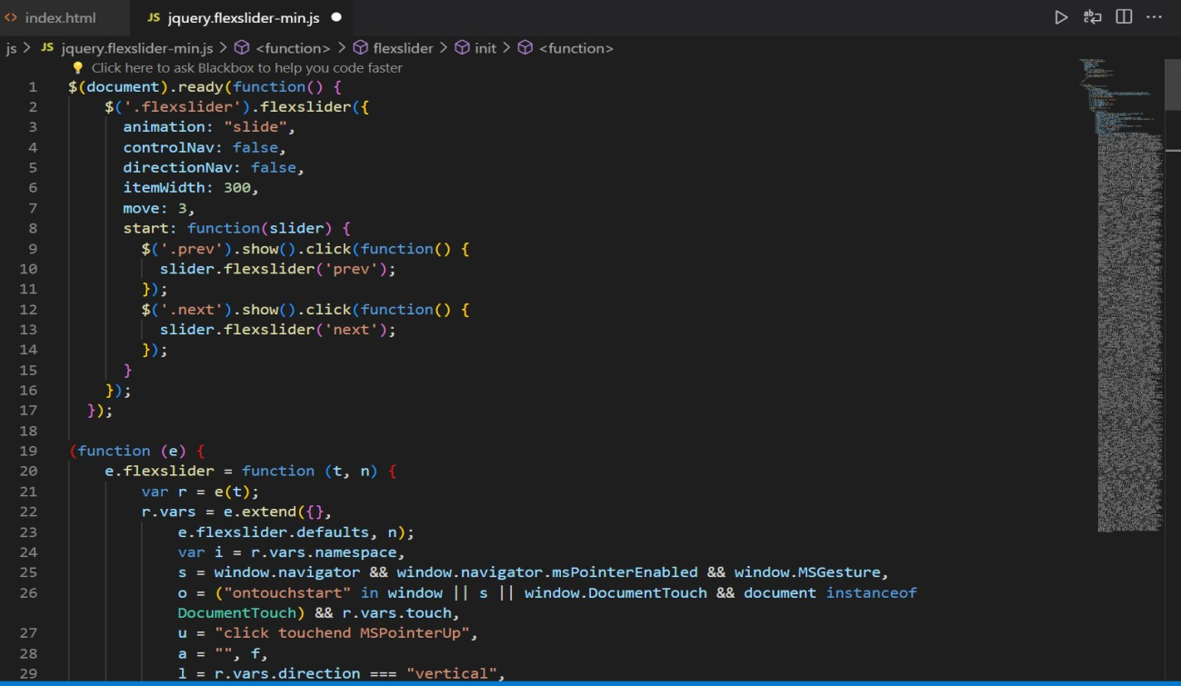

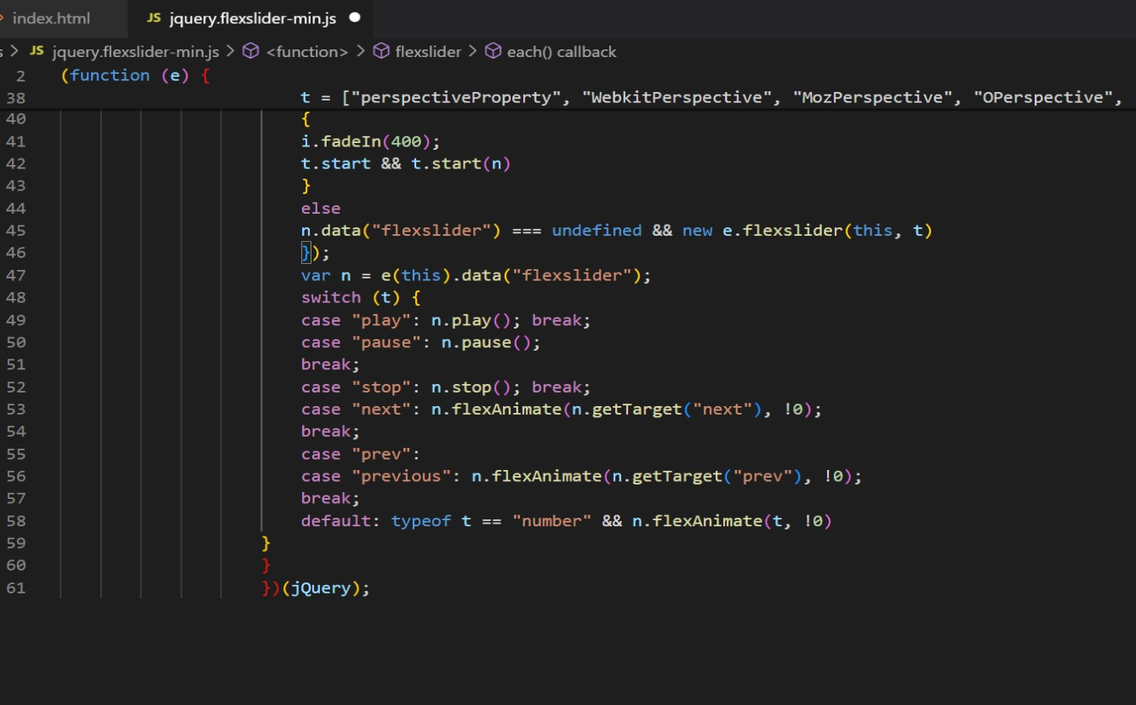

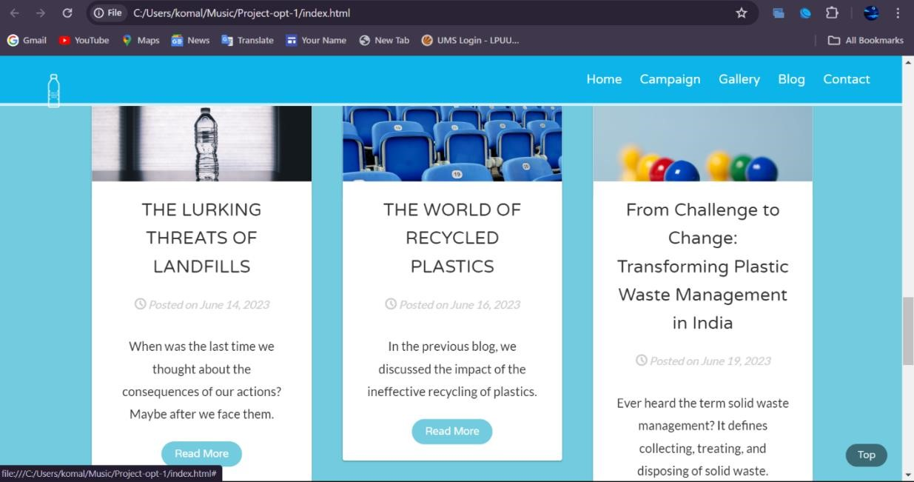

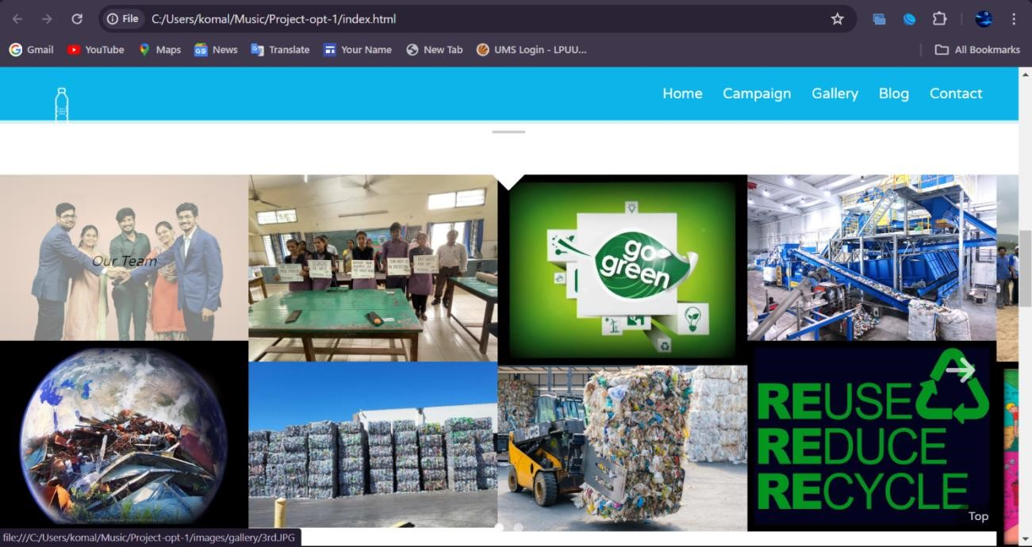

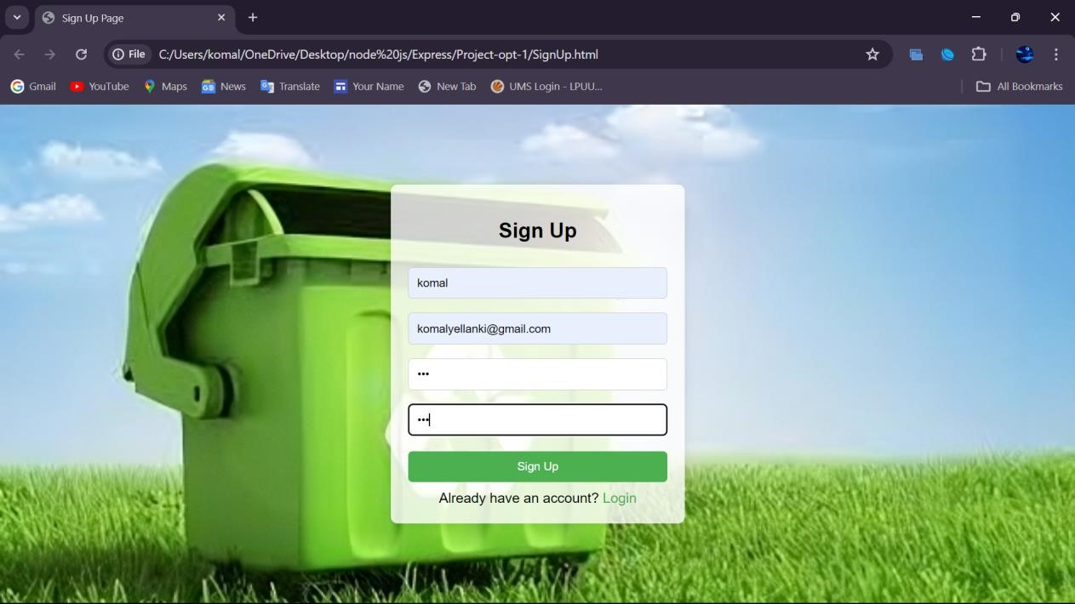

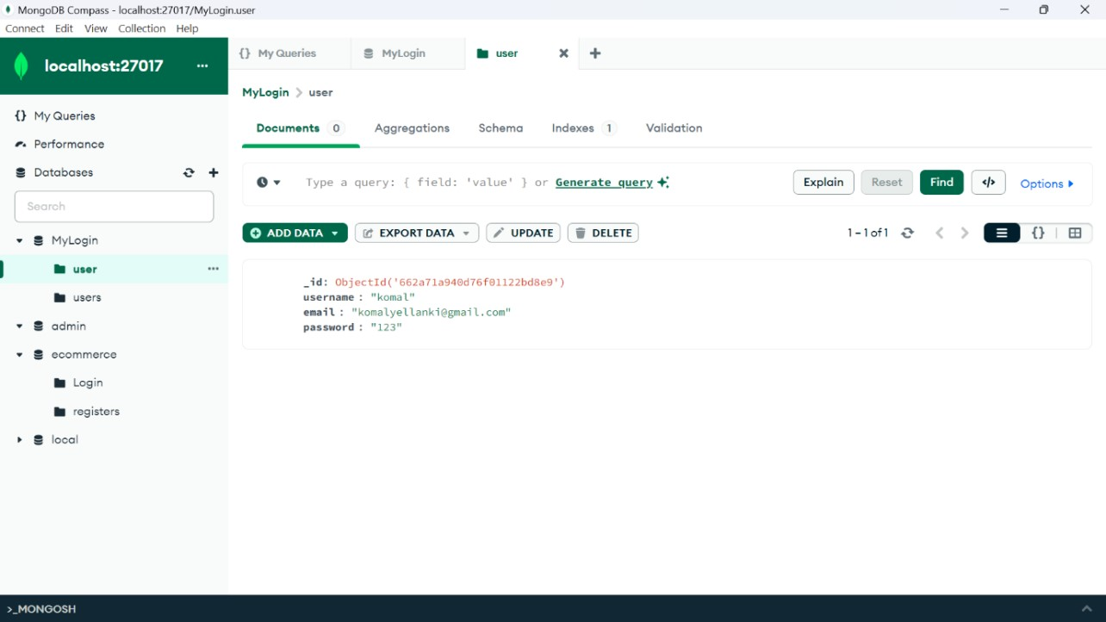

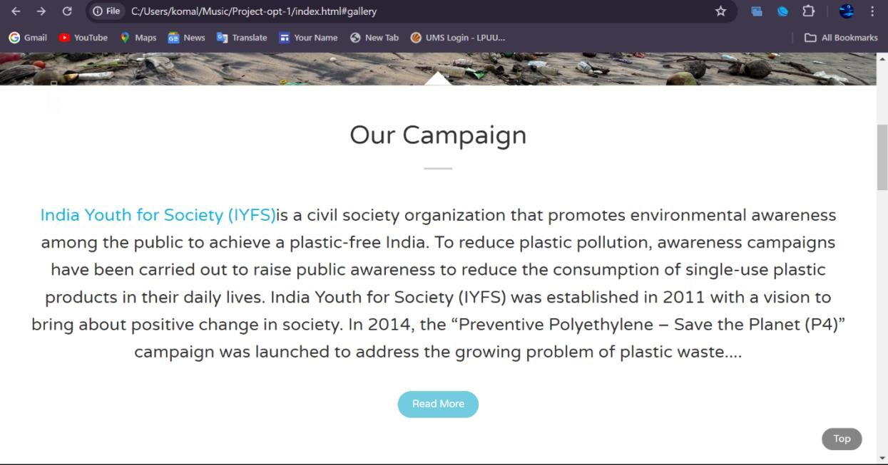

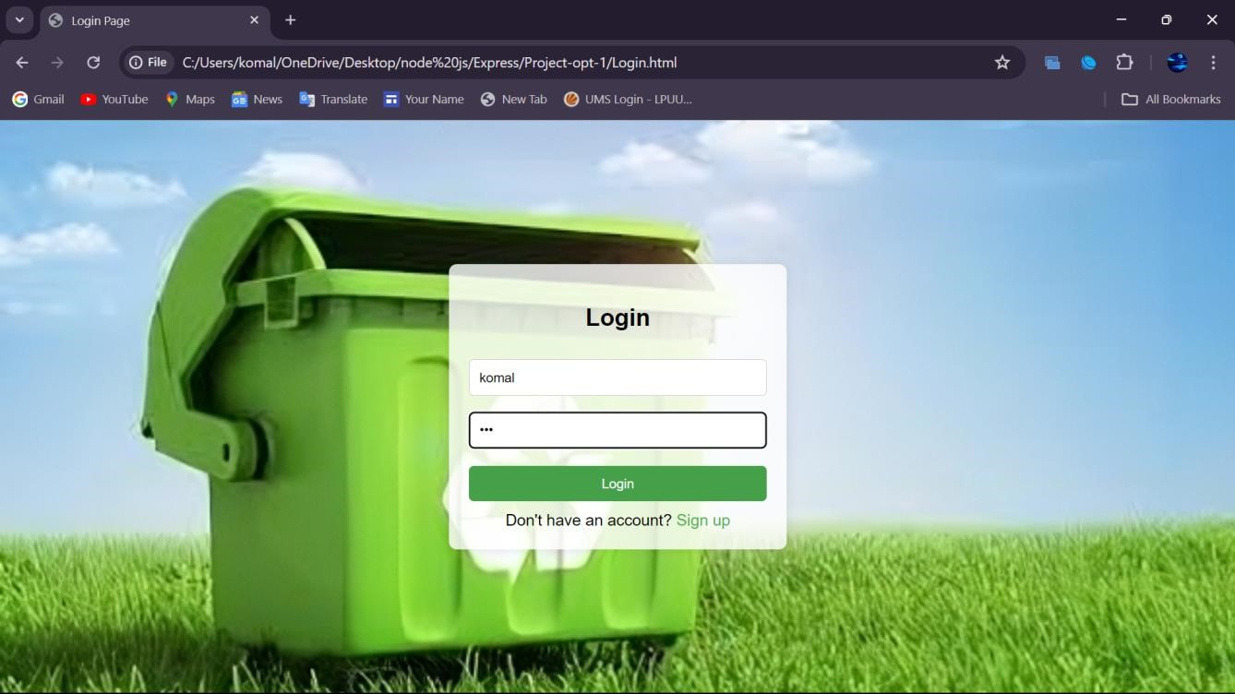

# *ADVANTAGES OF TESTING*

1. **\*Quality Assurance:\*** Ensuring your plastic waste management system website functions flawlessly guarantees accurate information and reliable services, reinforcing trust and professionalism in your platform.

1. **\*Enhanced User Experience:\*** Testing helps in identifying and rectifying any usability issues, ensuring visitors can easily navigate the website and access crucial information about plastic waste management practices.

1. **\*Cross-Platform Compatibility:\*** Testing across various devices and browsers ensures a seamless experience for users regardless of their preferred platform, enhancing accessibility and usability.

1. **\*Responsive Design:\*** With the prevalence of mobile usage, testing for responsiveness ensures users can access your plastic waste management resources on any device, promoting wider engagement and awareness.

1. **\*Optimized Load Times:\*** Testing load times and optimizing performance ensures quick access to information, enhancing user satisfaction and encouraging prolonged engagement with the website.

1. **\*SEO Performance:\*** Proper testing ensures your website is optimized for search engines, improving visibility and making it easier for individuals to find resources and information on plastic waste management.

1. **\*Accessibility:\*** Testing for accessibility ensures inclusivity, allowing individuals with disabilities to navigate and benefit from the resources provided by your plastic waste management website.

1. **\*Functionality Verification:\*** Thorough testing ensures all interactive elements, such as waste disposal guides and recycling information, work seamlessly, providing users with a hassle-free experience.
2. **\*Content Validation:\*** Regular testing ensures the accuracy and relevance of information presented on your website, establishing credibility and trust among users seeking guidance on plastic waste management practices.

1. **\*Security Measures:\*** Testing for security vulnerabilities protects both your website and users' data, instilling confidence in visitors and safeguarding against potential threats.

1. **\*Professionalism:\*** A meticulously tested plastic waste management website reflects dedication to providing a high-quality service, reinforcing your commitment to environmental sustainability and responsible waste management practices.

1. **\*Continuous Improvement:\*** Gathering feedback through testing allows for ongoing refinement and enhancement of the website, ensuring it remains relevant and effective in addressing evolving challenges in plastic waste management.

**SYSTEM IMPLEMENTATION:**

* 1. **HTML Structure:**

Node.js and Express Integration: Describe how Node.js and Express handle routing and rendering HTML views. Explain the use of templating engines like EJS or Handlebars to dynamically generate HTML content based on data from MongoDB.

MongoDB Data Integration: Discuss how HTML views are populated with data retrieved from MongoDB. Describe the process of querying MongoDB collections within the Express route handlers and passing the data to the HTML templates for rendering.

* 1. **CSS Styling:**

Node.js and Express for Serving CSS: Explain how Node.js and Express serve static CSS files to the client. Describe the configuration of Express middleware to serve static assets, including CSS files, from a designated directory.

CSS Preprocessing with Node.js: If applicable, discuss how Node.js can be used for CSS preprocessing tasks. Mention any libraries or tools commonly used for CSS preprocessing in Node.js projects, such as Less.js or Sass.

* 1. **JavaScript Functionality:**

Client-Side JavaScript: Describe how client-side JavaScript enhances interactivity and user experience. Discuss any JavaScript libraries or frameworks used in the frontend, such as jQuery for DOM manipulation or React.js for building dynamic UI components.

Server-Side JavaScript with Express: Explain how server-side JavaScript code is implemented using Express. Discuss the use of Express middleware for handling requests, parsing request bodies, and implementing custom middleware for authentication or authorization.

MongoDB Integration with Node.js: Detail how Node.js interacts with MongoDB for database operations. Discuss the use of MongoDB drivers or Object-Document Mapping (ODM) libraries like Mongoose.js to perform CRUD (Create, Read, Update, Delete) operations on MongoDB collections within Express route handlers.

# *CONCLUSION*

In developing this plastic waste management system website, I've embarked on a journey that merges environmental stewardship with technological innovation. By harnessing the power of web development tools and strategies, I've created a platform dedicated to educating and empowering individuals to make informed decisions about plastic waste disposal and recycling.

This project represents more than just a digital platform; it embodies a commitment to preserving our planet for future generations and fostering a culture of sustainability. As we continue to refine and expand the website based on user feedback and emerging best practices, I remain steadfast in my dedication to promoting responsible waste management practices and reducing the environmental impact of plastic pollution.

I extend my heartfelt gratitude to all who have supported this initiative thus far and look forward to the continued growth and impact of our collective efforts. Together, we can make

a meaningful difference in addressing the global challenge of plastic waste pollution and building a more sustainable future for all.

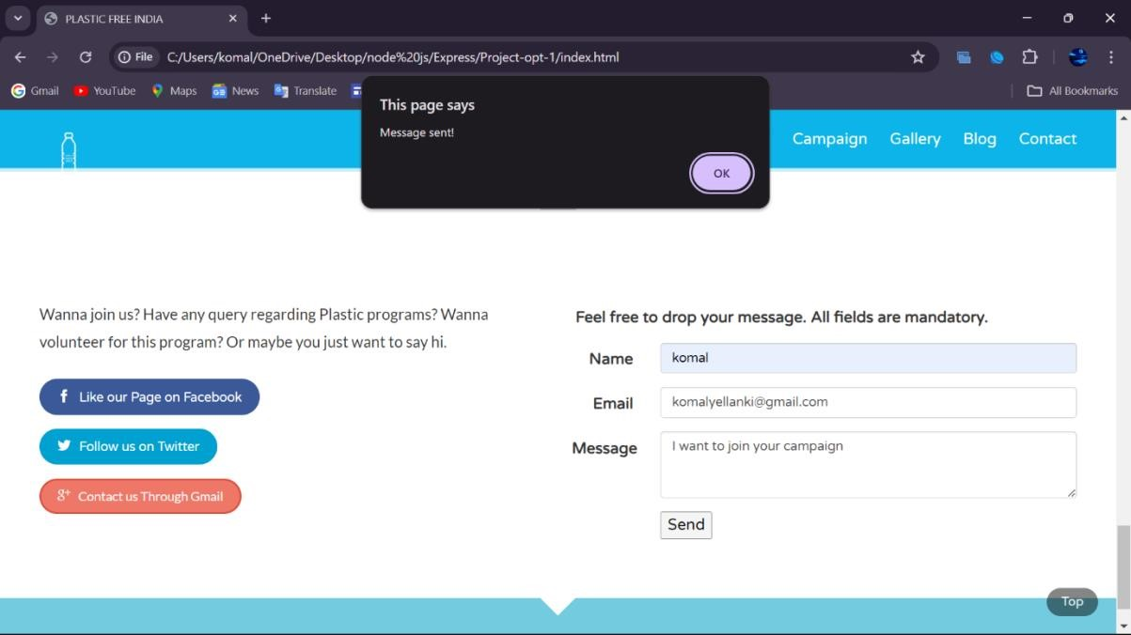

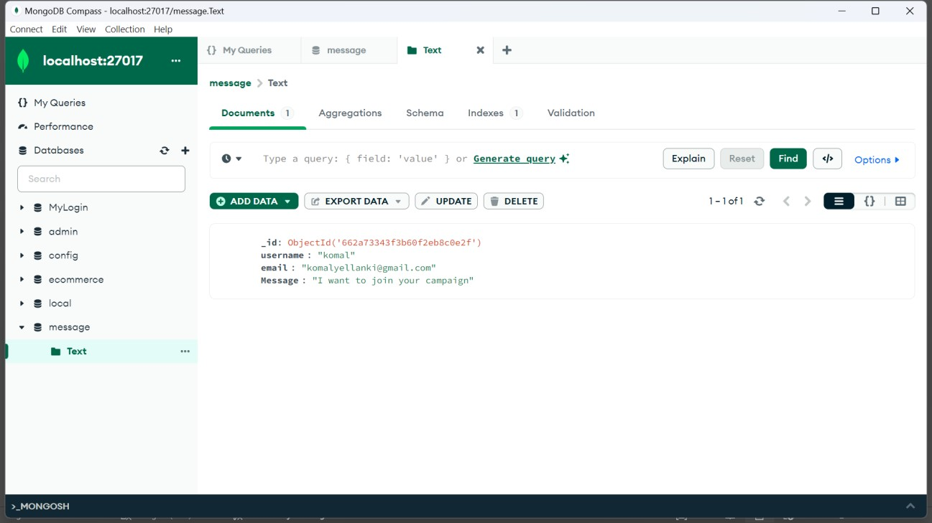

**GitHub Link: https://github.com/manikantareddy268/Plastic-waste-Management-Backend**

