AgriConnect
Week 3: Module Development and Integration Planning
Selected Module: Crop Data Management

1. Introduction
AgriConnect is an agribusiness platform intended to connect farmers, distributors, and buyers. This report specifies a Crop Data Management module that lets an authenticated farmer or administrator create, view, update, and archive crop records. It also plans integration with future inventory, order, notification, and analytics components. Code examples are illustrative and should be adapted to the final backend framework and database schema.

2. Module Specification

2.1 Scope and Functionality
The module records crop name, variety, growing season, planting date, expected harvest date, cultivated area, estimated quantity, unit, location, and status. This version does not include automated disease detection, live sensor monitoring, or price prediction.
- Create crop records after validating required fields.
- List and view permitted records with pagination and optional filters.
- Update allowed fields and archive records rather than permanently deleting them.
- Associate every record with its owner and maintain timestamps.
- Provide stable API endpoints for future modules to request crop availability.

2.2 User Stories
- Farmer: As a farmer, I want to add crop details so I can maintain digital cultivation records.
- Farmer: As a farmer, I want to update harvest dates and quantities when conditions change.
- Farmer: As a farmer, I want to see only records I am authorized to access.
- Buyer / distributor: As a future buyer, I want to see published crop availability to identify products to purchase.
- Administrator: As an administrator, I want to review reported records while preserving an audit trail.

2.3 Requirements
Functional requirements:
- FR-01: Authenticated, authorized users can create crop records.
- FR-02: The system validates required fields, dates, non-negative quantities, and supported units.
- FR-03: Users can retrieve only records they are permitted to access.
- FR-04: Users can update permitted fields and soft-archive records.
- FR-05: The API returns consistent success and error responses.
Non-functional requirements:
- NFR-01: Protected endpoints require authentication and server-side authorization.
- NFR-02: Server-side validation is required even if the frontend validates input.
- NFR-03: Parameterized queries or an ORM are used to reduce SQL injection risk.
- NFR-04: List endpoints use pagination.
- NFR-05: Logs must not expose passwords, access tokens, or secrets.

3. Data Design
Proposed crop_records table:
Field | Suggested type | Purpose / rule
id | UUID primary key | Unique record ID
owner_id | UUID foreign key | References user/profile
crop_name | VARCHAR(100) | Required crop name
variety | VARCHAR(100), nullable | Optional variety
season | VARCHAR(40) | Growing season
planting_date | DATE | Planting date
expected_harvest_date | DATE, nullable | Expected harvest
area_hectares | NUMERIC(10,2) | Positive if provided
estimated_quantity | NUMERIC(12,2) | Must be >= 0
quantity_unit | VARCHAR(20) | kg, tonne, quintal, etc.
location_text | VARCHAR(200) | Farm location description
status | VARCHAR(20) | planned, growing, ready, archived
created_at / updated_at | TIMESTAMPTZ | Audit timestamps
Recommended constraints: primary key, foreign key, required-field constraints, CHECK constraints for quantities and status, and indexes on owner_id and status. If Supabase is used, configure Row Level Security (RLS) policies to enforce ownership. Backend authorization must still be applied.

4. Proposed API Design
Method / route | Purpose | Expected result
POST /api/crops | Create crop | 201 Created
GET /api/crops | List permitted crops | 200 OK, paginated
GET /api/crops/:id | Retrieve one crop | 200 or 404
PATCH /api/crops/:id | Update allowed fields | 200 or validation/access error
DELETE /api/crops/:id | Soft archive | Success response
Protected routes require authentication. The server must derive owner_id from the verified user session/token and must not trust owner_id supplied by the client.

5. Code Structure
backend/
src/
routes/cropRoutes.js # URL-to-controller mapping
controllers/cropController.js # HTTP request/response handling
services/cropService.js # Business rules and validation
repositories/cropRepository.js# Database queries
middleware/requireAuth.js # Verifies user identity
validators/cropSchema.js # Request schema
app.js # Registers middleware and routes

6. Pseudocode and Code Snippet

6.1 Create Crop – Pseudocode
FUNCTION createCrop(request, authenticatedUser):
IF authenticatedUser is missing:
RETURN 401 Unauthorized
data = validateCropInput(request.body)
IF data is invalid:
RETURN 400 with field-level errors
data.owner_id = authenticatedUser.id
data.status = "planned" if not supplied
record = database.insertCrop(data)
RETURN 201 Created with record

6.2 Illustrative Express Controller
// Assumes trusted authentication middleware and cropService.
export async function createCrop(req, res, next) {
try {
const input = req.body;
if (!input.crop_name || !input.quantity_unit) {
return res.status(400).json({
error: "crop_name and quantity_unit are required"
});
}
const quantity = Number(input.estimated_quantity ?? 0);
if (!Number.isFinite(quantity) || quantity < 0) {
return res.status(400).json({
error: "estimated_quantity must be non-negative"
});
}
const crop = await cropService.create({
crop_name: String(input.crop_name).trim(),
variety: input.variety ?? null,
season: input.season,
planting_date: input.planting_date,
expected_harvest_date: input.expected_harvest_date ?? null,
estimated_quantity: quantity,
quantity_unit: String(input.quantity_unit).trim(),
owner_id: req.user.id
});
return res.status(201).json({ data: crop });
} catch (error) {
return next(error);
}
}
This demonstrates control flow rather than a complete production implementation. Add schema validation, date/unit checks, record-level authorization, and centralized database error handling.

6.3 Example SQL Schema
CREATE TABLE crop_records (
id UUID PRIMARY KEY DEFAULT gen_random_uuid(),
owner_id UUID NOT NULL REFERENCES profiles(id),
crop_name VARCHAR(100) NOT NULL,
variety VARCHAR(100),
season VARCHAR(40),
planting_date DATE,
expected_harvest_date DATE,
area_hectares NUMERIC(10,2)
CHECK (area_hectares IS NULL OR area_hectares > 0),
estimated_quantity NUMERIC(12,2) NOT NULL DEFAULT 0
CHECK (estimated_quantity >= 0),
quantity_unit VARCHAR(20) NOT NULL,
location_text VARCHAR(200),
status VARCHAR(20) NOT NULL DEFAULT 'planned'
CHECK (status IN ('planned','growing','ready','archived')),
created_at TIMESTAMPTZ NOT NULL DEFAULT now(),
updated_at TIMESTAMPTZ NOT NULL DEFAULT now()
);
CREATE INDEX idx_crop_records_owner_status
ON crop_records(owner_id, status);
Adapt the profiles table name and key type to the existing project schema. Use a trigger or application service to update updated_at on changes.

7. Integration Plan
The frontend sends JSON requests to the REST API. Authentication middleware verifies identity; the controller handles HTTP details; the service applies business rules; and the repository/database layer stores the record. The frontend displays success messages and field-level validation errors.
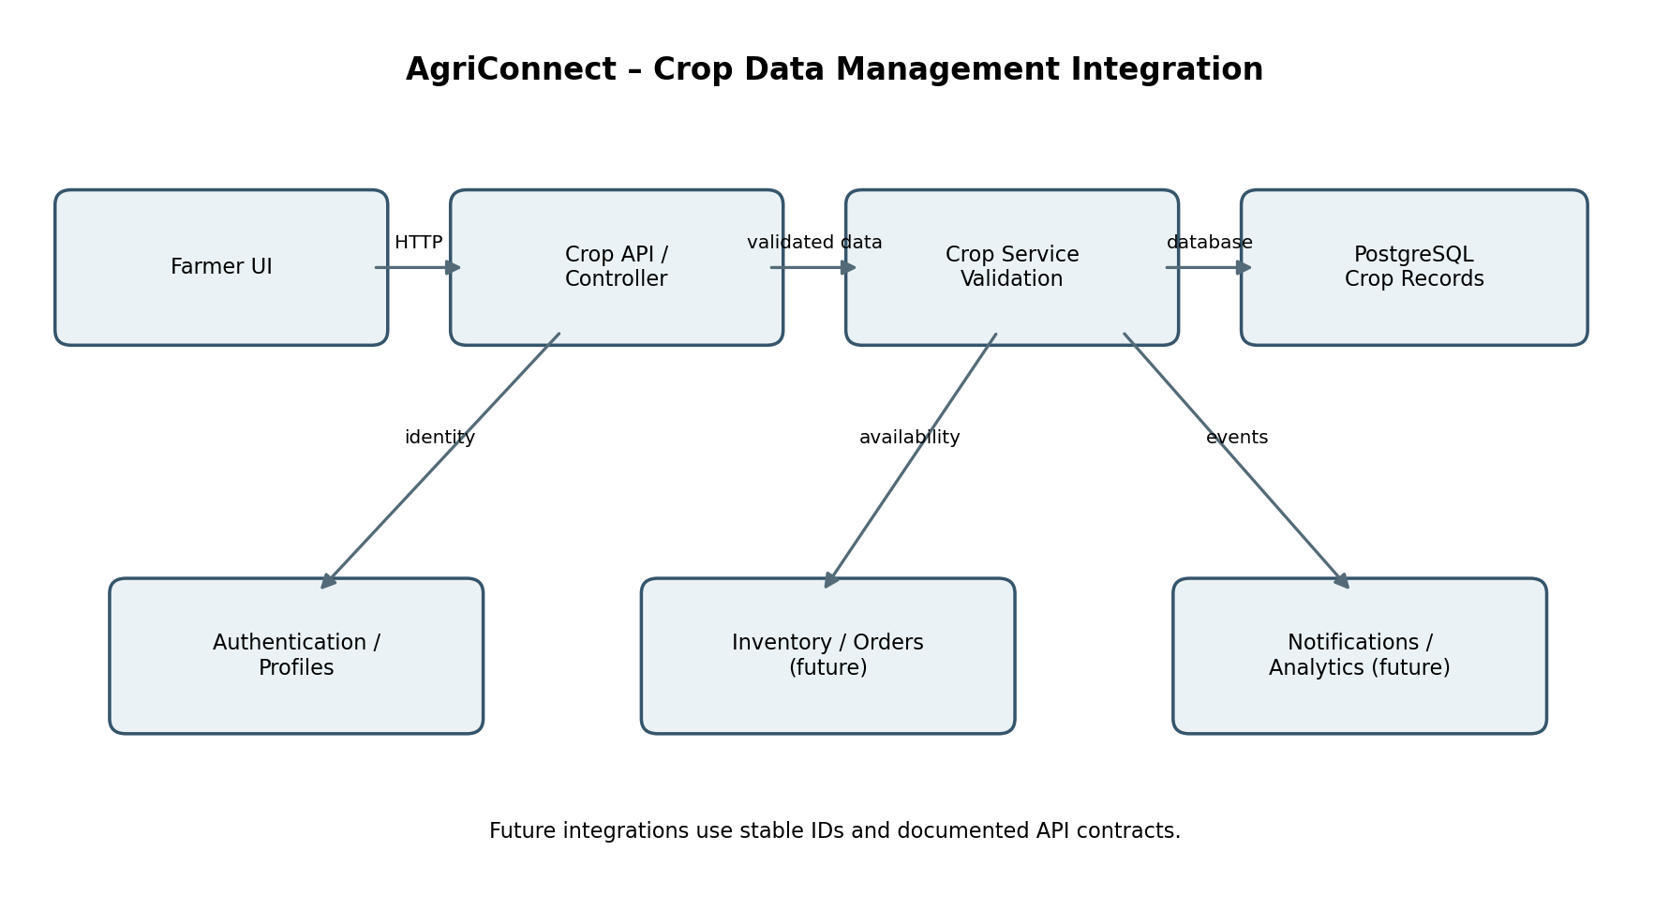

7.1 Integration Touchpoints
- Authentication/profiles: associate each record with the verified owner ID.
- Inventory (future): expose approved quantity and unit; do not treat estimated harvest as confirmed stock.
- Orders (future): reference crop/listing IDs; use transactions or reservations to prevent overselling.
- Notifications (future): emit events after important changes; notifications should not block saving the record.
- Analytics (future): use controlled aggregate queries and restrict identifiable farm-level data.
- Maps/location (optional): store only necessary location data and keep provider API keys on the server.

7.2 End-to-End Flow
Farmer submits crop form
↓
Frontend checks required fields
↓
POST /api/crops with access token
↓
Authentication + request validation
↓
Crop service applies business rules
↓
Database inserts crop record
↓
API returns 201 Created + record ID
↓
Frontend refreshes crop list
↓
Optional event for future integrations

8. Error Handling and Security
- 400 Bad Request: missing fields, invalid dates, unsupported units, or negative quantities.
- 401 Unauthorized: request has no valid authentication.
- 403 Forbidden: user attempts to modify another user's private record.
- 404 Not Found: record does not exist or is not visible to the caller.
- 409 Conflict: optional response for incompatible state changes.
- 500 Internal Server Error: return a safe message and log technical details securely.
Apply HTTPS in deployment, server-side validation, parameterized database operations, least-privilege access, Supabase RLS where applicable, rate limits on write endpoints, and secret-safe logging.

9. Testing and Evaluation Plan
Test case | Expected outcome
Valid create request | 201 response and record linked to authenticated owner
Missing crop name | 400 response; no record created
Negative quantity | Rejected by validation
Harvest date before planting date | Request rejected
Cross-user access | User A cannot read/update User B's private record
Database unavailable | Safe error response and secure logging
Pagination | Bounded page with consistent metadata
Archive | Hidden from active list but retained for permitted references

10. Development Challenges and Mitigation
Challenge | Mitigation
Incomplete crop information | Required fields, controlled units, date validation, clear form guidance
Data privacy | Verified owner identity and cross-user access tests
Future module dependencies | Stable IDs and documented API contracts
Overselling after orders are added | Transactional stock reservations in future order workflow
External API outages | Keep crop create/read/update operations independent of maps and notifications

11. Proposed Work Plan (30–35 Hours)
Activity | Planned effort
Requirements and user stories | 4 hours
Schema and API contract design | 5 hours
Controller/service logic | 8 hours
Validation, access control, error handling | 5 hours
Integration diagram and touchpoints | 4 hours
Testing and demonstration preparation | 4 hours
Documentation and review | 3 hours
Total planned effort: 33 hours. This is a proposed estimate for planning, not a claim that all hours have already been completed.

12. Conclusion
The Crop Data Management module provides a practical first feature for AgriConnect. It defines crop-record functionality, a proposed database schema, REST endpoints, pseudocode, illustrative Express logic, test cases, and future integration points. Separating routes, controllers, services, and data access supports independent testing and future connection to inventory, orders, notifications, maps, and analytics. The next step is to implement the endpoints against the actual project schema and verify the acceptance tests.

Appendix: Suggested Demonstration
- Sign in as a farmer.
- Create a crop record with a valid name, season, quantity, and unit.
- Show the record in the crop list.
- Submit a negative quantity and show validation feedback.
- Demonstrate that another user cannot access the private record.
- Explain how inventory and orders could consume approved crop availability.

