WEEK 1 REQUIREMENTS GATHERING AND ANALYSIS REPORT
AgriConnect – Digital Agribusiness Management Platform
A Software Requirements Analysis for an Integrated Agricultural Marketplace
Prepared by: ______________________________
Student ID: _______________________________
Module / Course: __________________________
Institution: _______________________________
Submission Date: __________________________
Week 1 – Requirements Gathering and Analysis

Executive Summary
AgriConnect is a proposed digital agribusiness management platform designed to improve the connection between agricultural producers, buyers, distributors and delivery service providers. The system addresses common operational problems such as fragmented market information, difficulty discovering buyers, manual order handling, limited visibility of inventory, communication gaps and weak end-to-end order tracking.
The requirements analysis is informed by the Indian agricultural-market context. The Government of India’s e-NAM describes a national electronic trading platform intended to connect agricultural markets, improve price discovery, reduce information asymmetry and support online payments. e-NAM explicitly identifies farmers, traders, APMCs, FPOs and mandi boards among its stakeholders. citeturn0search0turn0search2 AgriConnect is not intended to replace government market infrastructure; instead, it is a proposed academic system that applies similar digital principles to a broader producer-to-buyer workflow.
This report documents the project scope, stakeholder needs, research findings, user stories, use cases, functional and non-functional requirements, business rules, system flows, interface mock-ups, risks, assumptions and a requirements traceability matrix. The analysis is deliberately detailed so that it demonstrates the depth expected from approximately 30–35 hours of requirements work.

Table of Contents
Executive Summary
1. Introduction
2. Problem Statement
3. Objectives
4. Scope
5. Stakeholder Identification
6. Research and Challenge Analysis
7. Requirement Elicitation
8. User Stories
9. Use Cases
10. Functional Requirements
11. Non-Functional Requirements
12. Business Rules
13. Constraints and Assumptions
14. System Diagrams
15. UI Mock-ups
16. Data Requirements
17. Requirement Traceability Matrix
18. Risks
19. Future Enhancements
20. Conclusion
References

1. Introduction
Agriculture involves a chain of activities that starts with production and continues through aggregation, quality assessment, marketing, sales, transportation, payment and delivery. Digital systems can reduce manual coordination and give stakeholders better visibility of products, orders and transactions.
Existing digital agriculture initiatives demonstrate the value of structured market information. e-NAM describes its mission as creating a common online market platform, supporting transparent price discovery, quality-based trading and timely online payment. citeturn0search0 Its farmer module also provides digital lot tracking and allows farmers to accept or reject auction outcomes. citeturn0search9

1.1 Proposed System
AgriConnect is proposed as a responsive web application, with a future mobile extension, that allows producers to list agricultural products and allows verified buyers and distributors to discover products, place orders, coordinate delivery and view transaction status.

1.2 Intended Users
- Farmers / producers
- Farmer Producer Organisations (FPOs) or producer groups
- Wholesalers and buyers
- Distributors
- Transport / delivery operators
- Platform administrators
- Future: institutional buyers and retailers

2. Problem Statement
Producers may have difficulty identifying suitable buyers, comparing offers and maintaining accurate records of stock and sales. Buyers may struggle to find reliable suppliers, verify product details and coordinate quantities and delivery. Distributors and transporters require timely information about orders, locations and schedules. Administrators need a reliable way to verify users, monitor transactions and resolve disputes.
The proposed problem is therefore: How can a digital platform provide a transparent, usable and secure workflow for agricultural product discovery, ordering, inventory, payment records and delivery coordination while remaining accessible to users with different levels of digital literacy?

3. Project Objectives
- Provide a centralized digital marketplace for agricultural products.
- Allow producers to create and maintain product listings.
- Allow buyers to search, filter and request agricultural products.
- Support order creation, confirmation, cancellation and status tracking.
- Maintain inventory quantities and prevent orders beyond available stock.
- Record payment status and provide transaction history.
- Support delivery assignment and tracking.
- Provide notifications for important events.
- Provide administrators with user, product, order and report management.
- Improve information visibility and reduce dependence on fragmented manual communication.

4. Project Scope

4.1 In Scope
- User registration, login and role-based access
- Farmer, buyer, distributor and administrator profiles
- Product listing and catalogue management
- Search and filtering
- Order lifecycle management
- Inventory management
- Delivery assignment and status tracking
- Payment-status recording
- Notifications
- Ratings/feedback
- Basic dashboards and reports
- Audit trail for important administrative actions

4.2 Out of Scope for Initial Version
- Direct integration with banking systems
- Automated commodity price prediction using machine learning
- IoT-based farm sensors
- Automated crop disease diagnosis
- National government identity verification integration
- Autonomous vehicle delivery
- Complex accounting and tax filing
- Full auction engine equivalent to regulated market infrastructure

4.3 Success Criteria
- Users can register and access only the functions permitted by their role.
- Farmers can publish a product with quantity, price, quality and availability information.
- Buyers can discover products and place valid orders.
- Inventory decreases after confirmed orders and cannot become negative.
- Each order has a traceable status history.
- Delivery status is visible to authorized users.
- Administrators can investigate users and transactions.
- Core screens are usable on desktop and mobile-sized displays.

5. Stakeholder Identification
The stakeholder analysis distinguishes direct users, operational stakeholders and external stakeholders. e-NAM's published stakeholder list includes APMCs, farmers, traders, mandi boards and FPOs, which supports the relevance of these roles in an Indian agricultural-market scenario. citeturn0search2
Stakeholder | Priority | Main Responsibilities | Key Needs
Farmers / Producers | Primary | List produce, manage stock, receive and review orders | Simple workflows, market visibility, trust
FPOs / Producer Groups | Primary/Secondary | Aggregate produce, coordinate members | Bulk listings, consolidated orders
Buyers / Traders | Primary | Search and purchase produce | Accurate supply information, price/quality visibility
Distributors | Primary | Coordinate movement of goods | Order details, pickup/delivery scheduling
Transporters | Operational | Collect and deliver goods | Addresses, schedules, contact information
Platform Administrator | Operational | Moderate users, products and transactions | Control, auditability, reports
Payment Service Provider | External | Process/confirm payments if integrated | Secure transaction status
Government / Market Authorities | External | Regulatory and market ecosystem | Compliance and reporting
End Customers / Retailers | Future | Purchase through downstream channels | Product availability and delivery

6. Research and Challenge Analysis
The research uses public information about digital agricultural markets to identify realistic requirements. The following findings are used as requirement inputs rather than as claims that AgriConnect itself is a government platform.
Challenge / Need | Research Observation | Requirement Implication
Market information | e-NAM aims to reduce information asymmetry and provide real-time information around demand, supply, prices and arrivals. | Search, filtering, offer visibility and product information should be first-class functions. citeturn0search0turn0search7
Buyer reach | e-NAM describes expanded access to markets and buyers as a benefit for farmers and traders. | AgriConnect should allow producers to reach multiple verified buyers rather than relying on one contact channel. citeturn0search3turn0search7
Quality information | e-NAM supports quality assessment/assaying for commodities and exposes quality information to traders. | Product listings should contain quality/grade fields and optional supporting documents. citeturn0search3
Payments | e-NAM supports electronic payment methods and timely payment settlement. | The system should at minimum maintain payment status and transaction references; full payment integration can be a later phase. citeturn0search0turn0search7
Traceability | e-NAM records arrivals and assigns lot identifiers, allowing users to track progress. | AgriConnect should generate unique order/product-lot identifiers and preserve status history. citeturn0search7turn0search9
Mobile usability | e-NAM provides mobile workflows for farmers and traders. | AgriConnect should use responsive layouts and simple navigation for mobile users. citeturn0search6turn0search9

6.1 Stakeholder Pain Points
Stakeholder | Pain Point | System Response
Farmer | Uncertainty about buyers and offers | Central product marketplace; buyer discovery; offer/order history
Farmer | Manual stock and sales records | Inventory dashboard and automated stock updates
Farmer | Limited visibility after sale | Order and delivery tracking
Buyer | Difficulty finding suitable supply | Search, filters, product quality and availability
Buyer | Uncertainty about supplier reliability | Verification, ratings and transaction history
Distributor | Unclear pickup and delivery coordination | Delivery assignment, status and scheduling
Administrator | Manual investigation of issues | Audit logs, status histories and reporting

7. Requirement Elicitation
For an actual deployment, requirements should be validated through interviews, observation, questionnaires and prototype testing. For this academic Week 1 exercise, the following elicitation plan is proposed.
Technique | Participants | Purpose
Semi-structured interviews | Farmers, buyers, distributors, administrators | Understand workflows, terminology and pain points
Questionnaire | 20–50 representative users | Rank important features and usability barriers
Observation | Market/warehouse/order workflow | Identify manual steps and data handoffs
Document analysis | Market rules, invoices, product records | Identify data and compliance requirements
Prototype walkthrough | Representative users | Validate screen layout and terminology
Requirements workshop | All key roles | Resolve conflicts and prioritize requirements

7.1 Elicitation Questions
- For farmers: What information do you record when produce becomes available?
- How do you currently find buyers and compare offers?
- What causes delays between accepting an order and receiving payment?
- What information does a buyer need before committing to a purchase?
- How is product quality or grade communicated?
- How do distributors receive pickup and delivery information?
- What events should trigger an SMS, email or in-app notification?
- What would make the system difficult to use on a low-end smartphone?
- What information should administrators be able to see during a dispute?
- What reports are required weekly or monthly?

8. User Stories
ID | Actor | User Story
US-01 | Farmer | As a farmer, I want to create a profile so that buyers can identify my business and contact me through the platform.
US-02 | Farmer | As a farmer, I want to add a product listing so that buyers can see what produce I have available.
US-03 | Farmer | As a farmer, I want to update stock quantity so that buyers see accurate availability.
US-04 | Farmer | As a farmer, I want to view incoming orders so that I can accept or reject them.
US-05 | Buyer | As a buyer, I want to search by commodity, location, quantity and price so that I can find suitable suppliers.
US-06 | Buyer | As a buyer, I want to view product quality and seller details so that I can make an informed purchase.
US-07 | Buyer | As a buyer, I want to place an order so that the requested produce can be reserved.
US-08 | Buyer | As a buyer, I want to track my order so that I know its current delivery status.
US-09 | Distributor | As a distributor, I want to view assigned deliveries so that I can plan pickups and deliveries.
US-10 | Administrator | As an administrator, I want to verify users so that fraudulent or incomplete accounts can be controlled.
US-11 | Administrator | As an administrator, I want to review transaction history so that disputes can be investigated.
US-12 | All users | As a user, I want notifications for important events so that I do not miss orders or delivery changes.
US-13 | Buyer | As a buyer, I want to rate a completed transaction so that reliable suppliers can build reputation.
US-14 | Farmer | As a farmer, I want sales reports so that I can understand my transaction history.

9. Use Cases
ID | Use Case | Primary Actor | Success Result | Summary
UC-01 | Register Account | Visitor | Account created | User selects role, enters details, verifies contact, system creates account.
UC-02 | Login | All registered users | Authenticated session | System validates credentials and loads role dashboard.
UC-03 | Create Product Listing | Farmer/FPO | Product visible | User enters commodity, quantity, unit, price, grade and availability; system validates and publishes.
UC-04 | Search Marketplace | Buyer | Search results | Buyer enters filters; system returns matching active listings.
UC-05 | Place Order | Buyer | Pending order | Buyer selects listing, quantity and delivery details; system checks stock and creates order.
UC-06 | Accept/Reject Order | Farmer | Confirmed/rejected order | Seller reviews order; system records decision and updates inventory if accepted.
UC-07 | Assign Delivery | Distributor/Admin | Assigned delivery | Delivery is linked to an order and transporter; statuses become trackable.
UC-08 | Update Delivery Status | Transporter/Distributor | Current delivery status | Authorized user changes status; system timestamps the event and notifies stakeholders.
UC-09 | Record Payment | Buyer/Admin/Payment Integration | Payment status | System records payment reference and status; successful payment updates order.
UC-10 | Manage Users | Admin | Updated user status | Admin verifies, suspends or restores accounts with reason.
UC-11 | Generate Report | Admin/Farmer | Report | System aggregates transaction/inventory data into a report.

9.1 Detailed Use Case – Place Order
Field | Description
Use Case ID | UC-05
Goal | Buyer purchases a selected quantity of an active agricultural product.
Preconditions | Buyer is authenticated; listing is active; requested quantity is positive.
Main Flow | 1. Buyer opens listing. 2. Enters quantity. 3. Enters/chooses delivery details. 4. System checks availability. 5. System calculates subtotal and applicable delivery charges. 6. Buyer confirms. 7. System creates order. 8. Inventory is reserved/reduced according to business rules. 9. Farmer receives notification.
Alternative Flow A | Requested quantity exceeds available stock → system rejects submission and displays available quantity.
Alternative Flow B | Listing becomes inactive before confirmation → system asks buyer to refresh.
Alternative Flow C | Payment fails → order remains in payment-pending state or is cancelled according to configured timeout.
Postconditions | Order has unique ID, status and timestamp; relevant users can view it.
Priority | High

10. Functional Requirements
ID | Module | Requirement
FR-001 | Authentication | The system shall allow a new user to register with required identity and contact details.
FR-002 | Authentication | The system shall authenticate registered users using secure credentials.
FR-003 | Authorization | The system shall enforce role-based access for Farmer, Buyer, Distributor and Admin roles.
FR-004 | Profile | The system shall allow users to view and update permitted profile fields.
FR-005 | Verification | The system shall allow administrators to approve, reject or suspend user accounts.
FR-006 | Products | The system shall allow farmers/FPOs to create product listings.
FR-007 | Products | A listing shall store commodity name, quantity, unit, price, quality/grade, location, availability and description.
FR-008 | Products | The system shall allow authorized sellers to edit or deactivate listings.
FR-009 | Search | The system shall allow buyers to search by commodity name.
FR-010 | Search | The system shall support filters including location, price range, quantity and availability.
FR-011 | Product Detail | The system shall display seller, product, quality and availability information.
FR-012 | Orders | The system shall allow buyers to create orders from active listings.
FR-013 | Orders | The system shall validate order quantity against available stock.
FR-014 | Orders | The system shall generate a unique order identifier.
FR-015 | Orders | The system shall support order statuses: Pending, Accepted, Rejected, Packed, Dispatched, Delivered, Cancelled and Completed.
FR-016 | Orders | The system shall allow authorized sellers to accept or reject pending orders.
FR-017 | Inventory | The system shall update inventory when orders are confirmed/cancelled according to configured rules.
FR-018 | Delivery | The system shall allow an administrator/distributor to assign delivery details to an order.
FR-019 | Delivery | The system shall record delivery status changes with timestamps.
FR-020 | Payments | The system shall store payment status and transaction reference where available.
FR-021 | Notifications | The system shall notify relevant users when important order or delivery events occur.
FR-022 | Feedback | The system shall allow eligible users to submit ratings/feedback after completed transactions.
FR-023 | Reports | The system shall provide sales, order and inventory summaries.
FR-024 | Audit | The system shall record important administrative actions in an audit log.
FR-025 | Administration | The system shall allow administrators to manage categories, users, listings and flagged transactions.

11. Non-Functional Requirements
ID | Category | Requirement
NFR-001 | Performance | Normal page/API responses should target ≤2 seconds under the agreed baseline load.
NFR-002 | Availability | The production service should target at least 99.5% monthly availability, excluding approved maintenance.
NFR-003 | Security | Passwords shall never be stored in plaintext; authentication data must use secure hashing and appropriate session controls.
NFR-004 | Authorization | Users shall only access resources permitted by their role and ownership.
NFR-005 | Privacy | Personal and transaction data shall be collected only when needed for system functions and handled according to applicable privacy requirements.
NFR-006 | Integrity | The system shall prevent negative inventory and inconsistent order states through validation and transactional controls.
NFR-007 | Usability | Primary tasks should be understandable to first-time users with minimal training.
NFR-008 | Accessibility | Forms, controls and text should support keyboard navigation, readable contrast and meaningful labels.
NFR-009 | Responsiveness | The interface shall adapt to desktop, tablet and smartphone screen sizes.
NFR-010 | Scalability | The architecture should permit growth in users, listings and transactions without redesigning core modules.
NFR-011 | Maintainability | The codebase shall be modular, documented and separated into logical presentation, business and data layers.
NFR-012 | Reliability | Important transactions shall be atomic so partial failures do not leave inconsistent order/inventory states.
NFR-013 | Auditability | Security-sensitive and administrative actions shall include actor, action, timestamp and relevant record identifiers.
NFR-014 | Backup | Production data should be backed up according to a defined recovery policy.
NFR-015 | Localization | The system should be designed so additional Indian languages and currency/units can be added later.
NFR-016 | Compatibility | The web application should support current major versions of Chrome, Edge, Firefox and mobile browsers.

12. Business Rules
- BR-01: Only verified/approved accounts may perform role-specific transactions.
- BR-02: A product listing must have a positive available quantity.
- BR-03: A buyer cannot order more than the currently available quantity.
- BR-04: A seller may reject an order only before it enters a completed/delivered state.
- BR-05: Inventory changes must be recorded against the relevant order or adjustment.
- BR-06: Only authorized users can change delivery status.
- BR-07: Ratings can be submitted only after a transaction reaches Completed.
- BR-08: A cancelled order must have a cancellation reason recorded when required.
- BR-09: Administrative account suspension must record the administrator and reason.
- BR-10: Payment status must not be manually marked successful by an ordinary buyer.
- BR-11: Order status transitions must follow the configured lifecycle.
- BR-12: Deleted/deactivated listings must remain referenced by historical orders rather than destroying transaction history.

13. Constraints and Assumptions

13.1 Assumptions
- Users have access to a smartphone or web browser.
- Users can provide basic contact and profile information.
- Internet connectivity is available at the point of transaction, although intermittent connectivity should be considered in future mobile design.
- Prices, quality information and stock quantities are entered by authorized users unless an external data source is integrated.
- Delivery providers operate independently and provide status updates through the platform.

13.2 Constraints
- The first version is an academic prototype rather than a regulated market platform.
- External payment, identity and government integrations may require approvals and additional security work.
- Commodity rules and agricultural-market regulations may vary by state and commodity.
- The quality of user-entered data may affect marketplace reliability.
- Budget and development time may limit advanced analytics and integrations.

14. System Diagrams

14.1 High-Level Business Flow
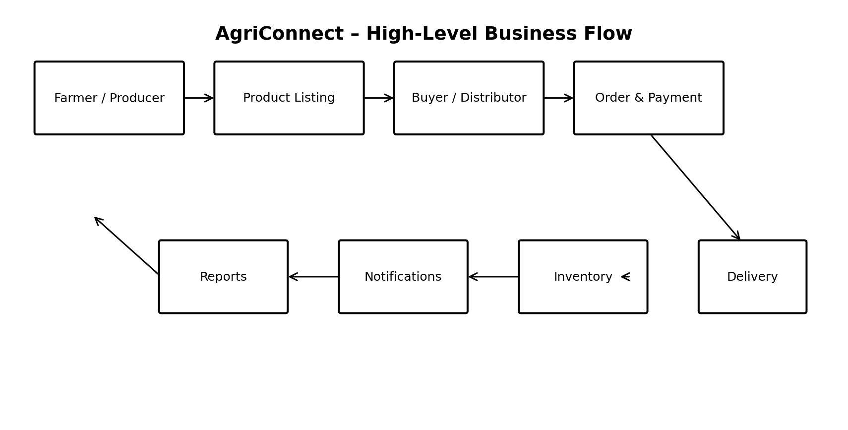
Figure 1. High-level AgriConnect business flow.

14.2 Use Case Diagram
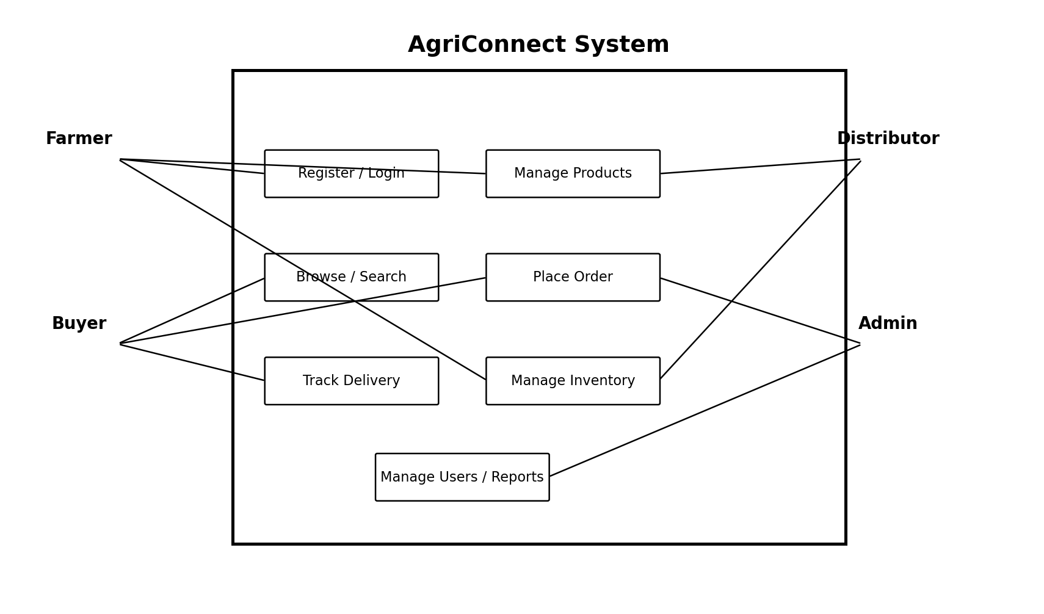
Figure 2. Main actors and use cases.

14.3 Order Lifecycle
Stage | Actor | Key Data | Next Possible State
Pending | Buyer | Order, quantity, delivery details | Accepted / Rejected / Cancelled
Accepted | Farmer | Confirmed quantity and price | Packed / Cancelled
Packed | Farmer/Distributor | Package readiness | Dispatched
Dispatched | Distributor | Vehicle/driver/status | Delivered / Delivery Exception
Delivered | Buyer/Distributor | Delivery timestamp | Completed
Completed | System | Final transaction record | Feedback / Reporting

15. UI Mock-ups
The following low-fidelity mock-ups are intended to validate information architecture before detailed visual design. They are deliberately simple so stakeholders can focus on workflow and information.

15.1 Login / Registration
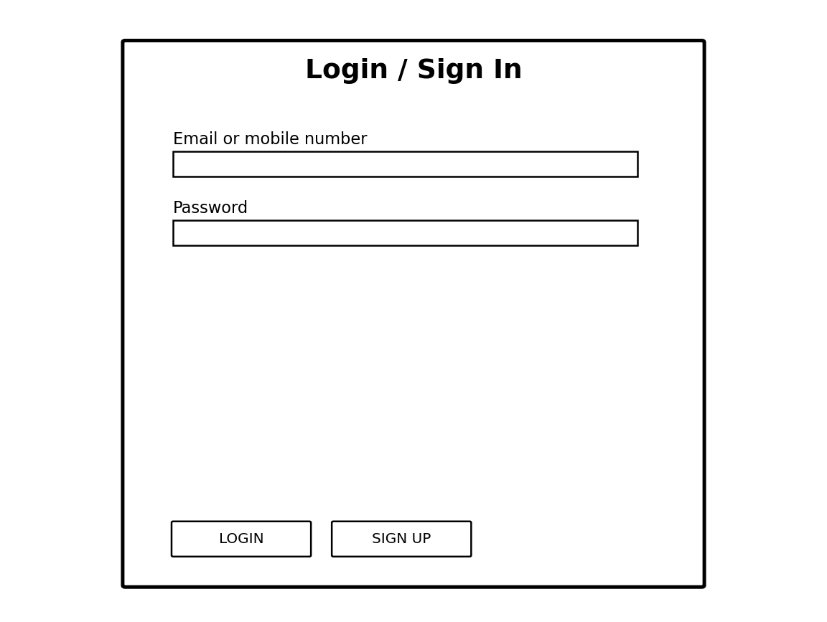
Supports account access and role-based onboarding.

15.2 Farmer Dashboard
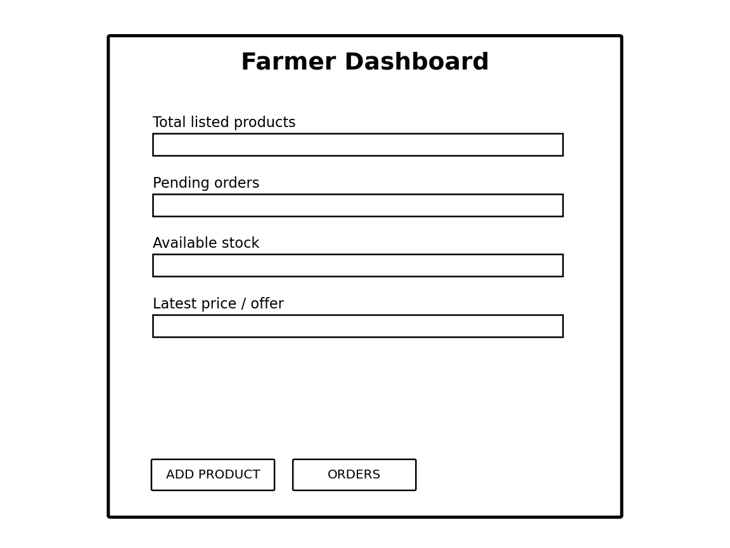
Shows key stock, orders and product-management actions.

15.3 Buyer Marketplace
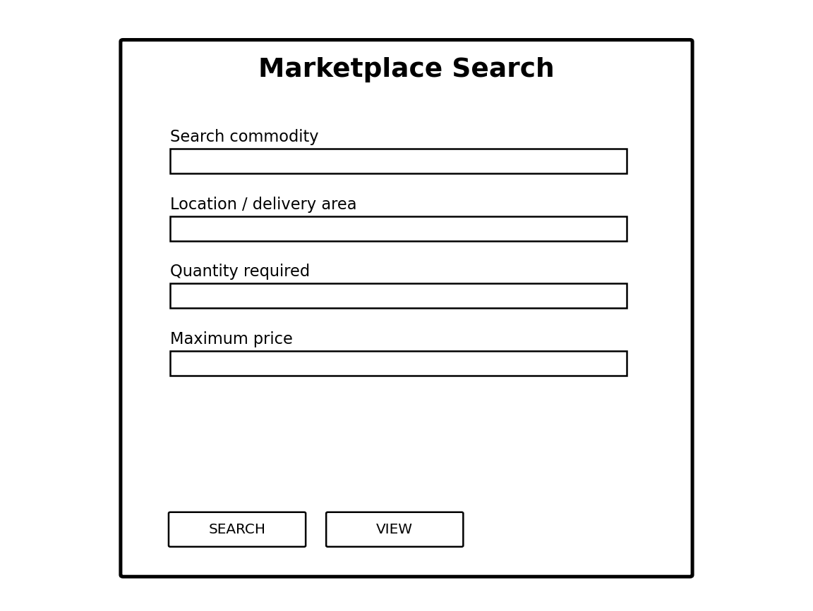
Provides commodity discovery through search and filters.

15.4 Order Tracking
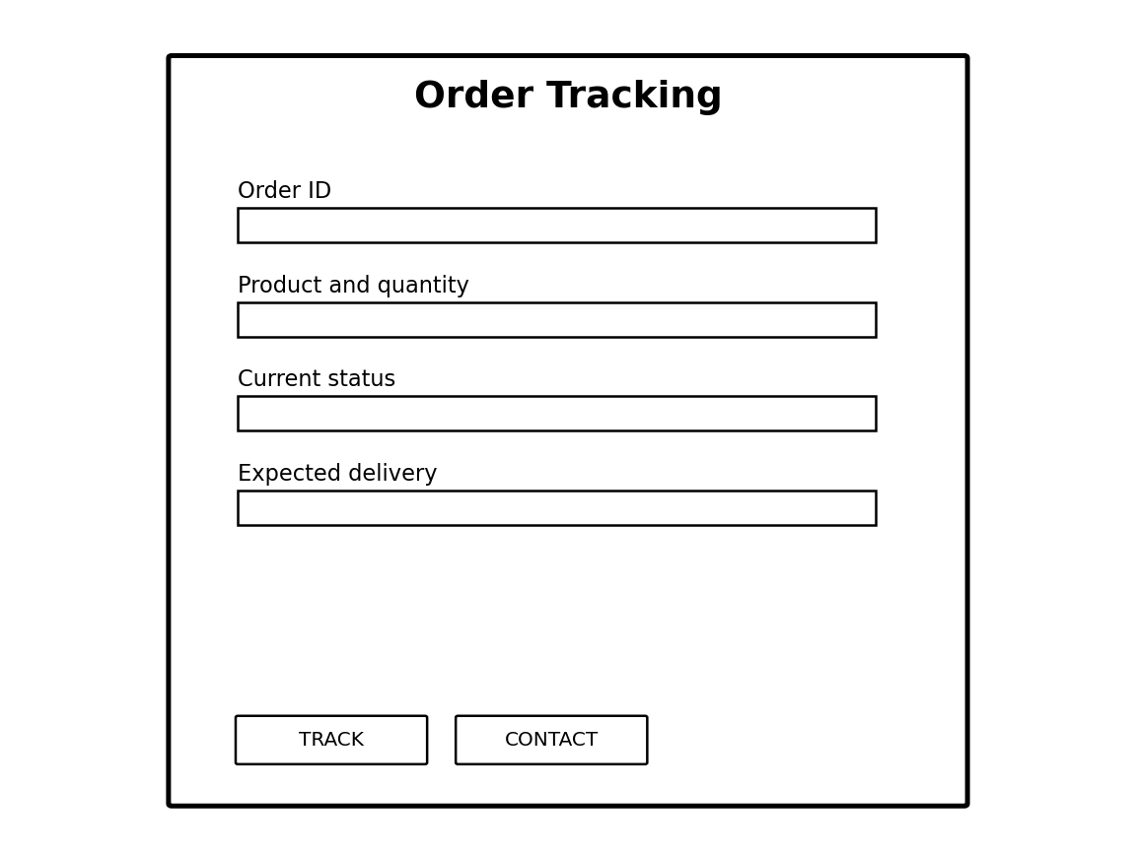
Shows order identity, status and expected delivery.

16. Data Requirements
Entity | Core Data
User | user_id, name, mobile/email, password_hash, role, verification_status, address, created_at
Farmer Profile | user_id, farm/business name, location, producer type, verification details
Product | product_id, seller_id, commodity, description, quantity, unit, price, grade, location, availability_status
Order | order_id, buyer_id, seller_id, order_date, total_amount, status, delivery_address
Order Item | order_item_id, order_id, product_id, quantity, unit_price, subtotal
Inventory | inventory_id, product_id, available_quantity, reserved_quantity, updated_at
Delivery | delivery_id, order_id, distributor_id, transporter_id, pickup, destination, scheduled_date, status
Payment | payment_id, order_id, amount, method, reference, status, paid_at
Notification | notification_id, user_id, type, message, read_status, created_at
Review | review_id, order_id, reviewer_id, reviewed_user_id, rating, comment, created_at
Audit Log | audit_id, actor_id, action, entity_type, entity_id, timestamp, details

16.1 Data Relationships
- One User can have one primary role/profile and may create many products if the role permits.
- One Product belongs to one seller and may appear in many order items over time.
- One Order belongs to one buyer and one seller in the initial design and contains one or more order items.
- One Order can have one active delivery record in the basic model.
- One Order can have zero or one payment record initially, with the design allowing multiple payment events later.
- One completed Order may generate feedback records according to platform rules.

17. Requirement Traceability Matrix
User Story | Functional Requirements | Non-Functional Requirements
US-02 | FR-006, FR-007, FR-008 | NFR-007, NFR-009
US-03 | FR-017 | NFR-006, NFR-012
US-05 | FR-009, FR-010, FR-011 | NFR-001, NFR-007
US-07 | FR-012, FR-013, FR-014, FR-015 | NFR-006, NFR-012
US-08 | FR-018, FR-019, FR-021 | NFR-001, NFR-009
US-10 | FR-005, FR-025 | NFR-003, NFR-004, NFR-013
US-11 | FR-024 | NFR-013
US-12 | FR-021 | NFR-001, NFR-009
US-13 | FR-022 | NFR-004
US-14 | FR-023 | NFR-001, NFR-005

18. Risks and Mitigation
Risk | Description | Impact | Mitigation
R1 | Low digital literacy | High | Simple UI, guided onboarding, local-language support, user testing
R2 | Incorrect product/stock information | High | Validation, timestamps, seller responsibility, admin flagging
R3 | Fraudulent accounts | High | Verification workflow, role controls, audit logs
R4 | Payment disputes | High | Payment references, immutable transaction history, dispute workflow
R5 | Poor connectivity | Medium | Lightweight pages and future offline/mobile support
R6 | Delivery delays | Medium | Delivery status, alerts and exception reasons
R7 | Data privacy/security incident | High | Least privilege, encryption, secure authentication, monitoring and backups
R8 | Scope expansion | Medium | Prioritized MVP and change-control process
R9 | Regulatory changes | Medium | Keep business rules configurable and conduct legal review before production

19. Future Enhancements
- Native Android application with offline-first features
- Regional language support
- Integration with trusted market-price data sources
- Digital weighing/quality-assessment integration
- Integrated payment gateway
- GPS-based delivery tracking
- Warehouse and cold-storage management
- AI-based demand and price forecasting
- Recommendation engine for buyers and sellers
- Digital invoices and tax/accounting integration
- Farmer advisory services and weather information
- Integration with government/FPO ecosystems subject to approvals

20. Conclusion
This requirements analysis establishes a practical foundation for AgriConnect, a proposed digital agribusiness platform connecting producers, buyers and distribution stakeholders. The analysis identifies the major stakeholder groups, their operational challenges, the information they require and the system capabilities needed to support their workflows.
The proposed requirements emphasize marketplace visibility, accurate product and inventory data, order traceability, delivery coordination, payment-status records, security and usability. These priorities are consistent with documented objectives of digital agricultural-market systems such as e-NAM, including reducing information asymmetry, expanding market access, supporting transparent price discovery and enabling electronic payment processes. citeturn0search0turn0search3turn0search7
The next phase should validate these requirements with representative stakeholders, convert the approved requirements into a system architecture and database design, and develop a prioritized MVP. Any production implementation should also undergo security, privacy, regulatory and usability validation before deployment.

References
- National Agriculture Market (e-NAM), Government of India – e-NAM Home and Overview. https://enam.gov.in/ citeturn0search0
- National Agriculture Market (e-NAM), Government of India – Stakeholders Involved. https://www.enam.gov.in/web/stakeholders-Involved citeturn0search2
- National Agriculture Market (e-NAM), Government of India – Farmers. https://www.enam.gov.in/web/stakeholders-Involved/farmers citeturn0search7
- National Agriculture Market (e-NAM), Government of India – Traders. https://www.enam.gov.in/web/stakeholders-Involved/traders citeturn0search3
- National Agriculture Market (e-NAM), Government of India – Farmers Module. https://www.enam.gov.in/web/mobile-app/farmers-module citeturn0search9
- National Agriculture Market (e-NAM), Government of India – Traders Module. https://www.enam.gov.in/web/mobile-app/traders-module citeturn0search6
- National Agriculture Market (e-NAM), Government of India – eNWR Trade. https://www.enam.gov.in/web/enwr-trade citeturn0search4
- National Agriculture Market (e-NAM), Government of India – National Dashboard. https://www.enam.gov.in/NAMV2/dashboard/statewise.html citeturn0search10

Appendix A – Suggested 30–35 Hour Analysis Log
Hours | Work Performed
1–2 | Understand assignment, define business problem and project concept
3–5 | Research agriculture-market stakeholders and existing digital-market workflows
6–8 | Identify stakeholder pain points and stakeholder priorities
9–11 | Define project scope, assumptions, constraints and objectives
12–15 | Draft user stories, scenarios and acceptance expectations
16–20 | Develop detailed functional requirements
21–23 | Develop non-functional requirements, business rules and data needs
24–26 | Develop use cases and process flows
27–29 | Design low-fidelity UI mock-ups and validate information architecture
30–32 | Build traceability matrix, risk analysis and future enhancements
33–35 | Review grammar, consistency, requirement numbering, diagrams and references

Appendix B – Acceptance Criteria Examples
ID | Acceptance Criterion
AC-01 | A farmer can register, log in and access the farmer dashboard after verification.
AC-02 | A seller cannot publish a listing with zero or negative quantity.
AC-03 | A buyer cannot submit an order greater than available stock.
AC-04 | Every successful order receives a unique order ID.
AC-05 | Order status changes are visible to authorized users and include timestamps.
AC-06 | A non-admin cannot access administrator-only user management screens.
AC-07 | A completed order can be reviewed according to feedback rules.
AC-08 | Historical order records remain available even if a product listing is deactivated.

