AGRICONNECT
Performance Evaluation and Final Project Documentation
Week 5 — Final Submission
Agribusiness Web Application | Evaluation • Risk Analysis • Design Consolidation • Roadmap
Deployment reference: https://agri-connect-web.onrender.com
Important: performance numbers are proposed or simulated, not verified production measurements.

Document Control
Item | Details
Project | AgriConnect — Agribusiness Web Application
Deliverable | Week 5: Performance Evaluation and Final Documentation
Purpose | Consolidate Weeks 1–4 and define an evidence-based evaluation, risk plan, and future roadmap.
Deployment reference | https://agri-connect-web.onrender.com
Evidence limitation | A deployment URL does not prove every feature, security control, or performance target has passed.
Metric status | All thresholds and hypothetical observations are labelled; replace them with real test results before claiming measured performance.

Contents
- 1. Executive Summary
- 2. Background and Objectives
- 3. Consolidation of Weeks 1–4
- 4. Architecture and Design Decisions
- 5. Requirements and Module Integration
- 6. Performance Evaluation Framework
- 7. Simulated Evaluation and Interpretation
- 8. Test Plan and Acceptance Criteria
- 9. Risk Assessment
- 10. Security, Privacy, and Data Governance
- 11. Maintainability and Operations
- 12. Future Recommendations
- 13. Implementation Roadmap
- 14. Conclusion
- Appendices: Work Plan, Checklist, Evidence Log, References

1. Executive Summary
AgriConnect is an agribusiness-oriented web application intended to make agricultural information and digital workflows easier to access. The project stages cover requirements gathering, architecture and design, module development and integration planning, and testing/debugging/deployment strategy. This final report consolidates those stages and proposes a structured assessment of effectiveness, efficiency, scalability, and maintainability.
The evaluation framework defines indicators such as page usability time, API latency, error rate, concurrent-user capacity, availability, data integrity, recovery time, and changeability. No verified load-test output or production monitoring export was provided for this report. Therefore, numeric thresholds and example outcomes are illustrative—not measured production facts.
The immediate priorities are to run and document a repeatable test suite, verify authentication and authorization, protect secrets, monitor the deployed application, inspect slow endpoints and queries, and maintain a safe release/rollback procedure. Advanced features should follow evidence of core reliability and actual user demand.
The deployment reference is https://agri-connect-web.onrender.com. The existence of a live URL alone cannot establish that all features are correct, secure, scalable, or performant.

2. Background and Objectives

2.1 Problem context
Agribusiness users may need timely agricultural information and digital workflows while using varied devices and network conditions. A modular web application can centralize access and provide a foundation for later data-driven services. It should remain usable by non-specialists and be maintainable as needs evolve.

2.2 Objectives
- Provide a clear, responsive interface for agricultural workflows and information.
- Separate user-interface responsibilities from business logic, persistence, and integrations.
- Validate input, enforce permissions, and handle errors safely.
- Define a deployment and maintenance process with smoke tests and recovery steps.
- Use measurable indicators to evaluate quality rather than unsupported claims.
- Identify technical, operational, security, data-quality, and adoption risks with mitigations.

2.3 Stakeholders
Stakeholder | Needs and concerns
Farmers/producers | Simple navigation, relevant information, mobile usability, reliable access.
Distributors/operators | Consistent data, efficient workflows, dependable service.
Administrators/support | Controlled access, useful logs, clear error reports, manageable configuration.
Developers | Modular code, repeatable tests, documented APIs, safe releases.
External providers | Defined integration contracts, protected credentials, sensible timeout handling.

3. Consolidation of Previous Deliverables
Stage | Focus | Consolidated outcome
Week 1 — Requirements | Users, functional/non-functional requirements, workflows and mock-ups. | Requirements baseline and criteria for acceptance.
Week 2 — Architecture/design | Frontend, backend, data, APIs, security boundaries, modular responsibilities. | Layered design and separation of concerns.
Week 3 — Module development/integration | Module responsibilities, code structure, data flow and integration points. | Module-level implementation and integration plan.
Week 4 — Testing/debugging/deployment | Positive/negative cases, debugging, staging, rollout, rollback and support. | Test and deployment approach.
Week 5 — Evaluation/documentation | Metrics, simulated evaluation, risks, final design decisions and roadmap. | This consolidated report and proposed evidence plan.

Traceability rule: each requirement should map to one or more modules, tests, and acceptance criteria. Where previous deliverables do not establish an exact implementation detail or measured result, this report describes a recommendation rather than assuming the work has already been completed.

4. Architecture and Design Decisions
Logical architecture (verify each component against the actual repository before treating it as a confirmed implementation inventory):
USERS (desktop/mobile browser)
↓
FRONTEND — React + Vite (responsive UI)
↓ HTTPS / REST
BACKEND — Node.js + Express API
↓ validation, authorization, business rules
DATABASE — PostgreSQL / configured database service
↔ Optional external services (weather, maps, market data)
Cross-cutting: authentication, environment configuration, logs, monitoring, backups, testing

4.1 Design decisions and validation
Decision | Rationale | Validation required
Layered frontend/backend | Separates presentation from business logic and persistence. | Confirm clear boundaries and no reliance on frontend-only permissions.
React + Vite (planned/recorded stack) | Component-based UI and efficient development/build workflow. | Verify package files and production build.
Node.js + Express (planned/recorded stack) | Centralizes request validation, business rules, and API responses. | Review routes, middleware, error handling, and limits.
PostgreSQL/configured relational database | Supports structured records, relationships, constraints, and transactions. | Confirm actual provider, schema, backup options, and migrations.
Environment-based configuration | Keeps deployment-specific values out of source code. | Check secrets are not committed or exposed in frontend bundles.
Render deployment reference | Provides a deployed endpoint for smoke testing. | Verify build, environment variables, health checks, logs, and rollback options.
Optional integrations kept modular | Reduces coupling and makes provider failures easier to contain. | Define timeouts, quotas, provenance, and fallback behavior.

4.2 Architecture boundaries
- The frontend presents data and gathers input; it must not be the only place where permissions are enforced.
- The backend validates every request and checks authorization before sensitive reads or writes.
- Database constraints protect integrity even if application-level validation is missed.
- External APIs should use timeouts and explicit failure handling; stale data should be labelled.
- Logging, monitoring, backup/recovery, and configuration are part of the system design, not optional afterthoughts.

5. Requirements and Module Integration

5.1 Functional requirement categories
ID | Requirement | Example acceptance condition
FR-01 | Access/navigation | Main pages open and navigation has no broken links.
FR-02 | Input handling | Required fields are validated and invalid input receives clear feedback.
FR-03 | Agribusiness information | Information is displayed with consistent labels, units, and timestamps where applicable.
FR-04 | API integration | Requests receive structured success or error responses.
FR-05 | Privileged workflows | Administrative actions are restricted to authorized users if such roles exist.
FR-06 | Deployment health | A health/smoke check confirms service response if configured.

5.2 Non-functional requirements
Dimension | Requirement | Evaluation method
Effectiveness | Users complete core tasks correctly. | Task-based tests and acceptance checklist.
Efficiency | Pages and APIs respond within thresholds. | Browser timings and API latency percentiles.
Scalability | System degrades gracefully under increasing load. | Step-load/stress tests and database review.
Maintainability | Changes can be made safely and efficiently. | Code review, automated tests, docs, change/defect log.
Security | Access is restricted and secrets protected. | Authorization tests, dependency/configuration review.
Reliability | Failures are detected and recoverable. | Error monitoring, backup/restore drills, incident exercises.
Usability/accessibility | Interface works across common devices and input methods. | Responsive checks, keyboard navigation, user walkthroughs.

5.3 Module overview
Module/layer | Responsibilities | Integration/test focus
Frontend UI | Navigation, page layout, form interactions, loading/error states, responsive layout. | Route refresh, validation, mobile layout, API failure states.
Backend API | Request parsing, validation, business rules, authorization, response formatting. | Valid/invalid requests, status codes, limits, exception handling.
Data layer | Persistence, relationships, constraints, queries. | CRUD, referential integrity, duplicate handling, recovery.
Authentication/authorization | Identity and access decisions, if implemented. | Unauthenticated, authenticated, wrong-role and wrong-owner access.
External service adapter | Calls to optional third parties and normalization. | Timeouts, quota exhaustion, malformed data, fallback.
Deployment/operations | Build, configuration, health checks, logs and releases. | Production smoke tests and recovery procedure.

Integration principle: document API request/response shapes, error codes, required fields, and authorization expectations. Avoid duplicating business rules in multiple layers.

6. Performance Evaluation Framework
The proposed thresholds below are initial acceptance targets for a small release, not universal standards. Adjust them after a baseline test and stakeholder review.
Metric | Definition | Proposed target | Evidence/method
Initial page usability | Time until main page is usable on a representative device/network. | ≤ 3.5 seconds under defined conditions. | Browser trace; repeat ≥5 times; report median and p95.
Read API latency | Request-to-response time for common read endpoints. | p95 ≤ 800 ms under normal load. | API load test; separate warm/cold-start results.
Write API latency | Time for validated create/update operations. | p95 ≤ 1.2 seconds under normal load. | Representative payloads and database writes.
Error rate | Failed requests divided by total requests. | < 2% in defined normal-load scenario. | Load-test output and logs; separate 4xx/5xx.
Concurrent users | Active virtual users in a workload. | Baseline 25 users, then step upward. | Ramp test; observe latency, resources, errors, DB connections.
Availability | Share of monitored time service responds successfully. | Initial goal ≥99.5% monthly, subject to hosting limits. | Uptime checks and incident log.
Data integrity | Stored data follows validation and relationship rules. | No unexplained loss or invalid relationships in tested cases. | Constraints, CRUD tests, reconciliation.
Recovery time | Time to restore after a defined failure. | Set an initial objective, e.g. within 4 hours, then validate. | Restore/rollback exercise.
Maintainability | Effort/risk to understand and change the system. | Critical paths documented; tests for core logic. | Code review, coverage, change lead time.

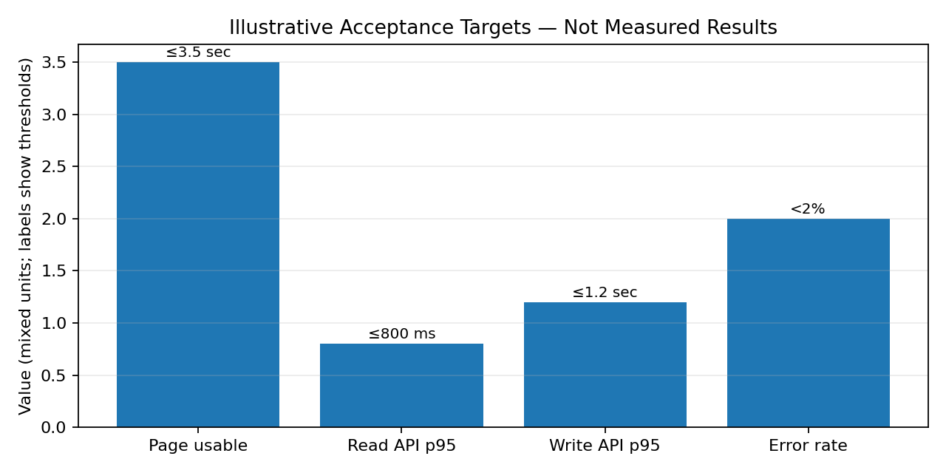
Figure 1. Illustrative acceptance targets. The bars use mixed units; see the labels for each threshold. These are not measured results.

6.1 Test environment and workload design
- Record date, commit/version, region, browser/device, network conditions, and database state.
- Separate staging tests from production smoke checks; do not stress production without permission and a controlled plan.
- Use representative journeys: landing page, list/search, detail page, form submission, and authenticated workflows if applicable.
- Warm up the application, run a steady-load period, ramp users gradually, then observe recovery.
- Report median, p95 and p99 latency, throughput, errors, and resource usage; averages alone can hide slow experiences.
- Repeat each scenario and preserve raw outputs so results can be reproduced.

7. Simulated Evaluation and Interpretation
The following table demonstrates how to interpret a hypothetical scenario. It is not evidence that the deployed site achieved these outcomes. Replace these examples with measurements from the actual code and environment.
Dimension | Hypothetical observation | Interpretation | Action
Effectiveness | 9 of 10 task attempts succeed in a walkthrough. | Illustrative 90% completion points to a failed workflow needing investigation. | Reproduce failure, fix, and retest.
Efficiency | Read API p95 720 ms; write API p95 1.1 sec. | Would meet proposed latency targets if verified under the defined load. | Repeat runs and include cold starts.
Scalability | At 25 concurrent users errors are 1%; at 75 users p95 rises sharply. | May indicate limited capacity, database contention, or inefficient queries. | Inspect logs/traces and profile slow endpoints.
Maintainability | Some modules have limited automated tests/setup notes. | Undocumented behavior increases change risk. | Add tests, API docs, setup notes, and code review.
Reliability | A simulated database interruption produces a clear error page. | Graceful failure helps, but recovery and alerting still need testing. | Add structured logs, alerts, and recovery drill.
Security | One negative test rejects a protected request without credentials. | A positive result for one test is not a security certification. | Test resource ownership, roles, direct API access, and secrets.

7.1 Suggested scoring rubric
Dimension | Weight | Question | Evidence
Effectiveness | 30% | Can users complete intended tasks correctly? | Completion rates, defects, acceptance results.
Efficiency | 25% | Are latency and resource use acceptable? | Latency percentiles, throughput, resource data.
Scalability | 25% | Does service handle rising load without unacceptable failure? | Ramp/stress tests and host/database metrics.
Maintainability | 20% | Can changes and releases be performed safely? | Tests, documentation, review, release records.

Score each dimension from 1 (poor) to 5 (strong), multiply by the weight, and record evidence. Do not publish a final score until tests and code review have actually been completed.

8. Test Plan and Acceptance Criteria
ID | Scenario | Expected result | Status in this report
T-01 | Open deployed home page. | Loads without fatal frontend error. | To execute; record actual result.
T-02 | Submit form with required fields missing. | Submission is blocked with clear validation. | To execute.
T-03 | Send malformed input directly to API. | Controlled 4xx response; no stack trace/secrets exposed. | To execute.
T-04 | Request protected resource without credentials. | Backend consistently denies access. | To execute if protected routes exist.
T-05 | Perform authorized workflow with valid account. | Action succeeds and stored data is correct. | To execute if auth/workflow exists.
T-06 | Refresh a nested frontend route. | Route resolves or redirects correctly; no hosting 404. | To execute.
T-07 | Simulate database/service timeout in safe environment. | Clear user-facing error and diagnostic logs. | To execute in staging.
T-08 | Use narrow mobile viewport and keyboard navigation. | Layout remains usable and controls accessible. | To execute.
T-09 | Run normal and ramp-load scenarios. | Record latency, throughput, errors, and resources. | To execute.
T-10 | Deploy version and run smoke tests. | Critical pages/API checks pass; rollback steps available. | To execute each release.

8.1 Defect severity
Severity | Example | Release response
Critical | Unauthorized data access, data corruption, total outage. | Block release; contain, fix, retest, assess impact.
High | Core workflow unavailable for many users. | Fix before release unless approved workaround exists.
Medium | Non-critical workflow fails or has major usability issue. | Prioritize by impact; document deferral.
Low | Cosmetic or minor wording/layout issue. | Schedule for maintenance release.

Evidence rule: mark a test Passed only after recording date, environment, steps, actual result, and screenshot/log/report. This report does not mark unexecuted tests as passed.

9. Risk Assessment
Likelihood and impact are scored 1–5. Priority = likelihood × impact. These are qualitative planning estimates, not statistical predictions.
ID | Risk | L | I | Score | Mitigation | Priority
R-01 | Authentication/authorization weakness | 4 | 5 | 20 | Enforce server-side authorization; test direct API access, roles, and resource ownership. | High
R-02 | Database/hosting outage | 3 | 5 | 15 | Monitor health, document recovery, confirm backups and test restoration. | High
R-03 | Slow API/cold start | 3 | 5 | 15 | Measure p95/p99, optimize measured slow queries, and improve loading/retry states. | High
R-04 | Secret/credential exposure | 3 | 5 | 15 | Use deployment secrets, rotate exposed credentials, keep server secrets out of frontend. | High
R-05 | Incorrect/stale agricultural data | 3 | 4 | 12 | Validate sources, show timestamps/units, add data-quality checks and correction path. | High
R-06 | Schema migration failure | 3 | 4 | 12 | Version migrations, test staging, protect data, and plan rollback/forward-fix. | High
R-07 | Dependency vulnerability | 3 | 4 | 12 | Review alerts, update deliberately, test changes, retain lockfile. | High
R-08 | Insufficient test evidence | 3 | 4 | 12 | Maintain test matrix, save outputs, link results to release version. | High
R-09 | Environment/CORS mismatch | 3 | 3 | 9 | Document variables, validate allowed origins, run deployment smoke tests. | Medium
R-10 | Low adoption/usability/connectivity barriers | 3 | 3 | 9 | User walkthroughs, mobile optimization, simplified journeys, feedback loop. | Medium
R-11 | External API quota/provider outage | 2 | 4 | 8 | Timeouts, quota monitoring, permitted caching, fallback message. | Medium
R-12 | Data loss/failed recovery | 2 | 5 | 10 | Define backup retention, test restoration, set recovery objectives. | High

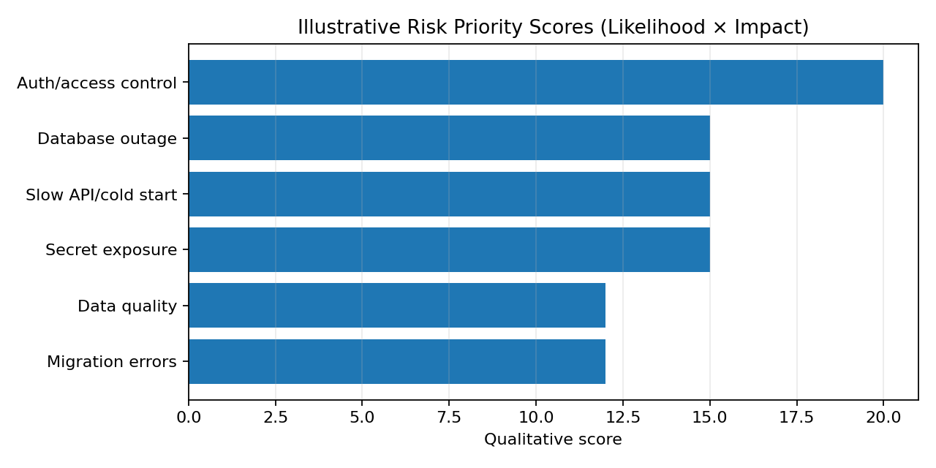
Figure 2. Illustrative risk priority scores; review them after implementation evidence and stakeholder feedback.

9.1 Risk monitoring
- Assign an owner, due date, and completion evidence to each high-priority mitigation.
- Review risks at each release and after major changes to authentication, data, hosting, or integrations.
- Record incident timeline, user impact, root cause, recovery action, and prevention task.
- Combine prevention, detection, response, and recovery controls instead of relying on one safeguard.

10. Security, Privacy, and Data Governance

10.1 Minimum controls
- Use HTTPS and avoid placing credentials or sensitive values in URLs.
- Validate input on the server and use parameterized database operations or a safe query layer.
- Enforce authentication and resource-level authorization on the backend, not only by hiding frontend controls.
- Store private keys/database credentials in server-side environment settings; expose only intentionally public client configuration.
- Use least-privilege database credentials and rotate credentials suspected of exposure.
- Return safe user-facing errors; use sanitized structured logs without secrets or unnecessary personal data.
- Review dependency vulnerabilities and remove unused packages where practical.
- Collect only data needed for a defined purpose and document access, retention, correction, and deletion processes.

10.2 Agricultural data quality
For crop, weather, soil, market, or other agricultural information, include source, timestamp, unit, and interpretation where relevant. Distinguish sourced facts from estimates or predictions. If a provider is unavailable or data is stale, show that limitation instead of silently presenting old information as current.

10.3 Privacy review
Document what personal or operational data is collected, why it is needed, who can access it, where it is stored, and how long it is retained. Conduct a route-by-route authorization review and test APIs directly; frontend navigation controls are not a security boundary.

11. Maintainability and Operations

11.1 Development practices
- Keep modules focused and separate UI components, API clients, route handlers, validation, and data access.
- Use consistent naming, formatting, linting, meaningful commits, and code review.
- Document local setup, environment variables, build/test commands, database setup, and deployment steps.
- Add automated tests for core validation, business rules, authorization, and high-risk integrations.
- Document API contracts, success payloads, errors, and authentication requirements.

11.2 Operational checklist
Area | Minimum practice
Monitoring | Check uptime and error rates; define an owner and escalation path.
Logs | Use timestamps and request context; never log secrets.
Backups | Confirm provider capabilities and retention; test restore periodically.
Releases | Deploy a known version, smoke-test, watch logs, and retain rollback/forward-fix steps.
Configuration | Document required variables and validate missing values at startup.
Dependencies | Review security alerts and test updates before production.
Support | Maintain known issues, incident notes, and a channel for user reports.

11.3 Release and rollback procedure
- Prepare a release candidate and record commit/version and configuration changes.
- Deploy to staging or a safe test environment where available.
- Run automated tests and smoke tests for critical user journeys.
- Protect data before risky schema changes; verify migration compatibility.
- Deploy during a monitored window and verify pages, API health, authentication, and critical data operations.
- If a critical failure occurs, roll back to a known-good version where safe; use a documented recovery/forward-fix plan for incompatible migrations.
- Record release outcome, incidents, and follow-up tasks.

12. Future Improvement Recommendations
Priority | Recommendation | Expected value | Caution/dependency
P0 Immediate | Execute and archive functional, negative, responsive, authorization, and smoke tests. | Creates credible release-readiness evidence. | Use actual deployed version and record real results.
P0 Immediate | Verify production configuration and secret handling; rotate exposed credentials. | Reduces compromise risk. | Confirm actual hosting/database setup.
P1 Short term | Add request/error monitoring and a simple operational dashboard. | Earlier detection of outages/regressions. | Choose metrics appropriate to project size.
P1 Short term | Profile slow endpoints/queries; add indexes only when query plans support them. | Improves latency without unnecessary complexity. | Measure before and after.
P1 Short term | Improve accessibility, mobile layout, loading states, and error messages. | Better usability across devices and connectivity conditions. | Test with representative users.
P2 Medium term | Add data provenance and freshness for agricultural information. | Improves trust and limits confusion about stale data. | Check authoritative sources and licensing.
P2 Medium term | Implement role-based access/audit history if multiple roles require it. | Better governance for multi-user workflows. | Avoid unnecessary roles.
P2 Medium term | Add CI checks for linting, tests, build, and dependency review. | More repeatable releases and fewer regressions. | Keep the pipeline maintainable.
P3 Longer term | Evaluate weather, crop advisory, market-price, map, or notification integrations based on demand. | Can improve decision support. | Assess accuracy, cost, quotas, licensing, and fallback.
P3 Longer term | Run pilot tests with farmers/producers/distributors. | Reveals practical usability issues. | Do not overstate pilot findings.
P3 Longer term | Consider caching, queues, background jobs, and horizontal scaling only when measurements justify them. | Supports growth while controlling complexity. | Avoid premature optimization.

12.1 Strategic direction
Use an evidence-led sequence: establish reliable core workflows and a baseline; improve security, monitoring, and measured bottlenecks; then expand based on real user needs. Advanced analytics and integrations should not outrank data quality, reliability, and understandable user feedback.

13. Implementation Roadmap
Phase | Activities | Exit condition
Phase 1 — Baseline (Week 1) | Verify repository stack and deployment settings; define journeys and test data; run smoke checks. | Architecture inventory and baseline test record.
Phase 2 — Quality/security (Weeks 2–3) | Run functional/negative tests; review authorization, secrets, dependencies, error handling. | Prioritized defects and security checklist.
Phase 3 — Performance (Weeks 3–4) | Run normal/ramp load tests; inspect p95/p99, error rate, and slow paths. | Performance report with raw output and improvement tasks.
Phase 4 — Operations (Week 4) | Verify logs, health checks, backup/restore options, release and rollback steps. | Release checklist and recovery notes.
Phase 5 — User feedback (ongoing) | Conduct walkthroughs and prioritize feedback-driven improvements. | Evidence-based product backlog.

13.1 Success indicators
- Every critical user journey has a test case and recorded outcome.
- No known critical security or data-integrity defect remains open at release.
- Performance claims are supported by reproducible measurements.
- Deployment has a smoke-test checklist and documented recovery approach.
- Every enhancement links to a stakeholder need, expected benefit, and risk review.

14. Conclusion
AgriConnect’s evaluation should be continuous rather than a one-time score. The previous stages establish the foundation for requirements traceability, modular design, integration planning, testing, and deployment. This report brings those elements together with a performance framework, risk register, operational controls, and prioritized roadmap.
The immediate task is to collect evidence from the actual codebase and deployed environment: execute the test cases, record latency percentiles, verify access controls, inspect logs, and document release/recovery outcomes. The proposed metrics and simulated scenarios show how to assess the system, but must not be presented as measured results until tests have been performed.

Appendix A — Proposed 32-Hour Work Plan
Work item | Hours | Output
Review Weeks 1–4 and confirm current implementation | 4 | Consolidated scope and verified architecture inventory.
Map requirements to modules and tests | 3 | Traceability matrix and acceptance criteria.
Define metrics and workload scenarios | 4 | Performance test plan and thresholds.
Functional, negative, and responsive checks | 6 | Test evidence and defect log; actual execution must be recorded.
Load testing and analysis | 4 | Performance report or documented setup if execution unavailable.
Risk assessment and security review | 4 | Risk register and mitigation owners.
Roadmap and operations checklist | 3 | Prioritized recommendations and release checklist.
Compile, format, and review final document | 4 | Final report.
TOTAL | 32 | Within the expected 30–35-hour effort.

This is a proposed effort breakdown for the assignment, not a timesheet claiming every activity has already been performed. Adjust it to reflect actual work completed.

Appendix B — Final Submission Checklist
- Executive summary covers purpose, approach, limitations, and next steps.
- Previous design stages are consolidated without inventing unsupported implementation details.
- Metrics include definitions, targets, methods, and evidence status.
- Hypothetical results are clearly labelled.
- Risks include likelihood, impact, priority, and mitigation.
- Security, privacy, data quality, maintainability, and operations are addressed.
- Charts are titled and explained.
- Recommendations are prioritized and linked to expected value.
- Tests are marked Passed only with actual evidence.
- Formatting, spelling, links, and repository consistency are reviewed.

Appendix C — Evidence Log Template
Evidence ID | Evidence to capture | Date/version | Result/file location
E-01 | Production build and browser console check | To fill | To fill
E-02 | API smoke-test output | To fill | To fill
E-03 | Functional and negative test results | To fill | To fill
E-04 | Load-test report: p50/p95/p99, throughput, errors | To fill | To fill
E-05 | Authorization and secret/configuration review | To fill | To fill
E-06 | Backup/restore or rollback exercise | To fill | To fill
E-07 | User walkthrough/usability feedback | To fill | To fill

References and Technical Resources
These official resources can guide implementation verification and evaluation. They are references, not evidence that any specific test has been completed.
- React documentation — https://react.dev/
- Vite documentation — https://vite.dev/guide/
- Node.js documentation — https://nodejs.org/en/learn
- Express documentation — https://expressjs.com/
- PostgreSQL documentation — https://www.postgresql.org/docs/
- OWASP Application Security Verification Standard — https://owasp.org/www-project-application-security-verification-standard/
- OWASP Cheat Sheet Series — https://cheatsheetseries.owasp.org/
- Web.dev performance guidance — https://web.dev/learn/performance/
- Render documentation — https://render.com/docs

