WEEK 2 SYSTEM ARCHITECTURE AND DESIGN REPORT
AgriConnect – Digital Agribusiness Management Platform
Architecture, Component Design, Security, Scalability and Deployment
Prepared by: ______________________________
Student ID: _______________________________
Module/Course: ___________________________
Institution: _______________________________
Submission Date: __________________________
Week 2 – System Architecture and Design

Executive Summary
AgriConnect is designed as a scalable, secure and modular digital agribusiness platform connecting farmers, buyers, distributors and administrators. This Week 2 design translates the Week 1 requirements into an implementable technical architecture. The proposed solution uses a React responsive frontend, Node.js/Express API layer, PostgreSQL through Supabase, and isolated external integrations for maps, payments and notifications.
The architecture uses clear boundaries for authentication, users, products, search, orders, inventory, delivery, payments, notifications and reporting. Security is based on authentication, role/resource authorization, least privilege, validation, protected APIs and audit logging. OWASP identifies broken object-level authorization and broken authentication as major API risks, while NIST recommends explicit authorization and least-privilege access. citeturn0search14turn0search48

Table of Contents
1. Introduction
2. Architecture Goals
3. Research and Design Drivers
4. Architecture Overview
5. Technology Stack
6. Component Identification
7. Module Design
8. Data Architecture
9. API Architecture
10. Security Architecture
11. Scalability and Performance
12. Integration Architecture
13. System Workflows
14. Deployment Architecture
15. Availability and Recovery
16. Design Rationale
17. Benefits and Limitations
18. Architecture Decisions
19. Testing Strategy
20. Risks
21. Implementation Roadmap
22. Conclusion
References
Appendix – 30–35 Hour Work Log

1. Introduction
Week 1 established requirements for product listings, marketplace search, orders, inventory, delivery, payment status, notifications, feedback and administration. Week 2 converts these requirements into a technical design defining how the user interface, application services, database and external systems communicate.

1.1 Architectural Scope
- Responsive web frontend
- REST API and business services
- Authentication and role management
- PostgreSQL/Supabase data services
- Product, inventory and order processing
- Delivery and notification services
- Maps/payment/messaging integrations
- Logging, monitoring, backup and deployment

2. Architecture Goals
Goal | Design Response
Scalability | Stateless API, indexed PostgreSQL, pagination and independent frontend/API scaling.
Security | HTTPS, authentication, resource-level authorization, validation, rate limiting, audit logs.
Modularity | Separate domain modules and provider adapters.
Reliability | Transactions, controlled state transitions, backups and monitoring.
Usability | Responsive React UI and simple role-specific workflows.
Maintainability | Layered structure, reusable components and automated testing.
Extensibility | Adapters for maps, payment and notification providers.
Observability | Logs, metrics, errors and security/audit events.

3. Research and Design Drivers
The Government of India's e-NAM describes a pan-India electronic trading portal intended to connect agricultural markets and improve information flow, price discovery, transparency and timely online payment. citeturn0search15turn0search49 These principles support AgriConnect requirements for structured product information, searchable supply, traceable transactions and digital status updates.
OWASP's API Security Top 10 highlights risks including broken object-level authorization, broken authentication, unrestricted resource consumption and security misconfiguration. citeturn0search1turn0search14 NIST's zero-trust architecture recommends that network location should not create implicit trust and that access should be explicitly authorized with minimum required privileges. citeturn0search0turn0search16

4. Architecture Overview
The selected architecture is a modular three-tier web architecture. The frontend handles presentation; the API layer implements authentication checks, validation and business rules; PostgreSQL stores transactional data; Supabase provides managed authentication, storage and realtime capabilities; and third-party integrations are isolated behind adapters.
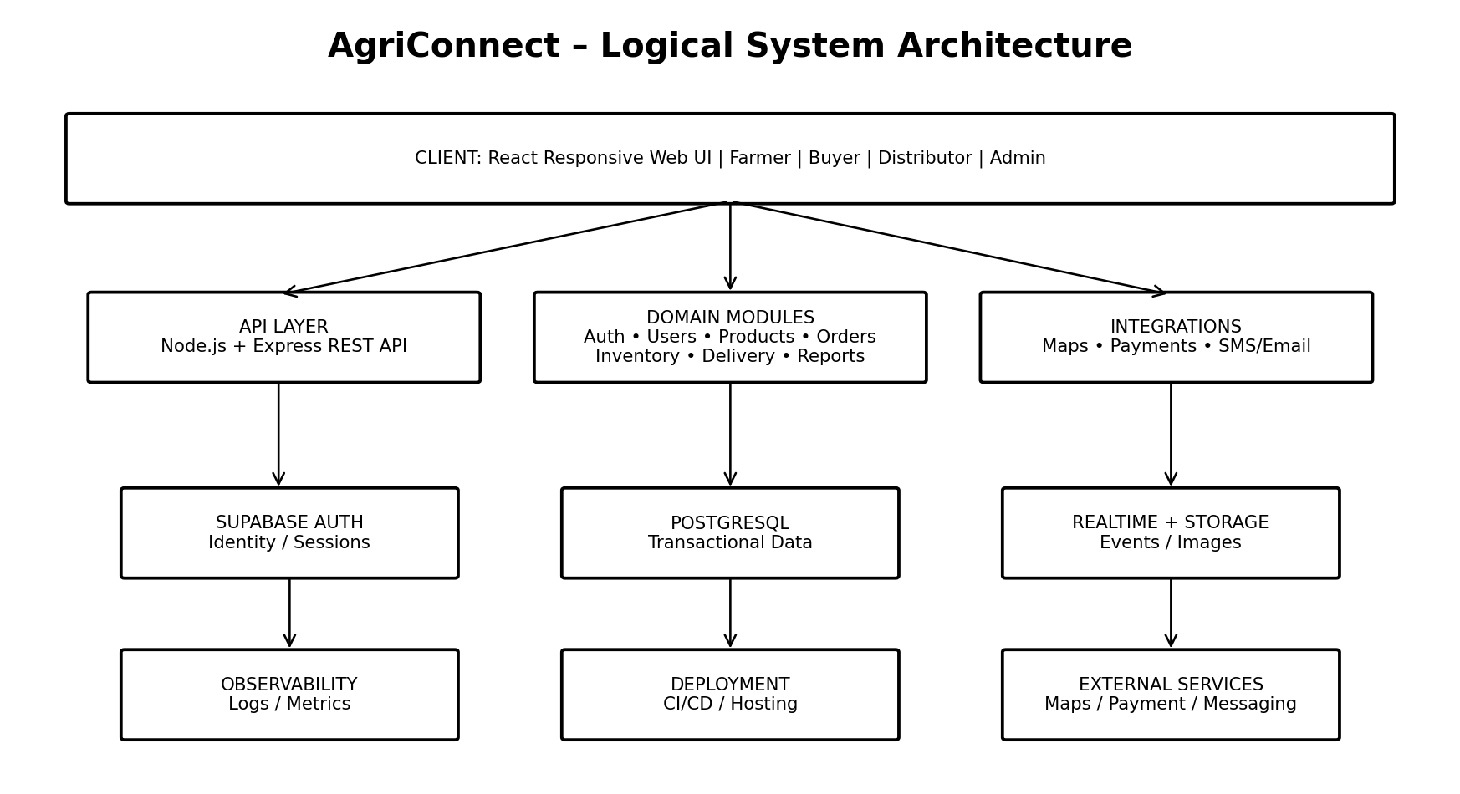
Figure 1. AgriConnect logical architecture.

4.1 Architectural Style
- Three-tier architecture for separation of presentation, business and data concerns.
- Modular monolith for the initial implementation.
- REST API for client communication.
- Event-oriented notifications for asynchronous operations.
- Managed cloud database/authentication to reduce infrastructure overhead.
- Adapter pattern for external providers.

4.2 Why Modular Monolith?
For a student-scale implementation, microservices would add service discovery, distributed tracing, deployment and cross-service consistency complexity. A modular monolith preserves domain boundaries while allowing later extraction of high-load modules if required.

5. Technology Stack
Layer | Technology | Purpose
Frontend | React + JavaScript/TypeScript | Responsive UI, routing, forms, dashboards
Styling | CSS/Tailwind or equivalent | Responsive design
Backend | Node.js + Express.js | REST API and business logic
Authentication | Supabase Auth | Identity and sessions
Database | PostgreSQL via Supabase | Transactional relational data
Realtime | Supabase Realtime | Live order/delivery updates
Storage | Supabase Storage | Images/documents
Maps | Google Maps Platform or equivalent | Geocoding and maps
Payments | Payment gateway adapter | Payment status/integration
Notifications | SMS/Email adapter | External alerts
Hosting | Cloud frontend + API hosting | Deployment
Version Control | Git + GitHub | Collaboration and CI/CD

6. Component Identification
Component | Responsibility
React Client | Pages, dashboards, forms, validation and responsive UI.
API Router | HTTPS requests, middleware and route handling.
Authentication | Identity/session verification and role mapping.
User Module | Profiles, verification and account lifecycle.
Product Module | Listings, categories, quality, availability and ownership.
Search Module | Marketplace filtering, pagination and retrieval.
Order Module | Creation, state transitions, cancellation and history.
Inventory Module | Available/reserved quantities and stock adjustments.
Delivery Module | Assignments, pickup/destination and status.
Payment Module | Payment status, references and provider callbacks.
Notification Module | In-app and external notifications.
Reporting Module | Sales/order/inventory summaries.
Audit Module | Sensitive administrative/security events.
Integration Layer | Maps, payment, SMS/email and future APIs.
Data Layer | PostgreSQL queries, constraints, indexes and transactions.

7. Module Design

7.1 Authentication and Authorization
Supabase Auth handles identity. The API verifies the authenticated user and performs server-side role and ownership checks. Frontend restrictions are treated as usability only, never as the security boundary.

7.2 Product Management
Manages listing creation, editing, activation/deactivation, quantity, price, quality and seller ownership.

7.3 Marketplace Search
Searches active listings using filters such as commodity, location, price, quantity and availability. Results are paginated.

7.4 Order Management
Validates quantity, creates orders, controls status transitions and coordinates inventory updates.

7.5 Inventory Management
Tracks available and reserved quantity. Order-related stock changes occur in database transactions.

7.6 Delivery Management
Stores pickup, destination, distributor/transporter assignment and status events separately from core order logic.

7.7 Payment Module
Initial version records payment status and provider reference. Gateway-specific code remains inside an adapter.

7.8 Notifications
Generates notifications for important events and sends optional external messages asynchronously.

7.9 Reporting
Provides sales, order and inventory summaries using optimized aggregate queries.

7.10 Administration
Manages users, categories, listings, flagged transactions, reports and audit records.

8. Data Architecture
PostgreSQL is appropriate because orders, inventory, payments and delivery records have strong relationships and require transactional consistency.
Table | Core Fields
users | id, auth_id, role, name, contact, verification_status, created_at
farmer_profiles | user_id, farm_name, location, producer_type
categories | id, name, description, active
products | id, seller_id, category_id, quantity, unit, price, grade, location, status
inventory | product_id, available_qty, reserved_qty, updated_at
orders | id, buyer_id, seller_id, status, total, delivery_address, created_at
order_items | id, order_id, product_id, quantity, unit_price, subtotal
deliveries | id, order_id, distributor_id, transporter_id, destination, status
payments | id, order_id, provider, reference, amount, status, paid_at
notifications | id, user_id, type, message, read_at, created_at
reviews | id, order_id, reviewer_id, reviewed_user_id, rating, comment
audit_logs | id, actor_id, action, entity_type, entity_id, timestamp, metadata

8.1 Database Principles
- Use foreign keys and constraints for integrity.
- Use transactions for order/inventory operations.
- Index common search and foreign-key columns.
- Paginate large result sets.
- Keep historical orders even when listings are deactivated.
- Apply appropriate database access policies.
- Use consistent timestamp and timezone rules.

9. API Architecture
The API uses versioned REST endpoints. Protected endpoints require authentication and resource-level authorization.
Method | Endpoint | Purpose | Access
GET | /api/v1/products | Search listings | Authenticated
POST | /api/v1/products | Create listing | Farmer/FPO
PATCH | /api/v1/products/:id | Edit listing | Owner/Admin
GET | /api/v1/products/:id | Product details | Authenticated
POST | /api/v1/orders | Create order | Buyer
GET | /api/v1/orders/:id | View order | Participant/Admin
PATCH | /api/v1/orders/:id/status | Change order state | Authorized role
GET | /api/v1/inventory | View stock | Farmer/FPO
POST | /api/v1/deliveries/:id/status | Update delivery | Distributor/Transporter
POST | /api/v1/payments/webhook | Payment callback | Provider
GET | /api/v1/reports/sales | Sales report | Authorized
GET | /api/v1/admin/users | User administration | Admin

9.1 API Middleware
- Request ID and logging
- Authentication/session verification
- Role and resource authorization
- Input validation
- Rate limiting
- Central error handling
- Audit logging
- Pagination and response formatting
- Monitoring/metrics hooks

10. Security Architecture
Control | Design
Identity | Supabase Auth with secure session handling; optional MFA later.
Authorization | Role-based plus object/ownership checks on every protected endpoint.
Least Privilege | Users and services receive only necessary permissions.
API Security | Validation, rate limiting, safe errors, security headers and authorization.
Data Protection | TLS in transit; managed encryption at rest; minimize sensitive data.
Secrets | Environment/secret manager; never commit keys.
Audit | Record admin, security and transaction-sensitive actions.
Payments | Do not store raw card credentials; use provider tokenization/hosted flows.
Files | Validate file type/size and use controlled storage access.
Monitoring | Failed-login, authorization failures, application errors and operational alerts.

10.1 Threat-to-Control Mapping
Threat | Control
Broken object authorization | Check role and ownership for every resource ID.
Broken authentication | Managed auth, secure sessions and protected auth endpoints.
Excessive API usage | Rate limits, pagination, request-size limits.
SQL injection | Parameterized queries and strict validation.
Privilege escalation | Server-side authorization and least privilege.
Secret leakage | Secrets outside source control; safe logging.
Fake payment callback | Verify provider signature and idempotency.
Unauthorized files | Private storage policies and controlled/signed access.

11. Scalability and Performance
Area | Initial Strategy | Future Strategy
Frontend | Static build + CDN | CDN optimization and code splitting
API | Stateless Node/Express | Horizontal replicas/load balancing
Database | Indexes and query optimization | Read replicas/partitioning if needed
Search | PostgreSQL indexes + pagination | Dedicated search engine if catalogue grows
Notifications | Async processing | Queue/worker architecture
Reports | Aggregate queries | Materialized summaries/analytics store
Files | Object storage | CDN/lifecycle management
External APIs | Adapters, timeouts | Caching/retries/circuit breakers
- Target normal API response around 2 seconds or less under an agreed baseline load.
- Do not return full catalogues; paginate results.
- Monitor slow queries.
- Use explicit timeouts for external calls.
- Keep long reports away from normal transaction paths.

12. Integration Architecture
External providers are accessed through internal adapters such as MapsService and PaymentService. Core business modules therefore remain independent of vendor-specific request formats.
Integration | Use | Failure Strategy
Maps API | Geocoding, location and delivery maps | Timeout, retry, text-address fallback
Payment Gateway | Payment initiation/status | Verified callbacks, idempotency, pending state
SMS/Email | External notifications | Retry; retain in-app notification
Market Data – future | Commodity price information | Show source/time; graceful degradation
Storage | Images/documents | Validation and controlled access

13. System Workflows
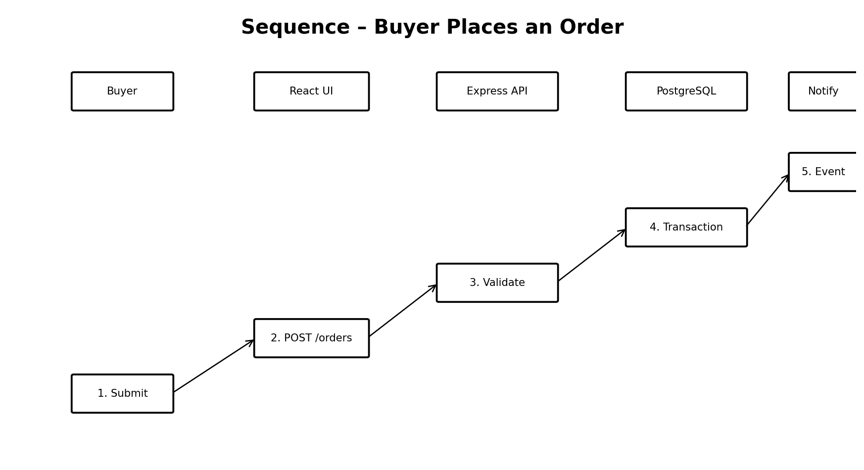
Figure 2. Buyer order sequence.

13.1 Order Workflow
- Buyer searches active listings.
- Buyer selects product and quantity.
- React sends authenticated request.
- API authenticates and authorizes buyer.
- Order service validates product and quantity.
- Inventory transaction reserves/reduces stock.
- Order records are created.
- Notification event is generated.
- API returns order ID and status.
- Buyer can track the order.

13.2 Failure Handling
- Insufficient stock: reject transaction without invalid order.
- Database failure: rollback transaction.
- Notification failure: retain order and retry notification.
- Payment outage: retain configured pending state.
- Maps outage: retain textual delivery address.

14. Deployment Architecture
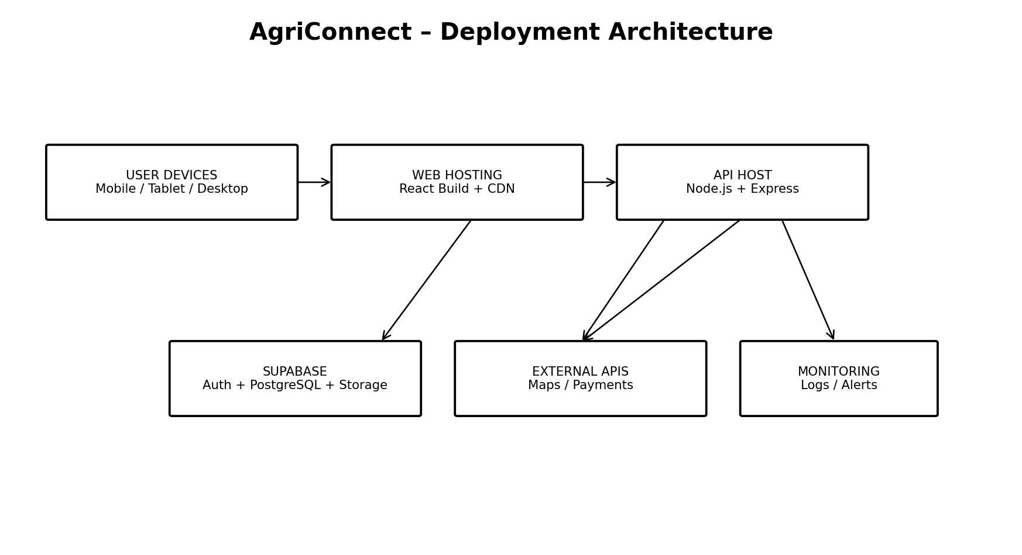
Figure 3. Proposed deployment architecture.
Environment | Purpose
Development | Local feature development and test data
Staging | Integration and acceptance testing
Production | Real deployment with protected secrets, monitoring and backups

14.1 CI/CD
- Feature branch
- Pull request/code review
- Automated linting and unit tests
- Build frontend/backend
- Security/integration checks
- Deploy staging
- Acceptance testing
- Production approval
- Monitor and rollback if needed

15. Availability, Backup and Recovery
- Use managed PostgreSQL backups with defined retention.
- Test restoration periodically.
- Separate production and development data.
- Maintain deployment rollback procedures.
- Monitor API, database, authentication and integration failures.
- Define RPO/RTO before production; do not claim untested guarantees.
Failure | Response
API instance | Restart/replace stateless instance.
Database | Use managed recovery/failover or tested restore.
Payment outage | Pending state + reconciliation.
Maps outage | Text address fallback.
Notification outage | In-app notification + retry.

16. Design Rationale
Decision | Rationale
React | Reusable components and role-based responsive dashboards.
Node + Express | Simple full-stack ecosystem and suitable API layer.
PostgreSQL | Strong relationships, constraints and transactions.
Supabase | Managed Auth, PostgreSQL, Storage and Realtime reduce infrastructure work.
Modular monolith | Avoids premature microservice complexity.
REST | Simple web/mobile interoperability.
Adapters | Avoid provider-specific code throughout business logic.
Server authorization | Prevents UI-only security and addresses API authorization risks.
Async notifications | Prevents external messaging failures from breaking core transactions.

17. Benefits and Limitations

17.1 Benefits
- Clear separation of concerns.
- Strong transactional consistency.
- Mobile clients can reuse the API.
- Providers can be replaced through adapters.
- Centralized security controls.
- Incremental scaling path.

17.2 Limitations
- Some platform dependency on Supabase.
- Modular monolith may need decomposition at very large scale.
- Internet dependence.
- Third-party cost/rate-limit risks.
- Real payments require additional compliance/security analysis.
- Production capacity planning requires further testing.

18. Architecture Decisions
ADR | Decision | Status
ADR-001 | React responsive client | Accepted
ADR-002 | Node.js + Express API | Accepted
ADR-003 | PostgreSQL through Supabase | Accepted
ADR-004 | Supabase Auth | Accepted
ADR-005 | Modular monolith initially | Accepted
ADR-006 | Provider adapters | Accepted
ADR-007 | Server-side resource authorization | Accepted
ADR-008 | Transactions for order/inventory | Accepted
ADR-009 | Asynchronous notifications | Accepted

19. Testing and Validation Strategy
Test Type | Focus
Unit | Validation, calculations, domain rules, state transitions
API | Authentication, authorization, CRUD, validation and errors
Integration | API + database + external adapters
Security | Authorization bypass, authentication, input attacks and rate limits
Performance | Search and concurrent inventory updates
Usability | Farmer/buyer workflows on mobile and desktop
Recovery | Backup restore and failure scenarios
Acceptance | Week 1 user stories and acceptance criteria

20. Architecture Risks and Mitigation
Risk | Impact | Mitigation
Database bottleneck | High | Indexes, query monitoring and future read scaling.
Third-party outage | Medium/High | Adapters, timeouts, retries and fallbacks.
Unauthorized access | High | Server authorization and security testing.
Data inconsistency | High | Foreign keys, constraints and atomic transactions.
Vendor lock-in | Medium | Isolate provider-specific operations.
Overengineering | Medium | Start modular monolith; scale only when justified.
Low connectivity | Medium | Lightweight UI and future offline support.

21. Implementation Roadmap
Phase | Focus | Deliverables
1 | Setup | Git, React, Express, Supabase, environment configuration
2 | Authentication | Login, signup, roles, protected routes
3 | Products | Categories, CRUD, images, search
4 | Orders | Order lifecycle and inventory transactions
5 | Delivery | Assignment and status tracking
6 | Notifications | In-app + external adapter
7 | Admin | Verification, moderation, reports, audit
8 | Security/Testing | Authorization, validation, rate limiting, security review
9 | Deployment | Staging, CI/CD, production and monitoring

22. Conclusion
The proposed AgriConnect architecture provides a practical foundation for implementing the Week 1 requirements. React, Node.js/Express, PostgreSQL/Supabase and isolated external integrations provide a balance of usability, maintainability, scalability and implementation simplicity.
The design emphasizes secure resource-level authorization, transactional consistency, managed identity, API validation, auditability, monitoring and controlled third-party integration. The modular-monolith approach also leaves a clear path toward future mobile applications, analytics and larger-scale deployment.

References
- Government of India – National Agriculture Market (e-NAM): https://www.enam.gov.in/web/
- Government of India – e-NAM Directory/Booklet: https://www.enam.gov.in/web/assest/download/eNAM_Directory_20210720.pdf
- OWASP API Security Top 10: https://api-security.owasp.org/
- OWASP API Security Top 10 2023: https://api-security.owasp.org/editions/2023/en/0x11-t10/
- NIST SP 800-207 Zero Trust Architecture: https://www.nist.gov/publications/zero-trust-architecture
- NIST SP 1800-35 Implementing Zero Trust Architecture: https://www.nist.gov/publications/implementing-zero-trust-architecture-high-level-document

Appendix – Suggested 30–35 Hour Architecture Work Log
Hours | Work
1–3 | Review Week 1 requirements and identify architectural drivers.
4–6 | Research agritech workflows and digital-market patterns.
7–9 | Compare monolith, modular monolith and microservices.
10–13 | Select frontend, backend, database and managed services.
14–17 | Define components and module boundaries.
18–20 | Design database and transaction boundaries.
21–23 | Design REST API, middleware and authorization.
24–26 | Design security controls and integrations.
27–29 | Create architecture, sequence and deployment diagrams.
30–32 | Evaluate scalability, availability, backup and recovery.
33–35 | Review decisions, risks, limitations, diagrams and document quality.

ENHANCED RESEARCH, EVIDENCE AND ORIGINAL DESIGN ANALYSIS
This supplementary section deepens the original architecture report with research findings, practical scenarios, traceability from evidence to design, explicit acceptance criteria and original architectural insights. Research figures below describe the cited national programmes or study estimates; proposed performance targets are project goals, not measured results.

1. Detailed Research Findings

1.1 Post-harvest loss and perishable inventory
The Ministry of Food Processing Industries has published results from a NABCONS assessment of post-harvest losses. The reported loss range is 6.02–15.05% for fruits and 4.87–11.61% for vegetables. These are study estimates across categories and contexts, not a prediction for every farm. They indicate why digital agribusiness software should represent freshness and collection timing rather than treating all available stock as interchangeable.
Design implication: a product listing should include commodity, grade/quality, quantity, unit, harvest date/time, pickup location, collection window, seller and active status. Search should support freshness and location filters. A listing with a passed collection window should be flagged for seller review or deactivated according to a documented policy.

1.2 Digital agricultural marketplace scale
PRS Legislative Research's review of the 2024–25 agriculture budget reported that e-NAM had 1,389 mandis across 27 States/Union Territories by 30 June 2024, with 1.8 crore farmers and 2.5 lakh traders registered for the reported period, and 1.72 lakh unified licences. These numbers describe e-NAM, not AgriConnect. They illustrate the scale and diversity that agricultural digital platforms may need to support.
Design implication: use indexed search filters, pagination, stable identifiers, clear onboarding, role-aware permissions and auditable order histories. Do not load the full catalogue into the browser or rely on client-side filtering for security.

1.3 Public investment in digital agriculture
The Government of India's Digital Agriculture Mission was approved in September 2024 with an outlay of ₹2,817 crore. Its stated direction includes digital public infrastructure, AgriStack and a Krishi Decision Support System. AgriConnect should therefore make future data-provider integration possible without assuming that any particular government dataset is automatically available, licensed for reuse or suitable for a given purpose.
Design implication: put external data behind provider adapters; store the source and retrieval timestamp; validate freshness and format; define consent, ownership and licensing before integrating personal or farm-level data.

1.4 API security and explicit trust
OWASP's API Security Top 10 (2023) includes broken object-level authorization, broken authentication and unrestricted resource consumption. NIST SP 800-207 explains that network location alone must not create implicit trust. In this system, a valid login is not enough: the API must check whether the user can access the specific listing, order, delivery or payment record referenced by each request.
Design implication: every protected route needs authentication, resource-level authorization, input validation, bounded pagination and suitable rate limits. Frontend route guards improve user experience but are not a security boundary.

2. Evidence-to-Architecture Traceability
Evidence / challenge | Architectural consequence | Concrete response | Validation
Fruit loss estimates: 6.02–15.05%; vegetable loss: 4.87–11.61% (MoFPI/NABCONS assessment) | Freshness and collection timing matter to usable supply. | Store harvest time, grade, quantity, unit, pickup window and listing status. | Create old/new listings and test freshness filters and expiry rules.
e-NAM reported 1,389 mandis and 1.8 crore farmer registrations in the reported 2024 period | Search, identity and audit design should not assume a tiny catalogue. | Indexed filters, pagination, normalized profiles and auditable status history. | Load synthetic catalogue data and measure p95 search response.
Digital Agriculture Mission outlay: ₹2,817 crore, approved 2024 | Future data integrations need clear boundaries and governance. | Provider adapters; record source/time; validate and label external data. | Simulate unavailable, malformed and stale provider responses.
OWASP API risks include object-level authorization and excessive resource use | Record IDs and high-volume endpoints are attack surfaces. | Ownership checks, rate limits, request-size limits and audit logs. | Cross-user GET/PATCH/DELETE tests and rate-limit tests.
NIST zero-trust principle | Internal network location should not bypass checks. | Verify identity and permissions for each sensitive operation; least privilege. | Test expired/missing tokens and denied operations.

3. Concrete Agribusiness Scenarios

3.1 A farmer lists a perishable lot
A farmer has 300 kg of tomatoes harvested this morning. The farmer creates a lot with quantity 300 kg, unit kg, price per kg, grade, harvest timestamp, pickup location and collection window. The API validates positive quantity, allowed unit, required fields and listing ownership. Search results show harvest time and remaining quantity alongside price. Buyers can distinguish a newly harvested lot from a listing whose pickup window has passed.

3.2 Buyer places a partial order
A buyer requests 80 kg from the 300 kg lot. The order service checks that the listing is active and stock is sufficient, creates the order and reserves 80 kg within one database transaction. The remaining available quantity becomes 220 kg if the chosen inventory policy deducts reservations from available stock. If any part of the transaction fails, the order and stock change roll back together. A cancellation releases reserved stock only through a valid state transition.

3.3 Two buyers compete for the final stock
Suppose only 50 kg remains and two buyers simultaneously request 35 kg each. A read-then-write implementation could accept both requests and produce negative stock. Use an atomic conditional update or row-level locking inside a transaction. For example, update inventory only where available_qty is at least the requested quantity, then verify exactly one row was updated. One request succeeds; the other receives an insufficient-stock response. This is a required concurrency test.

3.4 A user tries to edit another farmer's listing
A user guesses another farmer's product ID and sends PATCH /api/v1/products/{id}. The API verifies the session, loads the listing and checks ownership or an explicitly permitted administrator role. Hiding the Edit button in React is not sufficient. The API denies the request without disclosing private information and records a security event.

3.5 Duplicate payment callback
Payment providers may retry callbacks after timeouts. Verify the callback signature and store a unique provider event/reference ID. Processing the same event twice must not create duplicate payment records or advance an order twice. A browser redirect is not proof of payment; the verified server-side provider status is authoritative.

3.6 Maps or SMS outage
If the maps API times out during checkout, preserve the textual delivery address and allow the order to be saved when required address validation succeeds. If SMS fails after order creation, keep the order committed and retain an in-app notification for retry. External integrations should enhance core workflows, not silently corrupt or cancel them.

4. Original Architectural Insights

4.1 Model time-sensitive supply, not just products
A commodity name, price and quantity do not fully describe a perishable lot. Harvest time, grade, pickup window and remaining quantity affect whether the supply is usable. Separate the listing from inventory movements and from the order snapshot. Order items should preserve agreed price, unit and product description so later listing edits cannot rewrite transaction history.

4.2 Search should optimize practical fulfilment
A lowest-price-only result may be too far away, too small, too old or unavailable in the buyer's collection window. Apply hard filters first—active status, commodity, minimum quantity and feasible location—then rank by configurable factors such as price, distance, freshness and seller reliability. Explain the ranking criteria to users and evaluate them with feedback rather than claiming the score is objectively optimal.

4.3 Separate order state from notification state
An order can be confirmed while its SMS is pending or failed. Model commercial state and notification delivery as separate state machines. This enables retries and auditing without blocking the core transaction on a third-party messaging service.

4.4 Preserve traceability while minimizing data collection
Audit records should capture actor, action, entity, timestamp and minimal safe metadata. They should not contain passwords, access tokens, full payment credentials or unnecessary personal information. Traceability supports dispute handling and security investigation without turning logs into a second store of sensitive data.

4.5 Start simple, but make module boundaries real
A modular monolith is suitable for a student project because it avoids distributed deployment and consistency overhead. Still, ProductService should own listing rules, InventoryService stock adjustments, OrderService state transitions and PaymentService provider verification. If measurements later identify search or notifications as bottlenecks, those modules can be extracted without first untangling business rules from controllers.

5. Proposed Non-functional Acceptance Criteria
These are proposed test targets, not measured results or production guarantees. Review them after baseline testing in the chosen hosting environment.
Attribute | Proposed criterion | Test method
Search performance | p95 product-search response <= 2 seconds for an agreed baseline dataset/load. | Repeatable load test; report p50, p95 and p99.
Inventory integrity | No successful order causes available quantity to become negative. | Concurrent requests against deliberately limited stock.
Authorization | Users cannot access or modify another user's private listing/order without explicit permission. | Automated cross-user API tests for GET/PATCH/DELETE.
Input validation | Negative price, non-positive quantity, unsupported units and malformed IDs are rejected. | Schema and boundary-value tests.
Resilience | Maps/SMS failures do not roll back a valid order; failed notifications remain retryable. | Mock timeouts, HTTP 429 and HTTP 5xx provider responses.
Payment idempotency | Duplicate verified callbacks produce one logical payment completion. | Replay the same event/reference ID.
Observability | Requests have traceable request/order IDs and logs contain no secrets. | Inspect structured logs for success and failure paths.
Recovery | A documented backup restoration is tested in a non-production environment. | Restore test data and verify order/inventory consistency.

6. Data and Transaction Refinements
Recommended database constraints include quantity > 0, price >= 0, reserved_qty >= 0, foreign keys and unique payment-provider event IDs. Use a decimal/numeric type for money rather than floating-point values. Store timestamps consistently, normally in UTC, and convert them for display. Every quantity must have an explicit unit; validate unit compatibility before calculating totals.
Define an order state machine, for example pending → confirmed → preparing → dispatched → delivered, with cancellation/refund paths allowed only under documented conditions. Each transition must specify the permitted actor and preconditions. A buyer may be allowed to cancel before dispatch, while a distributor updates delivery progress. Invalid transitions such as delivered → preparing must be rejected. Model payment state separately—pending, paid, failed or refunded—so order and financial state cannot silently contradict each other.
Choose one authoritative inventory source. If both products.quantity and inventory.available_qty exist, document which field is authoritative and update both within the same transaction; otherwise remove the redundant field. Listing deactivation should prevent new purchases but preserve completed orders, order-item snapshots and audit history.

7. Expanded Security Checklist
- Reject missing, expired or malformed credentials on protected routes.
- Check resource ownership for each listing, order, delivery, payment and uploaded file.
- Combine role checks with ownership checks; authentication alone is insufficient.
- Validate request bodies with schemas and reject unexpected or oversized payloads.
- Apply rate limits to login, search, order creation, uploads and other abuse-prone endpoints.
- Use parameterized database operations and avoid building SQL from user-provided strings.
- Keep service-role keys and payment secrets on the server; never expose them in frontend bundles or logs.
- Verify payment webhooks and make callback processing idempotent.
- Use private storage by default for sensitive documents and validate upload type and size.
- Redact secrets and unnecessary personal data from application and audit logs.
- Test account recovery, session expiry, CORS configuration and production HTTPS.
- Review Supabase Row Level Security policies wherever client access reaches database tables directly.

8. Risk Analysis with Concrete Examples
Risk | Example impact | Mitigation | Residual concern
Unstable connectivity | Farmer cannot finish a long listing form. | Lightweight pages, clear retry messages and safe draft saving. | Offline order submission needs synchronization/conflict design.
Incorrect listing data | Buyer orders unavailable quantity or incorrect grade. | Required fields, units, timestamps, seller edit history and confirmation. | Human-entered quality claims may remain inaccurate.
Stock race condition | Two buyers reserve the same final quantity. | Atomic updates/locking and concurrency tests. | High volume may require further tuning.
External provider outage | Map, SMS or payment status is delayed. | Timeouts, bounded retries, pending state and reconciliation. | Some final states depend on provider confirmation.
Unauthorized record access | Buyer sees another buyer's address or edits a listing. | Server authorization and automated negative tests. | Rules must be updated as new roles are introduced.
Stale market data | Users rely on an outdated price observation. | Display source/time and flag stale data. | External datasets may be incomplete or licensed for limited use.
Overengineering | Team spends more time operating services than delivering features. | Modular monolith and evidence-based scaling. | Future growth may justify splitting workloads.

9. Suggested Demonstration and Evaluation Plan
Demonstrate normal and failure paths using two farmer accounts, one buyer and one distributor. Create a 300 kg tomato lot; search by commodity and pickup area; place an 80 kg order; verify remaining quantity; attempt concurrent orders that exceed stock; attempt to edit the listing as the second farmer; simulate an SMS timeout; replay a payment callback; and inspect the audit trail. Capture screenshots or automated test output for each step.
Demonstration | Expected result | Evidence
Farmer creates a lot | Listing appears with quantity, unit, harvest date and pickup location. | UI screenshot and database record.
Buyer orders 80 kg of 300 kg | Order is created and 220 kg remains available/reserved under the chosen policy. | Order confirmation and inventory values.
Concurrent orders exceed stock | Only valid quantities are accepted; stock never becomes negative. | Automated test output or API logs.
Other farmer edits listing | Request is denied without leaking private record details. | HTTP response and security test result.
Notification timeout | Order remains committed and notification is retryable. | Order record and notification status.
Duplicate payment event | Payment is processed once logically. | Payment/event record.
Backup restoration | Restored test environment has consistent orders and inventory. | Restore checklist and validation results.

10. Additional Research References
- Ministry of Food Processing Industries, Government of India. Annual reports and NABCONS post-harvest loss assessment materials. https://www.mofpi.gov.in/
- PRS Legislative Research. Demand for Grants 2024–25: Agriculture and Farmers Welfare. https://prsindia.org/
- Press Information Bureau, Government of India. Digital Agriculture Mission announcement, September 2024. https://pib.gov.in/
- OWASP Foundation. OWASP API Security Top 10 – 2023. https://owasp.org/API-Security/
- National Institute of Standards and Technology. SP 800-207, Zero Trust Architecture. https://www.nist.gov/publications/zero-trust-architecture

