RGB LED DISPLAY

--Installation Procedure--
1. Procedure to install Arduino IDE.
2. Install Libraries / ESP-32S3 – DEV Module.
3. Setting up Credentials(SSID, Password, Static IP).
4. Excel Sheet Settings.
5. Hardware Setup.
6. Output.

- Procedure to install Arduino IDE.
- Go to “https://www.arduino.cc/en/software”, and install the arduino with version 1.8.19
as shown in the picture below:
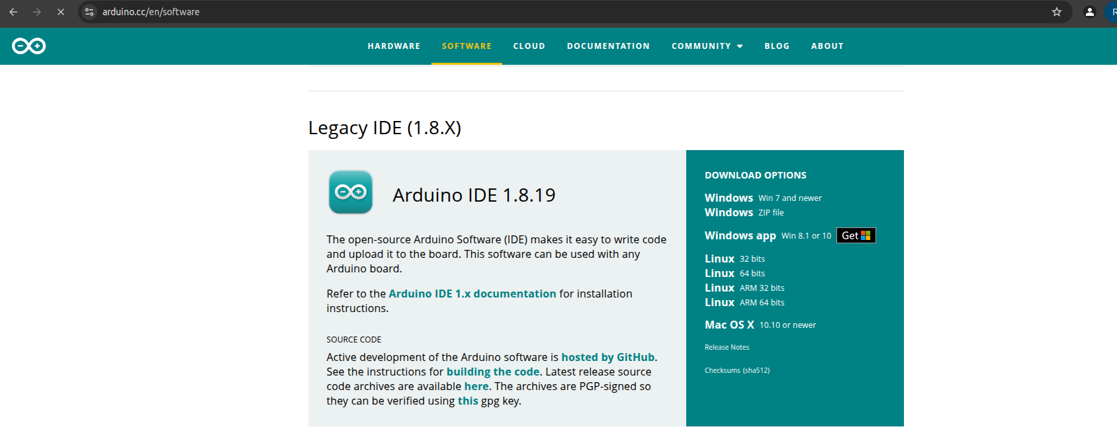

- Now select the version, as shown in the highlighted part below,
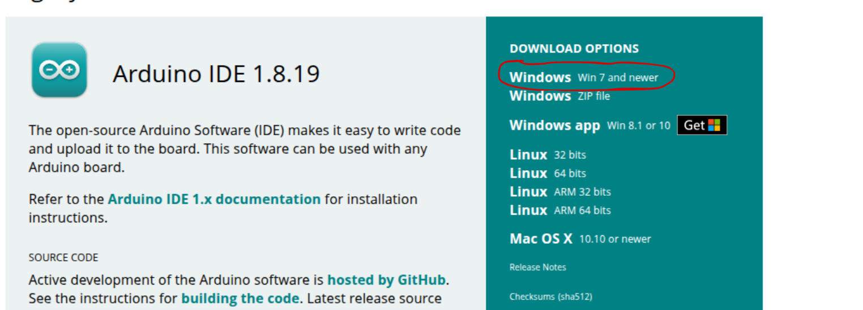

- After selecting the version, click on the “Just Download” button,

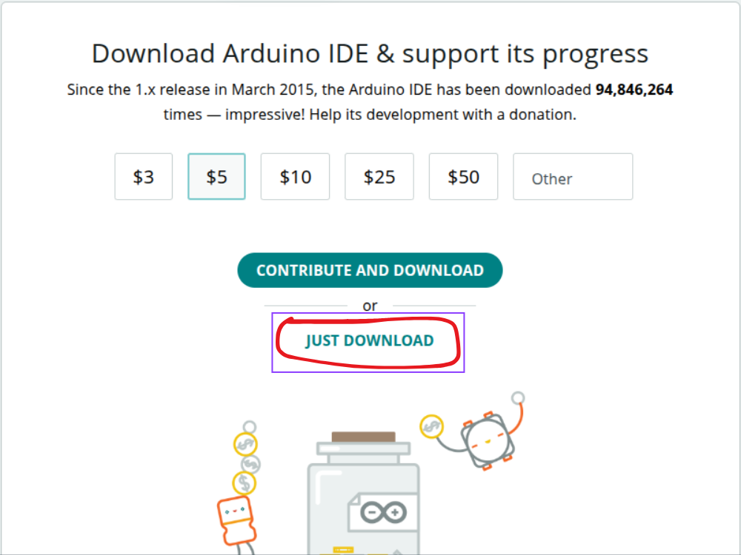
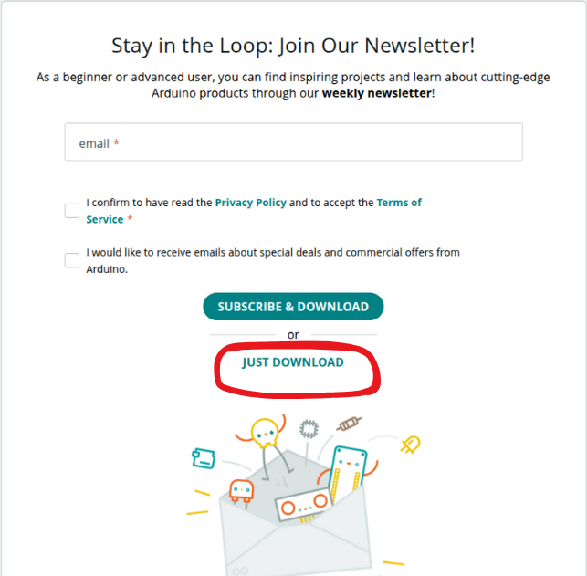
- Keep pressing the ‘Just Download” button , as shown

- Now extract and install the , downloaded, “ZIP FILE”.
- This complete your Arduino IDE Installation.

2.1 Install ESP-32S3 – DEV Module

- In the tools section go to --->Board----->Board Manager, then select as shown below and press install (select the highlighted version – 2.0.11)

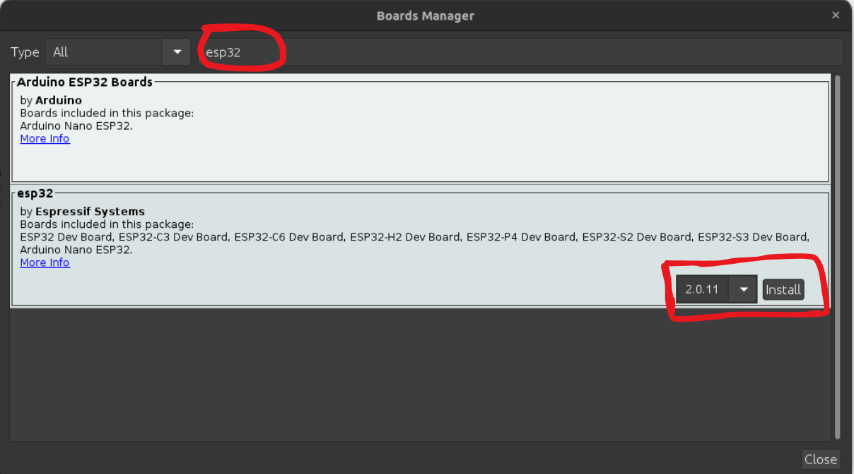

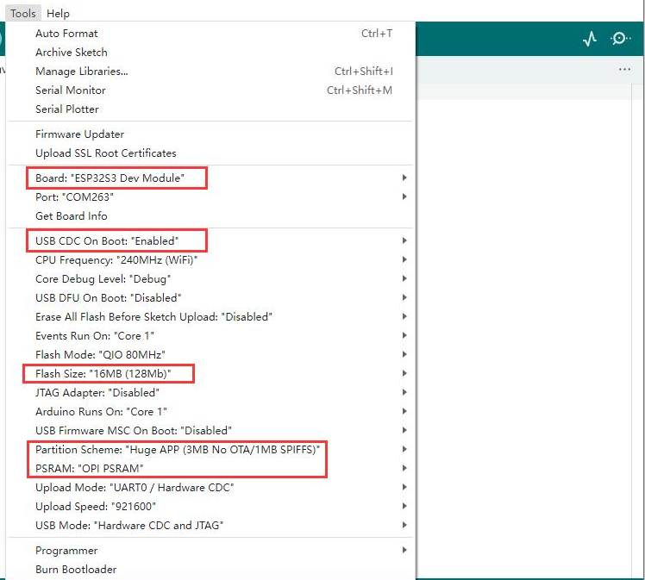
2. After installing the board, then select the board specifications as shown

NOTE: While uploading the code for first time you need to Erase the running code to do that follow the procedure as Click on “Erase all Flash Before Sketch Upload” click on “enable” then upload thw code. Now after erasing current code. One again Click on “Erase all Flash Before Sketch Upload” now “disable” then upload the code.

- You need to select the port while uploading the code to -
Port - /dev/ttyACM0 (ESP32 Family Device)

2.1.2 Install libraries
- Install all the below libraries.
- Click on Tools > Library Manager
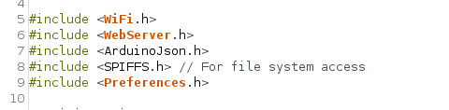

- select the libraries as show below
- wifi.h : for ESP32, gets installed automatically when you install the ESP32 board package via the Boards Manager.
- Webserever.h:
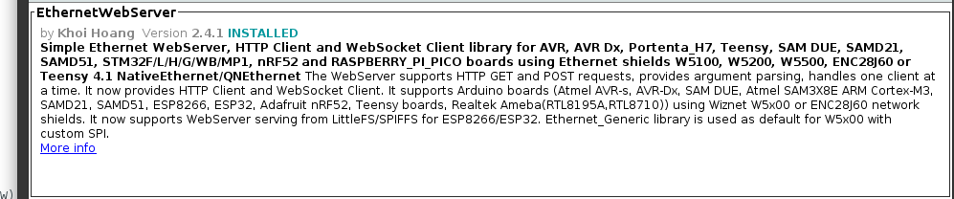
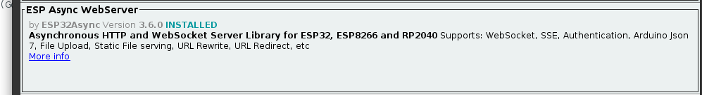
- install both the above webserver

3. ArduinoJson.h:
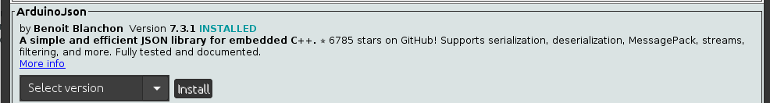
- install the above library for ArduinoJson.h

4. SPIFFS.h:

Install ESP32 SPIFFS Upload Tool

Download the tool
Go to this GitHub repo:
“https://github.com/me-no-dev/arduino-esp32fs-plugin”
- Click the green "Code" button.
- Select "Download ZIP".
- After downloading Click on Sketch > Include libraries > Add .zip folder click on add (this process should be followed in arduino while downloading SPIFFS.h.
5. Preferences.h:
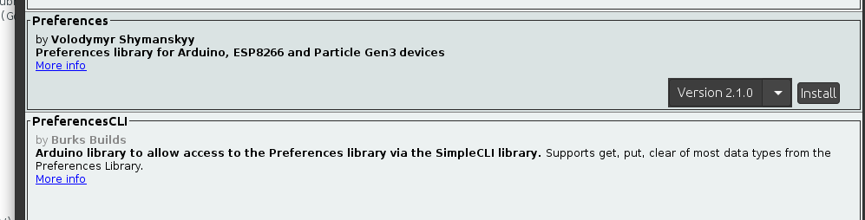
- Install both the files ”Prefrences” and “PreferencesCLI”.

3. Setting up Credentials(SSID, Password, Static IP).
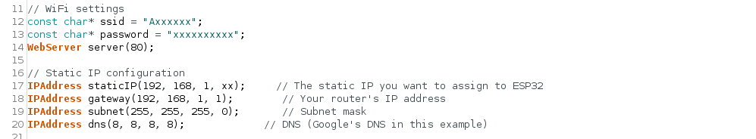
- In code change change the Credentials for wifi and set the static IP Address as shown in below picture.

4. Excel Sheet Settings.
- Here below there are two sections “Sheet1” for colour changing “setting” for IP setup.
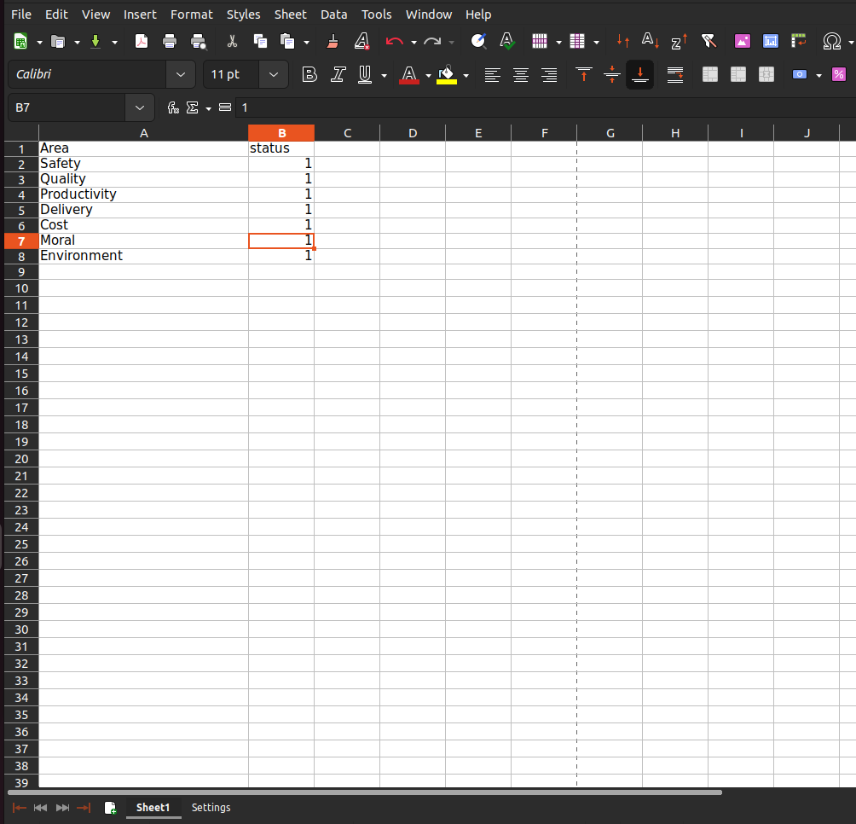
- Here in “sheet1” can change the colour of display by assigning numbers to them ie: 1 for “red” , 2 for “green” , 3 for “yellow” other than this numbers the diplay will turn to its default colour “white”.

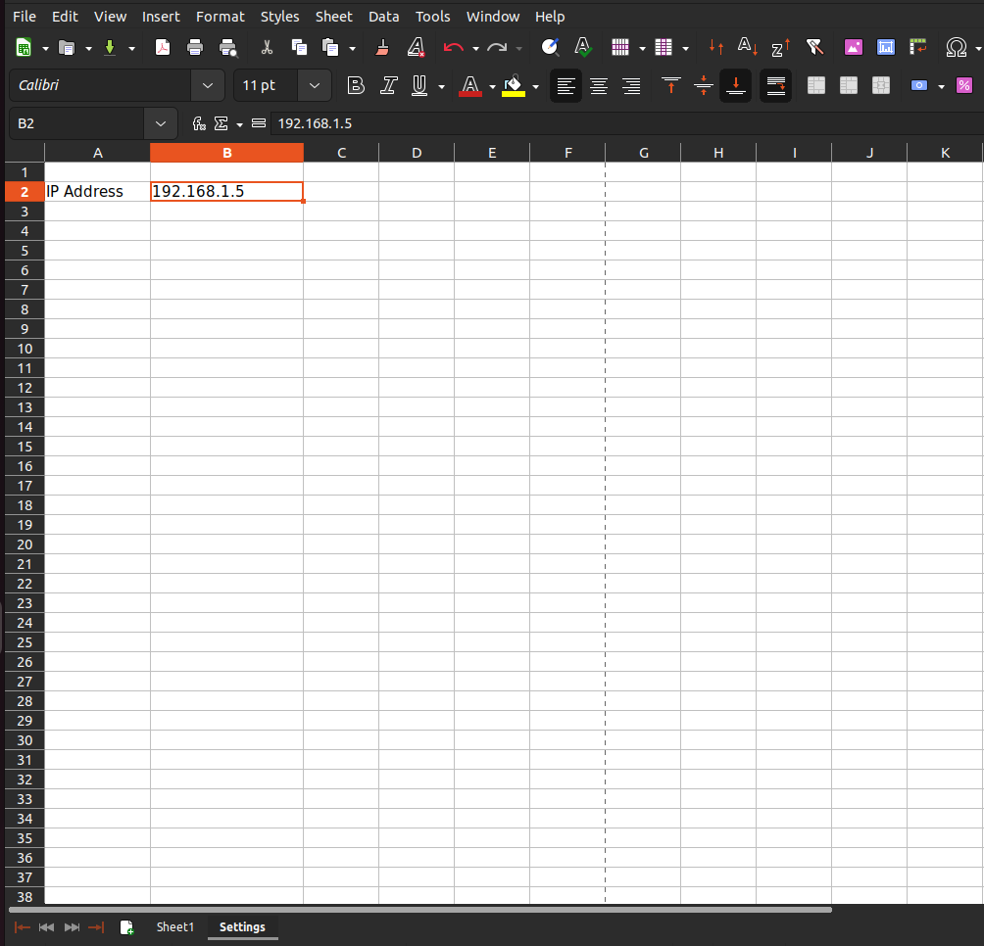
- In this “Settings” Section we can set the IP Address to maintain connectivity between device and EXCEL sheet.

5. Hardware Setup.
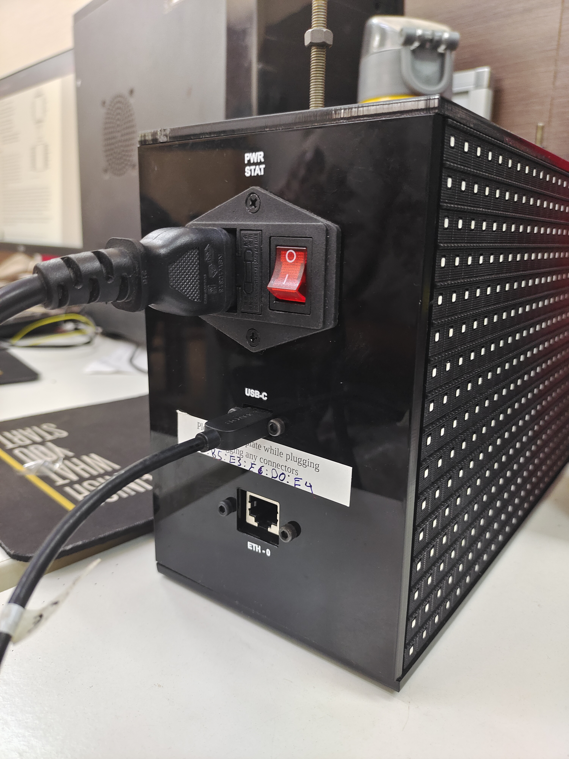
- Connect the USB- C Cable to thr device

2. connet the same cable to the system
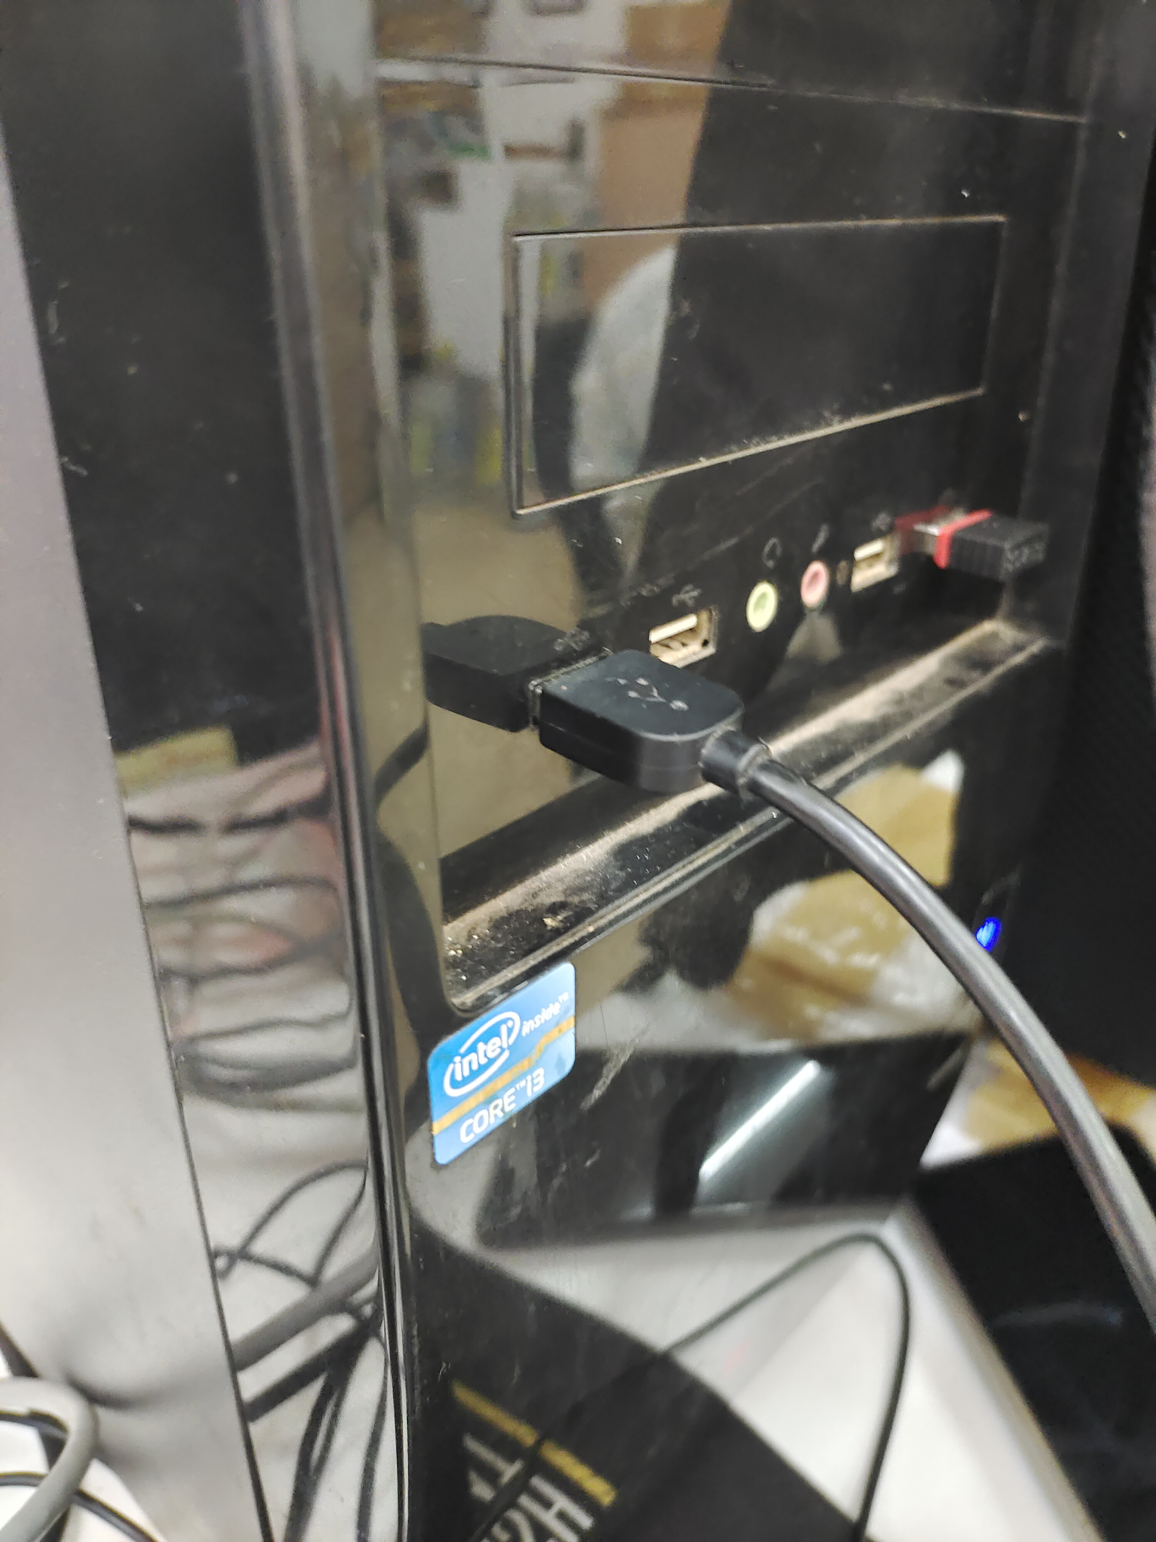

6. Output.
- After uploading code open serial monitor where u can see the output as:


