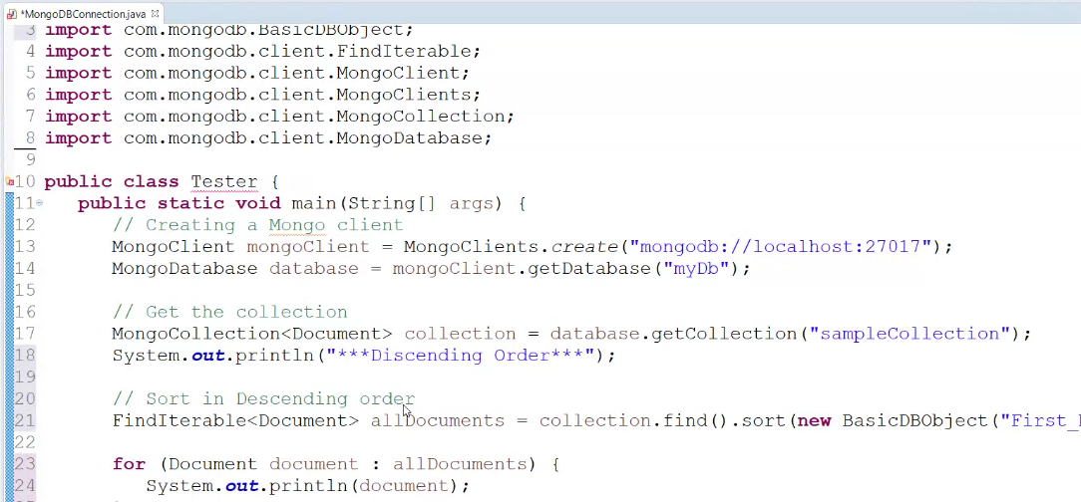

**Work:**

db.sales.insertMany([

{ "_id" : 1, "item" : "Americanos", "price" : 5, "size": "Short", "quantity" : 22, "date" : ISODate("2022-01-15T08:00:00Z") },

{ "_id" : 2, "item" : "Cappuccino", "price" : 6, "size": "Short","quantity" : 12, "date" : ISODate("2022-01-16T09:00:00Z") },

{ "_id" : 3, "item" : "Lattes", "price" : 15, "size": "Grande","quantity" : 25, "date" : ISODate("2022-01-16T09:05:00Z") },

{ "_id" : 4, "item" : "Mochas", "price" : 25,"size": "Tall", "quantity" : 11, "date" : ISODate("2022-02-17T08:00:00Z") },

{ "_id" : 5, "item" : "Americanos", "price" : 10, "size": "Grande","quantity" : 12, "date" : ISODate("2022-02-18T21:06:00Z") },

{ "_id" : 6, "item" : "Cappuccino", "price" : 7, "size": "Tall","quantity" : 20, "date" : ISODate("2022-02-20T10:07:00Z") },

{ "_id" : 7, "item" : "Lattes", "price" : 25,"size": "Tall", "quantity" : 30, "date" : ISODate("2022-02-21T10:08:00Z") },

{ "_id" : 8, "item" : "Americanos", "price" : 10, "size": "Grande","quantity" : 21, "date" : ISODate("2022-02-22T14:09:00Z") },

{ "_id" : 9, "item" : "Cappuccino", "price" : 10, "size": "Grande","quantity" : 17, "date" : ISODate("2022-02-23T14:09:00Z") },

{ "_id" : 10, "item" : "Americanos", "price" : 8, "size": "Tall","quantity" : 15, "date" : ISODate("2022-02-25T14:09:00Z")}]);

**MongoDB Code:**

db.sales.aggregate([

{

$group: {

_id: { item: "$item", size: "$size" },

maxPrice: { $max: "$price" }

}

},

{

$sort: { "_id.item": 1, "maxPrice": -1 }

},

{

$group: {

_id: "$_id.item",

sizeWithMaxPrice: { $first: "$_id.size" },

maxPrice: { $first: "$maxPrice" }

}

}

])

**JDBC CODE:**

package connection;

import org.bson.Document;

import com.mongodb.client.MongoClient;

import com.mongodb.client.MongoClients;

import com.mongodb.client.MongoCollection;

import com.mongodb.client.MongoDatabase;

import static com.mongodb.client.model.Aggregates.*;

import static com.mongodb.client.model.Accumulators.*;

import static com.mongodb.client.model.Sorts.*;

import java.util.Arrays;

public class MongoDB {

public static void main(String[] args) {

try (MongoClient mongo = MongoClients.create("mongodb://localhost:27017")) {

MongoDatabase db = mongo.getDatabase("vit");

MongoCollection<Document> sales = db.getCollection("sales");

sales.aggregate(Arrays.asList(

group("$item",

max("maxPrice", "$price"),

addToSet("sizes", "$size")

),

sort(descending("maxPrice"))

)).forEach((Document doc) -> {

System.out.printf("%-10s: $%2d (Sizes: %s)%n",

doc.getString("_id"),

doc.getInteger("maxPrice"),

doc.getList("sizes", String.class));

});

}}}