

Functional Specification Document for

uTax EMP Project: Administrative Functions

Version 2

**Revision History & Approval Details**

|  |  |  |  |  |  |
| --- | --- | --- | --- | --- | --- |
| **Version No** | **Date** | **Brief description of changes** | **Author** | **Reviewed By** | **Approved By** |
| V1 | 7/7/2016 | Baseline Document | Jhansi M | Saikumar C |  |
| V2 | 7/12/2016 | Document updated with changes for Banks Master Management and Affiliate Program Management | Jhansi M | Saikumar C |  |

Contents

1. INTRODUCTION: 4

2. uTax Administrative Roles : 4

2.1. User Administration 4

2.2. Integration Requirements related to Salesforce, CL QB, etc. 5

2.3. Bank and Bank related Questions 8

2.4. Sales Year Management 8

2.5. Fees Master Management 13

2.6. Security Questions Management 13

2.7. Tooltip Management 17

2.8. Phone Type Management 21

2.9. Contact Person Title Management 24

# INTRODUCTION:

Overview: uTax currently provides tax preparation software, bank product and electronic filing services to tax professionals within the income tax preparation industry. Customers of uTax comprises of individual tax offices, multi-office customers who own several tax preparation offices and Service Bureaus (SVB) who co-brand and resell the uTax software and services to their customers (SVB sub-sites). uTax would like to build a customer/sub-site facing section of online portal (EMP) that will allow all customers (or the Main site if they are controlling enrollment of their sub-sites) to complete the sites bank enrollment and general office information that will be used to activate the sites ability to submit E-filings of federal and state tax returns and bank products for their clients.

Scope: This document explains the high level process flow and the actors involved in the new EMP portal (Enterprise Management Portal)

# uTax Administrative Roles :

## **User Administration**

This feature allows uTax the ability to manage the various users on its side who will be accessing the application. These could be users from the Enrollment, Support, Management, Accounts, etc., who have various roles and functions in the application.

## Role and Permission-Based Security

Because this portal will be servicing different types of customers, including internal uTax staff, security and user level access will need to be developed to grant access to each different subset of users.

The management of system access, including user account creation, login and password management, read/write permissions for objects and records within EMP are defined below.

Note: In the future (Phase 3 or 4), we plan to allow our direct sites (SO, SVB/MO Main sites) to create additional users per site, meaning, they can have different staff accessing the EMP with specified Editing/Viewing rights. The login permissions that will be required to enter EMP are: User ID, Username, and Password.

### Requirements

The system should allow a user to:

* Login to the system using a user name and password
* Retrieve a missing password
* Change a password

The system should allow a system administrator to:

* Create user accounts, including login name, password, and appropriate roles and permissions.
* Activate and deactivate user accounts
* Create rules/guidelines for password creation
  + - Example:
    - Require users to change password up 1st entering site
    - Password length or special characters
* Create a user profile or “Role”
* Link a user account to the Role
* Change a user's password
* Reset a user’s password to default
* Activate/inactivate a user account
* View/export all user profiles

The system should allow authorized users to:

* Provide security for different levels of users, e.g. Administrator, Customer Service Representative, Accounting, Sales, etc.
* Send an email to the user (automatically) with the credentials and login URL when account is first created.
* Define security at the function level, e.g. allow a user to read and/or write data entry functions only.
* Limit access to one or more specific sections within the system, e.g. Fee Configuration, Sub-Site Configuration, View/Edit enrollment, etc.
* Limit access to a specific record or group of records within the system, e.g. (uTax users access all records, SVB-Main / MO-Main access only their Sub-sites, etc.).
* Restrict certain functions to authorized personnel only, e.g. certain user group has read-only access, another user group has ability to modify/delete data.

### Users

uTax needs the ability to create and manage EMP Portal users.

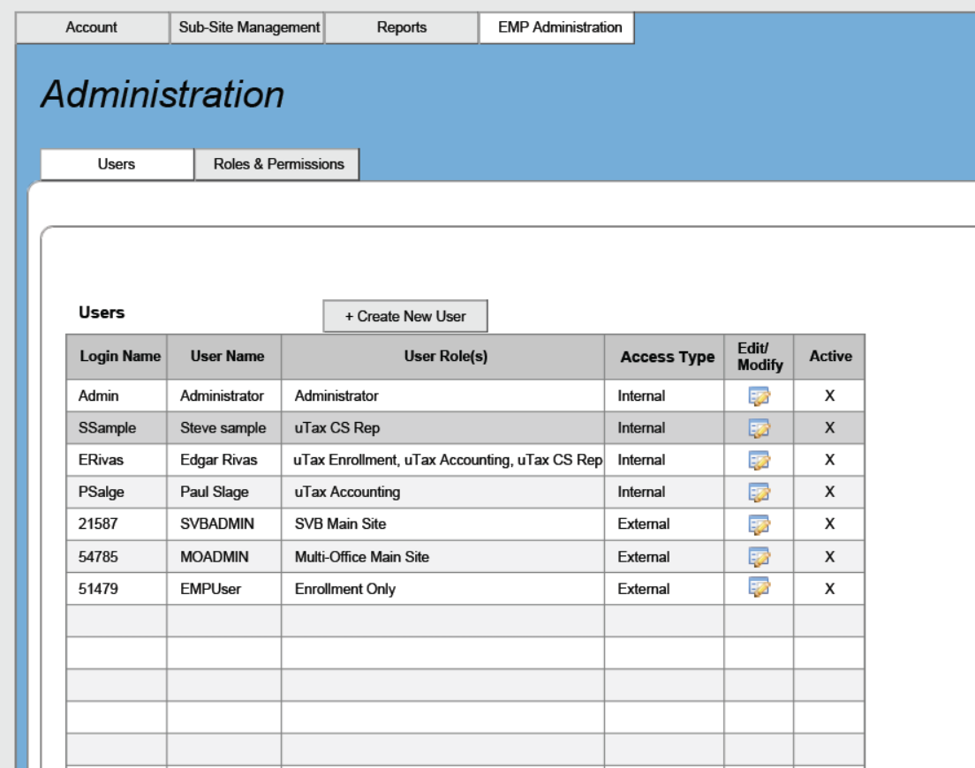

When creating a new user, the following fields will need to be completed and displayed in a grid for easy viewing and access:

* Login Name
* User Name
* Password
* User Role(s) – as defined in the Roles and Permissions section
* Access Type – Internal or External
* Active Status – Active or Inactive
* Ability to sort columns by alphabetical order
* Ability to search for login or user name

The grid should be used to access the user’s specific information and permissions by clicking on an edit icon.

A “new” button (or icon) should appear to add new users to the EMP system.

SO and Sub-sites will only have access to the Enrollment portion of EMP. The SVB/MO Main site will control what the Sub-site sees and doesn’t see. In the future, we plan to add Reports to this section of EMP for the SO and Sub-sites to access and report accessibility will need to be considered as some SVB/MO Main sites might not what their users to see certain reports. This will likely be part of a Phase 2 or 3 request.

### Roles and Permissions

#### Roles

uTax needs a location to setup the different roles that are assigned to specific subsets of users. These roles will help define what the users will be able to view, edit, or not view at all. A simple grid with these Roles needs to display:

* Ability to Add a new Role
* Role Name
* Group User Type
* Access Type
* Ability to Edit/Modify the permissions

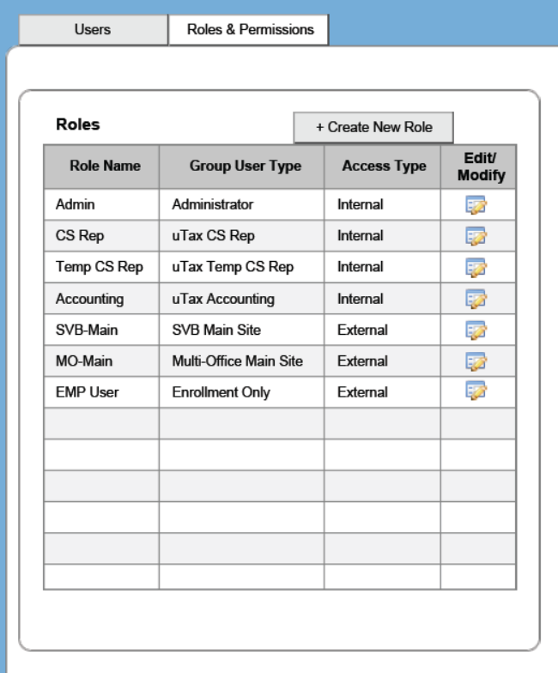

#### Permissions

In the Permissions section, the User Administrator will be able to define which sub-sections the Role will have access to by assigning the flowing permissions to each section:

* No Access (Not viewable)
* Read (only)
* Edit/Modify

The Administrator will need the ability to:

* Create, Edit, and Delete a Role– alpha/numeric data entry box
* Identify the Access Type – select Internal or External
* Define the group User Type
* Add a description of the user role

Security will be built around the tabs in the Management section of the EMP portal. These tabs will be broken further into the sub-sections identified in each tab. Access can be granted by tab or by section (when you expand the detail of the tab) as illustrated below.

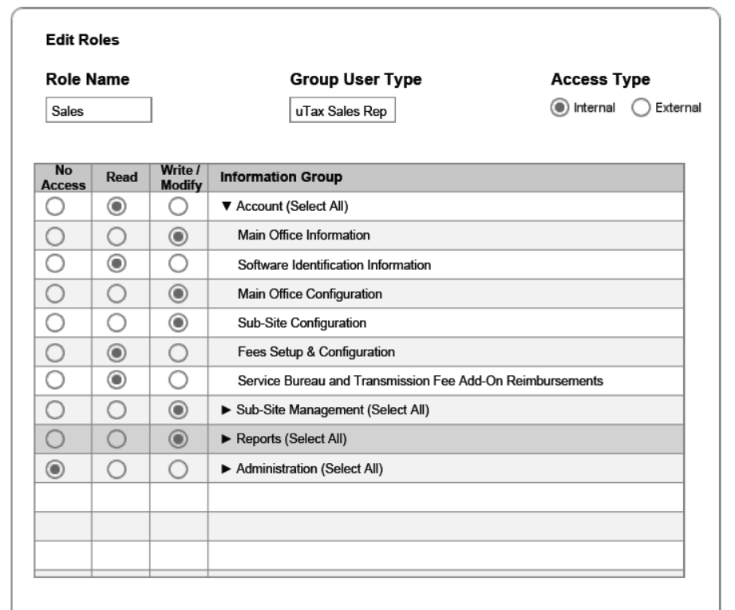

Once the Roll Permissions are set, a Role can be assigned to a user or Group User Type. Multiple rolls can be assigned to the user, with the least restrictive access taking priority – meaning – if a user is assigned a Support Role which has only read access and is assigned an Accounting roll which is able to edit the Account section, the Account section editing access with take priority.

### Site Deactivation

We need functionality that will allow us to deactivate all EMP site access (and/or individually) for sites that have not signed (Closed/Won) in SalesForce for the upcoming tax season or have not been Activated by the SVB/MO Main site at any time.

## **Integration Requirements related to Salesforce, CL QB, etc.**

This section primarily controls and defines the credentials or information required for the EMP application to connect or interact with the various 3rd party applications like Salesforce, Crosslink and Quickbooks.

The key connectivity information, schedules, credentials and associated information is managed from this section. A SQL database will be used to manage the data that flows from QuickBooks and to/from SalesForce and Crosslink.

This section will also include the ability to manage the details of the Email Account to be used for sending out any notifications and alerts, etc. from the application.

**User Interface**

The landing page for this function is accessible on the Administrative menu under “Integrations Management”. Clicking on this function presents the following user interface:

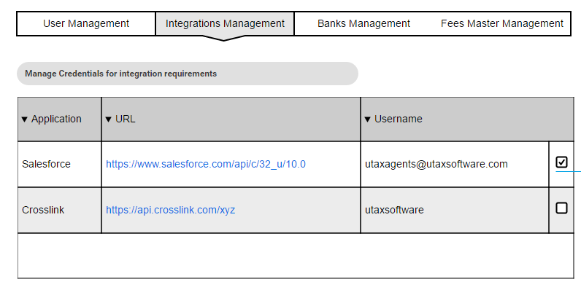

**Functionality Description**

The application presents the user with the information related to the various applications which are being used for integrations. Access to this functionality will be identified based on the permissions defined for the logged in user’s role.

The permitted user will have the ability to Edit and manage the information with the configured integration partner(s). There will not be an ability to add a new one from the interface since the requirement for that will be determined based on the development process.

Once an integration association or partner is required and there is a need for access details or credentials to be managed for business operations, the same would be made available in this interface.

Clicking on the “Edit” button next to the respective integration partner brings up an user interface block that looks like the following:

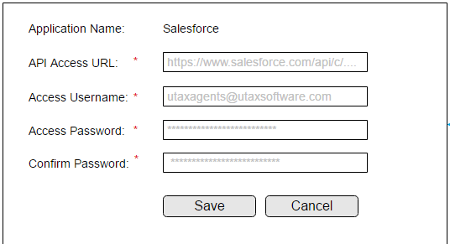

The name of the Integration partner or application is derived based on the entity for which the Edit button was clicked for.

The detailed description about the fields and actions involved are explained in the tabulation below:

|  |  |
| --- | --- |
| **Function ID** | Integrations Management |
| **TITLE** | Integrations Management – For Admin |
| **INPUT** | |  |  |  | | --- | --- | --- | | **Field Name** | **Data Type** | **Comments/value** | | Application Name | Label | The name of the integration partner or application will be displayed here | | Access URL | Text Field | This field captures the URL which is being accessed by the service processing the integration | | Access Username | Text field | This field will be used to capture the information related to the Username or the API Key as required for the background service integrating with the partner application | | Access Password | Text field (Masked) | This field will be used to capture the information about the password required to access the respective integration service | | Confirm Password | Text field (Masked) | This field serves to make sure that the user has specified the right (and the same) information in the password field and verified it again in this field. | | Save | Button | Used to update the access URL and Credentials associated with the respective integration service to the backend database. | | Cancel | Button | Used to cancel and discard any changes that were made on screen and return back to the main grid which displays the details of all active integration services | |
| **OPERATION** | * The landing page for the Integrations management is controlled and managed by user permissions as defined for the role that the user is assigned with * Once the user has determined to have access to the Integrations Management feature in Admin Functions, this menu option will be made visible to the user * Clicking on the menu, brings up a page which displays the information about all integration services which are currently defined in the application database and actively used * There is “No” provision to add a New Integration service from the interface instead that would be something which is managed at the backend based on the development requirements * For each of the active integration services displayed, there is only one function available which is to “Edit” and modify * Clicking on Edit presents the information related to the specific integration service as a popup * All the fields on the popup screen are mandatory for the user to be providing. All mandatory fields are indicated by a Red color asterisk next to the label representing the field * Once the user provides all the required information, the application allows the user to save the same and returns back to the main grid with the updated information reflected as applicable * The application internally mains an audit trail and information about all changes which are made to the data fields on this screen. This can help for tracking as well as any reporting that may be required in the future |
| **Validations** | * The application ensures that the access to the Integrations Management feature is provided only for authorized users based on their roles and permissions * On the popup for the individual service, all fields are mandatory and the application will show an Error message in Red Color just above the Save button to indicate the respective error about the field which is missing or invalid * Similarly, if the Password and the Confirm Password fields do not match, the application will display an error prompting the user to make sure that the Password and Confirm Password fields have matching values * When the user attempts to save the information, application will validate the URL being provided to make sure that it is matching the right format for a valid HTTP(S) URL. Else, the application displays the error message indicating the same and directs the user to enter a valid URL value |

## **Bank and Bank related Questions**

This section will be used to manage the various Banks that are offered by uTax to its customers for the enrollment process. This section will be used to hold the details about the Bank, the descriptions\notes, the maximum Fees amount restrictions, any code to be used while using this Bank for the enrollment with Crosslink, etc.

We understand that based on the Bank selected, there could be some questions that needs to be answered by the enrolling customers. We will include the ability to manage these dynamic questions in this section.

**User Interface**

The landing page for this function is accessible on the Administrative menu under “Banks Management”. Clicking on this function presents the following user interface:

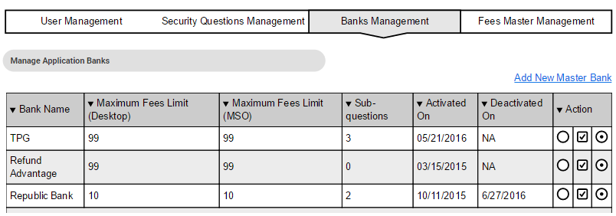

**Functionality Description**

The application presents the user with the information related to the various “Banks” which have been created thus far. Access to this functionality will be identified based on the permissions defined for the logged in user’s role.

The permitted user will have the ability to view the available information about the various “Banks” and their respective applicability in the application. The application allows the ability to view\edit the details of the respective Banks.

For each Bank, the application has the following distinct presentations for the various actions possible:

 : Allows the ability to Edit

Clicking on this icon displays the details associated with the specific Bank and modify the information as required.

 : Allows the ability to manage the Sub-questions applicable for a particular bank

Clicking on this icon brings up a view that allows the ability to manage any specific questions related to that bank which needs to be answered by a customer.

 : Allows the ability to Activate/Deactivate a particular Bank from the application database. Clicking on this icon allows the administrative user to either turn OFF a bank to not be available in the application database or turn it ON based on the business requirements at any time

Clicking on the “Add New Master Bank” link button at the top of the grid or the Edit icon at an individual Bank Level brings up the user interface block that looks like the following:

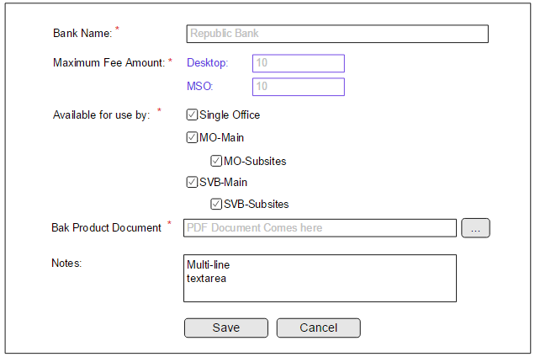

The detailed description about the fields and actions involved are explained in the tabulation below:

|  |  |
| --- | --- |
| **Function ID** | Banks Master Management |
| **TITLE** | Banks Master Management – For Admin |
| **INPUT** | |  |  |  | | --- | --- | --- | | **Field Name** | **Data Type** | **Comments/value** | | Bank Name | Text Field | This is the field that stores the name of the Bank to be displayed for all transactions on the application | | Maximum SVB Fee Amount (Desktop) | Text Field | This field is used to capture the information about the maximum fee that would be chargeable for a Desktop version when an enrollment happens with the specific bank being selected | | Maximum Transmission Fee Amount (Desktop) | Text Field | This field is used to capture the information about the maximum fee that would be chargeable for a Desktop version when an enrollment happens with the specific bank being selected | | Maximum SVB Fee Amount (MSO) | Text Field | This field is used to capture the information about the maximum fee that would be chargeable for a MSO version when an enrollment happens with the specific bank being selected | | Maximum Transmission Fee Amount (MSO) | Text Field | This field is used to capture the information about the maximum fee that would be chargeable for a MSO version when an enrollment happens with the specific bank being selected | | Available for use by | Multiple Checkboxes | This section is used to indicate the availability of a specific bank to the various customer types. By default all options will be selected and made available, but uTax has the ability to turn off the selections for specific customer type(s) | | Bank Product Document | File field | This field accepts the user to upload a document describing or explaining more about the Bank Product. This document can be made available for download or view on the front end transaction side for the users to understand the details and make the Bank selection accordingly. | | Save | Button | Used to add\update the Banks information provided. | | Cancel | Button | Used to cancel and discard any changes that were made on screen and return back to the main grid which displays the details of all the Master Banks listing | |
| **OPERATION** | * The landing page for the Banks Master management is controlled and managed by user permissions as defined for the role that the user is assigned with * Once the user has determined to have access to the Banks Master feature in Admin Functions, this menu option will be made visible to the user * Clicking on the Menu displays a view of all the “Banks” which were created in the application database * All administrative users with access to the Banks management functions will be notified as soon as request for a new bank is registered or the details of a specific bank is updated * Similarly a notification is sent out when a bank is marked as deactivated from the application database |
| **Validations** | * The application ensures that the access to the Banks Management feature is provided only for authorized users based on their roles and permissions * On the popup for the individual Bank information, some fields are mandatory and the application will show an Error message in Red Color just above the Save button to indicate the respective error about the field which is missing or invalid * The Maximum Fee Amounts (SVB and Transmission Fee) is mandatory and needs to be a value greater than Zero. Even decimals will be accepted. But the field should not accept any non-numeric character except for the decimal point * The Available for use by is mandatory and requires at least one Check-box to be selected for the information to be Saved or Updated * Unchecking the MO-Main or SVB-Main should automatically uncheck the child elements related to the sub-sites below it |

 : Allows the ability to manage the Sub-questions applicable for a particular bank

Clicking on this icon brings up a view that allows the ability to manage any specific questions related to that bank which needs to be answered by a customer. The UI for this function is illustrated below

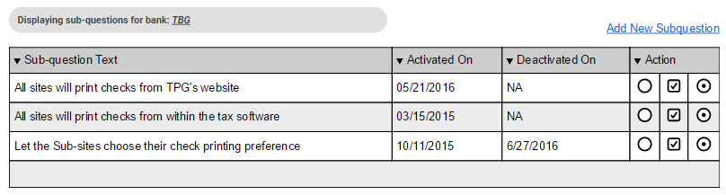

For each Sub-question, the application has the following distinct presentations for the various actions possible:

 : Allows the ability to Edit

Clicking on this icon displays the details associated with the specific Sub-question and modify the information as required.

 : Allows the ability to Activate/Deactivate a particular Sub-question from the application database

Clicking on this icon allows the administrative user to either turn OFF a sub-question to not be available in the application database or turn it ON based on the business requirements at any time

 : Clicking on this icon allows the administrative user to manage the display order for the sub-question when that specific bank is selected

Clicking on Edit for a specific sub-question or “Add New sub-question” at the top of the grid displays the following interface to the user:

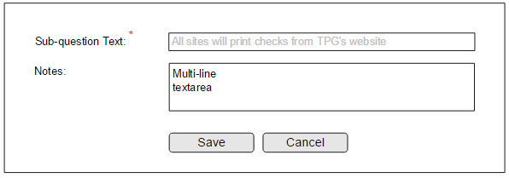

The detailed description about the fields and actions involved are explained in the tabulation below:

|  |  |
| --- | --- |
| **Function ID** | Banks Master – Sub Questions Management |
| **TITLE** | Sub-Questions Management – For Admin |
| **INPUT** | |  |  |  | | --- | --- | --- | | **Field Name** | **Data Type** | **Comments/value** | | Sub-question Text | Text Field | This is the field that represents the actual query or information sought as a part of this question | | Notes | Text field | Used to capture any information about the significance or impact of a particular sub-question. Useful for the internal processing teams only | | Save | Button | Used to add\update the Sub-question information provided. | | Cancel | Button | Used to cancel and discard any changes that were made on screen and return back to the main grid which displays the details of all the Sub-questions listing | |
| **OPERATION** | * All sub-questions defined under a Bank are displayed on the front end as a radio-set from which the user has to select one option * The response to a sub-questions set is mandatory * There need to be at least 2 sub-questions added under a bank for the same to be shown on the front end * Sub-questions are displayed in the order they are saved by default. But if the user manages the display order, then that is followed * The Display Order Management with the help of UP and DOWN arrow icons in the actual implementation * The UP arrow on the grid to define the Display Order will not be available on the first sub-question in the grid * The DOWN arrow on the grid to define the Display Order will not be available on the last sub- question in the grid * Except for the first and last rows, the UP and DOWN arrows will be displayed and made available on other rows of the grid * A sub-question cannot be deactivated if there is at least one user who has used that option * A sub-question cannot be edited if there is at least one user who has used that option |
| **Validations** | * The application should ensure that the text of the sub-question is unique within the bank under which it is being added * The sub-question text cannot be blank and needs to be provided mandatorily |

## **Sales Year Management**

Will be used to trigger or notify the start of a new Sales Year to the application. This can be triggered by users having specific permissions for this only. When a new Sales Year is triggered, the application will move all current sites to the upcoming sales year in a deactivated status. The sites in the prior years will remain at the same status they were in when they were moved/archived. Certain data will be allowed to change, with a notification going to enrollment to update Crosslink with the necessary information. This function needs to hold data for the current year and 2 prior years.

**User Interface**

The landing page for this function is accessible on the Administrative menu under “Sales Year Management”. Clicking on this function presents the following user interface:

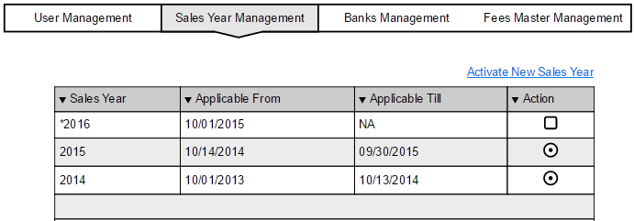

**Functionality Description**

The application presents the user with the information related to the various “Sales Years” which have been created thus far. Access to this functionality will be identified based on the permissions defined for the logged in user’s role.

The permitted user will have the ability to view the available information about the various “Sales Years” and their respective applicability in the application. The only interaction that is being allowed in this area is the ability to create a New Sales Year.

The application allows the ability to view\edit the details of the respective Sales year based on its activation status. If a Sales Year is marked for Scheduled Activation but not activated yet, then it can be Edited and the information update. For all other Sales years, only the View function will be available

For each Sales Year, the application has two distinct presentations to indicate the one which is currently active and the one which is a past year.

 : indicates a currently active Sales year

 : indicates a past or Archived Sales Year

Clicking on the above icon shows the details associated with the respective sales year as submitted at the time of activation. For a New Sales Year that is saved for Scheduled Activation, the application allows the ability for the information to be edited but not beyond or from the day on which the Sales Year gets activated.

The link called “Activate New Sales Year” is available to be clicked only once and a new Sales Year defined. At any given time, the system will allow for one current active year to be present and at a maximum an additional or incumbent Sales Year definition to be scheduled.

As soon as a new Sales year is marked for scheduled activation, the link at the top gets disabled and can be only active once the scheduled activation becomes eligible and a new sales year is created in the system

Each time a new Sales Year gets activated, all active business customer entities i.e. SO, MO and SVB Main and Subsites, gets flagged as archived but continue to retain the status that they held at the time of the archival process. Each of these entities automatically gets copied over to the new sales year to facilitate easy access and management for the new\upcoming sales year

For such copied entities, the application allows for certain information to be modified and accelerate the activation and management process. each such modification in turn triggers a notification to the enrollment department to review the modified information and execute appropriate action on the Crosslink portal

The transactions and information continues to be available for a maximum period of 2 additional Sales Years after the deactivation and is dropped after that

Clicking on the “Active New Sales Year” link button at the top of the grid brings up the user interface block that looks like the following:

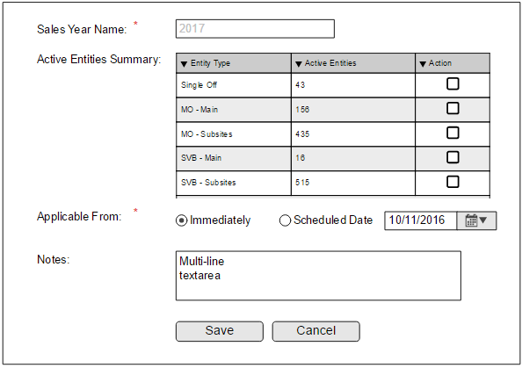

The detailed description about the fields and actions involved are explained in the tabulation below:

|  |  |
| --- | --- |
| **Function ID** | Sales Year Management |
| **TITLE** | Sales Year Management – For Admin |
| **INPUT** | |  |  |  | | --- | --- | --- | | **Field Name** | **Data Type** | **Comments/value** | | Sales Year Name | Alpha-numeric  Text Field | This is the name that will be assigned to Uniquely identify the new Sales Year being created in the application database | | Active Entities Summary | Read Only Grid | This grid displays the summarized information about all active entities that are active in the application as of today. This helps the user to plan for scheduling or delaying the Sales Year activation appropriately | | Applicable From | Radio or options selection | This section of the data capture allows the user to determine if the new Sales Year would be activated immediately or if it should be activated at a scheduled time.  There are two options available to the user:   1. Immediately: Selection of this option executes the required actions immediately as soon as the user clicks on Save 2. Scheduled Date: Prompts the user to select the specific date on which the new Sales Year would be activated. If this option is selected, then the user is mandated to specify the date on which the new Sales Year comes into force. The Date selection is mandated to be a value in the future | | Notes | Text field | This field allows the user to save in any notes or comments that may come in handy for reference later | | Save | Button | Used to add\update the Sales Year information provided. | | Cancel | Button | Used to cancel and discard any changes that were made on screen and return back to the main grid which displays the details of all the Sales Year definitions | |
| **OPERATION** | * The landing page for the Sales Year management is controlled and managed by user permissions as defined for the role that the user is assigned with * Once the user has determined to have access to the Sales Year feature in Admin Functions, this menu option will be made visible to the user * Clicking on the Menu displays a view of all the “Sales Year” which were created in the application database * All administrative users with access to the Sales Year management functions will be notified as soon as request for a new sales year is registered * The application will include the ability for the uTax customers and users to be able to see the information for the Archived Years and be able to have access to the transactions and the Reports thereof |
| **Validations** | * The application ensures that the access to the Sales Year Management feature is provided only for authorized users based on their roles and permissions * On the popup for the individual Sales Year, some fields are mandatory and the application will show an Error message in Red Color just above the Save button to indicate the respective error about the field which is missing or invalid * The “Scheduled Date” is a mandatory requirement if the user chooses to schedule the Sales Year activation for a later date * Application will ensure that the “Applicable From” cannot be a value in the past and at a minimum can be made as “Today” only |

## **Fees Master Management**

This section allows the ability for uTax to manage the various heads under which Fees is available to be used within the application. These could be fees elements like uTax Service Fees, Transmitter Fees, etc.

The section allows the ability to mark certain Fees elements as Constants and define the values associated with it. For certain fees elements, it can be marked as applicable based on the type of customers i.e. SO, MO, etc.

**User Interface**

The landing page for this function is accessible on the Administrative menu under “Fees Master Management”. Clicking on this function presents the following user interface:

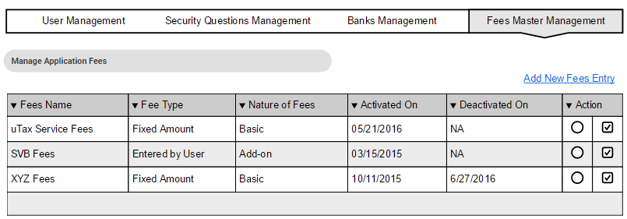

**Functionality Description**

The application presents the user with the information related to the various “Fees” which have been defined thus far. Access to this functionality will be identified based on the permissions defined for the logged in user’s role.

The permitted user will have the ability to view the available information about the various “Fees” and their respective applicability in the application. The application allows the ability to view\edit the details of the respective Fees amount.

For each Fee entry, the application has the following distinct presentations for the various actions possible:

 : Allows the ability to Edit

Clicking on this icon displays the details associated with the specific Fee entry to modify the information as required.

 : Allows the ability to Activate/Deactivate a particular Fee entry from the application database. Clicking on this icon allows the administrative user to either turn OFF a Fees entry to not be available in the application database or turn it ON based on the business requirements at any time

Clicking on the “Add New Fee Entry” link button at the top of the grid or the Edit icon at an individual Fee Level brings up the user interface block that looks like the following:

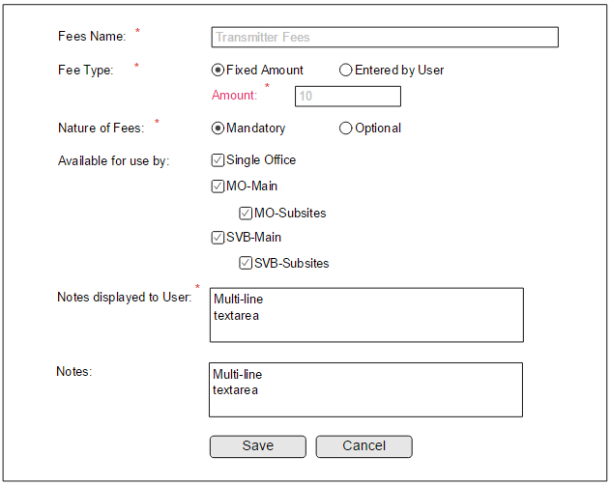

The detailed description about the fields and actions involved are explained in the tabulation below:

|  |  |
| --- | --- |
| **Function ID** | Fees Master Management |
| **TITLE** | Fees Master Management – For Admin |
| **INPUT** | |  |  |  | | --- | --- | --- | | **Field Name** | **Data Type** | **Comments/value** | | Fees Name | Text Field | This is the field that uniquely identifies the Fees entry being added to the application database | | Fees Type | Radio Selection | This field is used to identify the information about the type of the fees. There are two possible values:   1. Fixed Amount: Indicates the amount of fees that automatically applies to the selected customer types 2. Entered by User: indicates that a value for the fees will be entered at runtime by the user as applicable on the transaction screen | | Nature of Fees | Radio Selection | This field is used to identify the information about the nature of the specific fees entry. There are two possible values:   1. Mandatory: indicates that this is a mandatory amount that applies to all the selected applicable customer types 2. Optional: indicates that the decision to apply this fees is determined at runtime on the transaction screen | | Available for use by | Multiple Checkboxes | This section is used to indicate the availability of a specific bank to the various customer types. By default all options will be selected and made available, but uTax has the ability to turn off the selections for specific customer type(s) | | Notes Displayed to the User | Text field | This field is used to define a help or information text that displays next to each of the fees entry on the application frontend | | Notes | Text field | This field allows the user to save in any notes or comments that may come in handy for reference later | | Save | Button | Used to add\update the Fees information provided. | | Cancel | Button | Used to cancel and discard any changes that were made on screen and return back to the main grid which displays the details of all the Master Fees Entry listing | |
| **OPERATION** | * The landing page for the Fees Master management is controlled and managed by user permissions as defined for the role that the user is assigned with * Once the user has determined to have access to the Fees Master feature in Admin Functions, this menu option will be made visible to the user * Clicking on the Menu displays a view of all the “Fees” which were ever created in the application database * All administrative users with access to the Fees management functions will be notified as soon as request for a new fees is registered or the details of a specific fees is updated * Similarly a notification is sent out when a fees entry is marked as deactivated from the application database |
| **Validations** | * The application ensures that the access to the Fees Master Management feature is provided only for authorized users based on their roles and permissions * On the popup for the individual Fees information, some fields are mandatory and the application will show an Error message in Red Color just above the Save button to indicate the respective error about the field which is missing or invalid * The Available for use by is mandatory and requires at least one Check-box to be selected for the information to be Saved or Updated * Unchecking the MO-Main or SVB-Main should automatically uncheck the child elements related to the sub-sites below it * In case of Fixed fees amounts, the application validates that the amount specified does not exceed the maximum amount of Bank Fees across all active banks at the time |

## **Security Questions Management**

This section allows the ability for uTax to handle the security questions which are displayed to the end users as a part of the registration process. The section can be also used to define the display order associated with these questions.

The primary function of this feature is to allow uTax to manage and update the Security Questions that are made available to the users of the application. The Security Questions and the responses to the same are used to facilitate the password retrieval mechanism which is made available to all users of the EMP.

**User Interface**

The landing page for this function is accessible on the Administrative menu under “Security Questions Management”. Clicking on this function presents the following user interface:

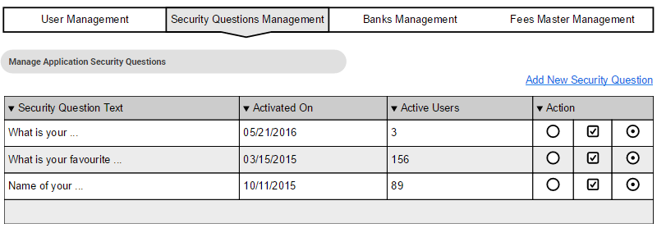

**Functionality Description**

The application presents the user with the information related to the various “Security Questions” which are active in the application database. Access to this functionality will be identified based on the permissions defined for the logged in user’s role.

The permitted user will have the ability to view the available information about the various active “Security Questions” and their respective applicability in the application. The administrative user will have the ability to execute the following actions on this list page:

* Click on the “Add New Security Question” link to initiate the process to add a new security question to the list
* Click on the “” icon to Edit the details of an active security question and modify the text as required. This function will not be available for Edit if there is at least one active user who is using the security question on their account
* Click on the “” icon to Deactivate an active security question and no longer have it accessible to the users beyond that point. This function will not be available for deactivation if there is at least one active user who is using the security question on their account

When the user clicks on this icon, the application will display a confirmation message on the following lines to confirm the user action before the respective security question is actually deactivated and no longer displayed in the Admin and Frontend sections.

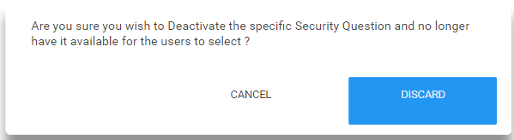

* The last icon “” allows the ability to define the Display order of the Security Question as it is to be presented on the front end. By default, the questions are displayed in the alphabetical order unless the Display Order function is used to set a different display order. This would be actually represented with UP and DOWN arrows in the application front end.

Clicking on the “Add New Security Question” link button at the top of the grid or the “Edit” icon at the individual Security Question row brings up the user interface block that looks like the following:

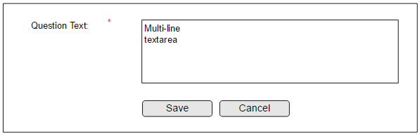

The detailed description about the fields and actions involved are explained in the tabulation below:

|  |  |
| --- | --- |
| **Function ID** | Security Questions Management |
| **TITLE** | Security Questions Management – For Admin |
| **INPUT** | |  |  |  | | --- | --- | --- | | **Field Name** | **Data Type** | **Comments/value** | | Security Question Text | Alpha-numeric  Text Field | This is the field that can be used by the admin to define the Security Question to be used in the application | | Save | Button | Used to add\update the Security Question text information provided. | | Cancel | Button | Used to cancel and discard any changes that were made on screen and return back to the main grid which displays the details of all the Security Question definitions | |
| **OPERATION** | * The landing page for the Security Questions management is controlled and managed by user permissions as defined for the role that the user is assigned with * Once the user has determined to have access to the Security Questions management feature in Admin Functions, this menu option will be made visible to the user * Clicking on the Menu displays a view of all the active “Security Questions” which were created in the application database * Any new security question added to the database or any Edits to a permitted security question will reflect in the application frontend immediately * The UP arrow on the grid to define the Display Order will not be available on the first security question in the grid * The DOWN arrow on the grid to define the Display Order will not be available on the last security question in the grid * Except for the first and last rows, the UP and DOWN arrows will be displayed and made available on other rows of the grid |
| **Validations** | * The application ensures that the access to the Security Questions Management feature is provided only for authorized users based on their roles and permissions * On the popup for the individual security question, all fields are mandatory and the application will show an Error message in Red Color just above the Save button to indicate the respective error about the field which is missing or invalid * Application will ensure that the Security Question text is unique and not case sensitive. This way the application presents an unique set of questions to the users on the front end |

## **Tooltip Management**

This section allows the ability for the uTax user to be able to manage the Tooltips or help information associated with some of the sections in the Registration and Enrollment process. Based on the feedback or information gathered, the support team can manage this text and have it updated regularly.

The primary function of this feature is to allow uTax to manage and update the Tooltip information that is presented to the users on the application frontend.

The tooltip being referred to here is the information that is displayed to the user when the blue color icon is clicked by the user on the application frontend:



**User Interface**

The landing page for this function is accessible on the Administrative menu under “Tooltip\Help Text Management”. Clicking on this function presents the following user interface:

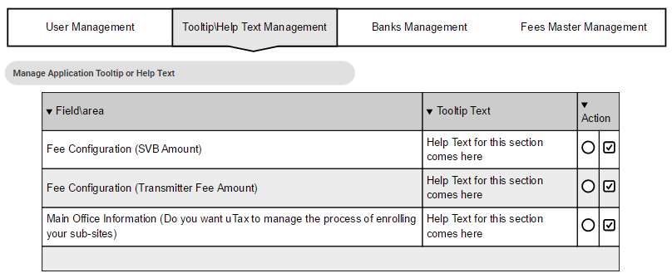

**Functionality Description**

The application presents the user with a display of all the sections where the Tooltip\Help text feature has been enabled in the code. The list will be updated\handled by the development team so that the internal tag references used in the code are managed.

Each time a new area of the website needs to have the tooltip ability it would need the code to be updated to reflect the same and the identification tag to be introduced in the database. Once done, the management section will allow the administrative user to update and manage the text that is displayed as a part of the tooltip. The administrative section will also allow the user to disable the tooltip if it is no longer required to be displayed to the end user.

The view presents the user with an indication of which section of the application is having a tooltip associated with it. This information cannot be changed per se. The administrative user will have the ability to execute the following actions on this list page:

* Click on the “” icon to Edit the Help Text associated with an active Tooltip section. The application will present a Rich Text editor that allows for content formatting and styling being included in the help text.
* The “” icon acts as a Toggle button to manage the status of a tooltip being presented to the user. For Active entries, it allows the tooltip to be deactivated and for De-activated ones, it allows for the entry to be re-activated.

When the user clicks on this icon, the application will display a confirmation message on the following lines to confirm the user action before the respective tooltip function is actually deactivated or reactivated for the Frontend sections.

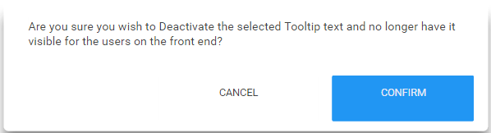

Clicking on the “Edit” icon at the individual Tooltip text row brings up the user interface block that looks like the following:

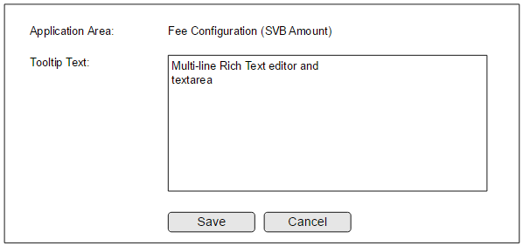

The detailed description about the fields and actions involved are explained in the tabulation below:

|  |  |
| --- | --- |
| **Function ID** | Tooltip Text Management |
| **TITLE** | Tooltip Text Management – For Admin |
| **INPUT** | |  |  |  | | --- | --- | --- | | **Field Name** | **Data Type** | **Comments/value** | | Application Area | Label | Displays the information about the section in the application where the respective tooltip text is being displayed. This is the information that is submitted by the Developers while integrating the tooltip tag in the database backed. | | Tooltip Text | Rich Text Editor Field | This is the information that is displayed to the user when the user clicks on the HELP icon on the front end application. This will actually be a Rich Text editor which will allow for the styling and formatting functions to be possible. | | Save | Button | Used to add\update the Tooltip Help text information provided. | | Cancel | Button | Used to cancel and discard any changes that were made on screen and return back to the main grid which displays the details of all the Tooltip definitions | |
| **OPERATION** | * The landing page for the Tooltip Text management is controlled and managed by user permissions as defined for the role that the user is assigned with * Once the user has determined to have access to the Tooltip Text management feature in Admin Functions, this menu option will be made visible to the user * Clicking on the Menu displays a view of all the active and inactive “Tooltip sections” which were created in the application database * There is no feature to add a New Tooltip Text from the front end but there is ability only to manage information that has been activated during development * There is ability to turn off a particular tooltip from not showing up any further in the application frontend. * There is ability to turn ON a particular deactivated tooltip at any point of time so that it shows up on the application frontend * The rich text editor will allow for a PREVIEW feature so that the user can see a firsthand representation of how the specified text would look like * There could be some minor differences in the actual rendering of the provided rich text based on the HTML on the page. But by and large it will be consistent with what is being updated in the editor |
| **Validations** | * The application ensures that the access to the Tooltip Text Management feature is provided only for authorized users based on their roles and permissions * On the popup for the individual tooltip text block, all fields are mandatory and the application will show an Error message in Red Color just above the Save button to indicate the respective error about the field which is missing or invalid * Application will ensure that the Tooltip text is provided and not blank since a blank tooltip text will disturb the user experience * Application to save and persist the styling information and present the same with as much accuracy and match as possible |

## **Phone Type Management**

This section allows the ability to manage the various Phone Types options which are displayed in the application on the Account and Office Details pages.

**User Interface**

The landing page for this function is accessible on the Administrative menu under “Phone Type Management”. Clicking on this function presents the following user interface:

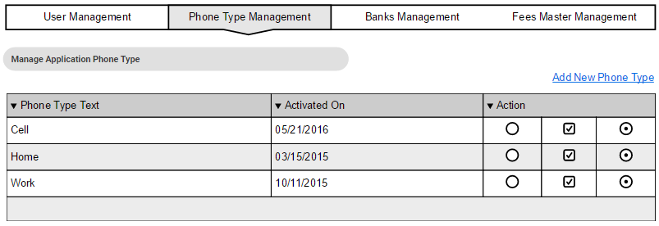

**Functionality Description**

The application presents the user with the information related to the various “Phone Types” which are active in the application database. Access to this functionality will be identified based on the permissions defined for the logged in user’s role.

The permitted user will have the ability to view the available information about the various active “Phone Types” and their respective applicability in the application. The administrative user will have the ability to execute the following actions on this list page:

* Click on the “Add New Phone Type” link to initiate the process to add a new phone type to the list
* Click on the “” icon to Edit the details of an active phone type and modify the text as required.
* Click on the “” icon to Deactivate an active phone type and no longer have it accessible to the users beyond that point. This function will not be available for deactivation if there is at least one active user who is using the phone type on their account

When the user clicks on this icon, the application will display a confirmation message on the following lines to confirm the user action before the respective phone type is actually deactivated and no longer displayed in the Admin and Frontend sections.

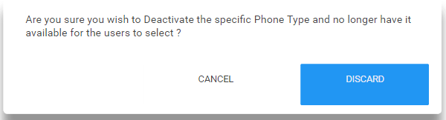

* The last icon “” allows the ability to define the Display order of the Phone Type as it is to be presented on the front end. By default, the phone types are displayed in the alphabetical order unless the Display Order function is used to set a different display order. This would be actually represented with UP and DOWN arrows in the application front end.

Clicking on the “Add New Phone Type” link button at the top of the grid or the “Edit” icon at the individual Phone Type row brings up the user interface block that looks like the following:

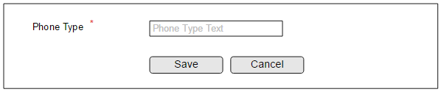

The detailed description about the fields and actions involved are explained in the tabulation below:

|  |  |
| --- | --- |
| **Function ID** | Phone Type Management |
| **TITLE** | Phone Types Management – For Admin |
| **INPUT** | |  |  |  | | --- | --- | --- | | **Field Name** | **Data Type** | **Comments/value** | | Phone Type Text | Alpha-numeric  Text Field | This is the field that can be used by the admin to define the Phone Types to be used in the application | | Save | Button | Used to add\update the Phone Type text information provided. | | Cancel | Button | Used to cancel and discard any changes that were made on screen and return back to the main grid which displays the details of all the Phone Type definitions | |
| **OPERATION** | * The landing page for the Phone Type management is controlled and managed by user permissions as defined for the role that the user is assigned with * Once the user has determined to have access to the Phone Type management feature in Admin Functions, this menu option will be made visible to the user * Clicking on the Menu displays a view of all the active “Phone Types” which were created in the application database * Any new phone type added to the database or any Edits to a permitted phone type will reflect in the application frontend immediately * The UP arrow on the grid to define the Display Order will not be available on the first phone type in the grid * The DOWN arrow on the grid to define the Display Order will not be available on the last phone type in the grid * Except for the first and last rows, the UP and DOWN arrows will be displayed and made available on other rows of the grid |
| **Validations** | * The application ensures that the access to the Phone Types Management feature is provided only for authorized users based on their roles and permissions * On the popup for the individual security question, all fields are mandatory and the application will show an Error message in Red Color just above the Save button to indicate the respective error about the field which is missing or invalid * Application will ensure that the Phone Type text is unique and not case sensitive. This way the application presents an unique set of Phone Types to the users on the front end |

## **Contact Person Title Management**

This section allows the ability to manage the various Contact Person title options which are displayed in the application on the Account and Office Details pages.

**User Interface**

The landing page for this function is accessible on the Administrative menu under “Contact Person Title Management”. Clicking on this function presents the following user interface:

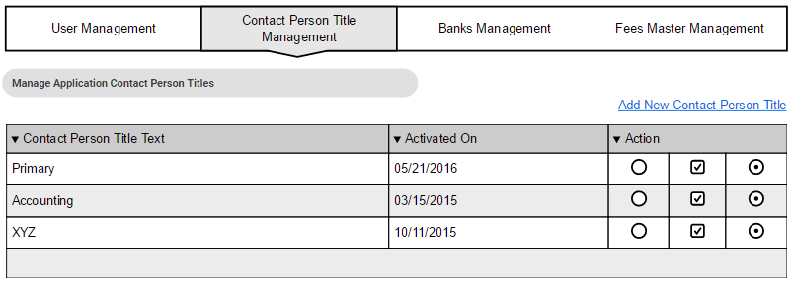

**Functionality Description**

The application presents the user with the information related to the various “Contact Person Titles” which are active in the application database. Access to this functionality will be identified based on the permissions defined for the logged in user’s role.

The permitted user will have the ability to view the available information about the various active “Contact Person Titles” and their respective applicability in the application. The administrative user will have the ability to execute the following actions on this list page:

* Click on the “Add New Contact Person Title” link to initiate the process to add a new Contact Person Title to the list
* Click on the “” icon to Edit the details of an active Contact Person Title and modify the text as required.
* Click on the “” icon to Deactivate an active Contact Person Title and no longer have it accessible to the users beyond that point. This function will not be available for deactivation if there is at least one active user who is using the Contact Person Title on their account

When the user clicks on this icon, the application will display a confirmation message on the following lines to confirm the user action before the respective Contact Person Title is actually deactivated and no longer displayed in the Admin and Frontend sections.

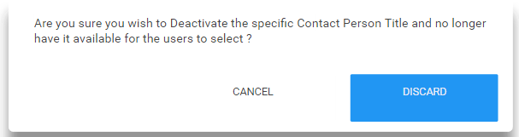

* The last icon “” allows the ability to define the Display order of the Contact Person Title as it is to be presented on the front end. By default, the Contact Person Titles are displayed in the alphabetical order unless the Display Order function is used to set a different display order. This would be actually represented with UP and DOWN arrows in the application front end.

Clicking on the “Add New Contact Person Title” link button at the top of the grid or the “Edit” icon at the individual Contact Person Title row brings up the user interface block that looks like the following:

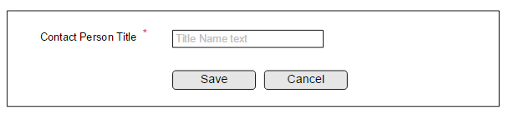

The detailed description about the fields and actions involved are explained in the tabulation below:

|  |  |
| --- | --- |
| **Function ID** | Contact Person Title Management |
| **TITLE** | Contact Person Titles Management – For Admin |
| **INPUT** | |  |  |  | | --- | --- | --- | | **Field Name** | **Data Type** | **Comments/value** | | Contact Person Title Text | Alpha-numeric  Text Field | This is the field that can be used by the admin to define the Contact Person Titles to be used in the application | | Save | Button | Used to add\update the Contact Person Title text information provided. | | Cancel | Button | Used to cancel and discard any changes that were made on screen and return back to the main grid which displays the details of all the Contact Person Title definitions | |
| **OPERATION** | * The landing page for the Contact Person Title management is controlled and managed by user permissions as defined for the role that the user is assigned with * Once the user has determined to have access to the Contact Person Title management feature in Admin Functions, this menu option will be made visible to the user * Clicking on the Menu displays a view of all the active “Contact Person Titles” which were created in the application database * Any new Contact Person Title added to the database or any Edits to a permitted Contact Person Title will reflect in the application frontend immediately * The UP arrow on the grid to define the Display Order will not be available on the first Contact Person Title in the grid * The DOWN arrow on the grid to define the Display Order will not be available on the last Contact Person Title in the grid * Except for the first and last rows, the UP and DOWN arrows will be displayed and made available on other rows of the grid |
| **Validations** | * The application ensures that the access to the Contact Person Titles Management feature is provided only for authorized users based on their roles and permissions * On the popup for the individual security question, all fields are mandatory and the application will show an Error message in Red Color just above the Save button to indicate the respective error about the field which is missing or invalid * Application will ensure that the Contact Person Title text is unique and not case sensitive. This way the application presents an unique set of Contact Person Titles to the users on the front end |

## **Affiliate Program Management**

This section will be used to manage the various Affiliate Programs that are offered by uTax to its customers as a part of the enrollment process. This section will allow uTax to manage the various Affiliate programs offered, the cost, supporting document and any reference information that is required

**User Interface**

The landing page for this function is accessible on the Administrative menu under “Affiliate Programs Management”. Clicking on this function presents the following user interface:

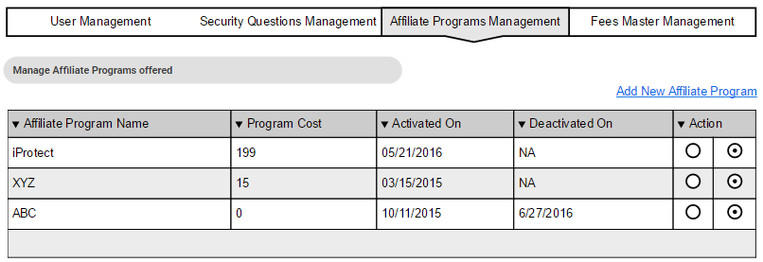

**Functionality Description**

The application presents the user with the information related to the various “Affiliate Programs” which have been created thus far. Access to this functionality will be identified based on the permissions defined for the logged in user’s role.

The permitted user will have the ability to view the available information about the various “Affiliate Programs” and their respective applicability in the application. The application allows the ability to view\edit the details of the respective Banks.

For each Affiliate Program, the application has the following distinct presentations for the various actions possible:

 : Allows the ability to Edit

Clicking on this icon displays the details associated with the specific Affiliate Program and modify information as required.

 : Allows the ability to Activate/Deactivate a particular Affiliate Program from the application database. Clicking on this icon allows the administrative user to either turn OFF an Affiliate Program to not be available in the application database or turn it ON based on the business requirements at any time

Clicking on the “Add New Affiliate Program” link button at the top of the grid or the Edit icon at an individual Affiliate Program Level brings up the user interface block that looks like the following:

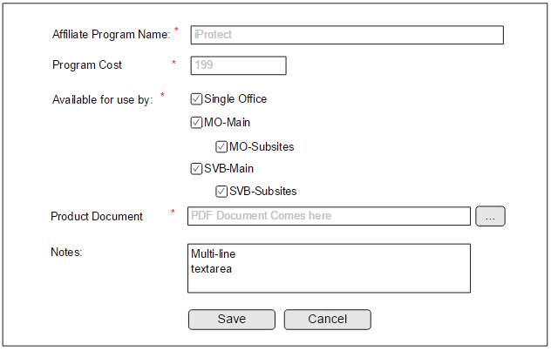

The detailed description about the fields and actions involved are explained in the tabulation below:

|  |  |
| --- | --- |
| **Function ID** | Affiliate Programs Management |
| **TITLE** | Affiliate Programs Management – For Admin |
| **INPUT** | |  |  |  | | --- | --- | --- | | **Field Name** | **Data Type** | **Comments/value** | | Affiliate Program Name | Text Field | This is the field that stores the name of the Affiliate Program to be displayed for all transactions on the application | | Program Cost | Text Field | This field is used to capture the information about the program costs that would be chargeable when an enrollment happens with the specific affiliate program being selected | | Available for use by | Multiple Checkboxes | This section is used to indicate the availability of a specific Affiliate Program to the various customer types. By default all options will be selected and made available, but uTax has the ability to turn off the selections for specific customer type(s) | | Product Document | File field | This field accepts the user to upload a document describing or explaining more about the Affiliate Program Product. This document can be made available for download or view on the front end transaction side for the users to understand the details and make the Affiliate Program selection accordingly. | | Notes | Text Field | General notes for Administrative Purposes | | Save | Button | Used to add\update the Affiliate Program information provided. | | Cancel | Button | Used to cancel and discard any changes that were made on screen and return back to the main grid which displays the details of all the Master Affiliate Programs listing | |
| **OPERATION** | * The landing page for the Affiliate Program management is controlled and managed by user permissions as defined for the role that the user is assigned with * Once the user has determined to have access to the Affiliate Programs feature in Admin Functions, this menu option will be made visible to the user * Clicking on the Menu displays a view of all the “Affiliate Programs” which were created in the application database * All administrative users with access to the Affiliate Programs management functions will be notified as soon as request for a new bank is registered or the details of a specific Affiliate Program is updated * Similarly a notification is sent out when a Affiliate Program is marked as deactivated from the application database |
| **Validations** | * The application ensures that the access to the Affiliate Programs Management feature is provided only for authorized users based on their roles and permissions * On the popup for the individual Affiliate Program information, some fields are mandatory and the application will show an Error message in Red Color just above the Save button to indicate the respective error about the field which is missing or invalid * The Program Cost field is mandatory but can accept a value equal to Zero. Even decimals will be accepted. But the field should not accept any non-numeric character except for the decimal point * The Available for use by is mandatory and requires at least one Check-box to be selected for the information to be Saved or Updated * Unchecking the MO-Main or SVB-Main should automatically uncheck the child elements related to the sub-sites below it |