**Little Angels Home Daycare**

**(972) 519 - 0201**

3909 Sandia Drive

Plano, Texas 75023

***Trusted for quality childcare in a safe and nurturing environment.***

**Home | Why Us? | Certifications | Contact Us| Helpful Links**

Picture Slideshow here.

Welcome to Little Angels Home Daycare!

Little Angels Home Daycare is a fully licensed home daycare that has been committed to providing a safe, caring and stimulating environment for infants and toddlers since 1995. Little Angels is based in Plano, Texas, northeast of the Dallas North Tollway and President George Bush Turnpike. We are conveniently located to serve Plano as well as the nearby communities of Allen, Frisco and Richardson. We look forward to meeting you and your child!

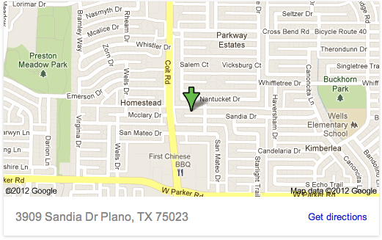General Information

**Address**

Little Angels Home Daycare

3909 Sandia Drive

Plano, TX 75023

**Phone**

(972) 519-0201

**Hours**

Monday – Friday

7:30 am - 5:30 pm

***\*\*Note: I would like for the map to link to google maps, so if you could embed that here ^ that would be great!***

**Little Angels Home Daycare**

**(972) 519 - 0201**

3909 Sandia Drive

Plano, Texas 75023

***Trusted for quality childcare in a safe and nurturing environment.***

**Home | Why Us? | Certifications |Contact Us| Helpful Links**

Picture Slideshow here.

Why choose Little Angels Home Daycare?

**Our Mission**

For over 15 years, we have been providing childcare for infants and toddlers with safety and nurturing as our top priorities. We are committed to providing your child with a loving and educational environment, lots of support for positive development, and most importantly plenty of love! We aim to give you peace of mind that your unique little angel is being provided the highest quality of individualized care.

**Our Home**

At Little Angels Home Daycare, we specialize in care for infants and toddlers, so we've made sure that our home is clean, comfortable and safe for your child. We use allergy filters, and have monitored fire and burglary alarms. We have a non-smoking home, with no pets and no swimming pool. All sleeping areas are personalized for comfort and hygiene. For recreational activities, we have a wonderful, spacious back yard as well as a separate playroom full of toys that cater to rapidly developing young minds.

**Our Services**

Here, all supplies and food are provided, so you don't have to worry about diapers or formula! If your child has specialty needs, you will need to bring any required supplies and we will be happy to accommodate them. We also strive to create a dynamic play schedule: indoor and outdoor play, story and music time are part of our daily routine. Our goal is to develop your child’s motor and language skills through age-specific activities and exercises.

**Little Angels Home Daycare**

**(972) 519 - 0201**

3909 Sandia Drive

Plano, Texas 75023

***Trusted for quality childcare in a safe and nurturing environment.***

**Home | Why Us? | Certifications | Contact Us| Helpful Links**

Picture Slideshow here.

Our Certifications

Little Angels Home Daycare is licensed by the state of Texas as well as the city of Plano. We are trained in CPR and First Aid and are constantly educating ourselves on providing quality care by attending care providers seminars. We make sure your child is being given nutritious meals and are enrolled in the USDA Child Care Food Program.

**Little Angels Home Daycare**

**(972) 519 - 0201**

3909 Sandia Drive

Plano, Texas 75023

***Trusted for quality childcare in a safe and nurturing environment.***

**Home | Why Us? | Certifications | Contact Us | Helpful Links**

Picture Slideshow here.

Contact Us

**Address**: Little Angels Home Daycare   
 3909 Sandia Drive   
 Plano, TX 75023

**Phone**: (972) 519-0201

**Email**: [Provider@childcareinplano.com](mailto:Provider@childcareinplano.com)

|  |  |
| --- | --- |
|  | |
| Name: |  |
| Address 1: |  |
| Address 2: |  |
| City: |  |
| State: |  |
| Zip / Postal Code: |  |
| Country: |  |
| Phone Number: |  |
| Email Address: |  |
| Web Address/URL: |  |
| Comments/Questions: |  |
|  |  |

**** Same as the contact us page on my website!

**Little Angels Home Daycare**

**(972) 519 - 0201**

3909 Sandia Drive

Plano, Texas 75023

***Trusted for quality childcare in a safe and nurturing environment.***

**Home | Why Us? | Certifications | Contact Us| Helpful Links**

Picture Slideshow here.

Helpful Links

“State Childcare Licensing Information”

(link to: <http://www.dfps.state.tx.us/Child_Care/Search_Texas_Child_Care/ppFacilityDetails.asp?ptype=DC&fid=141215>)

“USDA Food and Nutrition Information”

(link to: <http://fnic.nal.usda.gov>)

“CDC Guidelines for Developmental Milestones”

(link to: <http://www.cdc.gov/ncbddd/actearly/milestones/index.html>)

“Developmental Games for Infants and Toddlers”

(link to: <http://www.scholastic.com/teachers/article/infants-toddlers-playing-games-very-young-children>)