**SHANNON FANO ENCODING**



***NAME****: RAM MANIKUMAR*

***ROLL******NO****:2101105*

***GROUP*** *: EC31*

***Mini Project for VLSI Design Lab***

*B.Tech ECE* 3*rd Year* 6*th Semester*

## Electronics and Communication Engineering Department

**Indian Institute of Information Technology Guwahati**

**Chapter 1**

# Theoretical Background

Shannon fano encoding is the one of the optimal encoding which was introduced by the

 Claude Shannon and Robert Fano . It is one of the encoding which uses to transmite the information with the reduced number of bits .Shannon-Fano encoding aims to compress data by assigning variable-length codes to symbols based on their probabilities. By this encoding we can get the optimal one as compared to shannon first encoding but it not much optimal as compared to the huffman encoding . Shannon Fano Algorithm is an entropy encoding technique for lossless data compression of multimedia. Named after Claude Shannon and Robert Fano, it assigns a code to each symbol based on their probabilities of occurrence. It is a variable-length encoding scheme, that is, the codes assigned to the symbols will be of varying lengths.

**Chapter 2**

# Working Principle

>> Shannon fano works by taking the probabilites of symbols as inputs .

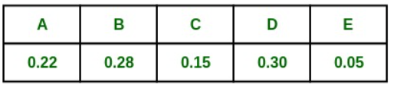

>> First we arrange the all the probabilites in the decreasing order.

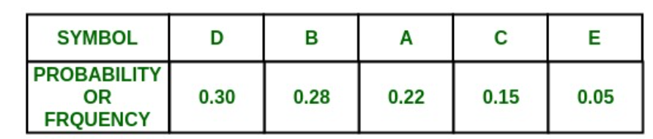

>> Split the list into two parts, with the total probability of both parts being as close to each other as possible.

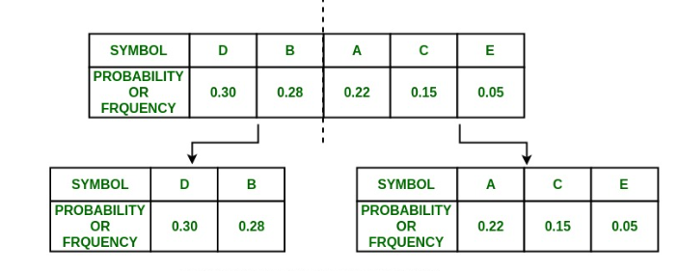

>> Repeat steps 3 and 4 for each part until all the symbols are split into individual subgroups.

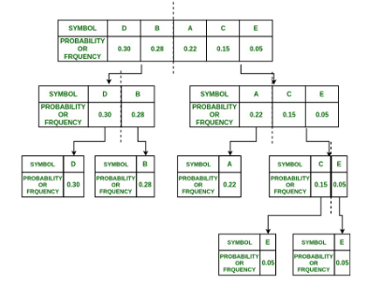

>> Then allot the symbols accordingly 0’s and 1’s .

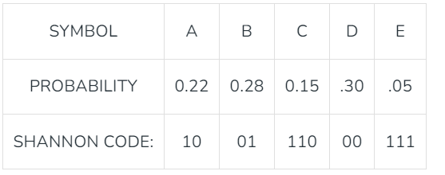

Then we get the codewords as above .

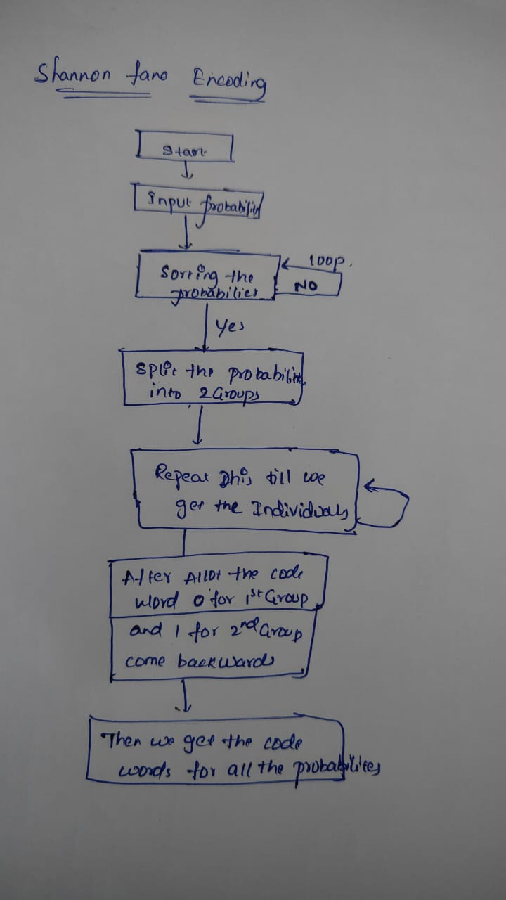

Figure 1: Flow Chart Of RLE Module.

**Chapter 3**

# Implementation

The Verilog module shannon encoding implements the algorithm for data compression. Shannon fano encoding The module takes in the following input and output signals:

**Inputs:**

**Input**  symbol probabilites : input [7:0] symbol_probabilities,

Probabilties in a bit stream of 5 example

**output** reg [3:0] codewords .

We get the output as bitstream of code word as single bit stream.

* We sort the probabilies using bubble sort algorithm.
* We divide and add the prefixes to every code word.
* We generate a output codeword bit stream .

**Chapter 4**

## Reports

### Post implementation Functional Simulation

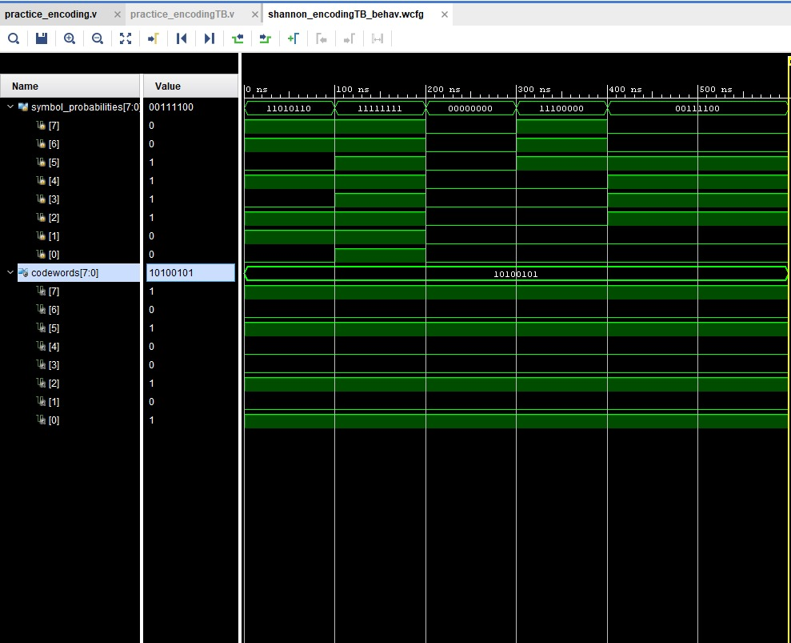

Figure 2: Output Signal Of Shannon fano module

### Synopsys Implementation

**Area Report:**

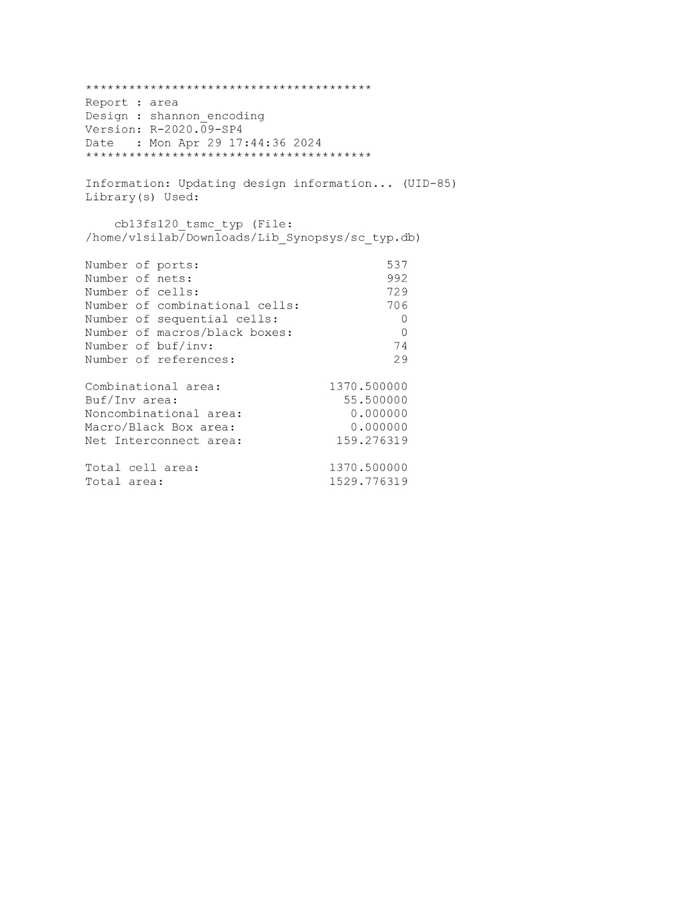

Figure 3: Area Report Of Shannon_encoding Module

**Power Report:**

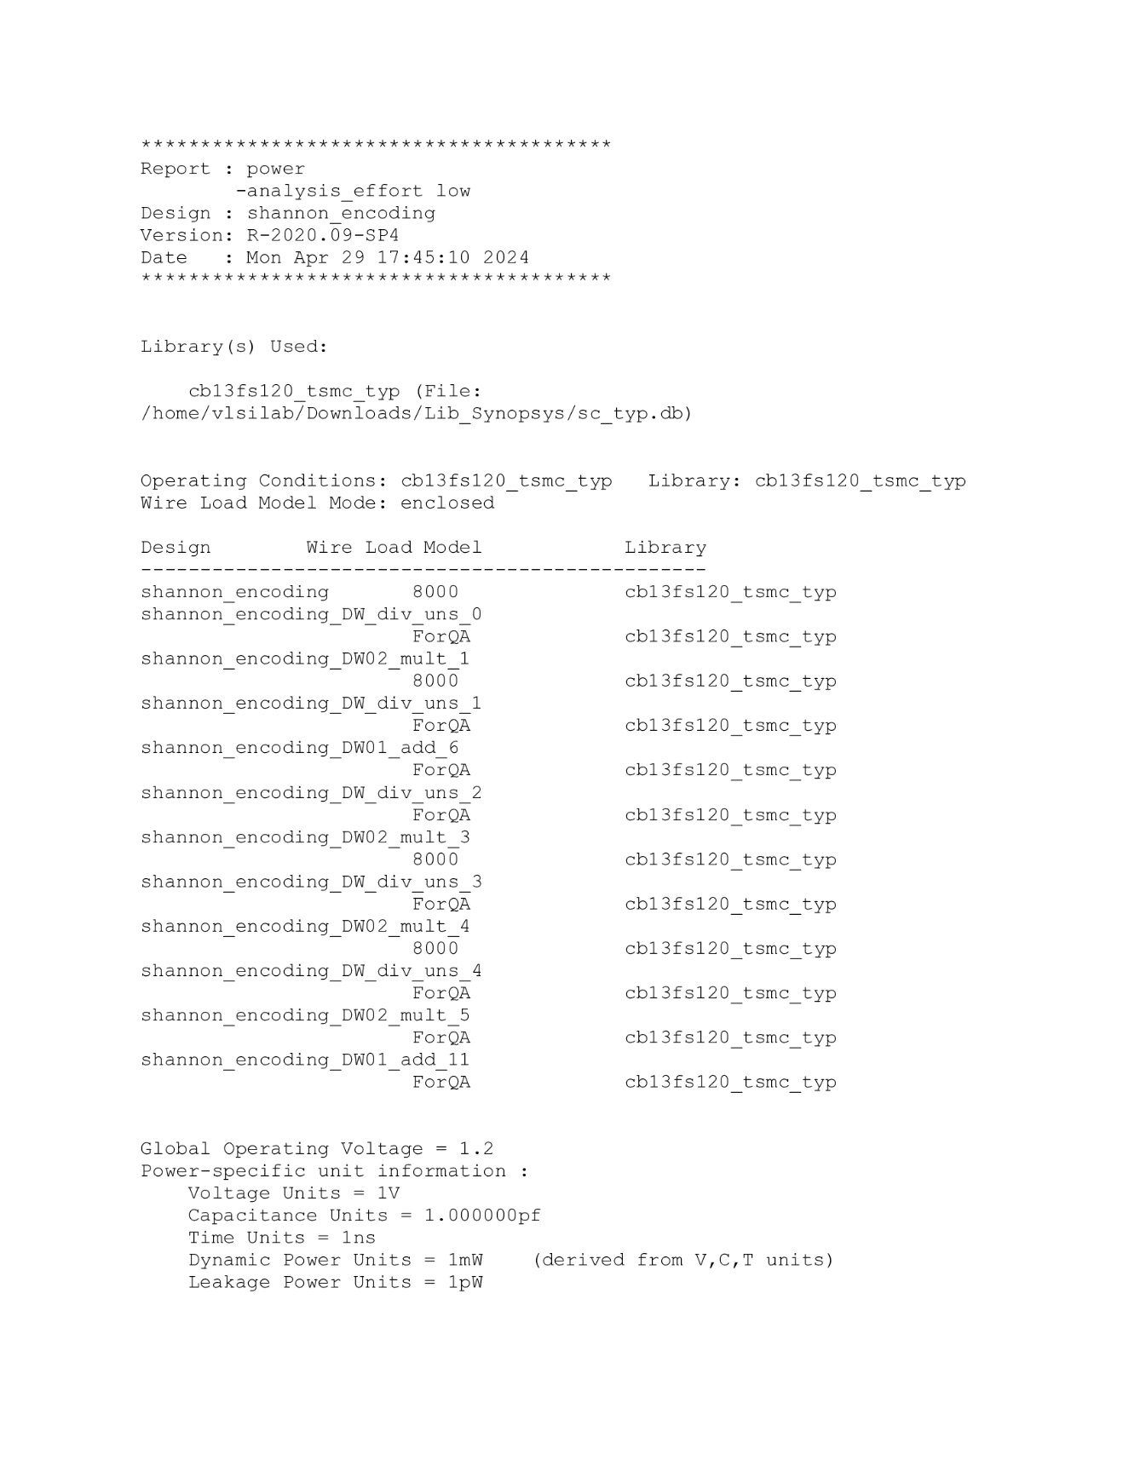

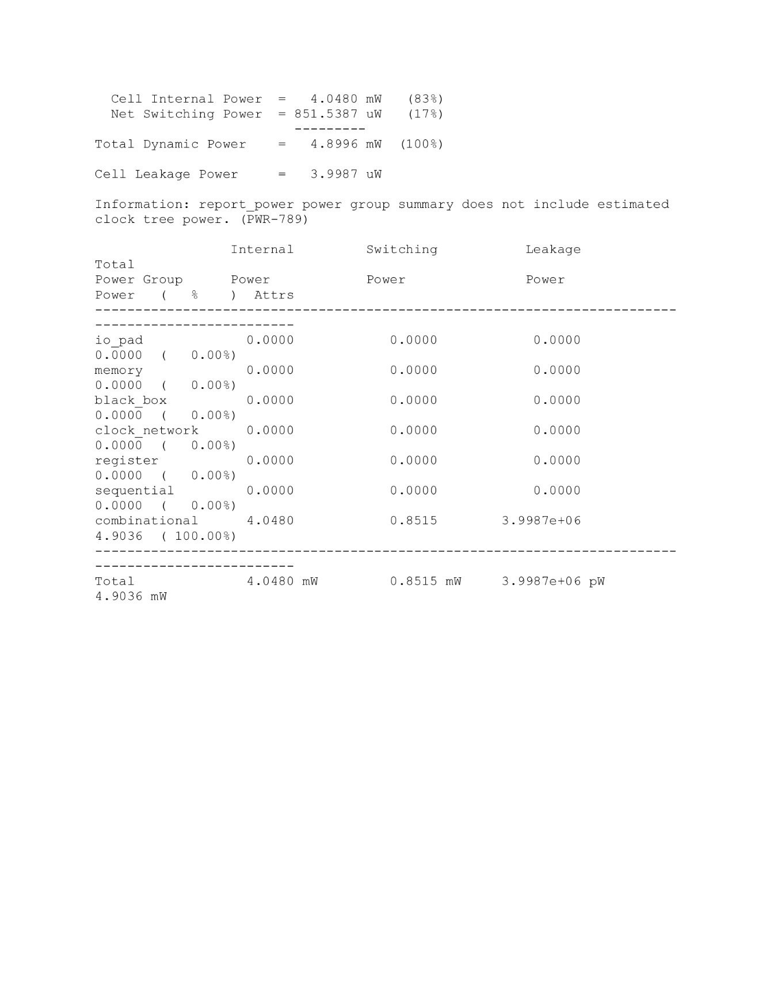

Figure 4: Power Report Of Shannon_encoding Modul

**Chapter 5**

# Conclusions

**Shannon fano coding is one of the encoding methods with efficiency nearly 100 percent. So with given probability of the source symbols are symbols are efficienctly encoded.**

**The source probabilities are estimated by finding the probabilities of each symbol in large typical data set produced by the source.**