Outlook Add-in — Fr8Labs Integration Plan
Feasibility, prerequisites, requirements, and solution approach for three ribbon buttons

1. What you are building
A single Outlook add-in with three ribbon buttons that appear on every email. Users stay inside Outlook; the add-in talks to a small backend, which in turn talks to an LLM (with optional RAG), Fr8Labs MCP, and (when available) Fr8Labs customer APIs.

2. Architecture diagram

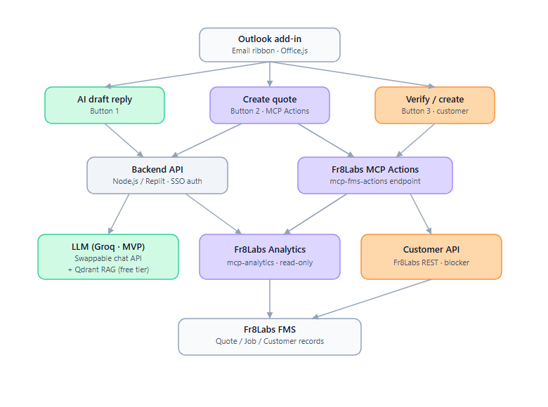

3. Feasibility assessment
Button | Feasibility | Confidence
AI Draft Reply | Fully feasible today | High
Create Quote (MCP Actions) | Feasible — MCP Actions endpoint is live | High
Verify / Create Customer | Partially blocked — awaiting Fr8Labs response for create API | Medium

4. Prerequisites

4.1 Microsoft 365
- M365 Business or Enterprise subscription (personal Outlook.com will not work for org deployment)
- Global Admin or Exchange Admin account for deployment
- Azure App Registration in Entra ID — one-time SSO setup so users never see a login screen

4.2 Fr8Labs
- Active Fr8Labs account with MCP access enabled by admin under Team Access
- Both MCP connectors activated:
  - https://notification-hub.fr8labs.co/mcp-analytics (read)
  - https://notification-hub.fr8labs.co/mcp-fms-actions (write / propose)
- For Button 3 Create: partner API access from Fr8Labs developer package — current blocker

4.3 MVP AI stack (free tier)
Component | MVP choice | Notes
LLM | Groq (free tier) | Fast inference; OpenAI-compatible API shape. Backend abstracts the provider so you can swap later.
Vector DB / RAG | Qdrant Cloud free tier | Store freight reply templates, terminology, and sample phrasing. Retrieve top chunks before the LLM call.
Embeddings | Free / low-cost embedding model via Groq or a compatible free embeddings API | Keep embedding + LLM behind the same backend config.

4.4 Hosting (Replit is viable for MVP)
- Frontend: Replit or Netlify (static files, must be HTTPS)
- Backend API: Replit Node.js repl (Always On for production; free tier OK for early dev)
- Replit .replit.app HTTPS satisfies Outlook’s requirement — no custom domain needed for MVP

5. Button 1 — AI Draft Reply
How it works: User opens an email → clicks the button → add-in reads the email body via Office.js → sends sanitised text to your backend → backend retrieves RAG context from Qdrant → calls Groq → draft reply is pre-filled in the Outlook reply window. User reviews and sends. Nothing is auto-sent.

Key implementation points
- Use Office.js item.body.getAsync to read email content
- Strip HTML on the backend before sending to the LLM (reduces prompt-injection risk)
- Enforce ~8,000 character limit
- RAG: store freight templates/terminology in Qdrant (free); retrieve relevant chunks before the LLM call
- Optional: if the sender is a known customer, query Fr8Labs Analytics and pass recent shipment context into the prompt
Inputs: Email body, sender info, Qdrant RAG chunks, optional Fr8Labs Analytics context
Output: Pre-filled Outlook reply draft

6. Button 2 — Create Quote
How it works: User reads a rate-request email → clicks the button → add-in / backend parses customer, route, and cargo → backend calls Fr8Labs MCP Actions (mcp-fms-actions) to propose a quote → user sees the proposal in the task pane and approves → QT-XXXX is created in Fr8Labs FMS.

Key implementation points
- Backend authenticates to Fr8Labs MCP Actions using Fr8Labs OAuth (user’s Fr8Labs login)
- Flow is propose → user approve — nothing is saved until approval (fits the task pane UX)
- Task pane shows proposed quote (customer, route, charges, total) with Approve / Edit / Reject
- Quote can later be converted to a job inside Fr8Labs as usual
Inputs: Email body parsed for customer name, origin/destination, cargo type, commodity, weight
Output: QT-XXXX created in Fr8Labs FMS after user approval

7. Button 3 — Verify / Create Customer
Most complex button; create path has a current blocker.

Create flow (blocked pending Fr8Labs)
- On submit: POST to Fr8Labs REST API to create the customer — no publicly documented endpoint yet
- Action: follow up with customersuccess@fr8labs.co for the Partner API / developer package

8. Architecture & hosting on Replit

Frontend (static)
Replit Repl 1 — Frontend
/manifest.xml ← add-in identity for M365 Admin Center
/taskpane.html ← button panel UI
/button1.js ← draft reply logic
/button2.js ← create quote logic
/button3.js ← verify / create customer logic
/icons/ ← 16px, 32px, 80px icons (required)

Backend API (Node.js)
Replit Repl 2 — Backend API
POST /draft-reply ← Groq LLM + Qdrant RAG
POST /create-quote ← Fr8Labs MCP Actions
GET /verify-customer ← Fr8Labs MCP Analytics
POST /create-customer ← Fr8Labs REST API (pending)

Replit caveats
- Free tier sleeps after inactivity — fine for dev; use Always On or an UptimeRobot ping for MVP demos
- For production later: move backend to Azure App Service or a small VPS; frontend can stay on Replit or move to Netlify

9. Deployment steps (in order)
- Azure App Registration — Entra ID → App Registrations → New registration (“Fr8Labs Outlook Add-in”, single-tenant). Create access_as_user scope, pre-authorise Office app IDs, generate client secret. Enables SSO.
- Deploy frontend to Replit — static HTML/JS, icons, manifest.xml. HTTPS URL goes into the manifest.
- Deploy backend API to Replit — Express endpoints for draft-reply (Groq + Qdrant), create-quote, verify-customer. Keep API keys in Replit Secrets.
- Build and validate the manifest — GUID, version, HTTPS URLs, Azure app IDs. Validate with office-addin-manifest (zero errors).
- Sideload and test — Outlook Web → Settings → Add-ins → Add from file. Test all three buttons end-to-end.
- Deploy org-wide — M365 Admin Center → Settings → Integrated Apps → Upload custom app. Assign to pilot group or all users (ribbon appears within ~24 hours).
10. Effort estimate
High-level effort estimate for planning. Assumes one experienced developer, existing Fr8Labs MCP access, and AI-assisted development to accelerate boilerplate and integration code.
10.1 Work packages
Work package | Scope | Hours | Timeline
Platform setup | Hosting, environment config, Outlook add-in shell (manifest + ribbon + SSO), backend API scaffold | 14 | Week 1
AI Draft Reply | RAG knowledge base, Groq integration, read email and pre-fill reply draft | 11 | Week 1-2
Create Quote | Parse rate-request email, Fr8Labs MCP Actions propose/approve flow, quote created in FMS | 13 | Week 2
Verify / Create Customer | Lookup customer via MCP Analytics; create form with placeholder until Partner API available | 8 | Week 2
Test and deploy | End-to-end testing, pilot, M365 org-wide rollout | 6 | Week 2-3
10.2 Summary
Scope | Notes | Hours | Calendar
Total | All three buttons; customer create uses placeholder until Fr8Labs API docs | 52 hrs | ~2-3 weeks
Customer create (within Verify / Create Customer) remains blocked until Fr8Labs provides Partner API documentation. MVP can ship with verify and placeholder create within the hours above.

