EMPLOYEE LEAVE MANAGEMENT SYSTEM

MINI PROJECT REPORT
Submitted By

Name: MANIKYA RAO MURAHARI
Roll Number: 23AK1A3348
Department: Artificial Intelligence
College: Annamacharya Institute of Technology and Sciences, Tirupati.

ABSTRACT

The Employee Leave Management System is a desktop-based application developed using Python, Tkinter, and SQLite. The main purpose of this project is to automate the process of managing employee records and leave balances. The system allows users to register employees, search employee details, apply leave, and maintain employee records through a user-friendly graphical interface. This application reduces manual work, improves accuracy, and provides efficient leave management.

- INTRODUCTION:

Employee leave management is an important task in every organization. Maintaining employee records and leave details manually can be difficult, time-consuming, and prone to errors. To overcome these problems, an Employee Leave Management System has been developed.
This project provides a simple graphical interface where employee information can be stored, searched, and updated. The system automatically manages leave balances and helps organizations maintain employee records efficiently.

2. PROBLEM STATEMENT:
In traditional systems, employee leave records are maintained manually using files and registers. This process requires more time and effort and may lead to calculation errors.
The major problems include:
- Manual record maintenance
- Difficulty in tracking leave balances
- Increased paperwork
- Time-consuming employee searches
- Chances of human error
Therefore, there is a need for an automated leave management system.

3. OBJECTIVES:

The objectives of this project are:
- To automate employee leave management.
- To maintain employee records efficiently.
- To provide employee search functionality.
- To manage leave balances accurately.
- To reduce paperwork and manual calculations.
- To improve productivity and efficiency.

4. SCOPE OF THE PROJECT:

The Employee Leave Management System can be used in organizations, educational institutions, and offices where employee leave information needs to be maintained.
The scope of the project includes:
- Employee Registration
- Employee Search
- Leave Application
- Leave Balance Management
- Employee Records Display

5. TECHNOLOGIES USED:

Programming Language:
Python
GUI Framework:
Tkinter
Database:
SQLite
Development Environment:
Visual Studio Code

6. SYSTEM REQUIREMENTS:

Hardware Requirements:
- Processor: Intel i3 or Above
- RAM: 4 GB or Above
- Storage: 500 MB Free Space
Software Requirements:
- Windows 10 / Windows 11
- Python 3.x
- SQLite Database
- Tkinter Library
- Visual Studio Code

7. SYSTEM DESIGN:

Database Table:
Employees
Field Name | Description
emp_id | Employee ID
name | Employee Name
department | Department
leave_balance | Available Leave Balance

Modules:

Employee Registration Module:
This module allows users to register employees by entering Employee ID, Employee Name, and Department. The information is stored in the SQLite database.
Employee Search Module:
This module allows users to search employee information using Employee ID and displays employee details.
Leave Management Module:
This module allows leave applications. The system checks the available leave balance and updates it after leave approval.
Employee Records Module:
This module displays all employee records in a tabular format using the Treeview widget.

8. METHODOLOGY:

The system works according to the following workflow:
- Register Employee
- Store Employee Data in Database
- Search Employee by Employee ID
- Apply Leave
- Verify Leave Balance
- Update Leave Balance
- Display Updated Employee Records

9.OUTPUT RESULTS:

The Employee Leave Management System successfully performs the following operations:
- Employee Registration
- Employee Search
- Leave Application
- Leave Balance Verification
- Leave Balance Update
- Employee Record Display
The graphical user interface provides an easy and efficient way to manage employee information and leave balances.
Output Screenshot:
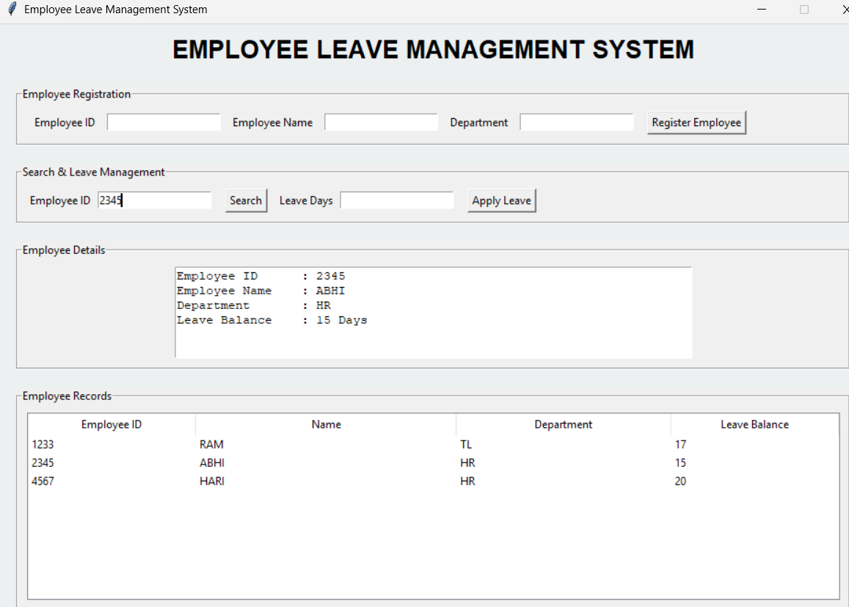
Figure : Employee Leave Management System User Interface

10. ADVANTAGES:
- User-friendly graphical interface
- Easy employee record management
- Reduced paperwork
- Improved accuracy
- Faster processing
- Efficient leave balance tracking
- Centralized database management

11. FUTURE ENHANCEMENTS:
The project can be enhanced with the following features:
- Employee Login Authentication
- Admin Login Module
- Leave Approval and Rejection System
- Email Notifications
- Report Generation
- Cloud Database Integration

12. CONCLUSION:

The Employee Leave Management System successfully automates employee record management and leave processing activities. The system helps organizations maintain employee records efficiently and accurately. The project demonstrates the practical implementation of Python, Tkinter, and SQLite in developing a real-world desktop application. It reduces manual effort and improves overall efficiency in leave management.

REFERENCES:
- Python Official Documentation
- Tkinter Documentation
- SQLite Documentation
- Visual Studio Code Documentation

