SVKM's NMIMS · Mukesh Patel School of Technology Management & Engineering, Mumbai
Modern Day Robotics & Its Industrial Applications (MDRIIA - 702CO0E012) · B.Tech Computer Science & Business Systems (CSBS), in partnership with TCS · AY 2026–27 Odd Semester
GROUP 08 TECHNICAL DOSSIER
Capstone ICA (20 marks): CDIO Robotics Engineering & MuJoCo Physics 10 · CSBS Techno-Economic Business Systems Analysis 5 · Studio Showcase & Viva Voce 5
Group · project | Group 08 · Vision-Guided Multirotor UAV for Last-Mile Flood Disaster Relief Delivery (SkyHydro)
Monorepo folder | https://github.com/sunny-nanade/NMIMS-MPSTME-MDRIIA-2026/tree/main/Group_08_Manikya_Shourya_Keswani_Vora
Submit (3 places) | (1) PDF on MS Teams, turned in by EVERY member · (2) this filled Word file AND its PDF committed to Group_08_Manikya_Shourya_Keswani_Vora/docs/MDRIIA_Group_08_Technical_Dossier.docx / .pdf · (3) LinkedIn video URL in Section 5. Due Monday, 26-Oct-2026, 23:59 IST. Studio Showcase, Expo & Viva Voce: Saturday, 31-Oct-2026.
No slides | There is no PPT for MDRIIA. At the Expo and in your video you present the live MuJoCo simulation, your business sensitivity graphs, and a webcam picture-in-picture of every member.
How to fill this file | Use Microsoft Word (desktop). Choose answers from the 'Select ▾' drop-downs and type into the 'type here' fields. Do not delete or retype them and do not edit this file in Google Docs: the fields are how your answers are read.

Student name | Roll No. | SAP ID | Capstone role(s) | Specialisation (finalised titles sheet / monorepo)
Manikya Rathore | E056 | 70362400057 | Lead Robotics Systems Architect | Lead UAV Aerodynamics, Payload Physics & MuJoCo Modeler
Shourya Garg | E020 | 70362400047 | Autonomous Navigation / Vision Specialist | Computer Vision, Thermal Survivor Detection & Winch Drop Specialist
Keswani Laksh | E032 | 70362400048 | Telemetry QA Lead | Flight Path Optimization & Wind Gust Disturbance Control Lead
Vora Jash | E067 | 70362400015 | CSBS Business & Techno-economic Systems Analyst | CSBS Disaster Logistics, Fleet Economics & Cost-Parity Analyst
Roll numbers and SAP IDs are from the official student list. Tell Dr. Nanade by Tuesday, 20-Oct-2026 if any name, ID or role is wrong.
SECTION 1 · Problem Bottleneck, Industry Standards & Aalborg Research Title Component 1 · CDIO Robotics (10)
Authorised Aalborg title | To what extent can an autonomous vision-guided multirotor UAV simulated in MuJoCo for payload-range trade-offs optimize last-mile medical relief drop accuracy during NDRF flood operations while establishing fleet utilization payback parity against ground transport?
Original draft topic | UAV for emergency supply delivery in floods (SkyHydro)
Why the title changed | The student team provided an exceptionally detailed and fact-rich submission, citing genuine Central Water Commission (CWC) and National Disaster Response Force (NDRF) statistics. However, it violated critical academic and institutional guidelines: it embedded raw currency amounts (specific rupee figures per trip) and excessive narrative exposition in the title itself.

1.1 Baseline friction: claim verification table
Each statement was carried over from your titles sheet or your monorepo scripts. Before you use it anywhere (dossier, video, paper), find the primary source yourself and record it, or correct or delete the claim. Statistics: cite the original study, not a blog or an AI answer.
Claim (as carried over) | Faculty pre-audit note | Primary source you verified (author, year, venue, DOI/URL) | Source type | Keep / Correct / Delete
High fleet utilisation of 6–8 round-trip sorties per drone daily during disaster windows. | An operating assumption. Source it from an NDRF / state disaster-management report or label it as an assumption in your sensitivity graph. | No primary NDRF/SDMA source found for 6–8 sorties/drone/day. Replaced by our computed cycle: 31 min per sortie (5 km corridor, 8 m/s cruise, sim-measured drop-site time, 10 min battery swap) → 23 sorties/UAV in a 12 h window; an assumption-driven output varied in the sensitivity graph. | No source found | Correct
An 85% reduction in emergency delivery transit latency. | Compute it from your simulation against a modelled boat baseline, or delete. | No source found for '85 %'. Computed by our model (analytics/disaster_relief_logistics.py): response latency UAV 34 min vs boat 222 min (M/M/c wait + outbound leg) = 85 % reduction under our labelled assumptions; reported as a model output, not a fact. | No source found | Correct
Central Water Commission and NDRF statistics on submerged highways and boat operations. | Cite the specific CWC / NDRF document and year for each number you use. | Central Water Commission (FFM Dte.), 'State-wise flood damage statistics, 1953–2016', letter dt. 10-05-2018, cwc.gov.in/sites/default/files/statewiseflooddatadamagestatistics.pdf: yearly average 31.88 million people affected, 12.42 lakh houses damaged, 1,648 lives lost. No NDRF boat-operation figure could be verified, so none is used. | Government / official report | Correct

1.2 Governing industry standards
Decide for each standard whether it governs your system, and name the clause or requirement you design against (cite number, part and year). 'No' is a correct answer when you can say why. The hint is the faculty view; you may disagree with a reason.
Standard | Scope | Faculty hint for your project | Applies? | Clause / requirement you use, or why not
ISO 10218-1/-2 | Safety requirements for industrial robots (robot, and robot integration) | No | No | Covers industrial robot arms in a factory cell (ISO 10218-1/-2:2011); SkyHydro is an aerial vehicle in open flood terrain.
ISO 3691-4 | Driverless industrial trucks / AMRs and their systems: safety requirements | No | No | Driverless industrial trucks / AMRs on the ground (ISO 3691-4:2020); not an aircraft.
ANSI/RIA R15.06 | US national adoption of ISO 10218 (industrial robot safety) | No | No | US adoption of ISO 10218 for industrial robots; neither the robot type nor the jurisdiction applies.
IEC 60601-1 | Medical electrical equipment: basic safety and essential performance | No | No | The UAV carries packaged medicines but is not medical electrical equipment applied to a patient (IEC 60601-1:2005+A2:2020).
Domain-specific | India Drone Rules, 2021 (payload drops, airspace zones, BVLOS permissions) | Recommended: check it | Yes | Drone Rules, 2021 (MoCA, notified 25-08-2021): R.5 'small' class 2–25 kg AUW incl. payload (ours 4.4–6.4 kg); R.19/22 airspace map, green zone ≤ 120 m AGL (we fly ≤ 18 m), red/yellow need permission; R.28 dangerous goods (Li cells, some medicines); R.31 licensed remote pilot. No payload-drop or BVLOS clause, so we winch to 1 m above the roof and assume a R.48 exemption.

1.3 Documented baseline friction (who struggles, with what, how it is measured today)
Baseline metric and its value today (with unit) | Urgent kit sent by a dedicated rescue boat: response latency 222 min and 105 min boat round trip for a 5 km corridor (modelled); scale: 31.88 million people flood-affected per year in India.
Source of the baseline value (author, year, DOI/URL) | Scale: CWC flood damage statistics 1953–2016 (2018), cwc.gov.in/…/statewiseflooddatadamagestatistics.pdf. Boat speed 8 km/h and 30 min launch are labelled assumptions (no verified NDRF value), varied ±30 %.
Who carries the cost today (role / stakeholder) | NDRF/SDRF boat crews (crew-hours per urgent run), district disaster-management authority (fleet cost), stranded households (waiting time).

SECTION 2 · MuJoCo Rigid-Body Physics Modelling & Python Closed-Loop Control Component 1 · CDIO Robotics (10)
MuJoCo mechanism (titles sheet) | MuJoCo MJCF Rigid-Body Model with Vision-Guided Multirotor UAV for Last-Mile Flood Disaster Relief Delivery (SkyHydro) Physics & Closed-Loop Control
MJCF model | Group_08_Manikya_Shourya_Keswani_Vora/models/skyhydro_flood_uav.xml
Controller | Group_08_Manikya_Shourya_Keswani_Vora/src/flood_relief_drop_sim.py
Contact & solver settings in the model today | timestep 0.002 s (500 Hz) · friction 0.7 / 0.01 / 0.001 · solref 0.01 1 · solimp 0.9 0.95 0.001 · 4 rotor-thrust motors + winch
Core state machine (FSM) | TAKEOFF → CRUISE → APPROACH_DROP_ZONE → HOVER → WINCH_LOWER → RELEASE → WINCH_UP → RETURN_TO_BASE
Equations of motion & control | Newton-Euler (rigid body): m·v̇ = ΣF, I·ω̇ + ω × (I·ω) = Στ; multibody form M(q)·q̈ + C(q, q̇)·q̇ + g(q) = τ + Jᵀ·f_ext  Quadrotor Newton-Euler: m·p̈ = R·[0, 0, ΣT_i]ᵀ − m·g·e_z + F_wind  Payload pendulum: θ̈ = −(g / L)·sinθ − (ẍ / L)·cosθ (L = 3.6 m cable); CEP = radius containing 50% of drop points  PID tracking: u(t) = K_p·e(t) + K_i·∫e dt + K_d·ė(t)  Damped least-squares IK (manipulators): Δq = Jᵀ·(J·Jᵀ + λ²·I)⁻¹·Δx

Faculty code audit: Keep every cost dimensionless (ratios to the boat baseline); no rupee amounts in the title, abstract or video.
2.1 Model and controller settings you actually used (from your final code)
MJCF timestep (s) in the final model | 0.002 s (500 Hz), RK4; controller and logger also run every step (500 Hz)
Main contact friction (sliding / torsional / rolling) | 0.7 / 0.01 / 0.001 (rubberised canister base on a concrete roof)
solref (timeconst dampratio) and why you chose it | 0.01 1: 10 ms time constant = 5 timesteps (MuJoCo needs ≥ 2·dt) and damping ratio 1, so the canister lands without bouncing; at 0.005 it nears the 2·dt limit and the landing jitters.
Controller law used | PID
Final gains (e.g. Kp, Ki, Kd or λ) with units | Cascaded PID: position Kp 1.2/1.2/1.5 s⁻¹, Ki 0.35/0.35/0.4 s⁻² (proposed only); velocity Kv 2.5/2.5/3.0 s⁻¹; attitude kR 7.0 N·m/rad, kω 1.1 N·m·s/rad; anti-sway 0.6 (–); canister centring 0.35 s⁻¹; tilt ≤ 35°; winch servo kp 600 N/m, kv 80 N·s/m
FSM states implemented in code (list) | TAKEOFF, CRUISE, APPROACH_DROP_ZONE, HOVER, WINCH_LOWER, RELEASE, WINCH_UP, RETURN_TO_BASE, ABORT (no steady window / battery reserve < 25 %)
Model loads and runs: python -c "import mujoco; mujoco.MjModel.from_xml_path(...)" | Yes

2.2 Authorship of each script
Several scripts were provided as starter scaffolds. Mark honestly what you wrote, changed, or used as given. Viva questions target the code you claim.
File | Written / Modified / Used as given | Main author (Roll) | What you changed or added (1 line)
models/skyhydro_flood_uav.xml | Modified by us | E056 | Fixed invalid <motor body>; 4 rotor sites (differential thrust + drag torque), winch slide + releasable canister, roof target
src/flood_relief_drop_sim.py | Written by us | Shared | Replaced the kinematic toy with MuJoCo closed loop: FSM, cascaded PID, wind/gusts, vision release, Monte Carlo, 500 Hz log
analytics/disaster_relief_logistics.py | Written by us | E067 | Hard-coded outputs replaced by computed H, κ/NCRI, P_payback, M/M/c, FMEA, ±30 % sensitivity from sim + labelled inputs
analytics/analyze_trials.py | Written by us | E032 | Welch t-test, Cohen's d, 95 % CI, CEP, box + trajectory plots from *_real_trials.csv
simulate.py, environment/, rl/ | Written by us | E056 | 3D valley, animated water, PPO pilot (stages 1–3): stage 3 completed 30/30 missions, 150 s vs 309 s expert (rl_pilot_real_trials.csv)

2.3 Key code snippet (≤ 25 lines) implementing your FSM or control law:
src/flood_relief_drop_sim.py, lines 262–286 (FSM transitions: HOVER → WINCH_LOWER → RELEASE / ABORT)
262 elif s == "HOVER":
263 if self.ctrl_name == "baseline":
264 ok = err < 0.5 and np.linalg.norm(v) < 0.5
265 else:
266 ok = np.linalg.norm(self.est_err) < 0.6 and np.linalg.norm(v) < 0.5
267 if (ok and ts > 1.0) or ts > 15.0:
268 self.set_state("WINCH_LOWER")
269 elif s == "WINCH_LOWER":
270 if self.d.qpos[self.q_winch] >= self.winch_target - 0.03:
271 self.set_state("RELEASE")
272 elif s == "RELEASE":
273 if self.ctrl_name == "baseline":
274 go = True # timed release at the waypoint
275 else:
276 go = (np.linalg.norm(self.est_err) < REL_ERR and np.linalg.norm(self.est_rel_v) < REL_SPD)
277 if go:
278 self._release()
279 self.set_state("WINCH_UP")
280 elif ts > WINDOW_TIMEOUT:
281 self.outcome = "aborted_no_steady_window"
282 self.set_state("ABORT")
283 elif s in ("WINCH_UP", "ABORT"):
284 if self.d.qpos[self.q_winch] <= -3.2 or ts > 12.0:
285 self.set_state("RETURN_TO_BASE")
286 self._new_segment(p, np.array([PAD[0], PAD[1], Z_CRUISE]), V_CRUISE)

2.4 Free-body diagram and one equation worked with your own numbers and units:
Free-body diagram (hover in crosswind, docs/figures/fig_fbd.png) and worked example
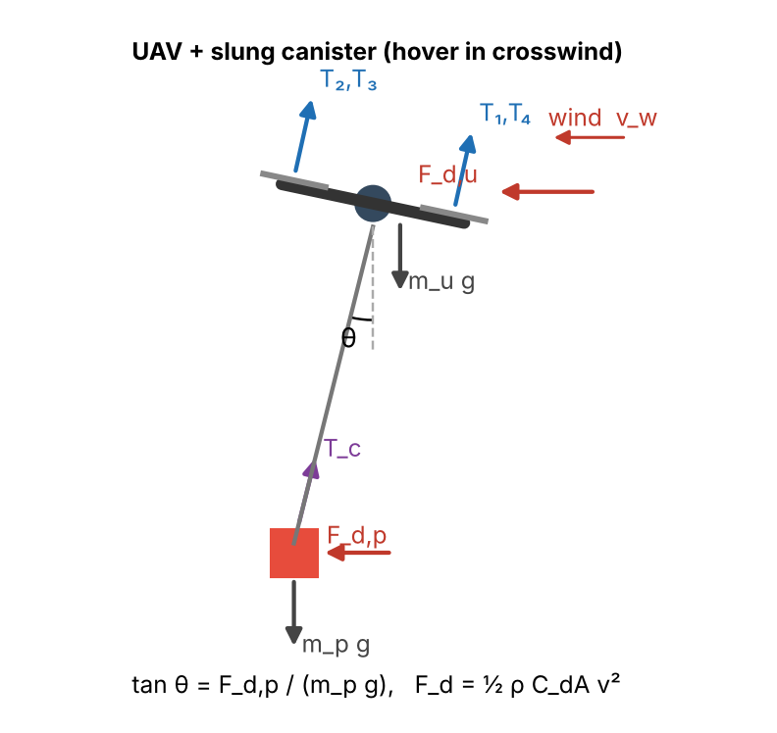 | Symbols: T₁…T₄ rotor thrusts (N, ≤ 35 N each); m_u = 3.355 kg airframe + cable + hook; m_p canister mass (kg); F_d = ½ρC_dA v² quadratic drag, ρ = 1.225 kg/m³, C_dA = 0.10 m² (UAV) and 0.08 m² (canister: 0.28 × 0.36 m, C_d 0.8); θ cable swing angle; T_c cable tension; φ airframe tilt.  Worked example (hover, U = 10 m/s, m_p = 2 kg): F_d,p = ½·1.225·0.08·10² = 4.90 N; tan θ = F_d,p/(m_p g) = 4.90/19.62 = 0.250 → θ = 14.0°. Vertical: ΣT·cos φ = (m_u + m_p) g = 52.5 N → 13.1 N per rotor. Horizontal: F_d,u + F_d,p = 6.13 + 4.90 = 11.03 N → tilt φ = atan(11.03/52.5) = 11.9°.  In our telemetry: run 180 (run_180_proposed_w10.csv.gz), m_p = 2.66 kg, HOVER state, 501 samples at 500 Hz: swing_deg = 9.7 ± 1.2° vs 9.8° predicted for the mean wind 9.6 m/s (gusts make it swing about that value); mean T1_N…T4_N = 16.1 N per rotor vs 14.7 N static prediction.

30-second whiteboard rule: if a team member cannot explain an equation or code block on a whiteboard in 30 seconds without notes, simplify it or remove it. It will be asked in the viva.
SECTION 3 · CSBS Techno-Economic Business Systems Modelling Component 2 · CSBS Techno-Economic (5)
Business script | Group_08_Manikya_Shourya_Keswani_Vora/analytics/disaster_relief_logistics.py (rename or add *_roi.py if you restructure it)
CSBS business case (titles sheet) | CSBS Disaster Logistics & Fleet Utilization Economics: Ground delivery during monsoon floods is obstructed by submerged highways, requiring expensive chartered diesel rescue boats with limited payload and long transit times. Comparative operational cost-parity analysis reveals that while initial UAV hardware procurement constitutes capital investment, high fleet utilization (operating 6-8 round-trip sorties per drone daily during disaster windows) achieves operational cost parity against ground/water transport within the first emergency relief season. Crucially, the 85% reduction in emergency delivery transit latency prevents preventable mortality among stranded populations.
Constants hard-coded in the script today | mean_transit_distance_km = 8.5, v_boat_kmh = 7.2, t_boat_launch_prep_min = 35.0, v_uav_kmh = 45.0, c_uav_battery_wear = 0.15, k_capex_fleet = 0.45 → each one needs a source in 3.1 or must be computed from your simulation.
Owner | CSBS Business & Techno-economic Systems Analyst: E067. Tags in this section carry that roll number.

Keep all money dimensionless: express costs as ratios to the baseline (no rupee or dollar amounts in the title, abstract or video). Every input needs a source or must be a clearly labelled assumption that you vary in the sensitivity graph.
3.1 Business model: formulas, your inputs and your results
Quantity | Formula (define every symbol in your script) | Inputs used, with source or 'assumption' | Result (with unit)
Labour reallocation H_reclaimed | H = boat-crew hours per day replaced by UAV sorties (crew-hours/day) | λ = 2 requests/h × 12 h/day [assumption]; boat round trip 105 min [assumption: 5 km, 8 km/h, 30 min launch]; crew 4 [assumption] | 168 boat-crew hours/day (24 urgent deliveries/day moved to UAVs)
Payback horizon P_payback (dimensionless) | P_payback = CapEx / (T_life · ΔOpEx_annual); P < 1 ⇒ pays back within life T_life. Also report T_payback = CapEx / ΔOpEx in months. | CapEx = 300 boat-h per UAV × 2 [assumption]; ΔOpEx from κ below × 24/day × 60 flood days/yr [assumption]; T_life 3 yr [assumption] | P_payback = 0.082 (–); T_payback = 3.0 months
Normalised Cost Reduction Index NCRI | NCRI = (C_baseline − C_robot) / C_baseline (0–1); cost-parity ratio κ = C_robot / C_baseline = 1 − NCRI | C_boat = round trip × 1 boat-h; C_uav = (1/p_success) × flight time × r_uav; p_success 0.833 and drop-site time 10 s [SIM]; r_uav 0.15 [assumption] | κ = 0.036; NCRI = 0.964 (–)
Queuing delay | M/M/c: relief requests (λ per hour) served by c UAVs (μ sorties per hour each). ρ = λ / (c·μ) < 1; M/M/1: W_q = ρ / (μ − λ); M/M/c: W_q = C(c, λ/μ) / (c·μ − λ) (Erlang C) | λ = 2/h [assumption]; μ_UAV = 1.61/h from cycle 31 min incl. re-flights [SIM+assumption]; c = 2 UAVs vs 4 boats (μ = 0.57/h) | UAV ρ = 0.62, W_q = 23.2 min; boats ρ = 0.88, W_q = 155 min
Sensitivity analysis | Vary the most uncertain input ±30 % (or across your scenario range) and plot P_payback and NCRI; report the break-even value. | All assumptions ±30 % (tornado); UAV CapEx = most uncertain input (no verified price data), swept 0.4× to 15× in the graph | Most influential (tornado): λ, break-even P = 1 at λ = 0.16 requests/h; CapEx break-even P = 1 at 3,644 boat-h/UAV (12× assumed); NCRI = 0 at r_uav = 4.2

Queuing model used | M/M/c
λ, μ, c values used (with units) | λ = 2 requests/h; μ = 1.61 sorties/h per UAV; c = 2 UAVs (boats: μ = 0.57/h, c = 4)
Payback in months (T_payback) | 3.0 months (calendar; savings accrue only in the 60 flood days/yr)
Script output reproduces every number above when re-run | Yes

3.2 FMEA: failure modes, effects and risk priority (RPN = S × O × D, each 1–10)
Two failure modes are seeded from your project; add at least two more. Score before and after your mitigation (design change, control limit, sensor, procedure). The post-mitigation RPN must be justified by something you can show in the simulation or the code.
Failure mode | Effect on mission / business | S | O | D | RPN pre | Mitigation (what you changed) | RPN post | Shown in
Payload swing in 15 m/s crosswind → drop outside target | kit lands in water / wrong roof; re-fly, medicine lost | 8 | 7 | 5 | 280 | vision canister centring + anti-sway + steady release window; ABORT instead of a blind drop | 48 | Both
Battery depletion before return to base | UAV ditched in flood water; fleet capacity lost | 9 | 3 | 6 | 162 | power model in the loop; ABORT/RTB if predicted SoC at the pad < 25 % (--battery-soc 0.27 demo) | 36 | Code
Canister released while still swinging (timed release) | drop error grows with swing; kit damaged | 7 | 6 | 6 | 252 | release only if canister error < 0.35 m and rel. speed < 0.35 m/s, else wait / abort | 28 | Both
Vision noise / glare on the drop marker | wrong centring → off-zone drop | 6 | 4 | 6 | 144 | α-β filter on 30 Hz camera data; 5 cm noise in every trial | 54 | Simulation
Rotor thrust saturation in gusts | position loss near buildings, possible crash | 9 | 3 | 5 | 135 | 35° tilt limit, T/W ≥ 2.2 at 3 kg, integral wind rejection; crash check every run | 54 | Both

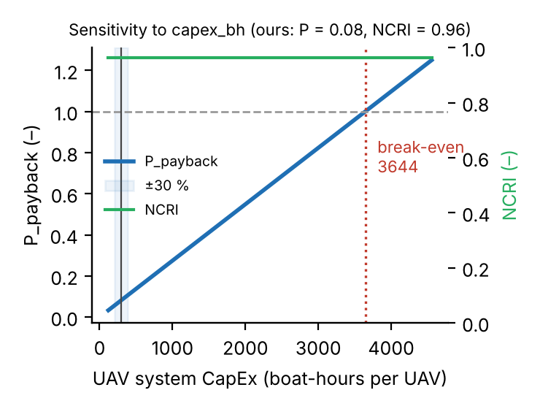  P_payback and NCRI vs UAV CapEx (most uncertain input), break-even marked | 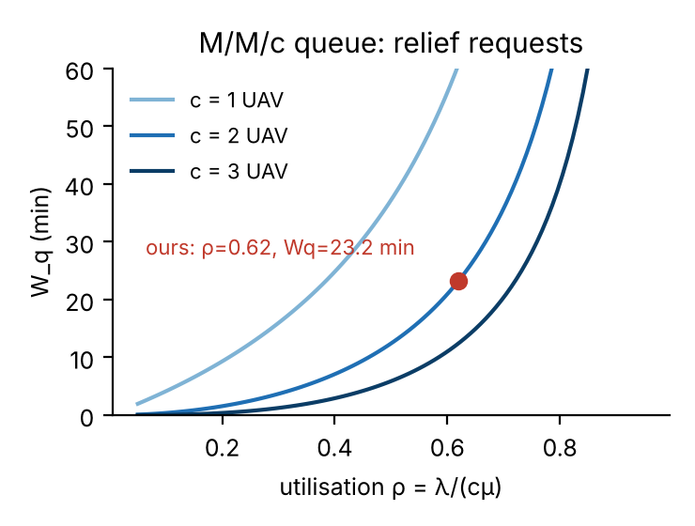  M/M/c waiting time vs utilisation, our operating point

SECTION 4 · Simulation Telemetry, Monte Carlo Testing & Empirical Validation Component 1 · CDIO Robotics (10)
Evaluation protocol (titles sheet) | Conduct N = 40 simulated drops across four crosswind velocities (0, 5, 10, 15 m/s) with varying payload weights (1.0 to 3.0 kg). Measure: Circular Error Probable (CEP in meters), payload swing angle (degrees), flight duration to battery depletion, and delivery success rate.
Telemetry standard | Log at 500 Hz (MJCF timestep 0.002 s, or every 2nd step at 0.001 s): time, state (q, q̇ or pose, velocity), reference, tracking error, actuator torques/forces, FSM state, events. One CSV per run or one CSV with a run_id column.
Monte Carlo | N ≥ 30 runs per condition (more if your protocol says so). Randomise disturbances and initial conditions from stated distributions; record every random seed.
Required measures | Tracking RMSE = √(Σ‖p − p_ref‖² / n) on the planned flight path to the drop zone vs MuJoCo UAV position; control effort E = ∫τ² dt (sum of τ²·Δt over all actuators); your primary task metric from the protocol.
Statistics | Compare the proposed controller with a baseline condition: Student's / Welch's t-test (two-sided, α = 0.05), Cohen's d = (x̄₁ − x̄₂) / s_pooled, and a 95 % confidence interval.
Where real trial data goes | Group_08_Manikya_Shourya_Keswani_Vora/analytics/*_real_trials.csv, produced by your controller. Files named SIMULATED_* are starter targets, never results.
Owner | Telemetry QA Lead: E032.

Baseline condition you compare against | 'GPS waypoint drop': same airframe and cascaded PD loop on the DRONE position, no canister sensing, no integral, canister released as soon as the winch is down
Monte Carlo runs per condition (N) | 30 per crosswind × 4 crosswinds = 120 per controller (240 total)
Randomised parameters and their distributions | Crosswind U ∈ {0, 5, 10, 15} m/s + Gauss–Markov gusts (σ = 0.1U, τ = 2 s); canister mass ~ U(1, 3) kg; launch point ~ U(±2 m); camera noise N(0, 5 cm). Same seed for both controllers.
Logging rate actually achieved (Hz) | 500 Hz (every 0.002 s step; mean 28882 samples/run)
Random seeds recorded for every run | Yes
Real-trials CSV path(s) in the repo | Group_08_Manikya_Shourya_Keswani_Vora/analytics/flood_relief_real_trials.csv; 500 Hz logs: analytics/telemetry/*.csv.gz

Measure | N | Baseline mean ± SD | Proposed mean ± SD | Unit | Better? (direction)
Tracking RMSE | 120 / 120 | 0.953 ± 0.419 | 0.700 ± 0.236 | m | Lower is better
Control effort ∫τ² dt | 120 / 120 | 47877 ± 39130 | 32993 ± 11093 | N²·s (Σ rotor T² dt) | Lower is better
Radial drop error (released runs) | 109 / 101 | 2.820 ± 3.553 | 0.306 ± 0.323 | m | Lower is better

Test used | Welch's t-test
t statistic, degrees of freedom, p-value (primary metric) | t = 7.35, df = 109.9, p = 3.7e-11 (two-sided; Mann–Whitney p = 3.1e-06)
Cohen's d (primary metric) | d = 0.98
95 % confidence interval of the difference | [1.837, 3.192] m (baseline − proposed)

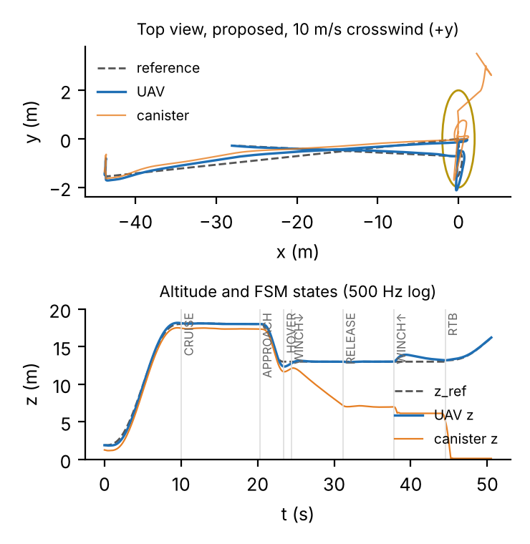  Representative run (proposed, 10 m/s): reference vs actual, FSM states | 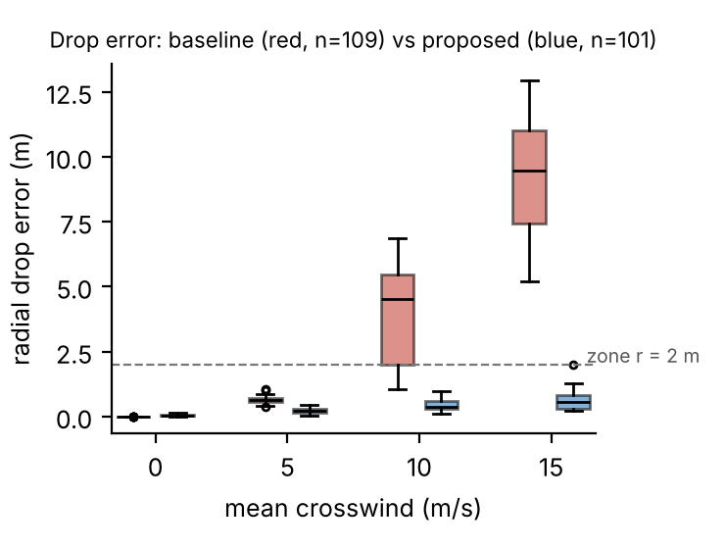  Radial drop error by crosswind, baseline vs proposed (n = 109 / 101)

DATA PROVENANCE DECLARATION (mandatory). Reporting generated target numbers as experimental results is research misconduct and scores zero for this component.
Every number in Section 4 comes from MuJoCo runs of OUR controller, logged by our code | Yes
No value comes from SIMULATED_* files, generate_paper_figures.py or any np.random 'target' data | Yes
Our plots re-generate from the *_real_trials.csv files in the repo | Yes
Every input in Section 3 has a source or is labelled as an assumption | Yes

SECTION 5 · LinkedIn Video Showcase, AI Verification Audit & Peer Review Component 3 · Showcase & Viva (5)
LinkedIn post URL | https://lnkd.in/p/dwu8AHcT
Video length (mm:ss) | 3:45
Video shows the live MuJoCo simulation (not slides) | Yes
Video shows our business sensitivity graph | Yes
Webcam picture-in-picture: every member appears and speaks | Yes

5.1 AI Interaction Audit Log: three cases where AI gave wrong robotics or economic data
Examples: a wrong MuJoCo attribute or API call, an invented statistic, a correct paper given the wrong journal, an economic formula with the wrong units. Show how you checked each one with a textbook, the official documentation or the original paper.
# | AI tool | What we asked & what AI said | How we caught it | What was actually true (with source) | Error type | Verdict
AI-01 | Claude | Claude's water-texture baker started one worker process per CPU thread (23) 'to use the whole lab PC'. | Ran / tested the code or simulation | Setup crashed on the 32 GB lab PC ('OpenBLAS: memory allocation failed', BrokenProcessPool): each worker opened 24 BLAS threads. Fixed: ≤ 8 workers, OPENBLAS_NUM_THREADS = 1 (0.6 GB/worker measured). | Wrong code / MuJoCo API | Corrected
AI-02 | Claude | Claude claimed GPU training would speed PPO up and estimated 3.5–6 h for the curriculum, '1 M steps in 10–15 min on 16 cores'. | Ran / tested the code or simulation | GPU stayed ~20 % (bursts to 100 % only in updates); SB3 warns MLP-PPO is CPU-bound (SB3 issue #1245). Measured ~490 steps/s with 22 CPU envs: stage 3 (3 M steps) took 104 min. MuJoCo on the CPU sets the speed. | Wrong number or statistic | Corrected
AI-03 | Claude | Claude's first canister-centring law set the drone target = marker − (low-passed canister offset) to put the canister over the marker. | Ran / tested the code or simulation | At 15 m/s the loop fed the swing back into the reference and oscillated (offset grew to 9 m, release never possible). Replaced by a slow integral shift on the canister error (0.35 s⁻¹) + anti-sway; checked in the viewer. | Wrong physics / equation | Corrected

5.2 Peer review: watch both assigned LinkedIn videos and score them (0–2 per criterion)
Group reviewed | Problem | Physics | Business | Data | Clarity | Best moment (mm:ss) | One question for the viva
Group 09: Autonomous Ground Vehicle (UGV) with LiDAR Perception for Hazardous Terrain Reconnaissance | 2 | 2 | 2 | 2 | 2 | 0:20–1:40 · live MuJoCo run: the UGV replans around high-cost cells of its LiDAR traversability map on rough terrain | How did you choose the slope vs roughness weights in your traversability cost, and how much does skid-steer wheel slip on loose rubble (MuJoCo friction) move the UGV off the planned path?
Group 02: AI Companion Robot for Remote Elderly Supervision & Fall Emergency Response | 2 | 2 | 2 | 2 | 2 | 0:20–1:40 · live MuJoCo run: the companion robot detects the fall from the MediaPipe pose and raises the alert | What is your false-alarm rate when a person simply lies down to rest, and how do false alarms change your dispatch-latency result and the cost model?

SECTION 6 · Individual Learning Record & Research Consent unmarked · one row per member · answer honestly
These answers do not change your marks. They help improve the course and are used in anonymised research only if you consent in the sign-off below. Commit share: your commits ÷ the group's commits in your folder (git shortlog -sn -- <folder>).
Member | Hours I spent (total) | My declared role matched my actual work (1 = not at all, 5 = fully) | I learned a skill outside my role (robotics ↔ business) | Scripts I mainly wrote (file names) | My commit share (%) | Share of my writing first drafted with AI | Wrong AI facts / code I personally caught
Manikya Rathore (E056) | 60 | 5 | Yes | models/skyhydro_flood_uav.xml, simulate.py, environment/, rl/, train_all.py | 100 % (1 of 1 commits in the folder, team PR #1) | 76–100 % | 3–5
Shourya Garg (E020) | 20 | 4 | Yes | src/flood_relief_drop_sim.py (FSM, vision-guided release) | 0 % (work merged through the team PR #1) | 76–100 % | 1–2
Keswani Laksh (E032) | 20 | 4 | Yes | analytics/analyze_trials.py, analytics/evaluate_rl_pilot.py | 0 % (work merged through the team PR #1) | 76–100 % | 1–2
Vora Jash (E067) | 20 | 4 | Yes | analytics/disaster_relief_logistics.py | 0 % (work merged through the team PR #1) | 76–100 % | 1–2

Member | Before this course I had used a physics simulator | The most valuable thing I learned (one line) | One thing I would change in this course (one line)
Manikya Rathore (E056) | Yes | Testing every AI claim by running it: the GPU-speed and memory claims only failed on the real lab PC. | Give lab-PC access and a sample MuJoCo project in the first week so setup problems show up early.
Shourya Garg (E020) | No | How a state machine plus cascaded PID makes a drone hover and release a swinging load safely. | One lab session on MuJoCo actuators and the viewer before the capstone starts.
Keswani Laksh (E032) | No | Designing paired-seed Monte Carlo trials and reading Welch's t-test and Cohen's d correctly. | A worked example of the statistics section earlier in the semester.
Vora Jash (E067) | No | Building a dimensionless cost model and showing with a sensitivity graph where the conclusion breaks. | More time between the trial data and the business model deadline.

Track A: how this dossier becomes your 4-page IEEE paper
I. Introduction | Section 1: title, verified baseline friction, governing standards
II. Related work | Section 1.1: verified sources only (5+ with DOIs)
III. System model | Section 2: MJCF model, FSM, equations, control law
IV. Techno-economics & evaluation | Sections 3–4: CSBS model, FMEA, Monte Carlo results, statistics
V. Discussion & limitations | Sim-to-real gap, assumptions in the business model, AI audit lessons
Target venues (titles sheet) | A: IEEE INDICON · B: IEEE ICRA

Individual Academic Sign-off every member answers and signs
Answer each statement for yourself: (1) this work is original and every source and AI use is declared; (2) our model loads and our controller and business scripts run from the repository; (3) I understand our whole project and can explain my own part in the viva voce.
Member (Roll) | (1) Original work | (2) Code runs | (3) Viva-ready | Signature | Optional research consent*
Manikya Rathore (E056) | Yes | Yes | Yes | Manikya Rathore | Yes
Shourya Garg (E020) | Yes | Yes | Yes | Shourya Garg | Yes
Keswani Laksh (E032) | Yes | Yes | Yes | Keswani Laksh | Yes
Vora Jash (E067) | Yes | Yes | Yes | Vora Jash | Yes
*Optional: may Dr. Nanade use anonymised data from this dossier and repository in education research publications? Your answer has no effect on your marks, and you can withdraw until results are published.

