这是我的早餐，看起来不错吧？

This is my breakfast. Does it look good?

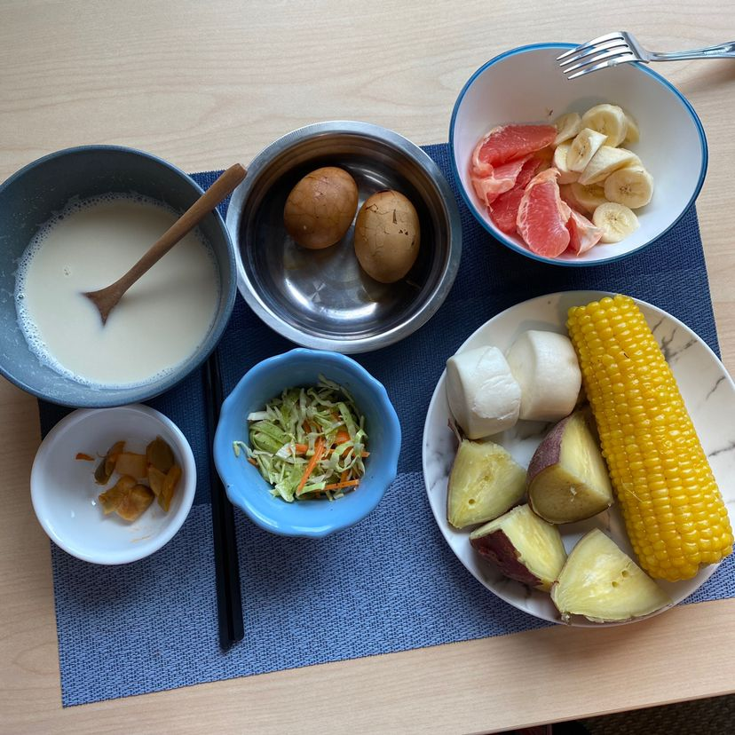

现在在香港疫情还是非常严重的，我现在准备带好口罩准备出发去公司，安全第一

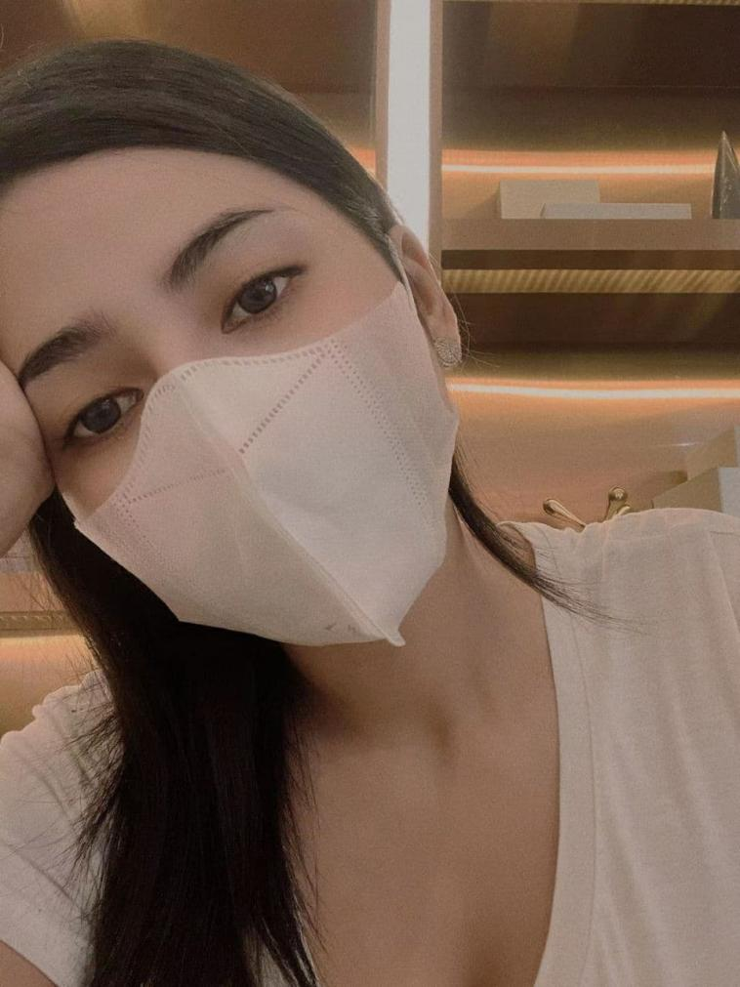

我公司中标了政府室外健身器材配建项目。这个项目预计将至少增加我今年利润的百分之10-20

Our company has won the bid for the government's newly-built polystyrene pellet environmental protection building materials project. This project is expected to increase my profit by at least 10-20% this year.

（间隔45分钟，告诉客户你到公司了！）

（然后包装去公司进行会议，和这个客户的聊天就可以告一段落了）

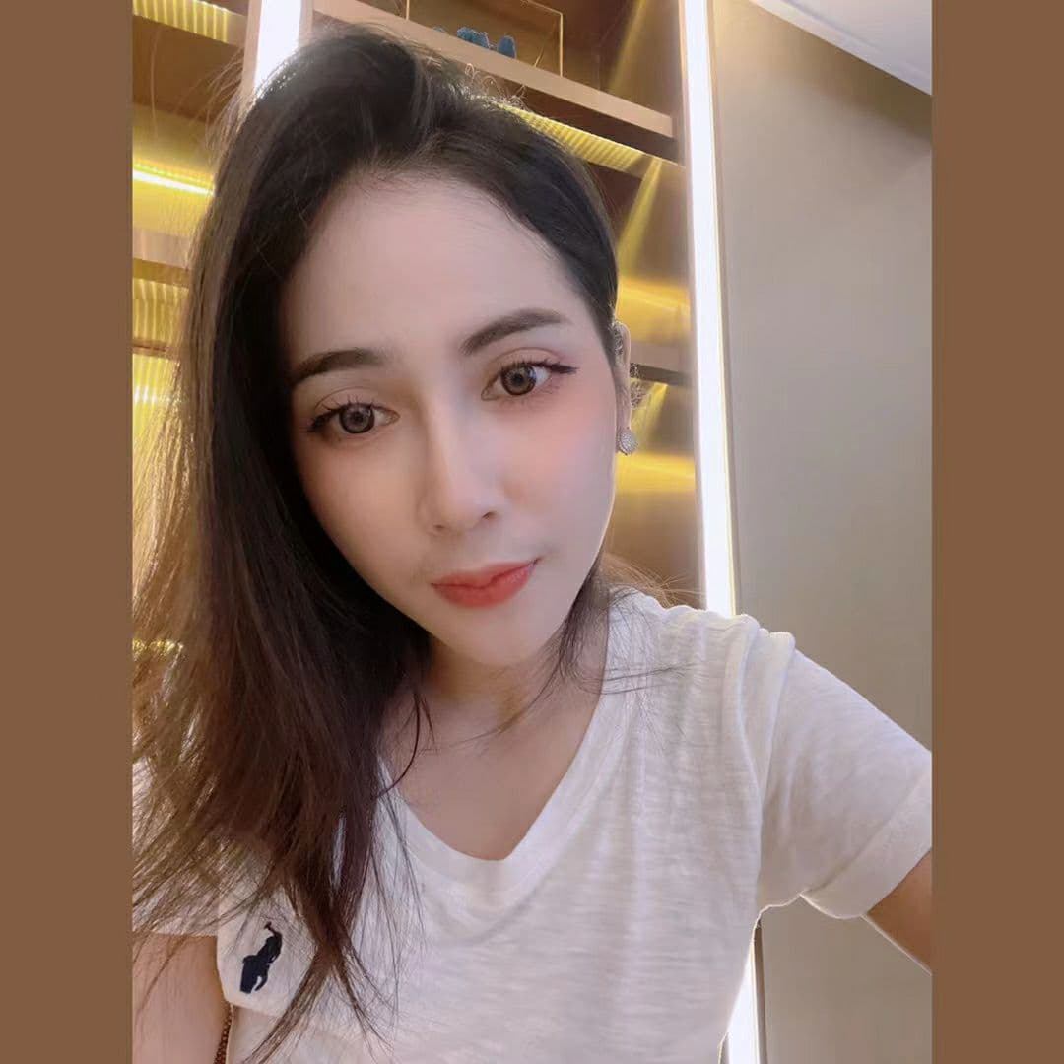

我现在已经到达公司

下午1点钟包装今天取得了不错的成绩，去给妈妈买礼物，然后讲个走心故事，和客户一起产生共鸣！继续深刻的走心

我刚刚结束了上午的会议，现在和朋友在商场吃午饭！

I have just finished the meeting in the morning and have lunch with my friends at the mall!

（吃饭的照片自己根据情况来搭配然后20分钟以后继续下面的内容）

我遇到一个难以抉择的问题，你觉得这两个项链哪个更好看呢

I have a hard choice. Which necklace do you think looks better

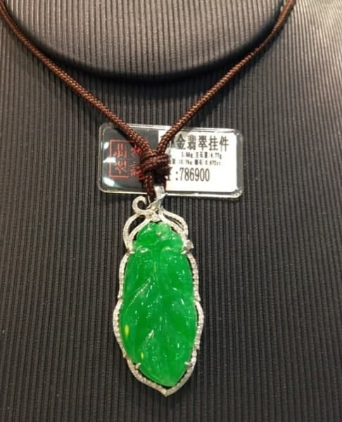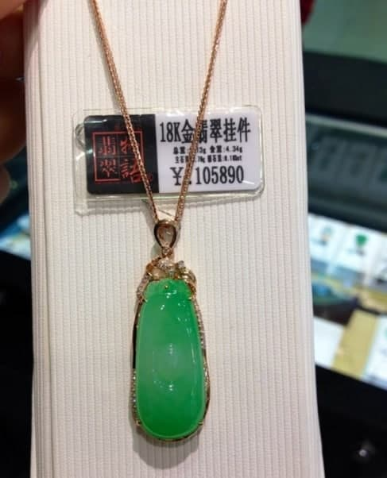

我妈妈生日快到了，以前都没怎么送礼物给她，这次想送她个小礼物

My mother's birthday is coming. I haven't given her any presents before. I want to give her a little present this time

你的眼光太好了，我也觉得这一个更好看，摸起来也更光滑，而且我觉得非常适合我的妈妈You have a good eye. I also think this one looks better and feels smoother. And I think it fits my mother very well

以前都是妈妈在承受整个家庭的担子，希望现在能让他们好好的享受生活关键是玉有灵气，去除百病 有益健康

Before is the mother in bear the burden of the whole family, I hope to let them enjoy life well the key is jade has aura, get rid of all diseases is good for health

每次想起小时候妈妈的不容易，我都会特别感谢我的妈妈，因为我的父亲，我和妈妈的日子过得非常的拮据

Every time I think about my mother's difficulties when I was a child, I will especially thank my mother. Because of my father's reasons, my mother and I are living very hard.

我最初有一个完整的家庭。 我仍然记得我只有八岁。 有一天夜里我听见妈妈的哭声，当时我不知道发生了什么。妈妈拉着我就前往了泉州市第一医院，当我看见趟在病床上满身血迹的父亲，那一幕我一辈子也忘不了。

I had a whole family at first. I still remember that I was only eight years old. One night I heard my mother crying, and I didn't know what had happened. My mother took me to the First Hospital of Quan Zhou. When I saw my father covered in blood in the hospital bed, I never forgot that scene.  
我父亲那晚出了车祸，他在医院的抢救无效。他永远离开了我

My father had a car accident that night, and his rescue in the hospital was invalid. He left me forever

两年后我妈妈带我离开家，来到香港。就这样，我们开始了新的生活，但一开始确实很困难。

Two years later, my mother took me away from home to Hong Kong. In this way, we started a new life, but it was really difficult at first.

母亲给了我我认为最好的生活，从小母亲对我的要求期望很高，我没有让她失望。我以优异的成绩进入香港大学。

My mother gave me what I think is the best life. My mother set high expectations for me when I was young, and I didn't let her down. I entered the University of Hong Kong with distinction.

虽然她没有说她的痛苦和疲劳，但我把它们记在心里，这就是为什么我要努力工作，让我母亲过上更好的生活最好的理由

Although she didn't talk about her pain and fatigue, I took them to heart. That's the best reason why I have to work hard to give my mother a better life

到目前为止，这些回忆对我和我的母亲来说是无法忍受的。 这是我埋在心里的伤口。 通常，我从不与他人交谈，也不知道为什么我可以与您交谈

So far, these memories are unbearable for me and my mother. This is the wound I buried in my heart. Usually, I never talk to others, and I don’t know why I can talk to you

在我读书的时候由于我没有爸爸，我会非常的自卑，但是自卑也是我学习的动力，和我比起来，你的童年经历一定是幸福的吧

When I was studying, because I had no father, I would feel very low self esteem, but low self esteem is also the motivation of my study. Compared with me, your childhood experience must be happy

PS:引起客户共鸣，倾听客户的故事

分享是一种神奇的东西，分享使悲伤变小，使快乐变大，我感觉我现在的心情平复了很多Sharing is an amazing thing. Sharing makes sadness smaller and happiness bigger. I feel my mood has calmed down a lot now

（然后话题自己延伸了，聊到这一天的客户粘度不会差的，走心的重点是在于让客户原因和你说一些属于他的秘密和难过伤心的事情，所以一定要挖出客户的心事，一个客户什么都愿意和你说，那你距离开发他不远了）

延伸话题，结束聊天的时候铺垫一下，

我刚做好面部护理，今天受到老师的邀请，明天要去参加老师的家宴

