早上好李杰，今天早上我去慢跑，你有这个习惯吗？

Good morning Bruce Lee, I went jogging this morning, do you have the   
跑步结束后，我打算去一趟汇丰银行提取一些资金，弥补昨天慈善的捐款，然后再去我的工厂，你今天怎么过的你的一天？

（客户有问，就说平时家里都有放置一些现金，本来计划用前天投资账户的资金去做慈善的，但是通常资金到账需要48小时）

After the running, I plan to take a trip to HSBC to withdraw some funds to make up for yesterday’s charitable donation.Then go to my factory, how did you spend your day today?

受全球此次疫情的影响，美国政府关闭了我在旧金山的出口贸易，导致我的工厂无法正常运转Affected by the global epidemic, the US government closed my export trade in San Francisco, which caused my factory to fail to operate normally

我的工厂主要生产体育运动器材，针对旧金山和中国大陆的出口贸易，向各大城市提供运动健身器材，我想我到了我的工厂我可以为你拍摄我工厂的照片

My factory mainly produces sports equipment, and provides sports and fitness equipment to major cities for the export trade of San Francisco and Chinese mainland. I think I can take photos of my factory for you when I arrive at my factory.

我现在要开车去我的工厂检查进程，我可以为拍一点工厂照片。让你了看看解一下我的工作，我们稍后再聊

I am going to drive to my factory to check the progress, and I can take some photos of the factory. Let you have a look and explain my work, we will talk later

间隔数小时发送

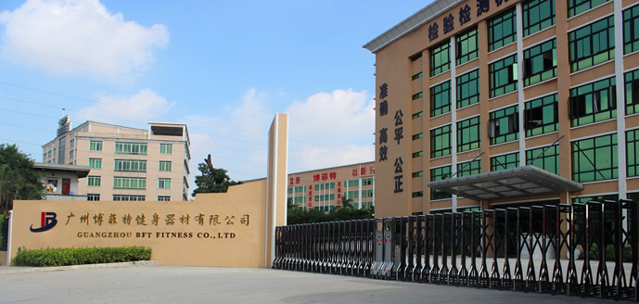

这是我公司大门

This is the gate of our company

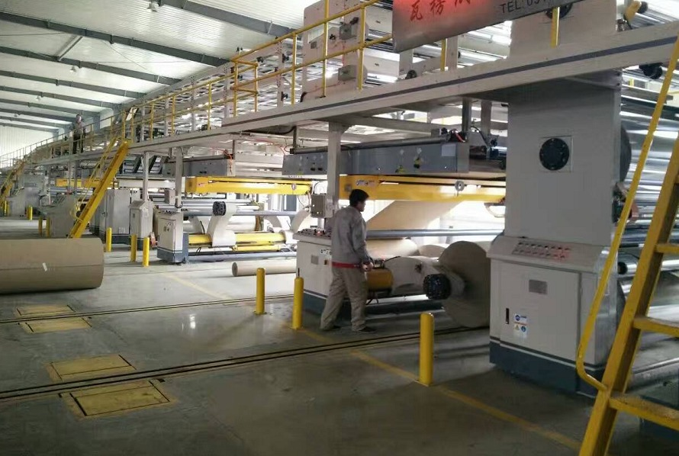

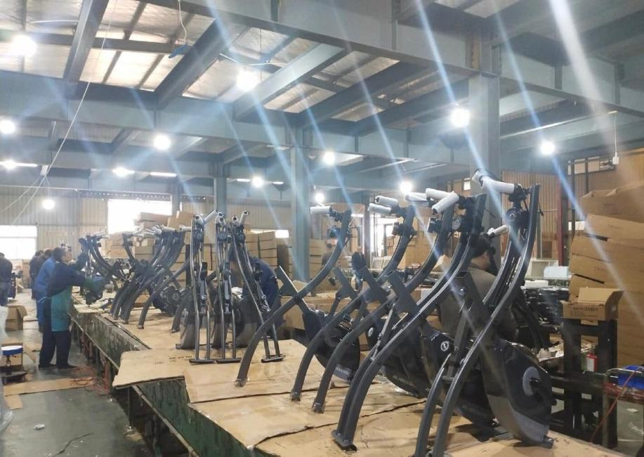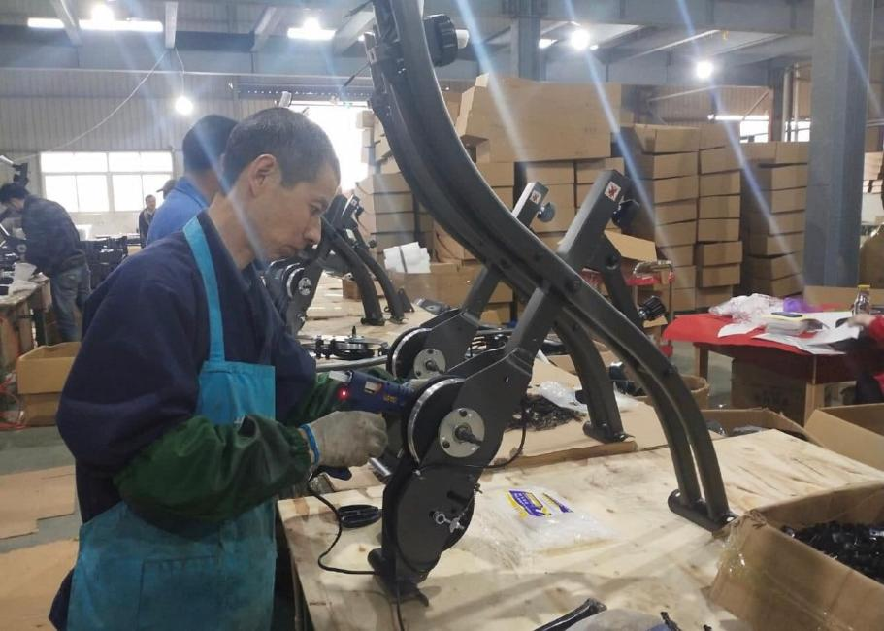

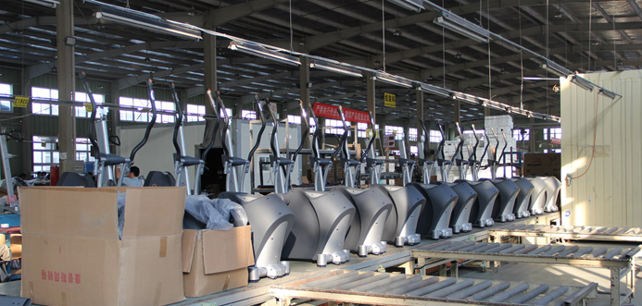

这是我的生产车间，制作是机械化，安装完全是人工化的，这些都是跟了我数年的老员工，他们工作非常认真

This is my production workshop. The production is mechanized, and the installation is completely manual. These are the old employees who have been with me for several years, They work very seriously

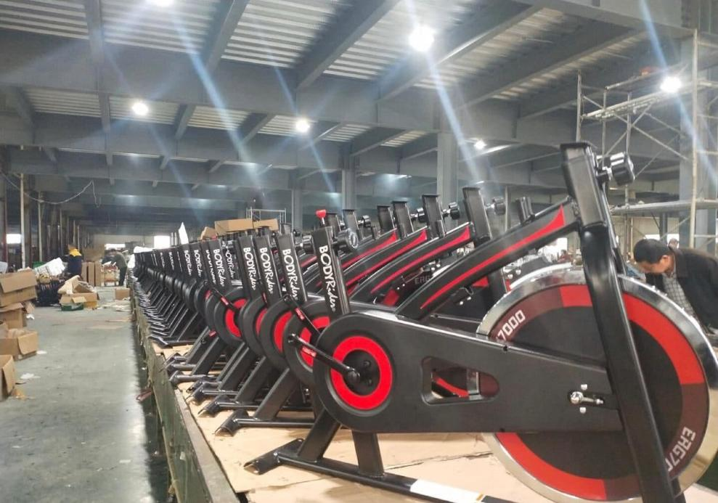

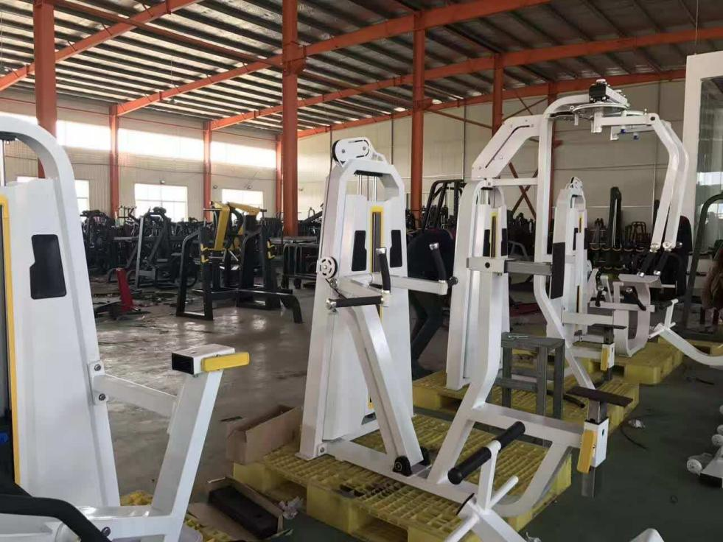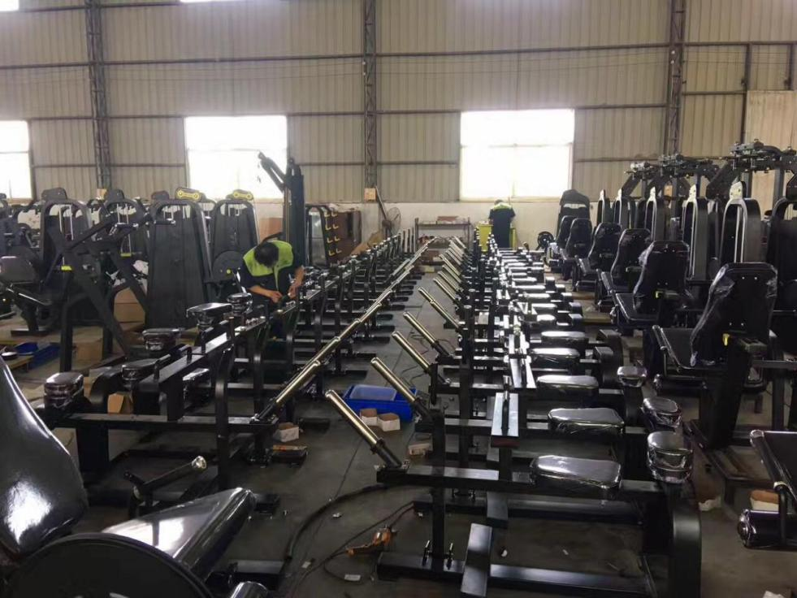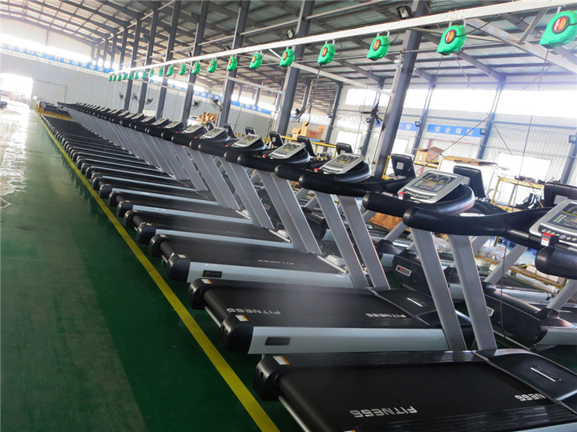

这是我的仓库。由于疫情，这些运动器材没有库存。我有4个这样的厂房。

This is my warehouse. Due to the COVID-19 outbreak. These sports equipment has been placed in some inventory. I have 4 such

factories.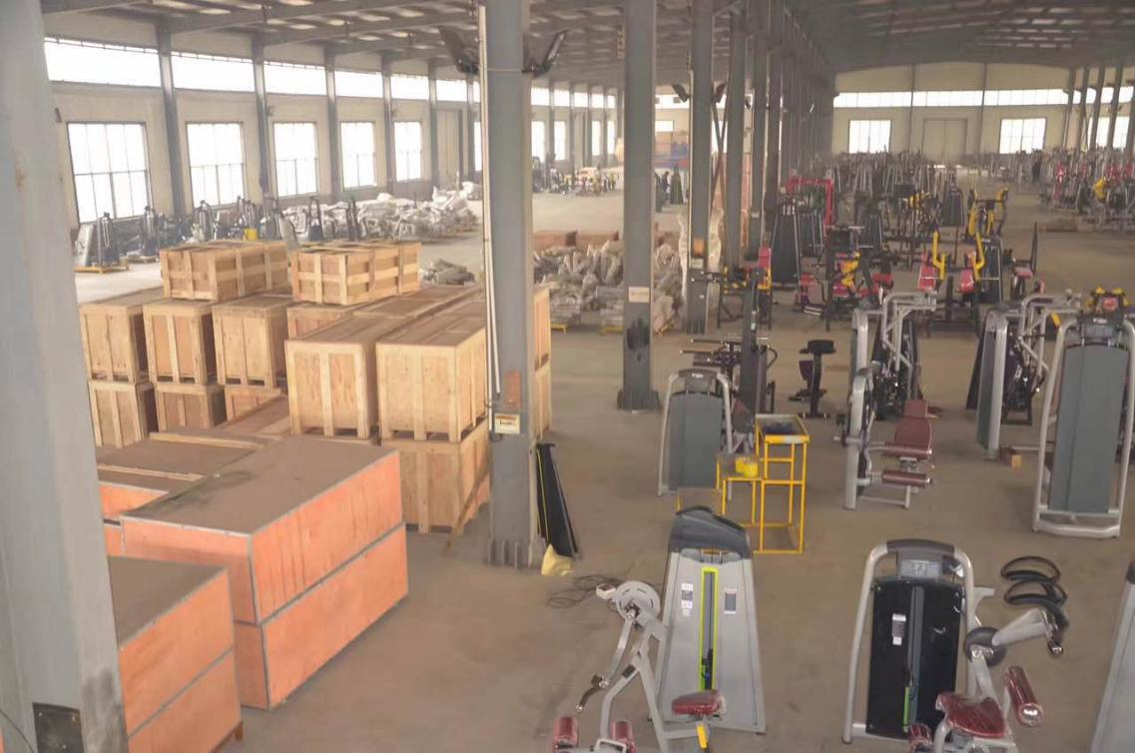

这是我的出口包装部港口，工人将打包好器材放置到集装箱中，发往欧洲市场，我现已实现生产运输流水线，我的梦想是拿下整个亚洲市场的运动器材的份额，你的梦想是什么？（记住客户的梦想）客户说了梦想，就让他去实现

This is my outlet port packing department, workers will pack up equipment placed in the container, destined for the European market, I now realize production and transport lines, my dream is to win the share of sports equipment throughout the Asian market, your dreams What is it?

企业的发展离不员工的共同努力，虽然当初创业艰辛，但我始终相信时光不会辜负一个平静而努力的人。

The development of an enterprise is inseparable from the joint efforts of employees. Although it was difficult to start a business at the beginning, I always believe that time will not disappoint a calm and hardworking person.

但是现在受流行病影响，实物行业并不理想，订单很少，我将大部分管理工作都交给了我的管理层。如果我急于订购，生产线通常不得不加班。But now affected by the epidemic, the physical industry is not ideal, with very few orders, and I have delegated most of the management work to my management. If I rush orders, production lines often have to work overtime.

聪明的人知道如何顺应潮流并抓住机遇。 实际上，三分之二的美国富人都在经营货币市场

自选：愿意聊货币的（聊一下加密货币的交易便利及优势，夸大收益）

接着包装看望老师！

我买了一个好东西，准备送给我的老师，我分享给你，你猜猜是什么！

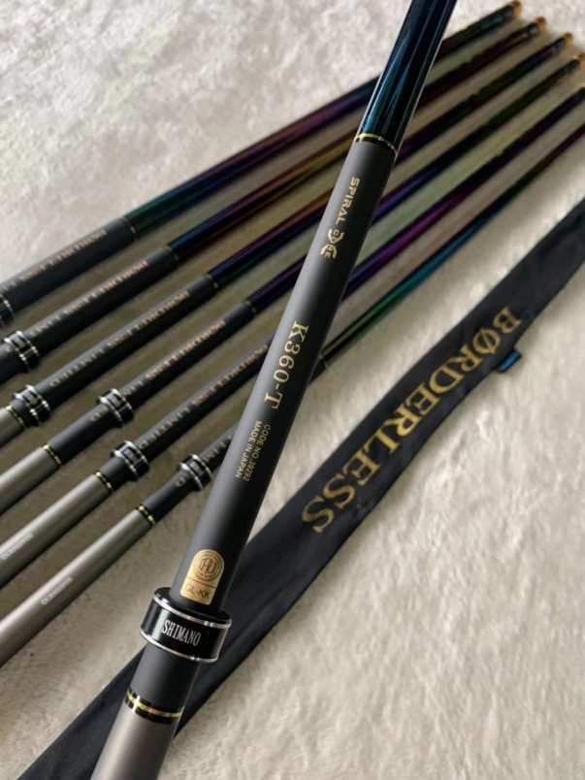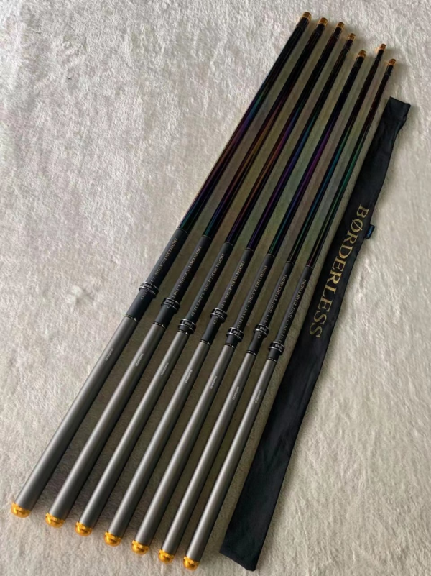

这是禧玛诺鱼竿，我的老师现在退休生活就是喜欢钓鱼。

因为我受到了老师和师娘的邀请，去他们家里一起吃饭，聊聊天，所以我买了一个礼物送给老师！

（然后聊聊中国文化象棋，接下来主要就是在晚上的一个聊天！）

包装行情话术：李杰告诉你一个好消息，我刚才接到通知，分析师告诉我明天可以进行加密货币交易，分析团队让我把握收益，预计在百分之30

PS:这个时候配每天的行情图片

此次的货币交易行情，我想你可以同我一起抓住此次的交易机会！

The foreign exchange market, I think you can seize this trading opportunity with me!

把消息变成效益，不管是数据是好是坏等等，团队分析的结果，利润买涨，坏话买跌

Turn the news into benefits, whether the data is good or bad, etc., the results of the team analysis, profit buying up, ill buying down

（这个时候之前受二切盈利刺激激进可以直接引导下盘跟着三切的操作，看自己手中客户情况）

意向客户回答愿意跟我们一起操作：直接引导下盘

非意向客户：转聊生活

意向回答：您可以扫码直接下载（平台二维码）

下载后，把截图给我，我会检查的

我建议你从小资金开始 客户问多少资金我刚开始是26万自己编看客户的资金情况 （一万）

客户还价直接推菲利克斯的名片，预约开通真实账户。

（下盘后我们与客户约好操作时间即可，然后转聊生活，慢热型的客户，我们包装行情后直接转聊生活，结束行情以后在引导下盘）

