每天醒来。 你们都有一个选择：实现你的梦想。 早上好！ 李杰。 你今天过得怎么样？Wake up every day. You all have a choice: to realize your dreams. Good morning! Li Jie. How was your day?

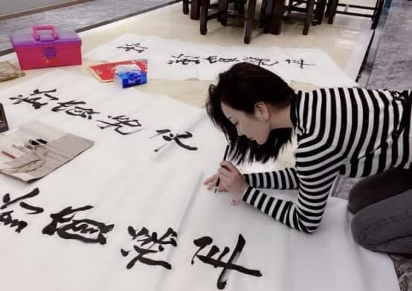

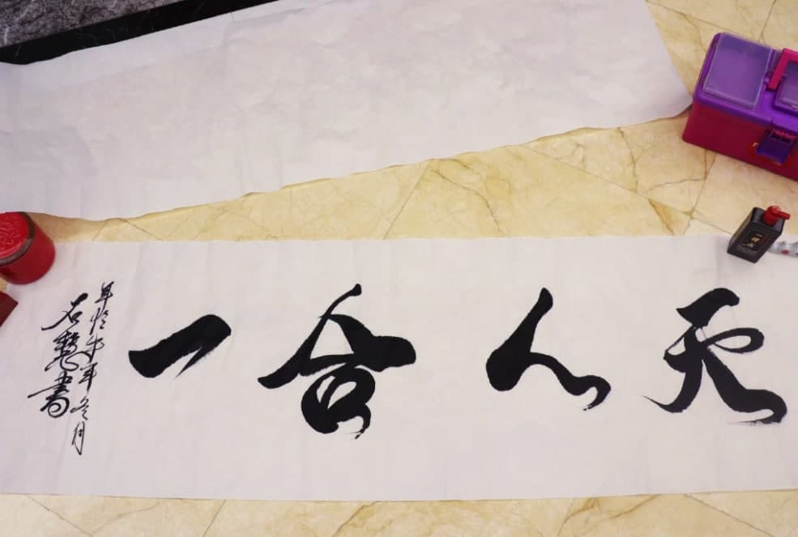

这是我昨天刚写好的毛笔字。你觉得我写的怎么样？

This is the brush calligraphy I just wrote today. What do you think of what I wrote?

我的爱好很多，书法也是我的其中之一，你知道我写的文字内容是什么吗

I have many hobbies, and calligraphy is one of my things. Do you know the meaning of the text I wrote?

天人合一：天地与我并生，万物与我为一：

Unity of nature and man:Heaven and Earth coexist with me, and everything is one with me（一合人天）

中国的汉字博大精深，如果你对汉字写写感兴趣的话，我认为你可以先写你的名字

If you are interested in practicing writing Chinese characters. I can teach you to write your Chinese name

我的中文名字是李玉，我用中文汉字分别把你和我的中文名字发给你

My Chinese name is Li Yu, I use Chinese characters to type out your Chinese name and mine respectively and send it to you

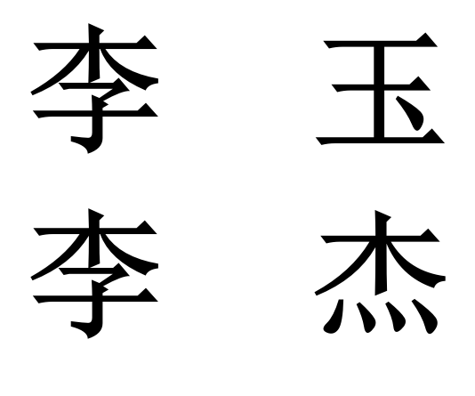

按照中国的文化习俗，我现在教你汉字，你应该称呼我李老师，哈哈

According to Chinese cultural customs, I am now teaching you Chinese characters, you should call me Mr. Li, haha

我录制一段视频。 教你如何写作。 因此，您可以进行更好的练习

I record a video. Teach you how to write. So you can practice better

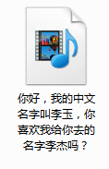

你先自己练习，我现在要做手术了

You practice by yourself first, I'm going to have an operation now

你先自己练习。然后拍图发给我。我会检查你写的怎么样。我现在需要做一个手术了

You practice by yourself first. Then take pictures and send them to me. I'll check how kind you write. I now need to do a surgerynow

间隔10分钟回复客户

我习惯把加密货币操作称为手术，我接到分析师的建议，刚刚操作了一次，猜猜我赚了多少钱

I used to refer to cryptocurrency operations as surgeries, I received advice from an analyst and just did one and guess how much money I made

我刚才赚了5万美元，市场就是这样，专业的事情交给专业的人去做，我们只需打开手机花上几分钟交易就可以了

I just made $150,000, that's the way the market is, professional things are done by professional people, we just turn on our phones and spend a few minutes trading

（盈利图不超过五万）最好3万左右

这是我这次的收益，在我的分析师指导下我赚取了######万美金，市场就是这样，专业的事情交给专业的人去做，我们只需打开手机花上几分钟交易就可以了

This is my revenue this time. I earned ###### $ under the guidance of my analysts. This is the market. Professional work is left to professional people. We only need to turn on our mobile phones and trade for a few minutes.

而且分析师的行情把握是很精确的，他们通常会花费一周甚至一个月的时间进行市场调研，只有百分百有把握的行情才会通知我们进行操作，所以我今天才会有这样的收益！

因为疫情导致的通货膨胀，接下来货币市场还有很不错的行情

如果你也想通过投资来改变生活，累积财富，我建议你也可以从小资金开始做货币交易

客户做就先让他下载Dbitmax加密货币软件，叫我来帮你们聊一次，你们后面就知道怎么聊了

现在，我正在与经纪人菲利克斯联系以提取资金，用于之前告诉你的美容院投资，经过慎重的考察和关注，我决定拿出40万美元来投资美容院 （我们账户余额不得低于100万）

Now, I am contacting my agent Dave to withdraw funds for the beauty salon investment I told you before. After careful investigation and attention, I decided to invest 400,000 US dollars in the beauty salon.

间隔半个小时发给客户

我已成功提款，资金将于今天到达我的汇丰银行账户，菲利克斯是我的经纪人，现在和我以朋友相处，他的服务态度非常好，非常专业，而且巴菲特也是他的客户之一

I have made a successful withdrawal and the funds will arrive in my HSBC account today, Felix is my broker and is now spending time with me as a friend, he is very good and very professional and Warren Buffet is one of his clients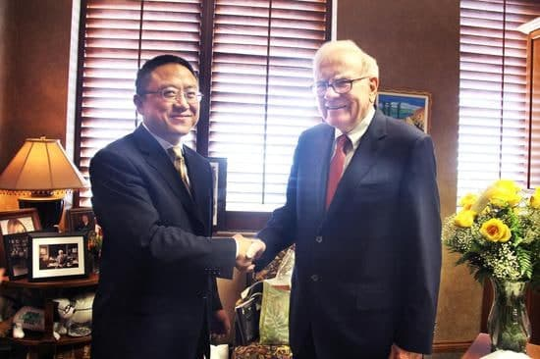

客户睡了就祝他好梦

下午我们包装取款

李杰，我现在要去汇丰银行提取我的资金，然后去签订美容院的合同

Li Jie, I have to go to Minsheng Bank now to withdraw my funds and then to sign the contract for the beauty salon

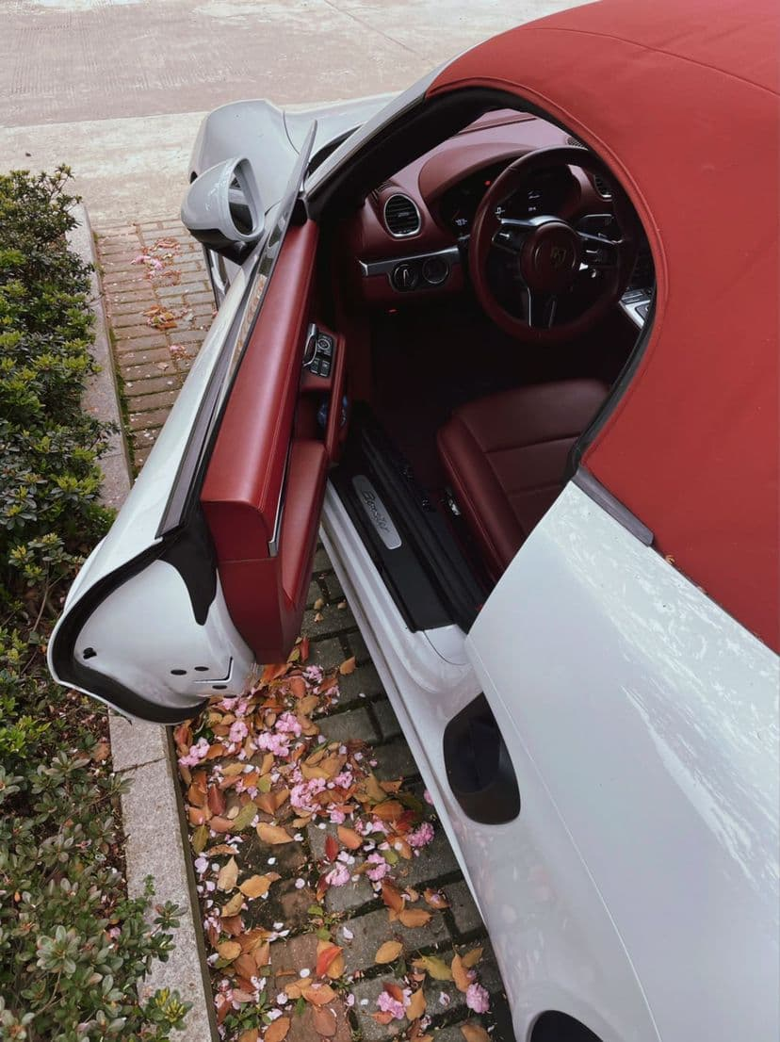

我到了

I have arrived

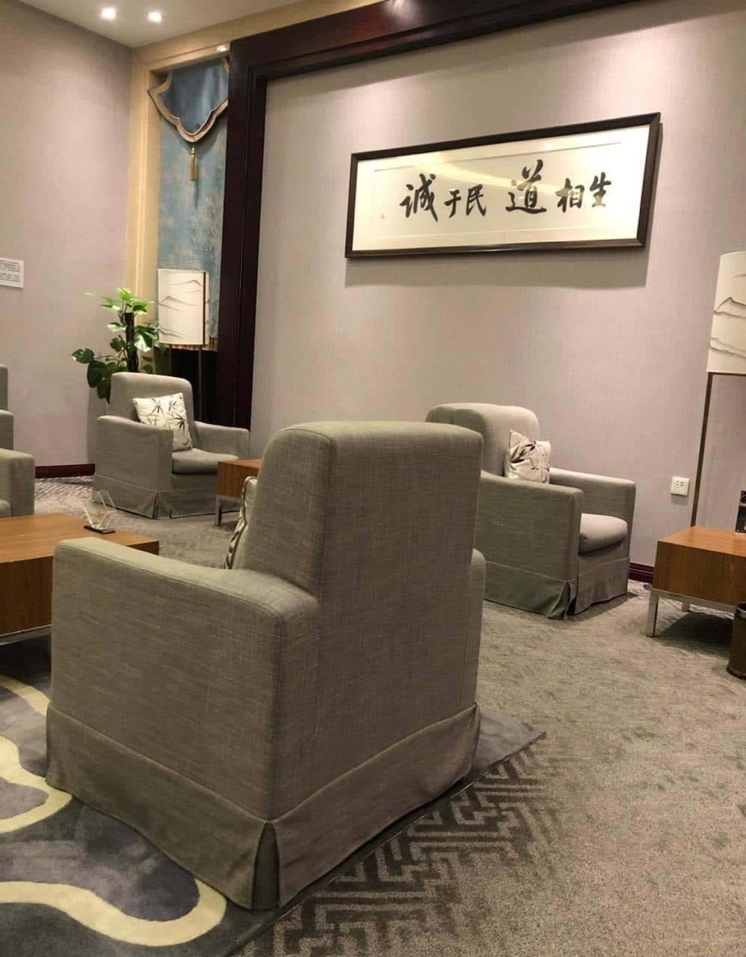

保护我李杰 haha

ProtectmeLiJiehaha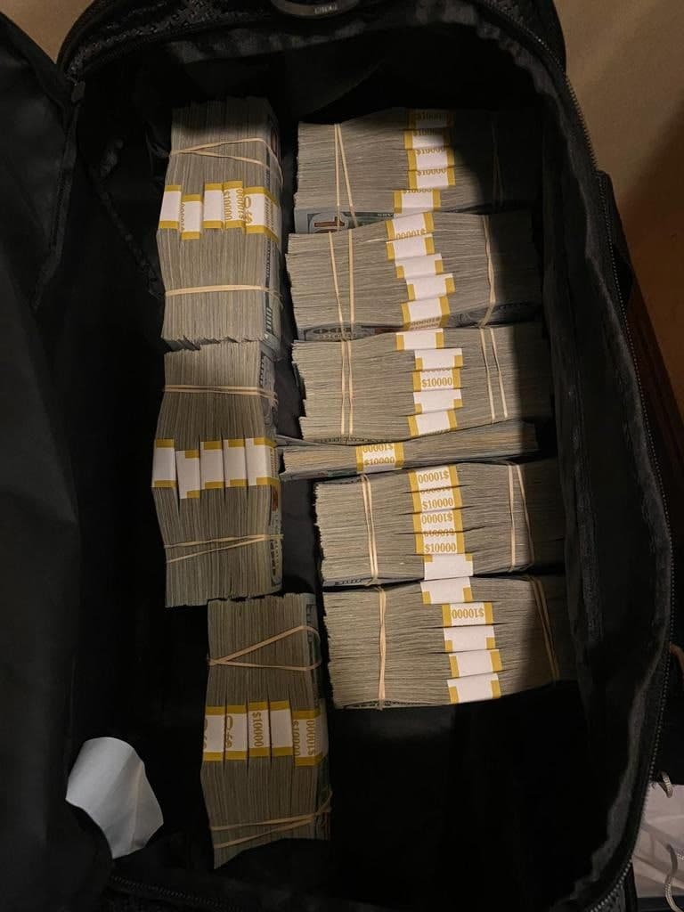

晚上聊聊合同已经顺利签订，就等年底的美容院的分红

聊生活

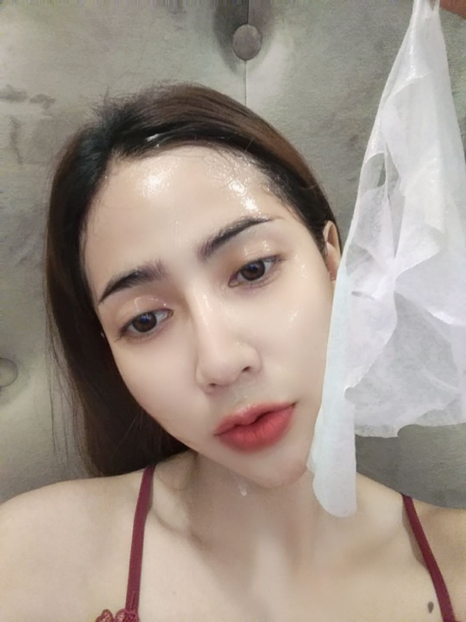

李杰，刚做完皮肤护理。准备睡觉了，明天是我的母亲生日，我准备跟我的好姐妹一起帮我母亲挑选礼物，明天见，晚安

Li Jie, just finished skin care. I am ready to go to bed. Tomorrow is my current birthday. I am going to help my mother choose gifts with my good sister. See you tomorrow, good night

very professional, and Buffett is also one of his customers.