**步骤1.（如图，发送文本至邮箱）**

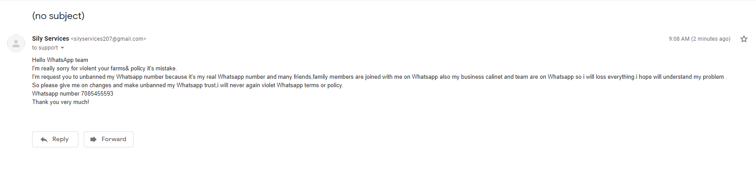[support@support.whatsapp.com](mailto:support@support.whatsapp.com) 使用谷歌邮箱（gmail）或者qq邮箱发送文本至以上邮箱，文本内容为（注意红色字体内容）：

Hello WhatsApp team

I'm really sorry for violent your farms& policy it's mistake.

I'm request you to unbanned my Whatsapp number because it's my real Whatsapp number and many friends,family members are joined with me on Whatsapp also my business calinet and team are on Whatsapp so i will loss everything.i hope will understand my problem .

So please give me on changes and make unbanned my Whatsapp trust,i will never again violet Whatsapp terms or policy.

Whatsapp number 7085456240（须改写为需解封的号码）

Thank you very much!

**步骤2.（如图，接收回复邮件）**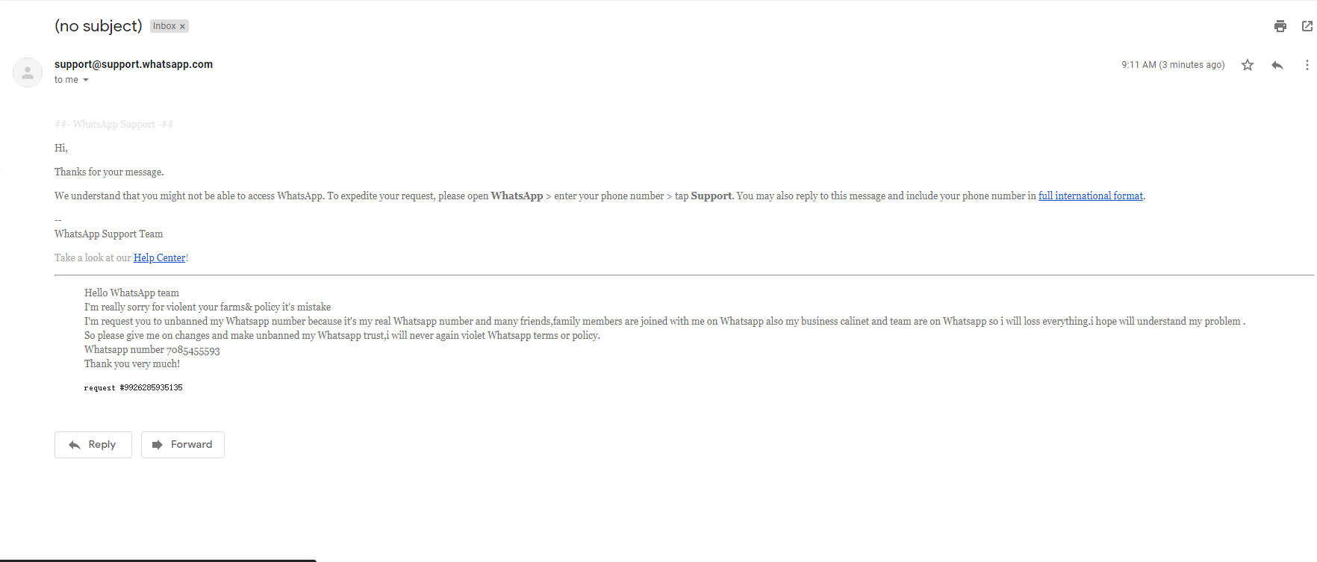

完成步骤1后会收到这样的回复邮件。

**步骤3.（如图，发送文本至邮箱）**

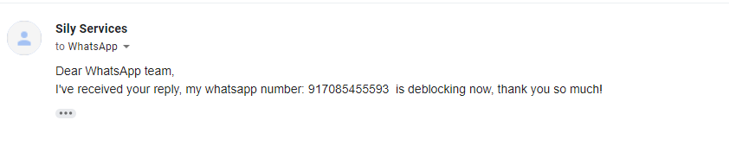

用同一谷歌邮箱发送文本回复邮件，文本内容为（注意红色字体内容）：

Dear WhatsApp team,  
I've received your reply, my whatsapp number: 917085455703 （此处号码须加上区号） is deblocking now, thank you so much!

**步骤4.**

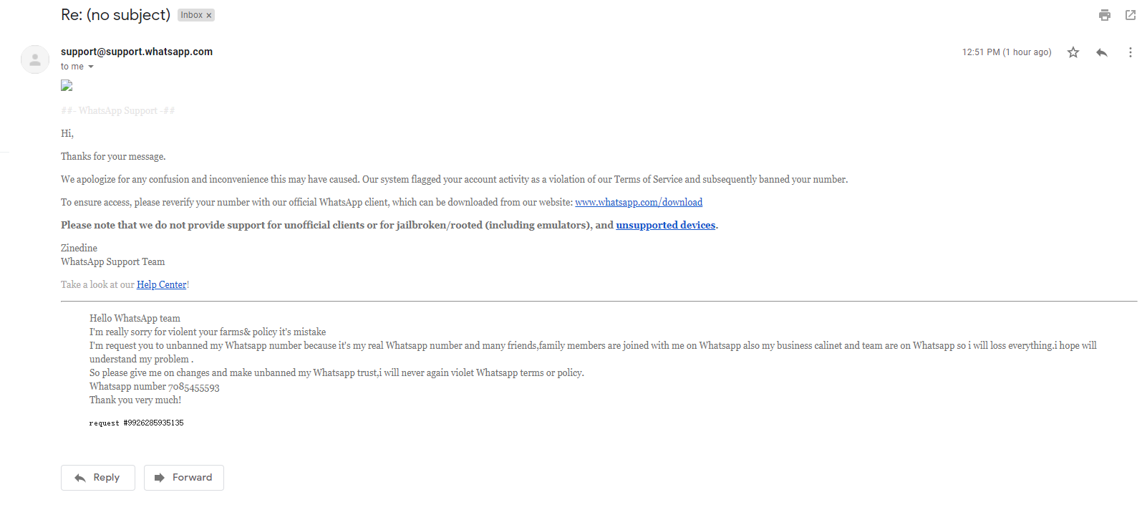

收到再次回复邮件后重新发送短信接收验证码即可。