**第一部分**

大家好，欢迎所有加入我们小组的新朋友。我是本小组的初级分析师。这里是BTUW投资顾问有限公司的比特币交易组。接下来，每天我都会在此与大家分享如何通过比特币增加财富，让您的财富快速增长。如果您不喜欢比特币投资，请离开。很抱歉打扰你

Hi everyone, welcome all new friends who join our group. I am a junior analyst in this group. This is the Bitcoin trading group of BTUW Investment Consultants Ltd. Next, I will share with you how to increase your wealth through Bitcoin every day and let your wealth grow rapidly. If you don't like Bitcoin investment, please leave from group, and sorry to bother you.



BTUW是一家总部位于英国的公司，成立于1974年，从2014年转型为专业的加密货币研究公司，也是全球最大、历史最悠久的CFD经纪公司

它在全球范围内运作，交易数以万计的品种(外汇、黄金、商品差价合约、加密数字货币)。

BTUW is a UK-based company that was founded in 1974 and transformed into a specialist cryptocurrency research firm in 2014. It is also the largest and oldest CFD brokerage in the world.

It operates worldwide and trades hundreds of varieties (FX, Gold, CFDs, Cryptocurrencies [and](C:/Program%20Files%20(x86)/Youdao/Dict/8.9.6.0/resultui/html/index.html" \l "/javascript:;) [so](C:/Program%20Files%20(x86)/Youdao/Dict/8.9.6.0/resultui/html/index.html" \l "/javascript:;) [on](C:/Program%20Files%20(x86)/Youdao/Dict/8.9.6.0/resultui/html/index.html" \l "/javascript:;)).

BTUW Investment Advisors Co.,Ltd是2020年全球最大的在线差价合约交易商（占全球零售合同外汇市场的23％），同时为超过185,000个数字货币合约以及零售客户和机构投资者提供金融和技术服务。

BTUW Investment Advisors Co.,Ltd is the world's largest online CFD dealer in 2020 (accounting for 23% of the global retail contract forex market), while providing financial and technical services to more than 185,000 digital currency contracts as well as retail clients and institutional investors.

BTUW投资咨询集团的资本实力不断增强，其业务已达到全球规模。

The capital strength of BTUW Investment Consulting Group continues to increase, and its business has reached a global scale.

BTUW推荐的加密货币平台的开户过程是安全便捷的。 BTUW是出色的外汇货币推荐和评估机构，也是加密数字货币交易的最佳选择。

The cryptocurrency platform recommended by BTUW has a secure and convenient opening process.BTUW is an excellent foreign exchange currency recommendation and evaluation institution, and the best choice for cryptocurrency trading.

BTUW的财务分析师能力很强，分析加密数字货币合约波动的参考准确率高达95％。 为投资者提供更多赢得交易的机会，并提供24小时全球服务和投资。

BTUW's financial analyst ability is very strong, and the reference accuracy rate of analyzing the fluctuation of encrypted digital currency contracts is as high as 95%. Provide investors with more opportunities to win transactions, and provide 24-hour global service and investment.

以上是关于BTUW的一些简介

The above is some introduction about BTUW

接下来，我会和大家介绍来自BTUW推荐的比特币合约投资，下图是关于合约投资一些细则，请浏览

Next, I will introduce you to the Bitcoin contract investment recommended by BTUW. Below are some details about contract investment, please browse.

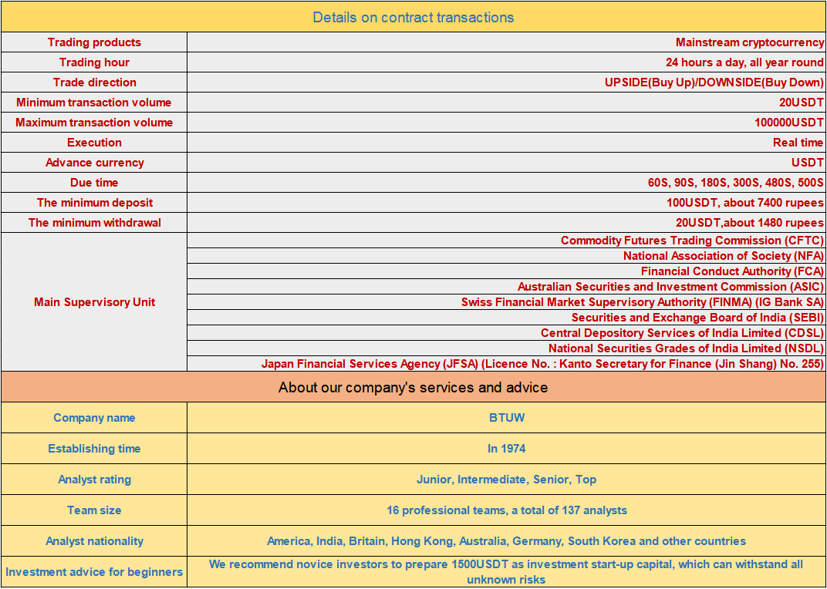

我们目前交易的比特币合约投资适合所有类型的投资者，无论你是新手还是有经验的投资者。最低的交易量是20USDT，每次交易时间是60秒，60秒后，如果分析师的投资预测正确，那么你可以立即赚16USDT。

The bitcoin contract investment we currently trade is suitable for all types of investors, Whether you are a novice or an experienced investor. The lowest trading amount is 20USDT, Each trading time is 60 seconds, after 60 seconds, if the analyst's investment forecasting is correct, then you can make 16USDT immediately.

稍后，我将分析实时波动的BTC并发送投资建议，喜欢BTC交易的朋友们请继续在群里参考，来验证我们的实力。

Later, I will analyze the real-time fluctuations of BTC and send investment suggestions. If you like BTC trading, please continue to refer to the group to verify our strength.

访问https://app.exn，选择签订合同，选择BTC / USDT

Go to https://app.exn.cash/reg , enter the Contract Transaction and select BTC/USDT

请联系Assistant Eartha领取注册邀请码 https://wa.me/85256923353

Please contact Assistant Eartha to get the User Recommendation Code. wa.me/85256923353

我将在本组带领所有人对比特币投资进行全新的认识并在此获利,请已经准备就绪的投资者做好准备

I will lead everyone in this group to a new understanding of investing in Bitcoin and to profit from it, get ready investors.

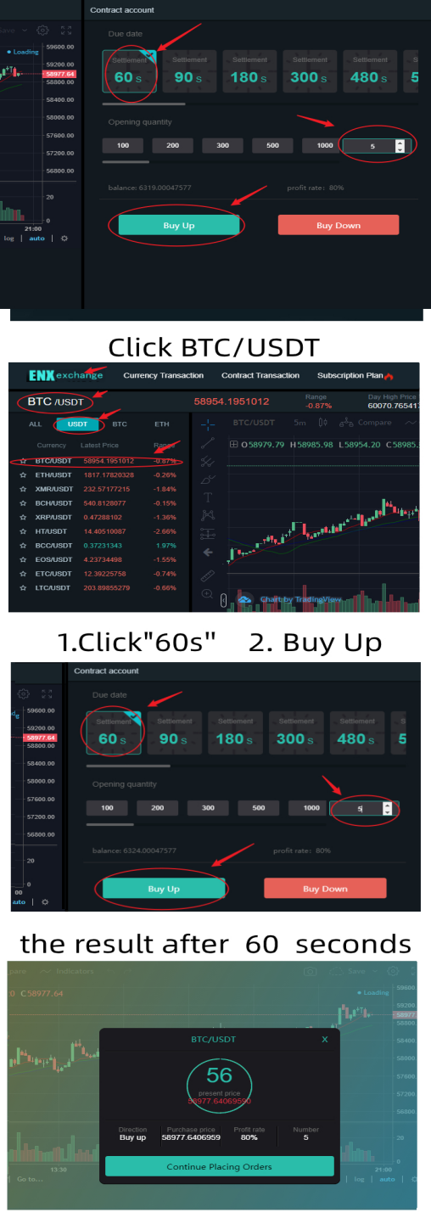

**发单，此处省略...中间穿插一下这段话**

有了合适的公司，你可以从比特币投资中获得巨额现金。比特币在全球范围内很容易获得和接受。你仍然可以在2021年赚很多钱。注册ENX交易所，获得最佳的投资体验和指导，将永远改变你的生活。

💯 易于访问

💯 快速交易

💯 即时存取款

💯 请求无限制

With the right company, you could earn huge amounts of cash from your bitcoin investments. Bitcoin is easy to access and accept around the world. In 2021, you can still make a lot of money. Sign up for an ENX Exchange account and get the best investment experience and guidance that will change your life forever.

💯 Easy to access

💯 Quick transaction

💯 Instant deposit and withdrawal

💯 No limitations on request

Click on the link to register：

<https://app.exn.cash/reg>

Please contact Assistant xxx to get the User Recommendation Code. [https://wa.me/85256923353](https://wa.me/xxxxxx)

注意：完成每笔订单后，请发送利润的屏幕截图，以便我可以继续下一个订单

Note: After completing each order, please send a screenshot of the profit so that I can continue with the next order

第一笔订单金额准备就绪：20USDT！（赚）+16

The first order amount gets ready: 20USDT!

BTC/USDT，买入，到期时间：60秒, 货币：20美元，单击“确认”

BTC/USDT, Buy Up, Due time:60S, Money:20USDT, Click Confirm

第二笔订单金额准备就绪：40USDT！（赚）+32

The second order amount gets ready: 40USDT!

BTC/USDT，买入，到期时间：60秒, 货币：40美元，单击“确认”

BTC/USDT, Buy Down, Due time:60S, Money:40USDT, Click Confirm

第三笔订单金额准备就绪：80USDT！（赚）+64

The third order amount gets ready: 80USDT!

BTC/USDT，买入，到期时间：60秒, 货币：80美元，单击“确认”

BTC/USDT, Buy Up, Due time:60S, Money:80USDT, Click Confirm

第四笔订单金额准备就绪：160美元！（赚）+128

The fourth order amount gets ready:160USDT!

BTC/USDT，买入，到期时间：60秒, 货币：160美元，单击“确认”

BTC/USDT, Buy Up, Due time:60S, Money:160USDT, Click Confirm

第五笔订单金额准备就绪：200USDT！（赚）+160

The fifth order amount gets ready: 200USDT!

BTC/USDT，买入，到期时间：60秒, 货币：200美元，单击“确认”

BTC/USDT, Buy Down, Due time:60S, Money:200USDT, Click Confirm

到目前为止，我们小组已经发出了5条关于比特币合约交易的建议。每个听从建议的人都可以获利400USDT。恭喜组里的每一个人。

So far we have sent out 5 advice of trading bitcoin contracts in our group today. Everyone who follows the advice can make a profit of 400USDT. Congratulations to everyone in the group.

接着，我大概和大家讲解一下如何开始和准备比特币合约投资

And then, I'm going to basically talk to you about how to start and prepare for a bitcoin contract investment

✅如何建立比特币合约投资

1. 获得一个加密货币钱包(https://www.binance.com/en)

2.ENX外汇账户(https://app.exn.cash/)

3.选择一个适合你的投资计划。

How To Set Up Bitcoin Contract Investment

1. Get a Cryptocurrency Wallet (https://www.binance.com/en)

1. ENX Exchange account
2. Choose an investment plan that works for you.

钱包是投资比特币的中转站。用于购买usdt参与比特币合约投资，并在盈利后卖掉usdt兑换成现在到你的银行卡，paytm,upi里

The Cryptocurrency Wallet acts as a transit point for investing in Bitcoin. We use it to buy USDT to participate in bitcoin contract investment, and after making profits, sell the USDT and convert it into cash into your bank card, Paytm or UPI.

You can get a Cryptocurrency Wallet from the Binance, the worlds biggest bitcoin exchange and altcoin crypto exchange. <https://www.binance.com/en>

ENX Exchange: <https://app.exn.cash/reg>

请联系Assistant Eartha 领取注册邀请码wa.me/85256923353

Please contact Assistant Eartha to receive the User Recommendation Code. wa.me/85256923353

新投资者的融资安排:

Funding arrangements for novice investors:

比特币合同的最小单笔投资是20USDT。一般情况下，我们建议新手投资者存入300USDT参与比特币合约投资

The minimum single investment for a Bitcoin contract is 20USDT. As a general rule, we recommend that novice investors deposit 300USDT to participate in Bitcoin contract investment

我们不能保证每个建议都能赚钱，在你有足够的准备之后，以最低的标准300本金，从20USDT开始，每天的总利润可以达到60-150USDT。当你拥有相对充足的资金是最安全的，可以抵御一切未知的风险。

We can't guarantee that every proposal will make money, after you have enough preparation, with the minimum standard 300 principal, starting from 20USDT, the total profit can reach 60-150USDT per day. When you have a relatively adequate capital is the safest, can resist all unknown risks.

如何在比特币合约交易中合理分配投资资金。  
如果你准备300USDT，你可以从20USDT开始。  
如果你准备600USDT，你可以从40USDT开始。  
如果你准备1500USDT，你可以从100USDT开始。  
…  
如果你准备好12000USDT，你可以从800USDT开始。  
…  
如果你没有完全准备好，我建议你等着瞧。充足的资金是投资的王牌。  
我们寻找的是稳定、长期的投资，而不是一夜暴富。如果你想从300美元中赚3000美元，这里就不适合你

How to properly allocate your investment funds in bitcoin contract transactions.

If you're preparing 300USDT, you can start at 20USDT.

If you are preparing 600USDT, you can start at 40USDT.

If you're preparing 1500USDT, you can start at 100USDT.

...

If you're ready for 12000USDT, you can start at 800USDT.

...

If you are not fully prepared, I suggest you wait and see. Sufficient funds are the trump card of investment.

We are looking for stable, long-term investments, not overnight riches. If you're going to make $3,000 out of $300, this is not the place for you.

我们的合作方式:

我们是一家投资顾问公司。我们为与我们合作赚钱的投资者提供专业的交易建议。当投资者赚钱时，我们拿一部分利润作佣金。我们期待的是长期互利的合作。

Our way of cooperation:

We are an investment advisors company. We provide professional trading advice to the investors we work with to make money. When the investors make money, we take part of the profits as commission. What we are looking for is a long-term mutually beneficial cooperation.

我们专注于比特币合约投资。如果您想与我们合作，我们有两种合作方式:  
1. 在你获得利润后，你将拿利润的20%作为我的佣金。  
2. 投资顾问保证百分之百的利润，但你得给我们利润的百分之五十作为佣金。如果有任何损失，我们将赔偿您50%的损失。

We focus on bitcoin contract investments.If you want to cooperate with us, we have two ways to cooperate:

1. After you make a profit, you will take 20% of the profit as my commission.

2. The investment adviser guarantees a 100% profit, but you need to give us a commission of 50 of your profit.If there is any loss, we will compensate you for 50% of the loss.

以上是初学者的指南。不需要任何技能，你所要做的就是联系助理注册和助理将指导您如何工作，交易和为您创造利润。聪明和行动明智，现在开始…

That's a beginner's guide. No skill is required, all you have to do is contact the assistant for

Registration and assistants will guide you on how to work, trade and make profits.

Be smart and act wisely, start now...

BTC交易组公告:最近BTC交易市场火爆。许多新的投资者加入了比特币交易团队。有些投资者没有及时添加BTC团队助理，进而无法得到BTC交易计划的细节，每笔交易都会带来风险!请随时及时联系助理，以下是助理whatsapp: wa.me/85256923353;添加助理后，您可以收到一份关于比特币投资交易盈利能力的计划。祝你在比特币交易群中获得越来越多的利润，早日实现财富的自由。

BTC Trading Group Announcement: The BTC trading market has been very popular recently. Many new investors have joined the BTC trading team. Some investors did not add BTC team assistant in time, so they could not get the details of BTC trading plan, every transaction will bring risks!

Please feel free to contact the assistant in time, here is the Assistant Eartha 'Whatsapp:

wa.me/85256923353; After adding the assistant, you can receive a plan on the profitability of BTC investment transactions. I wish you more and more profit in the BTC trading group and realize the freedom of wealth soon .

我们的分析师将在3小时后继续对BTC给出建议，没有注册账户的朋友可以联系助理Eartha 'wa.me/xxxxxx，申请注册邀请代码注册，完成注册参与下一笔比特币交易，与分析师每天赚取利润。

Our analysts will continue to send BTC advice after 3 hours. If you do not have a trading account, contact the assistant for detailed consultation wa.me/85256923353, Get involved in the next Bitcoin transaction as soon as possible and work with analysts to earn profits every day

**助理名片**

**第二部分**

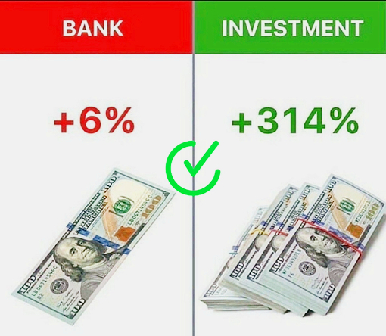

为什么不为自己和家人计划一个更好的未来呢?

不要把钱存起来，因为你可能最终会把钱用在对你无益的事情上。

不要把钱存进银行，因为这不会带来任何利润。

为什么不把它投资到可以盈利的地方呢?

BTUW投资顾问有限公司就在这里为您提供帮助。我们将为您提供最专业的交易建议，为您带来更大的利润。

Why not plan a better future for yourself and your family?

Don't save your money, cause you may end up using it for things that won't profit you.

Don't save them in the Bank, cause it won't bring any profit.

Why not invest it where it can earn you profit?

The BTUW Investment Advisors Co.,Ltd is here to help you. We will give you the most professional advice on trading and bring you more profits.

为什么btuw会给大家推荐比特币合约投资？

启动资金相对较低，有兴趣的人都可以加入。其次，你花在这项投资上的时间很短，不会影响你的工作和家庭。无论你是一个新手投资者或有经验的投资者，这个比特币合同为你提供了一个可观的回报。

Why would BTUW recommend investing in bitcoin contracts?

The start-up capital is relatively low, anyone who is interested can join in. Secondly, the time you spent on this investment is short, which will not hinder your work and family. Whether you're a novice investor or an experienced investor, this Bitcoin contract offers you a handsome return.

我们将继续今天的比特币合约投资，请各位投资留意

We will continue today's Bitcoin contract investment, please pay attention

如果对这项投资感兴趣请点击一下链接进行注册

If you are interested in this investment please click on the link to register

Click on the link to register：

<https://app.exn.cash/reg>

Please contact Assistant xxx to get the User Recommendation Code. <https://wa.me/xxxxxx>

**发单，此处省略...中间穿插一下这段话**

要想从比特币合约投资中赚钱，需要准备两种工具:

1: Cryptocurrency钱包

无论你拥有哪个钱包，只要你可以购买USDT并将其存入ENX Exchange进行比特币合约投资。

你可以从币安得到一个加密货币钱包。https://www.binance.com/en

2:投资平台

ENX Exchange注册链接:https://app.exn.cash/reg

To make money from Bitcoin contract investment, you need to prepare two tools:

1:Cryptocurrency wallet

No matter which wallet you own, as long as you can buy USDT and deposit them into ENX Exchange for Bitcoin contracts investment.

You can get a Cryptocurrency Wallet from the Binance. <https://www.binance.com/en>

2:Investment platform

ENX Exchange registration link:

<https://app.exn.cash/reg>

请联系Assistant xxx领取注册邀请码 https://wa.me/85256923353

Please contact Assistant xxx to receive the User Recommendation Code. wa.me/85256923353

注意：完成每笔订单后，请发送利润的屏幕截图，以便我可以继续下一个订单

Note: After completing each order, please send a screenshot of the profit so that I can continue with the next order

第六订单金额准备就绪：20美元！（赚）+16

The sixth order amount gets ready:20USDT!

BTC/USDT，买入，到期时间：60秒, 货币：20美元，单击“确认”

BTC/USDT, Buy Up, Due time:60S, Money:20USDT, Click Confirm

第七笔订单金额准备就绪：20美元！（亏）-20

The seventh order amount gets ready: 20USDT!

BTC/USDT，买入，到期时间：60秒, 货币：20美元，单击“确认”

BTC/USDT, Buy Down, Due time:60S, Money:20USDT, Click Confirm

第八笔订单金额准备就绪：40美元！（赚）+32

The eighth order amount gets ready: 40USDT!

BTC/USDT，买入，到期时间：60秒, 货币：40美元，单击“确认”

BTC/USDT, Buy Down, Due time:60S, Money:40USDT, Click Confirm

第九笔订单金额准备就绪：20美元！（赚）+16

The ninth order amount gets ready: 20USDT!

BTC/USDT，买入，到期时间：60秒, 货币：20美元，单击“确认”

BTC/USDT, Buy Up, Due time:60S, Money:20USDT, Click Confirm

第十笔订单金额准备就绪：20美元！（赚）+16

The ten order amount gets ready: 20USDT!

BTC/USDT，买入，到期时间：60秒, 货币：20美元，单击“确认”

BTC/USDT, Buy Down, Due time:60S, Money:20USDT, Click Confirm

这一小时内5个订单的收入是400USDT，加上4小时前3个订单的收入是112USDT。今天8个比特币合约交易订单的总收入是136USDT。

我们不能保证每个比特币建议都会赚钱，但只要你准备好了，赢家就是你。

The revenue of 5 orders within this hour is 24USDT, plus the revenue of 4 orders four hours ago is 112USDT. The total revenue of 8 bitcoin contracts trading orders today is 136USDT.

We can't guarantee that every bitcoin advice will make money, but as long as you're prepared, the winner will be you.

恭喜组里的每一个人。投资并不是生活的全部。在您获得投资比特币合约的收益后，请尽情享受生活，为您的家人带来更好的生活环境。

Congratulations to everyone in the group. Life is not all about investing. After you get the benefits of investing in the Bitcoin contract, please enjoy your life and bring a better living environment for your family.

新投资者的融资安排:

Funding arrangements for novice investors:

比特币合同的最低投资金额为20USDT。一般来说，我们建议新手投资者准备300USDT参与比特币合约，最低金额为20USDT。

The minimum Investment Amount for a Bitcoin contract is 20USDT. In general, we recommend that novice investors prepare 300USDT to participate in bitcoin contracts, starting with a minimum amount of 20USDT.

我们不能保证每个建议都能赚钱，在你有足够的准备之后，以最低的标准300本金，从20USDT开始，每天的总利润可以达到60-150USDT。当你拥有相对充足的资金是最安全的，可以抵御一切未知的风险。

We can't guarantee that every proposal will make money, after you have enough preparation, with the minimum standard 300 principal, starting from 20USDT, the total profit can reach 60-150USDT per day. When you have a relatively adequate capital is the safest, can resist all unknown risks.

关于如何去注册钱包，如何购买USDT做第一步合约投资的准备，请联系助理。助理会一步步为你解答

For information on how to register the wallet and how to purchase USDT to prepare for the first step of Bitcoin contract investment, please contact the assistant.The assistant will explain you step by step [wa.me/85256923353](https://wa.me/xxxxxx)

我们的合作方式:

我们是一家投资顾问公司。我们为与我们合作赚钱的投资者提供专业的交易建议。当投资者赚钱时，我们拿一部分利润作佣金。我们期待的是长期互利的合作。

Our way of cooperation:

We are an investment advisors company. We provide professional trading advice to the investors we work with to make money. When the investors make money, we take part of the profits as commission. What we are looking for is a long-term mutually beneficial cooperation.

我们专注于比特币合约投资。如果您想与我们合作，我们有两种合作方式:  
1. 在你获得利润后，你将拿利润的20%作为我的佣金。  
2. 投资顾问保证百分之百的利润，但你得给我们利润的百分之五十作为佣金。如果有任何损失，我们将赔偿您50%的损失。

We focus on bitcoin contract investments.If you want to cooperate with us, we have two ways to cooperate:

1. After you make a profit, you will take 20% of the profit as my commission.

2. The investment adviser guarantees a 100% profit, but you need to give us a commission of 50 of your profit.If there is any loss, we will compensate you for 50% of the loss.

BTC交易组公告:最近BTC交易市场火爆。许多新的投资者加入了比特币交易团队。有些投资者没有及时添加BTC团队助理，进而无法得到BTC交易计划的细节，每笔交易都会带来风险!请随时及时联系助理，以下是助理whatsapp: wa.me/85256923353;添加助理后，您可以收到一份关于比特币投资交易盈利能力的计划。祝你在比特币交易群中获得越来越多的利润，早日实现财富的自由。

BTC Trading Group Announcement: The BTC trading market has been very popular recently. Many new investors have joined the BTC trading team. Some investors did not add BTC team assistant in time, so they could not get the details of BTC trading plan, every transaction will bring risks!

Please feel free to contact the assistant in time, here is the Assistant xxxx'Whatsapp:

wa.me/85256923353; After adding the assistant, you can receive a plan on the profitability of BTC investment transactions. I wish you more and more profit in the BTC trading group and realize the freedom of wealth soon .

你所需要的是成功的决心，相信BTUW的专业，只要保持一致和正确的思维，你就会实现你的财务目标

All you need is the determination to succeed, trust the BTUW profession, and as long as you maintain consistency and the right thinking, you will achieve your financial goals

明天我们将继续在本群分享交易建议。如果你希望尽快在比特币合约投资上有一个好的开始，请联系助理Eartha。

Tomorrow we will continue to share trading advice in this group. If you want to have a good start in Bitcoin contract investment as soon as possible, please contact Assistant Eartha.

[wa.me/85256923353](https://wa.me/xxxxxx)

**助理名片**