**Software Requirements Specification**

For

NFT Art Chain

17th February, 2023

Prepared by

|  |  |  |
| --- | --- | --- |
| **Specialization** | **SAP ID** | **Name** |
| CCVT | 500082882 | Sahaj Somvanshi |
| CCVT | 500083041 | Manil Munjal |
| CCVT | 500084041 | Sai Kalyan Tirlangi |
| CCVT | 500084895 | Gantyada Heraj |

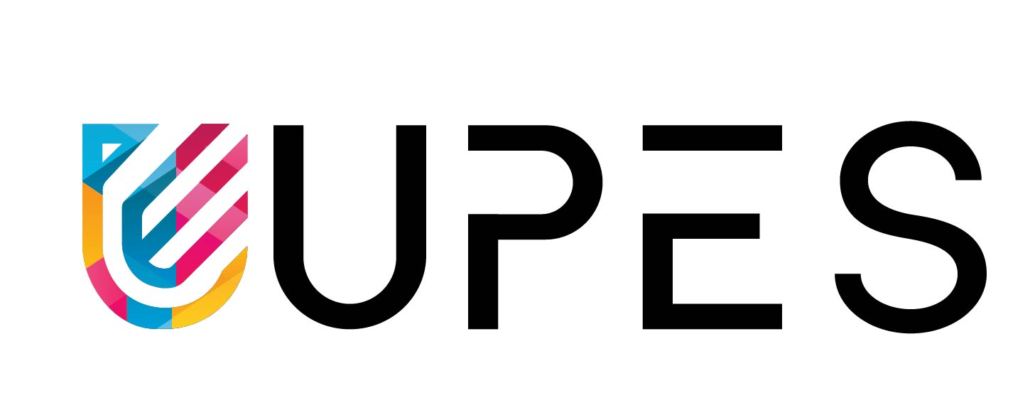

Department of Systemics

School Of Computer Science

UNIVERSITY OF PETROLEUM & ENERGY STUDIES,

DEHRADUN- 248007. Uttarakhand

Table of Contents

|  |  |  |
| --- | --- | --- |
| **Topic** | | **Page No** |
| Table of Content | | 2 |
| Revision History | | 3 |
| 1 | Introduction | 4 |
|  | 1.1 Purpose of the Project | 5 |
|  | 1.2 Target Beneficiary | 5 |
|  | 1.3 Project Scope | 5 |
|  | 1.4 References | 5-6 |
| 2 | Project Description | 6-7 |
|  | 2.1 Technologies used | 6 |
|  | 2.2 SWOT Analysis | 6-7 |
|  | 2.3 Project Features | 7 |
|  | 2.4 Design and Implementation Constraints | 7 |
|  | 2.5 Design diagrams | 8 |
|  |  |  |
| 3 | System Requirements | 9 |
|  | 3.1 User Interface | 9 |
|  | 3.2 Protocols | 9 |
|  |  |  |
| 4 | Non-functional Requirements | 10 |
|  | 4.1 Performance requirements | 10 |
|  | 4.2 Security requirements | 10 |
|  | 4.3 Software Quality Attributes | 10 |
|  |  |  |
| Appendix A: Glossary | |  |

**Revision History**

|  |  |  |  |
| --- | --- | --- | --- |
| **Date** | **Change** | **Reason for Changes** | **Mentor Signature** |
| 03-02-2023 | Discussion about Smart contracts, Ethereum and Blockchain |  |  |
|  |  |  |  |
|  |  |  |  |
|  |  |  |  |

1. INTRODUCTION

Imagine a future where everyone has a virtual character to use across multiple platforms, social media, video conferencing, games and other online spaces. A virtual “animated” version of you. What would your avatar look like? And how would it behave? When I ask these questions, the usual response is, “Why should I care? I am not interested in gaming. But, the time is fast approaching when we all need to think about and experiment with a virtual version of ourselves.

Blockchain[1] is a digital ledger technology that enables the secure and transparent storage and transfer of data in a decentralized network. In a blockchain system, data is stored in blocks that are linked together in a chain, creating an immutable and tamper-evident record of all transactions. Since the inception of crypto currencies such as Bit coin, and the maturity of block chains like Ethereum, digital value is minted, or created, then later stored or transferred across other technologies as a form of wealth in the form of various assets. This is creating an entirely new financial system, often called decentralized finance. Creators are joining the Metaverse [2]due to the success of the growing ecosystem of non-fungible token (NFT) mining platforms and marketplaces. Many reputable cryptocurrency exchanges have also started rolling out NFT offerings, which we believe will be a major revenue and growth driver.

NFTs are blockchain-based units of value, also known as tokens. Each NFT has a unique ID that links it to the underlying asset. An NFT consists of software code called a "smart contract" that contains the details of the physical or digital asset to which the NFT relates. All rules and rights related to NFTs are also included in this Code. The value attached to NFTs stems from their “unacceptable” nature. This means that tokens cannot be replaced with identical tokens, resulting in an inherent rarity effect. This is what differentiates it from crypto-currency which is fungible (identical in value and interchangeable with each other. Since NFTs are essentially metadata about assets, NFTs are generally not the actual assets themselves, unless specified otherwise in the smart contract. Therefore, ownership of NFTs generally does not match ownership of the underlying assets. So compared it to limited edition prints of artwork, the collector owns the physical print but not the original artwork.

The introduction of blockchain technology into gaming has changed the playing field for gamers. In this new era of digital ownership rights and financial inclusion, NFTs are a means of value exchange in virtual gaming worlds. This plays an important role in blockchain games and the so-called “play to earn” industry. Using the internet as a source of income during the global pandemic was a clever, new and modern way for artists to keep making a living. Players can also enter transactions involving characters and in-game items as NFTs. Thus, the digital assets they earn while gaming are valuable as in-game items, but also as a reliable means of actual income generation. Many games are based on transparency and security protocols. This ensures the authenticity of traded in-game assets and decentralizes platform ownership to real players.

* 1. Purpose of the Project

The purpose of this project is for the customer to have customized personal image of their preference and have NFTs attached to it so that these personalized avatars are owned by them and to provide unique logos, avatars or designs in our website that can be acquired by some startup companies. With the help of NFTs it allows the users to prove that a given asset belongs to them and they have acquired the rights and ownership of the art.

1.2 Target Beneficiary

The target beneficiaries of the NFTs are collectors and providers. The benefit for collectors is that they acquire a proof of ownership of their customized art and for the providers as they make a living by selling the customized art or even trading for profits like a crypto investment. The social media movement and obsession with individuality across various networks is also fueling demand. For instance, many collectors have replaced their social media profile pictures with headshots from the NFT avatars, and this trend is gaining traction in the NFT[3] space. Many users have shared his NFT avatar through social media and community groups such as Reddit and Discord, encouraging more crypto investors to join.

1.3 Project Scope

The scope of NFT art is continually expanding and evolving, as the market for NFT art has grown rapidly in recent years. The use of NFTs has expanded to include a variety of digital assets, such as music, videos, and even tweets, but the most popular use case is for visual art, such as images, animations, and virtual reality experiences. NFT art allows artists to monetize their digital creations by selling them as unique, authenticated pieces of art on the blockchain, with ownership and provenance recorded on a public ledger. NFT art has opened up new opportunities for artists to monetize their work, by allowing them to sell digital art as one-of-a-kind, authentic pieces with a clear chain of ownership. The potential market for NFT art is global, and it has already attracted many collectors and investors. Some NFT art pieces have sold for millions of dollars, and the NFT art market continues to grow and attract interest from collectors and art enthusiasts alike.

1.4 References

[1] Zheng, X. R., & Lu, Y. (2022). Blockchain technology–recent research and future trend. Enterprise Information Systems, 16(12). <https://doi.org/10.1080/17517575.2021.1939895>

[2] "The Role of NFTs in Gaming, Avatars, and Metaverse Funding." (2022). Lexology. Retrieved from <https://www.lexology.com/library/detail.aspx?g=e0dd3e07-b83f-403a-9be7-ea8884dd3077>

[3] Lee, T. H. (2022, January 6). Why all popular NFTs are avatars - from a product perspective. UX Collective. Retrieved from <https://uxdesign.cc/why-all-popular-nfts-are-avatars-from-a-product-perspective-3c60e8d156d7>

[4] Mueller-Bloch, C., Andersen, J. V., Spasovski, J., & Hahn, J. (2022). Understanding decentralization of decision-making power in proof-of-stake blockchains: An agent-based simulation approach. European Journal of Information Systems. Advance online publication. <https://doi.org/10.1080/0960085X.2022.2125840>

[5] Y. Chen, H. Li, K. Li and J. Zhang, "An improved P2P file system scheme based on IPFS and Blockchain," 2017 IEEE International Conference on Big Data (Big Data), Boston, MA, USA, 2017, pp. 2652-2657, doi: 10.1109/BigData.2017.8258226.

[6] D. Vujičić, D. Jagodić and S. Ranđić, "Blockchain technology, bitcoin, and Ethereum: A brief overview," 2018 17th International Symposium INFOTEH-JAHORINA (INFOTEH), East Sarajevo, Bosnia and Herzegovina, 2018, pp. 1-6, doi: 10.1109/INFOTEH.2018.8345547.

1. PROJECT DESCRIPTION

This project will mainly focuses on the personalized NFT generation platform where user can deploy their personalized NFT and use our auctioning site to get profit from their NFT, The NFTs can be personalized by using AI image generator, we can use some of the python libraries like Cartoonify to make a cartoonish image of the user using the platform.

* 1. Technologies used

Technologies that this project includes are:

* Smart contract: A smart contract is a self-executing contract with the terms of the agreement directly written into code, which is stored on a block chain. In the context of NFTs (non-fungible tokens), a smart contract can be used to define the ownership, transfer, and usage of an NFT.
* Test network: A test network is a version of a blockchain that allows developers to test and experiment with smart contracts and other features without using real cryptocurrency. This is useful for debugging and testing code before deploying it on the main network.
* Ethereum: Ethereum [6] is a blockchain platform that allows developers to build and deploy decentralized applications (dapps) using smart contracts. It was designed to be more flexible than Bitcoin, allowing for the creation of custom tokens and smart contracts.
* Blockchain : A blockchain is a decentralized, distributed ledger that records transactions on multiple nodes in a network. Each block in the chain contains a cryptographic hash of the previous block, ensuring the integrity and immutability of the data.
* Solidity: Solidity is a programming language used to write smart contracts on the Ethereum blockchain. It is similar to JavaScript and is designed to be easy to learn and use for developers familiar with object-oriented programming. Solidity is used to define the behavior of NFTs, including how they are created, transferred, and stored.
* Metamask wallet: Metamask is a popular cryptocurrency wallet that runs as a browser extension and provides users with a convenient way to interact with Ethereum-based decentralized applications (dApps) and the Ethereum blockchain.
* Hardhat: Hardhat is an open-source development environment for building and testing smart contracts on the Ethereum blockchain. It offers a robust suite of tools that enable developers to efficiently write, compile, deploy, and test their smart contracts. Hardhat also includes built-in support for popular Ethereum development frameworks like Truffle and Buidler, as well as a wide range of plugins and integrations with other popular blockchain development tools. One of the key features of Hardhat is its ability to simulate a local blockchain network, which allows developers to test their smart contracts in a secure and controlled environment without the need for real Ether. Overall, Hardhat is a powerful and flexible tool that can help blockchain developers streamline their development process and improve the quality and security of their smart contracts.
* IPFS: IPFS [5] (InterPlanetary File System) is a protocol and network designed for decentralized storage and sharing of files. It is a peer-to-peer network that allows users to share and access files without the need for a central server. its ability to provide permanent, decentralized storage for files. Because files are stored on a distributed network, they can be accessed and shared even if the original server hosting the files goes offline. Additionally, IPFS includes features such as content-addressing, which allows users to access files using a unique hash code that is based on the content of the file, rather than its location on a specific server. IPFS is also designed to be highly scalable, allowing for the creation of large, distributed networks of nodes that can store and share files on a massive scale. It is open-source and can be used for a wide range of applications, including decentralized web applications, content distribution networks, and blockchain-based systems.
* NFT.Storage: NFT.storage is a decentralized file storage system designed specifically for storing and retrieving non-fungible tokens (NFTs) and their associated metadata. It is built on top of the InterPlanetary File System (IPFS), a peer-to-peer file sharing protocol that allows for decentralized file storage and sharing.
  1. SWOT analysis

Strengths:

1) Secure and transparent transactions using blockchain technology

2) Potential for creating unique and valuable digital assets through NFTs

3) High demand for NFTs in the art and collectibles market

4) Ability to fractionalize ownership of assets and increase liquidity

Weaknesses:

1) Lack of understanding or interest in NFTs by a large portion of the population

2) Risk of hacking and theft of NFTs and associated assets

3) Difficult to build blockchain community.

4) High energy consumption and environmental impact of blockchain technology

Opportunities:

1) Expansion of the NFT market to new industries such as gaming, sports, and music.

2) Integration of NFTs with DeFi (Decentralized Finance) platforms, allowing for new investment opportunities.

3) Use of NFTs for verifying and tracking ownership of physical assets, such as real estate or luxury goods.

4) Integration of NFTs with social media and content creation, allowing for new revenue streams for creators.

Threats:

1) Regulatory uncertainty and potential restrictions on the use and trading of NFTs

2) Competition from other blockchain-based digital asset platforms

3) Technological challenges and potential for bugs and glitches in smart contracts

4) Lack of diversity and inclusivity in the NFT market, leading to potential backlash and decreased demand.

* 1. Project features

1. AI-based generation: The project could use machine learning algorithms to generate unique NFTs that are one-of-a-kind and cannot be replicated.
2. Customization options: Users could be able to customize their NFTs by selecting from a range of design options or by uploading their own images.
3. Metadata management: The project could include a metadata management system that allows users to add descriptive information to their NFTs, such as the artist's name, title, description, and other relevant data.
4. Smart contract integration: The project could be integrated with smart contracts to allow for the automatic distribution of royalties to the artist or creator of the NFT every time it is sold or traded on a blockchain platform.
5. Tokenization: The project could tokenize the generated NFTs, which would make them transferable and tradable on blockchain marketplaces.
6. Platform integration: The project could integrate with popular blockchain platforms, such as Ethereum or Binance Smart Chain, to make it easy for users to mint, trade, and buy NFTs.
7. Analytics and reporting: The project could provide analytics and reporting tools that allow users to track the performance of their NFTs, including sales, trading volume, and other relevant metrics.
8. Community features: The project could include social features that enable users to connect with other NFT enthusiasts and artists, participate in discussions, and showcase their work.
   1. Design and implementation constraints

* Some of the AI image generator do not provide with the API to use them.
* Security: Security is paramount in any blockchain-based platform, and the same goes for NFT auctioning platforms. The platform should be designed to ensure that user data and funds are secure. The platform should be tested thoroughly to ensure that there are no vulnerabilities or potential attack vectors.
* Interoperability: Interoperability is essential in blockchain-based platforms. The platform should be designed to work seamlessly with other blockchain platforms and marketplaces.
* Smart contract testing: Smart contract testing is essential to ensure that the smart contract functions as intended. The platform should be designed to ensure that the smart contract has been thoroughly tested before launching.
  1. Design diagrams

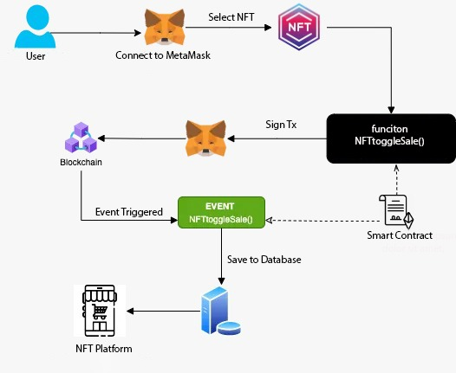

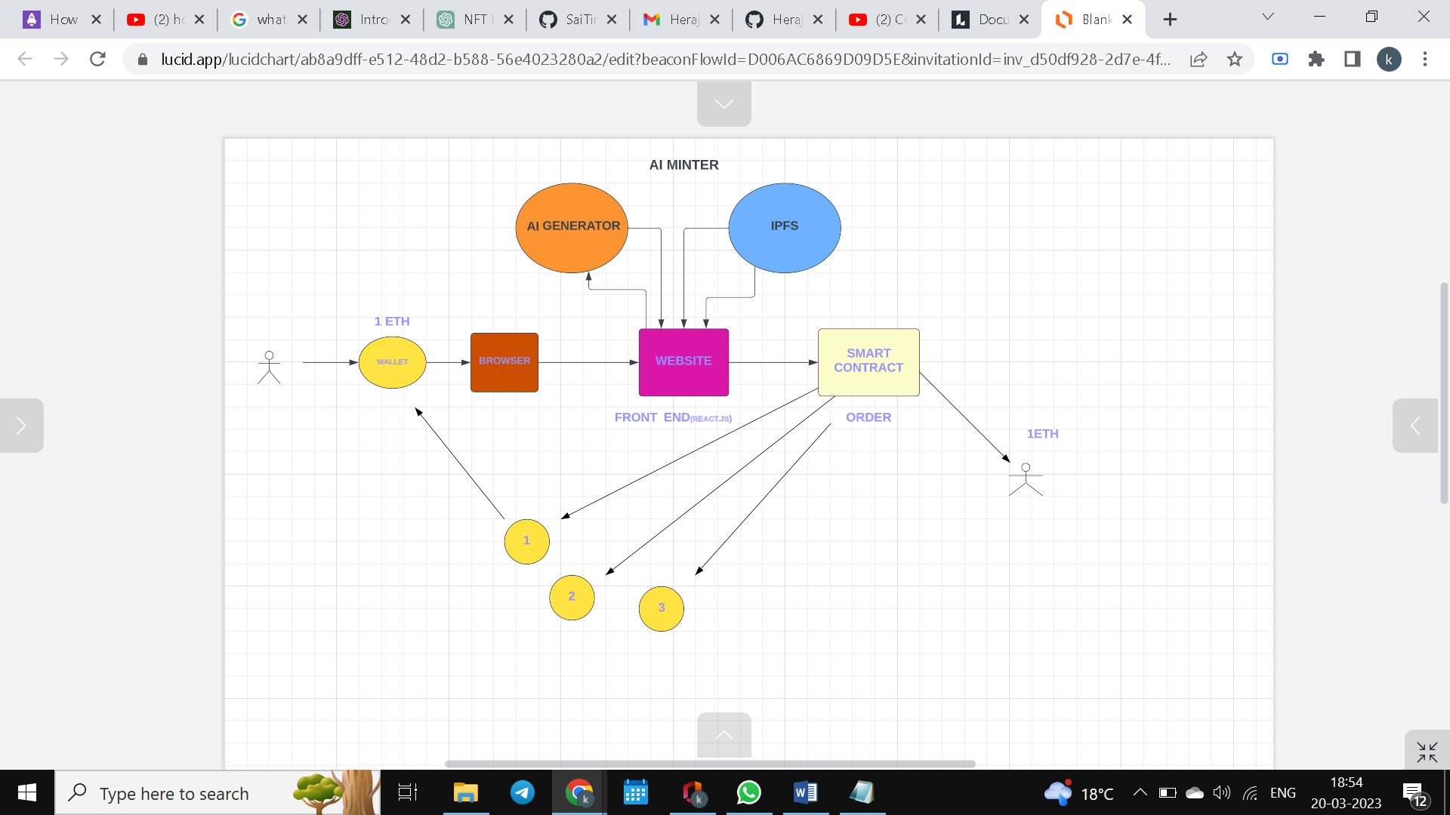

1. SYSTEM REQUIREMENTS

3.1 User Interface

Our project focuses on the UI with minimal user interactions as user should do the minimal work and in this project there is a simple UI which triggers everything like Metamask, uploading the NFT , Minting.

3.2 Protocols

PROOF OF STAKE (POS): Proof of Stake[4] (PoS) is a consensus algorithm used in blockchain networks to validate transactions and create new blocks. In a PoS protocol, validators (also known as "forgers" or "minters") are chosen to create new blocks and validate transactions based on the amount of cryptocurrency they hold as a stake. This stake acts as collateral and incentivizes validators to act in the best interest of the network.

In a PoS system, validators are chosen to create new blocks through a process called "minting," which is similar to the "mining" process in Proof of Work (PoW) systems. However, in PoS, validators do not need to solve complex mathematical problems to create new blocks. Instead, they are chosen based on the amount of cryptocurrency they hold as a stake, with larger stakes increasing the chances of being selected to create a block.

IPFS: IPFS (InterPlanetary File System) is a protocol and network designed for decentralized storage and sharing of files. It is a peer-to-peer network that allows users to share and access files without the need for a central server.

In traditional file-sharing systems, files are hosted on a central server and are accessed by clients who connect to that server. However, in IPFS, files are broken down into small pieces and stored on a distributed network of nodes. When a user requests a file, the IPFS protocol retrieves the file pieces from multiple nodes, reassembles them, and delivers the complete file to the user.

ERC-721: ERC-721 is a standard for non-fungible tokens (NFTs) on the Ethereum blockchain. Unlike fungible tokens, such as cryptocurrencies, which are interchangeable with one another, NFTs are unique and cannot be exchanged for other tokens on a one-to-one basis. ERC-721 provides a set of rules and guidelines for the creation and management of NFTs on the Ethereum network.To tokenize an asset using ERC-721, a developer would need to create a smart contract that defines the unique characteristics of the asset, such as its name, symbol, and total supply. The smart contract would also include functions for minting, transferring, and managing the NFTs. Once the smart contract is deployed on the Ethereum network, users can interact with it using a compatible wallet, such as MetaMask.When a user mints an ERC-721 token, they are essentially creating a unique digital asset that is tied to a specific identifier on the Ethereum blockchain. This identifier, also known as a token ID, is unique to each NFT and cannot be replicated. As a result, ERC-721 tokens are commonly used for digital art, collectibles, and other unique assets that cannot be easily replicated.

ERC-721 tokens can be bought, sold, and traded on various NFT marketplaces and platforms, such as OpenSea, Rarible, and SuperRare. The ownership and transfer of ERC-721 tokens are recorded on the Ethereum blockchain, providing a secure and transparent ledger of transactions.

4. NON-FUNCTIONAL REQUIREMENTS

4.1 Performance requirements

1. Transaction Speed: NFTs are often used for high-value transactions, so it's important to ensure that the platform can handle a high volume of transactions and process them quickly.
2. Scalability: The platform should be scalable to handle growth in the user base and the number of transactions.
3. Responsiveness: The platform should be responsive to user input, such as bidding or selling, to provide a smooth user experience. This requires fast response times, efficient processing.
4. Efficient Use of Resources: The platform should be designed to use resources efficiently to minimize costs and maximize performance.

* 1. Security requirements

Here are some of the security measures we intend to take for our project:

1. Reliable Smart Contract: A smart contract is the code that defines the NFT and its associated properties such as ownership, transferability, and royalties. The smart contract should be written by an experienced developer and audited by a reputable third-party auditor to ensure it is free from vulnerabilities and weaknesses.
2. Token Metadata: The metadata associated with the NFT should be securely stored and tamper-proof.
3. Marketplace Security: If you plan to sell your NFT art on a marketplace, make sure that the platform has strong security measures in place.
4. Backup and Recovery: It's important to have a backup plan in case your digital wallet or the smart contract is compromised.
   1. Software Quality Attributes
5. Security: One of the most critical software quality attributes for NFT art and auctioning platform is security.
6. Reliability: NFT art and auctioning platform should be highly reliable and available to users.
7. Privacy: The system should protect the privacy of users and their personal information.
8. Usability: The NFT art and auctioning platform should be user-friendly and easy to use for both buyers and sellers. The user interface should be intuitive and straightforward to navigate.