Dashboard Planning and Design Strategy
Interactive Tableau Dashboard for Telco Customer Churn
Virtual Tableau Visualization Internship, Week 2 Task
Prepared by: Madugula Manikumar | 1 October 2026

1. Purpose and Scope
This document is the plan and design strategy for an interactive Tableau dashboard. It covers the objectives and audience, the key metrics, the layout, the colour scheme, the visual elements and why they were chosen, how those elements work together, and how the user will interact with them.
The dashboard is planned on the Telco Customer Churn dataset that I explored in Week 1 (7,043 customers, 21 fields). The Week 1 insights are the starting point: they tell us what the dashboard must communicate. As required for this task, the focus is on conceptualisation and layout strategy, not on building the final dashboard. This document is meant to serve as the blueprint for building it in the following weeks.

2. Dashboard Objectives and Target Audience
Main objective: Help the business see how many customers are leaving, which customer segments are leaving the most, and what action to take to reduce churn, within a few seconds of opening the dashboard.

Target audience
Audience | What they need to know | How they will use it
Customer retention / success manager | Which segments are most at risk, so they can plan retention offers | Applies filters and clicks segments to explore
Pricing and marketing manager | Whether contract type, internet product and monthly price are linked to churn | Compares charts, reads the insights panel
Senior management | The headline churn number and the top recommendation | Reads the KPI cards and insights, usually in a meeting

Format: Desktop dashboard with a fixed size of 1200 x 800 px, so that it fits a standard laptop screen without scrolling and works on Tableau Public. A phone layout is optional and can be added later.

3. Business Questions the Dashboard Will Answer
- How many customers have churned, and what is the overall churn rate?
- Which contract types and internet services have the highest churn rate?
- How early in the customer lifetime do customers leave?
- Do customers who leave pay more per month than those who stay?
- Which customer segments should the business target first, and with what action?

4. Data Source and Key Fields
Source: Kaggle "Telco Customer Churn" (IBM sample data). One row per customer. The fields and calculated fields planned for the dashboard are listed below.
Field | Type | Role in the dashboard
Churn | Dimension (Yes/No) | Colour on all charts (orange = churned, blue = retained)
Contract | Dimension | Chart axis and filter
Internet Service | Dimension | Chart axis and filter
Tenure | Measure (months) | Average tenure chart, scatter plot, basis for Tenure Group
Monthly Charges | Measure | Average charges chart, scatter plot, KPI
Senior Citizen, Payment Method | Dimension | Filter and Page 2 chart
Churn Flag (calculated) | IF [Churn]="Yes" THEN 1 ELSE 0 END | Basis for counting churned customers
Churn Rate (calculated) | SUM([Churn Flag]) / COUNT([Customer ID]) | Main KPI; shows rates instead of raw counts
Tenure Group (calculated) | Bins: 0-12, 13-24, 25-48, 49-72 months | Filter and tenure analysis

5. Key Metrics (KPIs)
KPI | Definition | Why it matters (Week 1 value)
Total Customers | Count of customers | Gives the size of the base (7,043)
Churned Customers | Count where Churn = Yes | Shows the scale of loss (1,869)
Churn Rate | Churned / Total customers | The headline number (26.5%)
Avg Tenure of Churned Customers | Average Tenure where Churn = Yes | Shows how early customers leave (about 18 months)
Avg Monthly Charges of Churned Customers | Average Monthly Charges where Churn = Yes | Links price to churn (74.44)
Monthly Revenue at Risk (planned) | Sum of Monthly Charges where Churn = Yes | Turns churn into a business cost; to be calculated in the build phase

6. Layout Strategy
Figure 1 is the mock-up of Page 1 (Overview). The numbers in the circles match the zone table below. The mock-up uses the real Week 1 results as sample values.
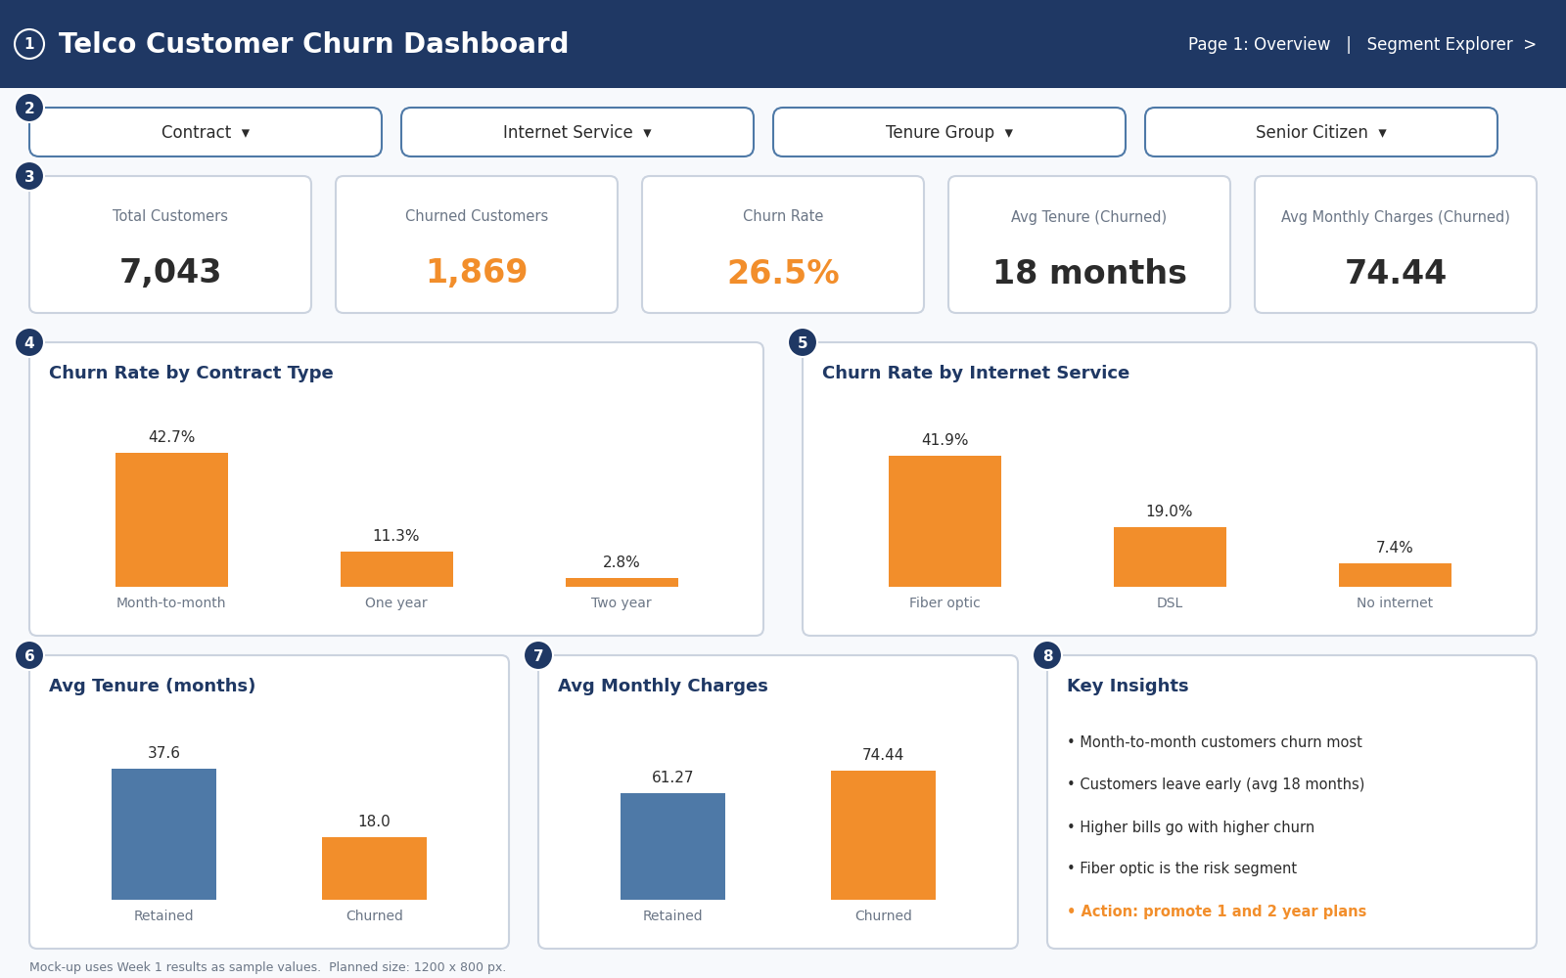
Figure 1: Mock-up of dashboard Page 1 (Overview)

Position and purpose of each zone
# | Zone / position | Content | Purpose
1 | Header, top | Dashboard title and page navigation | Tells the user what they are looking at
2 | Filter strip, below header | Contract, Internet Service, Tenure Group, Senior Citizen | Lets the user slice every chart in one place
3 | KPI row, upper third | Five KPI cards | Answers "how big is the problem?" at a glance
4, 5 | Middle row, two wide charts | Churn rate by Contract; churn rate by Internet Service | Show where churn is highest (the most important charts get the most space)
6, 7 | Bottom row, left and centre | Average tenure; average monthly charges (retained vs churned) | Show who leaves and whether price matters
8 | Bottom row, right | Key insights and recommended action | Turns the charts into a decision

Reading flow: The layout follows the natural top-to-bottom, left-to-right reading order: headline numbers first, then the biggest drivers, then supporting detail, then the conclusion. The most important information sits in the top half of the screen so it is seen without scrolling.
Implementation: Tableau layout containers (horizontal and vertical) will be used so that every zone aligns and keeps equal spacing, with a small padding around each chart.

7. Colour Scheme and Typography
Colour is used to carry meaning, not decoration. Orange always means churned and blue always means retained, the same as in my Week 1 charts, so the user learns the code once and it holds on every chart and page.
Hex code | Colour | Used for | Swatch
#F28E2B | Orange | Churned customers, churn rate, key call-to-action
#4E79A7 | Blue | Retained customers, filter outlines
#1F3864 | Dark navy | Header bar, chart titles
#F7F9FC | Very light grey-blue | Dashboard background
#2B2B2B / #6B7686 | Dark grey / mid grey | Main text / axis labels and captions

- Orange and blue are clearly different for people with red-green colour blindness, so the key comparison stays readable. Red and green are not used.
- Only these colours appear on the dashboard. Everything else is grey, so the orange stands out.
- Typography: one sans-serif font family. Dashboard title 20 pt bold, chart titles 12 to 13 pt bold, KPI numbers 24 pt bold, axis labels and captions 9 to 10 pt.

8. Visual Elements and Why They Were Chosen
Visual | Type | Fields | Why this choice
KPI cards | Big-number text cards | Customers, Churned, Churn Rate, Avg Tenure, Avg Charges | The fastest way to show headline numbers
Churn rate by Contract | Bar chart | Contract, Churn Rate | Bars are easy to compare; rate (%) is used instead of counts because contract groups are different sizes
Churn rate by Internet Service | Bar chart | Internet Service, Churn Rate | Same reason; same chart type keeps the page consistent
Average tenure | Bar chart (2 bars) | Churn, Avg Tenure | A simple comparison of two groups
Average monthly charges | Bar chart (2 bars) | Churn, Avg Monthly Charges | A simple comparison of two groups
Insights panel | Text box | None | States the conclusion in words so nobody has to guess

Improvement over Week 1: In Week 1 the contract and internet service charts showed stacked counts. For the dashboard I plan to show churn rate (%) instead. Counts can mislead because month-to-month has many more customers than the other contracts, whereas a rate compares the groups fairly (42.7%, 11.3% and 2.8%).

Page 2: Segment Explorer
To avoid overloading Page 1, deeper analysis goes on a second page (Figure 2). This keeps Page 1 simple for managers while giving analysts more detail (progressive disclosure).
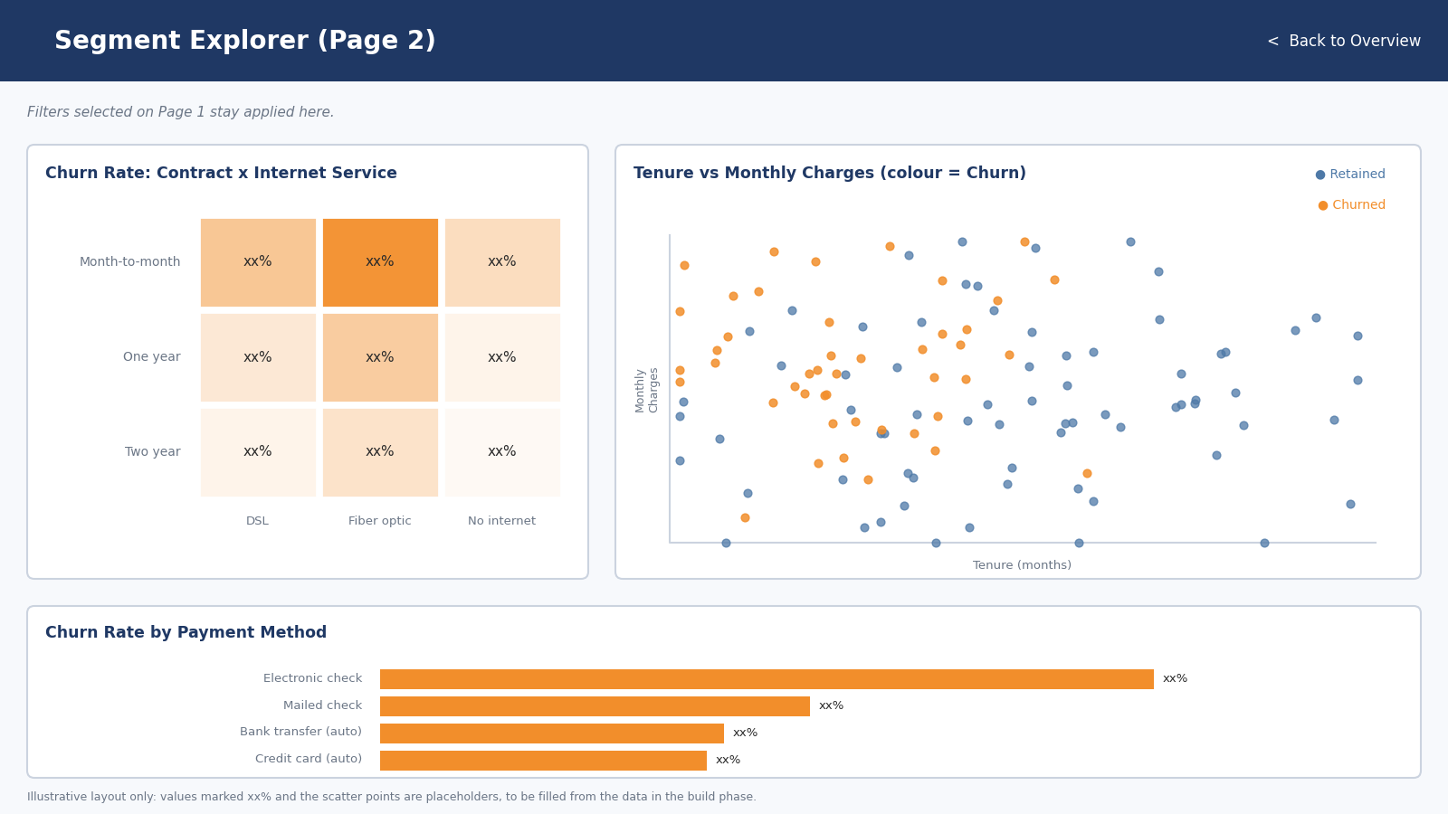
Figure 2: Mock-up of Page 2 (Segment Explorer). Values marked xx% are placeholders.
- Heat map (Contract x Internet Service): shows which combination has the highest churn. Darker orange means higher churn. This tests my Week 1 question of whether month-to-month fiber optic customers are the highest-risk group.
- Scatter plot (Tenure vs Monthly Charges, coloured by Churn): shows tenure and price together and reveals clusters, such as new customers on high bills.
- Bar chart (Payment Method): checks a variable not yet analysed in Week 1.

9. Integration Rationale: How the Visuals Work Together
The dashboard is designed as a short story with four steps, shown in Figure 3. Each visual has one job, and each step answers the question raised by the previous one.
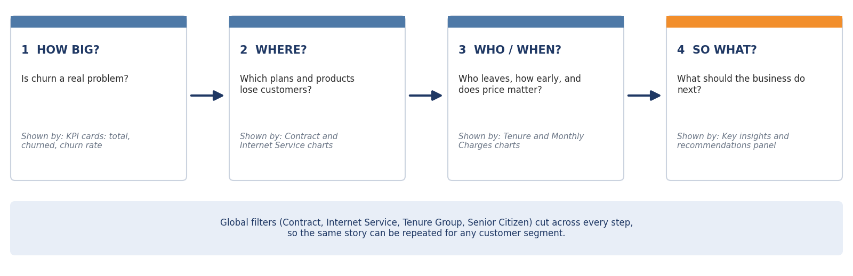
Figure 3: Data story flow of the dashboard
- How big? The KPI cards show that 26.5% of customers have churned, so the problem is worth solving.
- Where? The contract and internet service charts show that churn is concentrated in month-to-month and fiber optic customers.
- Who and when? The tenure and monthly charges charts show that churned customers leave early (18 vs 37.6 months) and pay more (74.44 vs 61.27).
- So what? The insights panel converts these findings into an action, such as moving month-to-month customers to longer contracts.
The visuals are also linked technically. They all use the same Churn field for colour, they share the same filters, and they are connected by dashboard actions (Section 10), so selecting a segment in one chart updates the others. This lets the user see the same segment from several angles at once, which is what makes it a single coherent data story instead of five separate charts.

10. Interactivity Plan
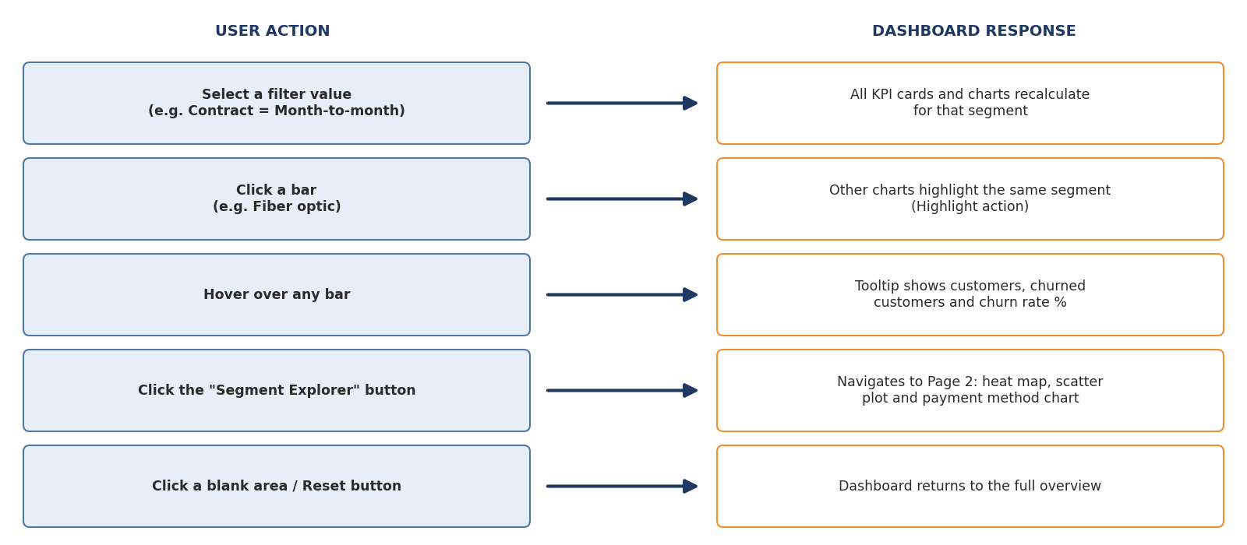
Figure 4: Interaction flow: what the user does and how the dashboard responds
Interaction | Tableau feature | Benefit to the user
Filters (Contract, Internet Service, Tenure Group, Senior Citizen) | Quick filters applied to all worksheets on the dashboard | One set of controls for the whole page
Click a bar to highlight a segment | Dashboard Highlight / Filter action | Compares one segment across all charts
Hover over a bar | Tooltips with customers, churned customers, churn rate | Exact numbers without cluttering the charts
"Segment Explorer" button | Navigation button to Page 2 | Moves from overview to detail
Reset / click blank area | Clear selection | Returns to the full view easily

11. How the Design Enhances User Understanding
- Answer first: the key number (26.5% churn) is the first thing seen, then the explanation.
- Consistent encoding: the same colours, chart types and fonts everywhere mean less effort to read.
- Limited content: Page 1 has only five KPI cards and four charts, so nothing competes for attention. Extra detail sits on Page 2.
- Direct labels: values are written on the bars, so the user does not have to read them off an axis.
- Written insights: the insights panel states the conclusion and the recommended action in plain language.
- Accessible: a colour-blind-safe palette, large KPI text, and sufficient contrast.

12. Implementation Roadmap
- Create the calculated fields: Churn Flag, Churn Rate, Tenure Group, Monthly Revenue at Risk.
- Build one worksheet for each KPI and each chart in Figure 1, using the colour code in Section 7.
- Create the dashboard at a fixed size of 1200 x 800 px and arrange the worksheets with layout containers following Figure 1.
- Add the filters and dashboard actions described in Section 10, and the custom tooltips.
- Build Page 2 (Figure 2) and add the navigation buttons.
- Format: fonts, padding, titles, and the insights panel text.
- Test by asking whether a new user can answer the five business questions in Section 3 within a minute.
- Publish to Tableau Public and add the files to the GitHub repository.

13. Risks and Limitations
- The dataset is a sample with no date field, so the dashboard cannot show churn trends over time.
- The findings show association, not proven cause. For example, fiber optic customers churn more, but this data does not say why.
- Tableau Public makes the data and dashboard public, so only non-sensitive data like this sample dataset should be published there.

14. Conclusion
This plan turns the Week 1 findings into a dashboard that tells a clear story: how big the churn problem is, where it is concentrated, who is leaving and when, and what to do about it. The layout puts the most important information first, a consistent colour code connects every chart, and the interactions let each audience explore what matters to them. The mock-ups, flow diagrams and roadmap in this document give a complete blueprint for building the dashboard in the next stage.

