Exploratory Data Analysis and Insight Generation
Telco Customer Churn Dataset, analysed in Tableau
Virtual Tableau Visualization Internship, Week 1 Task
Prepared by: Madugula Manikumar | 30 September 2026

1. Objective
The objective of this task is to select a publicly available dataset and carry out an initial exploratory data analysis (EDA) in Tableau. The focus is on understanding the variables, detecting trends and identifying business insights that can later be turned into dashboards.
For this task I chose the Telco Customer Churn dataset and set one guiding business question: which customers are leaving the company, and what do they have in common?

2. Dataset Description
Source: Kaggle, "Telco Customer Churn" (IBM sample data, uploaded by BlastChar). It is a public dataset.
Size: 7,043 customer records (rows) and 21 fields (columns). Each row is one customer of a telecom company.
Target variable: Churn (Yes = the customer left the company, No = the customer stayed).
The 21 fields cover customer demographics (gender, senior citizen, partner, dependents), account information (tenure, contract type, payment method, paperless billing, monthly charges, total charges) and the services each customer has subscribed to (phone, multiple lines, internet service, online security, online backup, device protection, tech support, streaming TV and streaming movies).

Variables chosen for analysis
Variable | Type | Why it was chosen
Churn | Dimension (Yes/No) | The outcome we want to understand.
Contract | Dimension (3 values) | Commitment level is a likely driver of loyalty.
Tenure | Measure (months) | Shows how long customers stay before leaving.
Monthly Charges | Measure (currency) | Tests whether price is linked to churn.
Internet Service | Dimension (DSL / Fiber optic / No) | Shows whether a particular product has a churn problem.

3. Approach and Tools
The analysis was done in Tableau Public Desktop using the following steps:
- Downloaded the CSV file from Kaggle and connected it to Tableau as a text file. Tableau loaded all 7,043 rows and 21 fields correctly.
- Checked the fields in the Data pane and separated dimensions (categorical fields such as Churn and Contract) from measures (numeric fields such as Tenure and Monthly Charges).
- Built five worksheets, each answering one question, using bar charts and stacked bar charts. Churn was placed on Color in every chart so that churned customers (orange) can be compared with retained customers (blue).
- Used Count of records for volume comparisons and Average for Tenure and Monthly Charges, then added data labels so exact values can be read.
- Combined all five worksheets into a single dashboard.

4. Analysis and Insights

4.1 Overall churn
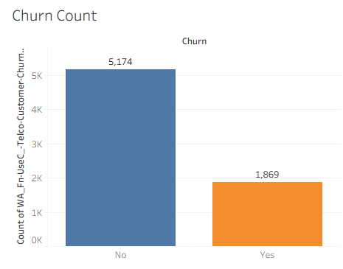
Figure 1: Churn Count (No = 5,174, Yes = 1,869)
Observation: Out of 7,043 customers, 1,869 have churned. This is an overall churn rate of about 26.5%, which means roughly one in every four customers has left.
Insight: The dataset is imbalanced (about 73% stayed, 27% left). Churn is large enough to be a serious business problem, so it is worth finding which groups are most at risk.

4.2 Churn by contract type
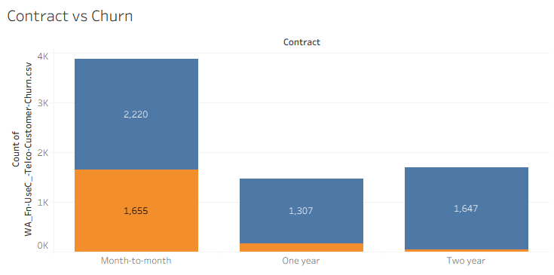
Figure 2: Contract type vs Churn
Contract | Customers | Churned | Churn rate
Month-to-month | 3,875 | 1,655 | 42.7%
One year | 1,473 | 166 | 11.3%
Two year | 1,695 | 48 | 2.8%

Observation: Month-to-month customers form the largest group and also churn the most. Almost 43 out of every 100 month-to-month customers left, compared with only about 3 out of 100 on two-year contracts.
Insight: Contract length is the strongest pattern in this dataset. Customers with no long-term commitment can leave easily. Encouraging month-to-month customers to move to one- or two-year plans (for example with discounts) could reduce churn considerably.

4.3 Churn and customer tenure
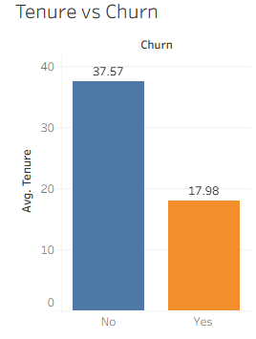
Figure 3: Average tenure of retained vs churned customers
Observation: Customers who stayed have an average tenure of 37.57 months, while customers who churned had an average tenure of only 17.98 months, less than half.
Insight: Customers tend to leave early, typically within the first one to two years. The early months are the most critical period, so onboarding support and early-retention offers for new customers are likely to be effective.

4.4 Churn and monthly charges
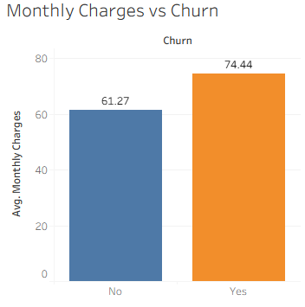
Figure 4: Average monthly charges of retained vs churned customers
Observation: Churned customers pay more per month on average (74.44) than retained customers (61.27), a difference of about 13.17 or roughly 21%.
Insight: Higher bills are associated with higher churn. Customers who pay more may expect more value, or may be more price-sensitive. Reviewing pricing and plan value for higher-paying customers is worthwhile.

4.5 Churn by internet service
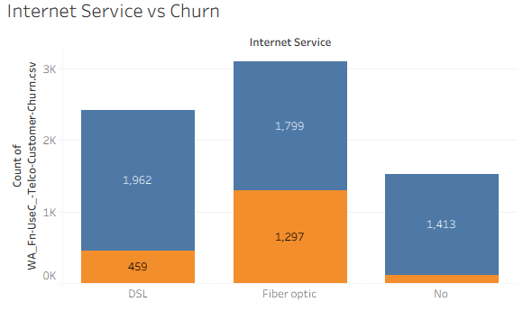
Figure 5: Internet service type vs Churn
Internet Service | Customers | Churned | Churn rate
Fiber optic | 3,096 | 1,297 | 41.9%
DSL | 2,421 | 459 | 19.0%
No internet | 1,526 | 113 | 7.4%

Observation: Fiber optic is the biggest internet product but has by far the highest churn rate (about 42%), more than double DSL (19%). Customers without internet service rarely leave (7%).
Insight: Fiber optic customers are the highest-risk product segment. Combined with Figure 4, this suggests a possible link between higher-priced fiber plans and churn, but this is a hypothesis to be tested, not something these charts prove.

5. Dashboard
The five charts were combined into one dashboard so that all key views can be read together.
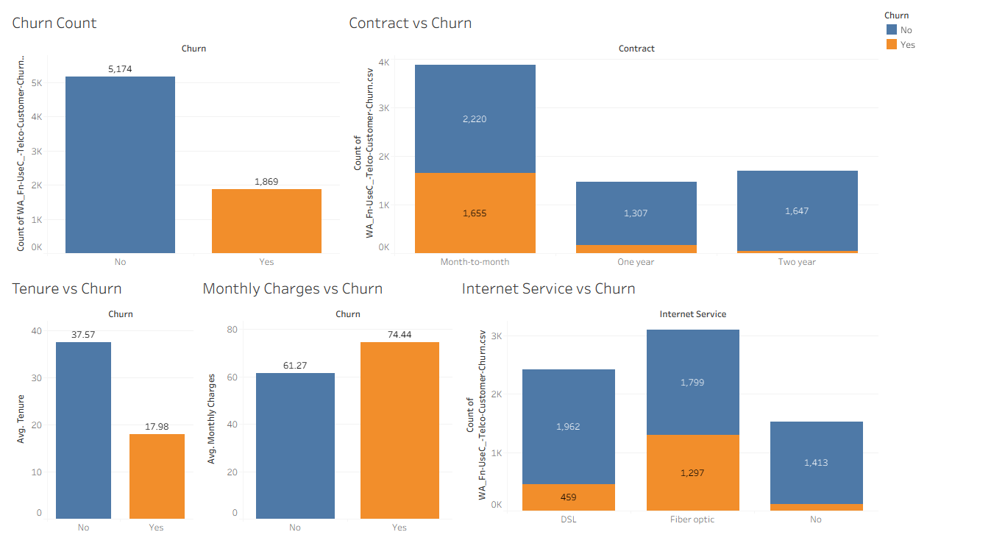
Figure 6: Churn Analysis Dashboard (Tableau)

6. Summary of Key Findings
- 26.5% of customers have churned (1,869 of 7,043).
- Contract type matters most: month-to-month churn is 42.7% vs 2.8% for two-year contracts.
- Customers leave early: average tenure is 18 months for churned vs 37.6 months for retained customers.
- Higher bills, higher churn: 74.44 vs 61.27 average monthly charges.
- Fiber optic is the risk segment: about 42% churn, versus 19% for DSL.

7. Areas for Further Investigation
- Combine the drivers: are month-to-month fiber optic customers with high monthly charges the group with the very highest churn?
- Investigate why fiber optic customers leave (price, service quality, or missing add-ons such as Tech Support and Online Security). This dataset has no service-quality or complaint data, so this needs additional information.
- Analyse other variables not yet explored: payment method, paperless billing, senior citizens, partner and dependents, and add-on services.
- Look at the distribution of tenure and monthly charges (histograms or box plots) to detect outliers and to find the exact tenure range where churn is highest.
- Build a predictive churn model in Python or Tableau to score the customers most at risk.

8. Conclusion
This exploratory analysis shows that churn in this telecom dataset is not random. It is concentrated among customers on month-to-month contracts, customers in their first two years, customers with higher monthly bills and customers using fiber optic internet. Tableau made it quick to compare churned and retained customers side by side, and the dashboard summarises the story in one view.
The patterns above show association, not proven cause. They point to where the business should look first, for example converting month-to-month customers to longer contracts and strengthening early-tenure retention, and they provide clear directions for the deeper analysis listed in Section 7.

