Performance Optimization and Interactive Feature Enhancement
Assessment, optimization strategies and interactive features for the Telco Churn Tableau dashboard
Virtual Tableau Visualization Internship, Week 5 Task
Prepared by: Madugula Manikumar | 5 October 2026
Repository: github.com/manimadugula03-ui/telco-churn-tableau-eda

1. Summary at a Glance
This report assesses the performance and usability of my Telco Customer Churn dashboard (Dashboard 1 and the three advanced sheets from Week 4), finds the bottlenecks, sets out optimization strategies and adds interactive features. The assessment uses my real workbook. Where I applied a change I say so and show a screenshot; where a change is only recommended I label it "Recommended".
Area | Result
Current design | 5 sheets on Dashboard 1, about 18 marks in total (2 to 6 marks per sheet), over 7,043 rows and 21 CSV columns. Small and fast to draw.
Biggest problem found | The workbook referenced the CSV by an absolute file path. When the file was no longer there, Tableau showed "Where is the data file?" and the data source showed an alert with no data preview.
Optimizations applied | Reconnected the data source; used a dashboard filter action instead of extra filter cards; kept every sheet aggregated to a few marks; documented the table-calculation settings.
Interactive feature built | "Use as Filter" on the Contract chart. Clicking Month-to-month updated all other charts (3,875 customers; 1,655 churned).
Recommended next | Package as .twbx, hide unused fields, use an aggregated extract, fixed dashboard size, quick filters, a drill-down hierarchy and a metric parameter.

Honest note about measurement
Tableau Public does not include Performance Recording (it is a Desktop Pro feature; I checked the Help > Settings and Performance menu). I therefore did not measure load times in seconds and I do not report any. The analysis is based on inspecting the real workbook (data size, marks, calculations, layout, errors I met) and on documented Tableau best practices. Section 9 explains how to take real timings in Tableau Desktop.

2. Scope and Method
- Opened the workbook Telco-Churn-EDA and inspected the data source, the dashboard and each sheet.
- Counted what the dashboard has to draw and calculate (sheets, marks, calculated fields, filters).
- Recorded real problems that occurred while working with the workbook.
- Matched each problem to an optimization strategy and tested the interactive feature on the dashboard.
- Checked the filtered results against values already validated in Week 4.

3. Assessment of the Current Dashboard
Item | What I found in the workbook
Data source | CSV text file, 7,043 rows and 21 columns. The Data Source page lists 25 fields once the calculated fields are included.
Dashboard 1 | 5 sheets: Churn Count, Contract vs Churn, Tenure vs Churn, Monthly Charges vs Churn, Internet Service vs Churn.
Marks per sheet | Churn Count 2, Contract 6, Tenure 2, Monthly Charges 2, Internet Service 6: about 18 marks in total.
Workbook sheets | 9 worksheets (one is an empty leftover called Sheet 9) and 1 dashboard.
Calculated fields | 5: Churn Flag, Churn Rate, Tenure Group, Segment (row-level or aggregate) and Cumulative % of Churned (table calculation).
Dashboard size and layout | Size is Automatic, layout is Tiled.
Filters | No filter cards. Interaction is through a dashboard filter action (Section 6).
Load time | Not measured (no Performance Recording in Tableau Public).

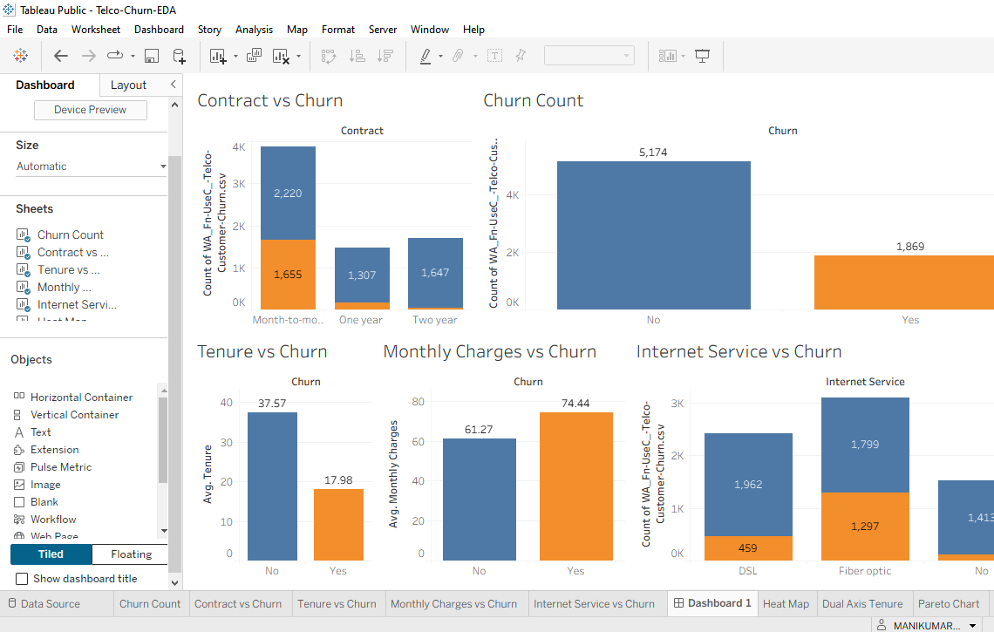
Figure 1: Dashboard 1 before interaction. Five aggregated sheets, no filter cards.
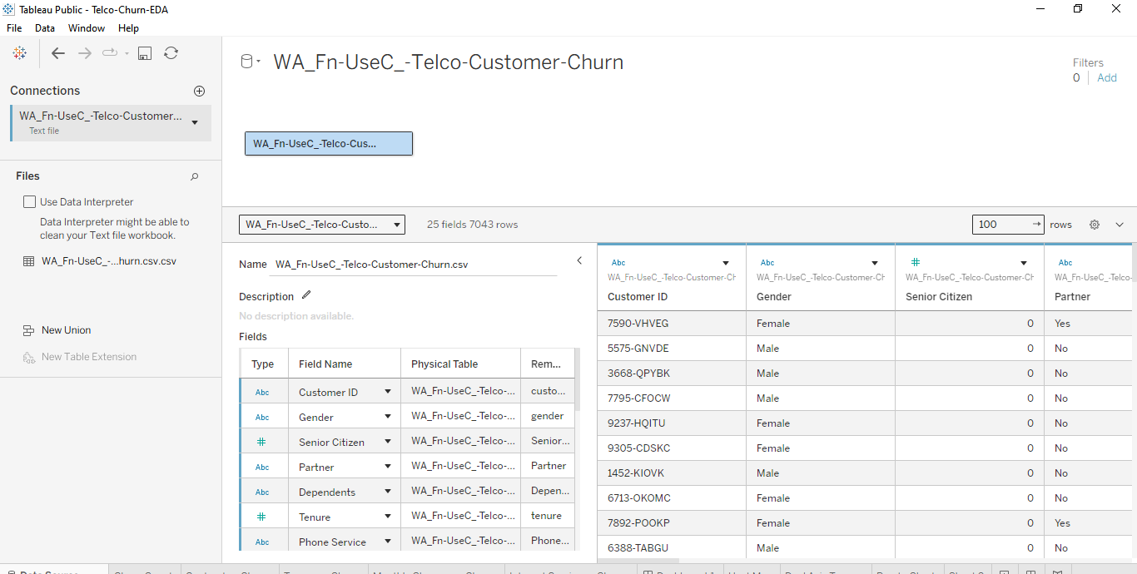
Figure 2: Data Source page after reconnecting: 7,043 rows, 25 fields (including calculated fields)

4. Bottlenecks Identified
Area | Evidence | Risk | Priority
Data connection and packaging | The workbook was saved as .twb and pointed to the CSV by file path. After the file location changed Tableau asked "Where is the data file?" (Figure 3) and the data source showed a red alert with "Data preview unavailable". The CSV also has a double extension (.csv.csv) because Windows hides extensions, which made Tableau look for a name that did not exist. | Dashboard shows no data; workbook is not portable | High
Unused fields | The CSV has 21 columns but the dashboard uses 6: Churn, Contract, Customer ID, Tenure, Monthly Charges and Internet Service. | Extra columns make the data pane cluttered and enlarge an extract | Medium
Calculations | Segment joins two text fields for every row. Tenure Group is a four-branch nested IF for every row. Cumulative % of Churned is a table calculation that depends on the sort order: my first Pareto chart gave wrong values until the sort was fixed (Week 4). | Slower at large volumes; wrong results if the settings are changed | Medium
Dashboard design | Size is Automatic, so the layout changes with screen size. While selecting a chart, one chart was dragged over another and the layout had to be corrected. | Layout shifts; extra redraws | Medium
Data volume (future) | 7,043 rows is small. If the data grew to hundreds of thousands of rows, text-file reads and row-level calculations would become noticeable. | Slower response | Low today
Clutter | An empty sheet (Sheet 9) is left in the workbook. | Confusing to users | Low

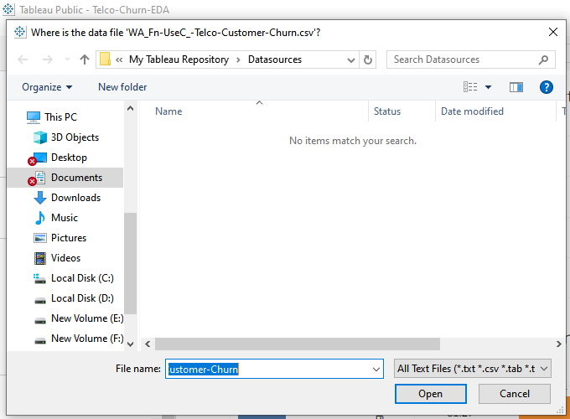
Figure 3: Tableau asking where the data file is (the data connection bottleneck)

5. Optimization Strategies
Strategy | How to do it in Tableau | Expected outcome | Status
Reconnect the data source | Edit Connection, then add the correct file from the Files list and remove the broken table | Dashboard shows data again (7,043 rows) | Applied
Package the workbook | File > Save As > Tableau Packaged Workbook (.twbx), so the data travels with the workbook | Opens on any computer; no missing-file prompt | Recommended
Fix the file name | Show file extensions in Windows and rename the file to a single .csv | Tableau finds the file by its real name | Recommended
Use a filter action instead of filter cards | Dashboard > Actions or the "Use as Filter" icon on a chart | Fewer controls, fewer queries, cleaner screen | Applied
Keep sheets aggregated | Every sheet shows 2 to 6 marks, never one mark per customer | Fast drawing at any data size | Applied
Document table-calculation settings | Record the sort and Compute Using setting for Cumulative % of Churned | Correct values after later edits | Applied (Week 4 report)
Hide unused fields | Hide the 15 columns that no sheet uses, or tick Hide All Unused Fields in the extract dialog | Smaller extract, cleaner data pane | Recommended
Aggregated extract | Data > Extract Data, aggregate for visible dimensions and filter out unused rows | Smaller data and faster queries as data grows | Recommended
Move row-level text work upstream | Create Segment and Tenure Group in the CSV or in Python so Tableau does not calculate them for every row | Less calculation at query time | Recommended
Fixed dashboard size | Dashboard > Size > Fixed size, for example 1200 x 800 | Same layout everywhere, steadier rendering | Recommended
Remove unused objects | Delete the empty Sheet 9 | Simpler workbook | Recommended

6. Interactive Features

6.1 Built and tested: filter action
I turned on Use as Filter for the Contract vs Churn chart (the funnel icon on the chart toolbar, ticked in the chart menu). Clicking the Month-to-month bar then filtered every other chart on the dashboard.
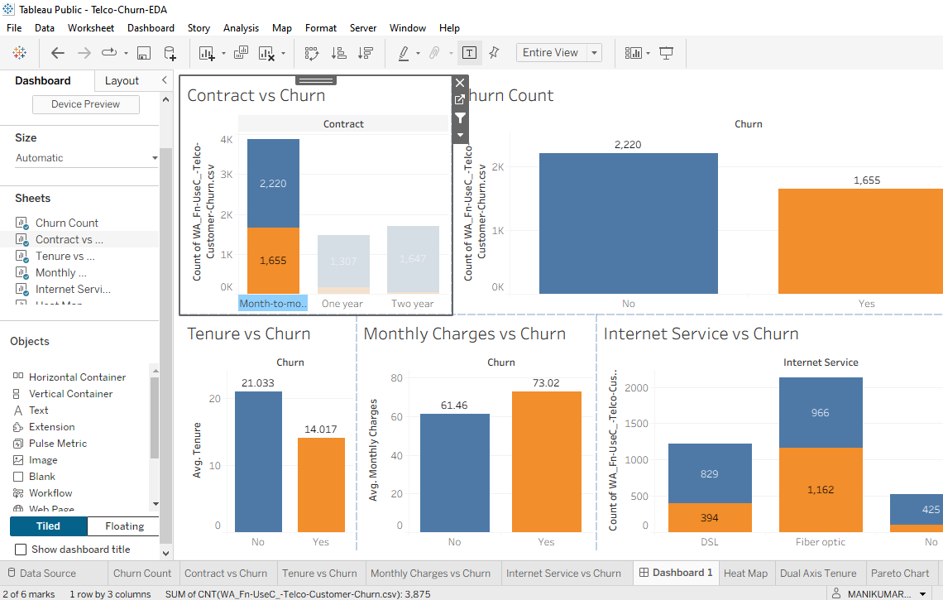
Figure 4: Dashboard 1 after clicking the Month-to-month bar. Other charts show only those customers.
What Tableau showed | Value | Independent check
Customers selected (status bar) | 3,875 | Month-to-month customers in the dataset: 3,875
Churn Count: No / Yes | 2,220 / 1,655 | Same as the Month-to-month bar in Contract vs Churn
Internet Service: DSL churned | 394 | Equals the Pareto bar for Month-to-month | DSL
Internet Service: Fiber optic churned | 1,162 | Equals the Pareto bar and heat map count for Month-to-month | Fiber optic
Fiber optic retained / DSL retained | 966 / 829 | 2,128 - 1,162 = 966 and 1,223 - 394 = 829
Average tenure: retained / churned | 21.0 / 14.0 months | Shown by Tableau; not separately recalculated
Average monthly charges: retained / churned | 61.46 / 73.02 | Shown by Tableau; not separately recalculated
Why it improves usability: the viewer explores one question ("what do month-to-month customers look like?") with a single click and sees the answer in every chart at once. No filter card has to be found and set, and the dashboard does not need extra controls, which also keeps the number of queries low.

6.2 Recommended: not built yet
Feature | How to build it | How it improves usability
Quick filters | Right-click Contract, Internet Service and Tenure Group, Show Filter, then set to Apply to Worksheets > Selected Worksheets | Viewers can narrow to any segment without clicking on charts
Drill-down hierarchy | Group Contract, Internet Service and Tenure Group into a hierarchy (Group by > Hierarchy); use the + on the field | Starts at a simple overview and lets the viewer open detail only when needed
Metric parameter | Create a parameter "Metric Selector" (Churn Rate, Churned Customers) and a calculated field that returns the chosen measure; show the parameter control | One chart can answer two questions, so the dashboard needs fewer sheets
Show/Hide button | Add a Show/Hide button to a container that holds the filters | Keeps the screen clean until filters are needed

Parameter field | Formula (to be tested in Tableau)
Selected Metric | CASE [Metric Selector]  WHEN "Churn Rate" THEN [Churn Rate]  WHEN "Churned Customers" THEN SUM([Churn Flag])  END

7. Priorities and Expected Outcomes
Priority | Action | Expected outcome
1 (about 10 min) | Save as .twbx, fix the file name, delete Sheet 9, upload to GitHub | Workbook opens anywhere with data, no missing-file error
2 (about 30 min) | Hide unused fields; aggregated extract; fixed dashboard size | Smaller data, steadier layout
3 (about 1 hour) | Quick filters, drill-down hierarchy, metric parameter | More exploration with fewer charts
4 (when data grows) | Move row-level text calculations upstream; test with Performance Recording | Stays responsive at larger volumes

8. Scalability: What Would Change if the Data Grew
The dashboard is fast to draw because each sheet shows few marks. Its cost comes from the data and calculation layers, not from drawing. If the dataset grew to hundreds of thousands of rows, the first things to matter would be extract size (unused columns), row-level text calculations (Segment, Tenure Group) and the number of sheets that query the data at once. The strategies in Section 5 address exactly these three, and the filter-action design already avoids adding more queries. This is a projection from design, not a measurement.

9. How to Measure the Improvement
In Tableau Desktop (Pro) the improvements can be measured with Help > Settings and Performance > Start Performance Recording, then using the dashboard and choosing Stop Performance Recording. The summary workbook lists query, layout and rendering times. I would record the dashboard before and after each priority in Section 7 and compare these figures: total time to open the dashboard, time to respond to a filter click, and the slowest single query. A reasonable target for a dashboard like this is that it opens and responds to a click in a few seconds. This target is a goal, not a result I measured.

10. Limitations
- No timings were measured because Tableau Public has no Performance Recording; conclusions about speed come from design inspection.
- Only one interactive feature (the filter action) was built and tested; the others are recommendations with steps.
- The dataset is small, so even the current design is fast; the value of the optimizations grows with the data.
- Average tenure and average monthly charges in Section 6.1 were taken from Tableau and were not recalculated separately.

11. Conclusion
The dashboard is already light, with 18 marks over 7,043 rows, so its main weakness is not drawing speed but how the workbook is connected and packaged. The data-path failure I met was real and has a clear fix (reconnect, rename the file, save as .twbx). The filter action I built shows how one interaction can replace several controls and keep every chart consistent, and its numbers match the values validated in Week 4. The remaining strategies are ordered by priority so they can be applied and then measured in Tableau Desktop.

