Crafting an Interactive Data Story
Data Story Approach and Planned Visual Narrative: Telco Customer Churn
Virtual Tableau Visualization Internship, Week 3 Task
Prepared by: Madugula Manikumar | 1 October 2026

1. Data Story Concept
This document plans an interactive data story built on the Telco Customer Churn dataset analysed in Week 1 (7,043 customers, 21 fields) and the dashboard design planned in Week 2. Where Week 2 decided what the dashboard looks like, this document decides what story it tells, in what order, and how the viewer can explore it.
Element | Description
Story title | "Who is leaving, and what can we do about it?"
Core narrative | One in four customers leaves. The loss is not random: it is concentrated in customers with no long-term contract, customers in their first two years, customers paying higher bills and fiber optic users. Moving customers to longer plans is the clearest way to reduce it.
Key message | Churn can be reduced by encouraging month-to-month customers to move to longer contracts, and by protecting new and high-paying customers early.
Call to action | Run a retention campaign aimed at month-to-month fiber optic customers in their first two years.

2. Target Audience
Audience | What the story gives them | Decision it supports
Senior management | The size of the problem and the main recommendation in the first and last story points | Whether to fund a retention programme
Retention / customer success team | Which segments to contact first, with filters to check any segment themselves | Who to target and when
Pricing and marketing team | The link between contract type, price, internet product and churn, and a what-if estimate | Which plans and offers to design

The story is written for non-technical viewers: each story point has a plain-language headline, so the message is clear even without reading the chart details.

3. Supporting Insights
Every story point is backed by a finding from my Week 1 exploratory analysis.
Insight | Evidence from the data | Used in
Churn is a big problem | 1,869 of 7,043 customers churned (26.5%) | Story point 1
Contract type is the strongest driver | Churn rate: month-to-month 42.7%, one year 11.3%, two year 2.8% | Story point 2
Customers leave early | Average tenure: churned 17.98 months vs retained 37.57 months | Story point 3
Higher bills go with higher churn | Average monthly charges: churned 74.44 vs retained 61.27 | Story point 4
Fiber optic is the risk product | Churn rate: fiber optic 41.9%, DSL 19.0%, no internet 7.4% | Story point 4
Highest-risk segment (to confirm) | Contract x Internet Service heat map; Week 1 suggests month-to-month fiber optic customers, to be verified in the build phase | Story point 5

4. Narrative Structure
The story follows a simple three-act structure that moves the viewer from a headline, through the evidence, to a decision. Each step answers the question left by the previous one, so the order is sequential and logical.
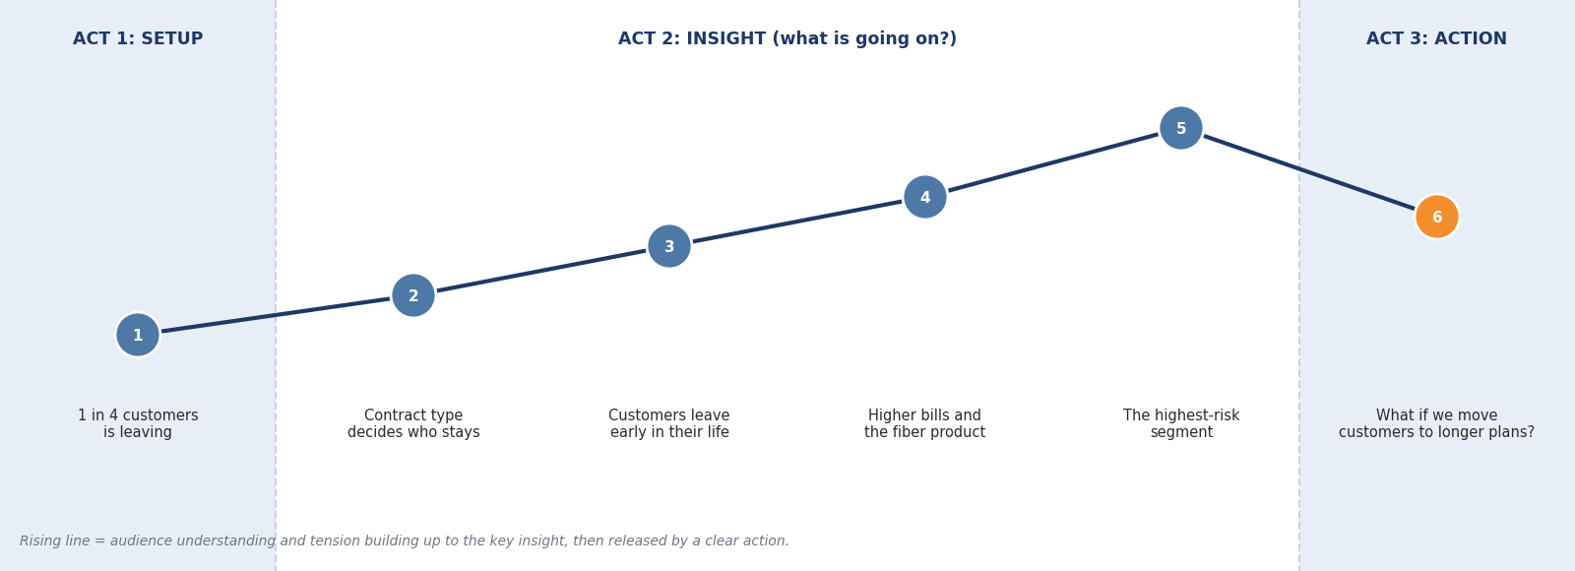
Figure 1: The story arc, from setup through insight to action
- Act 1, Setup: a strong opening fact ("1 in 4 customers is leaving") that makes the audience care.
- Act 2, Insight: four story points narrow the problem down step by step: which contract, which stage of the customer life, which price and product, and finally which combination.
- Act 3, Action: a what-if view that shows the effect of the recommended action, so the story ends with a decision rather than just information.

5. Visual Narrative Plan
Figure 2 is the storyboard. The sequence of visualizations is the order in which they will appear in the Tableau Story (or the dashboard with Next/Back navigation).
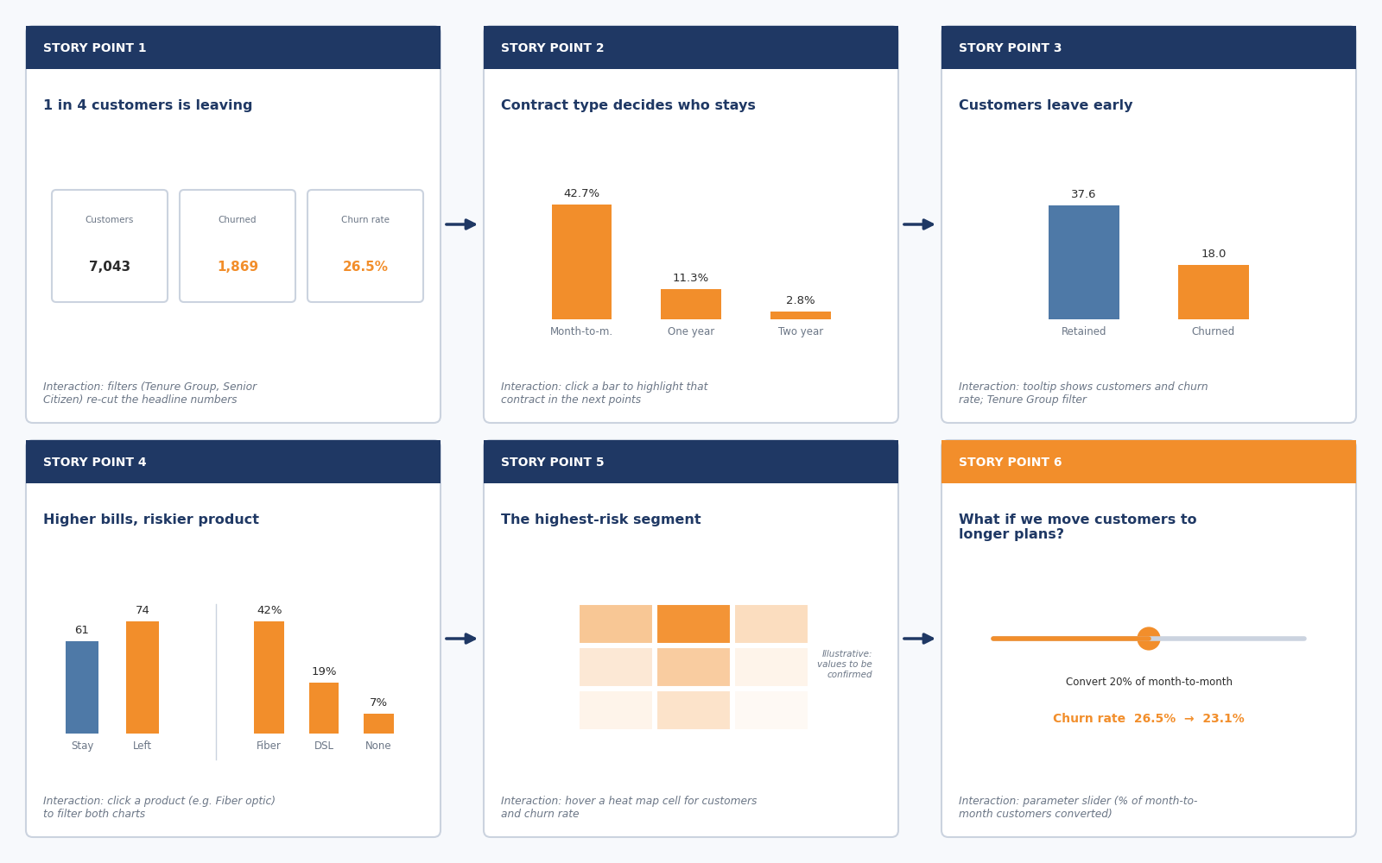
Figure 2: Storyboard of the six story points
# | Headline | Visualization | Contribution to the story
1 | 1 in 4 customers is leaving | KPI cards: customers, churned, churn rate | Hook: establishes that the problem is large enough to matter
2 | Contract type decides who stays | Bar chart: churn rate by contract | First and strongest explanation; shows where to look
3 | Customers leave early | Bar chart: average tenure, churned vs retained | Adds timing: the first two years are the danger zone
4 | Higher bills, riskier product | Bar charts: monthly charges and churn rate by internet service | Adds price and product as further reasons
5 | The highest-risk segment | Heat map: contract x internet service | Combines the previous findings into one priority group
6 | What if we move customers to longer plans? | Parameter slider with projected churn rate | Resolution: turns the insight into a measurable action

Transitions and annotations
- Each story point has a one-sentence caption that finishes with a link to the next point (for example: "So where is the churn coming from? Let us look at contracts").
- The same colour code is used throughout: orange = churned, blue = retained. The viewer never has to relearn the legend.
- The key number of each point is annotated directly on the chart, so the eye goes straight to it.

6. Interactive Elements
Figure 3 shows the interactive elements and which story points they support. They are designed to support the narrative, not to distract from it: the story runs in a planned order, and the controls let the viewer go deeper at any point.
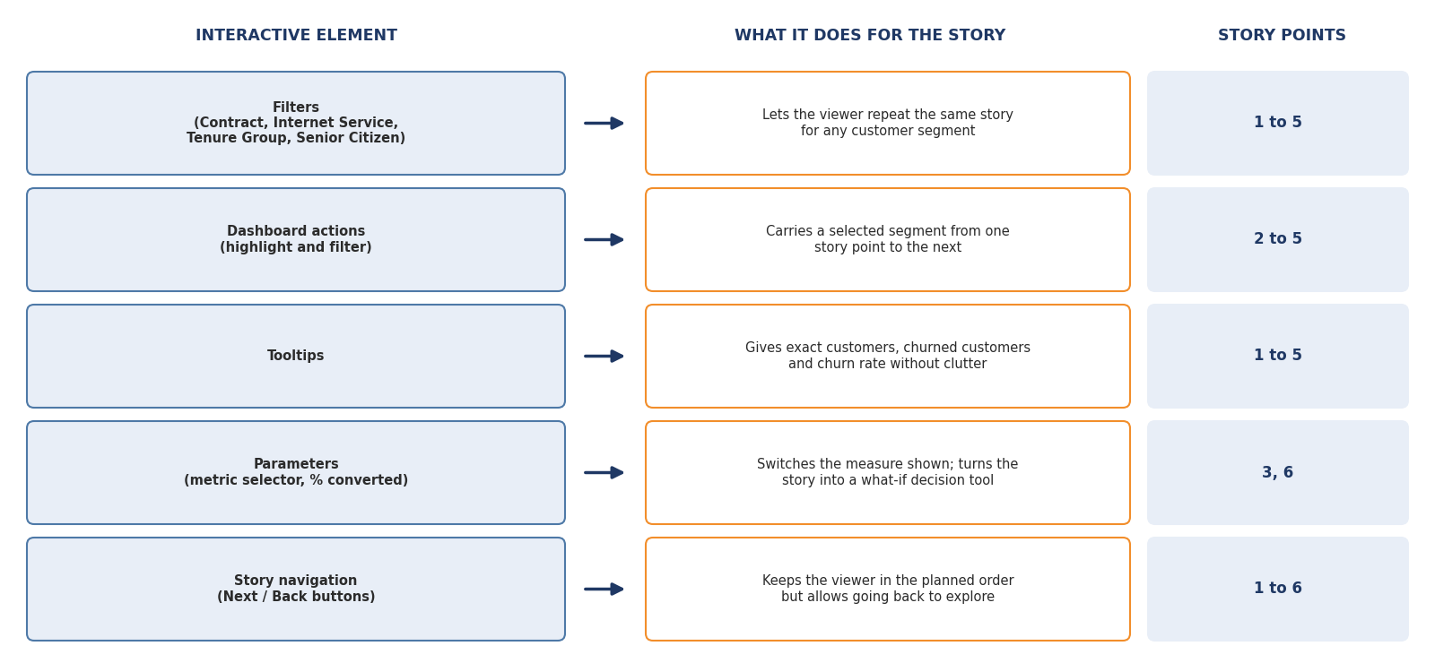
Figure 3: Interactive elements and how they support the narrative
Element | How it will be set up in Tableau | How it supports the narrative flow | How it allows deeper exploration
Filters | Quick filters on Contract, Internet Service, Tenure Group, Senior Citizen, applied to all story sheets | Keeps the same story structure for any segment | The viewer can test "does this hold for senior citizens?"
Dashboard actions | Highlight action and filter action from the contract and internet service charts | A segment chosen in one point stays highlighted in the next | The viewer can follow one segment through the whole story
Tooltips | Custom tooltips with customers, churned customers, churn rate | Adds detail without cluttering the chart | Gives exact numbers on demand
Parameters | Metric selector (customer count / churn rate) and a "% of month-to-month customers converted" slider | The slider drives the final story point | The viewer can test their own scenario
Story navigation | Tableau Story points with Next / Back captions, or navigation buttons on a dashboard | Guarantees the planned order | The viewer can step back and re-check any point

What-if parameter: how it will work
The parameter "% of month-to-month customers converted to a one-year contract" lets the viewer see the effect of the recommended action. The calculated field is:
Projected churned = Churned customers - (p x Month-to-month customers x (Month-to-month churn rate - One-year churn rate))
With the Week 1 numbers (3,875 month-to-month customers, churn rate 42.7% vs 11.3% for one-year contracts), the projected results would be:
Customers converted (p) | Customers moved | Churned customers | Projected churn rate
0% (today) | 0 | 1,869 | 26.5%
10% | 388 | about 1,747 | about 24.8%
20% | 775 | about 1,625 | about 23.1%
30% | 1,162 | about 1,504 | about 21.3%
40% | 1,550 | about 1,382 | about 19.6%

Assumption: this is a simple scenario that assumes customers who switch behave like today's one-year customers. It illustrates the size of the opportunity and is not a forecast, because the data shows association, not proven cause. This assumption will be stated on the story point itself.

7. How the Interactive Features Let Users Explore the Narrative in Greater Depth
The story is designed as guided exploration. A viewer first follows the planned path, then can leave it to investigate, then return. An example journey for a retention manager:
- Opens the story and reads the headline: 1 in 4 customers is leaving.
- At story point 2 clicks the month-to-month bar. The highlight action carries that selection to the next points.
- Uses the Tenure Group filter to check whether the pattern is stronger in the first year.
- Hovers over the fiber optic bar at story point 4 and reads the exact churn rate in the tooltip.
- At story point 6 moves the slider to 20% and sees the projected churn rate fall to about 23.1%.
- Goes back with the Back button to check the evidence before presenting the recommendation.
In short, the controls move the viewer through three levels: overview (KPIs), segment (filters and actions) and detail (tooltips and the what-if parameter). This gives the depth an analyst needs without overloading a manager who only wants the main message.

8. Implementation Notes
- Build one worksheet for each story point using the same colour code, then assemble them as Tableau Story points (or a dashboard with navigation buttons if the Story feature is not suitable for publishing).
- Create the calculated fields (Churn Flag, Churn Rate, Tenure Group, Projected Churned) and the two parameters first, because several story points depend on them.
- Write the caption for every story point at the same time as the chart, so that the headline, the visual and the transition stay consistent.
- Test with a person who has not seen the analysis: can they state the key message after one minute?

9. Risks and Limitations
- The dataset is a sample with no date field, so the story cannot show how churn changes over time.
- The patterns are associations, not proven causes. For example, the data does not explain why fiber optic customers leave more.
- The highest-risk segment (story point 5) and the what-if results depend on assumptions and must be verified when the dashboard is built.
- Too many interactive controls can distract from the story, so only the controls listed in Section 6 will be included.

10. Conclusion
The planned story takes the audience from a single striking fact to a concrete decision in six steps. The sequence is logical, each visualization has a clear role, and the interactive elements, filters, actions, tooltips, parameters and navigation, allow viewers to follow the story or explore it in more depth. Together with the Week 2 layout plan, this document gives a complete blueprint for building the final interactive dashboard.

