Advanced Chart Techniques and Calculation Insights
Heat map, dual-axis and Pareto charts with calculated fields, built in Tableau Public
Virtual Tableau Visualization Internship, Week 4 Task (resubmission)
Prepared by: Madugula Manikumar | 5 October 2026
Repository: github.com/manimadugula03-ui/telco-churn-tableau-eda

1. Summary at a Glance
This report continues the Telco Customer Churn analysis from Weeks 1 to 3 (7,043 customers, 21 fields). In Tableau Public I built three advanced charts and five calculated fields. Every chart in this document is a real screenshot from my Tableau workbook, and every number was checked against the dataset.
Item | What I built in Tableau | Key result
Heat map | Churn rate by Contract x Internet Service (9 cells) | Month-to-month fiber optic: 54.6% churn, the highest cell
Dual-axis chart | Customers (bars) and churn rate (line) by tenure group | 47.4% churn at 0-12 months, falling to 9.5% at 49-72 months
Pareto chart | Churned customers by segment with cumulative % line | Two segments cause 83.3% of all churn (1,556 of 1,869)
Calculated fields | Churn Flag, Churn Rate, Tenure Group, Segment, Cumulative % of Churned | Row-level, aggregate and table calculations, each tested

Main finding
Churn is concentrated: month-to-month fiber optic customers are 1,162 of the 1,869 churned customers (62.2%), and customers in their first 12 months churn at 47.4%. A retention effort aimed at new month-to-month fiber optic customers addresses most of the problem.

2. Research and Selection of Advanced Techniques
I compared several advanced chart types against the dataset and the business question: where and when do customers churn, and which groups matter most.
Technique | What it does | Fit for this dataset | Decision
Heat map | Compares a measure across two categories using colour intensity | Churn rate across Contract x Internet Service (9 combinations) | Built
Dual-axis chart | Shows two measures with different scales in one chart | Customer count (bars) and churn rate (line) by tenure group | Built
Pareto chart | Sorted bars plus a cumulative percentage line | Finds the few segments that cause most churn | Built
Box plot | Distribution and outliers | Useful for tenure and charges, but adds less to this story | Later
Bullet chart | Actual value against a target | The dataset has no churn target | Not used
Treemap | Part-to-whole using area | Exact churn rates are harder to read | Not used
Bump / slope chart | Rank change over time | The dataset has no date field | Not used
I built three techniques because each answers a different question and together they form one argument: the heat map shows where churn is highest, the dual-axis chart shows when customers leave, and the Pareto chart shows how much of the problem each segment causes.

3. Calculated Fields
All five fields were created in Tableau with Analysis > Create Calculated Field. Tableau confirmed each formula with "The calculation is valid". Figure 1 shows the dialog for the first field.
Field | Type | Formula | Why it was needed and what it showed
Churn Flag | Row-level | IF [Churn] = "Yes" THEN 1 ELSE 0 END | Churn is stored as Yes/No text, which cannot be summed. The flag makes it numeric. SUM(Churn Flag) = 1,869, the number of churned customers.
Churn Rate | Aggregate | SUM([Churn Flag]) / COUNT([Customer ID]) | Counts mislead when groups differ in size. The rate compares groups fairly: overall 26.5%, month-to-month fiber optic 54.6%.
Tenure Group | Row-level | IF [Tenure] <= 12 THEN "0-12"  ELSEIF [Tenure] <= 24 THEN "13-24"  ELSEIF [Tenure] <= 48 THEN "25-48"  ELSE "49-72" END | Turns continuous tenure (0 to 72 months) into four life stages. Revealed 47.4% churn in the first year.
Segment | Row-level | [Contract] + " | " + [Internet Service] | Combines two fields into nine segments, the unit for the Pareto chart.
Cumulative % of Churned | Table calculation | RUNNING_SUM(SUM([Churn Flag])) / TOTAL(SUM([Churn Flag])) | Running share of all churn along the sorted segments. Gives 62.2% after one segment and 83.3% after two. Computed along Segment.

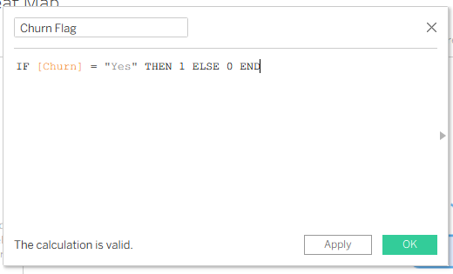
Figure 1: Churn Flag calculated field in Tableau (the calculation is valid)

Why different calculation types were used
- Row-level calculations (Churn Flag, Tenure Group, Segment) work on each customer record and prepare the data for analysis.
- Aggregate calculation (Churn Rate) works on the groups shown in the chart, so it gives the right rate for any cell, bar or point.
- Table calculation (Cumulative % of Churned) works on values already in the chart, so it depends on the sort order and on the Compute Using setting. Section 6 shows what happened when the sort was wrong.
Impact on the analysis: these fields move the work from describing the data (counts and averages in Weeks 1 to 3) to explaining and prioritising it (rates, life stages and concentration).

4. Advanced Visualization 1: Heat Map
Business question: Which combination of contract type and internet service has the highest churn rate? In Week 3 I suspected month-to-month fiber optic customers, but single-variable charts could not confirm it.

How I built it
- Dragged Internet Service to Columns and Contract to Rows.
- Changed the mark type on the Marks card to Square.
- Dragged Churn Rate (my calculated field) to Color and to Label, so each cell shows its rate.
- Edited the colour to an orange gradient, so darker orange always means higher churn (consistent with orange = churn in all earlier weeks).
- Sorted the rows as Month-to-month, One year, Two year.
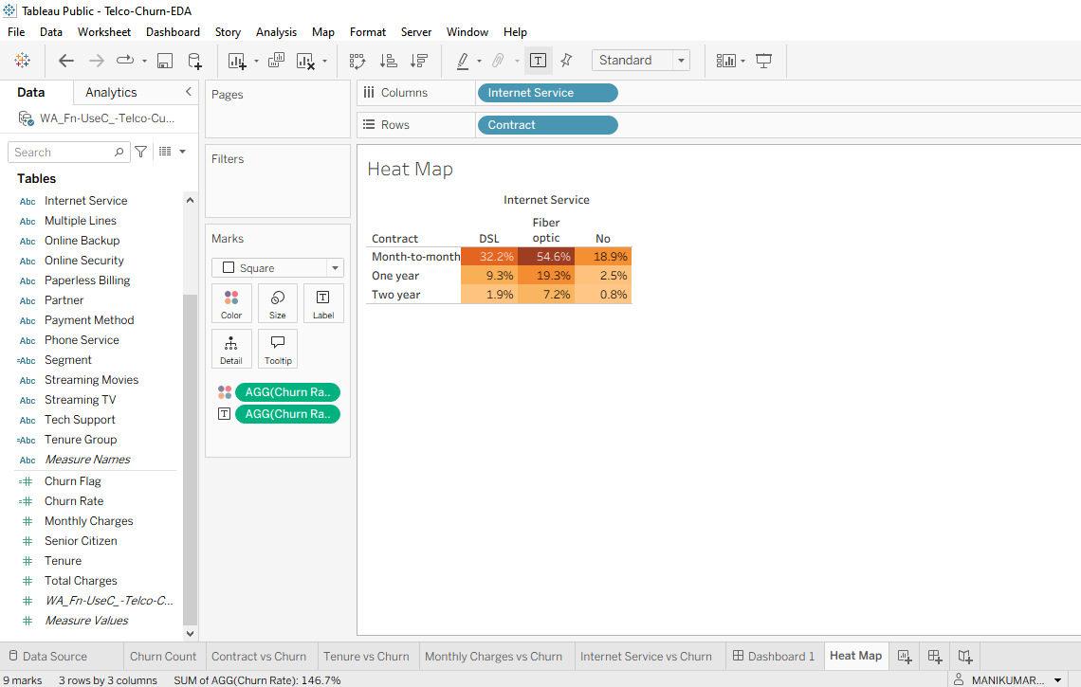
Figure 2: Heat map of churn rate by Contract and Internet Service (Tableau)

What it shows
- Month-to-month fiber optic is the highest-risk segment: 54.6% churn (1,162 of 2,128 customers). This confirms the Week 3 hypothesis.
- Fiber optic has the highest churn rate in every contract row, and churn falls as the contract gets longer in every column.
- Two-year customers are stable in every product (0.8% to 7.2%).

Why this technique
A heat map shows all nine combinations at once, and the eye goes straight to the darkest cell. A grouped bar chart would need nine bars and a legend. The single-hue colour scale avoids implying a good/bad split that the data does not define.

5. Advanced Visualization 2: Dual-Axis Chart
Business question: When in the customer lifetime does churn happen, and how many customers are at risk in each period? In Week 1 I only compared average tenure (18.0 months for churned vs 37.6 for retained), which hides the pattern inside the range.

How I built it
- Created Tenure Group and placed it on Columns (0-12, 13-24, 25-48, 49-72).
- Placed the customer count and Churn Rate on Rows, then made the second pill a dual axis so both share the same columns.
- Set the count to Bar (blue) and Churn Rate to Line (orange). My first attempt had the colours reversed (line blue, circles orange), so I corrected the mark types and recoloured them.
- Left the axes unsynchronized because one is a count and the other a percentage.
- Added labels to both marks.
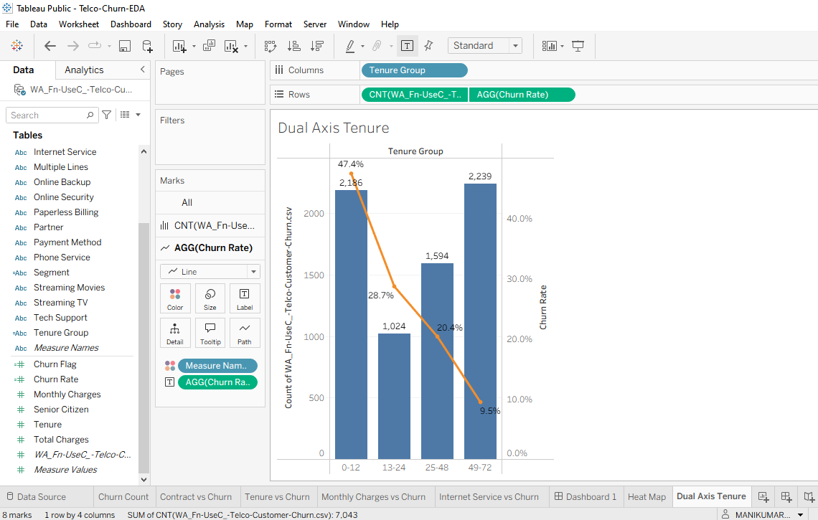
Figure 3: Customers (bars) and churn rate (line) by tenure group (Tableau)

What it shows
- Churn is highest in the first year: 47.4% of customers with 0 to 12 months of tenure churned, falling to 28.7%, 20.4% and 9.5% in later groups.
- The first group is also one of the largest (2,186 customers), so the early period is both risky and large. Bars and line together show this; neither would alone.
- The four groups add up to 7,043 customers (2,186 + 1,024 + 1,594 + 2,239).

Why this technique
The dual-axis chart combines volume and rate. Bars show size, and a line shows the trend across ordered tenure stages. Clear axis titles and unsynchronized axes prevent a misleading comparison between a count and a percentage.

6. Advanced Visualization 3: Pareto Chart
Business question: Which few segments cause most of the churn, so retention effort can be focused?

How I built it
- Placed Segment on Columns and SUM(Churn Flag) on Rows.
- Sorted Segment by Field: Churn Flag, Sum, Descending (right-click the Segment pill > Sort).
- Added Cumulative % of Churned to Rows as a second axis and set Compute Using to Segment.
- Set SUM(Churn Flag) to Bar (orange) and the cumulative measure to Line with markers, with the right axis from 0% to 100%.
- Added labels to the bars and to the line.
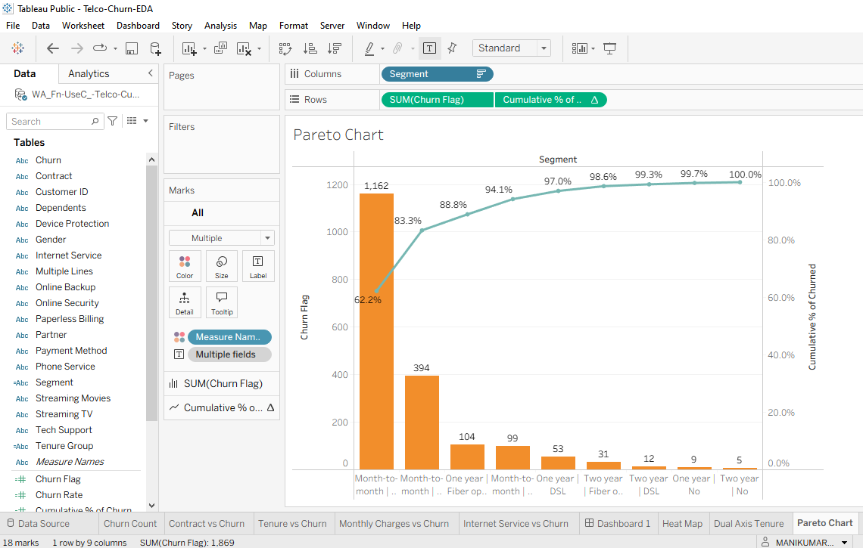
Figure 4: Pareto chart of churned customers by segment (Tableau)

What it shows
- One segment causes most churn: month-to-month fiber optic has 1,162 churned customers, 62.2% of all churn.
- Two segments cause 83.3%: adding month-to-month DSL (394) gives 1,556 of 1,869.
- The line reaches 88.8% after three segments and 100% at the ninth. The remaining seven segments together cause only 16.7% of churn.

Problem found and fixed: the table calculation depends on the sort
My first Pareto chart looked wrong. The Sort dialog had "Sort By: Alphabetic", so the bars appeared in alphabetical order and the cumulative line started at 0.3% and ended at 100% only after a huge jump (78.9% at the eighth bar). The values were right but the order was wrong, so the running total was meaningless.
The fix was to open Sort and choose Sort By: Field, with Field Name Churn Flag, Aggregation Sum and Descending order. After that the first bar was 1,162 and the line started at 62.2%, matching my pandas check. This confirms that a table calculation is only as correct as the sort and Compute Using setting behind it.

Why this technique
The question is about priorities. Sorting from largest to smallest and adding the cumulative line shows at once how concentrated the problem is. A plain sorted bar chart cannot show that.

7. How the Charts and the Explanations Work Together
Each chart is paired with a short written conclusion that points to the calculation behind it. The labels in the charts carry the numbers, and the text gives the meaning.
Data point | Calculation behind it | Explanation for the viewer
Darkest heat map cell: Month-to-month | Fiber optic | Churn Flag, Churn Rate | "Highest-risk segment: 54.6% churn, about twice the overall rate of 26.5%."
First point of the line: 0-12 months | Tenure Group, Churn Rate | "Customers in their first 12 months churn at 47.4%, the highest of any stage."
First bar and 83.3% point in the Pareto | Segment, Cumulative % of Churned | "Two segments cause 83.3% of all churn."
In the same workbook (Telco-Churn-EDA) the Week 1 charts are already combined on Dashboard 1. The three advanced sheets (Heat Map, Dual Axis Tenure, Pareto Chart) use the same colours (orange = churn, blue = counts and retained) so they can be placed on the Segment Explorer page planned in Week 2 without restyling. Dynamic text captions and filter actions linking the charts are planned as the next step (Section 9).

8. Validation Checks
I calculated the expected values separately from the CSV with pandas and compared them with what Tableau showed.
Check | Expected (pandas) | Shown in Tableau | Match
SUM(Churn Flag), total churned | 1,869 | 1,869 (status bar) | Yes
Tenure group customers 0-12 / 13-24 / 25-48 / 49-72 | 2,186 / 1,024 / 1,594 / 2,239 | 2,186 / 1,024 / 1,594 / 2,239 | Yes
Tenure group churn rates | 47.4 / 28.7 / 20.4 / 9.5% | 47.4 / 28.7 / 20.4 / 9.5% | Yes
Heat map: Month-to-month DSL / Fiber / No | 32.2 / 54.6 / 18.9% | 32.2 / 54.6 / 18.9% | Yes
Heat map: Two year DSL / Fiber / No | 1.9 / 7.2 / 0.8% | 1.9 / 7.2 / 0.8% | Yes
Pareto bars in order | 1,162, 394, 104, 99, 53, 31, 12, 9, 5 | 1,162, 394, 104, 99, 53, 31, 12, 9, 5 | Yes
Pareto cumulative % | 62.2, 83.3, 88.8, 94.1, 97.0, 98.6, 99.3, 99.7, 100 | Same values on the line | Yes
Cumulative line ends at exactly 100% | 100% | 100.0% | Yes

9. Impact on the Analysis and Next Steps
Area | Before (Weeks 1 to 3) | After (Week 4)
Comparing groups | Stacked counts | Churn rates, so groups of different sizes compare fairly
Contract and product | Each variable on its own; fiber optic risk was a hypothesis | Heat map confirms month-to-month fiber optic as highest risk (54.6%)
Timing | Average tenure only (18.0 vs 37.6 months) | Four tenure stages: 47.4% churn in the first year
Priorities | No ranking of segments | Pareto: two segments cause 83.3% of churn

Planned next (not yet built in Tableau)
The checks below are computed from the dataset in pandas. I plan to build them as Tableau fields and add them to the Segment Explorer page.
- Monthly Revenue at Risk: SUM(IF [Churn] = "Yes" THEN [Monthly Charges] END). Value from the dataset: 139,130.85 per month, 30.5% of all monthly charges; about 100,482 of it (72%) from month-to-month fiber optic customers.
- Overall Churn Rate benchmark as a FIXED level-of-detail expression, {FIXED : SUM([Churn Flag]) / COUNT([Customer ID])}, so each segment can show its gap to the 26.5% average.
- Combined finding to test with filters: in the dataset, the 916 month-to-month fiber optic customers in their first 12 months churn at 70.2%, a very specific first target for retention.
- Dynamic caption text and a dashboard filter action linking the heat map to the other two charts.

10. Limitations
- The dataset has no date field, so time-series techniques such as bump charts were not possible.
- The results show association, not cause. The data does not explain why fiber optic customers churn more.
- The Pareto cumulative line is correct only while the sort is by churned customers and Compute Using is Segment (see Section 6).
- Some segments are small (for example 364 one-year customers without internet), so small rates should be read with the customer counts.
- Total Charges has 11 blank values; it is not used in any calculation here.

11. Conclusion
A heat map, a dual-axis chart and a Pareto chart, supported by calculated fields, turned the earlier descriptive analysis into a precise one. They show where churn is concentrated (month-to-month fiber optic, 54.6%), when it happens (the first 12 months, 47.4%) and how concentrated it is (two segments cause 83.3%). Building the Pareto chart also showed that a table calculation depends on sorting, which is why each result was checked against values calculated separately from the data.
Files in the repository: this report, the Tableau workbook (Telco-Churn-EDA), the dataset CSV, the dashboard image and the README.

