**BANK APPLICATION SCREENSHOTS**

**Types:** There are three types of users for this application.

1. Manager.
2. Employee.
3. Customer

**Users and their roles:**

1. **Manager**: Manager is the root user of the application. His/her is the admin of the application, Admin can perform all actions on an account. The actions include creating new account, create new user for the application, suspend a account and delete a account.
2. **Employee**: Employee is also a user who has limited actions. The bank employee can do transactions as per the customer’s request. He/she can transfer fund, deposit amount, withdraw amount for an customer.
3. **Customer**: Customer can login into the application once approved by bank manager. He/she can check his bank balance and transaction history. Customer can send money to another Customer. The Customer can update his address details subjected to manager approval.

**Tools and Technologies**

* Front-End: Html, CSS, bootstrap, Angular 8
* Frameworks: Spring boot, Spring MVC, Spring Data, Spring security.
* Technology/Domain: Java
* Database: MYSQL
* Server: Tomcat 9.5

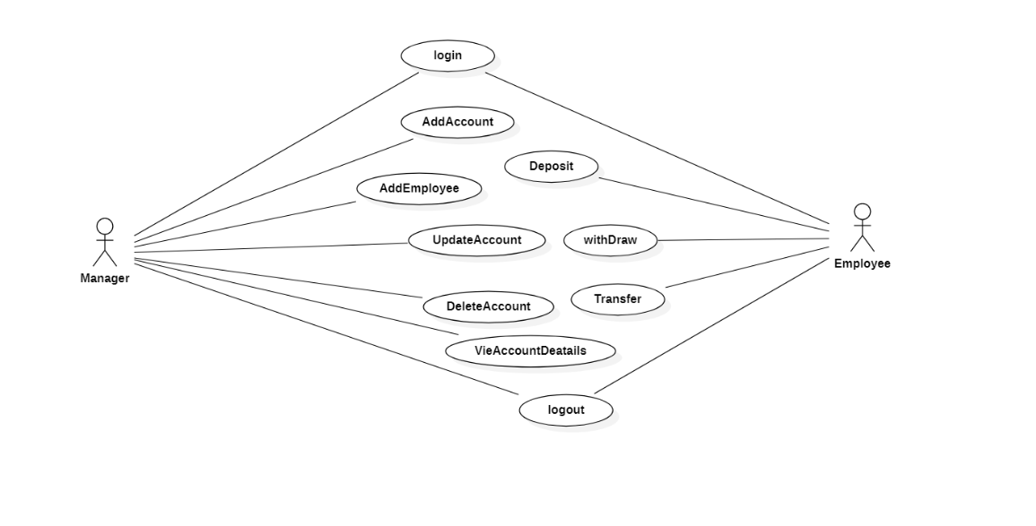

**Actions:**

**1.Login**: This is used to login for particular person. It takes parameters like username and password. If login fails he/she will be redirected to home page.

**Output:**

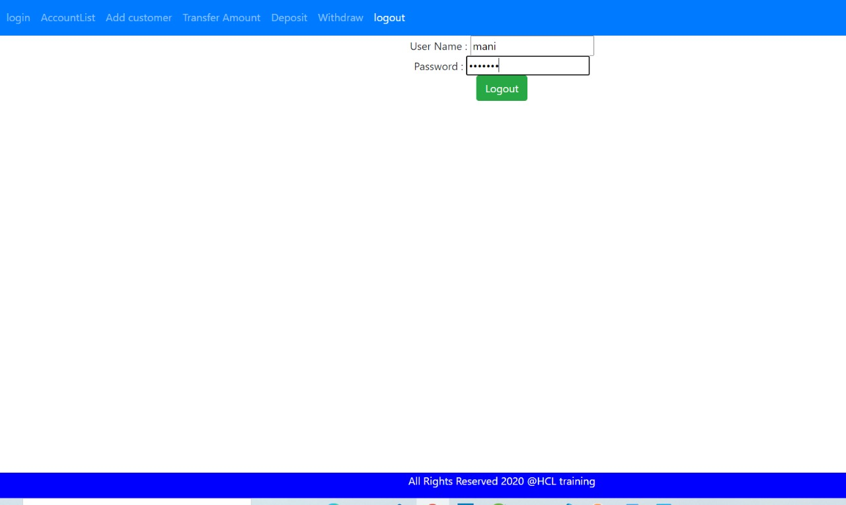

2. **Account List:** After the user Log In to the application with his/her credential the total accounts list are given below.

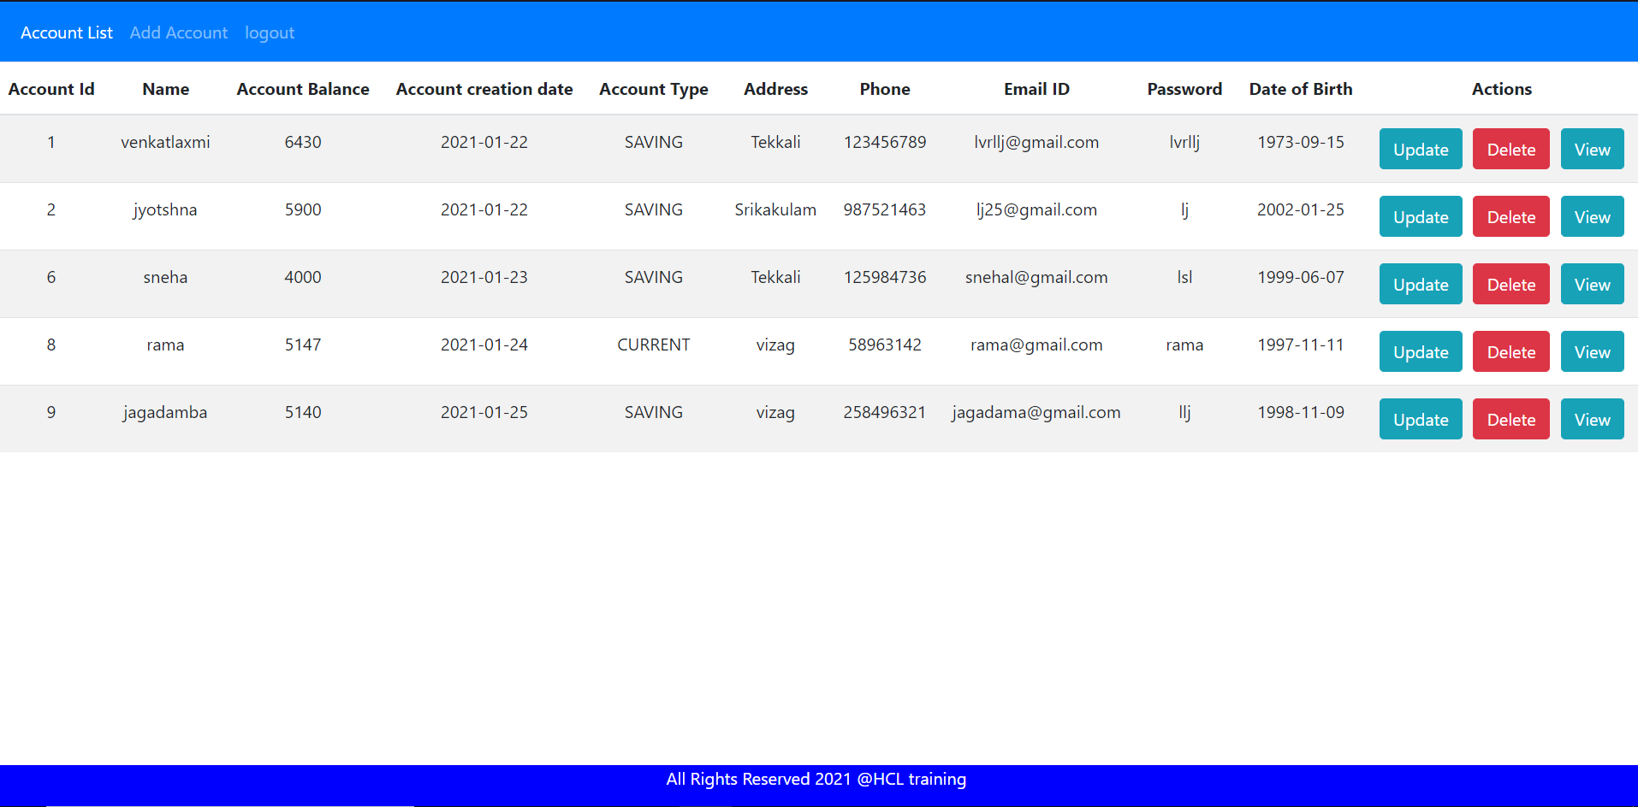

**3. Create Account:** This action allows us to add new Customer. The inputs are username, Email, address, phone number, Date of Birth.

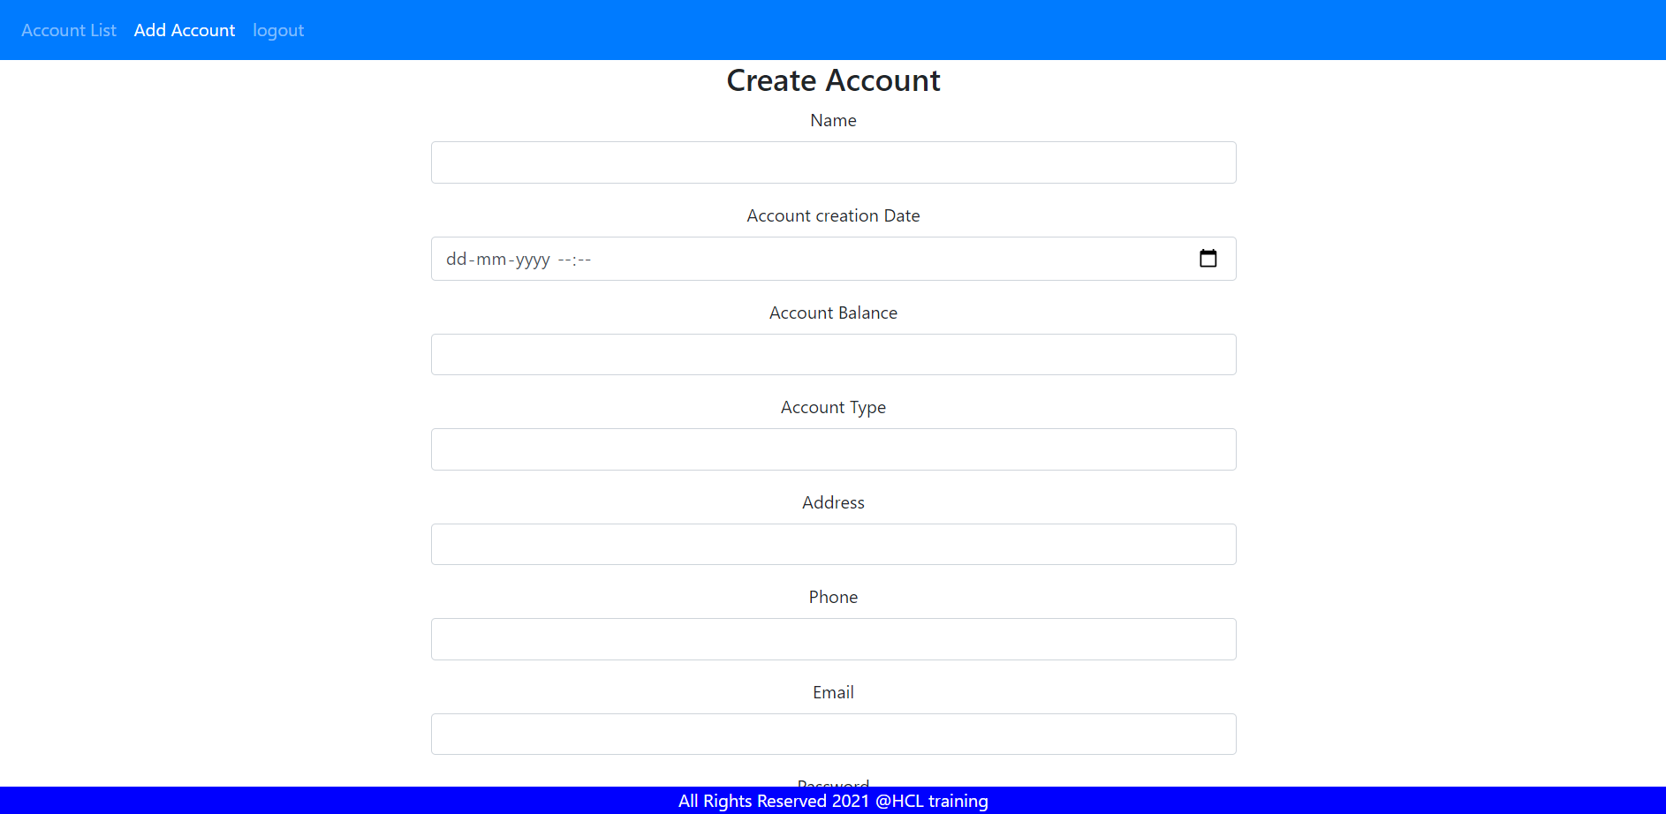

4. After adding new account to customer to view whether they are added or not click on account list to view total accounts list

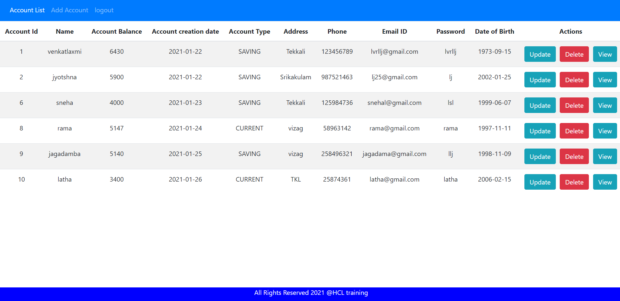

**5. Update account:** This action is used to update account details of particular customer we can update details like address, mobile number, email id.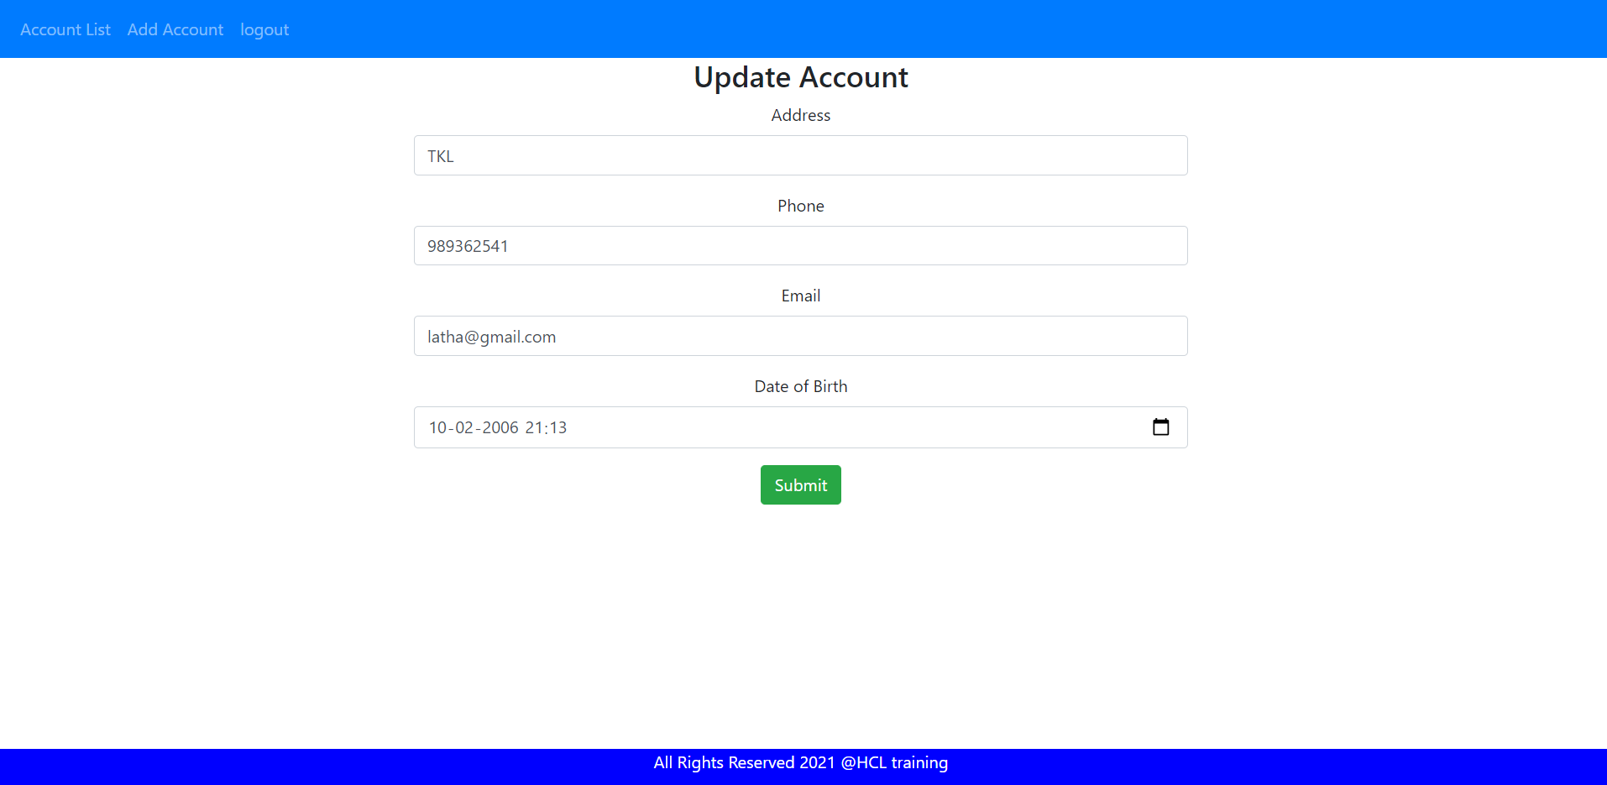

**6.view account details** :after updating particular account: click on account list then we

can view all account details with the help of account id we can know particular account details whether they are updated or not.

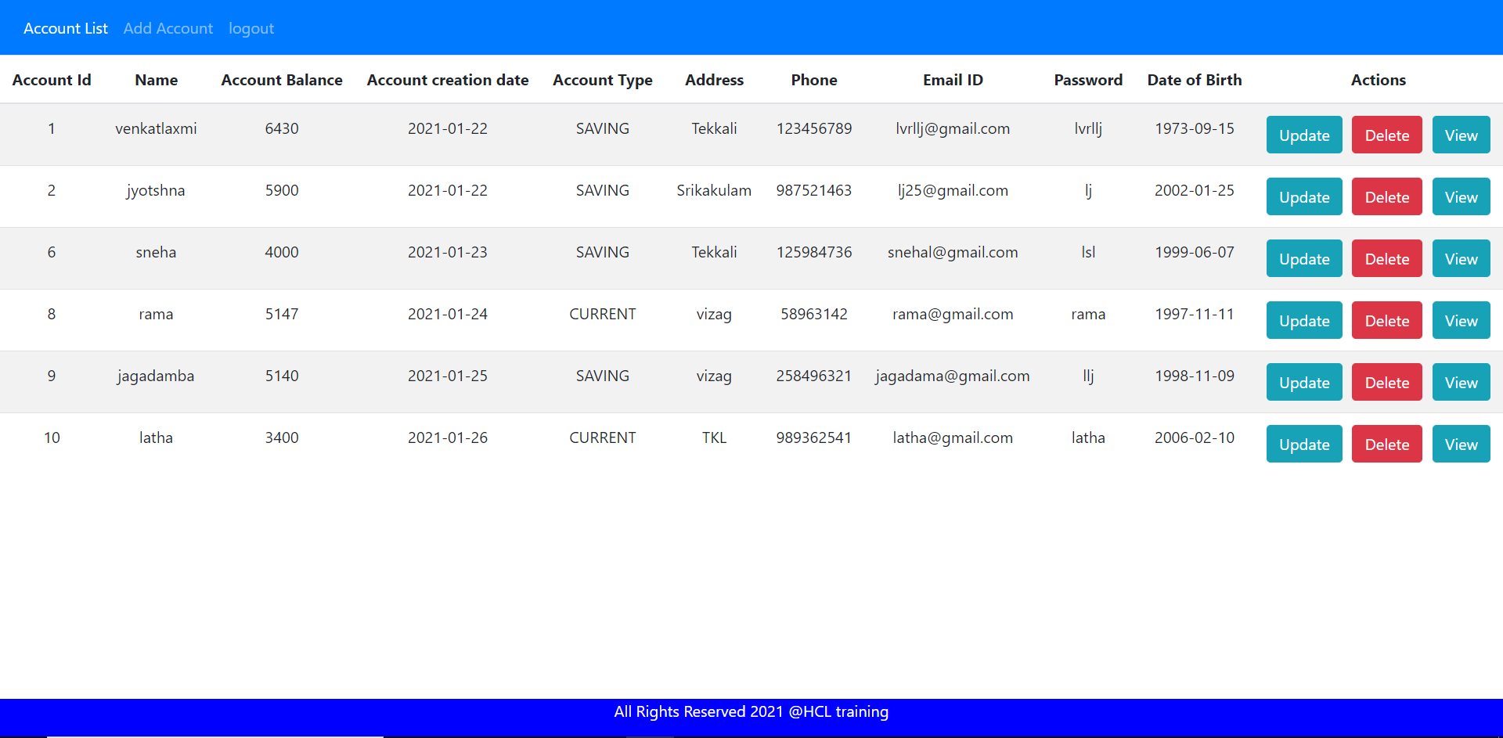

**7.Delete Account:** This action is used to delete particular customer account.By the use of delete button as shown below we can delete account.

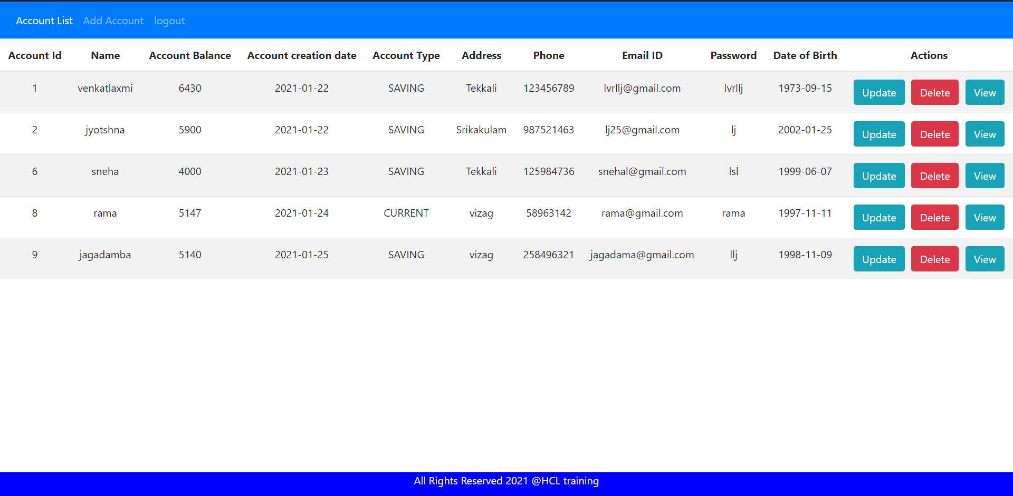

**8. Viewing account details :** To view particular account details of the customer we can view it by clicking view button of the particular customer

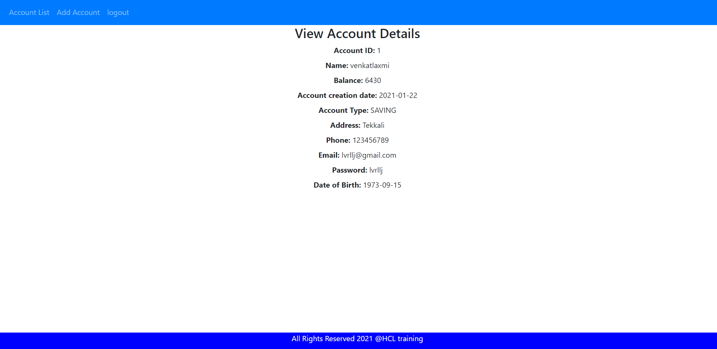

**9. logout:** This action is used to logout the application. After clicking logout option then it will redirect to login page.

