EXPERIMENT-9

224G1A0526 M MANIDHAR

Primary key :

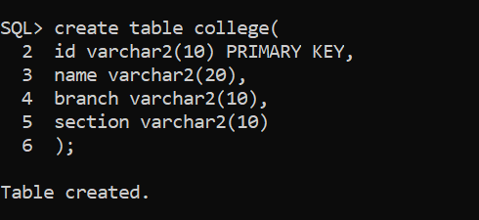

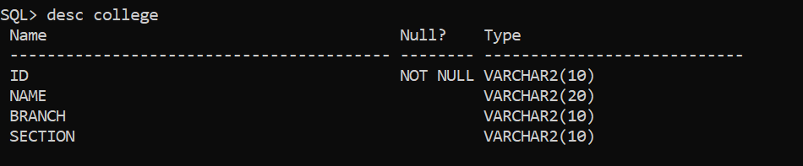

Foreign key :

