**SOEN 6481 Systems Requirements Specification**

Delivery #3

***Systems Requirement Specification Document***

Submitted To: **Prof. Dr. Rodrigo Morales**

Table of Contents

**Systems Requirement Specification Document**3

**1.** **Task 0 – Logging** 3

**2.** **Task 2 – Use case model** 3

2.1. Actor-Goal List 3

2.2. Use Case Models 3

**3.** **Task 3 - Supplementary Specification and glossary** 16

3.1. Introduction 16

3.2. Functionality 17

3.3. Usability 17

3.4. Reliability 17

3.5. Performance 18

3.6. Supportability 18

3.7. Design Constraints 18

3.8. Online User Documentation and Help System Requirements 18

3.9. Glossary 18

**Systems Requirement Specification Document** ETR (electronic tool rental)

# **Task 0 – Logging**

|  |  |
| --- | --- |
| **Tasks** | **Time Consumed** |
| Task 0 | 10 Minutes |
| Task 2 | 5 Hours 30 Minutes |
| Task 3 | 1 hour 30 Minutes |

# **Task 2 – Use case model**

## Actor-Goal List

|  |  |
| --- | --- |
| **Actor** | **Goal** |
| **Customers** | * Authentication * Checking tool availability * Checking tool rental rates * Reserving a tool * Returning a tool |
| **System Administrator** | * Authentication * Adding new branches * Creating user accounts for branch employees |
| **Branch Employee** | * Authentication * Adding tools to the store of a respective location * Removing tools from the store of a respective location * Handing out the tool to the customers * Receiving the tools from the customer post rental period * Updating the status of the tool in the ETR system |

## Use Case Models

**Id:  UC-01**

**Use Case : Customer search for a tool or equipment**

**Description :** ETR tool provides the provision to the customers to search the home improvement tools and look for its availability

**Level :** User-Level

**Primary Actor :** Customer

**Supporting Actors :** Branch Employees, System Administrator

**Stakeholders and Interests**

*Customers* – Customer searches for the equipment and finding the availability of the desired tool.

*Branch Employees* – Updating the tool availability in the system.

*System Administrator* – Having a store created in the ETR database, for the customers who belong to a particular location.

*Developer* - Application implementation team who implements the UC-01 features.

*Tester* - Application testing team who tests the UC-01 features before releasing.

**Pre-Conditions**

* Customer should have access to the tool by logging in to the system.

**Post Conditions**

Success end condition:

Customer’s search is successful, and the relevant tool availability was fetched by the user in the tool.

Failure end condition:

Customer’s search operation could fail due to multiple reasons like network down or application latency.

***Main Success Scenario***

* Customer login to the tool.
* Customer chooses the store based on the desired location.
* Customer search for the preferred tool.
* Customer checks for the availability of the tool.

***Extensions***

* Customer couldn’t login to the system
* ETR store might not be available for the customer’s desired location.
* ETR store and corresponding database might be inconsistent with the availability of the tools.

***Special Requirements***

* ETR application should function without any latency and manages traffic for multiple users.
* ETR should maintain the confidentiality of customer’s data.
* ETR should maintain Consistency.
* ETR should be reliable.

**Id:  UC-02**

**Use Case : Customer Make a reservation**

**Description :** ETR tool provides the provision to the customers to search the home improvement tools and look for its availabilityand make a reservation based on the customer’s requirements.

**Level :** User-Level

**Primary Actor :** Customer

**Supporting Actors :** Branch Employees, System Administrator

**Stakeholders and Interests**

*Customers* – Customer searches for the equipment and finding the availability of the desired tool and reserves it for a stipulated time(daily, weekly, monthly)

*Branch Employees* – Updating the tool availability in the system.

*System Administrator* – Having a store created in the ETR database, for the customers who belong to a particular location.

*Developer* - Application implementation team who implements the UC-02 features.

*Tester* - Application testing team who tests the UC-02 features before releasing.

**Pre-Conditions**

* Customer should have access to the tool by logging in to the system.
* Only one tool can be reserved with a reservation request.
* Customers can request a reservation for as early as the next day and up to 30 days in advance
* Minimal rental period is 4 hours
* Customers must be at least 18 years old.
* Have a government-issued photo ID that is valid at the time of rental.
* Have a valid credit card for a deposit at the time of pick-up.

**Post Conditions**

Success end condition:

Customer’s search is successful, and the desired tool is available to make a reservation.

Failure end condition:

* Customer’s search operation could fail due to multiple reasons like network down or application latency.
* Customer might try to reserve multiple tools per reservation which will result in reservation failure.
* Customer might try to reserve a tool for the same day or after 30th day, which will result in reservation failure.
* Customer might try to rent a tool for lesser than 4 hours, which will result in reservation failure.

***Main Success Scenario***

* Customer login to the tool
* Customer chooses the store based on the desired location
* Customer search for the preferred tool
* Customer checks for the availability of the tool
* Customer reserves the tool.

***Extensions***

* Customer couldn’t login to the system
* ETR store might not be available for the customer’s desired location.
* ETR store and corresponding database might be inconsistent with the availability of the tools.
* Customer might be lesser than 18 years old.
* Customer might not have a valid government ID.
* Customer might not have a credit card to pay for the rental services.

***Special Requirements***

* ETR application should function without any latency and manages traffic for multiple users.
* ETR should maintain the confidentiality of customer’s data.
* ETR should maintain Consistency.
* ETR should be reliable.

**Id:  UC-03**

**Use Case:** Customer Cancel a reservation

**Description :** A customer might cancel a reservation of the rental tool in ETR website.

**Level :** User-Level

**Primary Actor :** Customer

**Supporting Actors :** System Administrator

**Stakeholders and Interests**

*Customers* – Customer decides to cancel a reservation

*System Administrator* – Having a store created in the ETR database, for the customers who belong to a particular location.

*Developer* - Application implementation team who implements the UC-03 features.

Tester - Application testing team who tests the UC-03 features before releasing.

**Pre-Conditions**

* Customer should have access to the tool by logging in to the system.
* Customer should have made a reservation.

**Post Conditions**

Success end condition:

Customer’s reservation is cancelled.

Failure end condition:

Customer’s reservation cancellation operation could fail due to multiple reasons like network down or application latency or reservation unavailability in the system.

***Main Success Scenario***

* Customer login to the tool
* Customer chooses the store where the reservation was made
* Customer cancels the reservation of the tool.

***Extensions***

* Customer couldn’t login to the system
* ETR store might not be available for the customer’s desired location
* Customer couldn’t locate the reservation.

***Special Requirements***

* ETR application should function without any latency and manages traffic for multiple users.
* ETR should maintain the confidentiality of customer’s data.
* ETR should maintain Consistency.
* ETR should be reliable.

**Id:  UC-04**

**Use Case:** Branch employees CRUD operations on the tools catalog for their branch.

**Description :** Branch employees add or update the tools in the catalog of the respective store.

**Level:** User-Level

**Primary Actor :** Branch employee

**Supporting Actors :** System Administrator

**Stakeholders and Interests**

*Branch employee* – Branch employees add or update the tools in the store catalog.

*System Administrator* – Having a store created in the ETR database, for a particular location.

*Developer* - Application implementation team who implements the UC-04 features.

*Tester* - Application testing team who tests the UC-04 features before releasing.

**Pre-Conditions :**

* Branch employees should have access to the tool by logging in to the system.
* A store should be created in-prior by the system admin, for the branch employee to update or add the tool in the catalog of the respective store.

**Post Conditions**

Success end condition:

Branch employee will be able to add or update the tools in the respective store.

Failure end condition:

Branch employee is unable to add or update the tool in the store due to multiple reasons like network down or application latency.

***Main Success Scenario***

* Branch employee login to the tool
* Branch employee chooses the store where he/she is employed.
* Branch employee can add or update the tool details or availabilities in the system.

***Extensions***

* Branch employee couldn’t login to the system
* ETR store might not be temporarily available where he/she is employed.

***Special Requirements***

* ETR application should function without any latency and manages traffic for multiple users.
* ETR should maintain the confidentiality of Branch employee’s data.

**Id:  UC-05**

**Use Case:** Branch employees CRUD operations on the tools catalog for their branch.

**Description :** Branch employees deletes a tool in the catalog of the respective store.

**Level:** User-Level

**Primary Actor :** Branch employee

**Supporting Actors :** System Administrator

**Stakeholders and Interests**

*Branch employee* – Branch employee deletesthe tools in the store catalog.

*System Administrator* – Having a store created in the ETR database, for a particular location.

*Developer* - Application implementation team who implements the UC-05 features.

*Tester* - Application testing team who tests the UC-05 features before releasing.

**Pre-Conditions :**

* Branch employees should have access to the tool by logging in to the system.
* A store should be created in-prior by the system admin, for the branch employee to delete a tool in the catalog of the respective store.
* A store where the branch employee is working should already have tools in the catalog to delete from store’s database.

**Post Conditions**

Success end condition:

Branch employee will be able to delete a tool in the respective store.

Failure end condition:

Branch employee is unable to delete a tool in the store due to multiple reasons like network down or application latency.

***Main Success Scenario***

* Branch employee login to the tool
* Branch employee chooses the store where he/she is employed.
* Branch employee can delete a tool details or availabilities in the system.

***Extensions***

* Branch employee couldn’t login to the system
* ETR store might not be temporarily available where he/she is employed.

***Special Requirements***

* ETR application should function without any latency and manages traffic for multiple users.
* ETR should maintain the confidentiality of Branch employee’s data.

**Id:  UC-6**

**Use Case:** Branch employees Manage customers rentals (Rent, receive tool(s), extend, cancel rentals)

**Description :** Branch Employee maintains the customer rental activities of a store where he/she is employed.

**Level:** User-Level

**Primary Actor :** Branch Employee, Customer

**Supporting Actors :** System Administrator

**Stakeholders and Interests**

*Branch employee* – Branch employee manages the rental activities in the store

*Customer* – Customer arrives to the store to pick up the reserved rental tool.

*System Administrator* – Having a store created in the ETR database, for a particular location.

*Developer* - Application implementation team who implements the UC-06 features.

*Tester* - Application testing team who tests the UC-06 features before releasing.

**Pre-Conditions**

* Branch employees should have access to the tool by logging in to the system.
* A store where the branch employee is working should have reservations so that the branch employee can supply or receive the tools from the customer.
* Branch employees should verify the customer, that must be at least 18 years old.
* Branch employees should verify the customer, that they have a government-issued photo ID that is valid at the time of rental.
* Branch employees should verify the customer, that they have a valid credit card for a deposit at the time of pick-up.

**Post Conditions**

Success end condition:

Branch employee can decide to supply or deny the tool based on the pre-requisites of the customer.

Failure end condition:

Branch employee couldn’t locate the reservation in the system to make a decision to supply the tool to customers.

***Main Success Scenario***

* Branch employee login to the tool.
* Branch employee chooses the store where he/she is employed.
* Branch employee finds a reservation.
* Branch employee verifies the pre-requisites of the customer and supply the tool.

***Extensions***

* Branch employee couldn’t login to the system.
* ETR store might not be temporarily available where he/she is employed.

***Special Requirements***

* ETR application should function without any latency and manages traffic for multiple users.
* ETR should maintain the confidentiality of Branch employee’s data.

**Id:  UC-07**

**Use Case:** System administrator CRUD operations on branches

**Description :** System administrator creates or updates a branch detail of the ETR store of a particular location corresponding to the demands of the rental requirements.

**Level:** User-Level

**Primary Actor :** System Administrator

**Supporting Actors :** Customer

**Stakeholders and Interests**

*System Administrator* – System Administrator configures or updates a store detail corresponding to a location.

*Customer* – Customer creates a demand for a particular to have a store created by system admin

*Developer* - Application implementation team who implements the UC-07 features.

*Tester* - Application testing team who tests the UC-07 features before releasing.

**Pre-Conditions :**System Administrator should have access to the tool by logging in to the system.

**Post Conditions**

Success end condition:

System Administrator will be able to add or update a store configuration in the ETR system.

Failure end condition:

System Administrator is unable to add or update a store configuration in the ETR system due to multiple reasons like network down or application latency.

***Main Success Scenario***

* System Administrator login to the tool.
* System Administrator creates or updates a store corresponding to a location.

***Extensions***

* System Administrator couldn’t login to the system
* ETR system might not be temporarily available.

***Special Requirements***

* ETR application should function without any latency and manages traffic for multiple users.
* ETR should maintain the confidentiality of System Administrator’s data.

**Id:  UC-08**

**Use Case:** System administrator CRUD operations on branches.

**Description :** System administrator deletes a branch detail of the ETR store of a particular location due to less demand.

**Level:** User-Level

**Primary Actor :** System Administrator

**Supporting Actors :** Customer

**Stakeholders and Interests**

*System Administrator* – System Administrator deletes a store detail corresponding to a location.

*Customer* – Customer’s need for rental equipment impacts the demand to have a store deleted by system admin

*Developer* - Application implementation team who implements the UC-08 features.

*Tester* - Application testing team who tests the UC-08 features before releasing.

**Pre-Conditions :**

* System Administrator should have access to the tool by logging in to the system.
* ETR system should have a store for a particular location.

**Post Conditions**

Success end condition:

System Administrator will be able to delete a store configuration in the ETR system.

Failure end condition:

System Administrator is unable to delete a store configuration in the ETR system due to multiple reasons like network down or application latency.

***Main Success Scenario***

* System Administrator login to the tool.
* System Administrator deletes a store corresponding to a location.

***Extensions***

* System Administrator couldn’t login to the system.
* ETR system doesn’t have a store configured for the desired that the system administrator is trying to delete.
* ETR system might not be temporarily available.

***Special Requirements***

* ETR application should function without any latency and manages traffic for multiple users.
* ETR should maintain the confidentiality of System Administrator’s data.

**Id:  UC-09**

**Use Case:** System administrator CRUD operations on branch employees

**Description :** System administrator adds or updates a branch employee detail in the ETR store respective to a location.

**Level:** User-Level

**Primary Actor :** System Administrator

**Supporting Actors :** Branch Employee

**Stakeholders and Interests**

*System Administrator* – System Administrator adds or updates a branch employee detail corresponding to a location.

*Branch employee* – Branch employees are employed to a particular location.

*Developer* - Application implementation team who implements the UC-09 features.

*Tester* - Application testing team who tests the UC-09 features before releasing.

**Pre-Conditions**

* System Administrator should have access to the tool by logging in to the system.
* ETR system should have a store for a particular location.
* Branch Employees should have a valid employment with a respective branch.

**Post Conditions**

Success end condition:

System Administrator will be able add or update a branch employee detail in the ETR system.

Failure end condition:

System Administrator is unable to add or update a branch employee detail in the ETR system due to multiple reasons like network down or application latency.

***Main Success Scenario***

* System Administrator login to the tool.
* System Administrator check the employee’s employment information.
* System Administrator adds or updates a branch employee detail in the ETR system.

***Extensions***

* System Administrator couldn’t login to the system.
* ETR system might not be temporarily available.

***Special Requirements***

* ETR application should function without any latency and manages traffic for multiple users.
* ETR should maintain the confidentiality of System Administrator’s data.

**Id:  UC-10**

**Use Case:** System administrator CRUD operations on branch employees

**Description :** System administrator deletes a branch employee detail in the ETR store respective to a location.

**Level:** User-Level

**Primary Actor : System Administrator**

**Supporting Actors : Branch Employee**

**Stakeholders and Interests**

*System Administrator* – System Administrator deletes a branch employee detail corresponding to a location.

*Branch* *employee* – Branch employees are employed to a particular location.

*Developer* - Application implementation team who implements the UC-10 features.

*Tester* - Application testing team who tests the UC-10 features before releasing.

**Pre-Conditions**

* System Administrator should have access to the tool by logging in to the system.
* ETR system should have a store for a particular location.
* Branch Employees should have a valid employment with a respective branch.
* Branch employees should have an employee account created for them in the ETR system.

**Post Conditions**

Success end condition:

System Administrator will be able delete a branch employee detail in the ETR system.

Failure end condition:

System Administrator is unable to delete a branch employee detail in the ETR system due to multiple reasons like network down or application latency.

***Main Success Scenario***

* System Administrator login to the tool.
* System Administrator check the employee’s employee account in the ETR system
* System Administrator deletes a branch employee detail in the ETR system

***Extensions***

* System Administrator couldn’t login to the system
* ETR system might not be temporarily available.
* ETR system doesn’t have an employee account for the respective employee that the system administrator is trying to delete.

***Special Requirements***

* ETR application should function without any latency and manages traffic for multiple users.
* ETR should maintain the confidentiality of System Administrator’s data.

**Id:  UC-11**

**Use Case:** System administrator Create rental reports at branch level.

**Description :** System admins fetches/generate rental reports from the ETR system of a respective branch.

**Level:** User-Level

**Primary Actor:** System Administrator

**Supporting Actors**

**Stakeholders and Interests**

*System* *Administrator* – System Administrator generates rental report corresponding to a location.

*Developer* - Application implementation team who implements the UC-11 features.

*Tester* - Application testing team who tests the UC-11 features before releasing.

**Pre-Conditions**

* System Administrator should have access to the tool by logging in to the system.
* ETR system should have a store for a particular location.

**Post Conditions**

Success end condition:

System Administrator will be able fetch the rental reports in the ETR system.

Failure end condition:

System Administrator is unable to fetch the rental reports in the ETR system due to multiple reasons like network down or application latency.

***Main Success Scenario***

* System Administrator login to the tool.
* System Administrator chooses the store based on the desired location.
* System Administrator fetches the rental reports of the respective location.

***Extensions***

* System Administrator couldn’t login to the system
* ETR system might not be temporarily available.

***Special Requirements***

* ETR application should function without any latency and manages traffic for multiple users.
* ETR should maintain the confidentiality of System Administrator’s data.

## Use Case Model Diagrammatic Notations

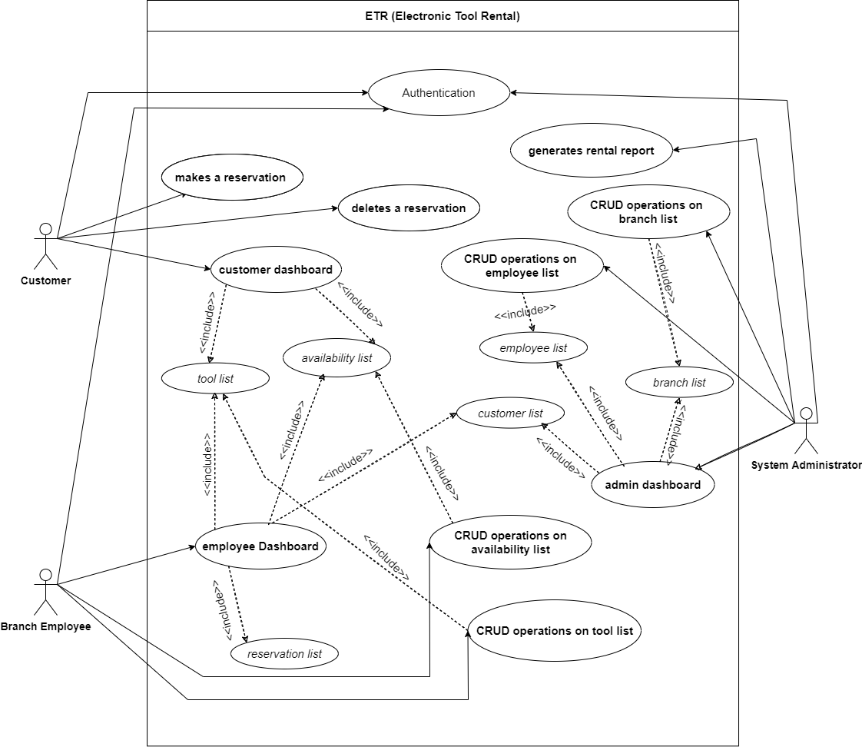

Figure 1: Use Case diagram of the ETR system

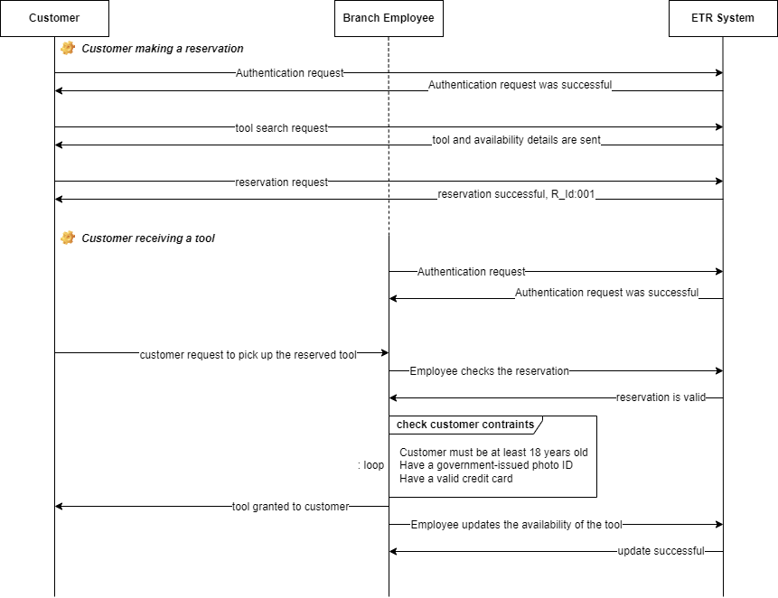

Figure 2 : Sequence diagram of customer making a reservation and receiving a tool

Figure 3: UML activity diagram for managing customers rentals

Figure 4: State machine diagram for a rental order

# **Task 3 - Supplementary Specification and glossary**

# **Introduction**

The document illustrates the supplementary requirements for ETR (Electronic Tool Rental), a website to help customers to rent tools and equipment for their home improvement at rental prices. The website allows customers to check tool availability and rental charges to make a reservation. The supplementary specification together with the use case model called as Software Requirement Specification (SRS), which is used to determine the functional and non-functional requirements for the ETR (Electronic Tool Rental).

## Purpose

The document is intended to specify the requirements of ETR (Electronic Tool Rental).system. This

supplementary specification captures requirements that were undermined in the use-case model. The

supplementary specification and the use-case models collectively point out all requirements of the

system.

## Definitions, Acronyms and Abbreviations

CRUD – Create, Read, Update and Delete.

MTTR – Mean Time To Repair .

MTBF – Mean Time Between Failures.

ETR – Electronic Tool Rental.

API – Application Programming Interface.

PCA-DSS – The Payment Card Industry Data Security Standard.

OS – Operating Systems

## References

Use Case Model survey - online [resource](https://sceweb.uhcl.edu/helm/RationalUnifiedProcess/examples/csports/ex_ucsurvey.htm) address

Supplementary Specification – [online resource address](https://sceweb.uhcl.edu/helm/RationalUnifiedProcess/examples/csports/ex_suppspc1.htm)

# **Functionality**

The below section describes the functional requirements common to several use cases.

* 1. Error Recovery

ETR is capable of recovering automatically using advanced circuit breaking mechanism for the cases like updating the tool details, branch details and reservation.

* 1. Application security

ETR system possess an encrypted dataset and the API endpoints are secured to handle safe transfers of user data over the network. ETR is PCA-DSS compliant.

* 1. Log insights

ETR’s log information is maintained in Azure App insights to look for application related information over the time.

* 1. Location Discovery Service

ETR system can identify the location of the user and loads the store of the respective location use GPS service API endpoints.

# **Usability**

The below section describes different requirements that relate to, or affect, the usability of the system.

* 1. Operating System Compliance

ETR is compliant with all the modern operating systems namely, Windows 11, Mac OS, and various Linux distributions.

* 1. Browser Compatibility

All modern browsers support ETR. The list of browsers and the version are mentioned below.

|  |  |  |  |
| --- | --- | --- | --- |
| Name | Vendor | Version Support from | Latest Version |
| Firefox | Mozilla Foundation | 88 | 102 |
| Samsung Internet | Samsung | 14.0.0 | 17.0.7 |
| Chrome | Google | 60 | 103 |
| Opera | Opera Software | 55 | 89 |

* 1. User Manual/Demo

ETR application is embedded with the video demo/user guide to register, login and reserve a tool.

# **Reliability**

4.1. Availability

The application can be accessible to the end user at any given time, 100% available unless maintenance is scheduled during a specified time window.

4.2. MTBF

The application failure can be within a quarter(3 months).

4.3. MTTR

The users might be unable to access the application for 4 hours. i.e. The application can remain user support/non-operational for a maximum of 4 hours.

4.4. Accuracy

The application must be 100% accurate with location related information and it will be consistent with details in terms of rental availability.

# **Performance**

5.1. Response Time

Response time of all transactions of ETR tool web API endpoints should be completed within 3 seconds.

5.2. Concurrent Users

The system shall support 5000 users at a single and should be able to cater all functionalities that each user wants.

5.3. Resource Utilization

The system shall utilize low disk space and memory in the user’s device. A cookie file will be stored in the user’s device, other than this all the system’s data will be stored in remote database. Thus, users will get what he/she wants in right manner in minimum time with minimum cost incurred with not no wastage of resources.

5.4. Throughput

The throughput of the system depends on the device’s internet connection speed. The Internet speed of 5 Mbps is considered and adequate to make a reservation and check availability of a tool . High throughput is recommended.

# **Supportability**

The section below describes requirements that will enhance the supportability or maintainability of the system.

6.1. Coding Standards

Sonar Qube is the code quality tool used to build the system and developers ensure the code is compliant with Sonar Qube rules and guidelines.

6.2. Naming Convention

Naming convention should be consistent for the project. All the constants used in project should be in capital letters, and camel case should be used for variables and functions name.

# **Design Constraints**

7.1. Software and technical methodology

The application should follow the agile process for implementation. The application will be implemented Spring and Angular Framework.

7.2. Hardware and Software requirements

The application can run on the above-mentioned OS environments

7.3. Internet Browsers

All modern browsers support ETR. The list of browsers and the version are mentioned below.

|  |  |  |  |
| --- | --- | --- | --- |
| Name | Vendor | Version Support from | Latest Version |
| Firefox | Mozilla Foundation | 88 | 102 |
| Samsung Internet | Samsung | 14.0.0 | 17.0.7 |
| Chrome | Google | 60 | 103 |
| Opera | Opera Software | 55 | 89 |

# **Online User Documentation and Help System Requirements**

ETR application is embedded with the video demo/user guide to register, login and reserve a tool.

# **Glossary**

CRUD – Create, Read, Update and Delete.

MTTR – Mean Time To Repair.

MTBF – Mean Time Between Failures.

ETR – Electronic Tool Rental.

API – Application Programming Interface.

PCA-DSS – The Payment Card Industry Data Security Standard.

OS – Operating Systems.