**Chapter 1**

**HTML5 and CSS3**

**Topics Covered Under This Chapter:**

HTML5 – Document Structure, Basic HTML Tags, Section elements, text, links, tables, images, forms, Working with Lists, Frames.

CSS3( Cascading Style Sheet)- Evolution of CSS3, Syntax of CSS3, Types, Selectors, Types of CSS, Background, Font, Text, Borders**.**

**INTRODUCTION TO HTML:**

* HTML stands for **H**yper **T**ext **M**arkup **L**anguage.
* HTML is a method of describing the format of web documents
* It is used to display the document in the web browsers.
* HTML was developed by Tim Berners-Lee. HTML standards are created by a group of interested organizations called W3C (World Wide Web consortium).

**HTML Tags:**

* + In HTML, formatting is specified by using tags.
  + A tag is a format name surrounded by angle brackets.
  + End tags which switch a format off also contain a forward slash.

Points to be remembered for HTML tags:

* They are not case sensitive i.e., <head>, <HEAD> and <Head> is equivalent.
* If a browser does not understand a tag it will usually ignore it.
* White spaces, tabs and newlines are ignored by the browser.

**1.1 DOCUMENT STRUCTURE:**

* HTML document consists of 2 sections.

1. Head Section
2. Body Section

The basic document is shown below.

<html>

<head>

<! -- Head Section -->

</head>

<body>

<! -- Body Section -->

</body>

</html>

**HTML ELEMENTS:**

An HTML element is everything from the start tag to the end tag

<p> This is a Paragraph </p>

Start Tag Element Content End Tag

**HTML ATTRIBUTES:**

HTMLElements can have Attributes. Attribute provide additional information about an element and are always specified in the start tag.

**Syntax:** <tag attributename=”value” > Content </tag>

**Sample.html**

<html>

<head>

<title> Basic HTML document </title>

</head>

<body>

<h1> Welcome to the world of Web Technologies</h1>

<p> A sample HTML program </p>

</body>

</html>

**Output:**

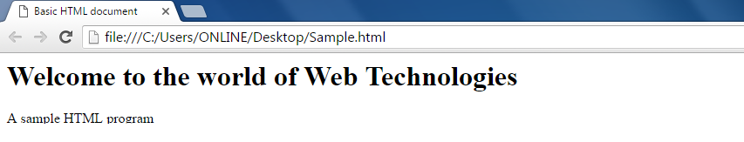

**1.2 BASIC HTML TAGS:**

1. **<html> :**

* The <html> tag tells the browser that this is an HTML document.
* The <html> tag represents the root of an HTML document.
* The <html> tag is the container for all other HTML elements.

1. **<title>:**

* defines a title in the browser toolbar
* provides a title for the page when it is added to favorites
* displays a title for the page in search-engine results

1. **<body>:**

* The <body> tag defines the document's body.
* The <body> element contains all the contents of an HTML document, such as text, hyperlinks, images, tables, lists, etc.

|  |  |  |
| --- | --- | --- |
| **Attribute** | **Value** | **Meaning** |
| background | URL | Specifies a background image for a document |
| bgcolor | Color | Specifies the background color of a document |
| text | Color | Specifies the color of the text in a document |

1. **<!- - - - > Comment Tag:**

* The comment tag is used to insert comments in the source code. Comments are not displayed in the browsers.

1. **Heading Tags:**

* There are 6 heading tags.
* The <h1> to <h6> tags are used to define HTML headings.
* <h1> defines the most important heading. <h6> defines the least important heading.

|  |  |  |
| --- | --- | --- |
| **Attribute** | **Value** | **Meaning** |
| Align | Left  Right  Center | Specifies the alignment of a heading |

Example: Headings.html

<html>

<head>

<title>Heading Tage</title>

</head>

<body bgcolor=yellow text=blue>

<! - - This is a Comment - - >

<h1 align="left">This is Heading 1</h1>

<h2 align="center">This is Heading 2</h2>

<h3 align="right">This is Heading 3</h3>

<h4>This is Heading 4</h4>

<h5>This is Heading 5</h5>

<h6 align="right">This is Heading 6</h6>

</body>

</html>

**Output:**

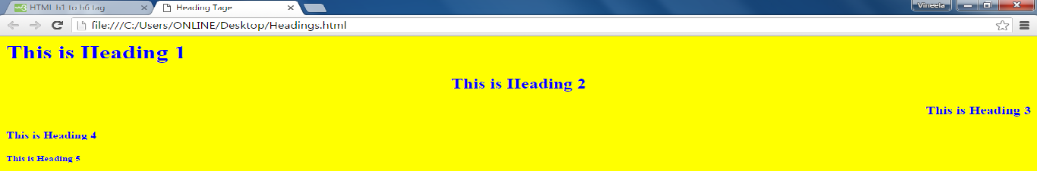

1. **<p>: paragraph Tag**

* Browser automatically add some space before and after each <p> element

|  |  |  |
| --- | --- | --- |
| **Attribute** | **Value** | **Meaning** |
| Align | Left, Right, Center  Justify | Specifies the alignment of text within a paragraph |

1. **<font>:**

The <font> tag specifies the font face, font size, and color of text.

|  |  |  |
| --- | --- | --- |
| **Attribute** | **Value** | **Meaning** |
| Color | rgb(x,x,x)  #xxxxxx  colorname | Specifies the color of text |
| Face | font_family | Specifies the font of text |
| Size | Number | Specifies size of text |

1. **<link>:**

* The <link> tag defines a link between a document and an external resource.
* The <link> tag is used to link to external style sheets.

|  |  |  |
| --- | --- | --- |
| **Attribute** | **Value** | **Meaning** |
| Href | URL | Specifies the location of the linked document |
| Target | _blank  _self  _parent  _top  framename | Specifies where the linked document is to be loaded |
| Rel | Stylesheet | Specifies the relationship between current document and the linked document |

1. **<div>:**

* The <div> tag defines a division or a section in an HTML document.
* The <div> tag is used to group block-elements to format them with CSS.

|  |  |  |
| --- | --- | --- |
| **Attribute** | **Value** | **Meaning** |
| Align | Left, Right, Center  Justify | Specifies the alignment of a heading |

1. **<br>:**

* The <br> tag inserts a single line break.
* The <br> tag is an empty tag which means that it has no end tag.

1. **<marquee>:**

It is used for Scrolling images and text in the web page

|  |  |  |
| --- | --- | --- |
| **Attribute** | **Value** | **Meaning** |
| behavior | Scroll, slide alternate | Defines the type of scrolling. |
| bgcolor | rgb(x,x,x) #xxxxxx colorname | *Deprecated*-Defines the direction of scrolling the content. |
| direction | Up, down,  left, right | Defines the direction of scrolling the content. |
| Loop | Number | Specifies how many times to loop. The default value is INFINITE, which means that the marquee loops endlessly. |
| scrolldelay | Seconds | Defines how long to delay between each jump. |
| scrollamount | number | Defines how how far to jump. |

**1.3 SECTION ELEMENTS:**

**1.4 Text**

The following HTML tags are used for format the appearance of the text on your web page.

(a). Headings – <h1> to <h6>

(b). Bold - <b> </b> or <strong> </strong>

The text in between the tags will be displayed in bold

(c). Italic - <i> </i>

Renders the text in italics i.e displays the text at a slight angle.

(d). Underline - <u> </u>

Underlines the text written in between the tags

(e). Strike out - <strike> </strike>

Defines strike through text, puts a line right through the center of the text, crossing it out.

(f).Preformatted text - <pre> </pre>

Text in <pre> element is displayed in fixed width font, and it preserves both spaces and line breaks.

(g). Typewriter Text - <tt> </tt>

The text appears to have been typed by a type writer\

(h). <big> </big> - Defines bigger text

(i). <small> </small> - Defines smaller text

(j). <sub> </sub> - Defines a subscript text. Subscript that appears half a character below the baseline.

(k). <sup> </sup> - Defines a superscript text. Superscript that appears half a character above the baseline.

(l). <center></center> - It align the text to the center of the page

**Example: TextFormattingTags.html**

<html>

<body>

<h1>This is Heading 1</h1>

<b>This text is in bold</b><br>

<i>This text is in Italics</i><br>

<u>This text is in Underlined</u><br>

<strike>This text is Striked</strike><br>

<em>This text is Emphasized</em><br>

<tt>This text is Type Writer Text</tt><br>

<big>This text is Bigger</big><br>

<small>This text is Smaller</small><br>

H<sub>2</sub>O<br>

(a+b)<sup>2</sup>=a<sup>2</sup>+2ab+b<sup>2</sup><br>

<center>This Text is aligned to Center</center><br>

</body>

</html>

**Output:**

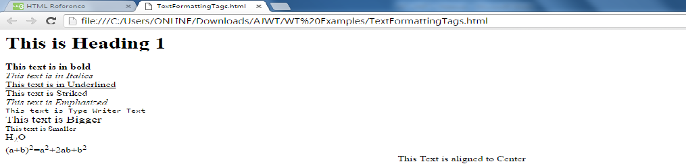

**1.5 LINK**

**<a>: Anchor Tag**

* The <a> tag defines a hyperlink, which is used to link from one page to another.
* The most important attribute of the <a> element is the href attribute, which indicates the link's destination.
* By default, links will appear as follows in all browsers:
* An unvisited link is underlined and blue
* A visited link is underlined and purple
* An active link is underlined and red

|  |  |  |
| --- | --- | --- |
| **Attribute** | **Value** | **Meaning** |
| href | URL | Specifies the destination of the link |
| target | _blank  _self  _parent  _top  framename | Specifies where to open the linked document |

**Example: Link.html**

<html>

<body>

<a href="http://www.google.com" target="_self"> GOOGLE</a>

<br>

<a href="http://www.yahoo.com" target="_blank">YAHOO</a>

<br>

<a href="Headings.html" target="_parent"> My Page</a>

</body>

</html>

**Output:**

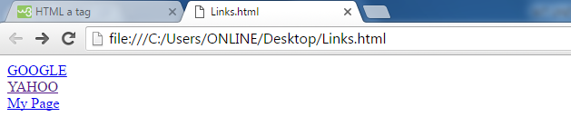

**1.6 TABLES:**

* For Systematic arrangement of information we often require Tabular Structure.
* The biggest advantage of using tables on the web page is that the information gets arranged systematically.
* The <table> tag defines an HTML table.
* An HTML table consists of the <table> element and one or more <tr>, <th>, and<td> elements.
* The <tr> element defines a table row, the <th> element defines a table header, and the <td> element defines a table cell.
* An HTML table has two kinds of cells:
  + Header cells - contains header information (created with the <th> element)
  + Standard cells - contains data (created with the <td> element)
* The text in <th> elements are bold and centered by default.
* The text in <td> elements are regular and left-aligned by default.

**Attributes of <table> tag:**

|  |  |  |
| --- | --- | --- |
| **Name** | **Value** | **Meaning** |
| align | Left  Right  center | Specifies the alignment of a table according to surrounding text |
| bgcolor | rgb(x,x,x)  #xxxxxx  colorname | Specifies the background color for a table |
| border | 0  1 | Specifies whether or not the table is being used for layout purposes |
| cellpadding | pixels | Specifies the space between the cell wall and the cell content |
| cellspacing | pixels | Specifies the space between cells |
| Width | Pixels  % | Specifies the width of a table |

**Attributes of <tr> tag:**

|  |  |  |
| --- | --- | --- |
| **Name** | **Value** | **Meaning** |
| align | Left  Right  Center  justify | Aligns the content in a table row |
| bgcolor | rgb(x,x,x)  #xxxxxx  colorname | Specifies a background color for a table row |
| valign | top  middle  bottom  baseline | Vertical aligns the content in a table row |

**Attributes of <th> and <td> tags:**

|  |  |  |
| --- | --- | --- |
| **Name** | **Value** | **Meaning** |
| align | Left, Right  Center  justify | Aligns the content in a cell |
| bgcolor | rgb(x,x,x)  #xxxxxx  colorname | Aligns the content in a cell |
| rowspan | number | Specifies the number of rows a cell should span |
| colspan | number | Specifies the number of rows a cell should span |
| valign | Top, middle  bottom  baseline | Vertical aligns the content in a cell |
| Width | Pixels  % | Specifies the width of a cell |

**Example:**

<html>

<body>

<table bgcolor="yellow" border="1" cellspacing="0" cellpadding="10" bordercolor="green" align="center">

<tr>

<th rowspan="2">Header1</th>

<th colspan="3">Header2</th>

</tr>

<tr>

<td>r1,c1</td>

<td>r1,c2</td>

<td>r1,c3</td>

</tr>

<tr>

<td colspan="2">r2,c1</td>

<td>r2,c2</td>

<td>r2,c3</td>

</tr>

<tr>

<td>r3,c1</td>

<td>r3,c2</td>

<td colspan="2">

<table border="1" bgcolor="cyan" cellspacing="0" bordercolor="red">

<tr>

<th colspan="2">Nested Table</th>

</tr>

<tr>

<td>One</td>

<td>Two</td>

</tr>

<tr>

<td>Three</td>

<td>Four</td>

</tr>

</table>

</td>

</tr>

</table>

</body>

</html>

**Output:**

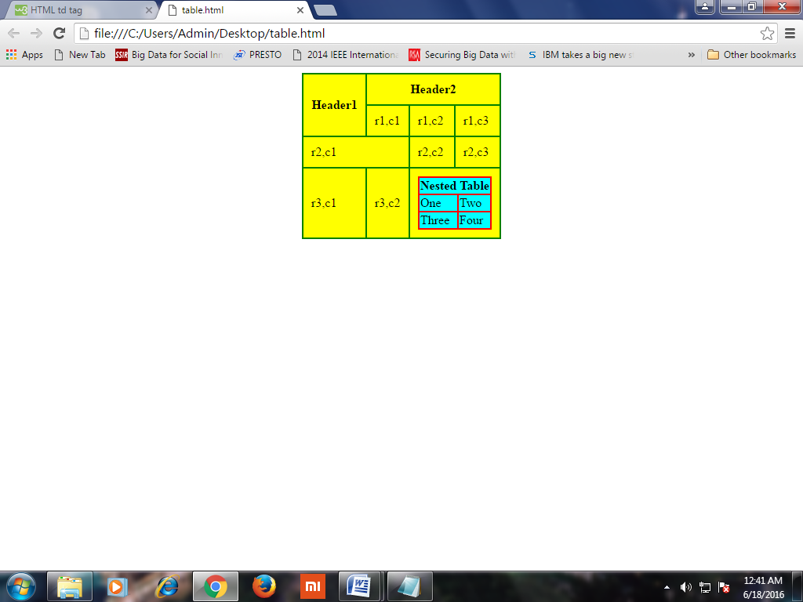

**1.7 IMAGE:**

* Images increase the visual appearance of web pages and make your web pages more attractive.
* The <img> tag defines an image in an HTML page.
* The <img> tag has two required attributes: src and alt.

**Attributes of <img> tag:**

|  |  |  |
| --- | --- | --- |
| **Name** | **Value** | **Meaning** |
| src | URL | Specifies the URL of an image |
| align | Top, bottom middle left, right | Specifies the alignment of an image according to surrounding elements |
| alt | text | Specifies an alternate text for an image |
| border | pixels | Specifies the width of the border around an image |
| width | pixels | Specifies the width of an image |
| height | pixels | Specifies the height of an image |
| hspace | pixels | Specifies the whitespace on left and right side of an image |
| vspace | pixels | Specifies the whitespace on top and bottom of an image |
| ismap | ismap | Specifies an image as a server-side image-map |
| usemap | #mapname | Specifies an image as a client-side image-map |

**Example:**

<html>

<body>

<br>

<img src="14.jpg" width="400" height="200" align="right">

<img src="C:\\Users\\Admin\\Desktop\\Others\\13.jpg" width="300" height="250" border="3" alt="Alternative Text">

</body>

</html>

**Output:**

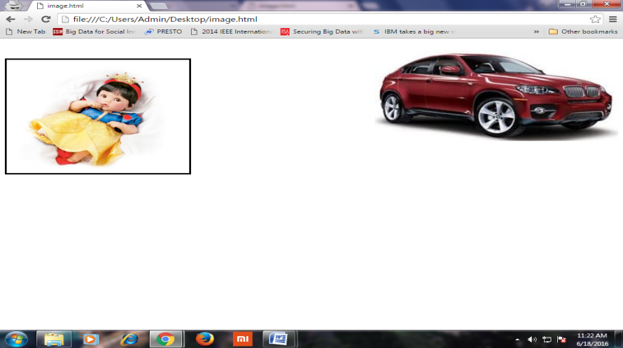

**1.8 FORMS:**

* Form is a typical layout on the web page by which a user can interact with the web page.
* The <form> tag is used to create an HTML form for user input.
* The <form> element can contain one or more of the following form elements:
  + <input> <textarea> <select> <option> <label>

**Attributes of <form> tag:**

|  |  |  |
| --- | --- | --- |
| **Name** | **Value** | **Meaning** |
| action | *URL* | Specifies where to send the form-data when a form is submitted |
| method | get post | Specifies the HTTP method to use when sending form-data |
| name | *text* | Specifies the name of a form |
| target | _blank _self _parent _top | Specifies where to display the response that is received after submitting the form |

**<input>:**

* The <input> tag specifies an input field where the user can enter data.
* <input> elements are used within a <form> element to declare input controls that allow users to input data.
* An input field can vary in many ways, depending on the type attribute.

**Attributes of <input > tag:**

|  |  |  |
| --- | --- | --- |
| **Name** | **Value** | **Meaning** |
| Type | Button, checkbox date, file, hidden image, month, number  password, radio, reset submit, text | Specifies the type <input> element to display |
| Name | text | Specifies the name of an <input> element |
| Checked | checked | Specifies that an <input> element should be pre-selected when the page loads (for type="checkbox" or type="radio") |
| Value | *Text* | Specifies the value of an <input> element |

**<textarea>:**

* The <textarea> tag defines a multi-line text input control.
* A text area can hold an unlimited number of characters, and the text renders in a fixed-width font (usually Courier).
* The size of a text area can be specified by the cols and rows attributes

**Attributes of <textarea > tag:**

|  |  |  |
| --- | --- | --- |
| **Name** | **Value** | **Meaning** |
| Name | text | Specifies a name for a text area |
| Rows | number | Specifies the visible number of lines in a text area |
| Cols | number | Specifies the visible width of a text area |

**<select>:**

* The <select> element is used to create a drop-down list.
* The <option> tags inside the <select> element define the available options in the list.

**Attributes of <select > tag:**

|  |  |  |
| --- | --- | --- |
| **Name** | **Value** | **Meaning** |
| Name | name | Defines a name for the drop-down list |
| Multiple | multiple | Specifies that multiple options can be selected at once |
| Size | number | Defines the number of visible options in a drop-down list |

**<label>:** The <label> tag defines a label for an <input> element.

**Example:** Login.html

<html>

<body>

<form name="f1" method="post" action="">

<table align="center" cellspacing="10">

<tr>

<td><label> Username: </label> </td>

<td><input type="text" name="t1"></td>

</tr>

<tr>

<td><label> Password: </label></td>

<td><input type="password" name="t2"></td>

</tr>

<tr>

<td><input type="submit" value="SUBMIT" ></td>

<td><input type="reset" value="RESET" ></td>

</form>

</body>

</html>

**Output:**

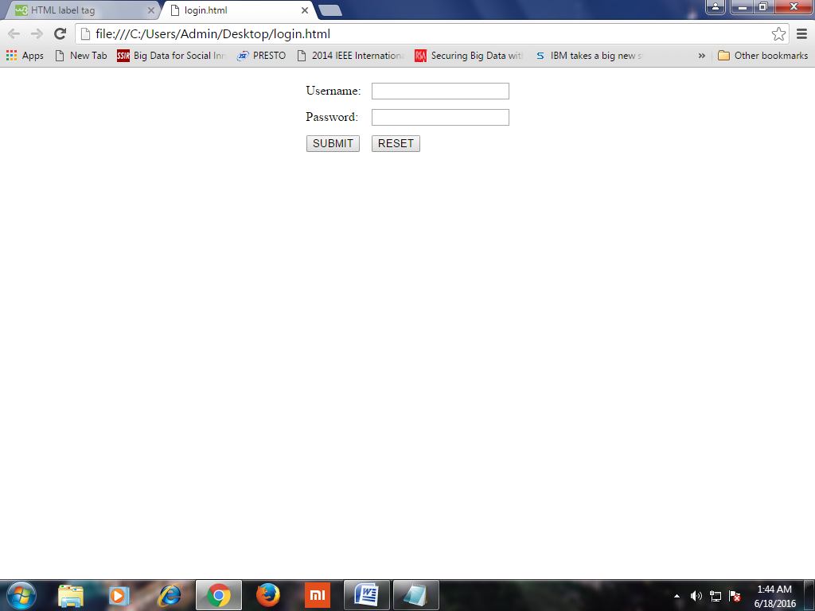

**1.9 WORKING WITH LISTS:**

* Lists are used to collect a group of items.
* There are 3 types of Lists in HTML

1. Ordered List
2. Unordered List
3. Definition List
4. **ORDERED LIST:**

* These are those in which the items are arranged in some specific order.
* This list can be numerical or alphabetic.
* **<ol> tag:** The <ol> tag defines an ordered list.

**Attributes:**

|  |  |  |
| --- | --- | --- |
| **Name** | **Value** | **Meaning** |
| type | 1  A  a  I  i | Specifies the kind of marker to use in the list |
| start | number | Specifies the start value of an ordered list |
| reversed | reversed | Specifies that the list order should be descending |

**<li> tag:** defines a list item.

**Example:**

<html>

<body>

<ol>

<li>Red</li>

<li>Green</li>

<li>Blue</li>

</ol>

<ol type="A">

<li>Red</li>

<li>Green</li>

<li>Blue</li>

</ol>

<ol start=3 type="i">

<li>Red</li>

<li>Green</li>

<li>Blue</li>

</ol>

</body>

</html>

**Output:**

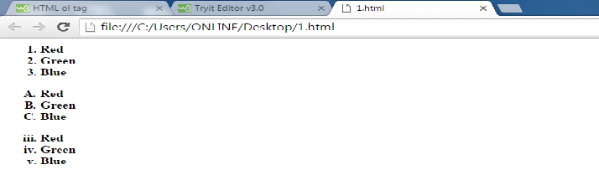

1. **UNORDERED LIST:**

* The Unordered lists are those in which the items are not arranged in any order.
* This defines a Bulleted List.
* **<ul> tag**: defines an unordered (bulleted) list.

**Attributes:**

|  |  |  |
| --- | --- | --- |
| **Name** | **Value** | **Meaning** |
| Type | Disc  Square  Circle | Specifies the kind of marker to use in the list |

**<li> tag:** defines a list item.

**Example:**

<html>

<body>

<ul>

<li>Red</li>

<li>Black</li>

<li>White</li>

</ul>

<ul type="circle">

<li>Red</li>

<li>Black</li>

<li>White</li>

</ul>

<ul type="square">

<li>Red</li>

<li>Black</li>

<li>White</li>

</ul>

</body>

</html>

**Output:**

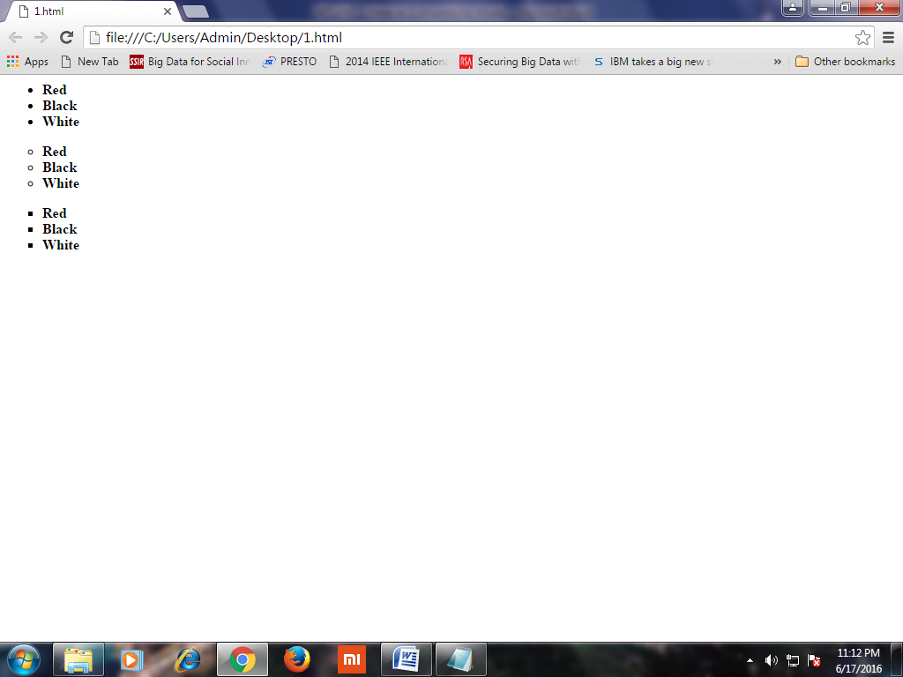

1. **DEFINITION LIST**

* These are lists of items that have 2 parts, a term to be defined and the definition.
* This create lists similar to a dictionary.
  + **<dl> tag:** defines a definition list. It is used in conjunction with <dt> and <dd>
  + **<dt> tag:** defines a term/name in a definition list.
  + **<dd> tag:** used to describe a term/name in a definition list.
* **Example:**

<html>

<body>

<dl>

<dt>HTML:</dt>

<dd>Hyper Text Markup Language</dd>

<dt>CSS:</dt>

<dd>Cascading Style Sheets</dd>

</dl>

</body>

</html>

**Output:**

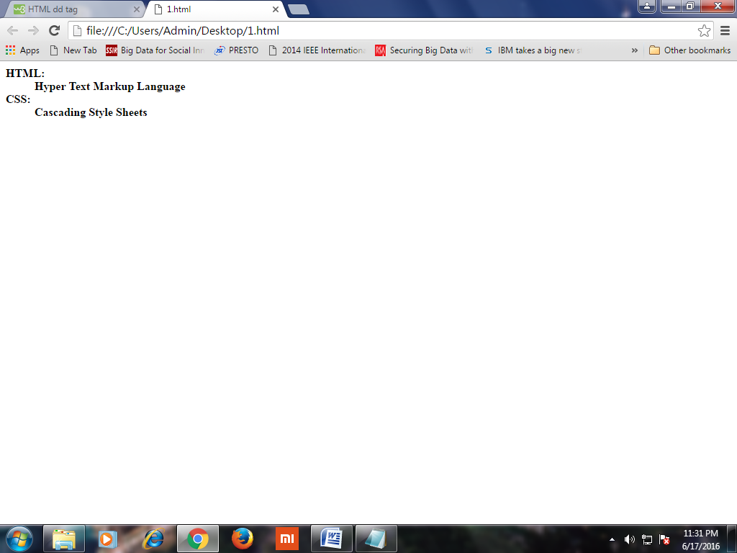

**1.10 FRAMES:**

* HTML Frames divide a browser window into several pieces or panes, each pane containing a separate HTML page.
* Each portion is called as a ***Frame***.
* A Collection of Frames in the browser window is known as a ***Frameset***.
* HTML Frames allow authors to present documents in multiple views, which may be independent windows or sub windows.
* One of the Key advantages that frames offer is that you can load and reload single frames without having to reload the entire contents of the browser window.
* **<frameset>:**
* The <frameset> tag defines a frameset.
* The <frameset> element holds one or more <frame> elements. Each <frame> element can hold a separate document.
* The <frameset> element specifies how many columns or rows there will be in the frameset, and how much percentage/pixels of space will occupy each of them.

**Attributes of <frameset> tag:**

|  |  |  |
| --- | --- | --- |
| **Name** | **Value** | **Meaning** |
| cols | Pixels, % * | Specifies the number and size of columns in a frameset |
| rows | Pixels, % * | Specifies the number and size of rows in a frameset |

**<frame>:**

* The <frame> tag defines one particular window (frame) within a <frameset>.
* Each <frame> in a <frameset> can have different attributes, such as border, scrolling, the ability to resize, etc.

**Attributes of <frame> tag:**

|  |  |  |
| --- | --- | --- |
| **Name** | **Value** | **Meaning** |
| src | URL | Specifies the URL of the document to show in a frame |
| frameborder | 0 1 | Specifies whether or not to display a border around a frame |
| name | *text* | Specifies the name of a frame |
| noresize | noresize | Specifies that a frame is not resizable |
| scrolling | yes no auto | Specifies whether or not to display scrollbars in a frame |

**Example:**

**Frames.html:**

<html>

<frameset cols="25%,*,25%">

<frame src="http://www.bing.com" name="f1" noresize>

<frame src="http://www.w3schools.com" name="f2" noresize>

<frame src="Mypage.html" name="f3" noresize>

</frameset>

</html>

**CSS3(CASCADING STYLE SHEET)**

**INTRODUCTION TO CSS:**

* A Style sheet is a set of Stylistic rules that expresses the Presentation and Layout of Structured documents (Web Pages).
* Using CSS we can determine the style and layout of the web page.
* CSS is a style sheet language used to describe the presentation semantics of a document written in Markup Language.
* They allow us to specify rules for how the content of elements within your document appears.
* With CSS, all formatting could be removed from the HTML document and stored in a separate CSS file.
* **Advantages of CSS:**

1. Improves the formatting capability of a HTML page
2. Reduced Document size
3. Reduced Complexity and repetition – can reuse the same style sheet with many different HTML documents.
4. Saves time
5. A style sheet can import and use styles from other style sheets.

**1.11 Evolution of CSS3**

**1.12 CSS SYNTAX:**

* CSS consists of set of rules that determines how the content of elements within your document should be formatted.

**Syntax:**

**Selector { property1:value ; property2:value; }**

* CSS rule is made up of 2 parts:
  1. Selector
  2. Declaration
* **Selector :** Element/ set of elements to which declaration must be applied to
* **Declaration:** (i). Property: CSS Property that is to be applied

(ii). Value: Value of CSS property

* **Example:**

h1

{

font**-**family **:** arial**;**

color **:** blue**;**

text**-**align **:** center**;**

}

**1.13 Types of Selectors**

**Grouping of Selectors:** Separate selector with a Comma

h1**,** h2**,** h3

{

color **:** blue**;**

font**-**family **:** calibri**;**

text**-**align **:** center**;**

}

**‘CLASS’ SELECTOR / STYLESHEET CLASS:-**

* ‘Class’ selector allows us to define multiple styles for the same type of HTML element.
* **Syntax:**

**s**elector**.**classname

{

Property1 **:** valuel**;** property2 **:** value**;**

}

* To define a style that can be used by multiple HTML elements remove tag name/selector.
* **Syntax:**

**.**classname

{

Property1 **:** valuel**;** property2 **:** value**;**

}

**THE ‘id’ SELECTOR:**

* The #id selector styles the element with the specified id
* **Syntax:**

**#**id

{

Property1 **:** valuel**;** property2 **:** value**;**

}

**EXAMPLE:**

<html>

<head>

<style type="text/css">

p.center

{ text-align:center; }

p.right

{ text-align:right; }

h2

{ text-align:center; color:orange; font-family:calibri; }

.cl1

{ color:green; }

#id1

{ color:blue; background-color:orange; }

</style>

</head>

<body>

<p class="center">This paragraph is styled by class 'center'</p>

<p class="right">This paragraph is styled by class 'right'</p>

<p class="cl1">This paragraph is styled by class 'cl1'</p>

<p id="id1">This paragraph is selected by ID selector</p>

<h1 class="cl1">This Heading is styled by class 'cl1'</h1>

</body>

</html>

**Output:**

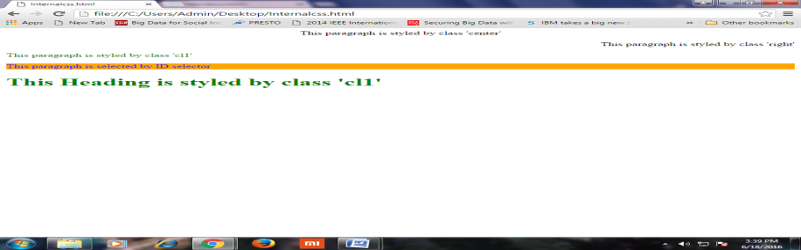

**1.14 TYPES OF CSS:**

* When a browser reads a style sheet, it will format the HTML document according to the information in the style sheet.
* There are three ways of inserting a style sheet:
  1. Inline style sheet
  2. Internal/Embedded style sheet
  3. External style sheet

1. **INLINE STYLE SHEET:**

* Inline styles are placed directly inside a specific HTML element in the code.
* The style is applied at the occurrence of the HTML element by using “style” attribute in the relevant tag.
* The style attribute can contain any CSS Properties
* Inline styles cannot be reused at all
* **Example:**

<html>

<body>

<h1>This is Normal Text</h1>

<p style="color:red;font-size:30pt;text-align:center">This Text is Styled</p>

</body>

</html>

**Output:**

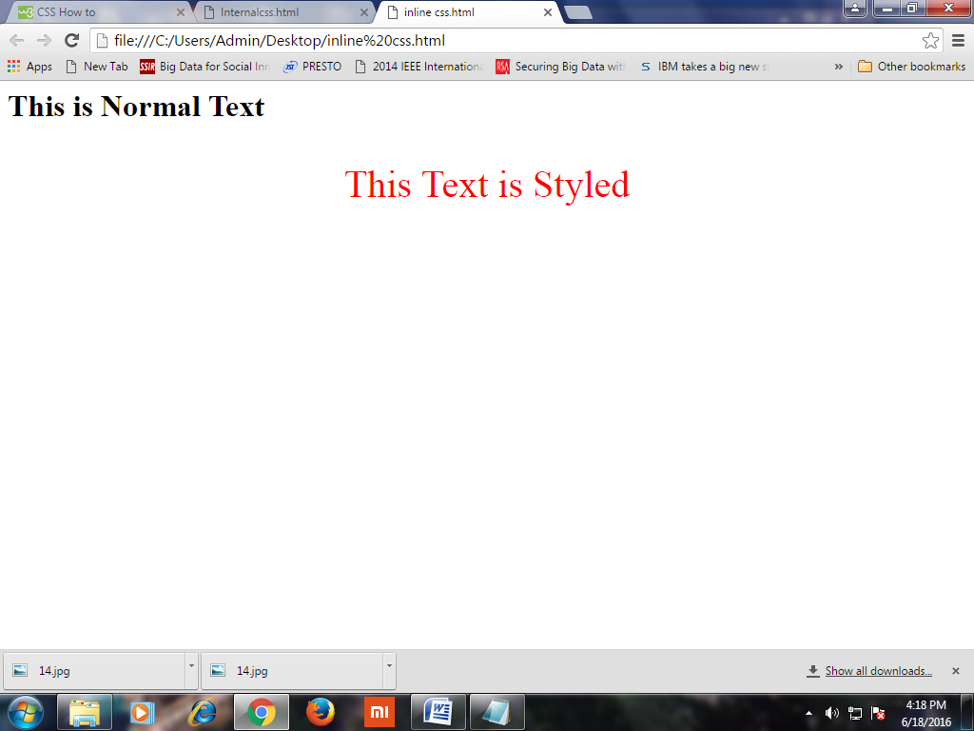

1. **INTERNAL STYLE SHEET:**

* An internal style sheet may be used if one single page has a unique style.
* Internal styles are defined within the <style> element, inside the <head> section of an HTML page.
* All the desired selectors along with the properties and values are included in the header section between <style> and </style> tags.
* **Example:**

<html>

<head>

<style>

body {

background-color:pink;

}

h1 {

color: maroon;

font-family: verdana;

}

</style>

</head>

<body>

<h1>This is a heading</h1>

<p>This is a paragraph.</p>

</body>

</html>

**Output:**

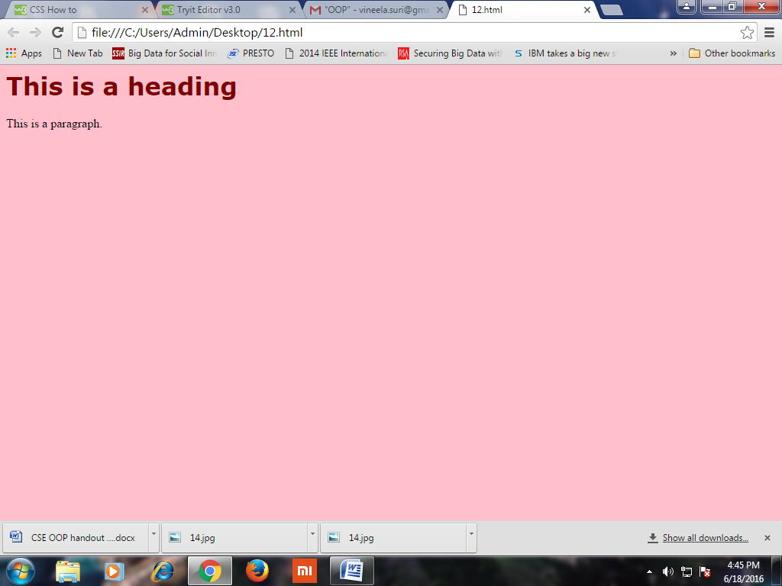

1. **EXTERNAL STYLE SHEET:**

* External Style Sheets are useful when we need to apply particular style to more than one web page.
* The central idea in this type of style sheet is that the desired style is stored in an external **.css** file.
* The name of the external **.css** file has to be mentioned on our web pages. Then the styles defined in the **.css** file will be applied to all those web pages.
* **<link>** tag is used to link the external style sheet to a web page.
* **Example:**

**Mystyle.css:**

p.left

{

text-align:left;

color:red;

text-decoration:overline;

font-family:tahoma;

font-size:20pt;

}

p.center

{

color:green;

text-align:center;

text-decoration:underline;

font-family:calibri;

font-size:30pt;

}

**Ext.html:**

<html>

<head>

<link rel="stylesheet" href="Mystyle.css">

</head>

<body>

<p class="left">This paragraph is styled by class 'left'</h1>

<p class="center">This paragraph is styled by class 'center'</p>

</body>

</html>

**Output:**

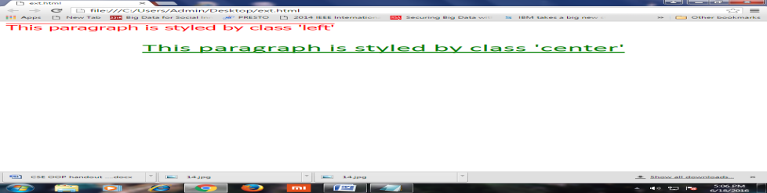

**CSS PROPERTIES:**

**1.15 CSS BACKGROUND PROPERTIES:**

|  |  |
| --- | --- |
| **PROPERTY NAME** | **VALUE** |
| background-attachment | fixed, scroll |
| background-color | Rgb(X,X,X), #XXXXXX, colorname |
| background-image | url(‘ url of image’) |
| background-position | left top,  left center,  left bottom  center top,  center bottom,  center center  right top,  right center,  right bottom |

**Example:**

<html>

<head>

<style type="text/css">

h1

{

background-image:url('2.gif');

background-attachment:fixed;

background-repeat:no-repeat;

}

body

{

background-position:center top;

background-image:url('bunny giving flower.gif');

background-repeat:no-repeat;

background-attachment:fixed;

background-color:green;

}

</style>

</head>

<body>

<h1>This element is Styled</h1>

</body>

</html>

**Output:**

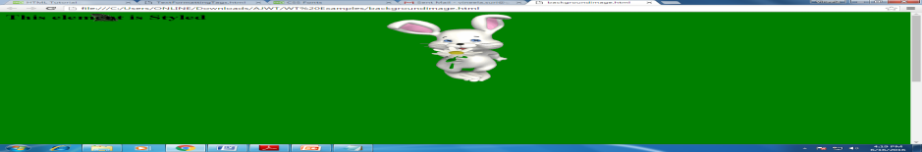

**1.16 CSS TEXT PROPERTIES:**

|  |  |
| --- | --- |
| **PROPERTY NAME** | **VALUE** |
| color | Color name |
| direction | ltr,rtl |
| text-align | left, right, center, justify |
| text-decoration | Underline, overline, Line-through, blink |
| text-transform | none, uppercase, lowercase, capitalize |
| text-indent | length, % |
| vertical-align | length, %, top, middle, bottom, sup, super |
| letter-spacing | normal, length(-ve) |
| word-spacing | normal, length |

**1.17 CSS FONT PROPERTIES:**

|  |  |
| --- | --- |
| **PROPERTY NAME** | **VALUE** |
| font-family | Arial, Times New Roman, Etc…… |
| font-size | Small, smaller, medium, large, larger, length, % |
| font-style | normal, italic |
| font-variant | normal, small-caps |
| font-weight | normal, bold, bolder, 100-900 |
| font-stretch | Normal, wider, narrower |

**Example:**

**TextFont.css:**

p.right

{

color:red;

font-size:large;

text-transform:capitalize;

text-align:right;

font-weight:200;

letter-spacing:-3;

word-spacing:5;

}

p.center

{

color:blue;

text-align:center;

text-decoration:underline;

text-tranform:uppercase;

font-style:italic;

font-size:30;

}

.left

{

color:green;

text-indent:20;

text-decoration:overline;

text-transform:lowercase;

font-family:tahoma;

font-size:small;

font-style:italic;

}

#id1

{

color:purple;

font-weight:900;

font-family:verdana;

text-decoration:line-through;

text-align:right;

font-variant:small-caps;

font-size:20;

}

**TextFont.html:**

<html>

<head>

<link rel="stylesheet" type="text/css" href="TextFont.css">

</head>

<body>

<p>This Paragraph is not styled</p>

<p class="left">This paragraph is styled by class left</p>

<p class="right">This paragraph is styled by class right</p>

<p class="center">This pragraph is styled by class center</p>

<p id="id1">This paragraph is styled by id</p>

</body>

</html>

**Output:**

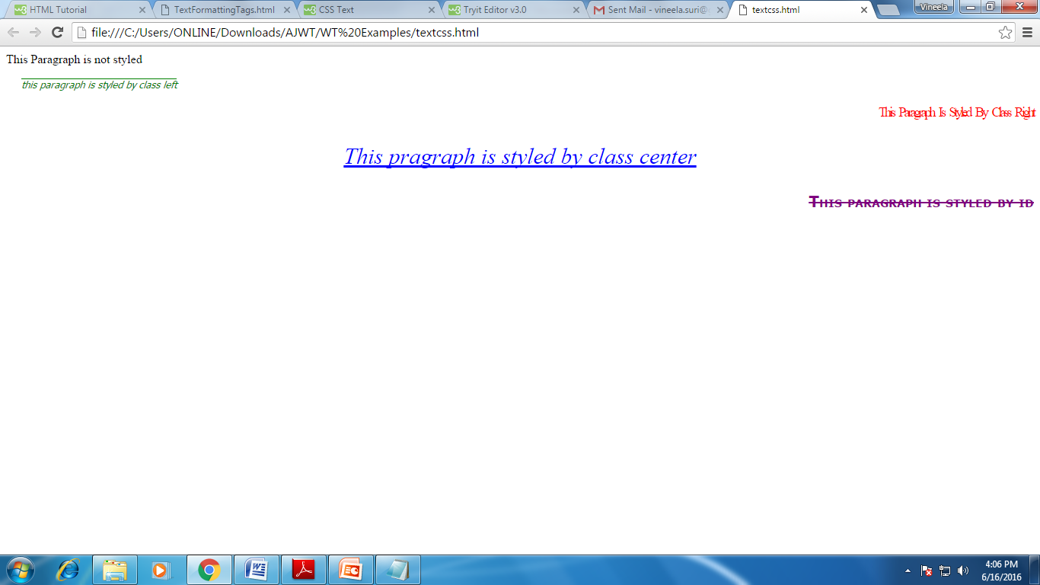

**1.18 CSS POSITIONING ELEMENTS:**

|  |  |
| --- | --- |
| **PROPERTY NAME** | **VALUE** |
| Position | static (normal flow), fixed (will not move)  relative (can overlap), absolute ( x & y co-ordinates) |
| Left, right, top, bottom | any Numeric value |

**Example:**

<html>

<body>

<h1 style="position:relative;left:10;top:10;z-index:3;background-color:yellow">This is layer 1</h1>

<h1 style="position:relative;left:50;top:-20;z-index:2;background-color:red"> This is layer 2</h1>

<h1 style="position:relative;left:100;top:-50;z-index:1;background-color:green"> This is layer 3</h1>

<br><br><br>

<h1 style="position:relative;left:10;top:10;z-index:2;background-color:yellow"> This is layer 1</h1>

<h1 style="position:relative;left:50;top:-20;z-index:3;background-color:red"> This is layer 2</h1>

<h1 style="position:relative;left:100;top:-50;z-index:1;background-color:green"> This is layer 3</h1>

<br><br><br>

<h1 style="position:relative;left:10;top:10;z-index:1;background-color:yellow"> This is layer 1</h1>

<h1 style="position:relative;left:50;top:-20;z-index:2;background-color:red"> This is layer 2</h1>

<h1 style="position:relative;left:100;top:-50;z-index:3;background-color:green"> This is layer 3</h1>

</body>

</html>

**Output:**

