ReactJS application
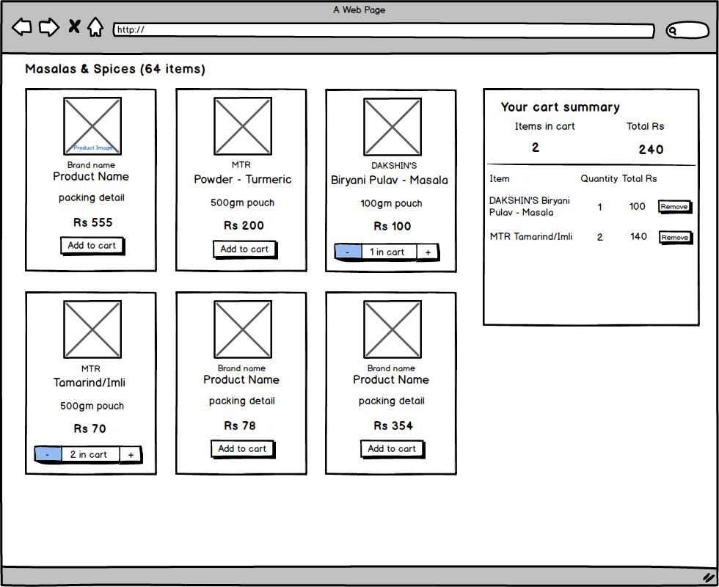

The given wireframe is for a product listing page.

You are expected to create an ReactJS application for the same.

Requirements :

- The cart panel should always be visible on the page if there is any item already added in the cart.
- All the required data should be rendered via external JSON file. Item should be unique.

Data properties are:

Product image

Brand name

Product name

Packing detail

Price

- On clicking on the “add” button item should be added to the cart and cart summary should be updated.

- The ‘-’ and ‘+’ buttons should be visible with the detail shown in wireframe, if the particular item is already added to the cart.

- If an Item is added to the cart and item added quantity is ‘1’ and user click on ‘-’ button the item should be removed from the cart. At the same time “add” button should be visible again for the item.

- Item should be removed from the cart on clicking on “Remove” button.

- All the states should be maintained after page refresh also. i.e. if there is an item in the cart and user refreshes the page, Item should remain in the cart after page refresh also.

- You are free to use any color, fonts, layout measurements, product images, product details etc. . You can develop all other required functionality by understanding the wireframe properly.

Please implement the design using ReactJS that allows us to measure your JavaScript, markup and CSS skills.

It is good if you can upload the developed application to server or Git and send us the link to access it.

