Rust
important rust chat with chat GPT link: https://chatgpt.com/c/6980b063-4dc8-8321-b9d9-da07974988d3
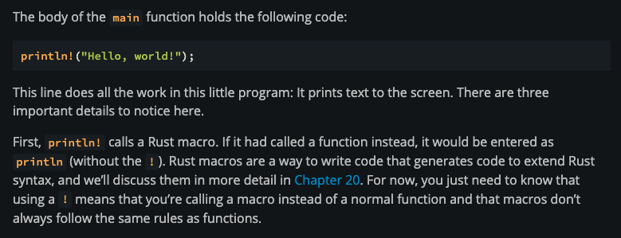
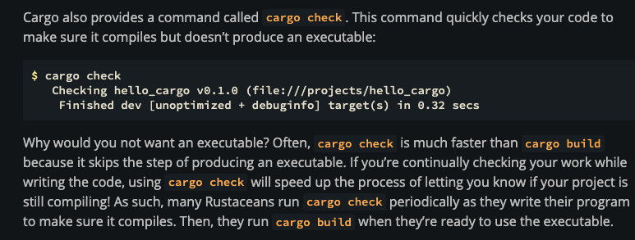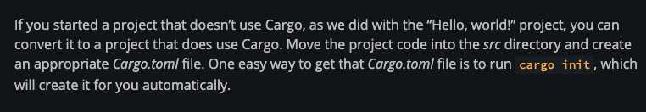
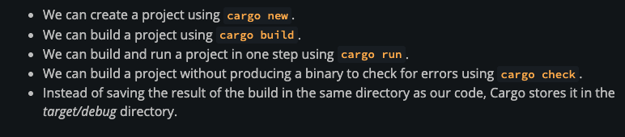
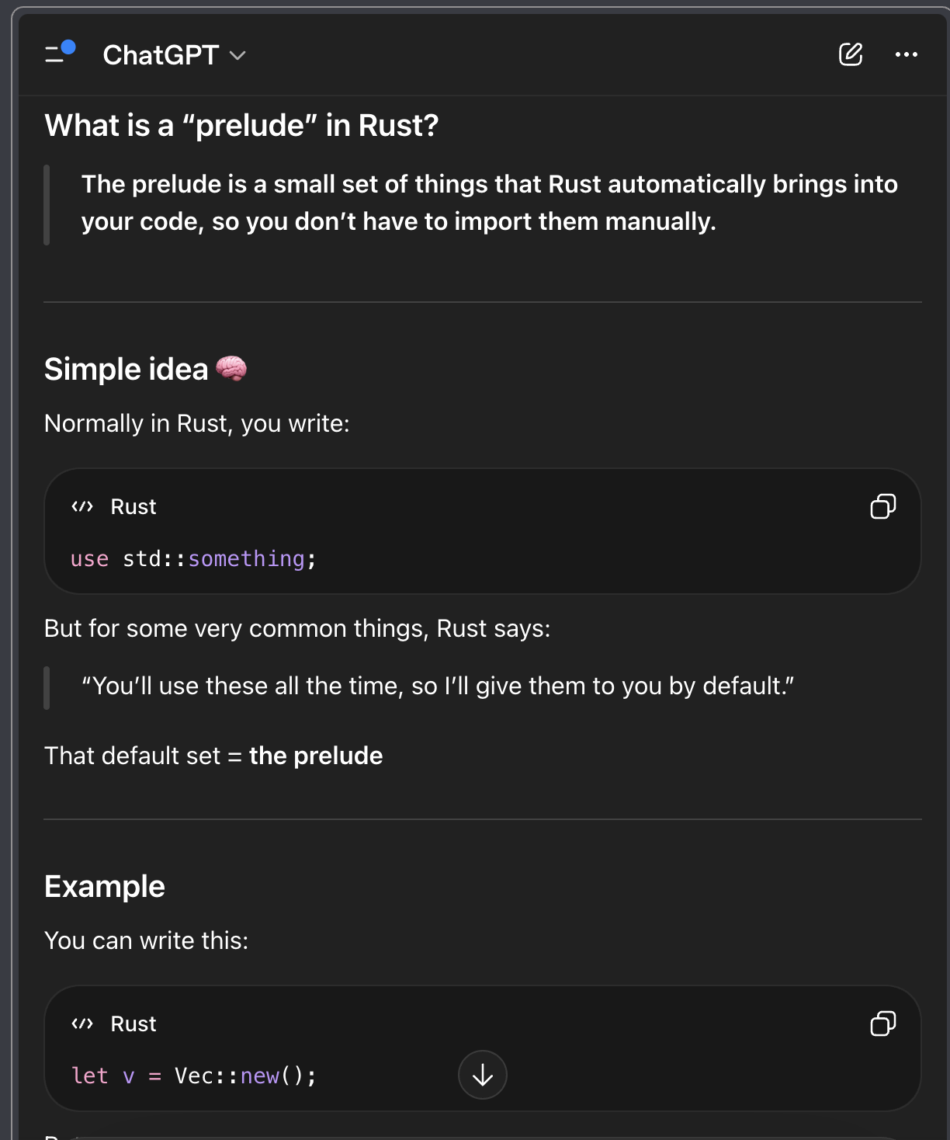
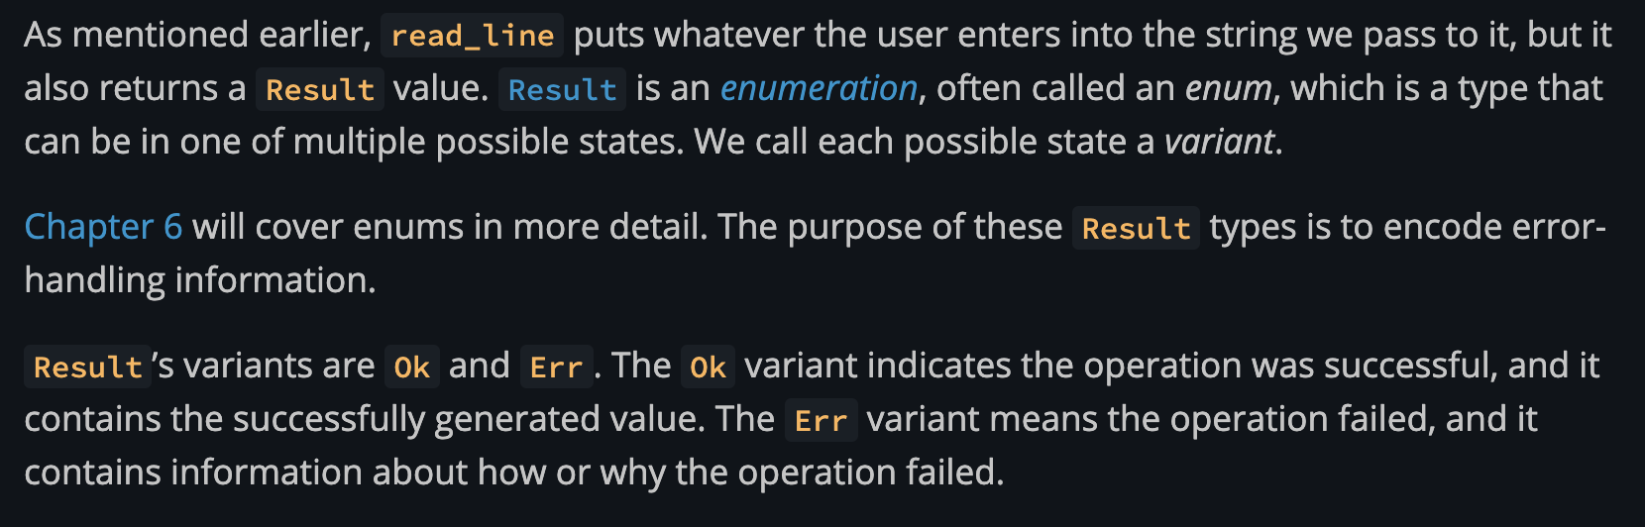

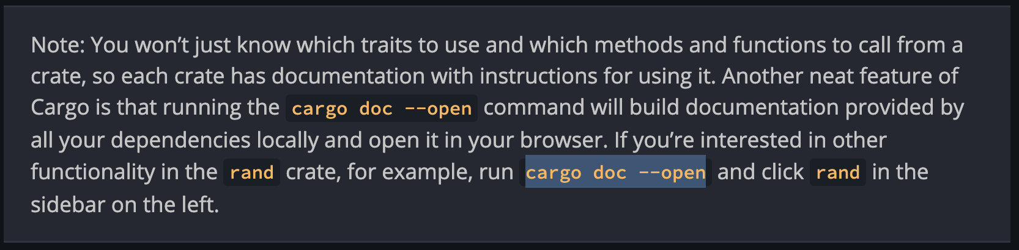
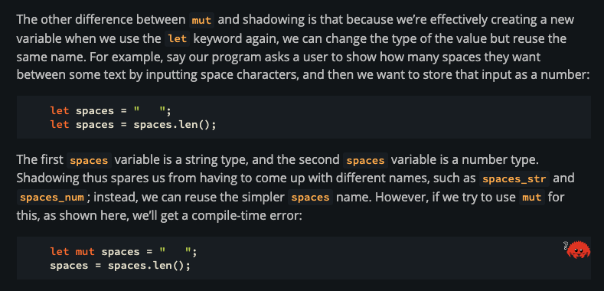
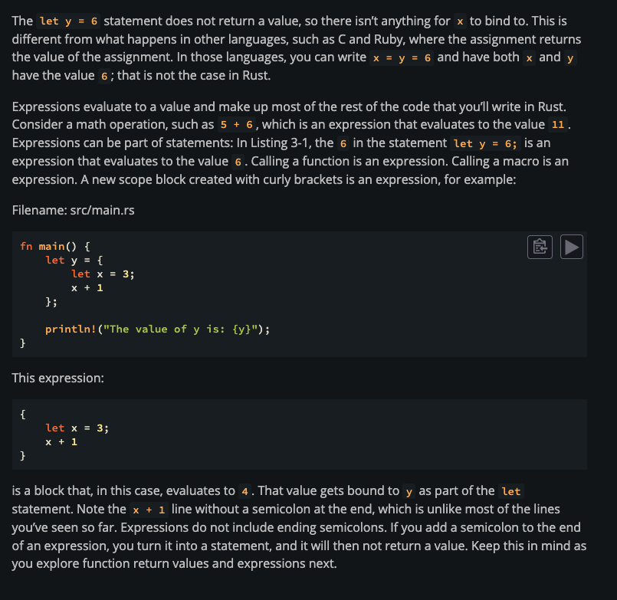

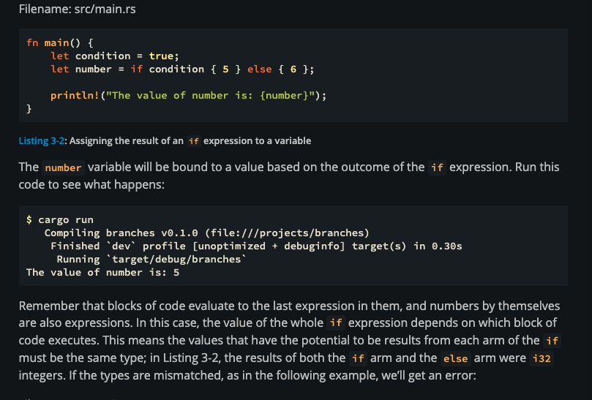

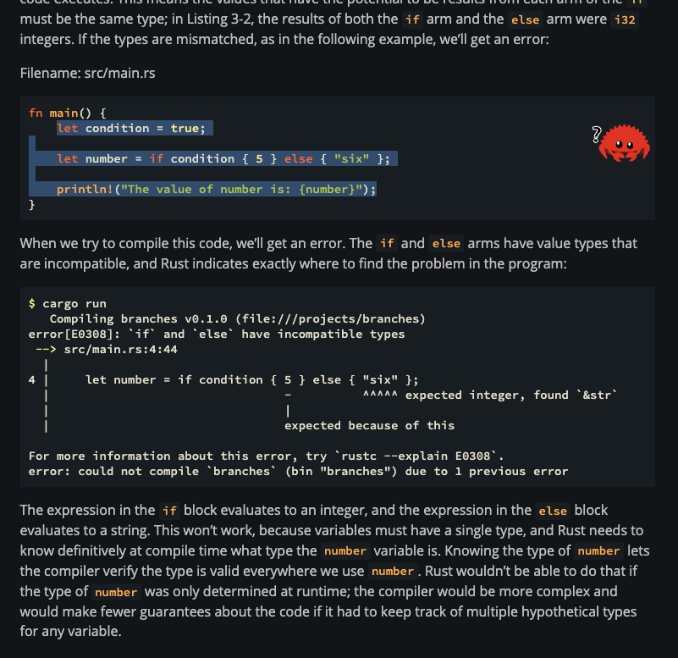
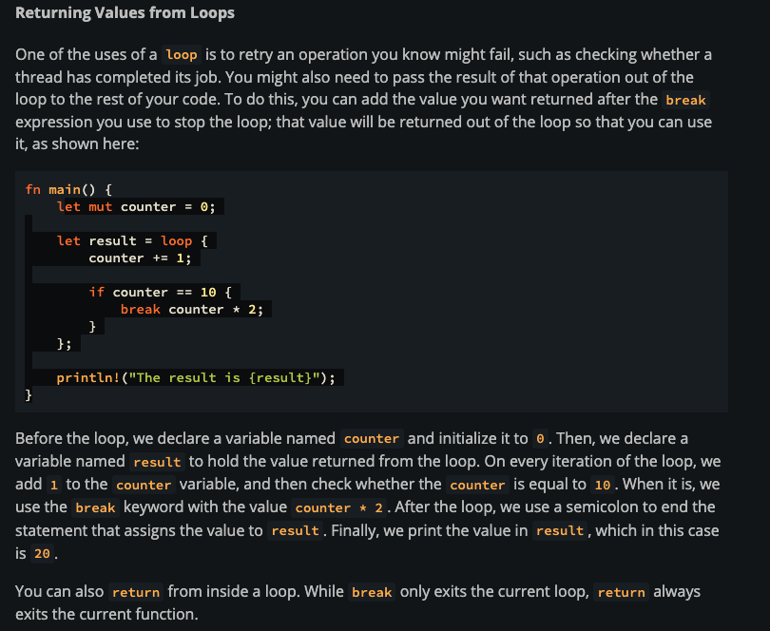

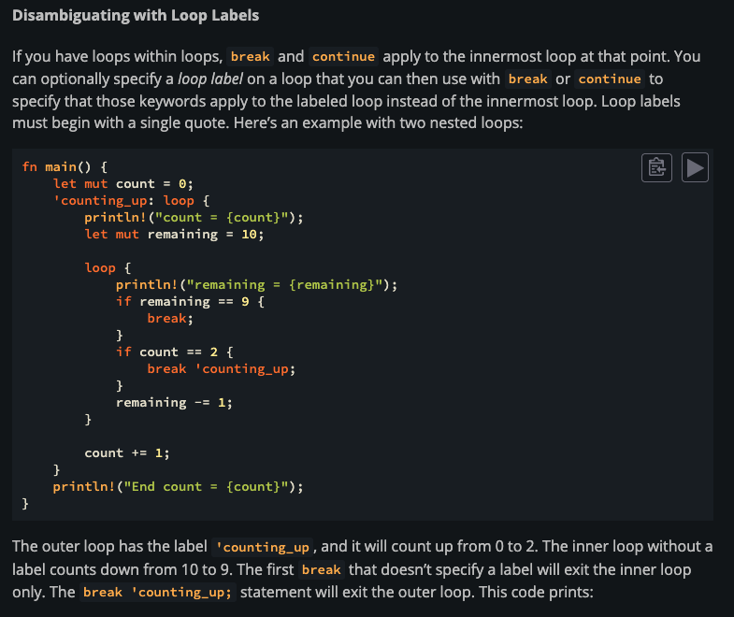

››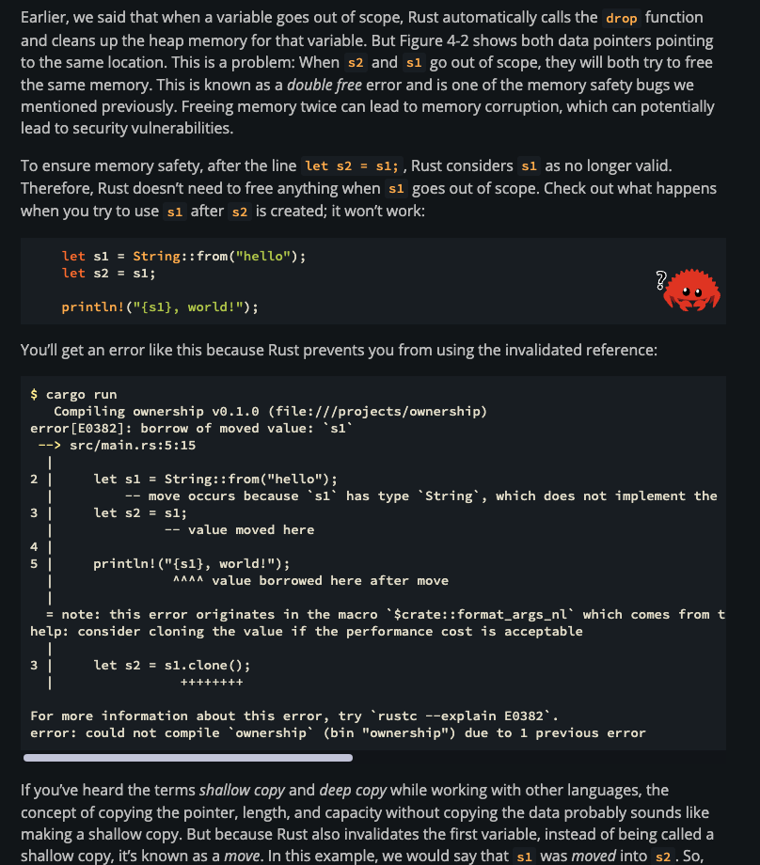

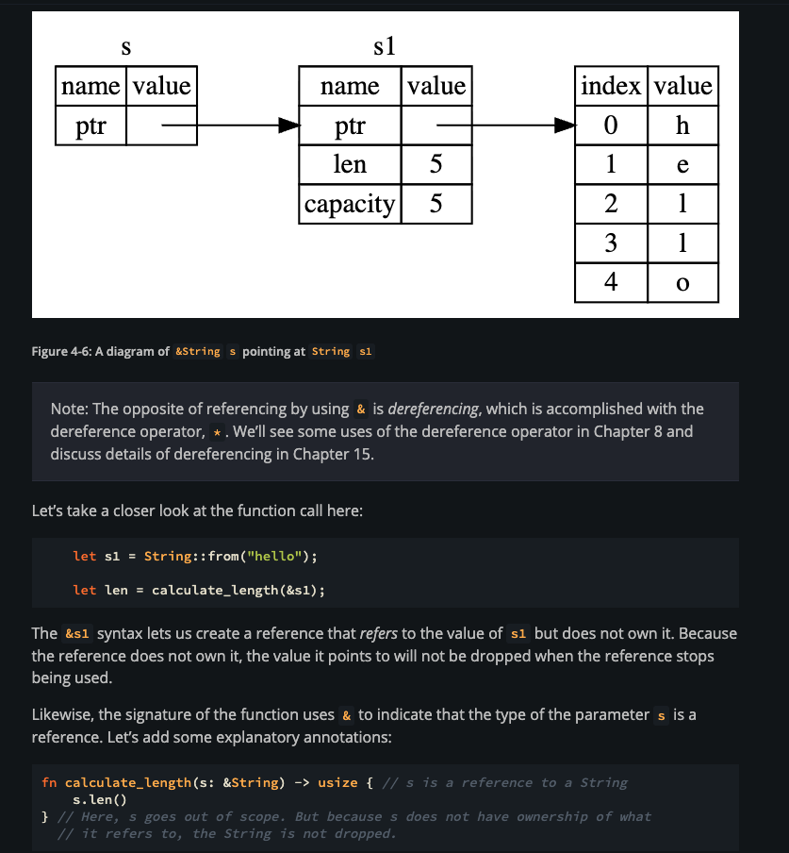

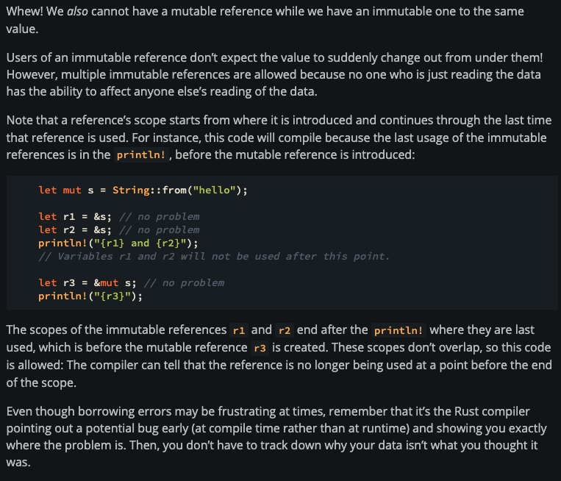

Important
explain what is the issue with the below code fn main() { let mut x = vec![1,2,3]; let last = x.last().unwrap(); x.push(4); println!("the last element is {:?}", last) } and also explain why it compiles if i put the line x.push(4); before let last = x.last().unwrap();
This is a classic borrowing + mutation conflict in Rust. Let’s walk through it clearly 👇

🔹 Your code
fn main() {
let mut x = vec![1,2,3];
let last = x.last().unwrap();
x.push(4);
println!("the last element is {:?}", last)
}

🔥 What’s the issue?

Step 1:
let last = x.last().unwrap();
- x.last() returns:
Option<&i32>
- So last is:
&i32 // a reference into the vector
👉 Important:
You now have an immutable reference to data inside x

Step 2:
x.push(4);
👉 This tries to mutably borrow x

❌ Problem
Rust rule:
You cannot have a mutable borrow while an immutable borrow is still active
Here:
- last → immutable borrow of x
- x.push(4) → mutable borrow of x
👉 Conflict → compile error

🔥 Why is Rust strict here?
Because push may:
- Reallocate memory
- Move elements to a new location
👉 Then last would point to invalid memory (dangling reference 💥)
Rust prevents this at compile time.

🔹 Why does this version work?
fn main() {
let mut x = vec![1,2,3];
x.push(4); // ✅ happens first
let last = x.last().unwrap();
println!("the last element is {:?}", last)
}

Step-by-step:
- x.push(4)
  - Mutates vector
  - No borrows yet → safe ✅
- let last = x.last().unwrap();
  - Now creates a reference
  - No mutation after → safe ✅

🔥 Key difference

❌ Original order:
borrow → mutate → use borrow ❌

✅ Working order:
mutate → borrow → use borrow ✅

🔹 Another fix (limit scope)
fn main() {
let mut x = vec![1,2,3];
{
let last = x.last().unwrap();
println!("last = {:?}", last);
} // borrow ends here
x.push(4); // now safe
}

🧠 Mental model
- last = “I’m holding a reference into x”
- push = “I might move x’s memory”
👉 Rust says:
“You can’t move the data while someone is still pointing at it”

✅ Final takeaway
- x.last() creates a reference
- x.push() needs a mutable borrow
- Rust prevents mixing them at the same time to avoid invalid memory

If you want, I can show how this behaves with iterators vs indexing — that reveals even deeper borrowing rules 🔥
Why does this version work?
fn main() {
let mut x = vec![1, 2, 3];
x.push(4);
let last = x.last().unwrap();
println!("the last element is {:?}", last)
}

Step-by-step:
x.push(4)
Mutates vector
No borrows yet → safe ✅
let last = x.last().unwrap();
Now creates a reference
No mutation after → safe ✅
i didn't get this part properly i would say both mutable and immutable reference exist at the same time see the below code
fn main() {
let mut x = vec![1, 2, 3];
x.push(4); // -> x is mutable borrow
let last = x.last().unwrap(); // > here last holds immutable borrow
println!("the last element is {:?}", last)
}
This is a really sharp observation — you’re very close, but there’s one key misunderstanding 👇

🔥 The misunderstanding
You said:
x.push(4); -> x is mutable borrow
👉 This is NOT correct

🔹 Important rule
A borrow only exists while it is being used, not forever after the line executes.

🔍 Let’s analyze this line
x.push(4);
- Yes, push temporarily takes a mutable borrow
- But that borrow:
  - starts when the function call begins
  - ends immediately after the function call finishes
👉 It does NOT persist

🔹 So what actually happens
fn main() {
let mut x = vec![1,2,3];
x.push(4); // (1) mutable borrow START → END (same line)
let last = x.last().unwrap(); // (2) immutable borrow starts
println!("{}", last); // (3) borrow used here
}

🔥 Timeline view
Line 1: x.push(4)
[ mutable borrow active ]
[ mutable borrow ends immediately ]
Line 2: let last = ...
[ immutable borrow starts ]
Line 3: println
[ immutable borrow used ]
👉 They do NOT overlap ✅

❌ Compare with your original broken code
let last = x.last().unwrap(); // immutable borrow starts
x.push(4); // ❌ tries mutable borrow WHILE immutable still alive

Timeline:
Line 1: immutable borrow starts
Line 2: mutable borrow starts ❌ (conflict)
👉 They overlap → error

🔹 Key concept: borrow lifetime
A borrow lives:
- From where it is created
- Until its last usage

In working code:
let last = x.last().unwrap();
println!("{}", last); // last used here
👉 Borrow ends after println!

🔹 Why Rust allows the working version
Because:
The mutable borrow (push) is finished before the immutable borrow even starts

🧠 Better mental model
Don’t think:
“This line creates a borrow forever”
Think:
“This borrow exists only for the duration it is needed”

🔥 Super simple analogy
- push() = “I briefly take control of the vector”
- last = “I hold a reference to the vector”
👉 Rust says:
- You can take control, then give it back
- Then someone else can safely look at it

✅ Final takeaway
- x.push(4) → mutable borrow is temporary
- It ends right after the call
- So when last is created, no mutable borrow exists
- Therefore no conflict

If you want, I can show non-lexical lifetimes (NLL) — that’s the feature that makes this behavior possible and smarter 🔥

fn main() {
let mut s: String = String::from("hello");
modify_string(&mut s); --- mutable ref of s
append_symbols(&mut s); --- mutable ref of s
println!("the string after modify is {}", s);
}
fn modify_string(s: &mut String) {
s.push_str("world");
}
fn append_symbols(s: &mut String) {
s.push_str("!!!!");
}
This is a really good question — and it shows you’re starting to think like Rust 👏
At first glance, it looks like two mutable borrows at the same time, but that’s not what’s actually happening.

🔥 Key idea
Mutable borrows must not overlap in time — but they can happen one after another

🔹 Your code
let mut s: String = String::from("hello");
modify_string(&mut s); // borrow 1
append_symbols(&mut s); // borrow 2

🔍 What actually happens (timeline)

Step 1:
modify_string(&mut s);
- A mutable borrow of s is created
- It is passed into the function
- Function runs
- Borrow ends when the function returns

Step 2:
append_symbols(&mut s);
- A new mutable borrow is created
- Previous borrow is already gone ✅

🔥 Timeline view
modify_string(&mut s)
[ mutable borrow active ]
[ borrow ends ]
append_symbols(&mut s)
[ new mutable borrow active ]
[ borrow ends ]
👉 No overlap → safe

❌ When would it fail?
If borrows overlap:
let r1 = &mut s;
let r2 = &mut s; // ❌ error
👉 Here:
- r1 is still alive
- You try to create r2
- Overlap → not allowed

🔹 Why your case is different
Because function calls are temporary borrows
modify_string(&mut s);
👉 Equivalent idea:
{
let temp = &mut s;
modify_string(temp);
} // temp dropped here

🔹 Important concept
Rust uses non-lexical lifetimes (NLL)
👉 Borrow ends:
- as soon as it is no longer used
- not just at the end of the scope

🧠 Mental model
Think:
- “I give s temporarily to this function”
- Function returns → I get it back
- Then I can give it again

🔥 Super simple analogy
- modify_string → “I borrow your book”
- Returns → “Here’s your book back”
- append_symbols → “Now I borrow it”
👉 No one is holding it at the same time

✅ Final takeaway
- ✔ You can have multiple mutable borrows
- ❗ But they must be sequential, not simultaneous
- ✔ Function calls create temporary borrows
- ✔ Borrow ends after function call completes

If you want, I can show a tricky example where it looks like this but actually fails — that’s where understanding becomes rock solid 🔥
Nice — let’s look at a case that looks similar to your working code but actually fails 👇

❌ Tricky failing example
fn main() {
let mut s = String::from("hello");
let r1 = &mut s;
modify_string(r1);
let r2 = &mut s; // ❌ error
append_symbols(r2);
println!("{}", s);
}
fn modify_string(s: &mut String) {
s.push_str(" world");
}
fn append_symbols(s: &mut String) {
s.push_str("!!!");
}

🔥 Why this fails
At first glance, you might think:
“modify_string(r1) is done, so r1 should be gone”
But Rust says ❌

🔍 What Rust sees
let r1 = &mut s;
👉 r1 is a mutable reference that is still alive
Even after:
modify_string(r1);
👉 Because r1 is still in scope

🔥 Timeline
r1 created → mutable borrow starts
modify_string(r1) → uses borrow
r1 still exists ❗
r2 created → tries second mutable borrow ❌ conflict

✅ Fix 1: limit scope
fn main() {
let mut s = String::from("hello");
{
let r1 = &mut s;
modify_string(r1);
} // r1 dropped here ✅
let r2 = &mut s;
append_symbols(r2);
println!("{}", s);
}

✅ Fix 2: don’t store the reference
fn main() {
let mut s = String::from("hello");
modify_string(&mut s); // borrow ends here
append_symbols(&mut s); // new borrow
println!("{}", s);
}
👉 This is your original working version

🔥 EVEN MORE TRICKY (NLL magic)
This works:
fn main() {
let mut s = String::from("hello");
let r1 = &mut s;
println!("{}", r1); // last use of r1
let r2 = &mut s; // ✅ allowed
println!("{}", r2);
}

🔍 Why this works
👉 Because of Non-Lexical Lifetimes (NLL)
- r1 is no longer used after println!
- So Rust ends its borrow early

🧠 Key difference

❌ Fails:
let r1 = &mut s;
modify_string(r1);
let r2 = &mut s; // r1 still alive

✅ Works:
let r1 = &mut s;
println!("{}", r1); // last use
let r2 = &mut s; // r1 is dead now

🔥 Big insight
Rust doesn’t care about:
“Where the variable is declared”
It cares about:
“When it is LAST USED”

🧠 Mental model upgrade
- Borrow lives until last use
- Not until end of scope (thanks to NLL)

✅ Final takeaway
- Storing a reference (let r1 = ...) keeps it alive
- Function calls with &mut s → temporary borrow
- Use scopes {} or avoid storing references to control lifetime

If you want, I can give you a few predict-the-output / will-it-compile puzzles — that’s the fastest way to master this 🔥
Top of Form

Bottom of Form

fn main() {
let mut s = String::from("hello world");
let word = first_word(&s);
s.clear();
println!("First word: {}", word);
}

fn first_word(s: &String) -> &str {
let bytes = s.as_bytes();
for (i, &item) in bytes.iter().enumerate() {
if item == b' ' {
return &s[..i];
}
}
&s[..]
}
here explain why will it work if i put s.clear(); after println but fails if i keep it before
This is a great question — you’re right at the point where Rust’s rules start to feel “strict but smart.”
Let’s compare the two cases very clearly.

❌ Case 1 (Your current code — FAILS)
let word = first_word(&s);
s.clear();
println!("First word: {}", word);

What happens step-by-step:

1. Borrow happens
let word = first_word(&s);
- word is a &str
- It points inside s
- So now:
  - s is immutably borrowed
  - word depends on s's data

2. You try to mutate s
s.clear();
- This needs a mutable borrow (&mut s)
- But Rust sees:
  - ❗ There is already an active immutable borrow (word)

🚨 Conflict
Rust rule:
You cannot have a mutable borrow while immutable borrows are still in use.
Because if Rust allowed this:
- clear() would delete the string’s contents
- word would point to invalid memory
👉 That’s a dangling reference → Rust forbids it at compile time

✅ Case 2 (WORKS)
let word = first_word(&s);
println!("First word: {}", word);
s.clear();

What’s different?

1. Borrow happens
let word = first_word(&s);
Same as before — word borrows from s

2. You use the borrow
println!("First word: {}", word);
👉 This is key.
After this line:
- word is no longer used
- Rust sees: “Okay, the borrow is finished”

3. Borrow ends (important concept!)
Even though word is still in scope, Rust uses Non-Lexical Lifetimes (NLL)
That means:
A borrow ends at its last use, not at the end of the scope.
So effectively:
let word = first_word(&s);
println!("{}", word); // last use of `word`
👉 After this line, the borrow is considered dead

4. Now mutation is allowed
s.clear(); // ✅ allowed
Because:
- No active references to s anymore

🧠 The Real Insight

Rust is not thinking in terms of scope like this:
{
let word = ...
// borrow active until end of block ❌ (old thinking)
}

It’s thinking like this:
let word = first_word(&s);
println!("{}", word); // last use → borrow ends here
s.clear(); // ✅ now safe

🔥 Mental Model
Think of it like:
- word = someone reading a page in a book (s)
- println! = they finish reading
- clear() = you erase the book

❌ Bad order:
- Erase book while someone is still reading → not allowed

✅ Good order:
- Let them finish reading → then erase → safe

⚡ One-line summary
It works after println! because Rust sees the borrow is no longer used, so it safely allows mutation.

If you want to push this further, I can show you a tricky variation where it looks like the borrow ended… but Rust still rejects it — that’s where deeper understanding kicks in.

Top of Form

Bottom of Form

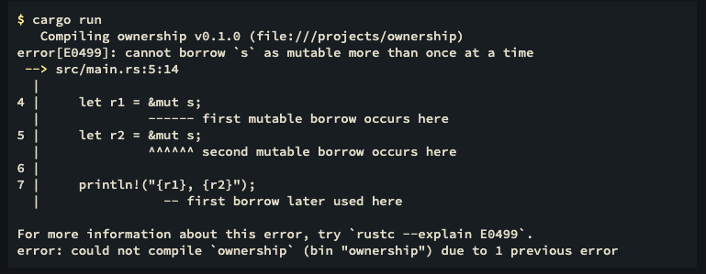
to understand the above error follow the below link
https://doc.rust-lang.org/book/ch04-02-references-and-borrowing.html#:~:text=a%20reference%20to.-,Mutable%20References,-We%20can%20fix

Important
Q: Recall that we talked about string literals being stored inside the binary. i wanna understand this sentence
Great—this is a very important concept, and once you get it, a lot of Rust memory behavior becomes clear.

🧠 What does “stored inside the binary” mean?
When you write:
let s = "hello";
👉 The string "hello" is put into the compiled program itself, not created at runtime.

🔍 Step-by-step

1️⃣ You write code
let s = "hello";

2️⃣ Rust compiles your program
It creates a binary executable file (like .exe or just a compiled file on Linux/Mac).
👉 Inside that file, Rust stores:
hello

3️⃣ When the program runs
- "hello" is already sitting in memory (loaded from the binary)
- s just points to it

📦 Where exactly is it stored?
Inside a special section called:
Read-only data section (.rodata)
👉 This memory:
- is loaded when the program starts
- cannot be modified
- lives for the entire program

🔍 Visual Idea

Your program file (binary):
[ machine code ]
[ constants ]
[ "hello" ] ← stored here

At runtime:
Stack:
s → (ptr, len)
Read-only memory:
"hello"

🧩 Why Rust does this
Because:

✅ Efficient
- No need to allocate memory at runtime

✅ Fast
- Already available when program starts

✅ Safe
- Immutable → cannot accidentally change

⚠️ Important Difference

String Literal
let s = "hello";
- Stored in binary
- Immutable
- Type: &'static str

Heap String
let s = String::from("hello");
- Created at runtime
- Stored in heap
- Mutable

📖 Analogy
Think of your program like a book 📘
- String literals = printed text in the book
- You don’t create them while reading—they’re already there

🔥 Key Insight
“Stored in the binary” means the data is baked into your program at compile time, not created while running.

🚀 One-Line Summary
👉 String literals are pre-stored inside the compiled program, and your code just references them at runtime.

When you write: let s = "hello"; 👉 The string "hello" is put into the compiled program itself, not created at runtime. what do you mean by this?
Great—this line can feel a bit abstract, so let’s make it very concrete and intuitive.

🧠 What does this mean?
let s = "hello";
“"hello" is put into the compiled program itself”
👉 Means:
The string is already inside your program file before it runs.

🔍 Step-by-step (real process)

1️⃣ You write code
let s = "hello";

2️⃣ Rust compiles it
Rust creates a binary file (your executable).
👉 Inside that file, it literally stores:
hello

3️⃣ When you run the program
- The OS loads your program into memory
- "hello" is already there
- s just points to it

📦 Important Contrast

🔴 String literal (&str)
let s = "hello";
- ✅ Stored in binary
- ❌ Not created at runtime
- ❌ No heap allocation

🟢 Heap string (String)
let s = String::from("hello");
👉 This DOES happen at runtime:
- Allocate memory on heap
- Copy "hello" into it

🧩 Analogy (Very Clear)

String literal
- Like a printed word in a book 📖
- Already exists before you start reading

String::from
- Like writing the word on paper while reading ✍️
- Created during execution

🔍 Visual

Binary (your program file):
[ machine code ]
[ constants ]
[ "hello" ] ← already stored here

Runtime:
Stack:
s → (pointer, length)
Read-only memory:
"hello"

⚠️ Why this matters
Because:

✅ Faster
- No allocation at runtime

✅ Safer
- Immutable

✅ Lives forever
- 'static lifetime

🔥 Key Insight
"hello" is not “constructed” when your program runs—it is embedded into the program during compilation.

🚀 One-Line Summary
👉 String literals are baked into your executable, and your variable just points to them at runtime.

If you want, I can show:
- actual compiled binary view (very cool)
- or how multiple "hello" literals are optimized by Rust (memory deduplication)
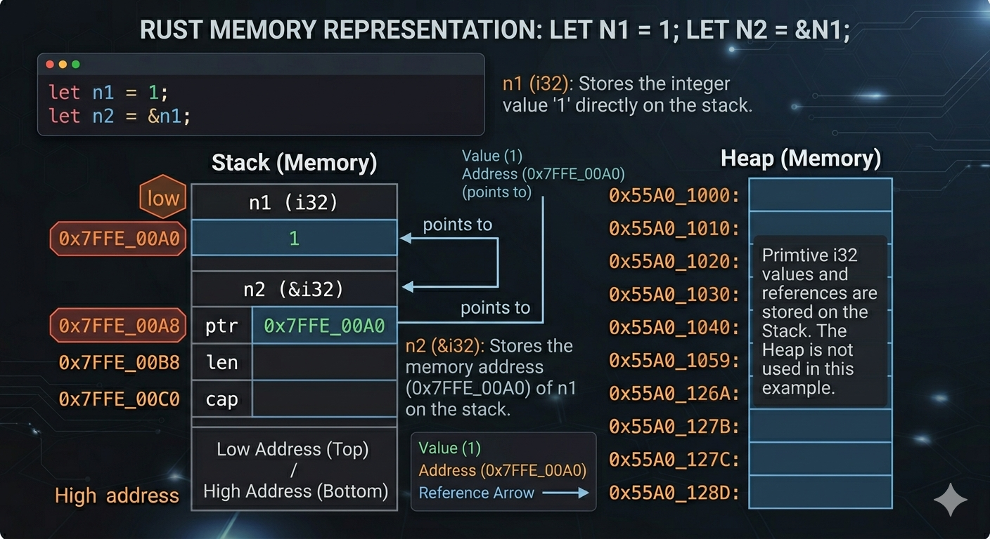

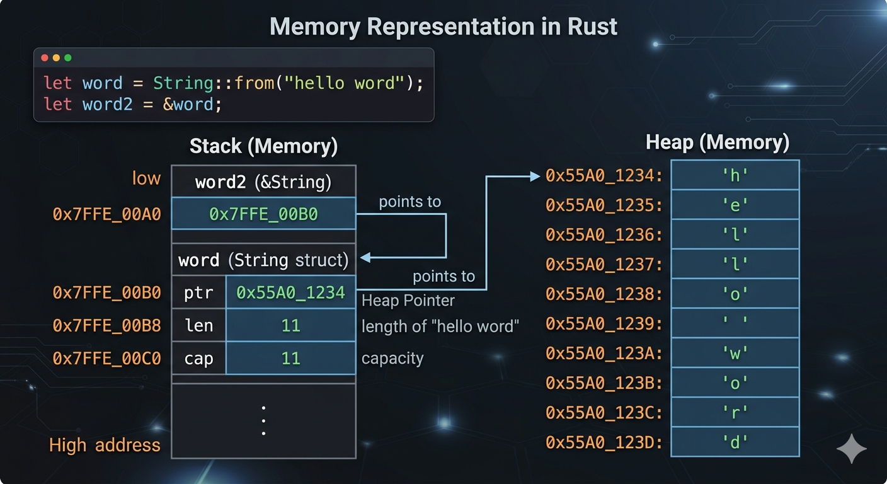

let word = String::from("hello word"); what does word store is it the actual word 'hello word or address + length + capacity
Great question — this gets to the core of how memory works in Rust.

🧠 What does word actually store?
let word = String::from("hello world");
👉 The variable word does NOT store the actual text directly
Instead, it stores:
✅ pointer (address) + length + capacity

📦 Memory breakdown

🔹 On the stack (inside word)
word contains:
- 📍 pointer → points to heap memory
- 📏 length → number of characters used
- 📦 capacity → total allocated space

🔹 On the heap
The actual string data:
"h e l l o w o r l d"

📊 Visual
STACK (word variable)
---------------------
| ptr | len | cap |
↓
HEAP
---------------------
| h | e | l | l | o | | w | o | r | l | d |

🔍 Example values
For "hello world":
- length = 11
- capacity ≥ 11 (maybe 11, 12, or more)

⚠️ Important distinction

🟢 String
let s = String::from("hello");
- Owns data
- Stores pointer + len + cap
- Heap allocation

🔵 &str
let s = "hello";
- Stores:
  - pointer + length ONLY
- No capacity
- Usually stored in binary (read-only)

🧩 Why Rust does this
Because:
- Strings can grow (push, push_str)
- Needs dynamic memory (heap)
- Efficient resizing

🔥 Final takeaway
👉 word stores:
- ❌ Not the actual string
- ✅ pointer + length + capacity
👉 Actual "hello world" lives on the heap

💡 One-line intuition
String = “a smart handle pointing to text stored elsewhere”

If you want, I can show:
- what happens during clone() vs move (very important)
- or how capacity changes when you append text 👀
let word2 = &word; now what does word2 store?
Nice — this is where Rust gets really interesting 👀

🧠 Your code
let word = String::from("hello world");
let word2 = &word;

✅ What does word2 store?
👉 word2 is a reference to word
So it stores:
✅ just a pointer to the String struct (on the stack)

📦 Full memory picture

🔹 word (on stack)
- pointer → heap data
- length
- capacity

🔹 word2 (on stack)
- pointer → points to word (not heap directly)

📊 Visualization
STACK
-------------------------
word:
ptr ───────────────┐
len │
cap │
↓
HEAP
-------------------------
"h e l l o w o r l d"
word2:
ptr ───────────────→ word (the struct, not heap)

🔍 Key insight
- word → owns the actual string data (heap)
- word2 → borrows word (not the heap directly)

⚠️ Important detail
Type of word2:
&String
👉 Not &str

🔄 If you did this instead
let word2 = &word[..];
Then:
- type = &str
- pointer goes directly to heap data

🧩 Comparison
Variable | Type | Points to
word | String | Heap data
word2 = &word | &String | Stack (word)
word2 = &word[..] | &str | Heap data

🔥 Final takeaway
👉 word2 = &word stores:
- ✅ pointer to the String struct
- ❌ not directly to string data

💡 One-line intuition
- String → owns the data
- &String → points to the owner
- &str → points to the actual text

If you want, I can show:
- why &str is used more than &String (very important in real Rust 👀)

`*` is the **dereference operator**. It follows a reference to get the actual value it points to.

```rust
let x: usize = 5;
let r: &usize = &x; // r is a reference to x

println!("{}", r); // prints 5 (println auto-dereferences)
println!("{}", *r); // prints 5 (manually dereferenced)

// But for comparison:
// r == 5 → error: can't compare &usize with usize
// *r == 5 → works: comparing usize with usize
```

In your code, `j_index` is `&usize` (a reference to a usize). `*j_index` dereferences it to get the plain `usize` value, so you can compare it with `sentence.len() - 1` which is also a plain `usize`.

Think of it like: `&` creates a reference (address of), `*` follows the reference (value at that address).

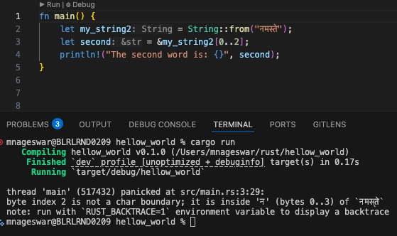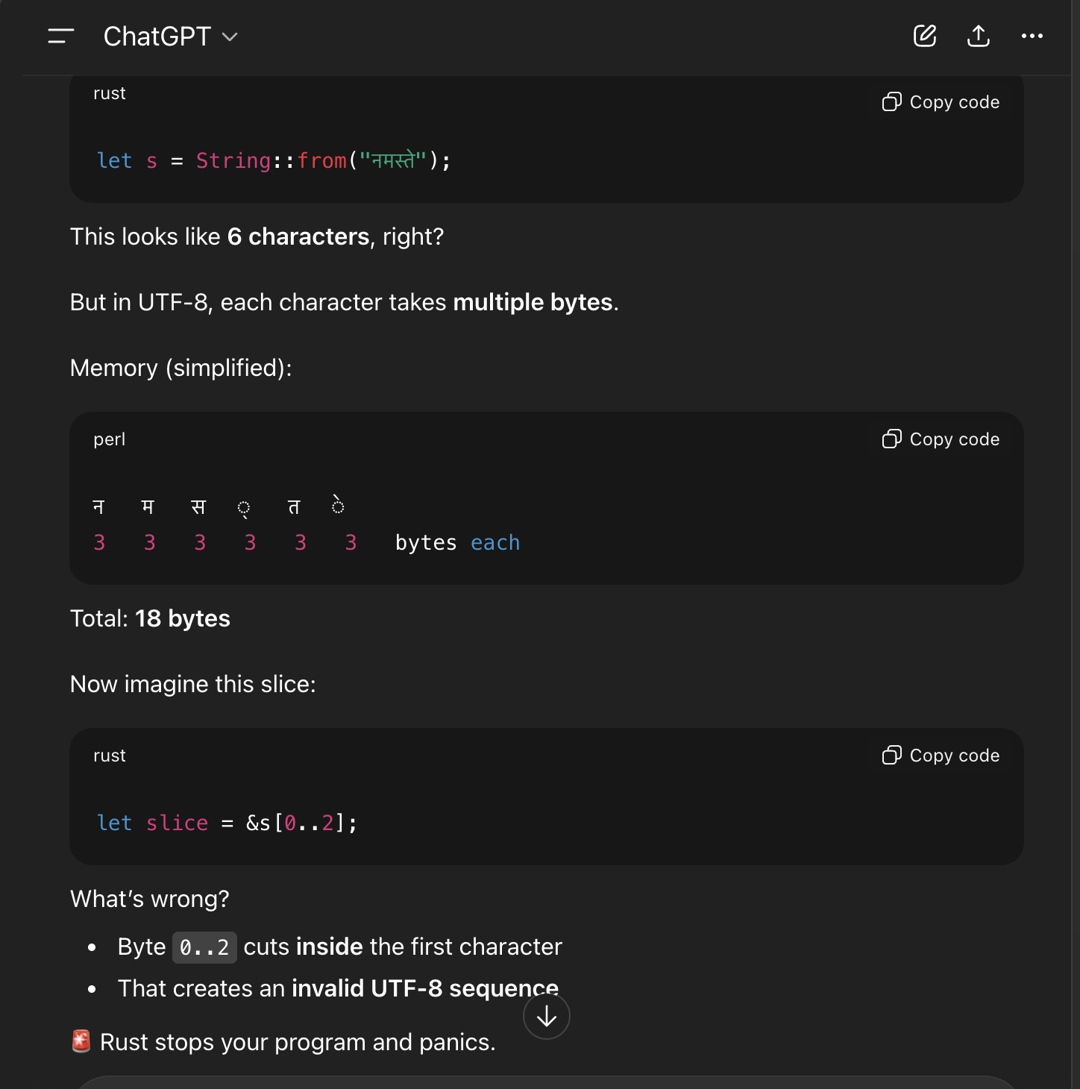
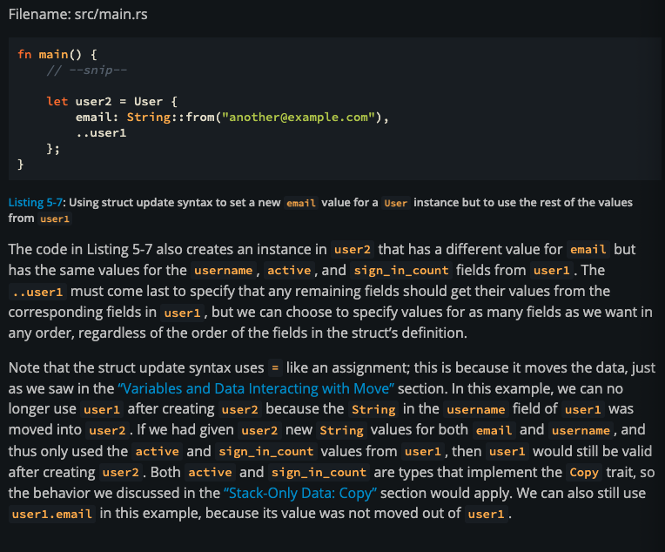
let's say there is a struct called Car {}. now let's say this car has an associated function called get_purpose() and a method get_color() now we created an instance of it like let car1 = Car {} now we can access the method like car1.get_color() right so can we do car1::get_purpose() how is it behave for enums?
Short answer:
👉 car1.get_color() ✅ valid (method)
👉 car1::get_purpose() ❌ invalid syntax
Now let’s break why, because this gets into how Rust separates methods vs associated functions.

🧠 1. Methods vs Associated Functions
Given:
struct Car;
impl Car {
fn get_purpose() -> &'static str {
"transport"
}
fn get_color(&self) -> &'static str {
"red"
}
}

✅ Method (has self)
let car1 = Car;
car1.get_color();
- Uses . because it operates on an instance
- Rust automatically passes &car1 as self

✅ Associated function (no self)
Car::get_purpose();
- Uses :: because it belongs to the type, not an instance
- No self, so no object needed

❌ Why car1::get_purpose() is invalid
car1::get_purpose(); // ❌
Rust does not allow this because:
- :: is for types / namespaces
- car1 is a value (instance), not a type
👉 So the compiler will complain: expected type, found value

🤯 But wait… can you still call it via the instance?
Yes, but not with :::
car1.get_purpose(); // ⚠️ This actually works!
Why?
Rust does a little trick:
- It sees get_purpose has no self
- It rewrites it as: Car::get_purpose()
👉 This is called method call syntax fallback
BUT:
- It’s not idiomatic
- Most Rust code uses Car::get_purpose()

🔹 2. How this behaves for enums
Enums behave exactly the same way.

Example:
enum Vehicle {
Car,
Bike,
}
impl Vehicle {
fn get_category() -> &'static str {
"transport"
}
fn describe(&self) -> &'static str {
match self {
Vehicle::Car => "four wheeler",
Vehicle::Bike => "two wheeler",
}
}
}

✅ Calling associated function
Vehicle::get_category();

❌ Invalid
let v = Vehicle::Car;
v::get_category(); // ❌ same error

⚠️ Works (but not preferred)
v.get_category(); // works, but unusual

✅ Method call
v.describe();

🔥 Key takeaway
Call style | Works? | Why
car1.get_color() | ✅ | method (has self)
Car::get_purpose() | ✅ | associated function
car1::get_purpose() | ❌ | :: requires type
car1.get_purpose() | ⚠️ | allowed, but not idiomatic

🧠 Clean mental model
- . → "I have an instance"
- :: → "I’m referring to the type itself"

deref coercion

consider the below code and if you run the code it will print “the reference value is accessed”

fn main() {
let s = String::from("hello");
let r1 = &s;
if r1 == "hello" {
println!("the reference value is accessed")
}
}
here r1 stores the reference(address and length) of s. if that’s the case you must be thinking in order to compare value at the ref r1 with the string “hello” you have to access the value at the ref r1 for that you have to derefer which is *r1 and then compare it with “hello” but if you do that it will fail cuz here *r1 would be of type String and “hello” is of type &str which are different so you need a way to turn String to &str that exctaly what Deref coercion is

**Deref coercion** is Rust's automatic dereferencing feature. It allows a reference to be automatically dereferenced to match a function's or comparison's expected type.

**Definition:**
When Rust encounters a reference where a dereferenced value is expected, it automatically dereferences it (using the `Deref` trait) as many times as needed to match the required type.

**Simple example:**

```rust
let s = String::from("hello");
let r = &s; // r is &String (reference to String)

// Without deref coercion, you'd need:
if *r == "hello" { }

// With deref coercion, Rust automatically dereferences:
if r == "hello" { } // Rust converts &String -> &str automatically
```

**More examples:**

```rust
fn print_string(s: &str) {
println!("{}", s);
}

let s = String::from("hello");
let r = &s;

print_string(r); // ✓ Works! Rust coerces &String to &str
// Without coercion, you'd need: print_string(&*r) or print_string(r.as_str())
```

**Why does it work?**
- `String` implements the `Deref` trait
- `Deref` for `String` returns `&str`
- Rust uses this automatically in contexts where the coercion is safe

**Benefits:**
- Cleaner, more ergonomic code
- Less manual dereferencing needed
- You don't have to write `*reference` everywhere

This is one of Rust's convenience features!

Now consider the below code
fn main() {
let s = String::from("hello");
let r1 = &s;
if r1 == String::from("hello") {
println!("the reference value is accessed")
}
}
If you want the if condition to be true you have to access the value at r1(dereference it) like use *r1 then it will work

**What is a shared reference?**

A **shared reference** (`&`) is called "shared" because multiple references can exist to the same data at the same time:

```rust
let s = String::from("hello");
let r1 = &s; // shared reference 1
let r2 = &s; // shared reference 2
let r3 = &s; // shared reference 3 — all valid at once
```

It's called "shared" because the data is **shared** among multiple borrowers. The opposite is a **mutable reference** (`&mut`), which is **exclusive** — only one can exist at a time.

**What does "behind a shared reference" mean?**

"Behind" means **accessed through** or **on the other side of**. Think of a reference as a pointer — the actual value is "behind" (on the other side of) that pointer.

```
r ──points to──> s (the String "hello")
│ │
│ reference │ the actual value is "behind" the reference
```

So `*r` is the value **behind** `r`. The error is saying:

> "You're trying to move the value that sits behind `r`, but `r` is a shared reference — it only has read access, not ownership, so you can't move it out."

**Putting the full error together:**

```
cannot move out of `*r` which is behind a shared reference
│ │ │
│ │ └─ r is a & reference (shared, read-only)
│ └─ the actual String value accessed via *r
└─ you're trying to take ownership (move) of that value
```

**Why can't you move?**

```rust
let s = String::from("hello");
let r = &s; // r borrows s (shared/read-only)
let x = *r; // ✗ Tries to MOVE the String out of s, through r
// But r is just borrowing — it doesn't own s
// If this worked, s would be left invalid
// Other shared references would point to nothing
```

Moving would **invalidate** `s`, which is dangerous because `r` (and potentially other shared references) promised they'd only **read** the data, not destroy it.

**What works instead:**

```rust
let s = String::from("hello");
let r = &s;
let x = r.clone(); // ✓ Makes a copy, doesn't move
let x = *r; // ✗ Tries to move — not allowed through &
```

**Note:** This error only applies to types that don't implement `Copy`. For simple types like integers, it works fine because they are **copied**, not moved:

```rust
let n: i32 = 42;
let r = &n;
let x = *r; // ✓ Works! i32 implements Copy, so it's copied, not moved
```

let mut s = String::from("hello"); let r1 = &mut s; let r2 = &mut s; can you explain why this fails
This is one of the most important rules in Rust, and understanding why it fails will make everything click.

❌ Your code
let mut s = String::from("hello");
let r1 = &mut s;
let r2 = &mut s;

🔴 The error (conceptually)
cannot borrow s as mutable more than once at a time

🧠 The core rule
✅ You can have:
- many immutable references (&)
❌ OR:
- only one mutable reference (&mut) at a time

🔍 What’s happening step by step

Step 1
let r1 = &mut s;
- r1 gets exclusive access to s
- Rust guarantees:
“No one else can touch s right now”

Step 2
let r2 = &mut s;
- You try to create another mutable reference
👉 But r1 is still alive

💥 Why Rust rejects this
Because this could cause data races / inconsistencies

🧩 Imagine if it were allowed:
*r1 = "hello1";
*r2 = "hello2";
Now:
- Two writers
- Same data
- At the same time
👉 Result:
Unpredictable ❌

🧠 Rust’s guarantee
Rust enforces:
At any time, either:
- one writer (&mut)
- OR many readers (&)
👉 Never both, never multiple writers

🏠 Analogy
- s = a document
- &mut s = someone editing it
If:
- One person is editing → ✅ fine
- Two people editing at the same time → ❌ chaos

🔥 Important detail: Lifetime
The issue is:
- r1 is still in scope when r2 is created

✅ How to fix it

✔️ Option 1: Use them one after another
let mut s = String::from("hello");
let r1 = &mut s;
println!("{}", r1); // last use of r1
let r2 = &mut s; // ✅ now allowed
println!("{}", r2);
👉 Thanks to non-lexical lifetimes (NLL), Rust sees r1 is no longer used.

✔️ Option 2: Separate scopes
{
let r1 = &mut s;
}
{
let r2 = &mut s;
}

✅ Final intuition
&mut means exclusive access
So:
&mut s = “I am the ONLY one allowed to touch this”
Trying to create another:
&mut s again = “Now TWO people have exclusive access” ❌ contradiction

🚀 Final takeaway
- &mut = exclusive, one at a time
- Rust prevents:
  - race conditions
  - inconsistent state
- This rule is what makes Rust memory-safe without garbage collection

If you want, I can show:
- how this rule prevents real-world bugs (with examples)
- or how this relates to multithreading (where this becomes even more powerful)
what is non-lexical lifetimes (NLL), Rust sees r1 is no longer used.
Great — this is a key Rust concept, and once you get it, a lot of “why does this compile?” questions become clear.

🧠 What is Non-Lexical Lifetimes (NLL)?

🔹 Old idea (before NLL)
Rust used to think:
“A reference lives until the end of its scope (block)”

🔹 New idea (NLL)
Rust now thinks:
“A reference lives only until its last use”
👉 That’s what Non-Lexical Lifetimes means:
- Non-lexical = not tied to the { } block structure
- Lifetime ends where it’s last used, not where the block ends

🔍 Example (your case)
let mut s = String::from("hello");
let r1 = &mut s;
println!("{}", r1); // last use of r1
let r2 = &mut s; // ✅ allowed
println!("{}", r2);

🧩 Step-by-step

1. Create r1
let r1 = &mut s;
- r1 has exclusive access to s

2. Use r1
println!("{}", r1);
👉 This is the last time r1 is used

3. After this line…
Rust says:
r1 is no longer needed → its lifetime ends here

4. Now this is allowed
let r2 = &mut s;
Because:
- r1 is effectively “dead”
- So s is free again

🔥 Without NLL (old behavior)
Rust would think:
r1 lives until the end of the block ❌
So this would fail:
let r1 = &mut s;
println!("{}", r1);
let r2 = &mut s; // ❌ error (old Rust)

🧠 With NLL (modern Rust)
Rust is smarter:
r1 lives only until its last use ✅
So it allows:
let r2 = &mut s; // ✅

🧩 Visual timeline
r1: |----used----| (ends here)
↑ last use
r2: |----starts----|
No overlap → ✅ safe

🏠 Analogy
- r1 = someone editing a document
- After they finish editing → they leave
- Now r2 can start editing
👉 No overlap = no conflict

⚠️ Important detail
This still fails:
let r1 = &mut s;
let r2 = &mut s; // ❌ error
println!("{}", r1);
Because:
- r1 is still needed later
- So its lifetime hasn’t ended yet

✅ Final definition
Non-Lexical Lifetimes (NLL) means:
Rust determines a reference’s lifetime based on where it is actually used, not just the block scope.

🚀 Final takeaway
- Old Rust: lifetime = scope ({ })
- Modern Rust (NLL): lifetime = last usage
- This makes code:
  - more flexible ✅
  - still safe ✅

fn main() { let s = String::from("hello"); let r = &s; let x = *r; } explain why this code fails
This fails because of how dereferencing and ownership work in Rust.
Let’s go line by line:
let s = String::from("hello");
- s is a heap-allocated String
- It owns the data "hello"
let r = &s;
- r is a reference to s → type: &String
- It borrows s (does NOT take ownership)
let x = *r;
This is where the problem happens.

❌ Why it fails
*r tries to dereference r, meaning:
*r → s
So effectively:
let x = s;
But:
- s is a String, which is not Copy
- Moving it would transfer ownership
- You cannot move out of a borrowed reference
Rust error (conceptually):
cannot move out of *r which is behind a shared reference

🔥 Core Issue
- r is &String → a shared reference
- Rust does not allow moving ownership through a shared reference
- Dereferencing (*r) tries to move the String, which is illegal

✅ How to fix it

1. Clone the value
let x = r.clone();
- Creates a new owned String

2. Borrow instead of move
let x = r;
- x is also &String
- No ownership transfer

3. Convert to &str
let x: &str = &s;
or
let x = r.as_str();

🧠 Key Concept
- Types like String are not Copy
- Dereferencing a reference to a non-Copy type attempts a move
- Rust prevents moving data out of a borrowed context

💡 Rule to remember
You can read through a reference, but you cannot take ownership through it (unless the type is Copy).

If you want, I can show how this works differently with Copy types like i32—that makes the contrast very clear.
this is the error that i get cannot move out of *r which is behind a shared reference i understood this part "cannot move out of *r". I didn't get the other part "which is behind a shared reference" who and what is behind a shared reference can you eloborate
Good question — this is exactly the part that confuses most people at first.
Let’s unpack the phrase:
"cannot move out of *r which is behind a shared reference"

🔍 What does “behind a shared reference” mean?
Look at this line:
let r = &s;
- r is a shared reference (&String)
- It points to the value s
So memory-wise, you can think of it like:
r ───▶ s (String "hello")
Now when you write:
let x = *r;
- *r means: “go to what r is pointing to”
- That is: access the value behind the reference
👉 So:
“behind a shared reference” = the value that r is pointing to (i.e., s)

💥 Why is that a problem?
Rust is saying:
- You're trying to move the value (String) out
- But that value is only accessible through a shared reference (&)
And shared references have a rule:
❗ They allow read-only access, not ownership transfer

🧠 Intuition
Imagine this:
- s is owned by someone else
- r is just a borrowed view into it
Now you're trying to do:
"Hey, I know I just borrowed it… but I’ll take it completely 😄"
Rust says:
❌ Nope — you don’t own it, you only borrowed it

🔑 Key distinction
Concept | Meaning
s | owns the String
r = &s | borrows it (shared reference)
*r | tries to access the owned value
let x = *r | tries to move ownership
🚫 Not allowed because:
- You cannot move something through a shared reference

⚠️ Why Rust enforces this
If Rust allowed this:
let x = *r;
Then:
- s would be moved
- But r would still exist and point to... ❌ invalid memory
That would break memory safety.

✅ Compare with Copy types
This works:
let n = 5;
let r = &n;
let x = *r; // ✅ OK
Why?
- i32 is Copy
- So *r copies, not moves

🧩 Final takeaway
“behind a shared reference” means:
The value you’re trying to access (s) is only reachable via a & reference (r), and Rust does not allow moving ownership through such references.

If you want, I can show how this works with &mut (mutable references) — that adds another important layer to this concept.
can you explain the same with an anology like window as a reference(r in this case) and object behind the window as original data(like s in this case)
Nice — this “window” analogy fits perfectly here. Let’s build it step by step.

🪟 Setup
let s = String::from("hello");
let r = &s;
- s = the actual object inside a house (you own it)
- r = a window through which you can see the object
So:
You (owner) → House → Object (s = "hello")
↑
Window (r)

👀 What a shared reference allows
With a shared reference (&), the window is:
- Transparent ✅ (you can see/read)
- Locked ❌ (you cannot take anything out)
So this is fine:
println!("{}", r); // just looking through the window

💥 Now the problematic line
let x = *r;
Using the analogy:
You look through the window (r) and try to pull the object out of the house

🚫 Why Rust stops you
Because:
- The window (r) is not an ownership transfer tool
- It’s just a view
So Rust says:
❌ “You’re trying to take the object that is behind the window, but you only have viewing access.”

🔍 “Behind a shared reference” in this analogy
- Shared reference (r) = the window
- Behind it (*r) = the object inside the house (s)
So the error literally means:
“You’re trying to take the object that is inside the house, but you’re only accessing it through a window.”

⚠️ Deeper reason (important)
Imagine Rust allowed this:
let x = *r;
Then:
- You successfully pull the object out → x now owns it
- But the window (r) is still there
Now what happens if someone looks through the window?
👉 They see… nothing (or invalid memory)
💥 That’s unsafe — Rust prevents this situation entirely

✅ What is allowed?

1. Just look through the window
let x = r;
- You now have another window
- Still no ownership transfer

2. Make a copy (if possible)
If the object were copyable (like an i32):
let x = *r; // allowed because it copies, not removes
Analogy:
You’re not taking the object — you’re making a duplicate of it.

3. Clone it (for String)
let x = r.clone();
Analogy:
You look through the window and build an identical object outside

🧠 Final intuition
- & (shared reference) = window
- *r = reaching through the window
- Moving (let x = *r) = taking the object out
❗ Rust rule:
A window lets you see, not steal

If you want, I can extend this analogy to mutable references (&mut) — that’s like having a key to enter the house, which changes the rules quite a bit.
Top of Form

Bottom of Form
what do we call each line in
match arm
struct field
enum variant

Defining an Enum
Where structs give you a way of grouping together related fields and data, like a Rectangle with its width and height, enums give you a way of saying a value is one of a possible set of values. For example, we may want to say that Rectangle is one of a set of possible shapes that also includes Circle and Triangle. To do this, Rust allows us to encode these possibilities as an enum.
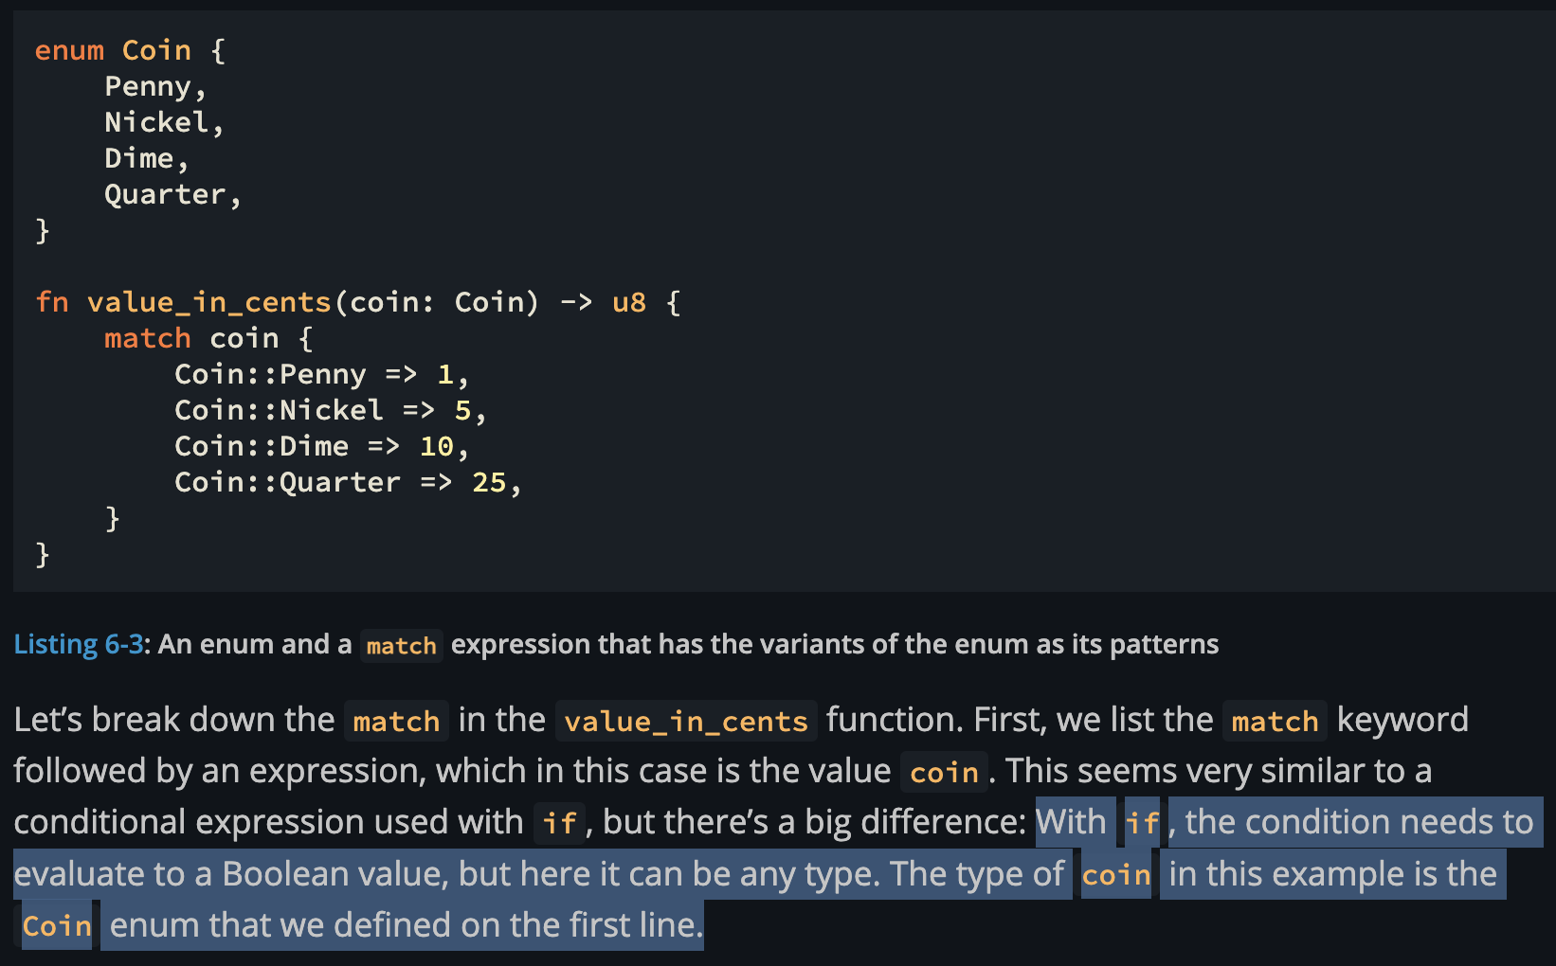
Chapter 8: Common Collections

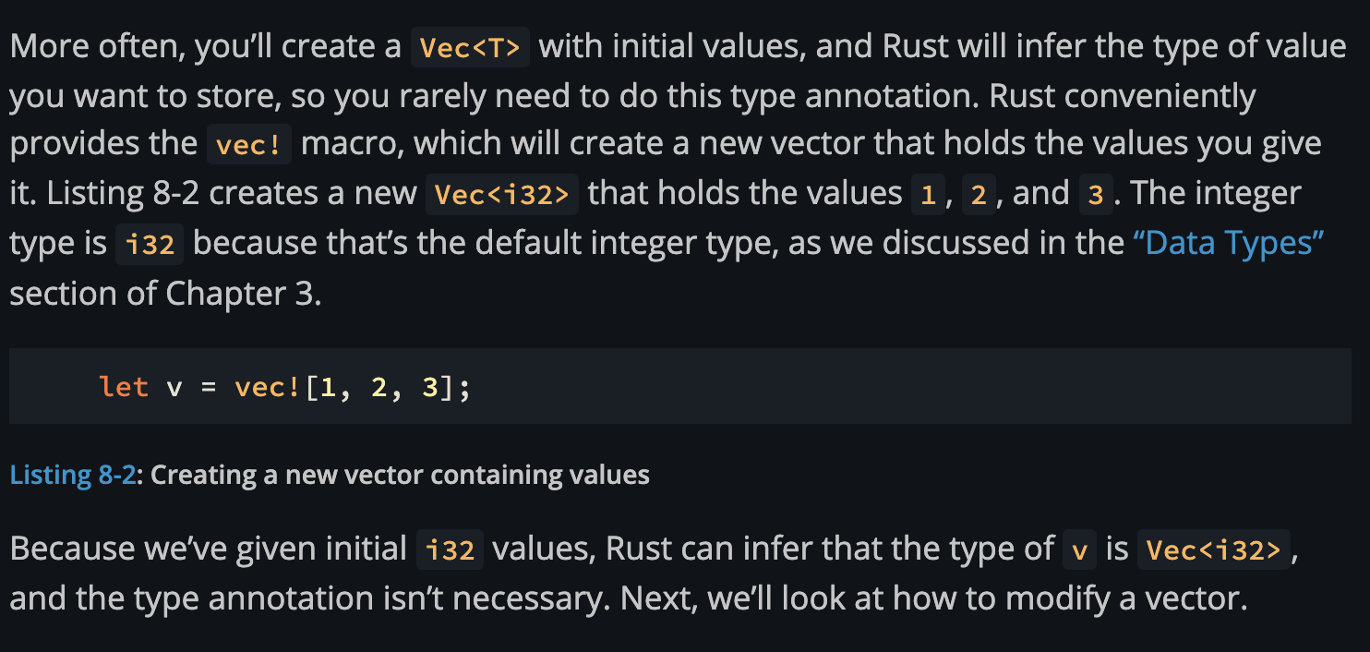

fn earlist_word<'a>(word1: &'a str, word2: &'a str) -> &'a str {
if &word1[..1] < &word2[..1] {
word1
} else {
word2
}
}

fn main() {
let word1 = String::from("apple");
let word2 = String::from("zebra");

let result = earlist_word(&word1, &word2);

// We move/drop word1, rendering 'result' potentially invalid
let word3 = word1;

// ERROR: cannot move out of `word1` because it is borrowed
println!("The earliest word is {}", result);
}

The above code will throw the below error
User: can you tell me what error will i get if i run the code in this file and explain why the error will occur

GitHub Copilot: The active `main` function will produce this error:

```
error[E0505]: cannot move out of `word1` because it is borrowed
--> earlist_word.rs
|
| let result = earlist_word(&word1, &word2);
| ------ borrow of `word1` occurs here
| let word3 = word1;
| ^^^^^ move out of `word1` occurs here
| println!("The earliest word is {}", result);
| ------ borrow later used here
```

**Why it happens:**

1. `earlist_word(&word1, &word2)` borrows both `word1` and `word2` with lifetime `'a`. The returned `result` is tied to that same lifetime — it's a reference that could point to either string.

2. `let word3 = word1;` tries to **move** ownership of `word1` into `word3`. But `word1` is still **borrowed** because `result` holds a reference that might point to it.

3. Rust's borrow checker rejects this: you can't move a value while an active borrow of it exists. The borrow stays alive until the last use of `result`, which is the `println!` below the move.

The fix would be to either drop `result` before moving `word1`, or clone `word1` instead of moving it:
```rust
let word3 = word1.clone(); // borrow of word1 still valid
```

User: 1. `let word3 = word1;` tries to **move** ownership of `word1` into `word3`. But `word1` is still **borrowed** because `result` holds a reference that might point to it.

here how does Rust's borrow checker knows that result` holds a reference that might point to it.

GitHub Copilot: The borrow checker looks purely at the **function signature**, not the function body.

The signature is:
```rust
fn earlist_word<'a>(word1: &'a str, word2: &'a str) -> &'a str
```

This tells the compiler: *"the returned reference lives as long as `'a`, and `'a` is constrained by **both** `word1` and `word2`"*.

The borrow checker does **not** look inside the function to see which branch actually runs. It only sees:

- `result` has lifetime `'a`
- `'a` is tied to **both** `word1` and `word2`
- Therefore, `result` **might** point to `word1`, or it **might** point to `word2`

Since it can't know at compile time which one `result` actually points to (that depends on runtime values), it conservatively assumes **both** borrows must stay alive for as long as `result` is used.

This is intentional — the borrow checker is a **static** analysis tool. It reasons about types and lifetimes, not runtime behavior. If the signature says the output lifetime depends on both inputs, the checker enforces that both inputs remain valid and unmoved for the entire lifetime of the output.

---

**Contrast:** If you had two separate lifetime parameters:
```rust
fn earlist_word<'a, 'b>(word1: &'a str, word2: &'b str) -> &'a str
```
Now the signature says the return **only** depends on `word1`. Moving `word2` would be fine, but moving `word1` would still error. The borrow checker would know `result` can only point to `word1`.

