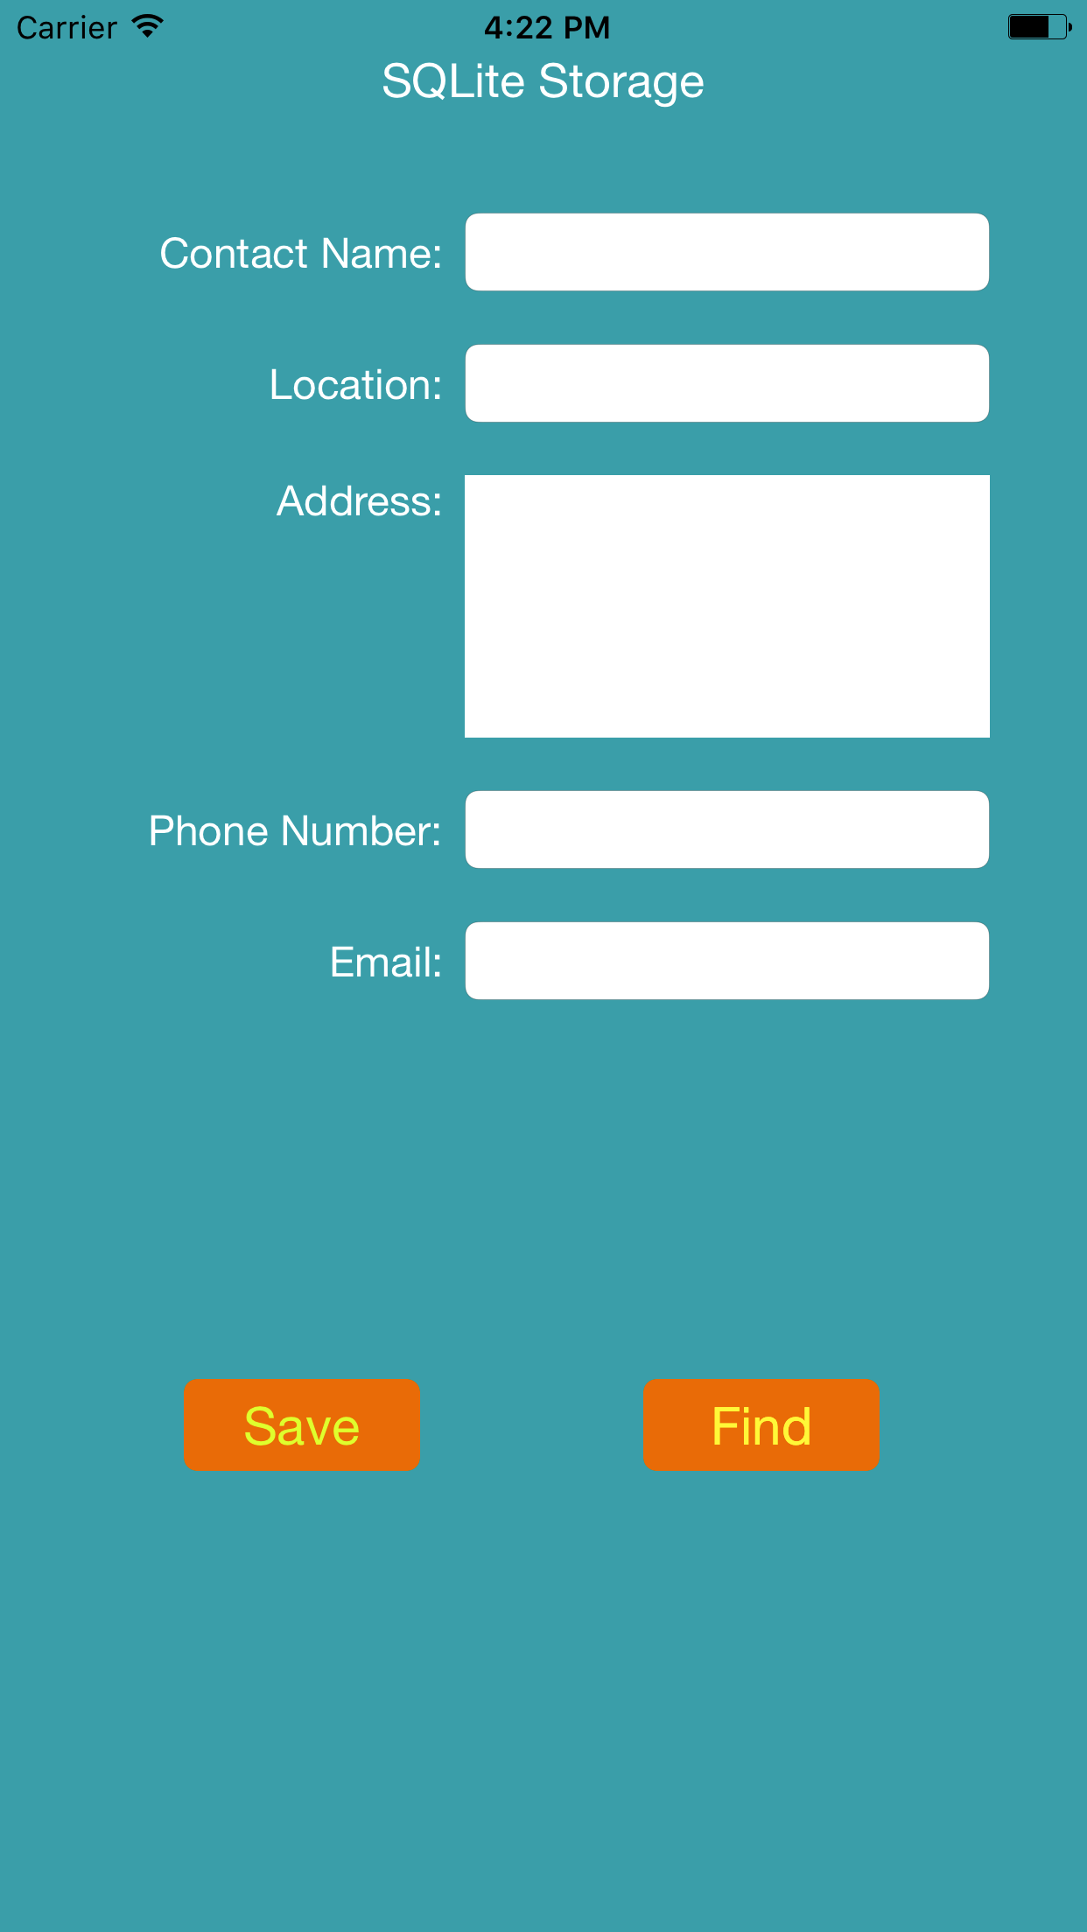

Following screen shows that user records are added to the SQLite database

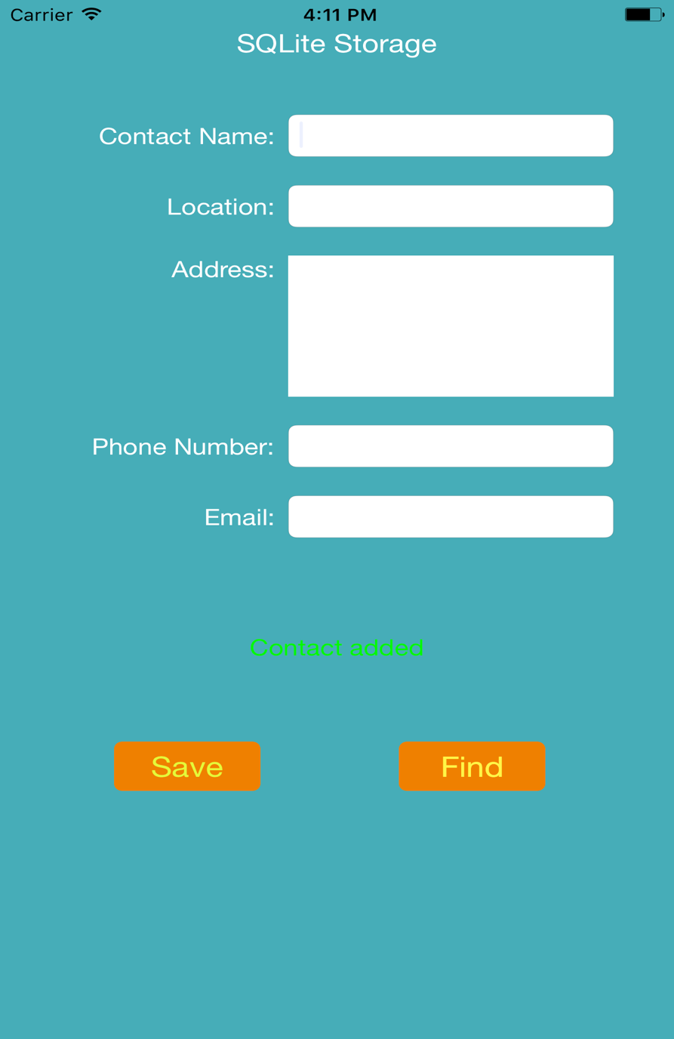

Following screen shows the search feature. Added records can be found if searched by the name.

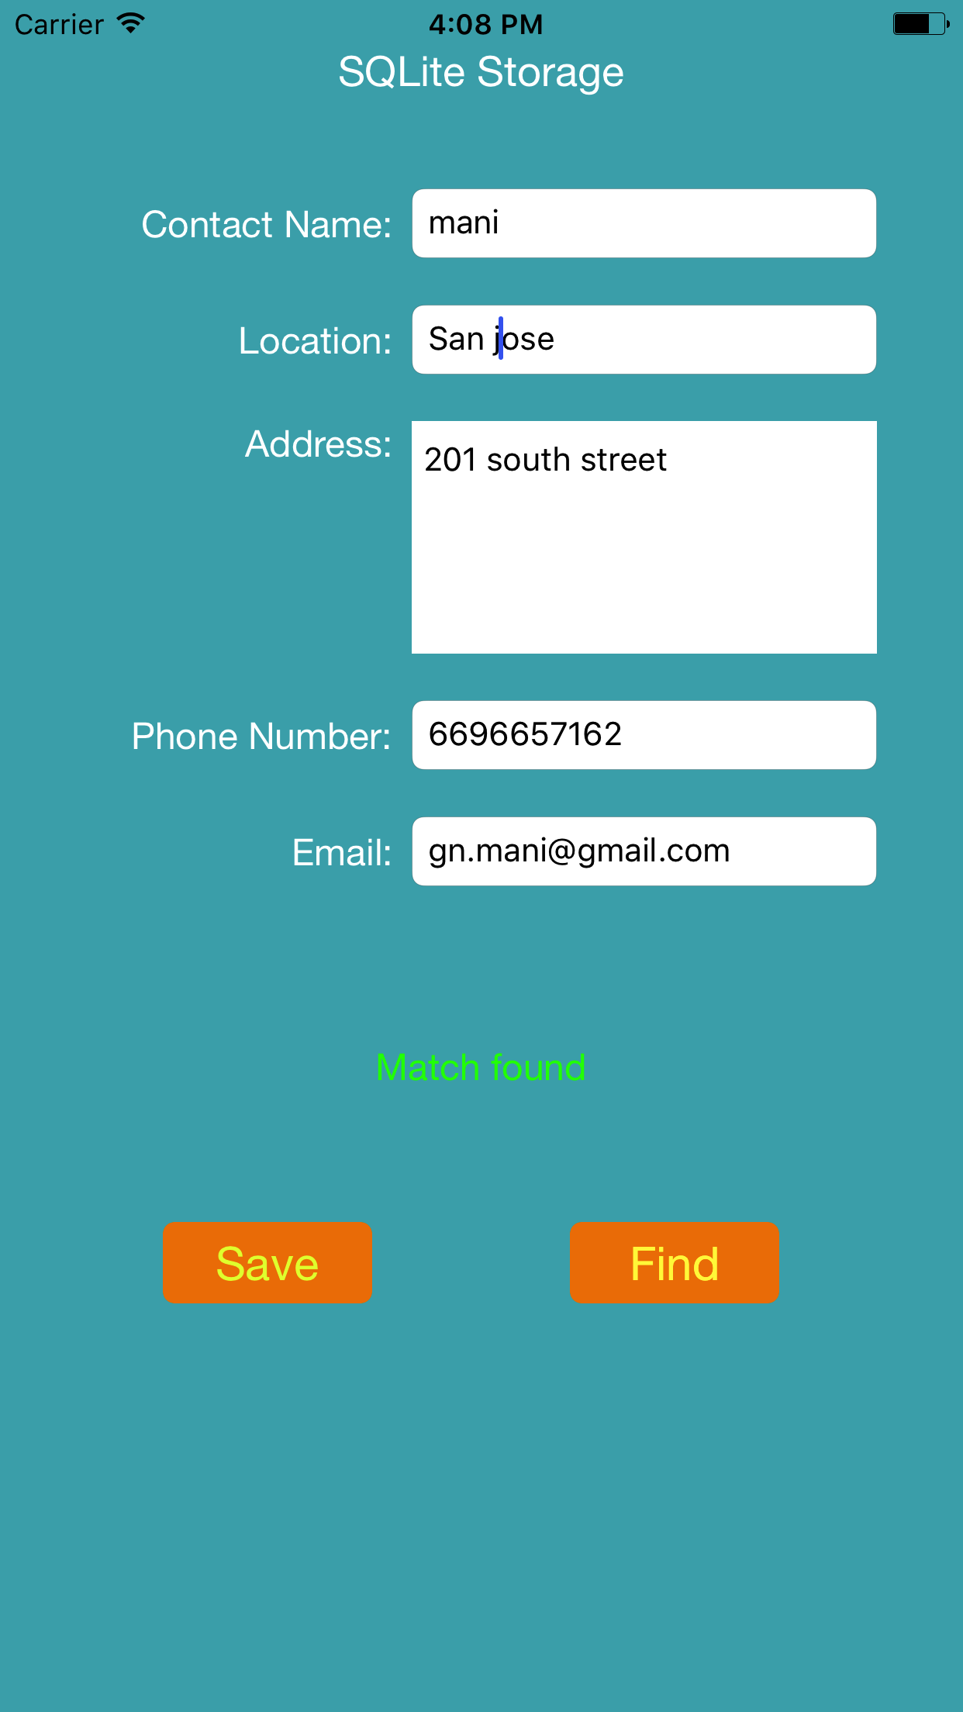

Following screenshot shows the screen if invalid records are searched.

