***AHMEDABAD UNIVERSITY***

**Program Name : B.Tech - ICT**

**Semester : 4th**

**Course Name : Database Management System Lab**

**Project Title : Online Shopping Management**

**System**

**Group Members : Dhara Vora - 1741046**

**Krushna Shah - 1741086**

**Description of Project :**

This is a small project for Online Shopping System. The basic idea is that the customer’s can buy products using online. And the administrator can enter the name and generate the receipt of the purchased product and the administrator can also view the yearly,monthly and daily reports of the products.

This project is an attempt to provide the advantages of online shopping to customers of a real shop. It helps buying the products in the shop anywhere through internet by using an android device. Thus the customer will get the service of online shopping and home delivery from his favorite shop. This system can be implemented to any shop in the locality or to multinational branded shops having retail outlet chains.

The central concept of the application is to allow the customer to shop virtually using the Internet and allow customers to buy the items and articles of their desire from the store. The information pertaining to the products are stores on the MySQL database. The Server process the customers and the items are shipped to the address submitted by them.

The system was designed into two modules, first is administrator who maintains and updates the information of the product. And the second is customer who wish to buy products. Order which are placed by the customer, will store into the database and according to the order detail, bill will be generated and the payment will be paid by the customer. According to our system, administrator can view the different records of the products, orders, bill details and the payments. Like, year wise order details , day wise placed orders , maximum pay mode used by customers , over all order details , etc.

**Relational Diagram :**

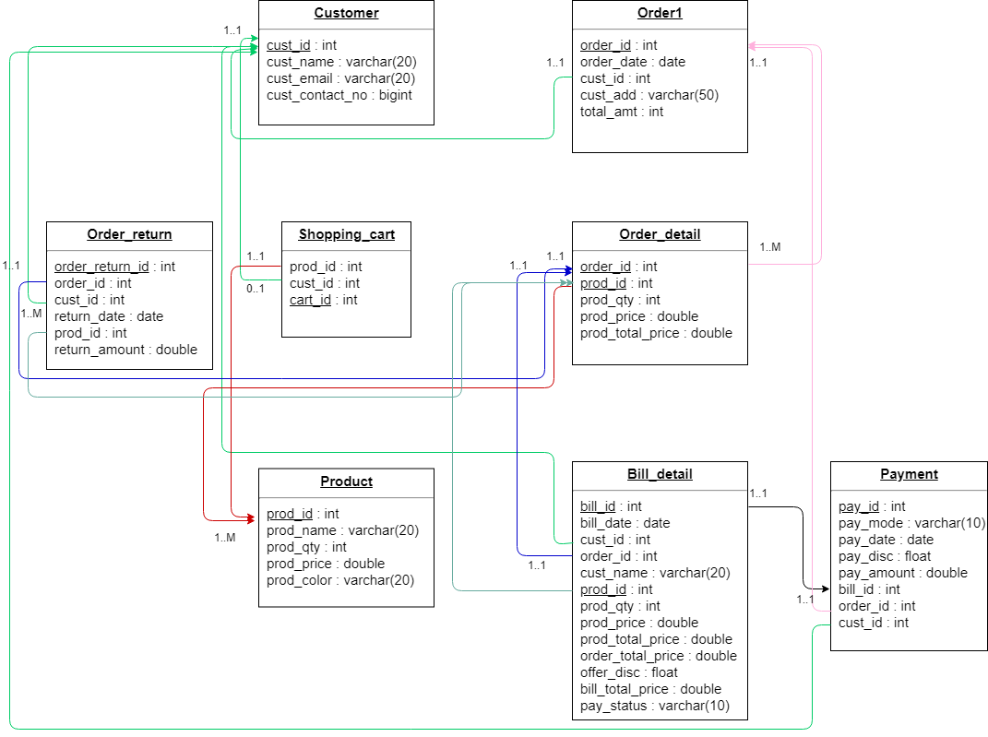

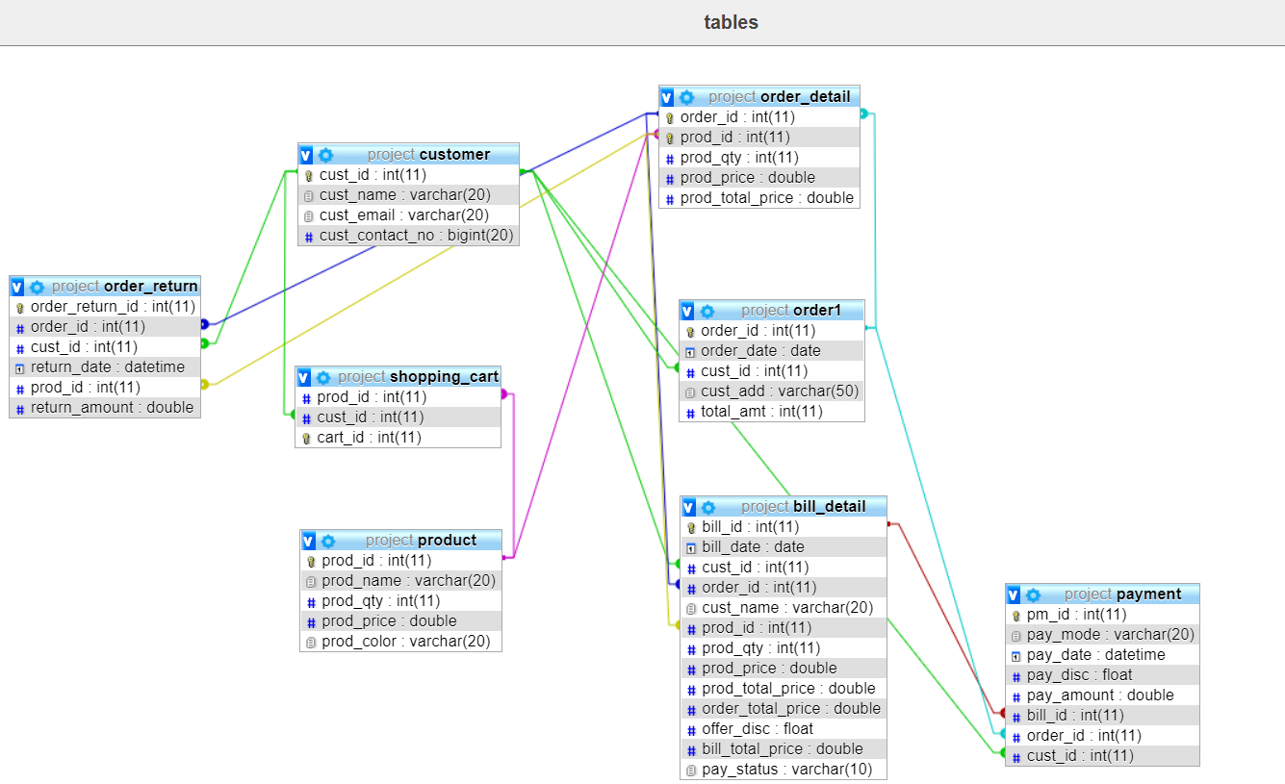

**Stored Procedures :**

**(1). This procedure will insert the product details into the**

**‘order_detail’ table. Only those customer can add the data who**

**has placed the order**.

Delimiter $

drop procedure insert_order_detail$

create procedure insert_order_detail(in order_id int,in pid int,in qty int)

begin

declare prod_total_price,prod_final_price,price, order_total_price double;

declare discount float;

declare id int;

declare b int;

declare cur1 cursor for select prod_id, prod_price from product where prod_id = pid;

declare continue handler for not found set b = 1;

set order_total_price = 0;

open cur1;

set b = 0;

fetch cur1 into id, price;

while b = 0 do

set prod_total_price = price*qty;

insert into order_detail values(order_id, pid, qty, price, prod_total_price);

fetch cur1 into id,price;

end while;

close cur1;

end$

call insert_order_detail(19, 2, 2)$

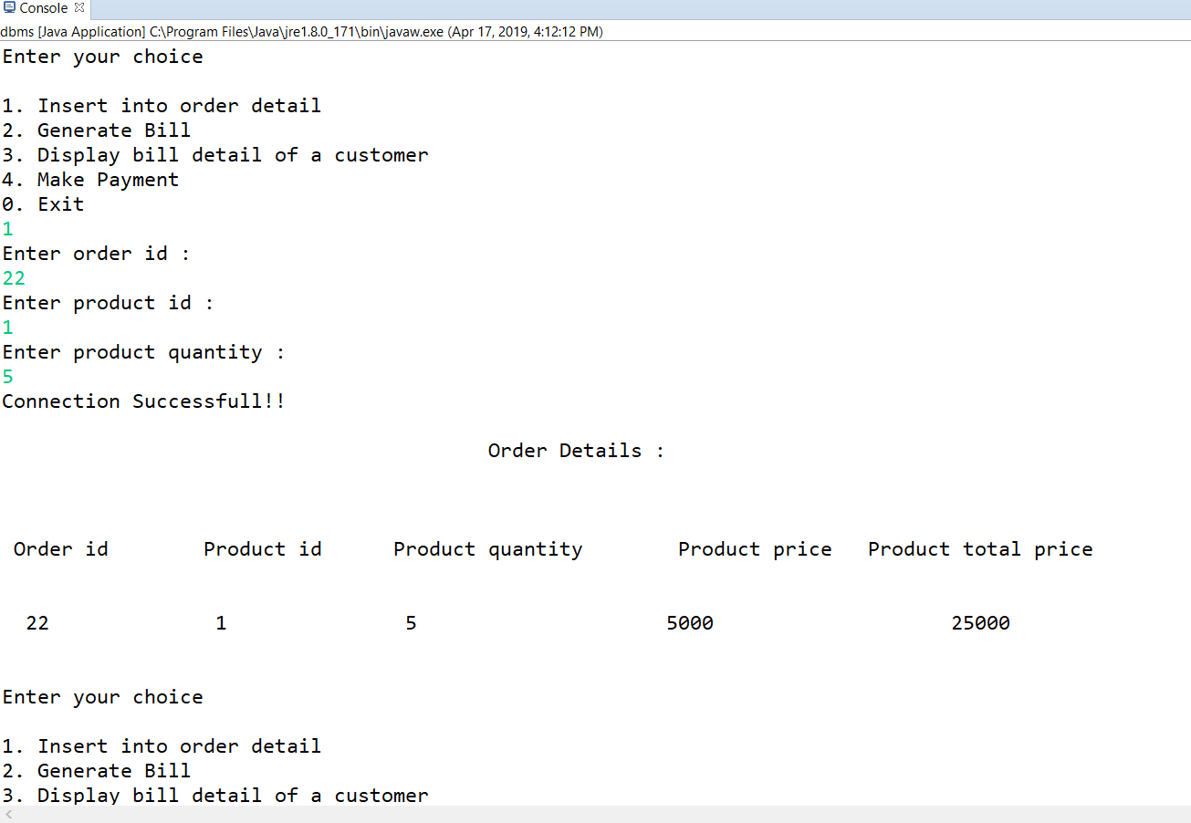

**(2) . This procedure will generate the bill of a customer based on the products purchased.**

Delimiter $

drop procedure generate_bill$

create procedure generate_bill(in oid int, in i int)

begin

declare b,o_id,b_date,day,month,c_id,pid,pqty , out_value int;

declare disc float;

declare btp, pprice,ptotal_price,t_amt double;

declare c_name varchar(20);

declare cur1 cursor for select prod_id,prod_qty,prod_price,prod_total_price from order_detail where oid = order_id;

declare continue handler for not found set b = 1;

open cur1;

set b = 0;

set i = i + 1;

fetch cur1 into pid,pqty,pprice,ptotal_price;

while b = 0 do

select cust_id into c_id from order1 where oid = order1.order_id;

select cust_name into c_name from customer where c_id = cust_id;

select total_amt into t_amt from order1 where oid = order_id;

insert into bill_detail(bill_id,cust_id, order_id, cust_name, prod_id, prod_qty, prod_price, prod_total_price,

order_total_price) values(i,c_id, oid, c_name, pid, pqty,pprice,ptotal_price, t_amt);

select order_date into b_date from order1 where oid = order1.order_id;

update bill_detail set bill_date = b_date where oid = order_id;

set day = extract(day from(b_date));

set month = extract(month from(b_date));

if day = 15 and month = 8 then

set disc = 10.0;

elseif day > 24 and day < 28 and month = 10 then

set disc = 15.0;

elseif day = 14 and month = 1 then

set disc = 20.0;

else

set disc = 5.0;

end if;

update bill_detail set offer_disc = disc where oid = order_id;

set btp = t_amt - (((t_amt)*disc)/100);

update bill_detail set bill_total_price = btp where oid = order_id;

fetch cur1 into pid,pqty,pprice,ptotal_price;

end while;

close cur1;

select * from bill_detail where oid = order_id;

end$

call generate_bill(20, 1)$

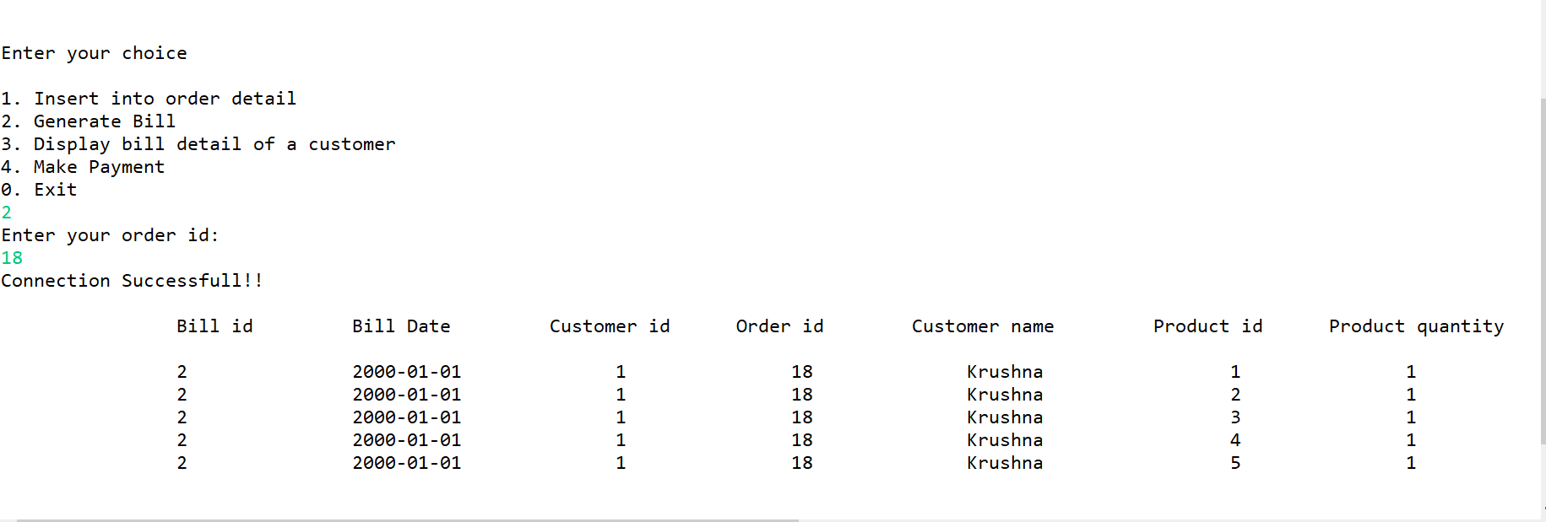

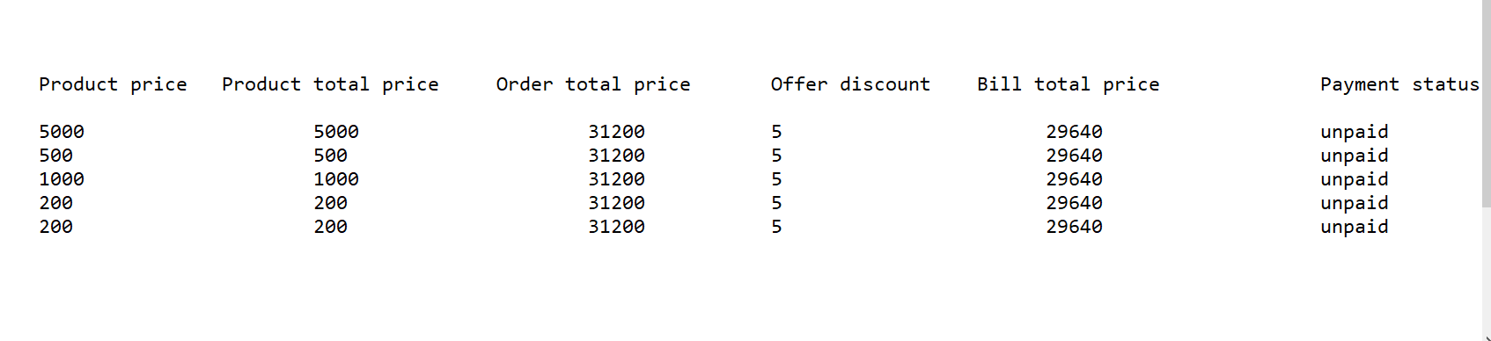

**(3) . This procedure will display the year wise order details to the**

**administrator.**

Delimiter $

drop procedure year_wise_order_detail$

create procedure year_wise_order_detail(year year)

begin

select year;

#select * from order1 where year = extract(year from order1.order_date);

select o.order_id, o.order_date, o.cust_id, o.cust_add, od.prod_id, od.prod_qty, od.prod_price,

od.prod_total_price, o.total_amt from order1 o inner join order_detail od

on o.order_id = od.order_id and year = extract(year from o.order_date) ;

end$

call year_wise_order_detail(2000)$

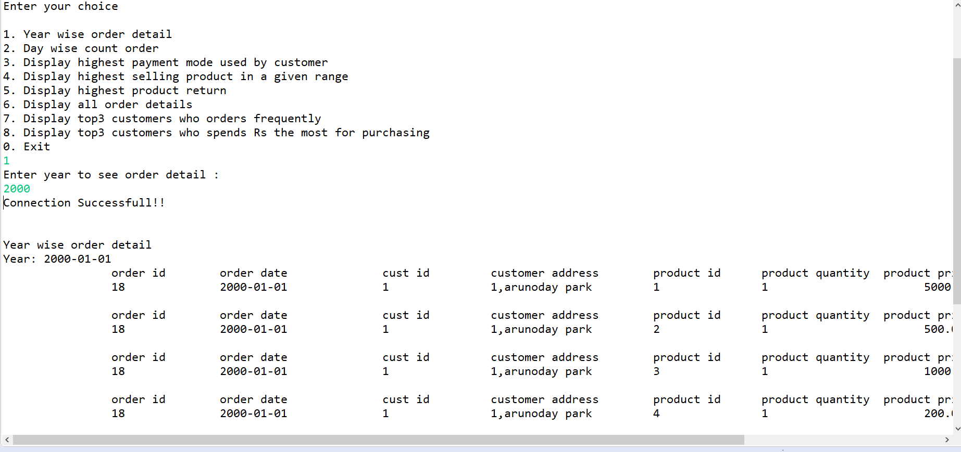

**(4). This procedure will display the customer id wise bill detail to the**

**customer.**

Delimiter $

drop procedure cust_wise_bill_detail$

create procedure cust_wise_bill_detail(in c_id int)

begin

select distinct cust_id,cust_name,order_id from bill_detail where c_id = cust_id;

select prod_id, prod_qty, prod_price, prod_total_price,

order_total_price from bill_detail where c_id = cust_id;

select offer_disc,max(order_total_price),bill_total_price from bill_detail where c_id = cust_id;

end$

call cust_wise_bill_detail(3)$

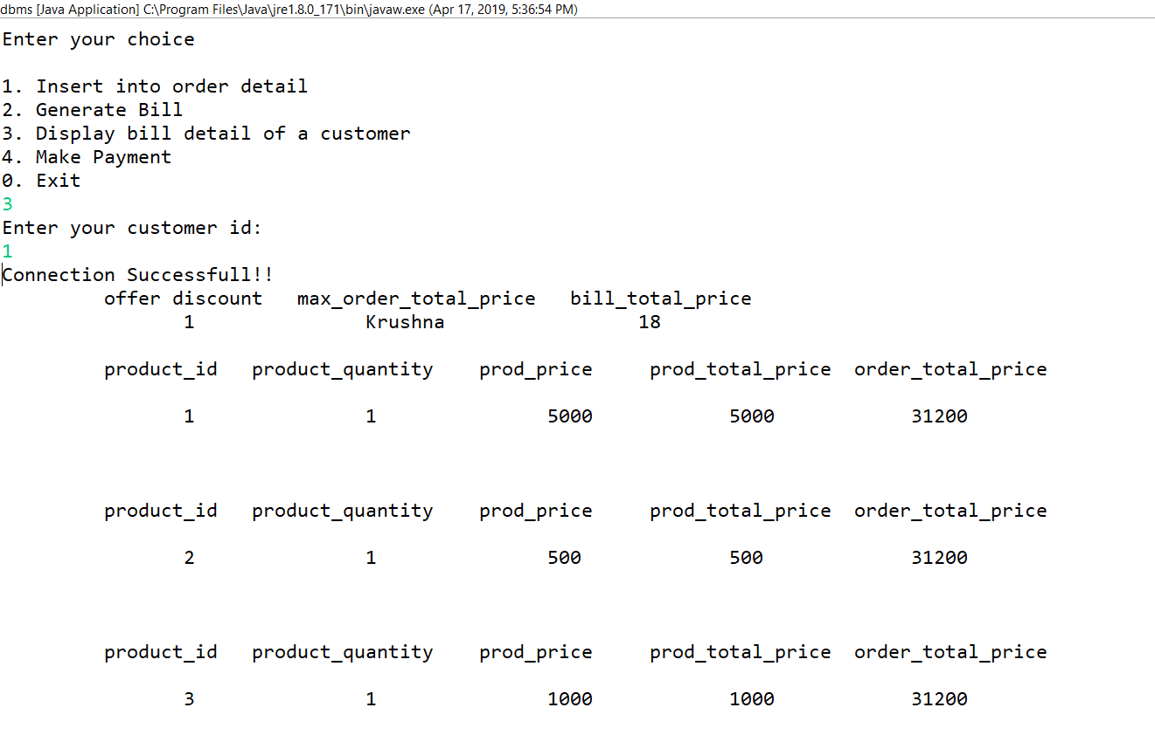

**(5). This procedure will take bill id and the payment mode input from**

**the customer and according to that insert the data into the**

**payment table and according to the bill total amount , offer**

**discount will be generated and display the final amount.**

Delimiter $

drop procedure payment$

create procedure payment(in b_id int, in pay_mode varchar(20))

begin

declare cid,oid int;

declare btp double;

declare disc float;

declare note varchar(40);

declare bdate date;

declare pm_amount double;

select bill_total_price into btp from bill_detail where b_id = bill_id;

select cust_id into cid from bill_detail where b_id = bill_id;

select order_id into oid from bill_detail where b_id = bill_id;

select bill_date into bdate from bill_detail where b_id = bill_id;

if btp >1000 then

if pay_mode = 'cc' then

set disc = 10;

set note = 'Remain valid till 5 days!!';

select disc 'Discount' ;

select note 'Note';

elseif pay_mode = 'cod' then

set disc = 5;

set note = 'Remain valid till 3 days!!';

select disc 'Discount' ;

select note 'Note';

else

set disc = 0;

set note = 'No Discount';

end if;

end if;

set pm_amount = btp - (btp*disc/100);

insert into payment(pay_mode,pay_date,pay_disc,pay_amount,bill_id,order_id,cust_id) values(pay_mode,bdate,disc,pm_amount,b_id,oid,cid);

end$

call payment(23, 'cc')$

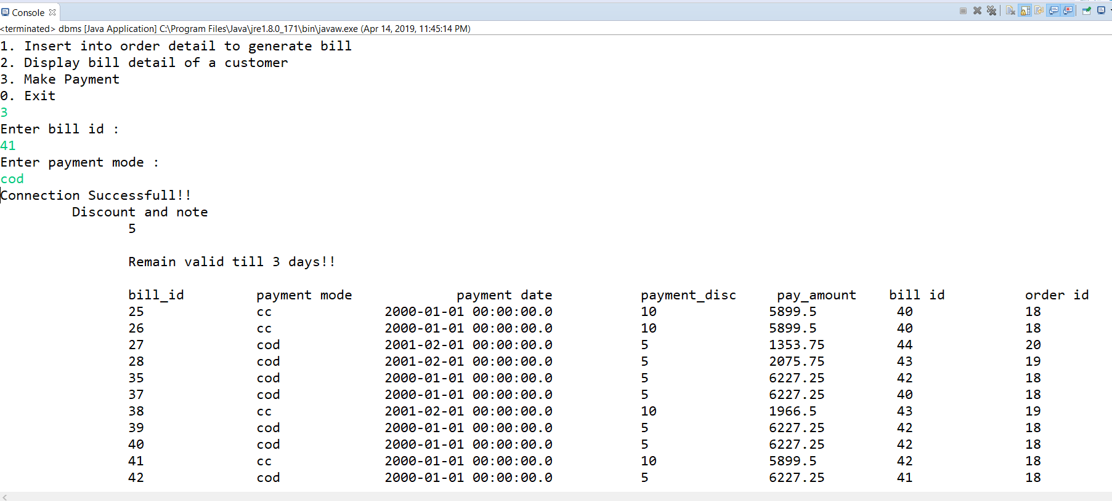

**(6). This procedure will display the payment_mode which was more**

**used by the customers.**

Delimiter $

drop procedure pay_mode$

create procedure pay_mode()

begin

declare cnt int;

select count(pay_mode) into cnt from payment group by pay_mode order by count(pay_mode) desc limit 1;

select pay_mode, count(pay_mode) from payment group by pay_mode having count(pay_mode) = cnt order by count(pay_mode);

end$

call pay_mode$

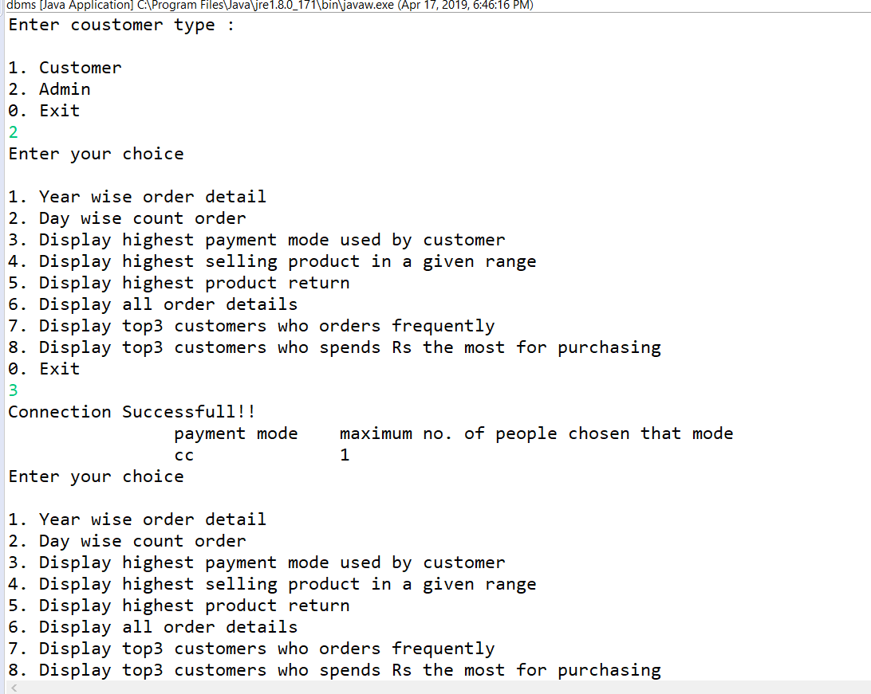

**(7) . This procedure will display the product which was highest sold.**

Delimiter $

drop procedure highest_sell$

create procedure highest_sell(in to_date date,in from_date date)

begin

declare o_date date;

declare b,cnt int;

declare cur1 cursor for select order_date from order1,order_detail where

order1.order_id = order_detail.order_id and order_date >= to_date and order_date <= from_date;

declare continue handler for not found set b = 1;

open cur1;

set b = 0;

fetch cur1 into o_date;

select order_id,prod_id,prod_qty from order_detail;

select sum(order_detail.prod_qty) into cnt from order_detail,product where order_detail.prod_id = product.prod_id

group by order_detail.prod_id order by sum(order_detail.prod_qty) desc limit 1;

select order_detail.prod_id as 'Product ID', product.prod_name as 'Product Name',

sum(order_detail.prod_qty) as 'Maximum quantity sold' from order_detail,product

where order_detail.prod_id = product.prod_id group by order_detail.prod_id

having sum(order_detail.prod_qty) = cnt order by sum(order_detail.prod_qty);

close cur1;

end$

call highest_sell('2000-02-02','2002-02-02')$

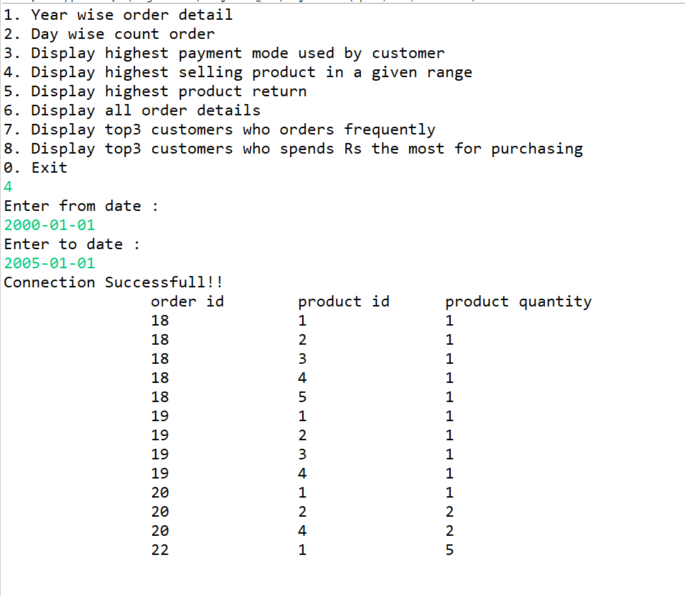

**(8). This procedure will display the product which was highest return**

**by the different or same customers.**

Delimiter $

drop procedure highest_prod_return$

create procedure highest_prod_return()

begin

declare cnt int;

select count(prod_id) into cnt from order_return group by prod_id order by count(prod_id) desc limit 1;

select prod_id, count(prod_id) from order_return group by prod_id having count(prod_id) = cnt order by count(prod_id);

end$

call highest_prod_return$

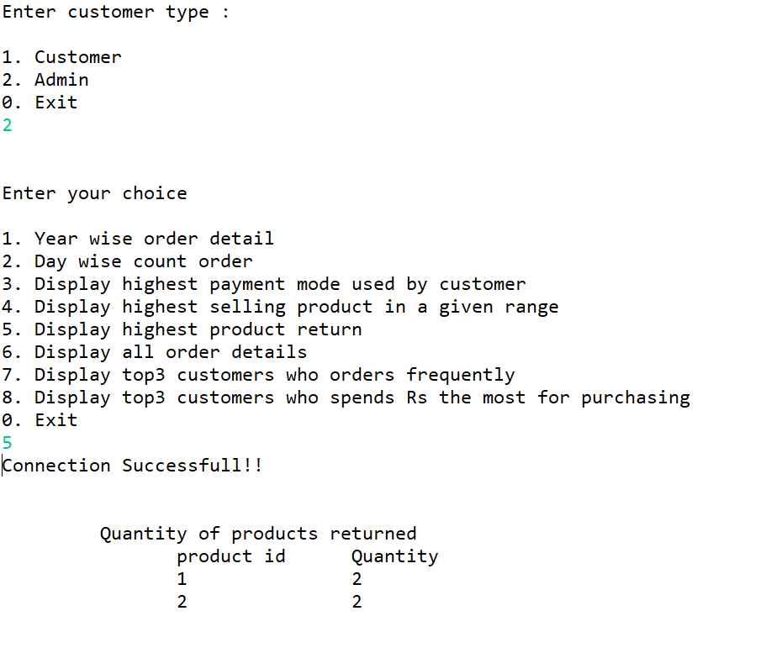

**(9). This procedure will manage the products which are in the**

**shopping Cart. As soon as the shopping cart product will add into**

**the order detail, the product will be delete from the shopping cart.**

Delimiter $

drop procedure manage_shopping_cart$

create procedure manage_shopping_cart(in pid int, in cid int)

begin

delete from shopping_cart where prod_id = pid and cust_id = cid;

end$

Call manage_shopping_cart$

**NOTE**: This procedure is being called from the trigger (i.e. after insert on order_detail).

**(10). This procedure will display the overall order details based on year**

**and month.**

Delimiter $

drop procedure orderdetail$

create procedure orderdetail()

begin

declare b int;

declare odate date;

declare cur1 cursor for select order1.order_date from order1 inner join order_detail

on order1.order_id= order_detail.order_id group by order_detail.order_id order by order1.order_date;

declare continue handler for not found set b = 1;

open cur1;

set b = 0;

fetch cur1 into odate;

while b = 0 do

select extract(year from odate);

select extract(month from odate);

select * from order1 inner join order_detail on order1.order_id = order_detail.order_id

where order1.order_date = odate;

fetch cur1 into odate;

end while;

close cur1;

end$

call orderdetail$

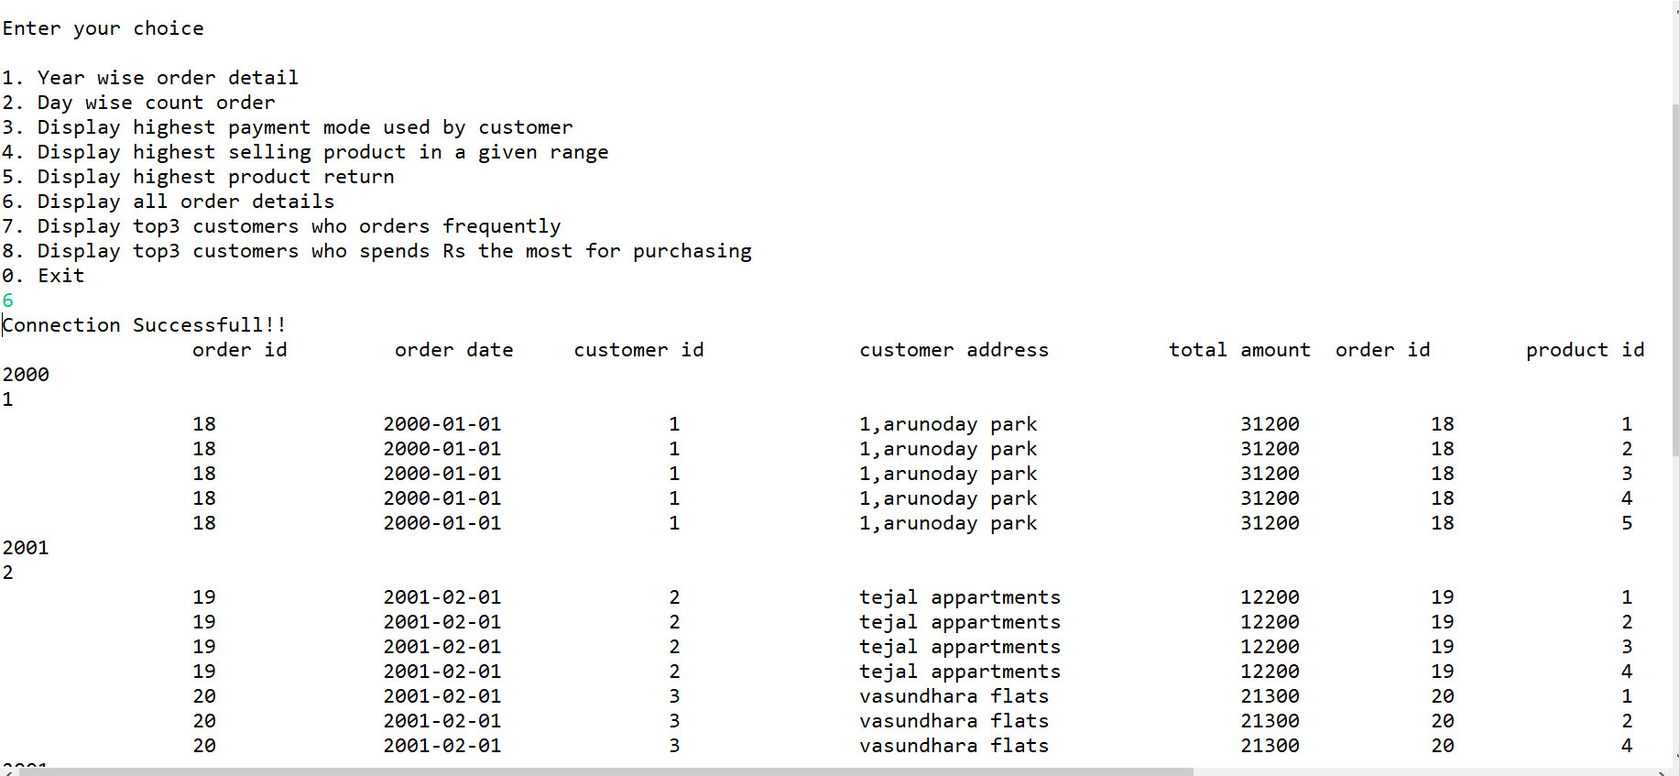

**(11). This procedure will display the list of top 3 customers who orders more frequently.**

Delimiter $

drop procedure top3_customers_based_on_order$

create procedure top3_customers_based_on_order()

begin

declare count int;

select distinct order1.cust_id, customer.cust_name, count(order_detail.order_id) as count from order1,customer,order_detail

where order1.order_id = order_detail.order_id and customer.cust_id = order1.cust_id

group by order1.cust_id order by count(order_detail.order_id) desc limit 3;

end$

call top3_customers_based_on_order$

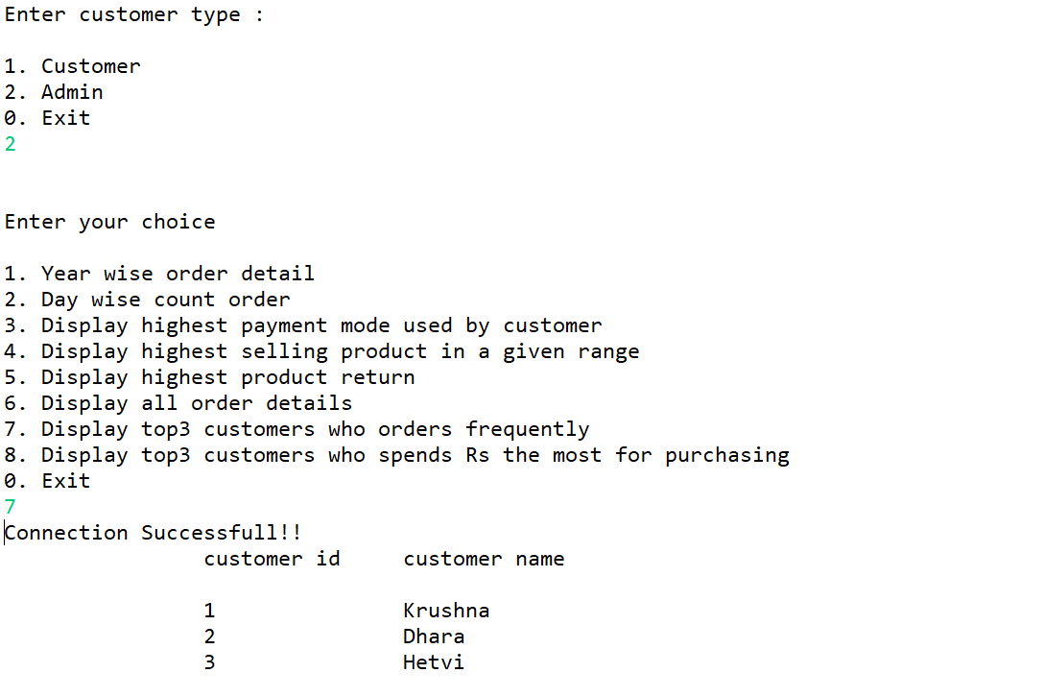

**(12). This procedure will display top 3 customers who spends more money for purchasing the products.**

Delimiter $

drop procedure top3_customers_based_on_amount$

create procedure top3_customers_based_on_amount()

begin

select distinct order1.cust_id, customer.cust_name, total_amt from order1, order_detail, customer

where order1.order_id = order_detail.order_id and customer.cust_id = order1.cust_id order by total_amt desc limit 3;

end$

call top3_customers_based_on_amount$

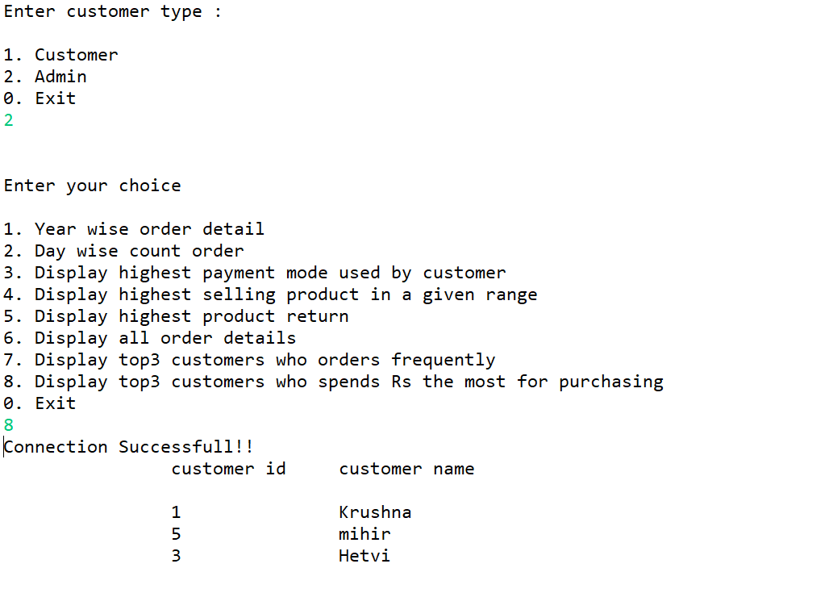

**Stored Function :**

**(1). This function will return the number of orders placed in a given day.**

Delimiter $

drop function day_wise_cnt_order$

create function day_wise_cnt_order(date date) returns int

begin

declare order_cnt int;

#select date;

select count(distinct order1.order_id) into order_cnt from order1 inner join order_detail

on order1.order_id = order_detail.order_id and date = order1.order_date group by order_date;

return (order_cnt);

end$

Select day_wise_cnt_order(‘2001-02-02’)$

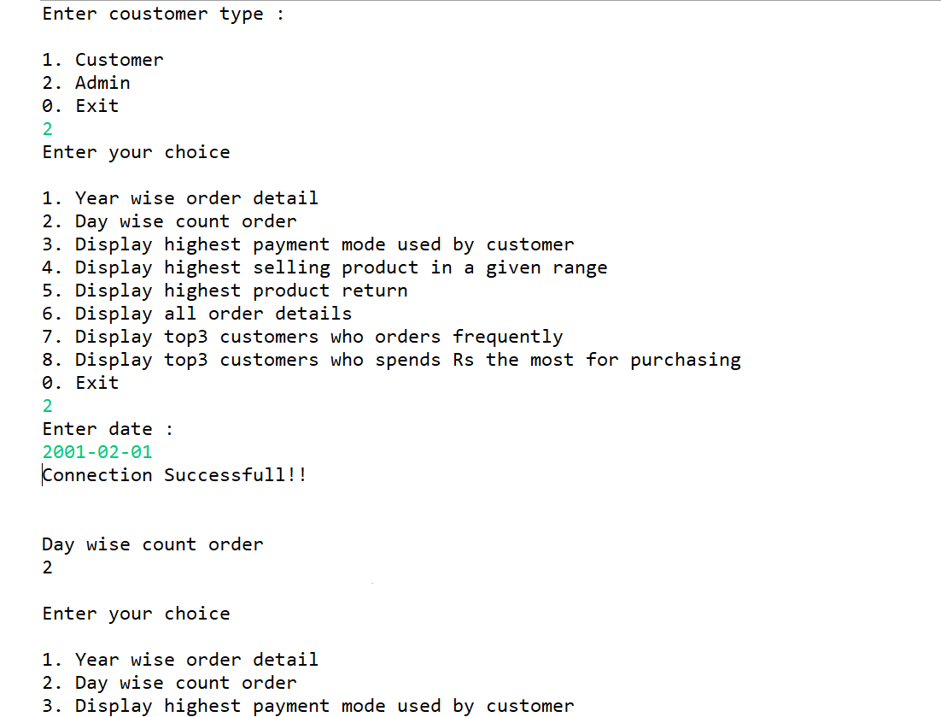

**Stored Triggers :**

**(1). This trigger will fired after insert on the order detail table. This**

**trigger Will update the total amount value in the order table,**

**update the , Product quantity in the product table and insert data**

**into the bill details.**

delimiter $

drop trigger err_ins1$

create trigger err_ins1 after insert on order_detail

for each row

begin

declare c_id int;

update order1 set total_amt = total_amt + new.prod_total_price where order_id=new.order_id;

update product set prod_qty = prod_qty - new.prod_qty where prod_id = new.prod_id;

select cust_id into c_id from order1 where order1.order_id = new.order_id;

call manage_shopping_cart(new.prod_id, c_id);

end$

call insert_order_detail(20,1,1)$

**(2). This trigger will fired if the customer’s desired quantity is greater**

**than the total available quantity.**

delimiter $

drop trigger err_ins2$

create trigger err_ins2 before insert on order_detail

for each row

begin

declare msg varchar(128);

declare p_qty int;

select distinctrow product.prod_qty into p_qty from product inner join order_detail on new.prod_id = product.prod_id;

#set pid = select prod_id from product where prod_id = new.prod_id;

if p_qty < new.prod_qty then

set msg = 'Not enough quantity.....';

elseif new.prod_qty < 0 then

set msg = 'Quantity can not be negative.....';

end if;

signal sqlstate '45001' set message_text = msg;

end$

**(3). This trigger will update the payment status after the payment**

**make by the customer.**

Delimiter $

drop trigger pay_status$

create trigger pay_status after insert on payment

for each row

begin

update bill_detail set pay_status = 'Paid' where bill_id = new.bill_id;

end$

**(4). This trigger will update the product quantity in the product table**

**after the order return.**

delimiter $

drop trigger qty_return$

create trigger qty_return after insert on order_return

for each row

begin

declare p_qty int;

select prod_qty into p_qty from order_detail where order_detail.order_id = new.order_id and order_detail.prod_id = new.prod_id;

update product set prod_qty = prod_qty + p_qty where prod_id = new.prod_id;

end$