LIYANAGE N.D.G. EG/2023/5706

EC5202 – Digital Systems Design with HDL
2:1 Multiplexer Design and Verification

- Verilog Module

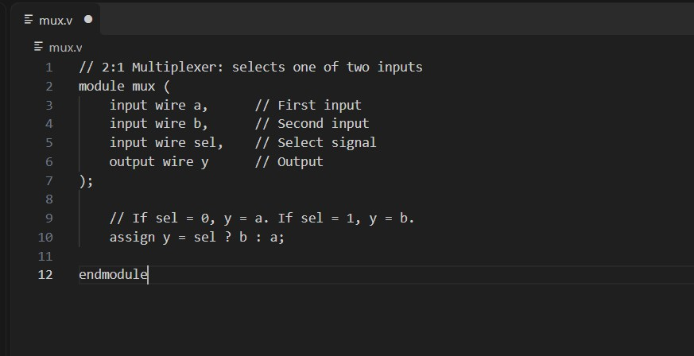

- Test Bench Code
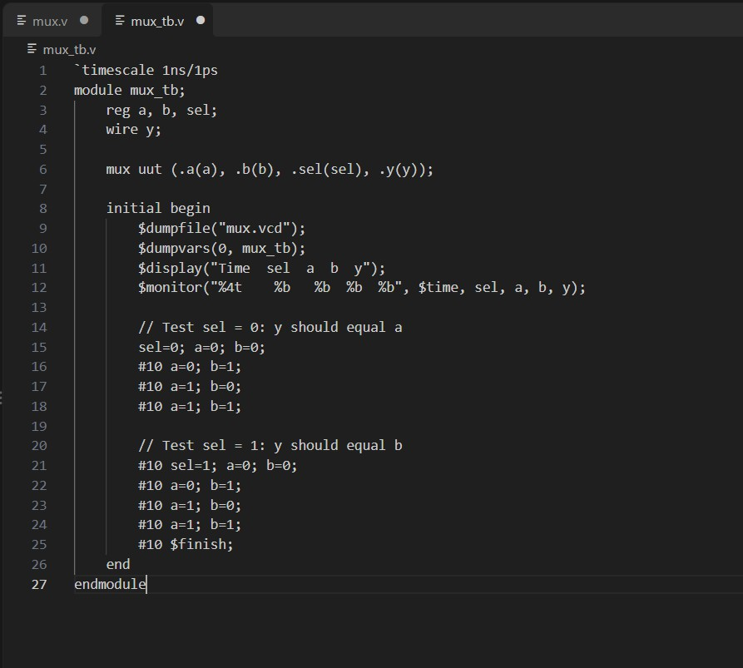

- Output in cmd

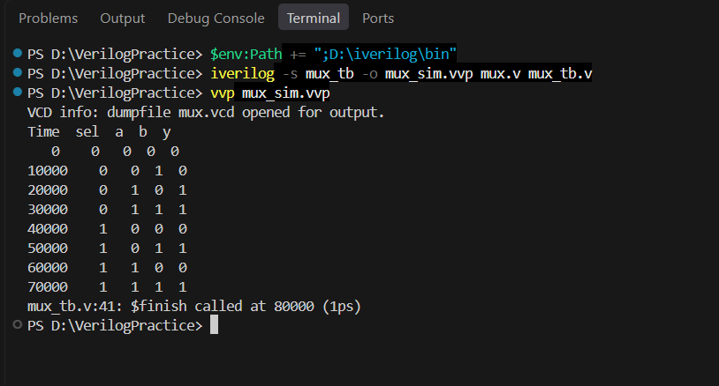

- Waveform
