Assignment:
Introduction to Dynamic Programming

NAME : [Your Name]
REG No. : [Your Registration No.]
SEMESTER : 04
DATE : 22/09/2026

Table of Contents
Introduction 3
Source Code Snippets 4
Running Time Table 7
Performance Graphs 8
Discussion & Analysis 9

Introduction
The problem is called Climbing Stairs. A staircase has n steps. Each time, you can climb 1 step or 2 steps. The task is to find in how many different ways the top can be reached.
To reach step n, the last move must have come from step n − 1 (a 1-step move) or step n − 2 (a 2-step move), so Ways(n) = Ways(n − 1) + Ways(n − 2), with Ways(1) = 1 and Ways(2) = 2. For example, Ways(3) = 3 and Ways(4) = 5.
Dynamic Programming is effective here because the problem has overlapping subproblems (the same smaller value of Ways(k) is needed many times) and optimal substructure (the answer for n is built directly from the answers for n − 1 and n − 2).
Three solutions were implemented in C++: naive recursion, memoization (top-down) and tabulation (bottom-up). Each was benchmarked across a range of input sizes and the empirical timings are compared against the theoretical complexity of each approach. unsigned long long is used throughout so that the large Fibonacci-like values for n up to 90 do not overflow.

Source Code Snippets
Header files
5 #include <iostream>
6 #include <vector>
7 #include <chrono>
8 using namespace std;
9 using namespace std::chrono;
Naive Recursive Approach
16 unsigned long long naiveApproach(int n) {
17 if (n <= 2) return n;
18 return naiveApproach(n - 1) + naiveApproach(n - 2);
19 }
Memoization (Top-Down DP)
27 unsigned long long memoizationApproach(int n, vector<unsigned long long>& memo) {
28 if (n <= 2) return n;
29 if (memo[n] != 0) return memo[n];
30 memo[n] = memoizationApproach(n - 1, memo) + memoizationApproach(n - 2, memo);
31 return memo[n];
32 }

Tabulation (Bottom-Up DP)
40 unsigned long long tabulationApproach(int n) {
41 if (n <= 2) return n;
42 vector<unsigned long long> table(n + 1);
43 table[1] = 1;
44 table[2] = 2;
45 for (int i = 3; i <= n; ++i) {
46 table[i] = table[i - 1] + table[i - 2];
47 }
48 return table[n];
49 }
The main function (benchmarking loop)
51 int main() {
52 int sizes[] = {10, 20, 30, 40, 45, 50, 60, 70, 80, 90};
53 cout << "n,ways,naive_us,memo_us,tab_us" << endl;
54
55 for (int n : sizes) {
56 unsigned long long naiveAnswer = 0, memoAnswer = 0, tabAnswer = 0;
57 double naiveTime = -1;
58
59 // Naive recursion: only test up to n = 45 (O(2^n) is otherwise unusable).
60 // Small n is repeated many times so the timer has enough signal.
61 if (n <= 45) {
62 int runs = 1;
63 if (n <= 10) runs = 1000000;
64 else if (n <= 20) runs = 100000;
65 else if (n <= 30) runs = 100;
66 auto t1 = steady_clock::now();
67 for (int i = 0; i < runs; ++i) {
68 naiveAnswer = naiveApproach(n);
69 }
70 auto t2 = steady_clock::now();
71 naiveTime = duration<double, micro>(t2 - t1).count() / runs;
72 }
73
74 // Memoization
75 auto t1 = steady_clock::now();
76 for (int i = 0; i < 1000000; ++i) {
77 vector<unsigned long long> memo(n + 1, 0);
78 memoAnswer = memoizationApproach(n, memo);
79 }
80 auto t2 = steady_clock::now();
81 double memoTime = duration<double, micro>(t2 - t1).count() / 1000000;
82
83 // Tabulation
84 t1 = steady_clock::now();
85 for (int i = 0; i < 1000000; ++i) {
86 tabAnswer = tabulationApproach(n);
87 }
88 t2 = steady_clock::now();
89 double tabTime = duration<double, micro>(t2 - t1).count() / 1000000;
90
91 // Sanity check: all three approaches must agree.
92 if (memoAnswer != tabAnswer || (n <= 45 && naiveAnswer != tabAnswer)) {
93 cerr << "Mismatch at n=" << n << endl;
94 }
95
96 cout << n << "," << tabAnswer << ","
97 << (naiveTime >= 0 ? to_string(naiveTime) : "-1") << ","
98 << memoTime << "," << tabTime << endl;
99 }
100 return 0;
101 }

Running Time Table
The program was compiled with g++ 13.3.0 (-O2, C++17) and actually executed to produce the timings below; naive recursion, memoization and tabulation are timed separately using std::chrono::steady_clock, and small/fast cases are averaged over many repeated runs so the timer has enough resolution.
claude@dev:~/dpproj$ g++ -O2 -std=c++17 -o climbing_stairs climbing_stairs.cpp && ./climbing_stairs
n,ways,naive_us,memo_us,tab_us
10,89,0.050348,0.0377704,0.0209591
20,10946,8.590134,0.0911212,0.0249527
30,1346269,1073.973760,0.223785,0.0286521
40,165580141,112559.915000,0.348357,0.0327845
45,1836311903,1370731.245000,0.411798,0.0327504
50,20365011074,-1,0.474649,0.0345785
60,2504730781961,-1,0.602674,0.038743
70,308061521170129,-1,0.720348,0.0413461
80,37889062373143906,-1,0.854213,0.0452748
90,4660046610375530309,-1,0.990592,0.049434

Table 1: Comparative execution times (in microseconds) of Naive Recursion, Memoization, and Tabulation across varying input sizes (n)
n | Ways(n) | Naive (µs) | Memoization (µs) | Tabulation (µs)
10 | 89 | 0.0503 | 0.0378 | 0.0210
20 | 10,946 | 8.590 | 0.0911 | 0.0250
30 | 1,346,269 | 1,073.97 | 0.2238 | 0.0287
40 | 165,580,141 | 112,559.9 | 0.3484 | 0.0328
45 | 1,836,311,903 | 1,370,731.2 | 0.4118 | 0.0328
50 | 20,365,011,074 | not tested | 0.4746 | 0.0346
60 | 2,504,730,781,961 | not tested | 0.6027 | 0.0387
70 | 308,061,521,170,129 | not tested | 0.7203 | 0.0413
80 | 37,889,062,373,143,906 | not tested | 0.8542 | 0.0453
90 | 4,660,046,610,375,530,309 | not tested | 0.9906 | 0.0494

Performance Graphs
At n = 45, naive recursion took about 1,370,731 µs (roughly 1.37 seconds), while memoization took only 0.41 µs and tabulation 0.033 µs. Plotting all three on one linear-scale graph would force the Y-axis up into the millions, leaving the memoization and tabulation lines flattened against the bottom and unreadable. The results are therefore split across two graphs, both using the real measured values from Table 1.
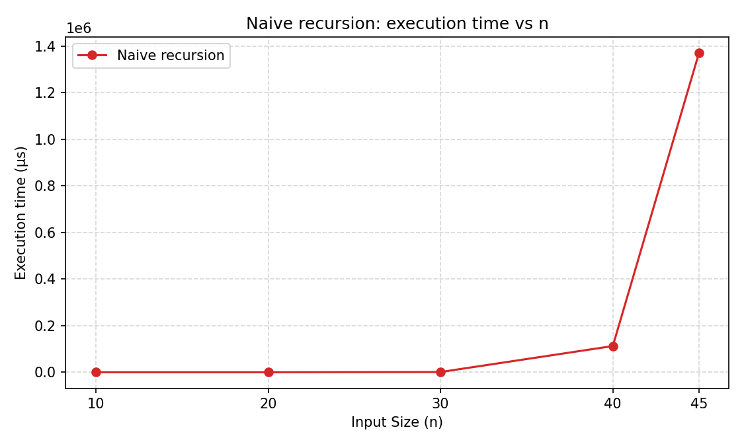
Figure 1: Naive recursion execution time vs input size (n)
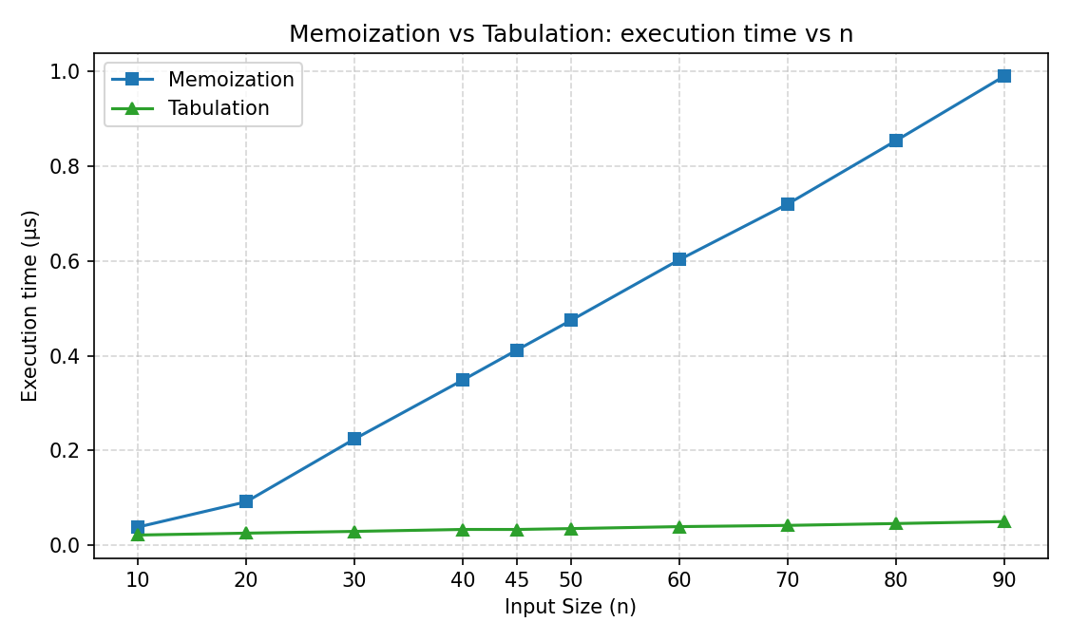
Figure 2: Memoization vs Tabulation execution time vs input size (n)

Discussion & Analysis
Why does the naive recursive approach perform so poorly compared to the others?
Naive recursion recomputes the same subproblems repeatedly: computing Ways(n) calls Ways(n − 1) and Ways(n − 2), but Ways(n − 1) itself calls Ways(n − 2) again, so smaller values are recalculated many times over. The number of calls roughly doubles the recursion tree at every level, giving O(2ⁿ) growth. The measured results show this clearly: from n = 20 to 30 the naive time increased by about 125×, from n = 30 to 40 by about 105×, and from n = 40 to 45 by about 12×. At n = 45 naive recursion needed roughly 1.37 seconds for a single call, while memoization needed 0.41 µs and tabulation only 0.033 µs — naive recursion is already about 3 million times slower than tabulation at that size.
What is the theoretical Big-O time and space complexity for each of the three approaches? Do your empirical graphs reflect these theoretical limits?
Approach | Time | Space
Naive recursion | O(2ⁿ) | O(n) — recursion stack depth
Memoization | O(n) | O(n) — memo vector + O(n) recursion stack
Tabulation | O(n) | O(n) for the table (reducible to O(1) with two variables)

The empirical graphs match these bounds well. The naive-recursion curve (Figure 1) stays low up to about n = 30 and then rises steeply, consistent with exponential O(2ⁿ) growth. Memoization and tabulation (Figure 2) both stay under 1 µs even at n = 90 and grow only gently: going from n = 10 to n = 90 (a 9× increase in n), memoization grew about 26× and tabulation about 2.4×. Both are far below the millions-of-times growth naive recursion shows over a similar range, and are broadly consistent with linear O(n) growth once the small fixed overhead of allocating a vector on every call is accounted for. Space-wise, all three approaches use O(n) in this implementation — naive recursion through its call stack, memoization through its call stack plus memo vector, and tabulation through its table array, which could be reduced to O(1) by keeping only the last two values instead of the full array.
Was there a noticeable performance difference between Top-Down (Memoization) and Bottom-Up (Tabulation) in C++? If so, why might this be?
Yes. Tabulation was faster than memoization at every tested size. At n = 90, memoization took 0.99 µs versus tabulation's 0.049 µs — about 20× faster — and the gap widened as n grew. Both approaches are O(n), so the difference comes from constant-factor overhead rather than complexity class. Memoization still performs actual function calls (building and tearing down a stack frame for roughly 2n calls) and checks the memo vector on every call, whereas tabulation is a single straight-line loop with no recursive call overhead and no cache-check branch. This matches the general expectation that bottom-up DP is usually a little faster than top-down DP in a compiled language like C++, even though both share the same asymptotic time complexity.

Conclusion
Dynamic Programming turns an unusably slow solution into a fast one. Naive recursion gives the correct answer but becomes impractical past about n = 45, where it already takes over a second. Memoization and tabulation both solve n = 90 in under 1 µs. Both share O(n) time complexity, but tabulation was consistently faster in these tests because a plain loop avoids the overhead of recursive function calls. The measured results align with the theoretical expectations for all three approaches, and together they show why storing previously computed answers — whether top-down or bottom-up — is so valuable.

