Case Study Report



**Tech Saksham**

Data Analytics with Power BI

**“An analysis of unemployment in Republic India”**

**“Urumu Dhanalakshmi College, Tiruchirappalli - 19”**

|  |  |
| --- | --- |
| **NM ID** | **NAME** |
| 5FB531BD8D30786A1F941F3A8F19E0D7 | **N.MANIKANDAN** |

|  |  |
| --- | --- |
|  |  |
|  | Trainer Name Ms. UMAMAHESWARI |
|  | Master Trainer |

**ABSTRACT**

In the digital age, data has become an invaluable asset for businesses, particularly in the banking sector. The proposed project, “Analysis of Unemployment in Republic of India” aims to leverage PowerBI, a leading business intelligence tool, to analyze and visualize real-time un- employment data. This project will enable an organization or a government to gain deep insights into un-employment, The real-time analysis will allow a government or an organization to identify the total number of persons who are unemployed.

**INDEX**

|  |  |  |
| --- | --- | --- |
| **Sr. No.** | **Table of Contents** | **Page No.** |
| 1 | Chapter 1: Introduction | 4 |
| 2 | Chapter 2: Services and Tools Required | 6 |
| 3 | Chapter 3: Project Architecture | 7 |
| 4 | Chapter 4: Modeling and Result | 9 |
| 5 | Conclusion | 18 |
| 6 | Future Scope | 19 |
| 7 | References | 20 |
| 8 | Links | 21 |

**CHAPTER 1**

**INTRODUCTION**

* 1. **Problem Statement**

The term unemployment refers to a situation where a person actively [searches for employment](https://www.investopedia.com/financial-edge/0711/9-different-ways-to-find-a-new-job.aspx) but is unable to find work. Unemployment is considered to be a key measure of the health of the economy. The most frequently used measure of unemployment is the [unemployment rate](https://www.investopedia.com/terms/u/unemploymentrate.asp). It's calculated by dividing the number of unemployed people by the number of people in the labor force. Many governments offer unemployment insurance to certain unemployed individuals who meet eligibility requirements. For the task mentioned above, this project would be useful in finding out and analyzing the data related to unemployment.

* 1. **Proposed Solution**

The proposed solution is to develop a PowerBI dashboard that can analyze and visualize real-time unemployment data. The dashboard will comprise a detailed insight into unemployment status. The dashboard will be interactive, user-friendly, and customizable, allowing an organization or a government to tailor it to their specific needs. The real-time analysis capability of the dashboard will enable an organization or a government to respond promptly to changes in the status of unemployment.

* 1. **Feature**
* **Real-Time Analysis**: The dashboard will provide real-time analysis of customer data.
* **Unemployment**: It will segregate the unemployment data based on various parameters like age, gender, etc.
* **Trend Analysis**: The dashboard will identify and display trends in unemployment status.
* **Predictive Analysis**: It will use historical data to predict future unemployment status.
  1. **Advantages**
* **Data-Driven Decisions**: An organization or Government can make decisions based on real-time data analysis.

.

* 1. **Scope**

The project can be further extended to incorporate more data sources and advanced analytics techniques, such as machine learning and artificial intelligence, to provide more sophisticated insights into unemployment status.

**CHAPTER 2**

**SERVICES AND TOOLS REQUIRED**

**2.1 Services Used**

* **Data Collection and Storage Services**: Banks need to collect and store customer data in real-time. This could be achieved through services like Azure Data Factory, Azure Event Hubs, or AWS Kinesis for real-time data collection, and Azure SQL Database or AWS RDS for data storage.
* **Data Processing Services**: Services like Azure Stream Analytics or AWS Kinesis Data Analytics can be used to process the real-time data.
* **Machine Learning Services**: Azure Machine Learning or AWS SageMaker can be used to build predictive models based on historical data.

**2.2 Tools and Software used**

**Tools**:

* **PowerBI**: The main tool for this project is PowerBI, which will be used to create interactive dashboards for real-time data visualization.
* **Power Query**: This is a data connection technology that enables you to discover, connect, combine, and refine data across a wide variety of sources.

**Software Requirements**:

* **PowerBI Desktop**: This is a Windows application that you can use to create reports and publish them to PowerBI.
* **PowerBI Service**: This is an online SaaS (Software as a Service) service that you use to publish reports, create new dashboards, and share insights.
* **PowerBI Mobile**: This is a mobile application that you can use to access your reports and dashboards on the go.

**CHAPTER 3**

**PROJECT ARCHITECTURE**

**3.1 Architecture**

Here’s a high-level architecture for the project:

1. **Data Collection**: Real-time customer data is collected from various sources like bank transactions, customer interactions, etc. This could be achieved using services like Azure Event Hubs or AWS Kinesis.
2. **Data Storage**: The collected data is stored in a excel database
3. **Data Processing**: The stored data is processed in real-time using Power BI
4. **Data Visualization**: The processed data and the results from the predictive models are visualized in real-time using PowerBI. PowerBI allows you to create interactive dashboards that can provide valuable insights into the data.
5. **Data Access**: The dashboards created in PowerBI can be accessed through PowerBI Desktop, PowerBI Service (online), and PowerBI Mobile.

**CHAPTER 4**

**MODELING AND RESULT**

**Manage relationship**

**There are two table such as people-with-age-details and people-with-unemployment. The following show the relationship the between these two tables.**

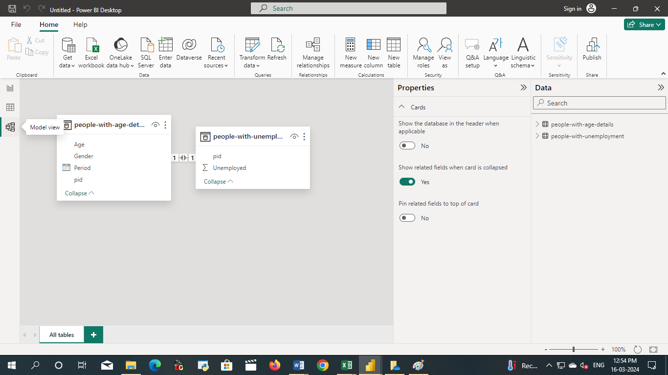

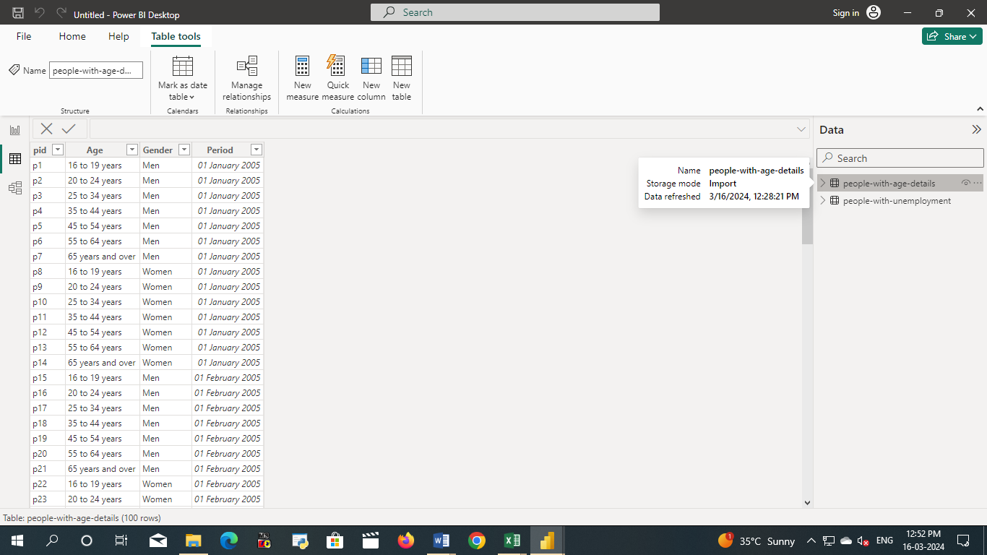

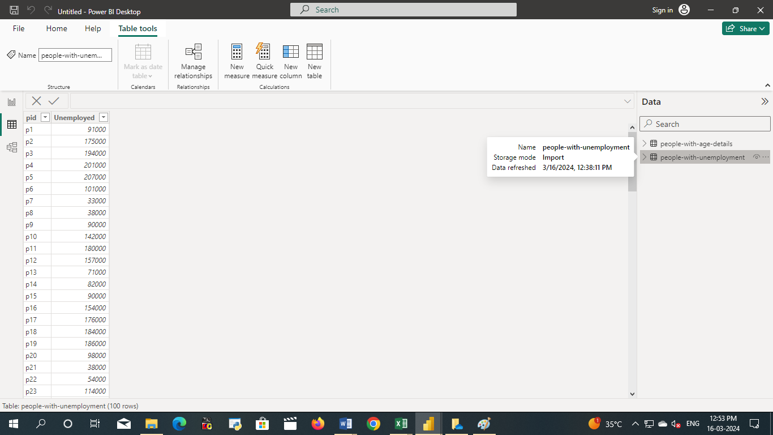



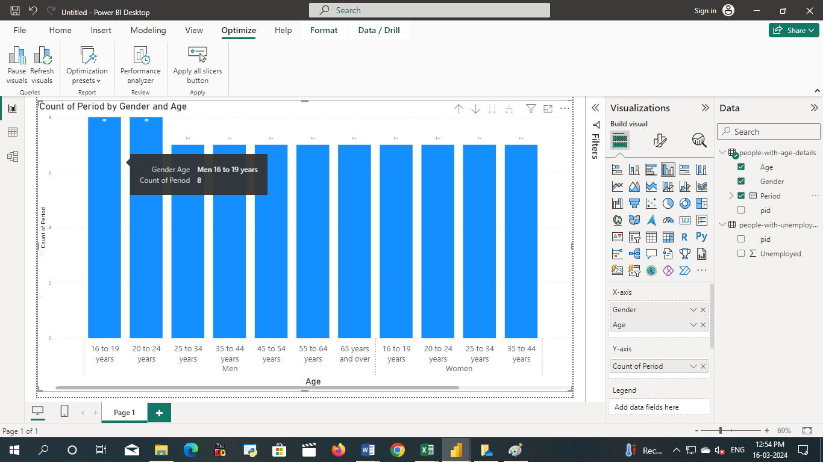

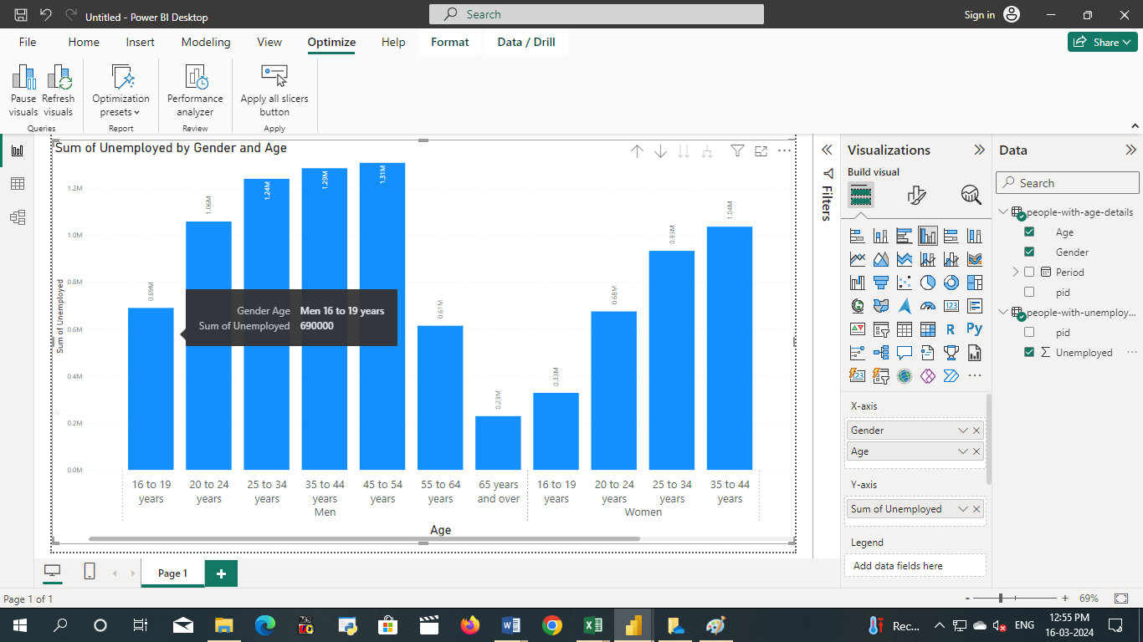

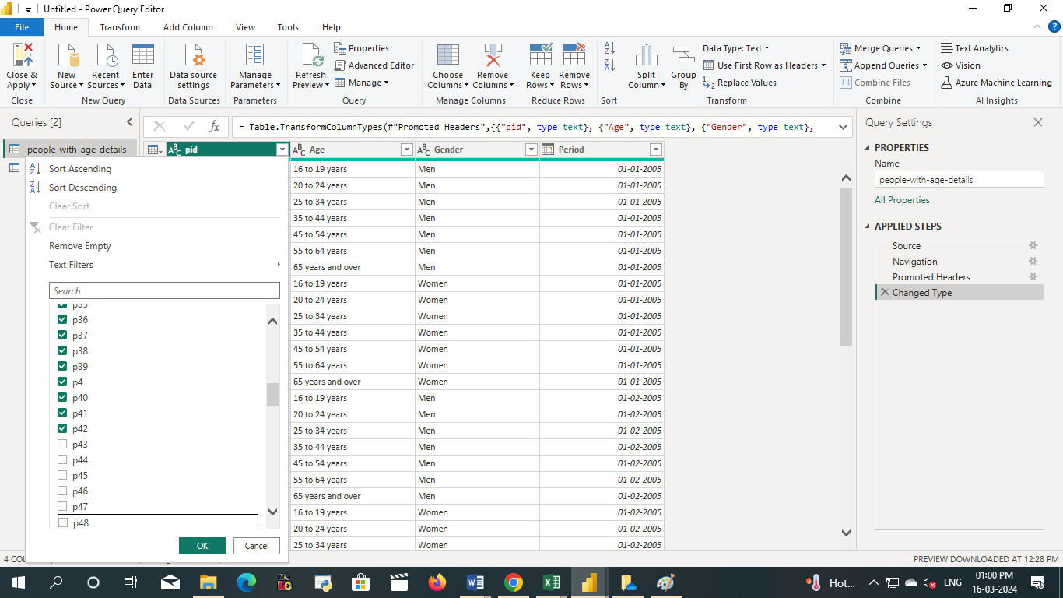

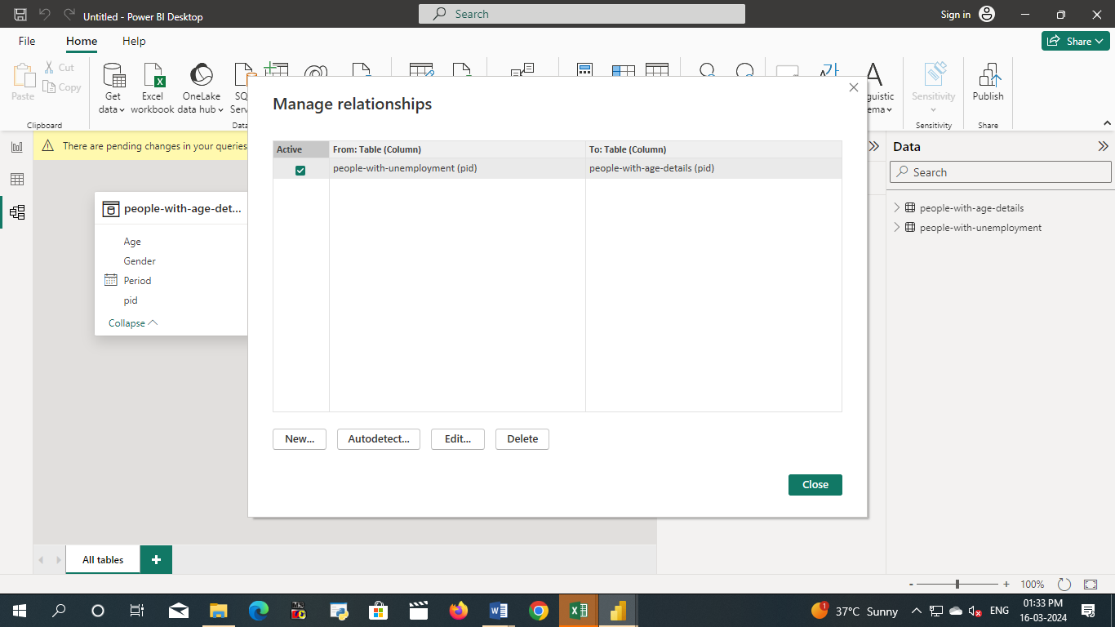

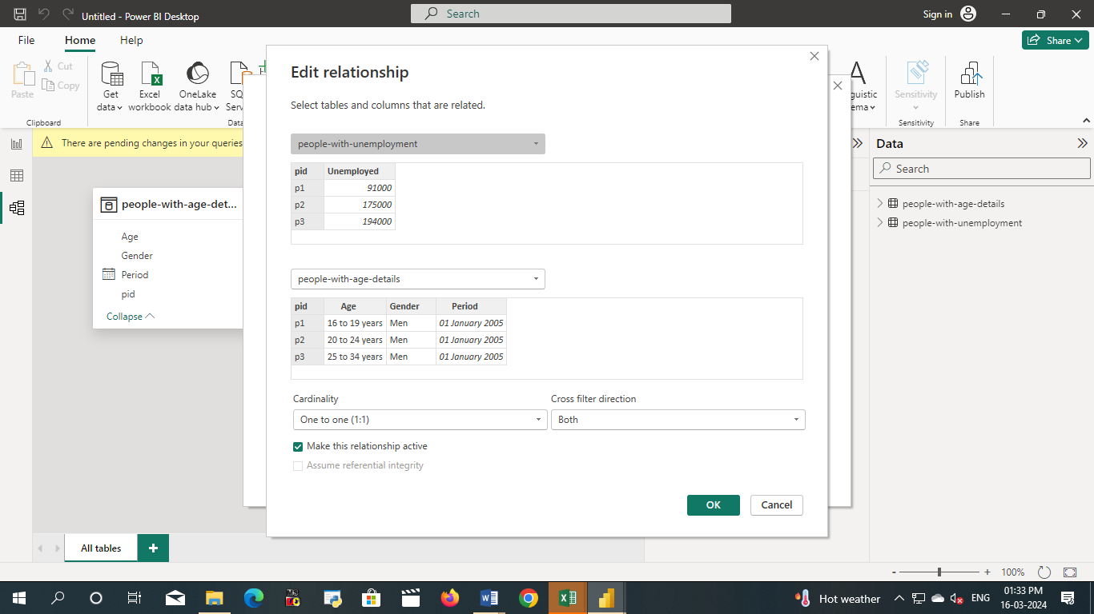

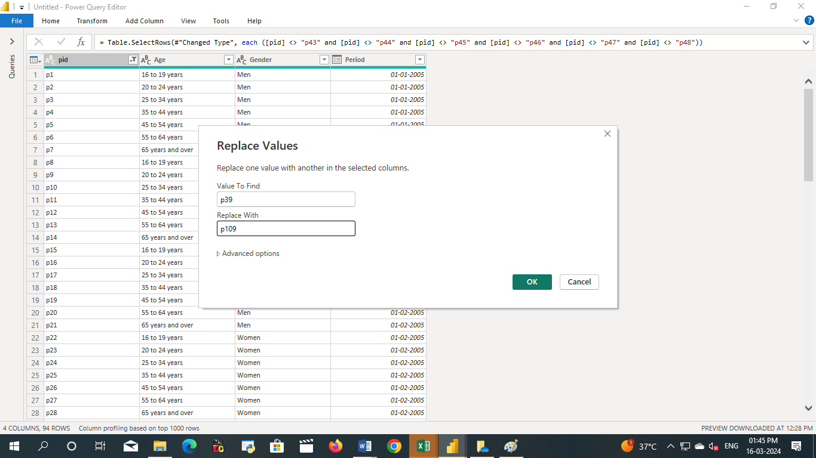

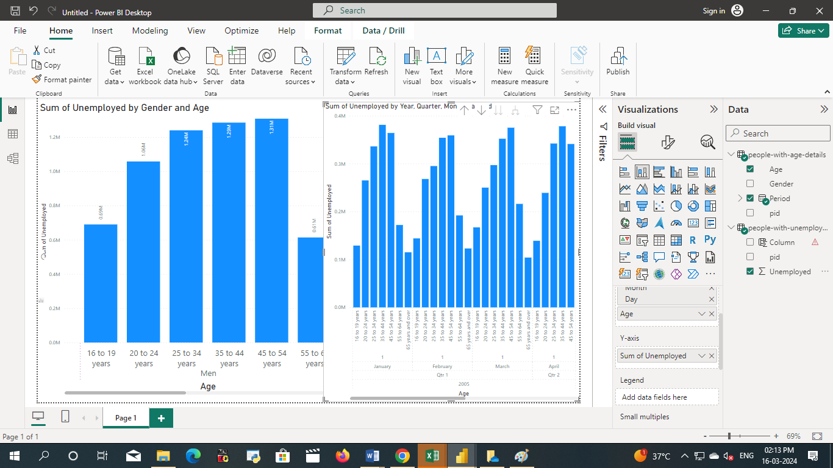

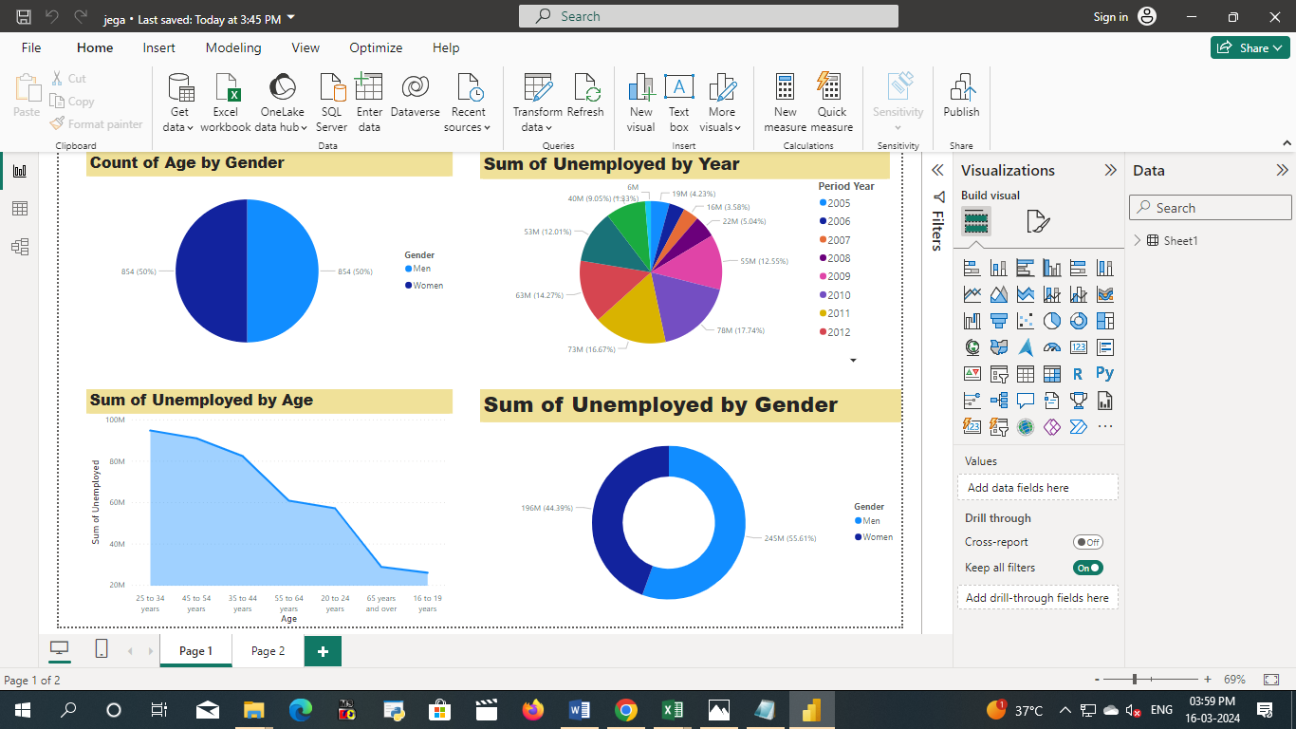

**CONCLUSION**

The project “An Analysis of unemployment in republic India” using PowerBI has successfully demonstrated the potential of data analytics related to unemployment. The real-time analysis of unemployment data has provided valuable insights into reason for unemployment

**FUTURE SCOPE**

The future scope of this project is vast. With the advent of advanced analytics and machine learning, PowerBI can be leveraged to predict future trends based on historical data. Integrating these predictive analytics into the project could enable the government to solve the problem of unemployment

Gitub link