**EXPERIMENT-1**

**Q1**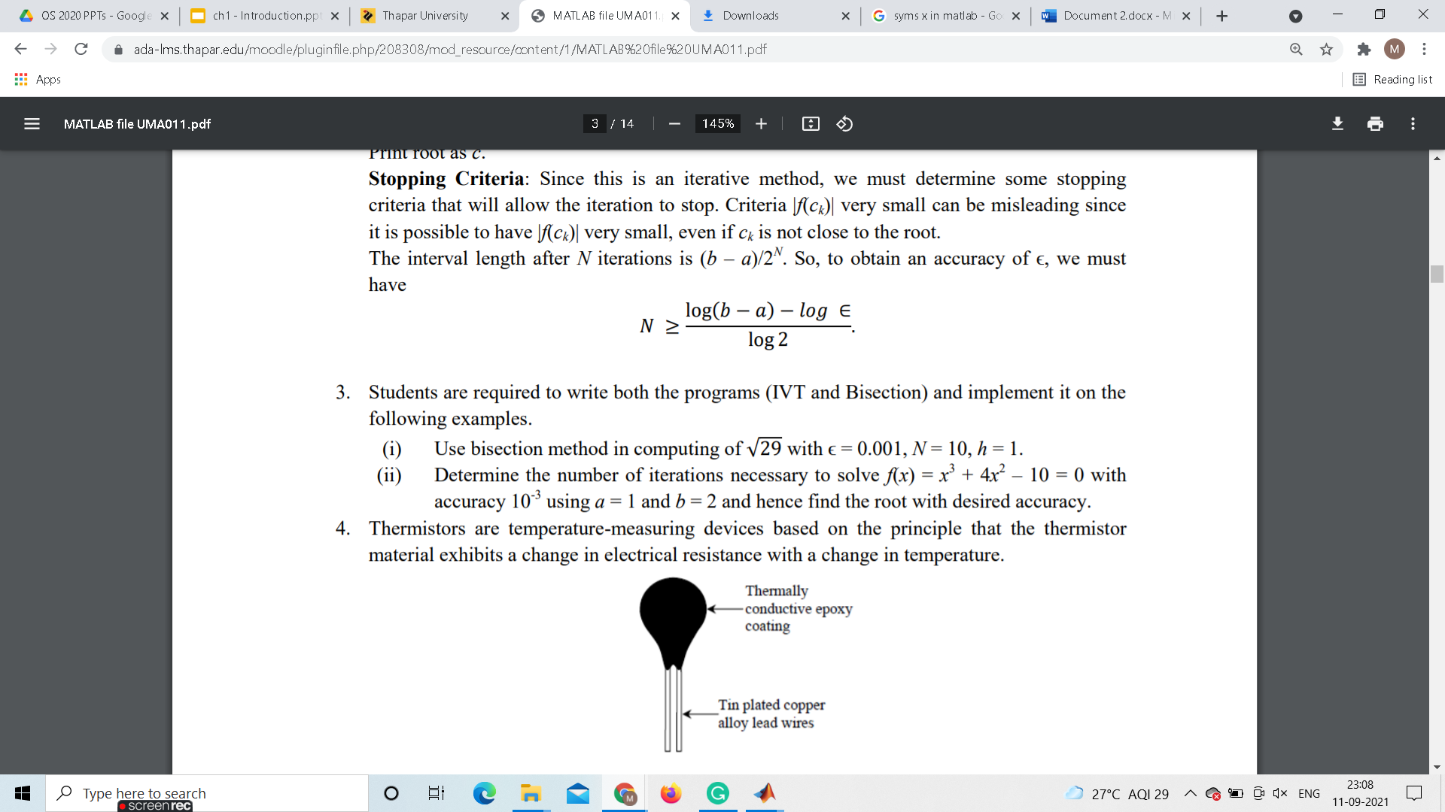

**Ans1(i)**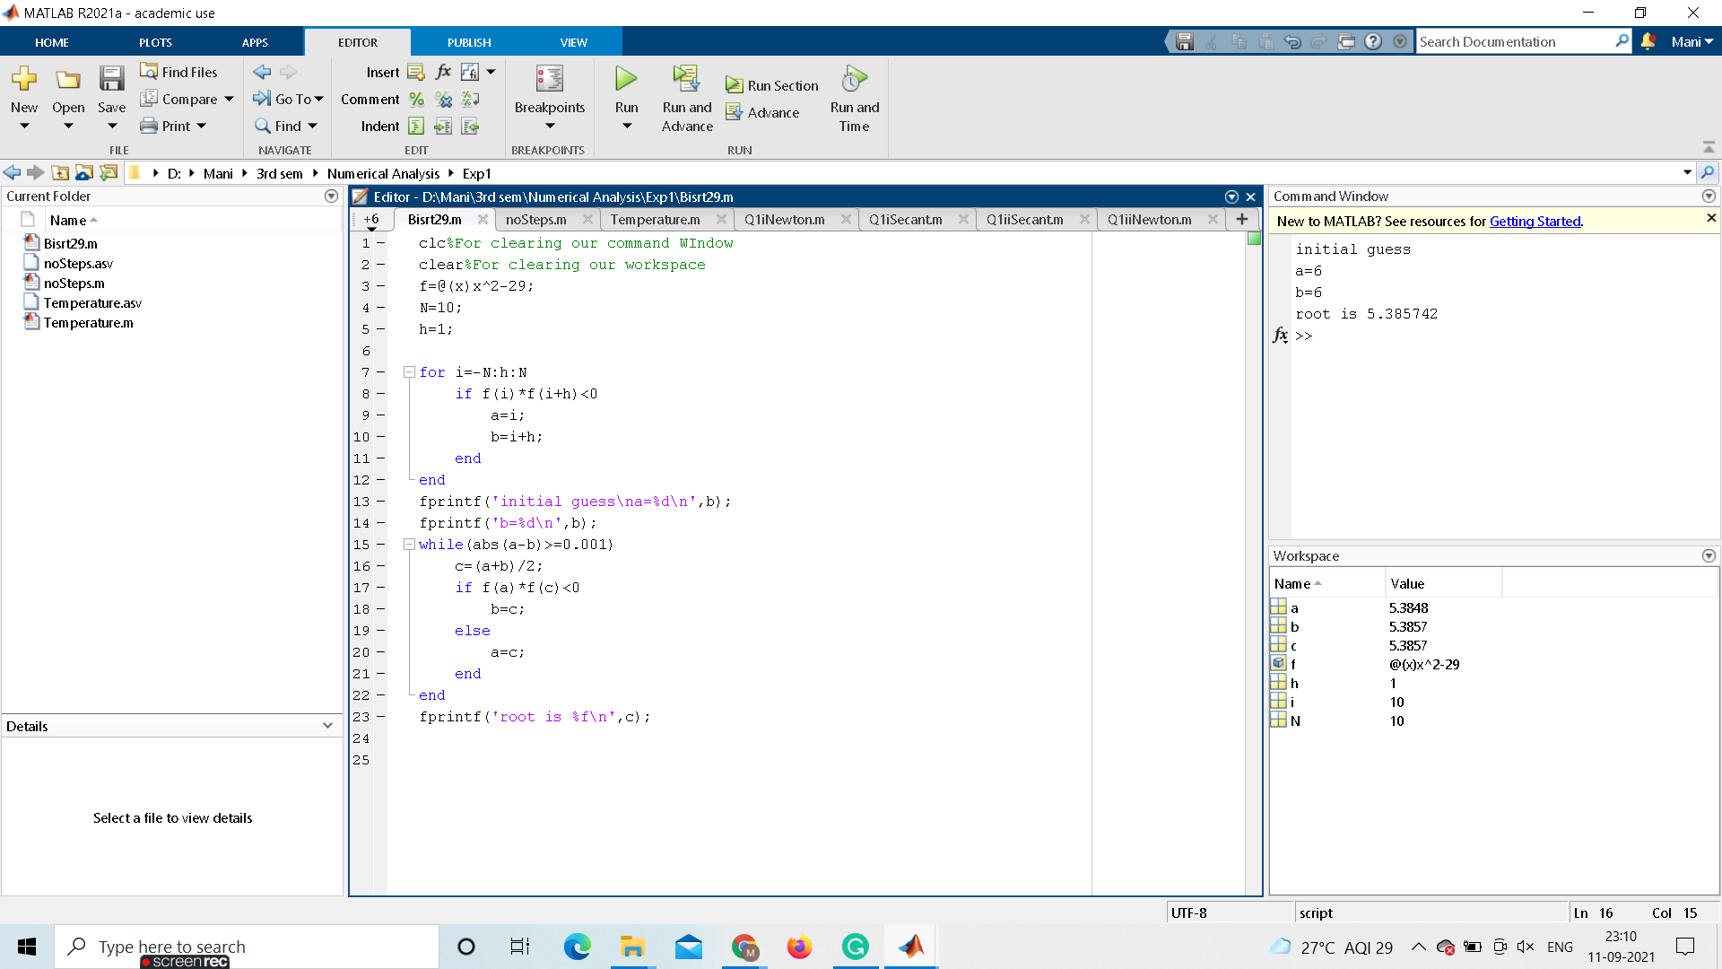

**CODE:**

clc%For clearing our command Window

clear%For clearing our workspace

f=@(x)x^2-29;

N=10;

h=1;

for i=-N:h:N

if f(i)*f(i+h)<0

a=i;

b=i+h;

end

end

fprintf('initial guess\na=%d\n',b);

fprintf('b=%d\n',b);

while(abs(a-b)>=0.001)

c=(a+b)/2;

if f(a)*f(c)<0

b=c;

else

a=c;

end

end

fprintf('root is %f\n',c);

**Ans1(ii)**

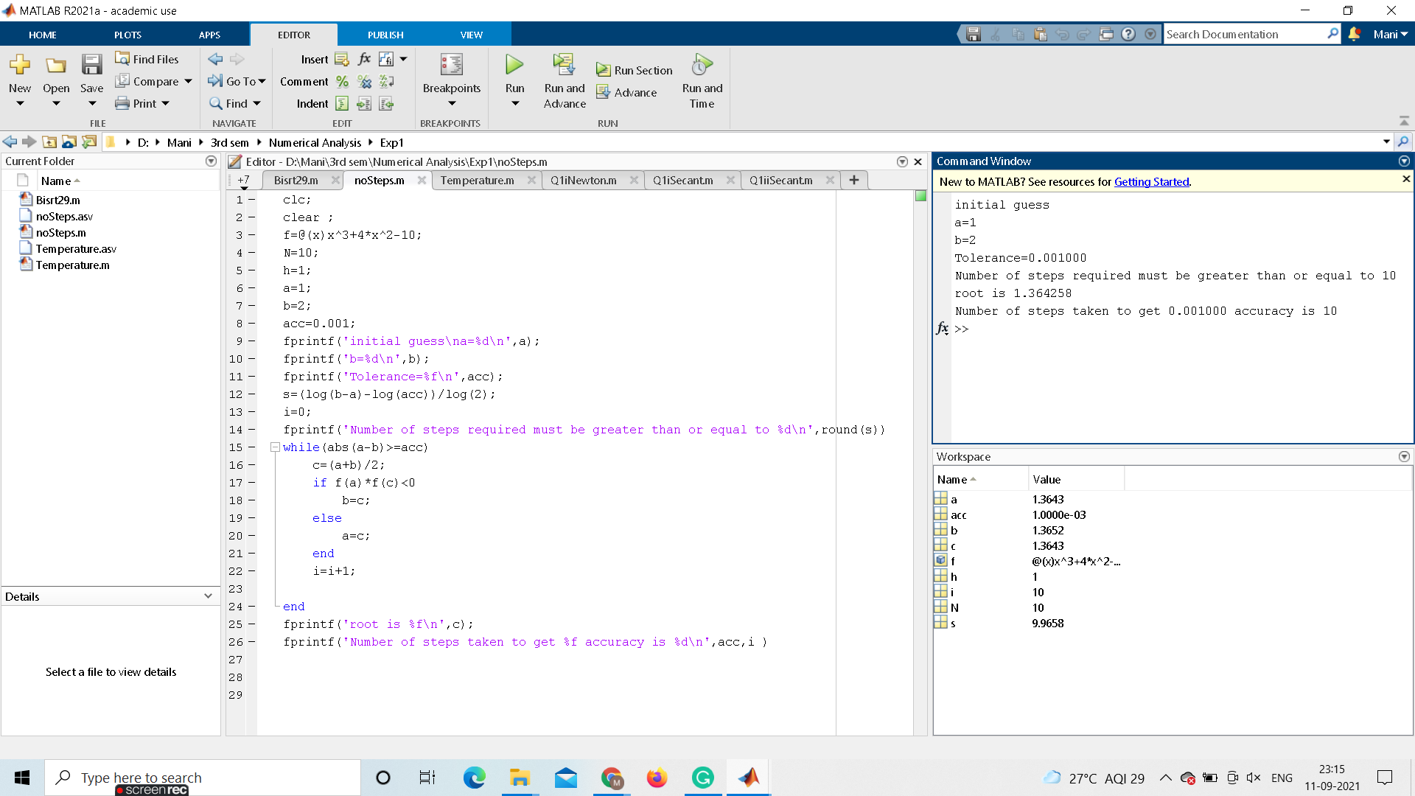

**CODE:**

clc;

clear ;

f=@(x)x^3+4*x^2-10;

N=10;

h=1;

a=1;

b=2;

acc=0.001;

fprintf('initial guess\na=%d\n',a);

fprintf('b=%d\n',b);

fprintf('Tolerance=%f\n',acc);

s=(log(b-a)-log(acc))/log(2);

i=0;

fprintf('Number of steps required must be greater than or equal to %d\n',round(s))

while(abs(a-b)>=acc)

c=(a+b)/2;

if f(a)*f(c)<0

b=c;

else

a=c;

end

i=i+1;

end

fprintf('root is %f\n',c);

fprintf('Number of steps taken to get %f accuracy is %d\n',acc,i )

**Q2**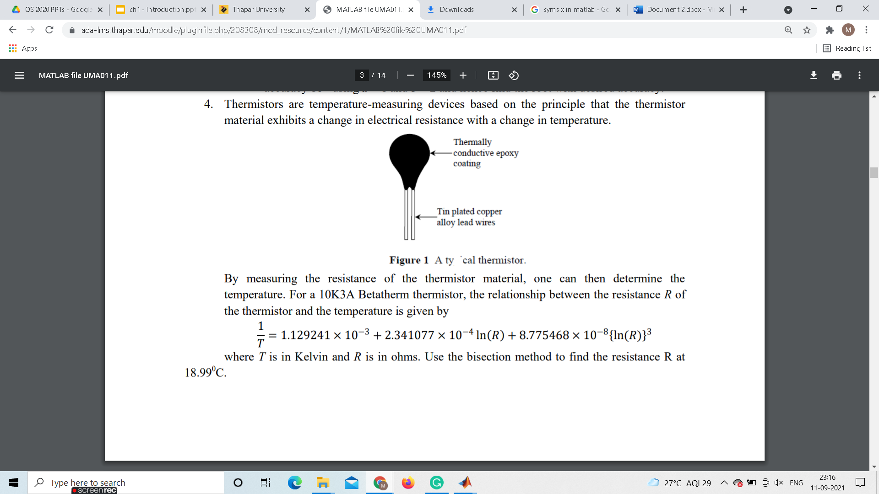

**Ans2**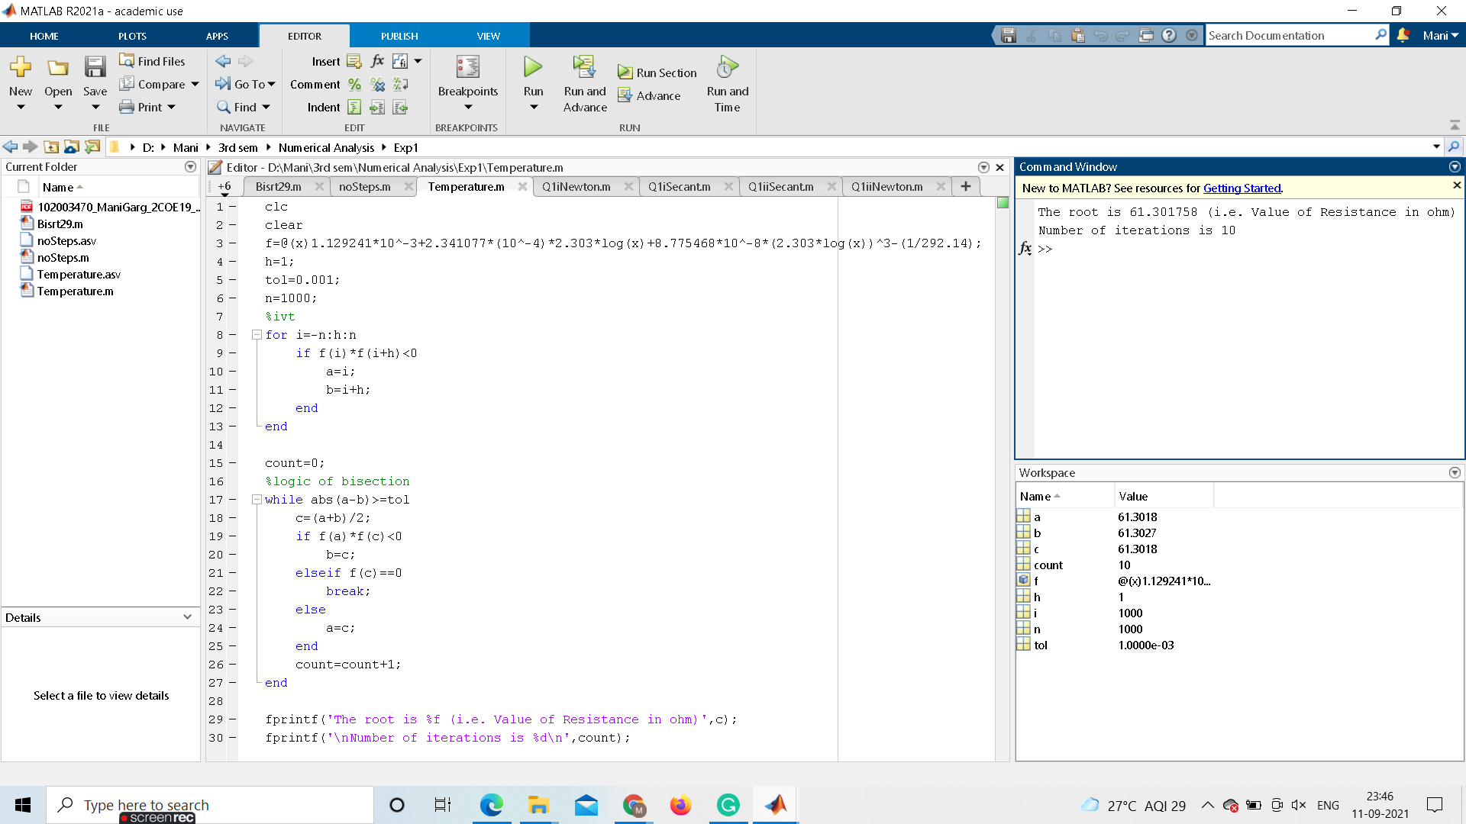

**CODE:**

clc

clear

f=@(x)1.129241*10^-3+2.341077*(10^-4)*2.303*log(x)+8.775468*10^-8*(2.303*log(x))^3-(1/292.14);

h=1;

tol=0.001;

n=1000;

%ivt

for i=-n:h:n

if f(i)*f(i+h)<0

a=i;

b=i+h;

end

end

count=0;

%logic of bisection

while abs(a-b)>=tol

c=(a+b)/2;

if f(a)*f(c)<0

b=c;

elseif f(c)==0

break;

else

a=c;

end

count=count+1;

end

fprintf('The root is %f (i.e. Value of Resistance in ohm)',c);

fprintf('\nNumber of iterations is %d\n',count);