**EXPERIMENT-2**

**Q1**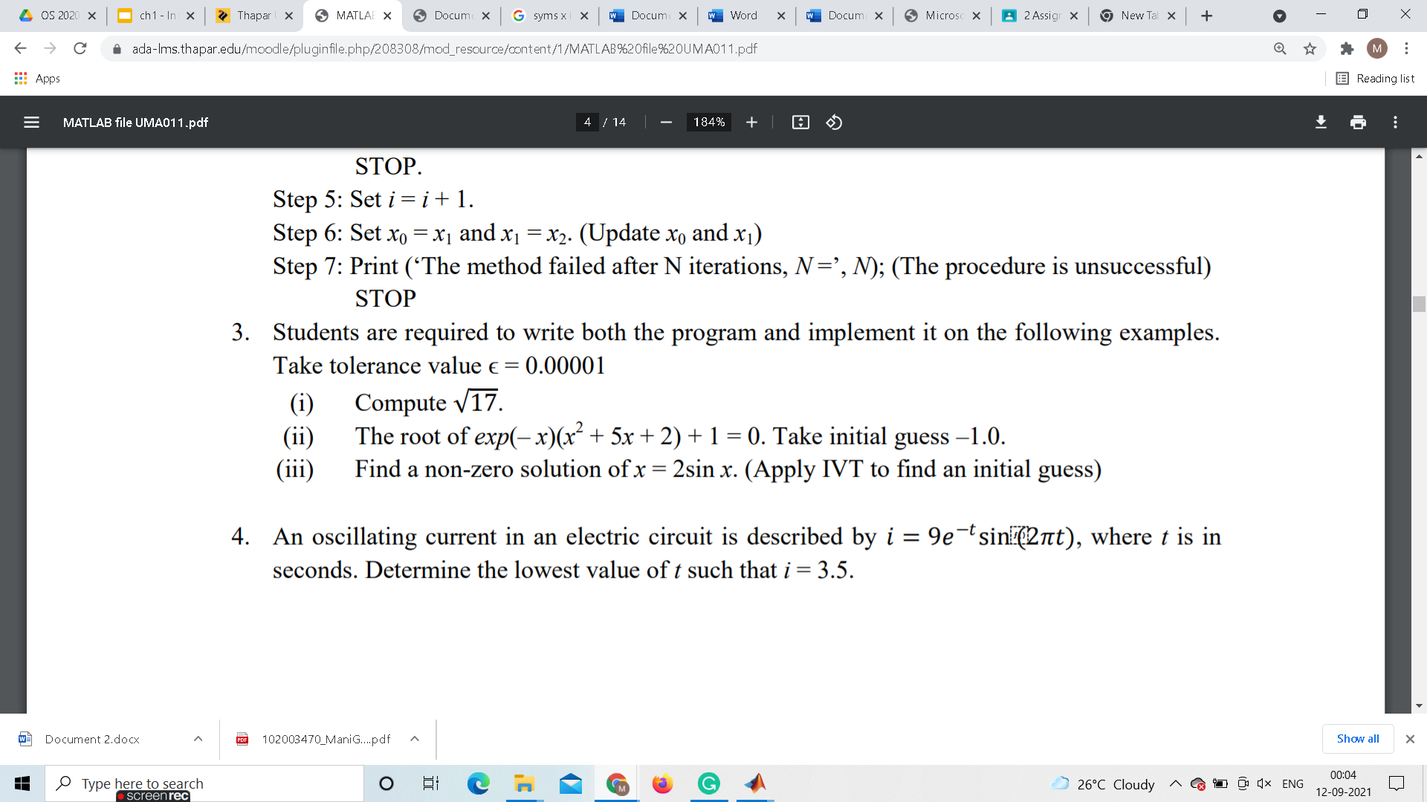

**Ans1(i) by Newton Method**

**SUCCESSFUL:**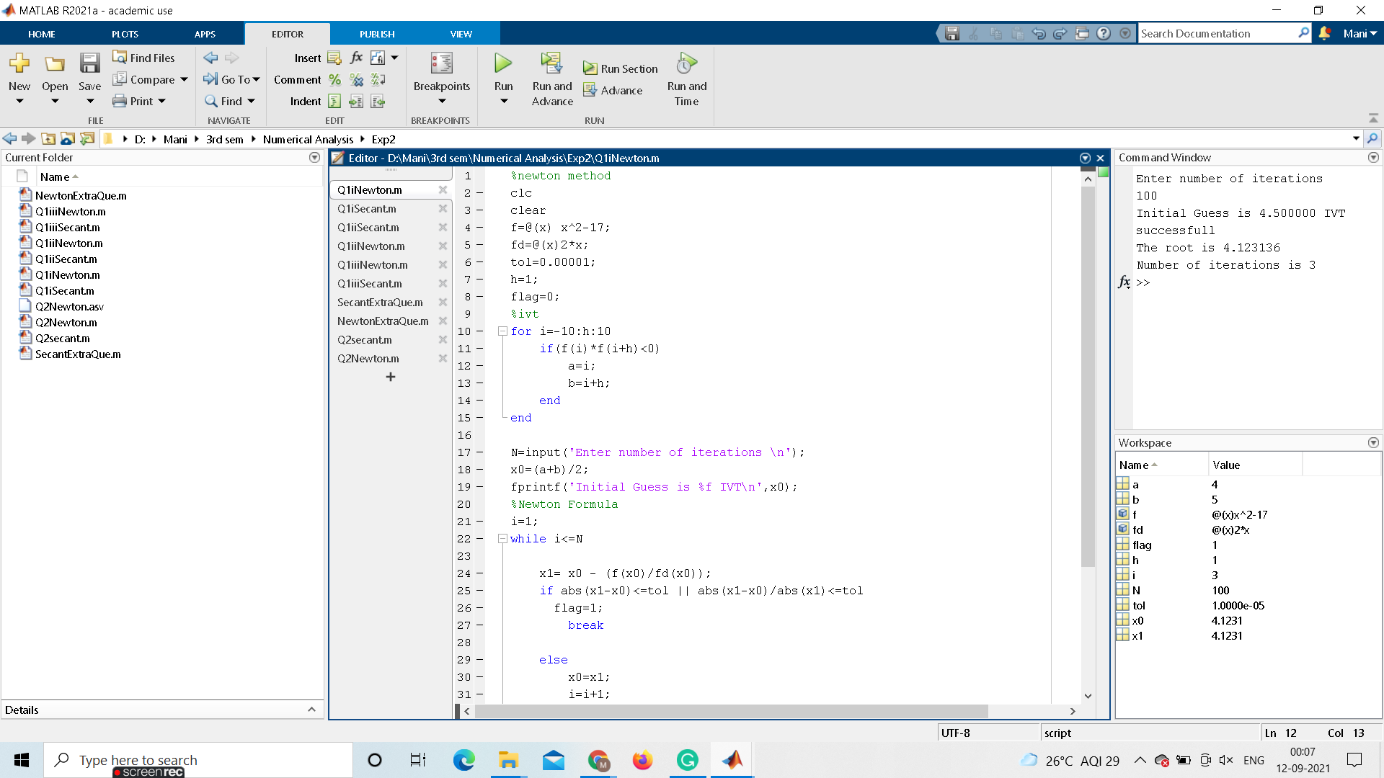

**UNSUCCESSFUL:**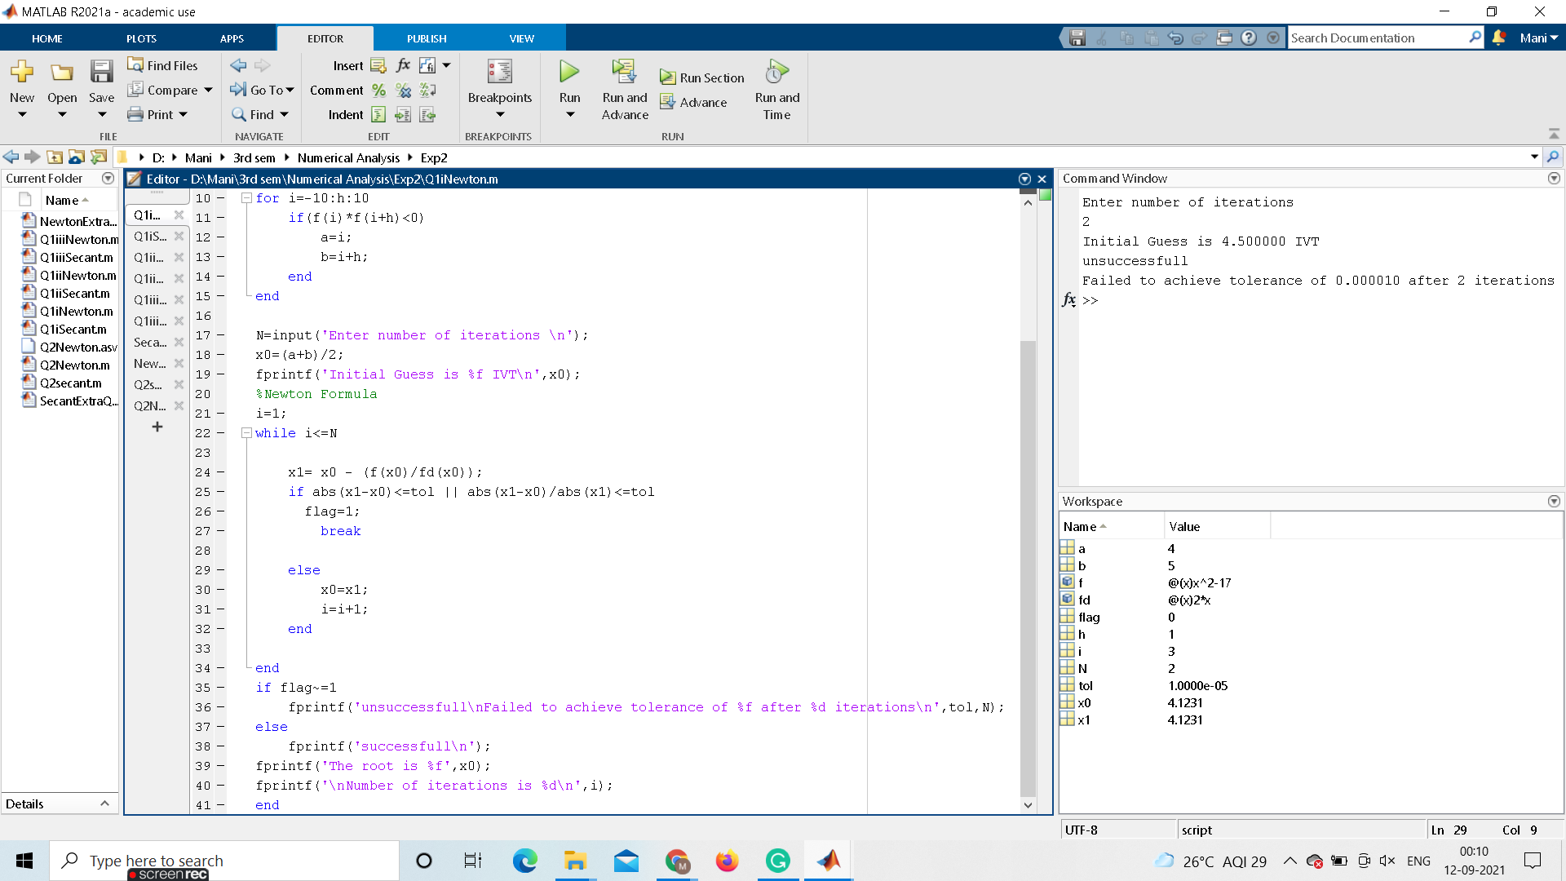

**CODE:**

%newton method

clc

clear

f=@(x) x^2-17;

fd=@(x)2*x;

tol=0.00001;

h=1;

flag=0;

%ivt

for i=-10:h:10

if(f(i)*f(i+h)<0)

a=i;

b=i+h;

end

end

N=input('Enter number of iterations \n');

x0=(a+b)/2;

fprintf('Initial Guess is %f IVT\n',x0);

%Newton Formula

i=1;

while i<=N

x1= x0 - (f(x0)/fd(x0));

if abs(x1-x0)<=tol || abs(x1-x0)/abs(x1)<=tol

flag=1;

break

else

x0=x1;

i=i+1;

end

end

if flag~=1

fprintf('unsuccessfull\nFailed to achieve tolerance of %f after %d iterations\n',tol,N);

else

fprintf('successfull\n');

fprintf('The root is %f',x0);

fprintf('\nNumber of iterations is %d\n',i);

end

**Ans1(i) by Secant Method**

**SUCCESSFUL:**

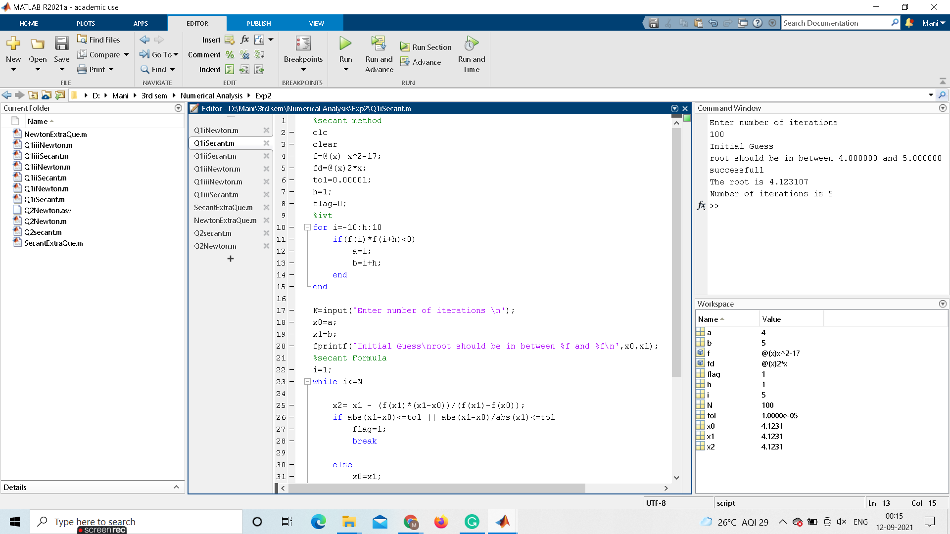

**UNSUCCESSFUL:**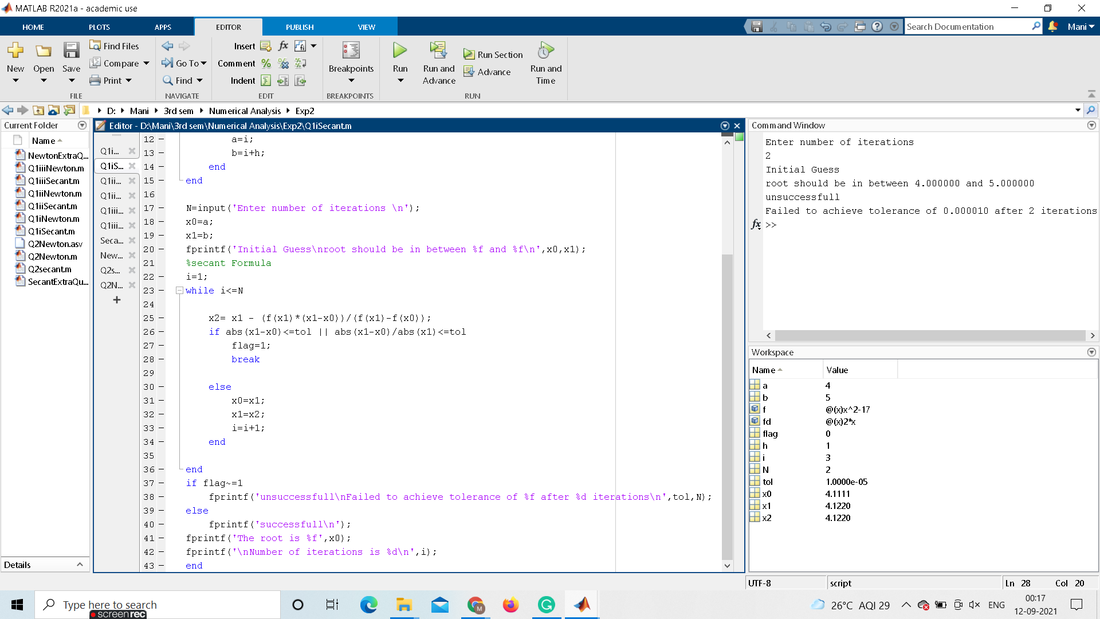

**CODE:**

%secant method

clc

clear

f=@(x) x^2-17;

fd=@(x)2*x;

tol=0.00001;

h=1;

flag=0;

%ivt

for i=-10:h:10

if(f(i)*f(i+h)<0)

a=i;

b=i+h;

end

end

N=input('Enter number of iterations \n');

x0=a;

x1=b;

fprintf('Initial Guess\nroot should be in between %f and %f\n',x0,x1);

%secant Formula

i=1;

while i<=N

x2= x1 - (f(x1)*(x1-x0))/(f(x1)-f(x0));

if abs(x1-x0)<=tol || abs(x1-x0)/abs(x1)<=tol

flag=1;

break

else

x0=x1;

x1=x2;

i=i+1;

end

end

if flag~=1

fprintf('unsuccessfull\nFailed to achieve tolerance of %f after %d iterations\n',tol,N);

else

fprintf('successfull\n');

fprintf('The root is %f',x0);

fprintf('\nNumber of iterations is %d\n',i);

end

**Ans1(ii) by Secant Method**

**SUCCESSFUL:**

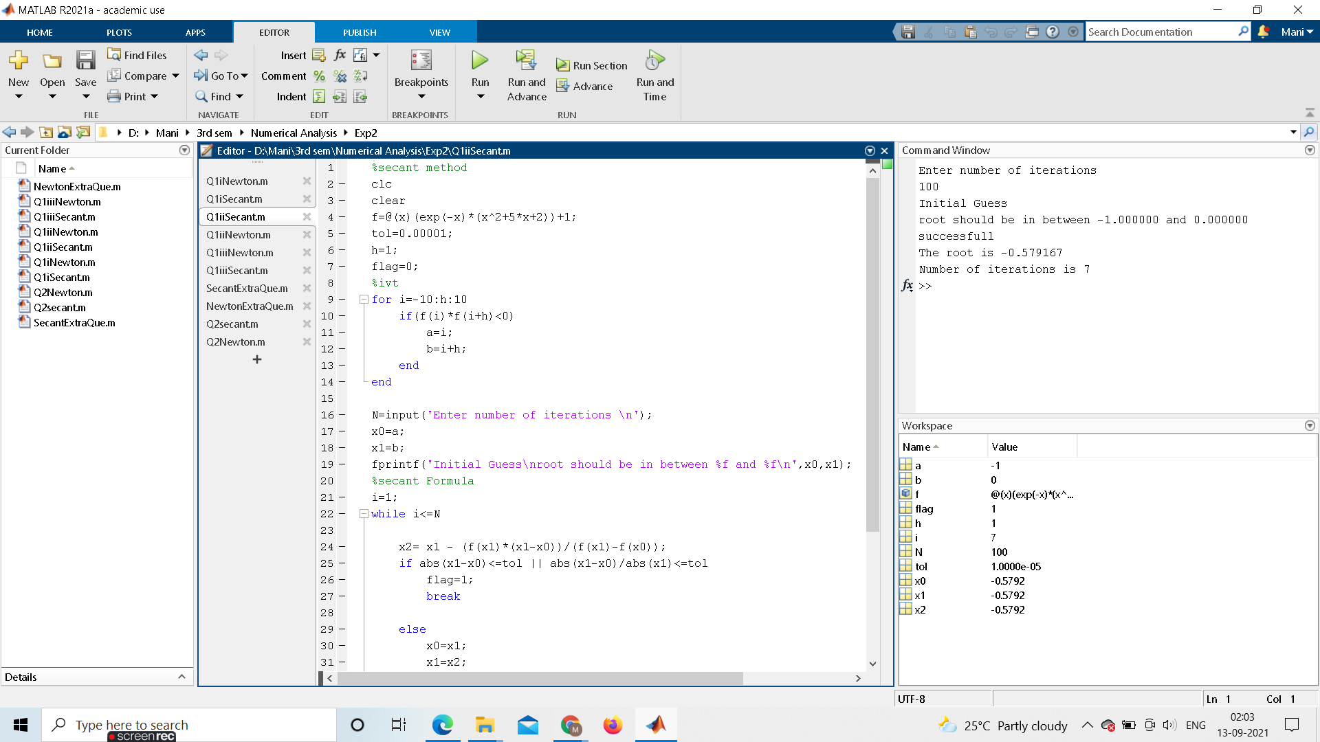

**UNSUCCESSFUL:**

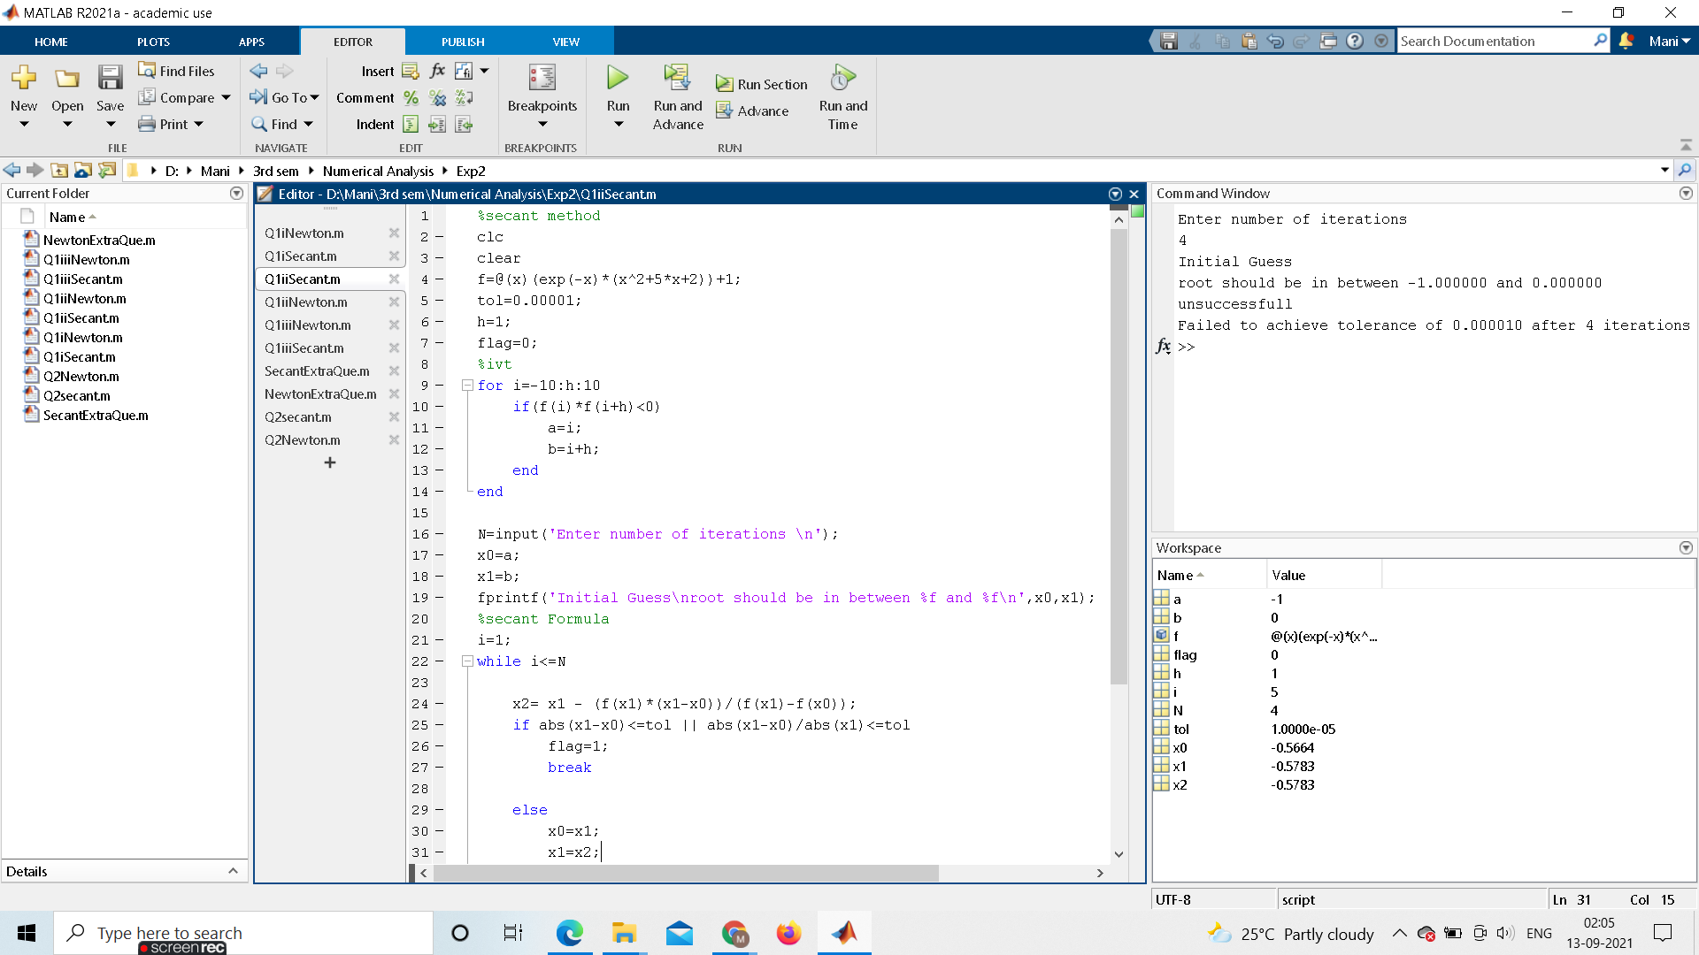

**CODE:**

%secant method

clc

clear

f=@(x)(exp(-x)*(x^2+5*x+2))+1;

tol=0.00001;

h=1;

flag=0;

%ivt

for i=-10:h:10

if(f(i)*f(i+h)<0)

a=i;

b=i+h;

end

end

N=input('Enter number of iterations \n');

x0=a;

x1=b;

fprintf('Initial Guess\nroot should be in between %f and %f\n',x0,x1);

%secant Formula

i=1;

while i<=N

x2= x1 - (f(x1)*(x1-x0))/(f(x1)-f(x0));

if abs(x1-x0)<=tol || abs(x1-x0)/abs(x1)<=tol

flag=1;

break

else

x0=x1;

x1=x2;

i=i+1;

end

end

if flag~=1

fprintf('unsuccessfull\nFailed to achieve tolerance of %f after %d iterations\n',tol,N);

else

fprintf('successfull\n');

fprintf('The root is %f',x0);

fprintf('\nNumber of iterations is %d\n',i);

end

**Ans1(ii) by Newton Method**

**SUCCESSFUL:**

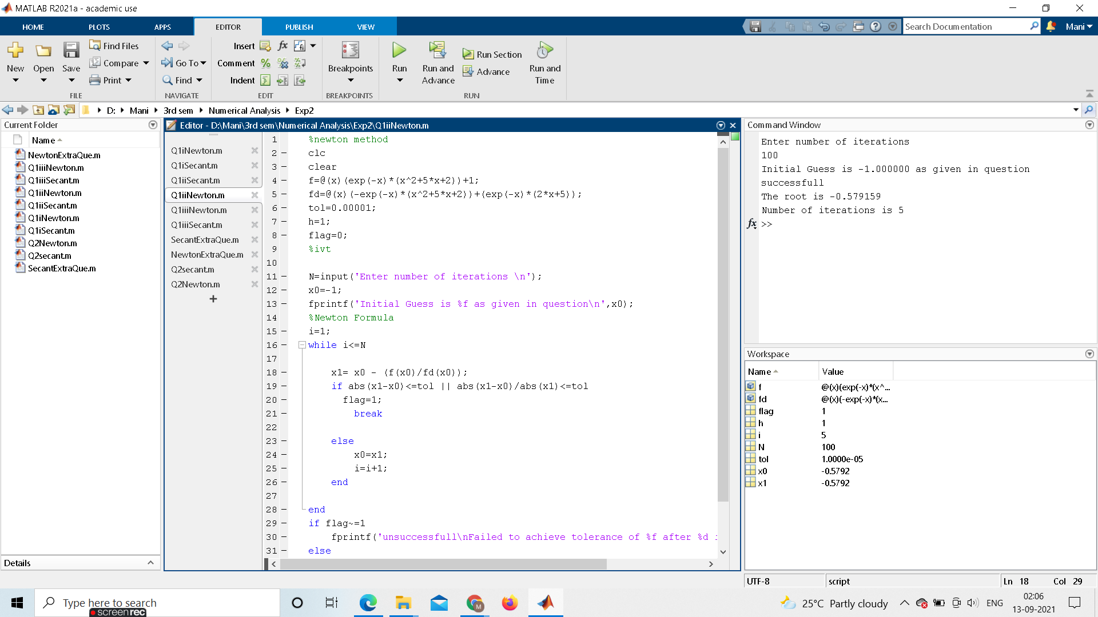

**UNSUCCESSFUL:**

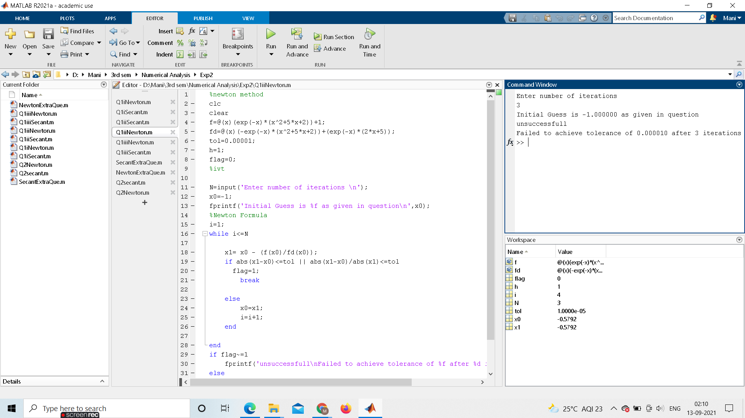

**CODE:**

%newton method

clc

clear

f=@(x)(exp(-x)*(x^2+5*x+2))+1;

fd=@(x)(-exp(-x)*(x^2+5*x+2))+(exp(-x)*(2*x+5));

tol=0.00001;

h=1;

flag=0;

%ivt

N=input('Enter number of iterations \n');

x0=-1;

fprintf('Initial Guess is %f as given in question\n',x0);

%Newton Formula

i=1;

while i<=N

x1= x0 - (f(x0)/fd(x0));

if abs(x1-x0)<=tol || abs(x1-x0)/abs(x1)<=tol

flag=1;

break

else

x0=x1;

i=i+1;

end

end

if flag~=1

fprintf('unsuccessfull\nFailed to achieve tolerance of %f after %d iterations\n',tol,N);

else

fprintf('successfull\n');

fprintf('The root is %f',x0);

fprintf('\nNumber of iterations is %d\n',i);

end

**Ans1(iii) by Newton Method**

**SUCCESSFUL:**

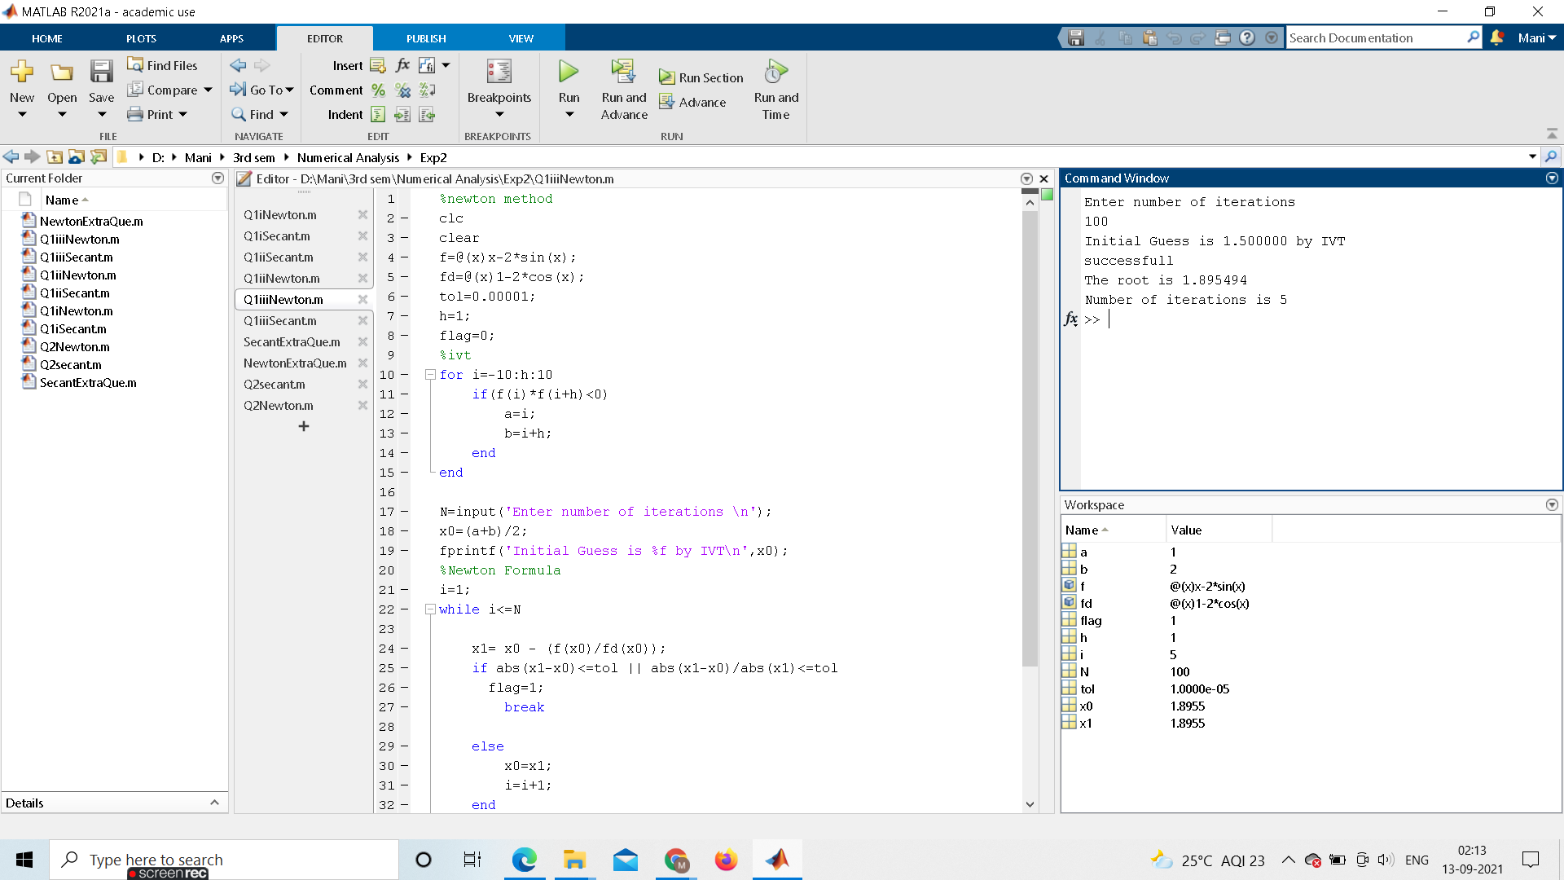

**UNSUCCESSFUL:**

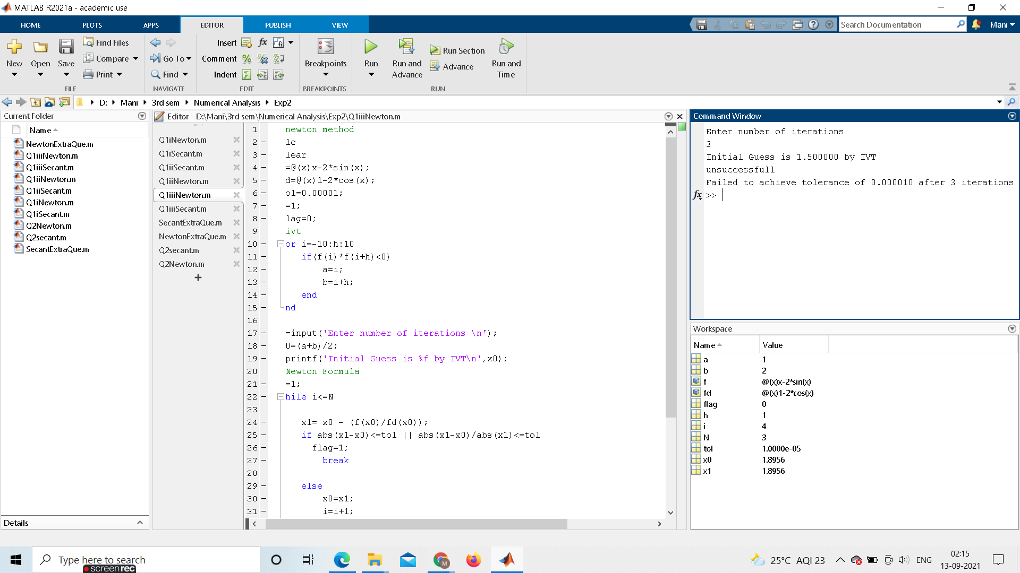

**CODE:**

%newton method

clc

clear

f=@(x)x-2*sin(x);

fd=@(x)1-2*cos(x);

tol=0.00001;

h=1;

flag=0;

%ivt

for i=-10:h:10

if(f(i)*f(i+h)<0)

a=i;

b=i+h;

end

end

N=input('Enter number of iterations \n');

x0=(a+b)/2;

fprintf('Initial Guess is %f by IVT\n',x0);

%Newton Formula

i=1;

while i<=N

x1= x0 - (f(x0)/fd(x0));

if abs(x1-x0)<=tol || abs(x1-x0)/abs(x1)<=tol

flag=1;

break

else

x0=x1;

i=i+1;

end

end

if flag~=1

fprintf('unsuccessfull\nFailed to achieve tolerance of %f after %d iterations\n',tol,N);

else

fprintf('successfull\n');

fprintf('The root is %f',x0);

fprintf('\nNumber of iterations is %d\n',i);

end

**Ans1(iii) by Secant Method**

**SUCCESSFUL:**

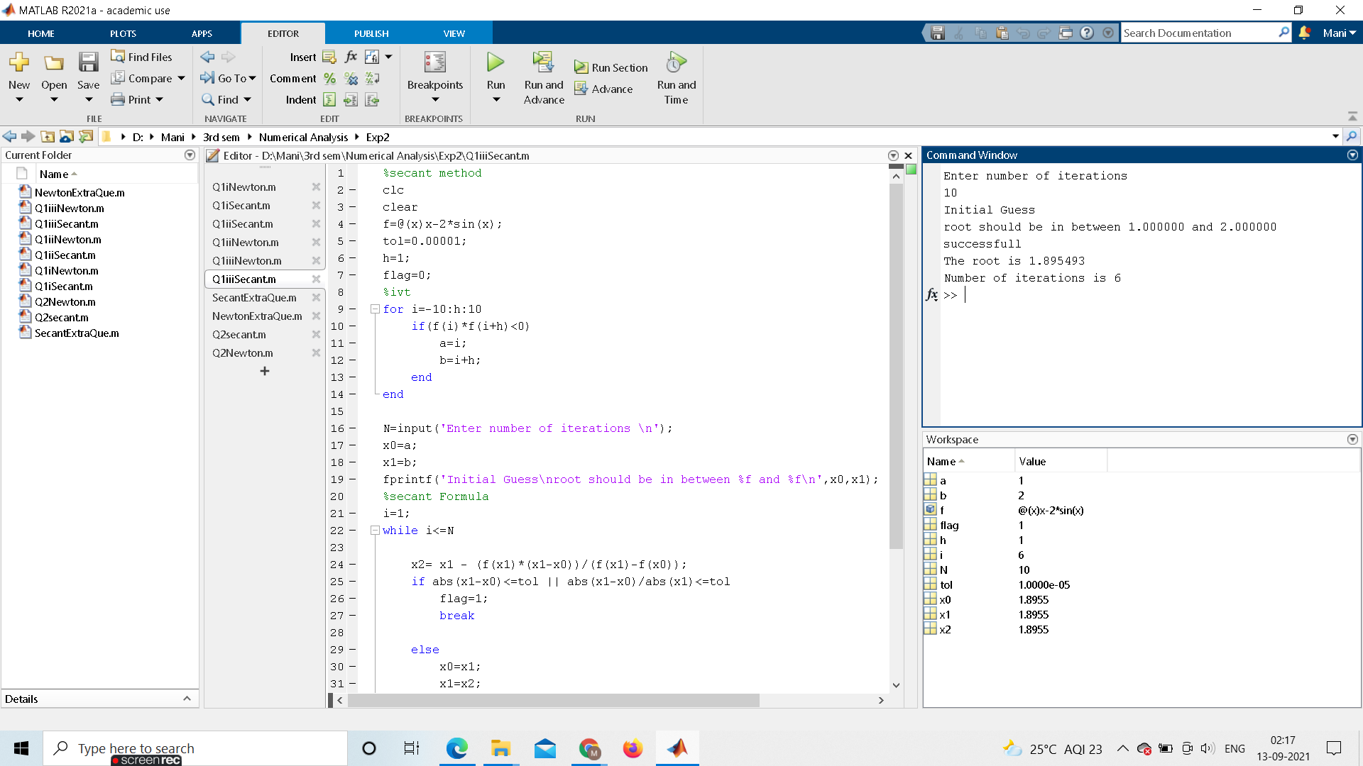

**UNSUCCESSFUL:**

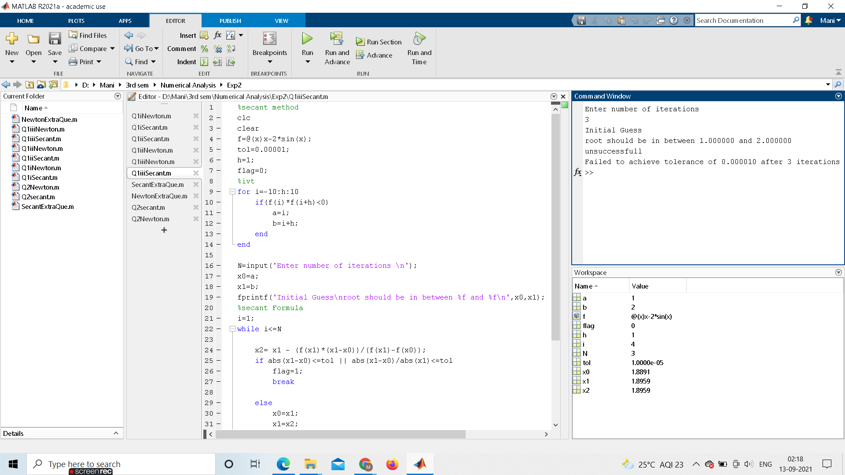

**CODE:**

%secant method

clc

clear

f=@(x)x-2*sin(x);

tol=0.00001;

h=1;

flag=0;

%ivt

for i=-10:h:10

if(f(i)*f(i+h)<0)

a=i;

b=i+h;

end

end

N=input('Enter number of iterations \n');

x0=a;

x1=b;

fprintf('Initial Guess\nroot should be in between %f and %f\n',x0,x1);

%secant Formula

i=1;

while i<=N

x2= x1 - (f(x1)*(x1-x0))/(f(x1)-f(x0));

if abs(x1-x0)<=tol || abs(x1-x0)/abs(x1)<=tol

flag=1;

break

else

x0=x1;

x1=x2;

i=i+1;

end

end

if flag~=1

fprintf('unsuccessfull\nFailed to achieve tolerance of %f after %d iterations\n',tol,N);

else

fprintf('successfull\n');

fprintf('The root is %f',x0);

fprintf('\nNumber of iterations is %d\n',i);

end

**Q2**

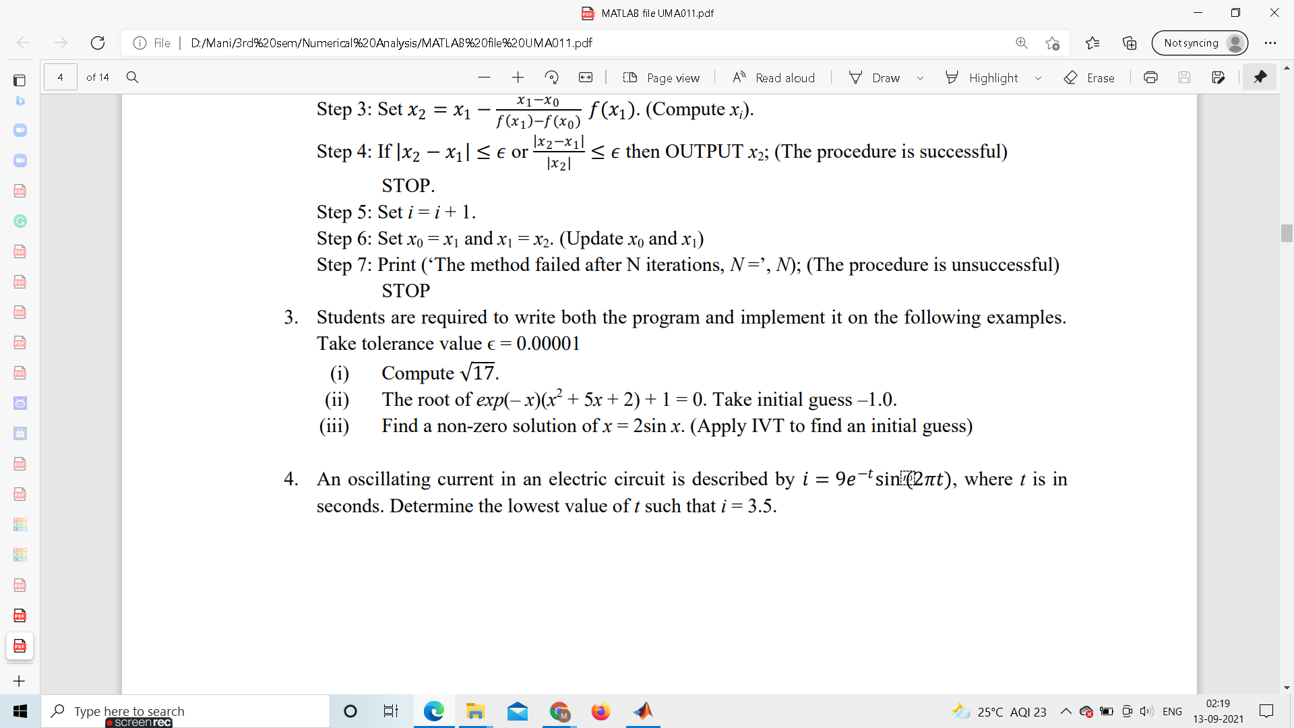

**Ans2 by Secant Method**

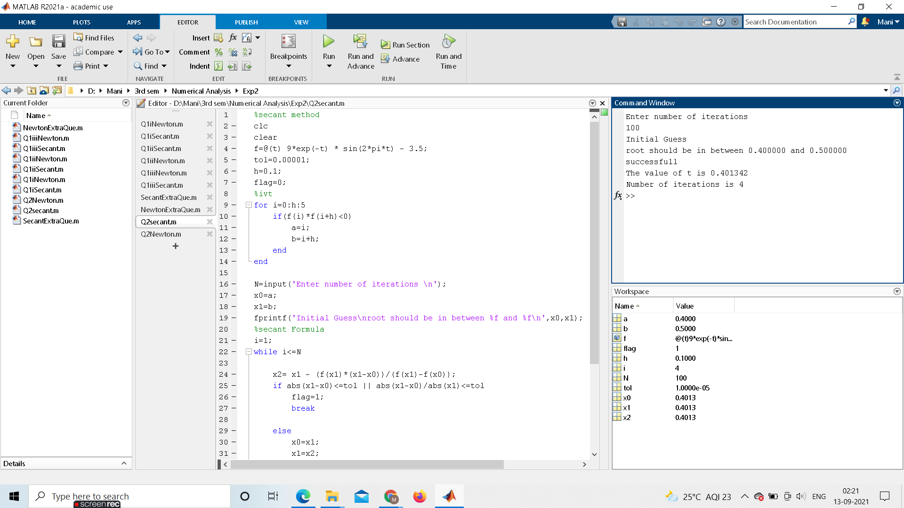

**CODE:**

%secant method

clc

clear

f=@(t) 9*exp(-t) * sin(2*pi*t) - 3.5;

tol=0.00001;

h=0.1;

flag=0;

%ivt

for i=0:h:5

if(f(i)*f(i+h)<0)

a=i;

b=i+h;

end

end

N=input('Enter number of iterations \n');

x0=a;

x1=b;

fprintf('Initial Guess\nroot should be in between %f and %f\n',x0,x1);

%secant Formula

i=1;

while i<=N

x2= x1 - (f(x1)*(x1-x0))/(f(x1)-f(x0));

if abs(x1-x0)<=tol || abs(x1-x0)/abs(x1)<=tol

flag=1;

break

else

x0=x1;

x1=x2;

i=i+1;

end

end

if flag~=1

fprintf('unsuccessfull\nFailed to achieve tolerance of %f after %d iterations\n',tol,N);

else

fprintf('successfull\n');

fprintf('The value of t is %f',x0);

fprintf('\nNumber of iterations is %d\n',i);

end

**Ans2 by Newton Method**

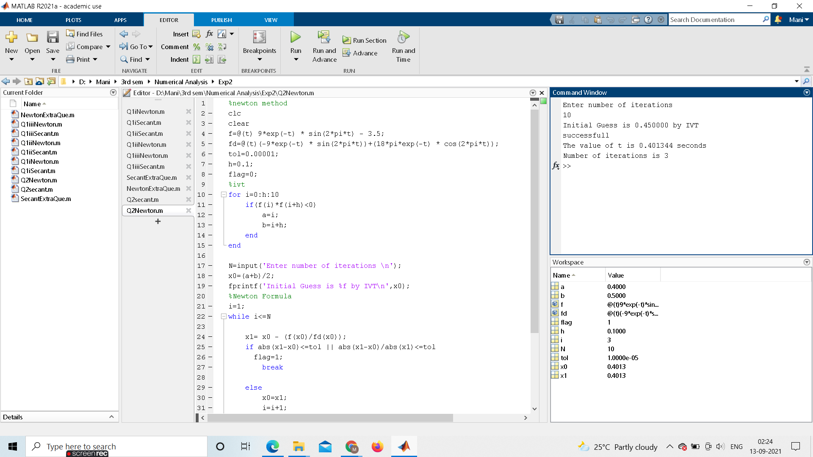

**CODE:**

%newton method

clc

clear

f=@(t) 9*exp(-t) * sin(2*pi*t) - 3.5;

fd=@(t)(-9*exp(-t) * sin(2*pi*t))+(18*pi*exp(-t) * cos(2*pi*t));

tol=0.00001;

h=0.1;

flag=0;

%ivt

for i=0:h:10

if(f(i)*f(i+h)<0)

a=i;

b=i+h;

end

end

N=input('Enter number of iterations \n');

x0=(a+b)/2;

fprintf('Initial Guess is %f by IVT\n',x0);

%Newton Formula

i=1;

while i<=N

x1= x0 - (f(x0)/fd(x0));

if abs(x1-x0)<=tol || abs(x1-x0)/abs(x1)<=tol

flag=1;

break

else

x0=x1;

i=i+1;

end

end

if flag~=1

fprintf('unsuccessfull\nFailed to achieve tolerance of %f after %d iterations\n',tol,N);

else

fprintf('successfull\n');

fprintf('The value of t is %f seconds',x0);

fprintf('\nNumber of iterations is %d\n',i);

end

**EXTRA QUES GIVEN: exp(x)=cos(x)**

**Ans by Newton Method**

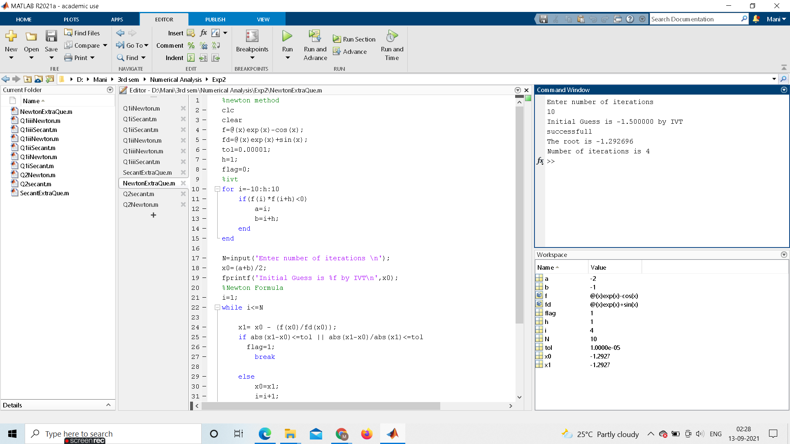

**CODE:**

%newton method

clc

clear

f=@(x)exp(x)-cos(x);

fd=@(x)exp(x)+sin(x);

tol=0.00001;

h=1;

flag=0;

%ivt

for i=-10:h:10

if(f(i)*f(i+h)<0)

a=i;

b=i+h;

end

end

N=input('Enter number of iterations \n');

x0=(a+b)/2;

fprintf('Initial Guess is %f by IVT\n',x0);

%Newton Formula

i=1;

while i<=N

x1= x0 - (f(x0)/fd(x0));

if abs(x1-x0)<=tol || abs(x1-x0)/abs(x1)<=tol

flag=1;

break

else

x0=x1;

i=i+1;

end

end

if flag~=1

fprintf('unsuccessfull\nFailed to achieve tolerance of %f after %d iterations\n',tol,N);

else

fprintf('successfull\n');

fprintf('The root is %f',x0);

fprintf('\nNumber of iterations is %d\n',i);

end

**Ans by Secant Method**

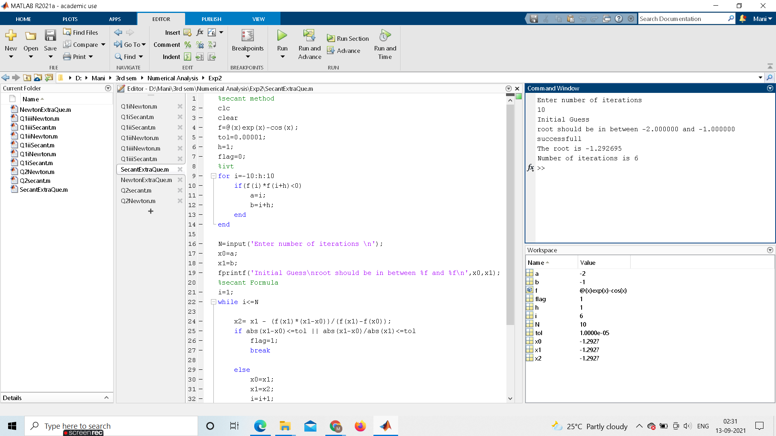

**CODE:**

%secant method

clc

clear

f=@(x)exp(x)-cos(x);

tol=0.00001;

h=1;

flag=0;

%ivt

for i=-10:h:10

if(f(i)*f(i+h)<0)

a=i;

b=i+h;

end

end

N=input('Enter number of iterations \n');

x0=a;

x1=b;

fprintf('Initial Guess\nroot should be in between %f and %f\n',x0,x1);

%secant Formula

i=1;

while i<=N

x2= x1 - (f(x1)*(x1-x0))/(f(x1)-f(x0));

if abs(x1-x0)<=tol || abs(x1-x0)/abs(x1)<=tol

flag=1;

break

else

x0=x1;

x1=x2;

i=i+1;

end

end

if flag~=1

fprintf('unsuccessfull\nFailed to achieve tolerance of %f after %d iterations',tol,N);

else

fprintf('successfull\n');

fprintf('The root is %f',x0);

fprintf('\nNumber of iterations is %d\n',i);

end