Assignment 2

Report:
For the 3d Model I choose to make the Model of "Shivling".

To Start with it.I chose UV-Sphere (or can use Cylinder).
After that remove the half bottom of it.
Extrude the ring edges vertically down.
Scale the bottom ring outside so as to give shape of frustum.
Adding loop cuts and using Bevel at edges making different design as you can see in image
For the small details like tilak ,I used plane and given it some depth and then duplicate it thrice.
Also sphere for the central red tilak.
For the extended long part I used one of loop cut and extrude it normally outside.
Using extrude given it some depth and closing it at boottom.

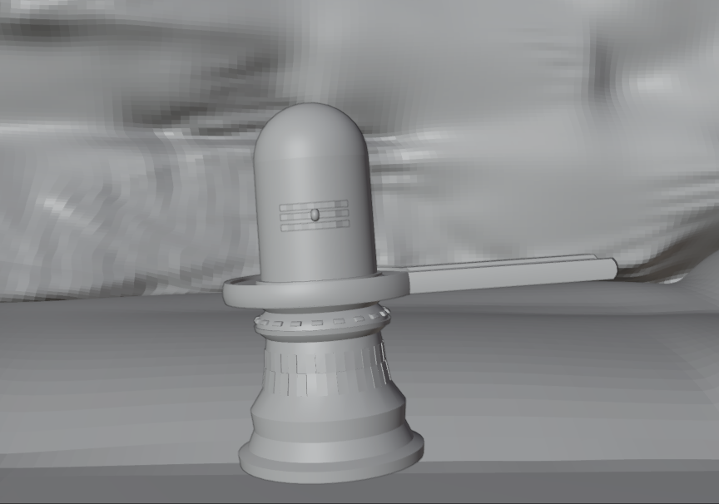

For the shader purpose
I used emission shader nodes on tilak and text behind.
Also, for the Shivling with 0.341 roughness black as base colour and using different noise in shader editor.

For the snow I used following step4 properties in shader nodes.

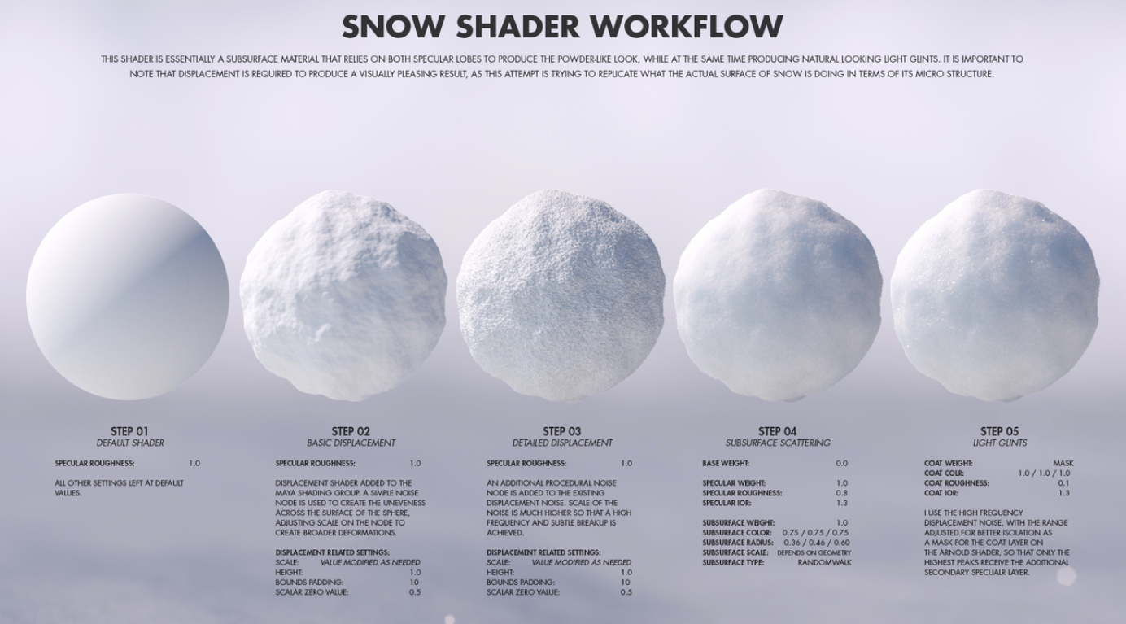

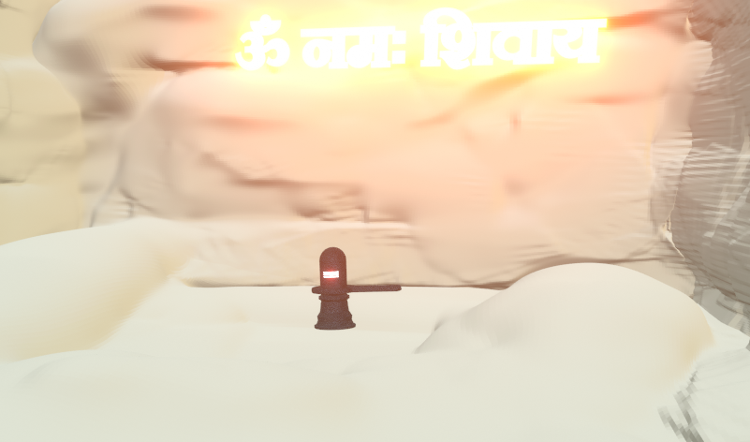

For the Motion Animation I did Keyframing.

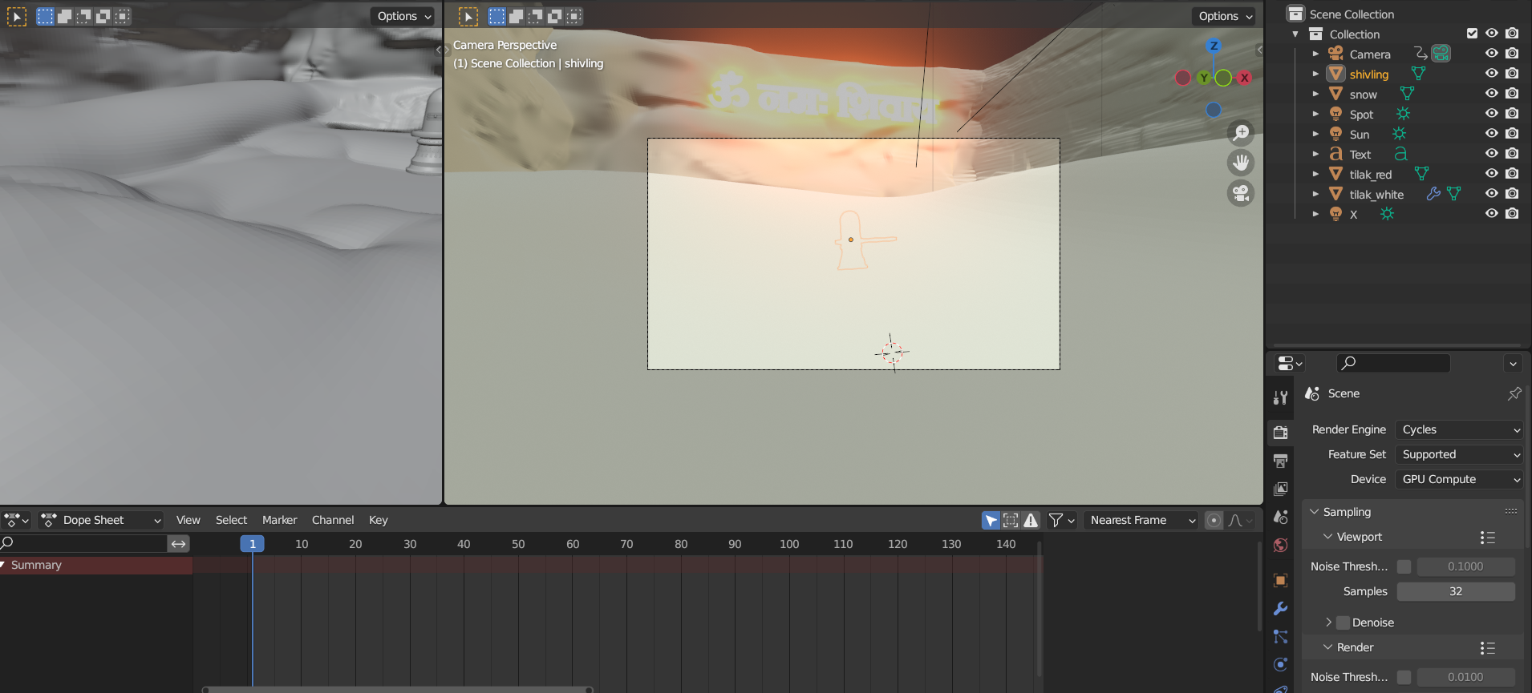
For the Sound I used Video Sequencer

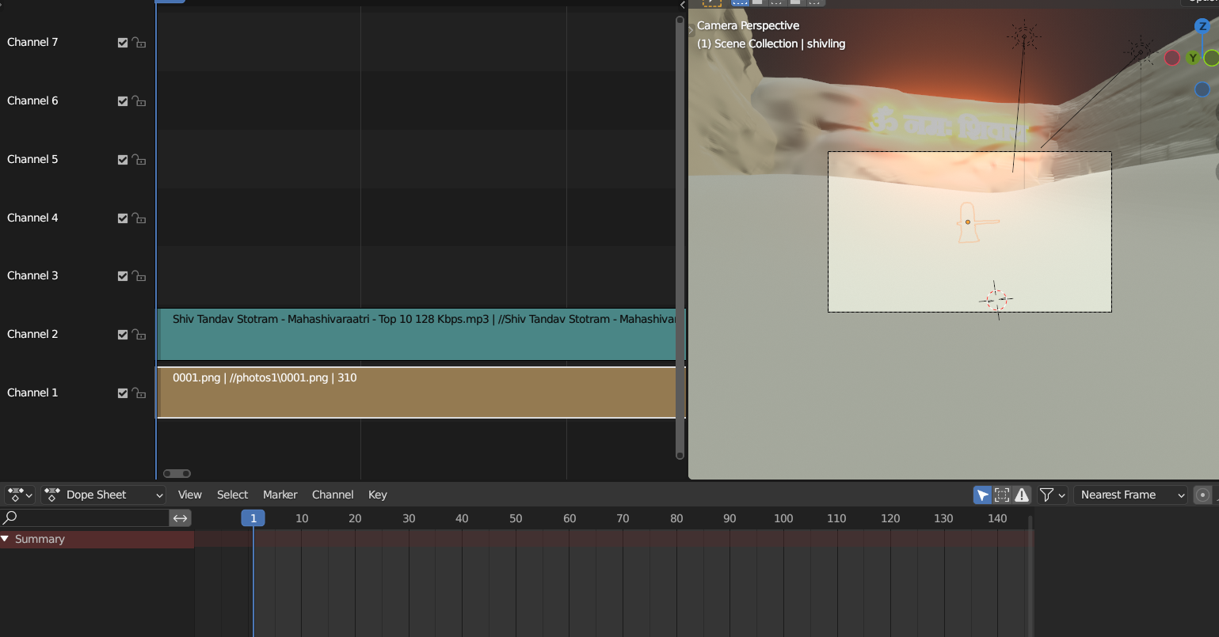
ANS1.
I. Duplicate:- Object ‣ Duplicate Objects. Shortcut. Shift - D. This will create a visually-identical copy of the selected object(s). The copy is created at the same position as the original object and you are automatically placed in move mode
Merge:- This tool allows you to merge all selected vertices to a unique one, dissolving all others. You can choose the location of the remaining vertex in the menu this tool pops up before executing: At Center. It will place the remaining vertex at the center of the selection
II. Normal:- In geometry, a normal is a direction or line that is perpendicular to something, typically a triangle or surface but can also be relative to a line, a tangent line for a point on a curve, or a tangent plane for a point on a surface.
Importance:- a) Easiest way to smoothen an object is through normals.
b) Setting an angle is accomplished through normal.
c) Lighting with positive normal on back-faces of the mesh in the viewport
III. ,IV.Formally, the extrude tool can be defined as a tool that duplicates the selected vertices, edges, and faces, connecting them to the original model in series of the original vertices, edges, or faces. The Inset tool is similar to the Extrude tool, but the new faces it creates are on the surface of the selection and will not change the surface's shape. This tool generates a copy of the geometry that is an inset of the original selection (it's possible to also add height to the new geometry).
V.The Snap menu (also available from the 3D header in both Object Mode and Edit Mode Object ‣ Snap and Mesh ‣ Snap). This menu provides a number of options to move the cursor or your selection to a defined point (the cursor, selection or the grid). Snaps the currently selected object(s) to the nearest grid point
VI.The Array modifier creates an array of copies of the base object, with each copy being offset from the previous one in any of a number of possible ways. Vertices in adjacent copies can be merged if they are nearby, allowing smooth Subdivision Surface frameworks to be generated.
VII.So after applying the subdivisional modifier in my model, it added a lot of detailing to my model. So, the round corner of my model were smooth after applying this.

ANS2.
a=(-2.5,3),
b=(1,2),
c=(2.5,2),
d=(-1,1),
e=(0,0),
f=(2,-0.5),
g=(-0.5,-1.5),
h=(0,-2),
i=(-3,-2)

ANS3.
A=(1,2,4),
b=(-3,-3,-5),
c=(-3,6,2.5),
d=(3,0,-1),
e=(0,0,0),
f=(0,0,3),
g=(-3.5,4,0),
h=(5,-5,-1.5),
i=(4,1,5)

ANS4.

There are actually only 6 unique ways that the 3D axes may be assigned to the directions "north", "east", and "up", and these can be flipped or rotated to produce the remaining 42 combinations.
Here are the 6 unique assignments:
- North along the +y-axis, East along the +x-axis, Up along the -z-axis (Right-handed)
- North along the -y-axis, East along the +x-axis, Up along the +z-axis (Left-handed)
- North along the -x-axis, East along the +z-axis, Up along the +y-axis (Left-handed)
- North along the +x-axis, East along the -z-axis, Up along the +y-axis (Right-handed)
- North along the +z-axis, East along the +x-axis, Up along the +y-axis (Right-handed)
- North along the -z-axis, East along the -x-axis, Up along the +y-axis (Left-handed)
To obtain the remaining 42 combinations, each of the above assignments can be flipped or rotated in various ways. For example, flipping the first assignment along the x-axis yields:
North along the +y-axis, East along the -x-axis, Up along the -z-axis (Left-handed)
Similarly, rotating the second assignment 90 degrees around the z-axis yields:
North along the -x-axis, East along the -y-axis, Up along the +z-axis (Right-handed)
And so on, for a total of 48 combinations.

ANS5.
a. Right Hand Coordinate
b.To convert 3D coordinates from the coordinate system used by 3DS Max to the coordinate conventions discussed in, we would need to perform a rotation and a reflection. Specifically, we would need to rotate the 3D coordinates 90 degrees around the x-axis and then reflect them across the y-z plane. This can be accomplished using a 4x4 transformation matrix with the following values:
[ 1 0 0 0 ]
[ 0 0 1 0 ]
[ 0 -1 0 0 ]
[ 0 0 0 1 ]
We can apply this transformation matrix to the 3D coordinates as a homogeneous vector [x, y, z, 1] by multiplying them from the right.
c. To convert 3D coordinates from our conventions to the 3DS Max conventions, we would need to perform the inverse transformation of what we did in part (b). Specifically, we would need to reflect the 3D coordinates across the y-z plane and then rotate them -90 degrees around the x-axis. This can be accomplished using the following transformation matrix:
[ 1 0 0 0 ]
[ 0 0 -1 0 ]
[ 0 1 0 0 ]
[ 0 0 0 1 ]
We can apply this transformation matrix to the 3D coordinates as a homogeneous vector [x, y, z, 1] by multiplying them from the right.

