Price Prediction Project Question

What is a DataFrame?
A Pandas DataFrame is a 2 dimensional data structure, like a 2 dimensional array, or a table with rows and columns.
Pandas DataFrames (w3schools.com)

What is a df.describe()?
The describe() method returns description of the data in the DataFrame.
If the DataFrame contains numerical data, the description contains these information for each column:
count - The number of not-empty values.
mean - The average (mean) value.
std - The standard deviation.
min - the minimum value.
25% - The 25% percentile*.
50% - The 50% percentile*.
75% - The 75% percentile*.
max - the maximum value.
*Percentile meaning: how many of the values are less than the given percentile. Read more about percentiles in our Machine Learning Percentile chapter.
How to find duplicates?
Find duplicate rows in a Dataframe based on all or selected columns - GeeksforGeeks

Box-Plot gives 3 quartiles

2nd is mefian of data and 1st is median of lower half and 3rd is median of upper half
whisker1 25% 2ndpoint 25% 1stpoint 25% 3rdpoint 25% whisker

Seaborn?
Seaborn is a library that uses Matplotlib underneath to plot graphs. It will be used to visualize random distributions.

KDE Plot?
KDE Plot described as Kernel Density Estimate is used for visualizing the Probability Density of a continuous variable. It depicts the probability density at different values in a continuous variable.

Why Normal distribution is Important?
We want to apply reggression model for continous data prediction and for that
Simple linear regression is a parametric test, meaning that it makes certain assumptions about the data. These assumptions are:
- Homogeneity of variance (homoscedasticity): the size of the error in our prediction doesn’t change significantly across the values of the independent variable.
- Independence of observations: the observations in the dataset were collected using statistically valid sampling methods, and there are no hidden relationships among observations.
- Normality: The data follows a normal distribution.

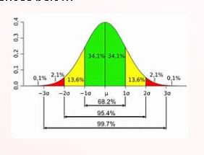

Because of its symmetric properties we can conclude important points like how much data is present at how much standard deviation from mean.
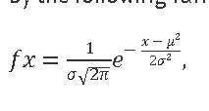

if we have this plot at origin we can conclude the things as mean is 0 and sd is 1
Understanding the properties of normal distributions means you can use inferential statistics to compare different groups and make estimates about populations using samples
Because normally distributed variables are so common, many statistical tests are designed for normally distributed populations

Correlation
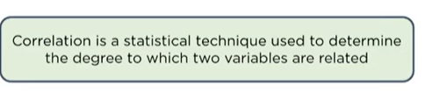

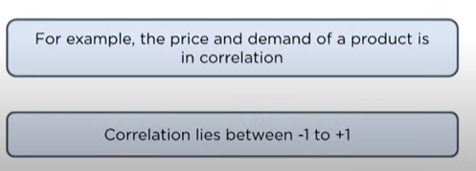

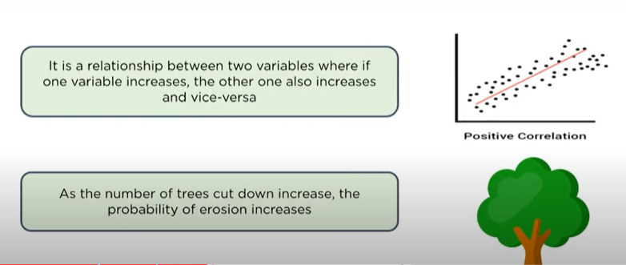
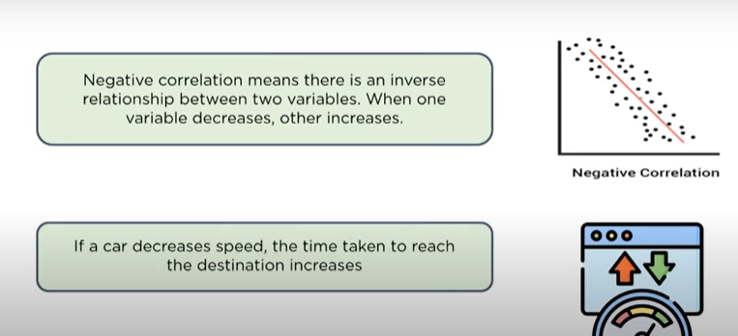
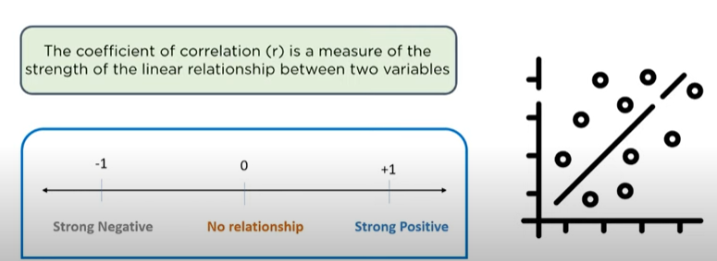
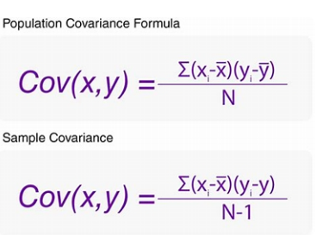
variance=
(mean-x)^2
____________
N

cov(x,y)/sd(x)sd(y)

Level of Measurements:
Levels of Measurement | Nominal, Ordinal, Interval and Ratio (scribbr.com)
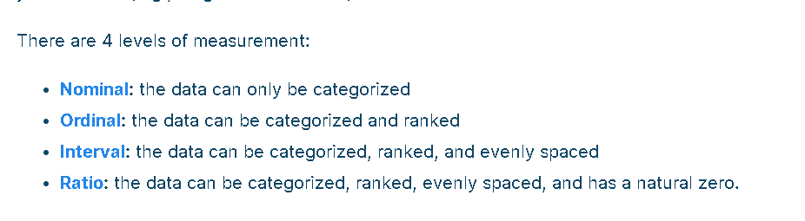
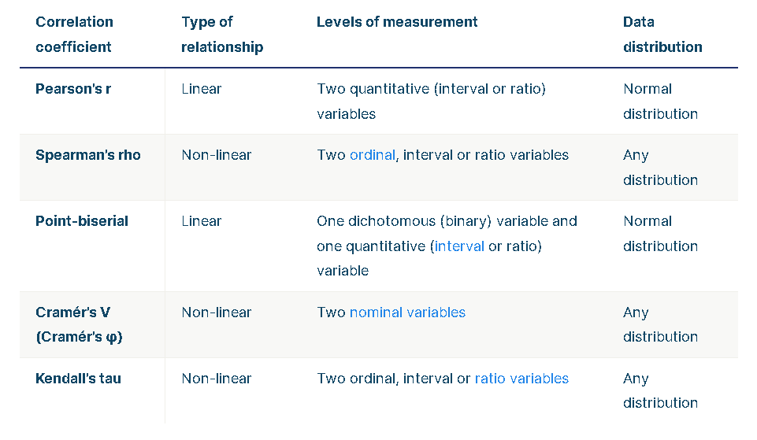
Why Spearman?
Both entities aren't ND and standard implemented are spearman and kendall only.

What is pd.get_dummies(df)
converts categorical data to numerical

Simple linear regression vs multi linear
simple is for relation between two variable
multi can have more than two variables
Simple linear regression is a parametric test, meaning that it makes certain assumptions about the data. These assumptions are:
- Homogeneity of variance (homoscedasticity): the size of the error in our prediction doesn’t change significantly across the values of the independent variable.
- Independence of observations: the observations in the dataset were collected using statistically valid sampling methods, and there are no hidden relationships among observations.
- Normality: The data follows a normal distribution.
Main normal distribution hove
minmaxScaler
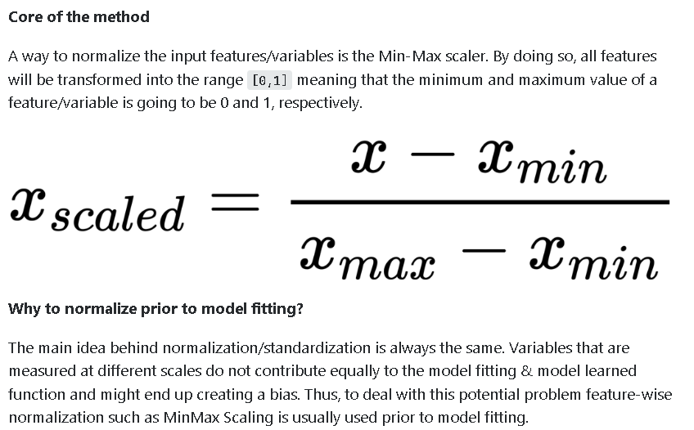
As 99.7% of the data typically lies within three standard deviations, the number of outliers will be close to 0.3% of the size of the dataset.
How to Detect Outliers in Machine Learning – 4 Methods for Outlier Detection (freecodecamp.org)

