Name :G.Tejomayi
Roll No : 2303A54064
Batch : 47_b

AI Assisted Coding Assignment – 4.3

Lab 4: Advanced Prompt Engineering – Zero-shot, One-shot, and Few-shot
Techniques
Task 1: Zero-Shot Prompting – Leap Year Check
Scenario:
Zero-shot prompting involves giving instructions without providing examples.

Prompt used : #Write a Python function that takes a year as input and checks whether it is a leap year.
#The function should return an appropriate message indicating whether the year is a leap year or not.
#Do not include any input-output examples.

  - Generated code :
def is_leap_year(year):
if (year % 4 == 0 and year % 100 != 0) or (year % 400 == 0):
return True
else:
return False

year = int(input("Enter year: "))
print(is_leap_year(year)

  - Sample Input :
Enter year:2024
  - Sample Output :
True
  - Short Explanation of Logic :
the program checks the leap year conditions using logical operators .a year is a leap year if the it is divisible by 400 or divisibe by 4 but not divisible by 100 . the logic is implemented directly without providing any prior .
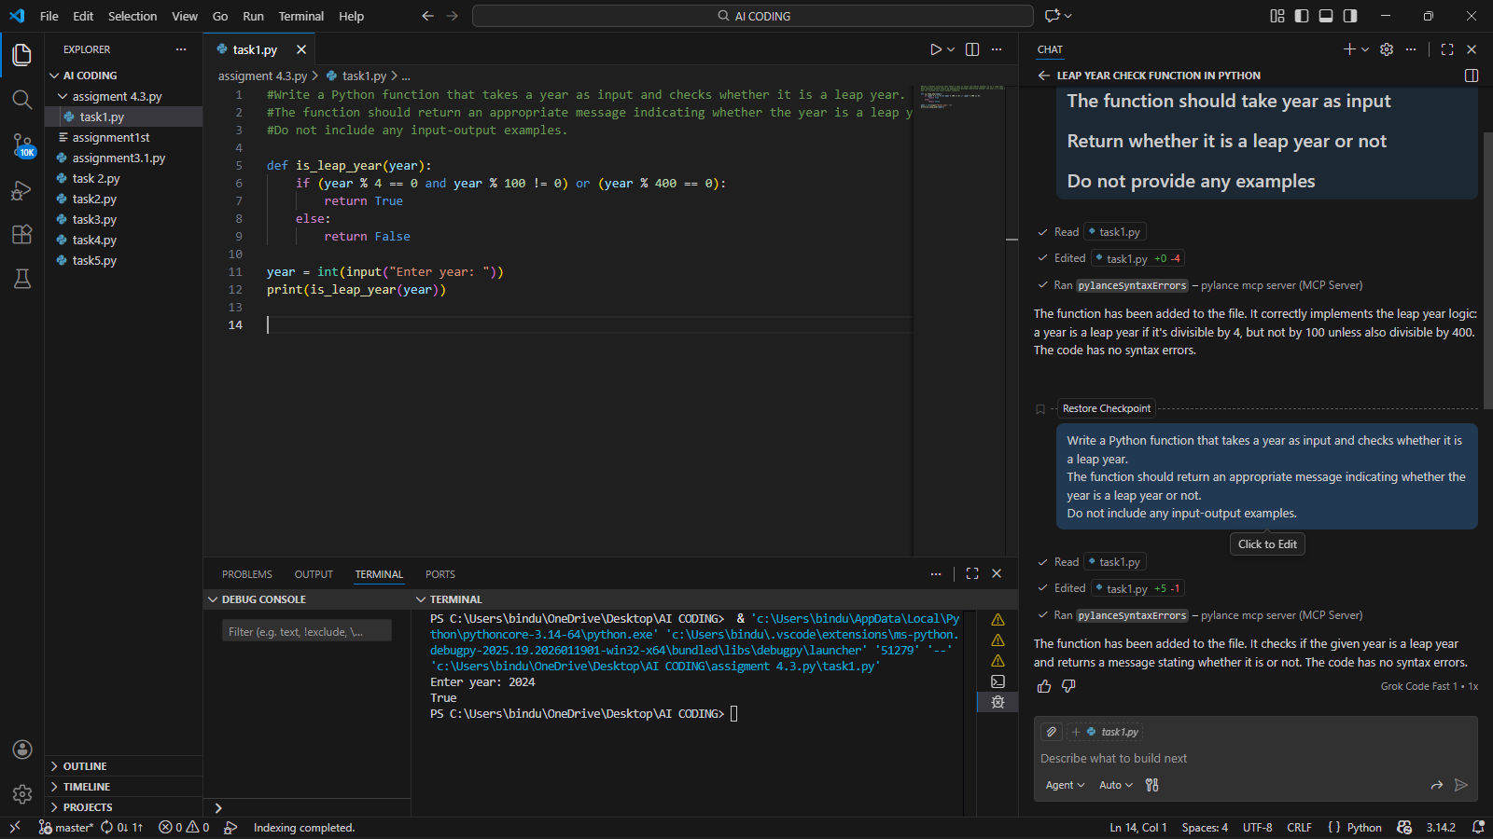

Task 2: One-Shot Prompting – Centimeters to Inches Conversion
- Scenario : One-shot prompting guides AI using a single example.
  - Prompt used :
  - # Write a Python function to convert centimeters to inches
  - # Use the formula inches = centimeters / 2.54
  - # Example:
  - # Input: 10 cm
  - # Output: 3.94 inches
  - Generated code :
def cm_to_inches(centimeters):
"""
Convert centimeters to inches.

Args:
centimeters: A number representing length in centimeters

Returns:
A float representing the length in inches
"""
inches = centimeters / 2.54
return round(inches, 2)

# Example usage
if __name__ == "__main__":
cm_value = 10
result = cm_to_inches(cm_value)
print(f"Input: {cm_value} cm")
print(f"Output: {result} inches")

  - Sample Input :
  - Enter value in cm: 25.4
  - Sample Output :
10.0 inches
Short Explanation of Logic :
The function takes centimeters as input and converts it into inches using the standard formula
Cm %2.54 one example in the prompt helps the ai to generate the logic accurately in one short

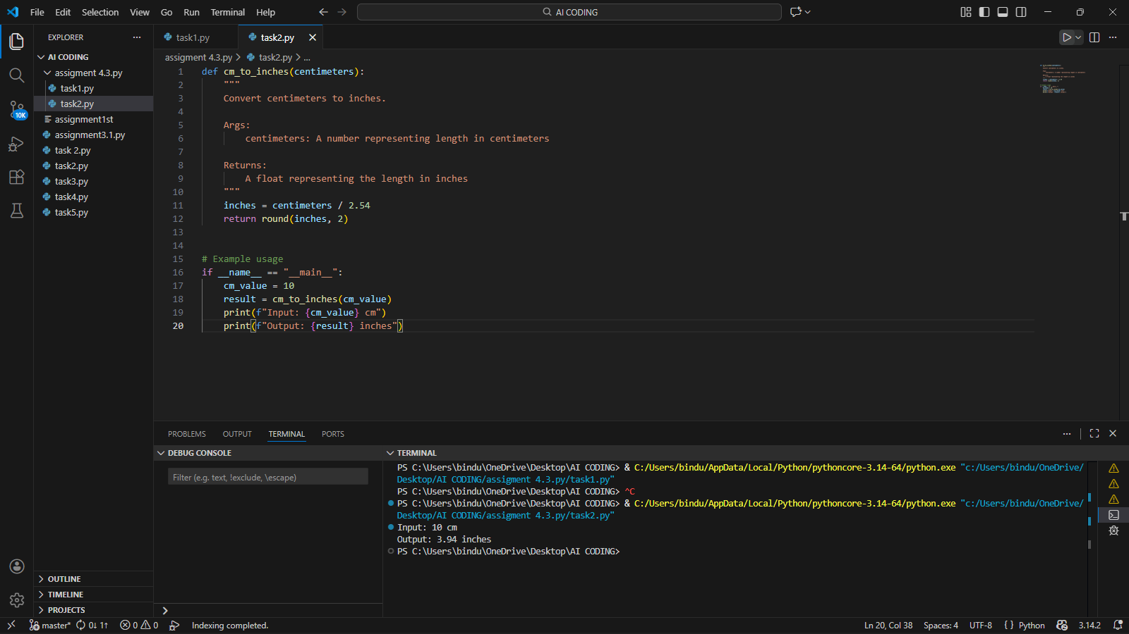

Task3:Few-shot promting-Name Formatting
Scenario:
Few-shot prompting improves accuracy by providing multiple examples.

  - Prompt used :
  - # Write a Python function to format names as "Last, First"
  - # Examples:
  - # "John Smith" -> "Smith, John"
  - # "Anita Rao" -> "Rao, Anita"

  - Generated code :
"""

def format_name(full_name):
"""
Format a full name as "Last, First"

Args:
full_name (str): A full name in "First Last" format

Returns:
str: The name formatted as "Last, First"
"""
parts = full_name.split()
if len(parts) >= 2:
first_name = parts[0]
last_name = parts[-1]
return f"{last_name}, {first_name}"
return full_name

# Test examples
print(format_name("John Smith")) # Smith, John
print(format_name("Anita Rao")) # Rao, Anita

  - Sample Input :
Enter full name: John Smith

  - Sample Output : Smith, John

Short Explanation of Logic : The function splits the full name into first and last names and rearranges them in the required format it providing multiple examples improves few short

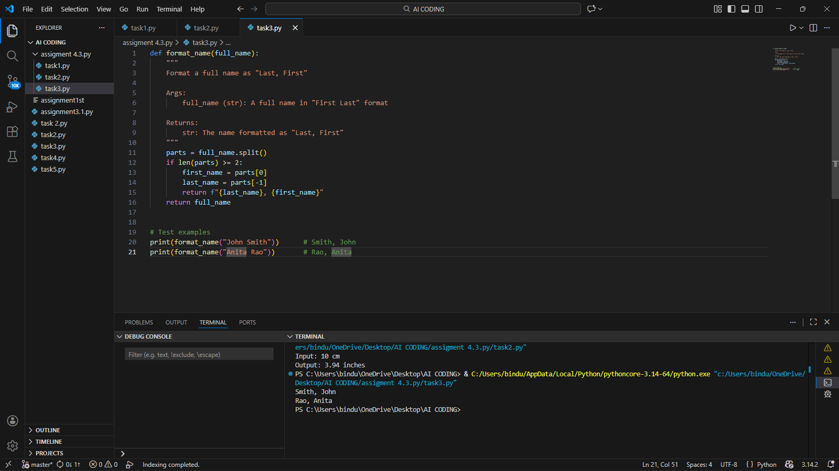

Task 4: Comparative Analysis – Zero-Shot vs Few-Shot
  - Scenario:
Different prompt strategies may produce different code quality.
  - Prompt 1: Zero-Shot Prompting
Write a Python function that counts the number of vowels in a given string.
The function should return the total count.
Do not provide any examples.
Generated code:
def count_vowels(string):
vowels = "aeiouAEIOU"
count = 0
for char in string:
if char in vowels:
count += 1
return count

  - Sample Input :
Enter string: Hello World
  - Sample Output :
Number of vowels: 3

  - Prompt 2: Few-Shot Prompting

  - Write a Python function to count vowels in a string.
  - Examples:
  - Input: "hello" → Output: 2
  - Input: "AI Assisted Coding" → Output: 7
- Generated code:
- ef count_vowels(string):
- """Count the number of vowels in a string."""
- vowels = "aeiouAEIOU"
- return sum(1 for char in string if char in vowels)

- # Test cases
- print(count_vowels("hello")) # Output: 2
- print(count_vowels("AI Assisted Coding")) # Output: 7

  - Sample Input :
Enter string: Hello World
  - Sample Output :3

Explanation (Few-Shot);
The function uses a predefined vowel set and python’s sum with the generator expression to count vowels efficiently the logic is compact and easier to understand due to example .
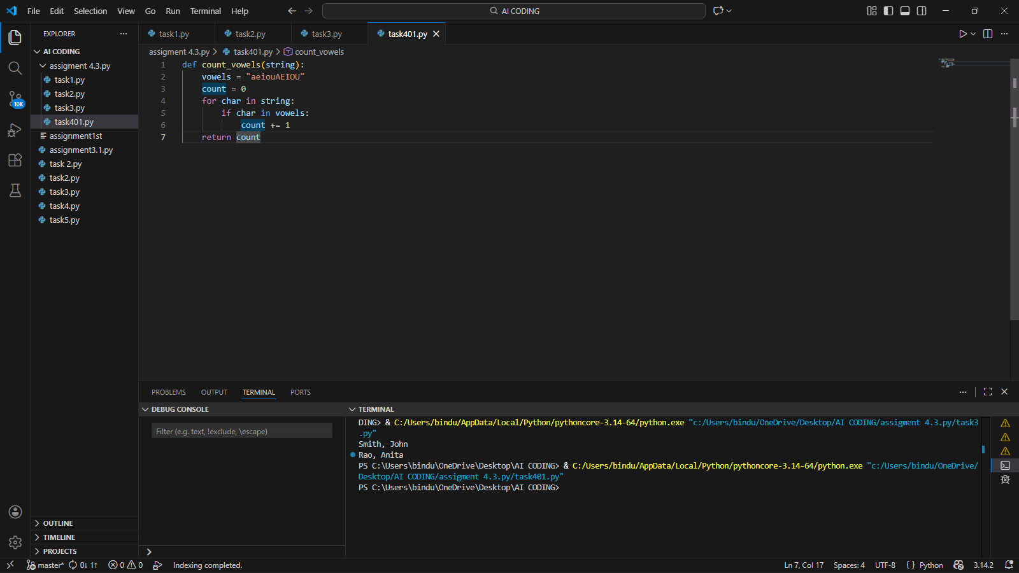

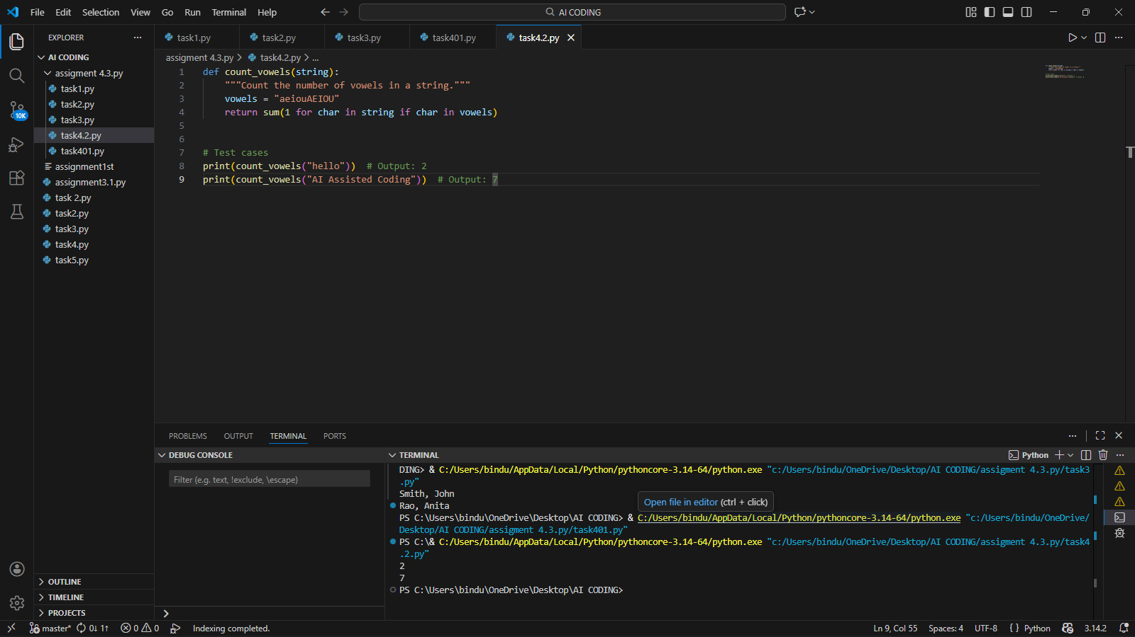

Comparison Table
Criteria | Zero-Shot | Few-Shot
Accuracy | Correct | Correct
Readability | Medium | High
Logical Clarity | Simple | Very clear
Code Length | Longer | Shorter

Task 5: Few-Shot Prompting – File Handling (Line Count)
Scenario : You are building a text file analyzer that counts the number of lines in a file. Clear examples help ensure correct file handling.
Prompt used :

# Write a Python function to read a text file
# The function should take the file name as input
# Open the file in read mode# Count the total number of lines in the file
#Return the line count as an integer
# Example:
# If "file.txt" contains 3 lines, the output should be 3

Generated code :
def count_lines(filename):
"""
Read a text file and count the total number of lines.

Args:
filename (str): The name of the file to read

Returns:
int: The total number of lines in the file
"""
try:
with open(filename, 'r') as file:
line_count = sum(1 for line in file)
return line_count
except FileNotFoundError:
print(f"Error: File '{filename}' not found.")
return 0

# Example usage
if __name__ == "__main__":
result = count_lines("file.txt")
print(f"Total lines: {result}")

  - Sample Input :
  - print(count_lines("file.txt"))
  - Sample Output :
3

Short Explanation of Logic :
The program reads a text file in read mode and counts the number of lines present in it a counter variable is used to keep track of the number of lines. Each time a line is read from the file the counter increases by one. After reading the entire file, the function returns the total number of lines. This method ensures accurate line counting and is easy to understand

