

School of Computing

Department of Computer Science and Engineering

OBJECT ORIENTED ANALYSIS AND DESIGN USING UML
CERTIFICATE

This is to certify that the Cornerstone project work entitled “AI-Based Food Waste Reduction Platform (FoodLoop)” is submitted by

Srinadh Palamala | (24B11AI318)
P N B S Vignesh | (24B11AI355)
Mani Sai Neeli | (24B11AI295)
Sindhuja Naragam | (24B11AI291)

in partial fulfilment of the requirements for the award of the B.Tech. degree in Artificial Intelligence And Machine Learning during the academic year 2024-2028

Project Guide  Mrs Vijaya Nirmala  Assistant Professor  Department of AIML |  | Head of the Department  Dr K. Naga Bhargavi  Associate Professor & HOD  Department of AIML

DECLARATION

We hereby declare that the project entitled “AI-Based Food Waste Reduction Platform (FoodLoop)” is our original work and is submitted to ADITYA UNIVERSITY, Surampalem, in partial fulfillment of the requirements for the award of the B.Tech. degree in Computer Science and Engineering-We further declare that this project work has not been submitted, either in full or in part, for the award of any degree or diploma in this or any other institution. We also confirm that this work has been carried out with academic honesty and complies with the Institutional Academic Integrity and AI Usage Policy.
Place:
Surampalem
Date:

By
Srinadh Palamala | (24B11AI318)
P N B S Vignesh | (24B11AI355)
Mani Sai Neeli | (24B11AI295)
Sindhuja Naragam | (24B11AI291)

ACKNOWLEDGEMENT

It is with immense pleasure that we express our sincere gratitude to our Cornerstone Project Guide, Mrs Vijaya Nirmala , Assistant Professor, who has guided us throughout the project. Their valuable support, encouragement, and guidance have greatly contributed to the successful completion of this work.
We would like to thank our Deputy Heads of the Department, Dr R Suneetha, Assistant Professor, Dr B Manikyala Rao, Assistant Professor and Dr D Veeraswamy, Assistant Professor, , Department of CSE, for their support and valuable suggestions.
Our deepest thanks to our Head of the Department, Dr. K Naga Bhargavi, Assistant Professor & HOD, for their inspiration and for providing all the necessary facilities and resources required for this project.
We also extend our sincere thanks to Dr. M.V. Rajesh, Associate Dean, School of Computing, for his encouragement and support during our project.
We would like to express our sincere gratitude to Dr. G. Suresh, Registrar; Dr. A. Ramesh, Pro Vice-Chancellor (Engineering & Sciences); Dr. S. Rama Sree, Pro Vice-Chancellor (Academics); Dr. M.B. Srinivas, Vice-Chancellor; and Dr. M. Sreenivasa Reddy, Deputy Pro Chancellor and Management, Aditya University, for providing excellent infrastructure and state-of-the-art laboratories.
Finally, we would like to thank the faculty members, lab technicians, non-teaching staff, and our friends who have directly or indirectly supported us in completing this Cornerstone project successfully.

ABSTRACT
Food waste is a serious environmental and economic problem. Restaurants, hotels, supermarkets, hostels and households routinely discard edible surplus because there is no fast, centralised way to publish it or to find a nearby organisation that can use it in time. This project, FoodLoop, is an AI-based Food Waste Reduction Platform that closes that gap. It gives food providers a single workspace in which to register accounts, publish surplus food listings with quantity and best-before information, and monitor every request that arrives. Community partners — NGOs, community kitchens, shelters and food banks — log in to a dedicated portal, browse what is available nearby and request the food they can collect. The provider accepts or declines each request, schedules a pickup, and tracks the donation through to delivery, while an activity feed and an impact dashboard make every kilogram that is diverted visible.
The system was analysed and designed using the Object-Oriented Analysis and Design methodology. Requirements were gathered from the food-waste problem domain, leading to sixteen functional and twelve non-functional requirements, fourteen identified use cases, six external actors and a fourteen-event analysis table. The resulting models comprise a use case diagram, a domain class diagram, an object diagram, an activity diagram, a system sequence diagram, a high-level sequence diagram, a detailed sequence diagram, a communication diagram, a design class diagram organised into architectural layers, a state machine diagram, and package, component and deployment diagrams. Chapter 8 maps the class model onto a relational schema and provides a CRUD matrix for the nine collections the implementation uses.
The prototype is implemented as a responsive single-page application built with HTML, CSS and JavaScript on the client and a Node.js and Express REST API on the server, backed by MongoDB through the Mongoose ODM. JSON Web Token authentication separates the admin and NGO roles, and a fifteen-second polling loop keeps every view synchronised with the database. Food photographs are resolved automatically from TheMealDB so that each listing is instantly recognisable to a partner browsing from a phone.
Keywords: Food waste reduction · surplus food redistribution · OOAD · UML · Node.js · Express · MongoDB · Mongoose · JSON Web Token · community kitchens · NGO partnerships
Table of contents
S.No. | Contents | Pages
1 | Certificate | i
2 | Declaration | ii
3 | Acknowledgement | iii
4 | Abstract | iv
5 | Table of Contents | v
6 | List of Figures | viii
7 | List of Tables | x
Chapter 1 | INTRODCUTION | 1
1.1 | Introduction to the Project | 1
1.2 | Project Modules | 3
1.3 | Problem Statement | 3
1.4 | Objectives of the Project | 4
1.5 | Scope of the Project | 5
Chapter 2 | REQUIREMENT ANALYSIS | 6
2.1 | Functional Requirements | 6
2.2 | Non-Functional Requirements | 7
2.3 | Actors and Their Roles | 8
2.4 | Use Case Identification | 9
2.5 | Use Case Descriptions | 10
2.6 | Event List | 13
2.7 | Event Table | 14
Chapter 3 | USE CASE AND DOMAIN MODELLING | 16
3.1 | Use Case Modelling | 16
3.1.1 | Use Case Diagram | 16
3.1.2 | Description and Terminology | 17
3.1.3 | Project-Specific Explanation | 17
3.2 | Domain Modelling | 20
3.2.1 | Domain Class Diagram | 20
3.2.2 | Description and Terminology | 21
3.2.3 | Project-Specific Explanation | 22
Chapter 4 | INTERACTION MODELLING | 24
4.1 | System Sequence Diagram | 24
4.2 | High-Level Sequence Diagram | 25
4.3 | Detailed Sequence Diagram | 26
4.4 | Communication Diagram | 27
Chapter 5 | DESIGN CLASS MODELLING | 29
5.1 | Design Class Diagram | 29
5.2 | Classes, Attributes and Operations | 29
5.3 | Relationships and Multiplicity | 31
5.4 | Interfaces, Dependencies and Generalization | 31
Chapter 6 | BEHAVIOURAL MODELLING | 33
6.1 | Activity Diagram | 33
6.2 | State Machine Diagram | 35
Chapter 7 | ARCHITECTURAL MODELLING | 37
7.1 | Package Diagram | 37
7.2 | Component Diagram | 38
7.3 | Deployment Diagram | 39
Chapter 8 | DATABASE DESIGN | 42
8.1 | Mapping Class Diagram to Relational Database | 42
8.2 | Database Tables | 43
8.3 | Primary Keys and Foreign Keys | 43
8.4 | CRUD Matrix | 44
Chapter 9 | TOOLS AND TECHNOLOGIES USED | 46
9.1 | Overview of Tools and Technologies | 46
9.2 | UML Modelling Tool | 48
9.3 | Introduction to the Tool | 48
9.4 | Features and Capabilities | 49
Chapter 10 | CONCLUSION AND FUTURE SCOPE | 54
10.1 | Conclusion | 54
10.2 | Limitations | 54
10.3 | Future Enhancements | 55
LIST OF FIGURES
S.No. | Figure | Page
1.1 | Sign-in screen with the Admin / NGO role selector | 2
1.2 | NGO portal listing surplus food available near the partner, with a request action on every card | 2
2.1 | Create-account screen implementing FR-01, with the role that will be requested from the server | 7
3.1 | Use case diagram of the AI-Based Food Waste Reduction Platform | 16
3.2 | Food listings view — UC-02 List Surplus Food and UC-03 View Available Food | 18
3.3 | Donation requests inbox — UC-04 Request Surplus Food and UC-05 Manage Donation, with live status tabs | 19
3.4 | Pickup coordination board — UC-06 Arrange Pickup and UC-07 Track Delivery | 19
3.5 | Community partners view — UC-11 Manage Partner, filtered by partner type | 20
3.6 | Domain class diagram with attributes, operations and multiplicities | 21
3.7 | Object diagram — an instance snapshot of a donation in progress | 23
3.8 | Waste log view — UC-09 Record Food Waste and UC-10 Analyse Food Waste, grouped by reason | 23
4.1 | System sequence diagram for publishing surplus and completing a donation | 24
4.2 | High-level sequence diagram showing the interaction between the major components | 25
4.3 | Detailed sequence diagram of the donation process, with the approve and reject branches | 26
4.4 | Communication diagram of the same scenario, showing the object links in chronological order | 28
5.1 | Design class diagram organised into presentation, service, entity and persistence layers | 29
6.1 | Activity diagram of the surplus food redistribution workflow | 34
6.2 | Overview dashboard — live impact counters and the recent activity feed | 35
6.3 | State machine diagram of the DonationRequest life cycle | 36
7.1 | Package diagram of the FoodLoop logical structure | 37
7.2 | Component diagram of the FoodLoop runtime components | 39
7.3 | Add food listing modal — the presentation component that collects the data for UC-02 | 39
7.4 | Deployment diagram of the FoodLoop runtime topology | 40
8.1 | Relational schema mapped from the design class diagram | 42
9.1 | Impact reports view — UC-12 Generate Reports, rendered from the metrics and waste collections | 47
9.2 | Notifications panel — UC-13 Receive Notifications, fed by the activity collection | 48
9.3 | Global search command palette — FR-19, implemented as a presentation component driven by app.js | 50
9.4 | The About FoodLoop view, which embeds this project's own documentation and UML diagrams | 51
9.5 | Settings view showing the account, the API and database connection, and notification preferences | 51
9.6 | Help centre modal — the in-application guidance component | 52
9.7 | Responsive layout at 430 px, satisfying NFR-08 | 53

LIST OF TABLES
S.No. | Table | Page
1.1 | Functional modules of FoodLoop | 3
1.2 | Scope of the project | 5
2.1 | Functional requirements | 6
2.2 | Non-functional requirements | 8
2.3 | Actors and their roles | 9
2.4 | Identified use cases | 9
2.5 | Use case specification — Register / Log In | 10
2.6 | Use case specification — List Surplus Food | 11
2.7 | Use case specification — Request Surplus Food | 11
2.8 | Use case specification — Manage Donation | 12
2.9 | Use case specification — Record Food Waste | 13
2.10 | Event list | 14
2.11 | Event table — stimulus, response and requirement | 14
3.1 | Use case modelling terminology | 17
3.2 | Domain modelling terminology | 21
4.1 | Messages of the system sequence diagram | 24
5.1 | Design classes, attributes and operations | 29
5.2 | Relationships and multiplicity in the design model | 31
5.3 | Interfaces, dependencies and generalisation | 31
7.1 | Packages and their responsibilities | 38
7.2 | REST endpoints exposed by the server | 40
8.1 | Database tables (MongoDB collections) | 43
8.2 | Primary keys, foreign keys and constraints | 42
8.3 | CRUD matrix | 44
9.1 | Tools and technologies used | 46
9.2 | Features of the UML modelling tool used | 49
10.1 | Planned enhancements | 55

Chapter 1
INTRODUCTION
1.1 Introduction to the Project
FoodLoop is a centralised web platform that reduces avoidable food waste by connecting the organisations that produce surplus food with the organisations that can use it. A restaurant, hotel, supermarket, hostel or household publishes what it has; an NGO, community kitchen, shelter or food bank asks for what it can collect; the platform records the agreement, coordinates the pickup and reports what was saved. The unit of value in the system is the kilogram of edible food that reaches a person instead of a bin.
The system is deliberately split into two role-specific experiences. A food provider signs in as an administrator and receives a workspace with a surplus inventory, an inbox of donation requests, a pickup board, a waste log, a partner directory and an impact dashboard. An NGO signs in and receives a much simpler portal that lists only the food currently available, with a single action — “Request this food” — on each card. Both experiences read and write the same MongoDB database through one Express REST API, so a request raised by an NGO appears in the provider's inbox within seconds.
Everything the provider sees is real data. Listing cards carry photographs, quantities and best-before times; the request inbox is filtered by status; the pickup board groups collections into Today, Tomorrow and Completed; the waste log explains what could not be rescued and why; and the dashboard aggregates kilograms diverted, meals shared, pending pickups and active partners. Nothing on screen is a static mock-up.

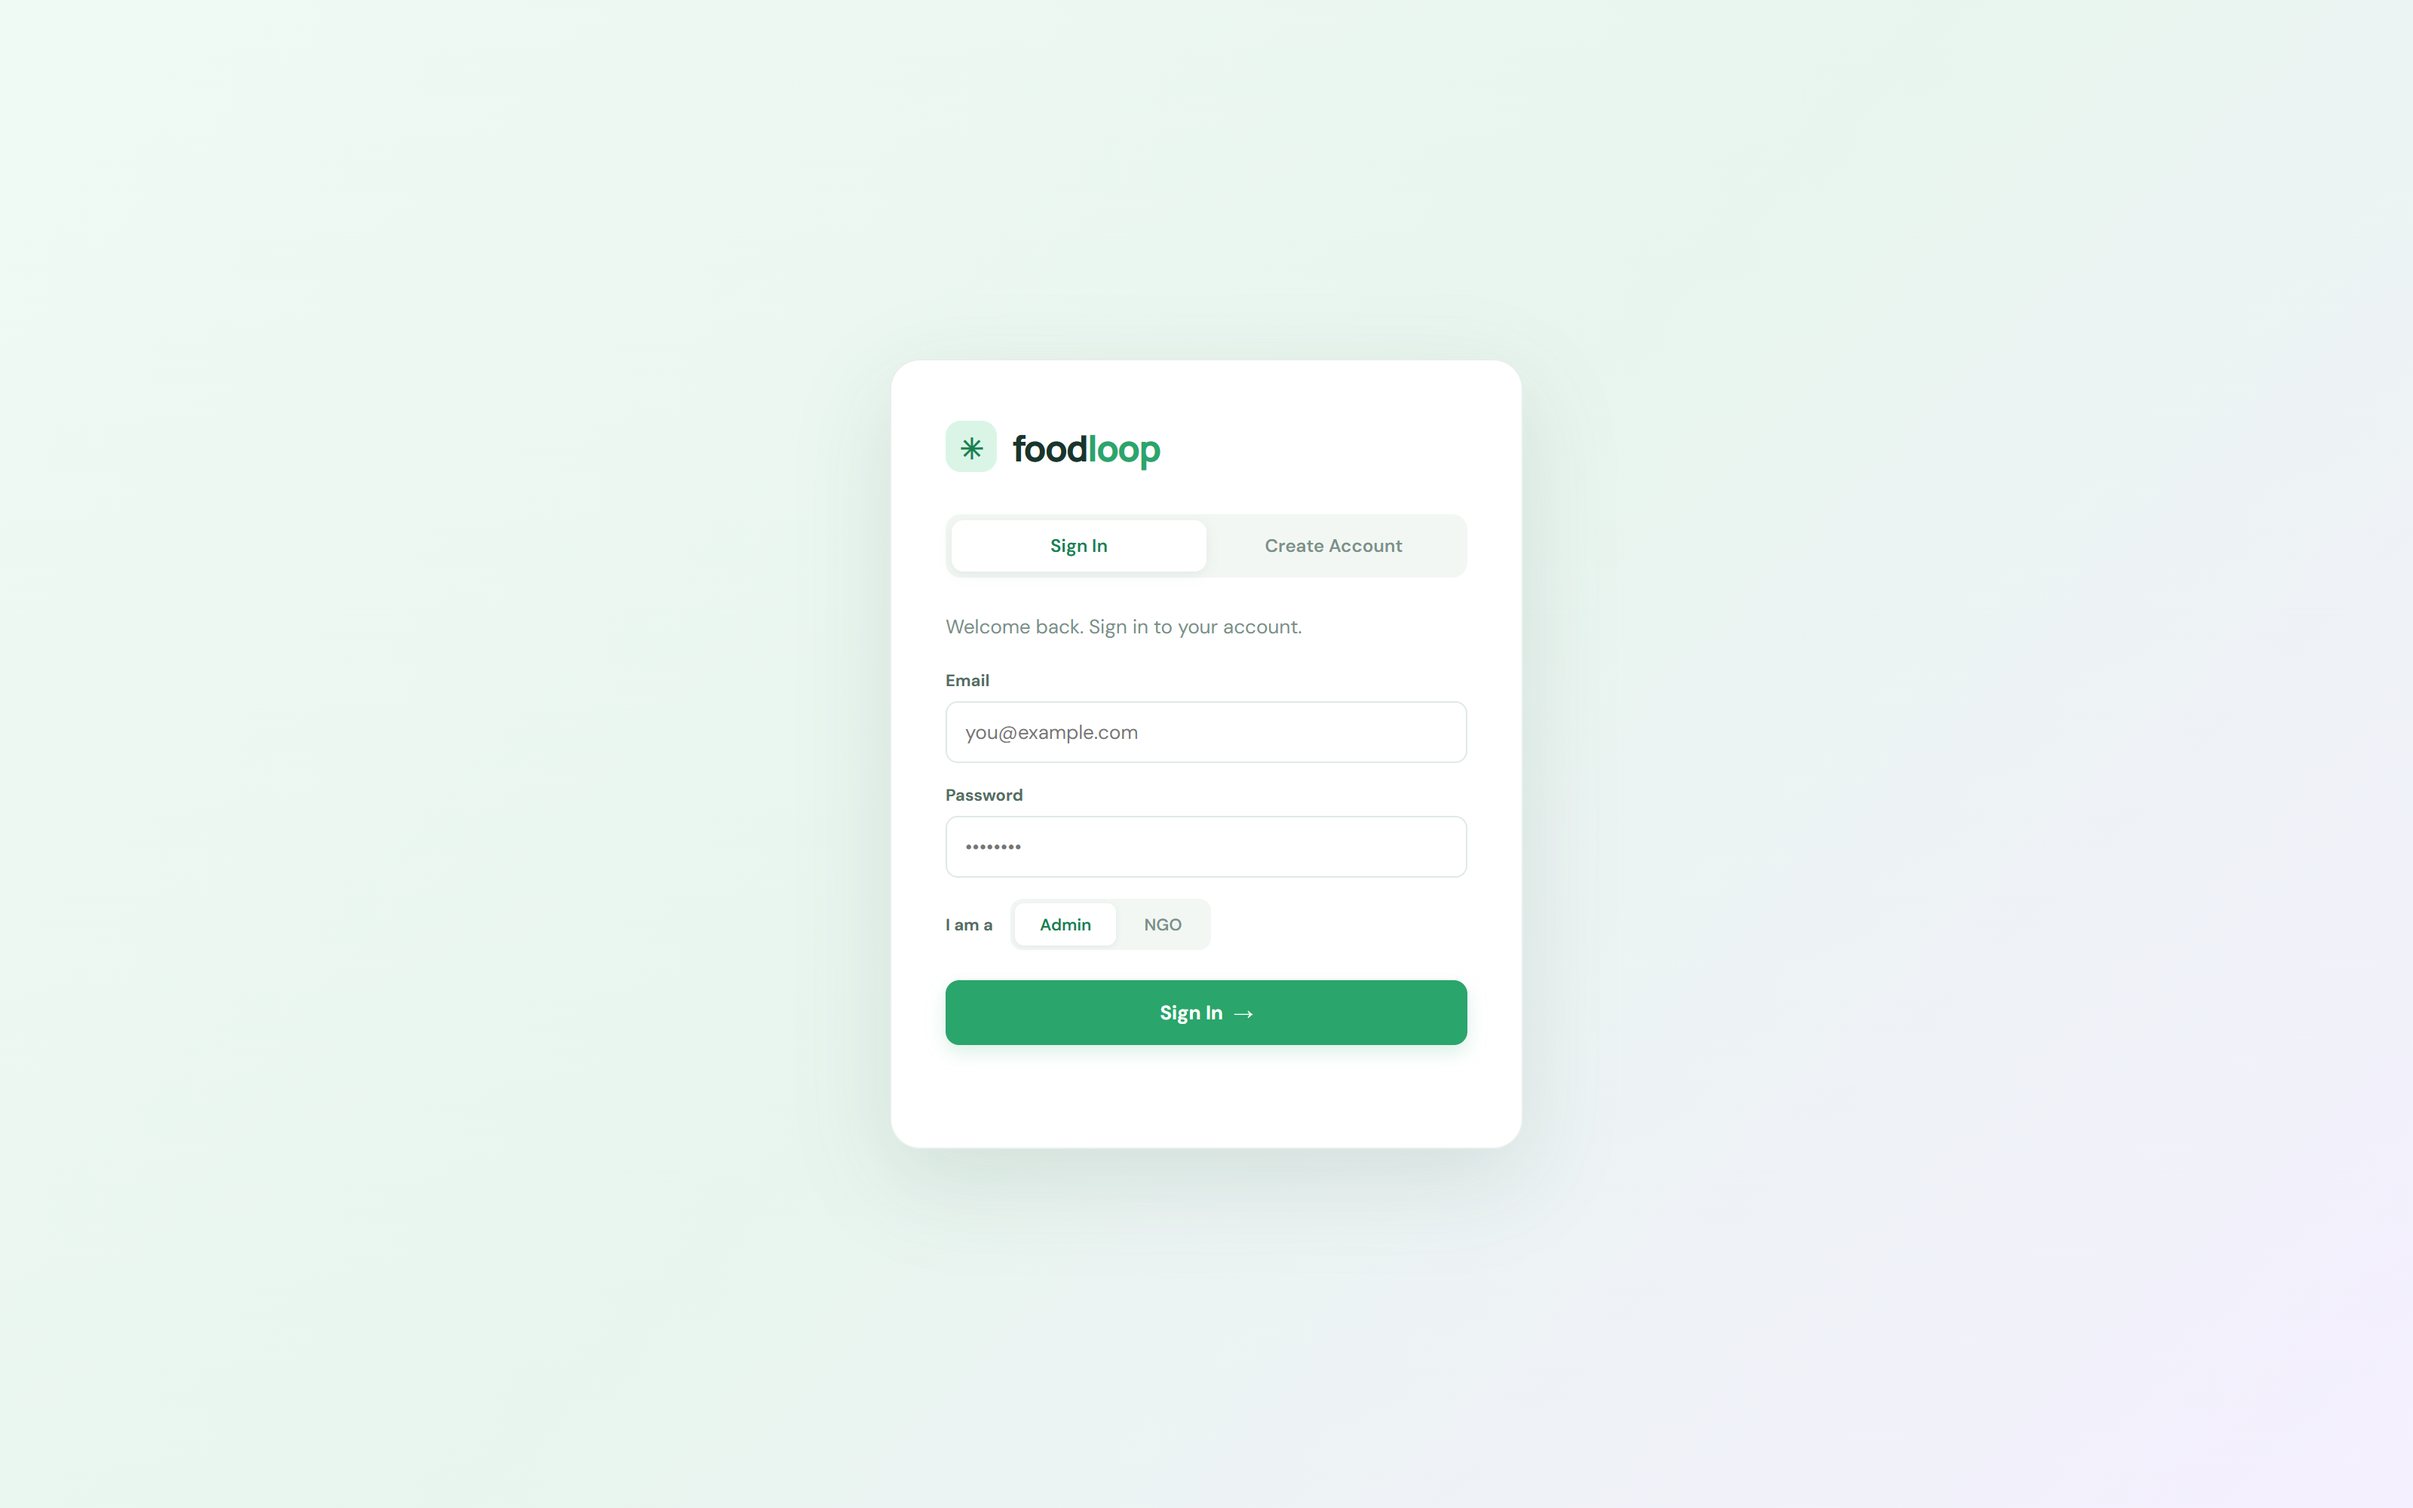
Figure 1.1 Sign-in screen with the Admin / NGO role selector
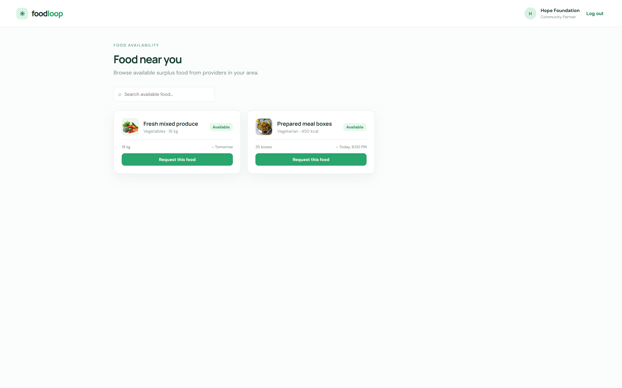
Figure 1.2 NGO portal listing surplus food available near the partner, with a request action on every card
The prototype is deployed publicly and is reachable at https://manisaineeli.github.io/FoodLoop/. The static page is published from GitHub Pages, while the REST API is hosted separately; the two are connected by a single configurable base URL held in config.js.
1.2 Project Modules
The platform is decomposed into nine modules. Each module owns one slice of the workflow and maps to a group of use cases in Chapter 2 and to a set of REST endpoints described in Chapter 7.
Table 1.1 Functional modules of FoodLoop
Code | Module | Responsibility
M1 | Authentication & Role Management | Registration and sign-in for admins and NGOs, bcrypt password hashing, JWT issue and verification, role-guarded views.
M2 | Food Listing Management | Publish surplus food with name, quantity, best-before and notes; automatic photograph resolution; availability and reservation state.
M3 | Donation Request Handling | Raise, accept and decline requests; status history; partner-facing browsing of what is available.
M4 | Pickup & Delivery Coordination | Schedule a collection against a day and time, attach a delivery partner and close the pickup on delivery.
M5 | Community Partner Network | Maintain the directory of NGOs, kitchens, shelters and food banks with type, service area and connection status.
M6 | Food Waste Logging & Analysis | Record waste by category, quantity and reason; analyse dominant causes so prevention can be planned.
M7 | Notifications & Activity Feed | Append-only event stream surfaced in the notifications panel and the Recent Activity card.
M8 | Impact Reporting | Aggregate kilograms diverted, meals shared, pending pickups and active partners; export a plain-text impact report.
M9 | AI Recommendation | Predict demand for a dish and analyse waste patterns to suggest the next action for the provider.

1.3 Problem Statement
Large quantities of edible food are discarded every day because nobody who could use it knows that it exists. Donation activity is handled through phone calls, text messages and personal contacts, which does not scale: a provider who discovers forty surplus meal boxes at 6 p.m. has very little time to reach a partner before the food becomes unusable, and the provider has no way to know whether the food was actually collected.
• There is no centralised platform on which a provider can publish surplus food or a partner can discover it.
• Finding a nearby NGO, community kitchen, shelter or food bank depends on personal contacts rather than a searchable directory.
• Surplus quantities, best-before times and reservation status are not tracked, so the same batch can be claimed twice or not at all.
• Pickup and delivery are coordinated verbally, leaving no record of who collected what, or when.
• Food that cannot be rescued is not logged with a reason, so the provider cannot see whether the real cause was overproduction, spoilage or a quality issue.
• Providers have no measure of the impact they generate, so a successful programme is difficult to justify or improve.
1.4 Objectives of the Project
1. Provide a single web workspace where any food provider can register an account and publish surplus food in under a minute.
2. Expose every currently available listing to registered NGOs and community partners with photographs, quantity and best-before time.
3. Allow a partner to request a listing and a provider to accept or decline that request, with the decision persisted against the request record.
4. Coordinate the resulting pickup by recording the collection day, time and delivery partner, and closing the pickup on delivery.
5. Maintain a persistent, queryable record of food waste with category, quantity and reason so that recurring causes become visible.
6. Generate an impact report showing kilograms diverted, meals shared, pending pickups and active partners, and allow it to be exported.
7. Model the whole system with UML so that requirements, structure, behaviour and architecture can be reviewed before and during implementation.
8. Deliver a responsive interface that works on a phone in a food bank as well as on a desktop in a restaurant office.
1.5 Scope of the Project
The scope below is what the delivered prototype actually implements. Items marked out of scope are deliberate design decisions, not omissions.
Table 1.2 Scope of the project
In scope | Out of scope (and why)
Web application served by a single Express process that serves both the page and the REST API. | Native mobile applications — the responsive web interface already covers the phone use case.
MongoDB persistence for users, listings, requests, NGO requests, pickups, partners, waste, activity and metrics. | Payments and settlement between providers and partners — outside the purpose of a surplus redistribution tool.
Two roles: admin (food provider) and NGO (community partner). | Separate roles for delivery drivers and regulators — modelled as future work in Chapter 10.
Automatic food photograph resolution through TheMealDB. | Machine-learning demand prediction — the AI Recommendation module is specified and stubbed, not trained.
Fifteen-second live polling so several users see the same data. | Real-time push notification — polling already satisfies the requirement for freshness.
JWT authentication with bcrypt password hashing. | Password reset and e-mail verification — left for a later release.

Chapter 2
REQUIREMENT ANALYSIS
2.1 Functional Requirements
Functional requirements state what the system must do. Each is given an identifier so that it can be traced to a use case, to a screen and to an endpoint later in this report.
Table 2.1 Functional requirements
ID | Requirement | Priority | Realised by
FR-01 | The system shall allow a user to register an account with a name, email address, password and a role of admin or NGO. | Must | M1 · POST /api/signup
FR-02 | The system shall authenticate a user with an email address, password and role, and reject a mismatch between the role and the stored account. | Must | M1 · POST /api/signin
FR-03 | The system shall store passwords only as bcrypt hashes and shall never return a password or hash in any response. | Must | M1
FR-04 | The system shall issue a signed JSON Web Token on successful authentication and shall accept it on every subsequent request. | Must | M1
FR-05 | The system shall present a separate interface to an NGO account that shows available food and allows a request to be raised. | Must | M1 · M2
FR-06 | The system shall allow an admin to publish a surplus food listing with a name, quantity, best-before time and optional notes. | Must | M2 · POST /api/listings
FR-07 | The system shall attach a photograph to every listing, resolved automatically from the food name. | Should | M2 · ImageResolver
FR-08 | The system shall let an admin view all listings and search them by name. | Must | M2 · GET /api/bootstrap
FR-09 | The system shall allow an NGO to request any listing whose status is Available. | Must | M3 · POST /api/requests
FR-10 | The system shall allow an admin to accept or decline a pending request and shall persist that decision. | Must | M3 · PATCH /api/requests/:id
FR-11 | The system shall let an admin filter requests by All, Pending, Accepted and Declined and search by partner or item. | Must | M3
FR-12 | The system shall allow an admin to schedule a pickup with a day, time, item and delivery partner. | Must | M4 · POST /api/pickups
FR-13 | The system shall group pickups into Today, Tomorrow and Completed and let an admin search them. | Must | M4
FR-14 | The system shall allow an admin to maintain a partner directory with name, type and distance. | Should | M5 · POST /api/partners
FR-15 | The system shall allow an admin to log a waste entry with date, category, quantity, reason and the person who logged it. | Must | M6 · POST /api/waste
FR-16 | The system shall maintain an activity feed recording every listing, request, decision, pickup, waste entry and new partner. | Must | M7
FR-17 | The system shall display food diverted, meals shared, pending pickups and active partners on the dashboard. | Must | M8 · metrics
FR-18 | The system shall allow an admin to export the current impact figures and the live listings and requests as a report file. | Should | M8
FR-19 | The system shall provide a global search across listings, requests, pickups and partners that navigates to the matching view. | Should | M2 · M3 · M4 · M5
FR-20 | The system shall report a clear, actionable message when the backend cannot be reached, instead of a generic failure. | Must | All modules

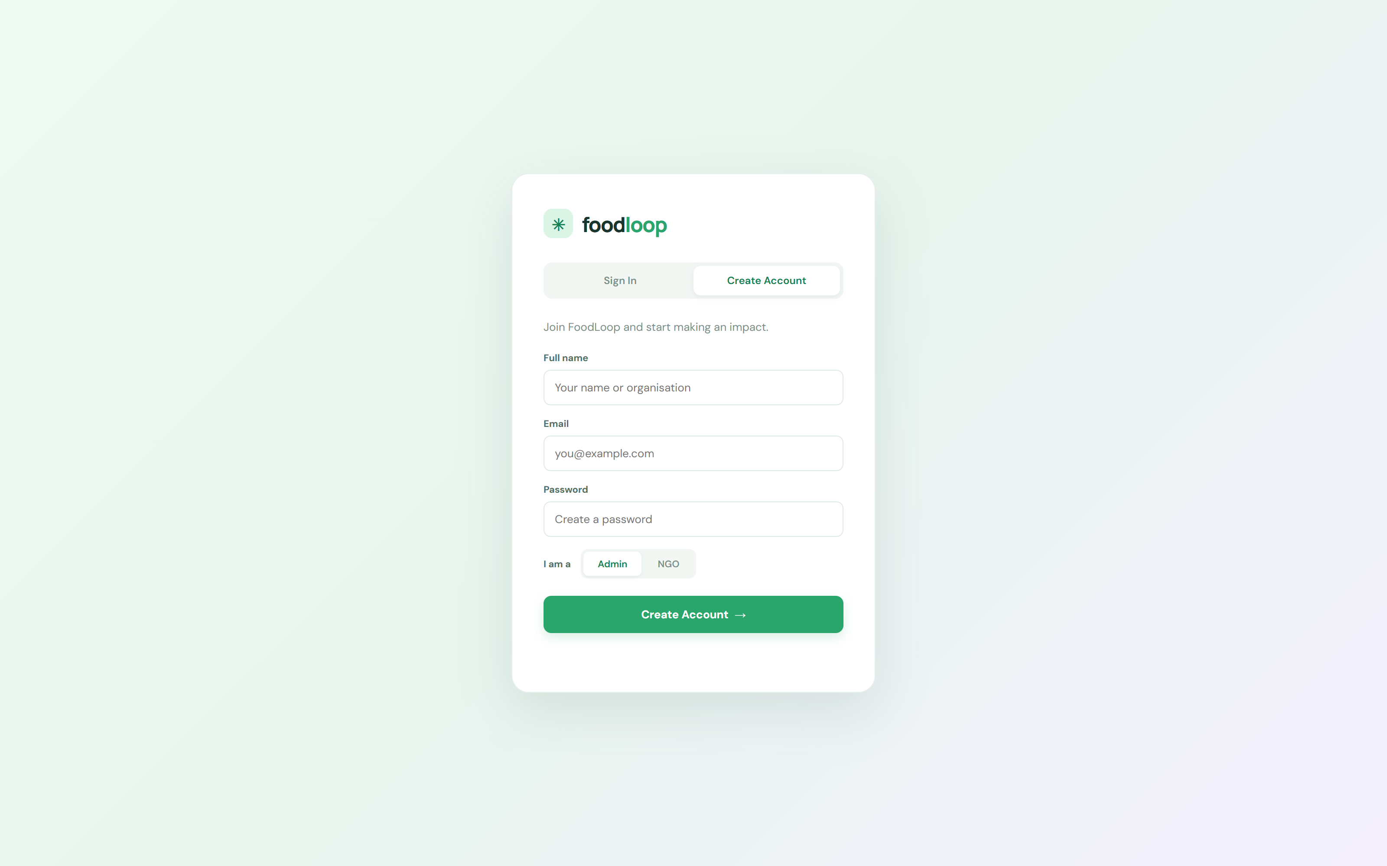
Figure 2.1 Create-account screen implementing FR-01, with the role that will be requested from the server
2.2 Non-Functional Requirements
Non-functional requirements constrain how the system must behave rather than what it must do. They are grouped by the quality attribute they protect.
Table 2.2 Non-functional requirements
ID | Category | Requirement | Measure
NFR-01 | Performance | A view must render within two seconds of the data request completing. | Observed on load
NFR-02 | Performance | Live data must refresh without a page reload at least every thirty seconds. | 15 s poll interval
NFR-03 | Availability | The host health endpoint shall report service status without depending on the database. | GET /api/health
NFR-04 | Scalability | The data access layer shall isolate storage behind an interface so the database can be replaced. | IRepository
NFR-05 | Security | Passwords shall be stored as salted bcrypt hashes and never returned by the API. | bcrypt cost 10
NFR-06 | Security | A successful authentication shall return a time-limited signed token rather than a credential. | JWT, 7-day expiry
NFR-07 | Security | The API shall refuse to serve data while the database is unavailable instead of hanging. | HTTP 503
NFR-08 | Usability | The interface shall be usable on a 430-pixel wide phone screen. | Responsive CSS
NFR-09 | Usability | Every view shall be reachable from the sidebar within one interaction. | Single-level nav
NFR-10 | Reliability | The server shall retry a failed database connection with backoff instead of exiting. | 10 s to 15 s backoff
NFR-11 | Maintainability | Configuration shall live in environment variables so no secret is committed. | .env / render.yaml
NFR-12 | Portability | The same build shall run on a local machine and on a hosted Node environment. | render.yaml blueprint

2.3 Actors and Their Roles
An actor is any entity that interacts with the system from outside it. FoodLoop recognises six actors: four human roles and two supporting ones.
Table 2.3 Actors and their roles
Actor | Kind | Goal | Interfaces used
Admin (food provider) | Human | Publish surplus, decide on requests, schedule pickups, log waste, read the impact report. | Admin workspace
NGO / Food Bank | Human | Find food it can collect and request it before the best-before time. | NGO portal
Restaurant / Hotel / Supermarket | Human | Act as the concrete provider that records surplus; the admin role is used on their behalf. | Admin workspace
Delivery Partner | Human | Accept a pickup, collect the food and confirm receipt. | Pickup board
User | Human | Hold an authenticated session; the generic account holder from whom the specific roles are derived. | Sign-in screen
AI System | Supporting | Predict demand for a dish and analyse waste patterns to recommend an action. | AiRecommender
TheMealDB (external service) | External | Supply a photograph for a named dish or ingredient. | ImageResolver (HTTPS)

2.4 Use Case Identification
Fourteen use cases were identified from the actor analysis and the functional requirements. Each is given a stable identifier that the class model, the sequence diagrams and the database design all refer back to.
Table 2.4 Identified use cases
ID | Use case | Primary actor | Supporting actors | Requirement
UC-01 | Register / Log In | User | — | FR-01, FR-02, FR-04
UC-02 | List Surplus Food | Restaurant / Hotel / Supermarket | AI System, NGO | FR-06, FR-07
UC-03 | View Available Food | NGO / Food Bank | Admin | FR-05, FR-08
UC-04 | Request Surplus Food | NGO / Food Bank | Admin | FR-09
UC-05 | Manage Donation | Admin | NGO, Delivery Partner | FR-10, FR-11
UC-06 | Arrange Pickup | Admin | Delivery Partner | FR-12
UC-07 | Track Delivery | Delivery Partner | NGO, Admin | FR-13
UC-08 | Manage Users | Admin | — | FR-01, FR-02
UC-09 | Record Food Waste | Admin | AI System | FR-15
UC-10 | Analyse Food Waste | Admin | AI System | FR-15
UC-11 | Manage Partner | Admin | NGO | FR-14
UC-12 | Generate Reports | Admin | — | FR-17, FR-18
UC-13 | Receive Notifications | NGO | Admin | FR-16
UC-14 | Generate AI Recommendations | AI System | Admin, NGO | FR-07

2.5 Use Case Descriptions
The five most significant use cases are specified below in the standard template: the primary actor, the supporting actors, the trigger, the precondition, the normal flow, the alternative flows and the postcondition. The remaining nine are summarised in Table 2.4 and described in prose in the chapters that implement them.
Table 2.5 Use case specification — Register / Log In
Element | Description
Use case ID | UC-01
Name | Register / Log In
Primary actor | User
Supporting actor | None
Trigger | The user submits the sign-in or create-account form.
Precondition | The Express API is running and reachable.
Normal flow | 1. The system validates that all four fields are present.  2. It hashes the password with bcrypt at cost 10.  3. It rejects the attempt if the email is already registered (409).  4. It inserts the user document into the users collection.  5. It signs a JWT carrying the user id and role, valid for 7 days.  6. It stores the session and reveals the role-specific interface.
Alternative flows | A required field is missing → 400 with a field-level message.  The email already exists → 409, the form stays on Create Account.  The role does not match the stored account → 403 telling the user to switch roles.  The API cannot be reached → the form shows the actionable hint from FR-20.
Postcondition | An authenticated session exists and the correct workspace is displayed.
Related requirements | FR-01 to FR-04, FR-20 · NFR-05, NFR-06

Table 2.6 Use case specification — List Surplus Food
Element | Description
Use case ID | UC-02
Name | List Surplus Food
Primary actor | Restaurant / Hotel / Supermarket
Supporting actor | AI System
Trigger | The provider opens the Add food listing modal and submits it.
Precondition | The provider holds an admin session.
Normal flow | 1. The system validates the food name, quantity and best-before time.  2. It derives a search keyword from the name, stripping filler words.  3. It queries TheMealDB for a dish photograph and falls back to an ingredient photograph.  4. It inserts a listing with status Available and requests '0 requests'.  5. It appends a 'Food listing published' activity entry.  6. It returns the new listing and re-renders the inventory.
Alternative flows | A required field is empty → 400 and the modal stays open.  The photograph service times out → a default bread photograph is used.  No photograph is found at all → the listing falls back to its emoji glyph, so a tile is never blank.
Postcondition | The surplus food is visible to every partner browsing available listings.
Related requirements | FR-06, FR-07, FR-16 · NFR-01

Table 2.7 Use case specification — Request Surplus Food
Element | Description
Use case ID | UC-04
Name | Request Surplus Food
Primary actor | NGO / Food Bank
Supporting actor | Admin
Trigger | The partner presses “Request this food” on a listing card.
Precondition | The partner holds an NGO session and the listing status is Available.
Normal flow | 1. The system records the partner's request intent.  2. It inserts a request document with status pending.  3. It mirrors the item into the ngoRequests collection.  4. It appends a 'New request received' activity entry.  5. The card switches to 'Request sent' and becomes disabled.  6. The request appears in the provider's inbox on the next poll.
Alternative flows | The item is missing → 400 and the toast explains the failure.  The partner has already requested this item → the button stays disabled.  The API is unreachable → the last known good mirror is kept and a toast is shown.
Postcondition | A pending request exists against the listing and the provider has been notified.
Related requirements | FR-09, FR-16, FR-19 · NFR-02, NFR-08

Table 2.8 Use case specification — Manage Donation
Element | Description
Use case ID | UC-05
Name | Manage Donation
Primary actor | Admin
Supporting actor | NGO / Food Bank, Delivery Partner
Trigger | The provider presses Accept request or Decline on a pending request.
Precondition | The request status is pending.
Normal flow (accept) | 1. The system sets the request status to accepted and saves it.  2. It appends a 'Donation accepted' activity entry.  3. It returns the updated request, re-renders the inbox and reloads the data set.
Normal flow (decline) | 1. The system sets the request status to declined and saves it.  2. The listing stays Available so another partner can claim it.
Alternative flow | The request no longer exists → 404 with an explicit message.
Postcondition | The decision is persisted and visible to the partner.
Related requirements | FR-10, FR-11, FR-16

Table 2.9 Use case specification — Record Food Waste
Element | Description
Use case ID | UC-09
Name | Record Food Waste
Primary actor | Admin
Supporting actor | AI System
Trigger | The provider presses Log waste on the Waste log view.
Precondition | The provider holds an admin session.
Normal flow | 1. The system prompts for category, quantity and reason.  2. It validates that all three are present.  3. It inserts a waste document stamped with today's date and the logged-by name.  4. It appends a 'Waste logged' activity entry.  5. It re-renders the waste table.
Alternative flows | A field is empty → 400 and the table is left unchanged.  A reason is not chosen → 'Other' is recorded.
Postcondition | The loss is recorded and available for analysis under UC-10.
Related requirements | FR-15, FR-16

2.6 Event List
An event is a significant occurrence that the system must recognise. Events are the bridge between use cases and the design models: each one names the object it affects, the class that reacts and the notification that the user sees.
Table 2.10 Event list
ID | Event | Triggered by | Object affected | Maps to
E-01 | UserRegistered | A completed create-account form | User | UC-01 · FR-01
E-02 | UserSignedIn | A successful authentication | User | UC-01 · FR-02
E-03 | SurplusFoodListed | Publishing a listing | FoodItem | UC-02 · FR-06
E-04 | FoodPhotoResolved | A photograph is resolved for a listing | FoodItem | UC-14 · FR-07
E-05 | DonationRequested | A partner presses Request this food | Donation | UC-04 · FR-09
E-06 | DonationAccepted | The provider accepts a request | Donation | UC-05 · FR-10
E-07 | DonationDeclined | The provider declines a request | Donation | UC-05 · FR-10
E-08 | NotificationRaised | Any of E-03 to E-07 | Notification | UC-13 · FR-16
E-09 | PickupScheduled | Scheduling a collection | Pickup | UC-06 · FR-12
E-10 | FoodDelivered | Marking a pickup delivered | Pickup | UC-07 · FR-13
E-11 | WasteLogged | Recording a waste entry | WasteRecord | UC-09 · FR-15
E-12 | WasteAnalysed | A report or trend is requested | WasteRecord | UC-10 · FR-15
E-13 | PartnerJoined | A partner is added to the directory | NGO | UC-11 · FR-14
E-14 | ReportGenerated | Generating or exporting the impact report | Admin | UC-12 · FR-17

2.7 Event Table
Table 2.6 pairs each event with the response the system must produce and the requirement that justifies it. This table is the acceptance checklist used to test the implementation.
Table 2.11 Event table — stimulus, response and requirement
ID | Event | System response | Requirement
E-01 | UserRegistered | Insert the user document with a bcrypt hash, sign a JWT, store the session and open the correct workspace. | FR-01, FR-04
E-02 | UserSignedIn | Compare the hash, verify the role, return a token and a safe user object, and reject a role mismatch with 403. | FR-02, FR-03
E-03 | SurplusFoodListed | Persist the listing as Available, append an activity entry and re-render the inventory and dashboard counts. | FR-06, FR-16
E-04 | FoodPhotoResolved | Attach the first photograph URL that answers a HEAD request, otherwise fall back to an ingredient image and finally to the default. | FR-07
E-05 | DonationRequested | Insert a pending request, mirror it to ngoRequests, append an activity entry and notify the provider. | FR-09, FR-16
E-06 | DonationAccepted | Set the status to accepted, append 'Donation accepted' and reload so the partner sees the new state. | FR-10
E-07 | DonationDeclined | Set the status to declined and leave the listing Available for another partner. | FR-10
E-08 | NotificationRaised | Append to the activity collection, increment the badge and list the entry in the notifications panel. | FR-16
E-09 | PickupScheduled | Insert the pickup and place its card under Today, Tomorrow or Completed. | FR-12, FR-13
E-10 | FoodDelivered | Move the pickup to Completed, update the donation status and increment the diverted kilograms. | FR-13, FR-17
E-11 | WasteLogged | Insert the waste document with its reason and append 'Waste logged'. | FR-15
E-12 | WasteAnalysed | Aggregate waste by category and reason and show the dominant cause on the Waste log view. | FR-15
E-13 | PartnerJoined | Insert the partner, derive its initials, and append 'New partner joined'. | FR-14, FR-16
E-14 | ReportGenerated | Build the impact report from live data and offer it as a downloadable file. | FR-17, FR-18

Chapter 3
USE CASE AND DOMAIN MODELLING
3.1 Use Case Modelling
The use case model is the requirement model of the system. It shows what the system does for whom, and it is the first artefact to be reviewed with the client because it contains no implementation detail at all.
3.1.1 Use Case Diagram
Figure 3.1 is the use case diagram for the AI-Based Food Waste Reduction Platform. The rectangle is the system boundary. Six actors sit outside it and interact only through the fourteen use cases inside. Three relationships refine the model: «include» where one use case always calls another as part of its own completion, and «extend» where a use case adds behaviour only under a particular condition.
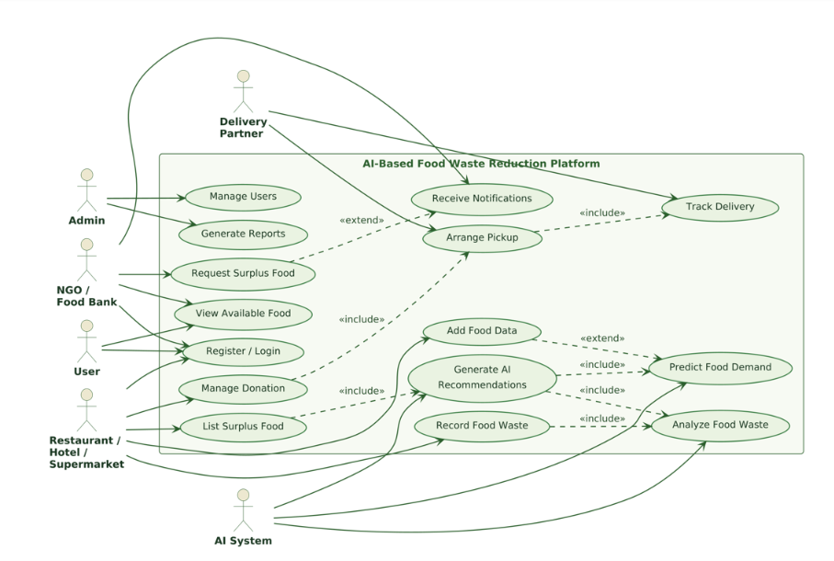
Figure 3.1 Use case diagram of the AI-Based Food Waste Reduction Platform
3.1.2 Description and Terminology
Table 3.1 Use case modelling terminology
Term | Meaning | Seen in this project
Actor | An external entity that interacts with the system and benefits from it. | Admin, NGO, Delivery Partner, AI System
Use case | A complete, externally observable behaviour that achieves one actor goal. | Fourteen, listed in Table 2.4
System boundary | The rectangle separating the system under construction from everything outside it. | The box labelled AI-Based Food Waste Reduction Platform
«include» | A mandatory reuse relationship: the base use case always invokes the included one. | Arrange Pickup «include» Track Delivery
«extend» | An optional relationship: the extending use case adds behaviour only when its condition holds. | Arrange Pickup «extend» Receive Notifications
Generalisation | An inheritance relationship between actors or between use cases, allowing a specialised actor to add behaviour. | User is the parent of Admin and NGO
Trigger | The event that starts the use case. | Submitting the Add food listing form
Precondition | The state that must hold before the use case runs. | An admin session exists
Postcondition | The state that holds once the use case completes. | The listing is Available to every partner
Alternative flow | A branch taken when a step cannot be completed as described. | The photograph service times out

3.1.3 Project-Specific Explanation
Three pairs of include and extend relationships carry most of the meaning in Figure 3.1, and each corresponds directly to a behaviour in the running application.
• Arrange Pickup «include» Track Delivery. A pickup cannot exist without being tracked, so the tracking behaviour is not optional. In the implementation, scheduling a pickup always creates the record that the pickup board reads back, and marking it delivered always updates the donation status.
• Arrange Pickup «extend» Receive Notifications. The pickup itself is not sent to the NGO portal; the notification is added only when a partner has to be told. This matches the code, where an activity entry is written for the pickup while the partner-facing alert is a separate decision.
• Record Food Waste «include» Analyse Food Waste, and Analyse Food Waste «extend» Predict Food Demand. Every waste entry is recorded so that it can be analysed; the prediction is invoked only when a provider asks for a trend rather than for a single entry.
• Generate AI Recommendations «include» Add Food Data. A recommendation is only as good as the data behind it, so the recommendation use case depends on the listing and waste data being present.
• User is the parent of both Admin and NGO. The sign-in form therefore asks for a role, and the server refuses a mismatch between the chosen role and the role stored against the account.
The four screenshots that follow are the running system showing three of these use cases and one supporting module. They are included so that the diagrams can be checked against what was actually built.
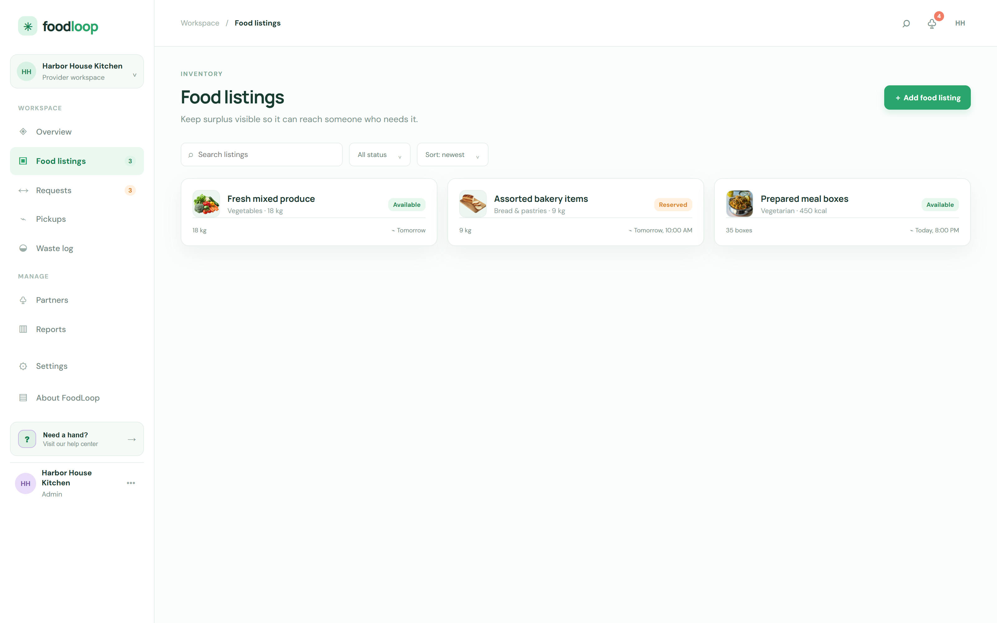
Figure 3.2 Food listings view — UC-02 List Surplus Food and UC-03 View Available Food
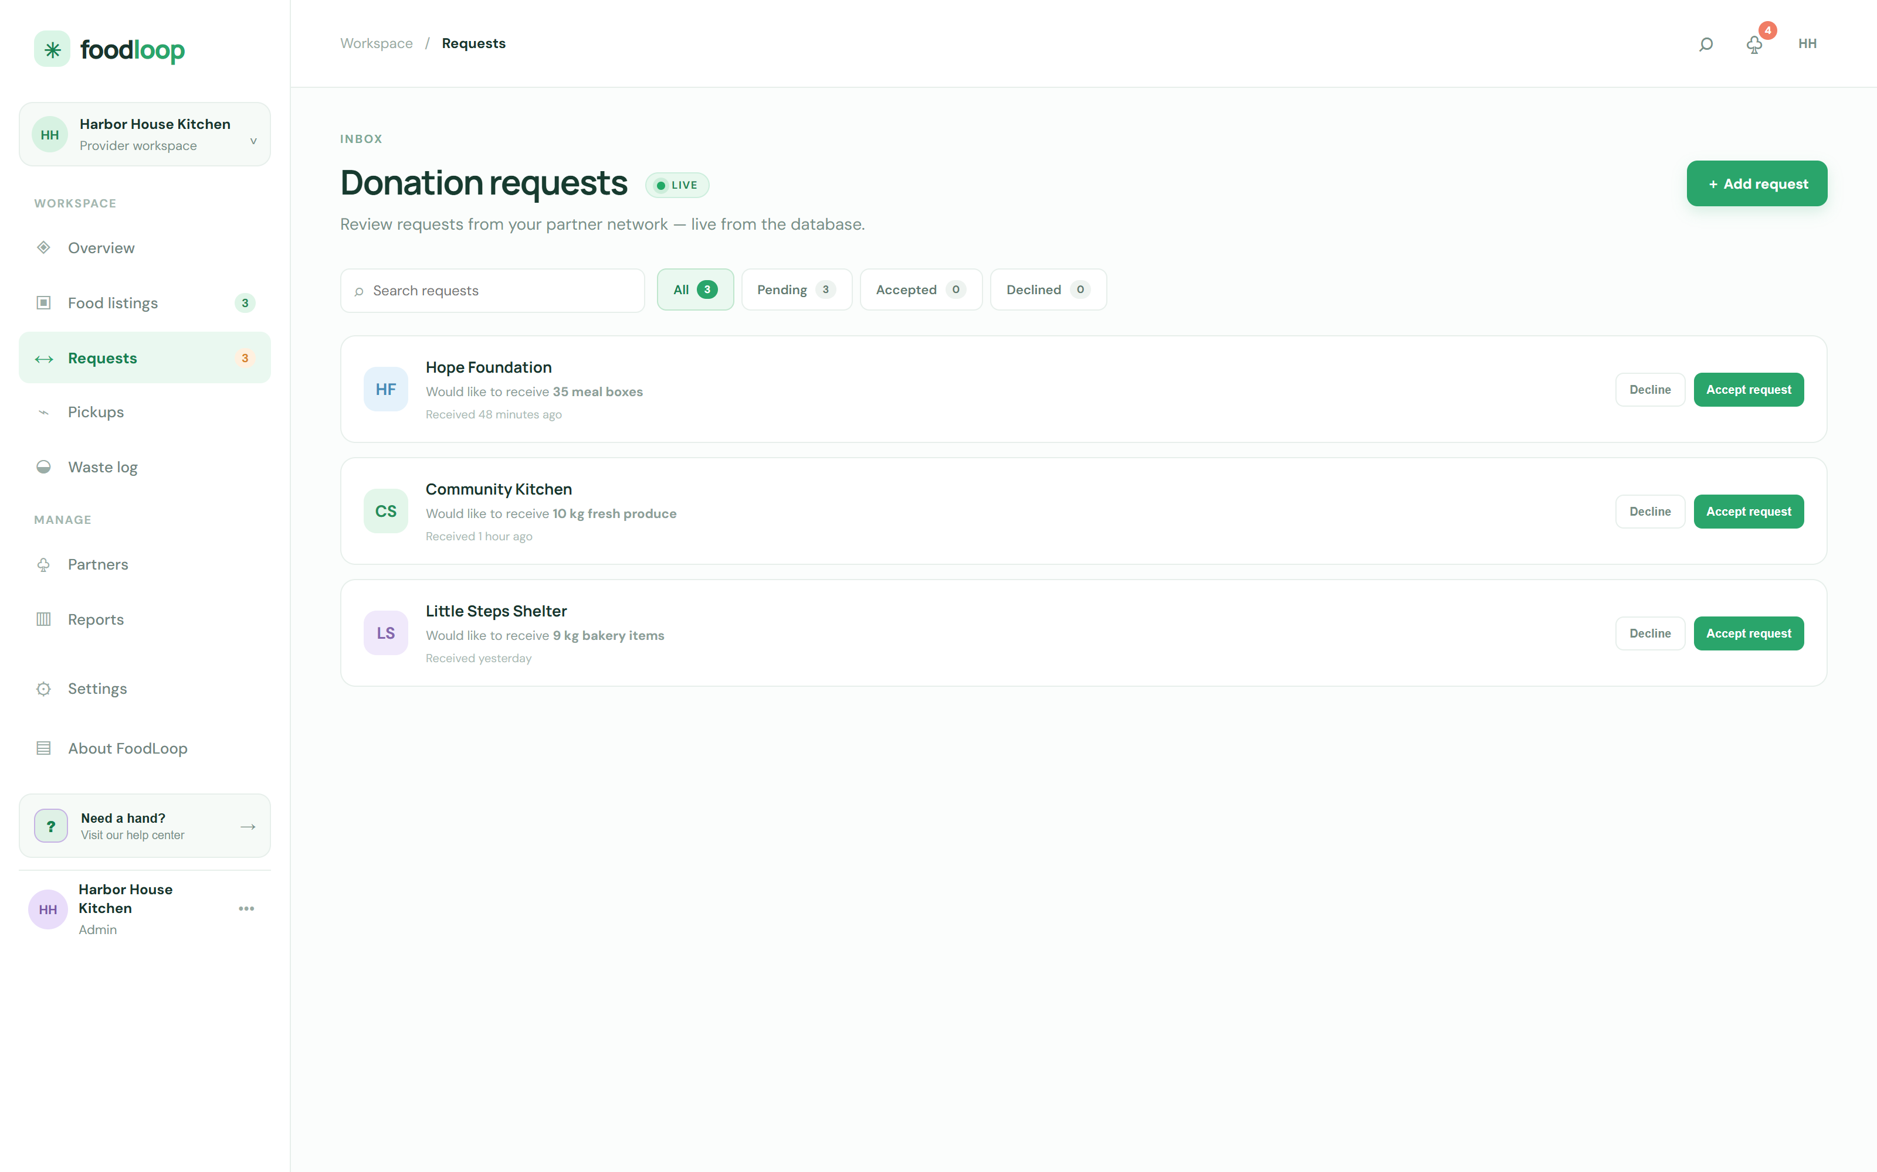
Figure 3.3 Donation requests inbox — UC-04 Request Surplus Food and UC-05 Manage Donation, with live status tabs
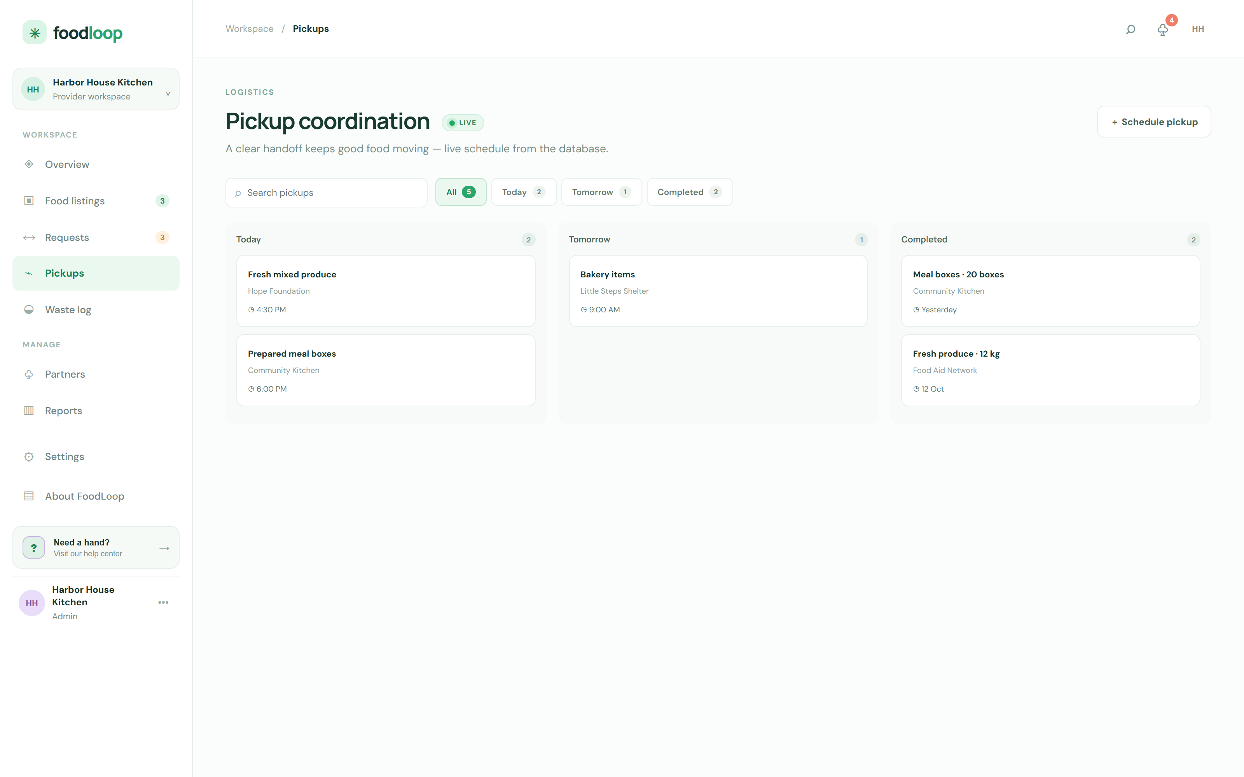
Figure 3.4 Pickup coordination board — UC-06 Arrange Pickup and UC-07 Track Delivery
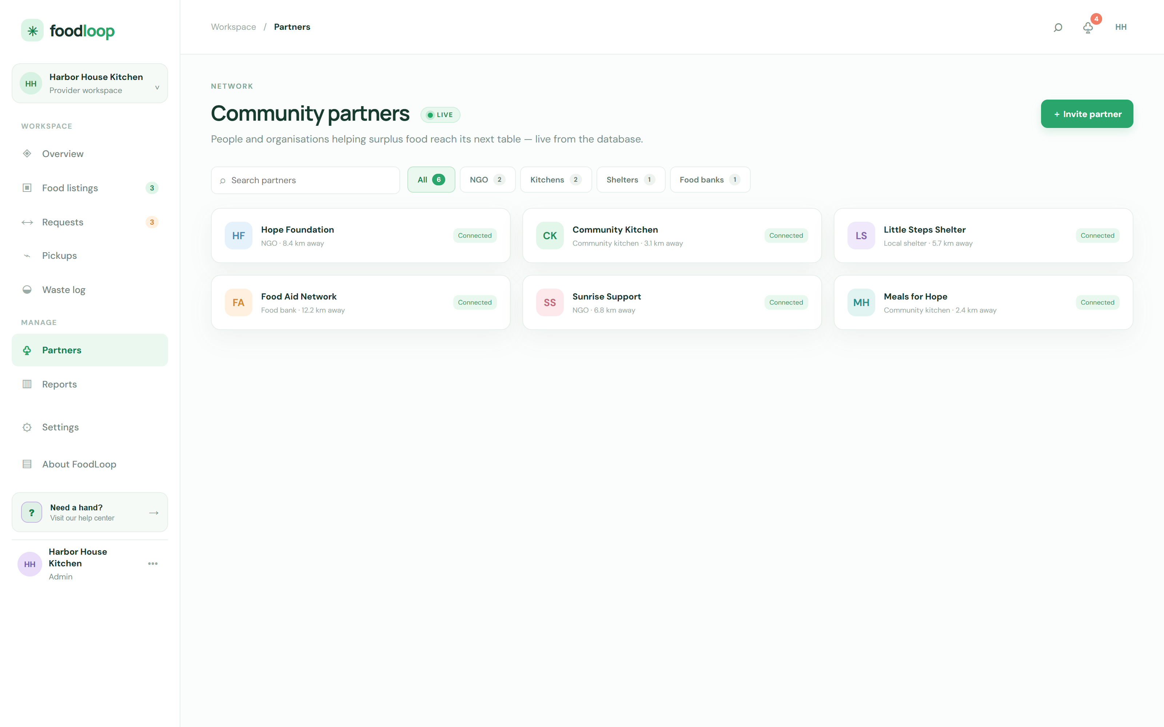
Figure 3.5 Community partners view — UC-11 Manage Partner, filtered by partner type
3.2 Domain Modelling
Where the use case model answers “what does the system do”, the domain model answers “what is the system made of”. The domain class diagram identifies the classes that hold the information the business rules act on, and it deliberately excludes anything that exists only to serve the implementation.
3.2.1 Domain Class Diagram
Figure 3.2 is the domain class diagram. Ten classes carry the vocabulary of the problem: Restaurant, FoodItem, Donation, NGO, Pickup, WasteRecord, Notification, User, Admin and AiRecommendation. Each class shows the attributes the business needs and the operations that change its state; visibility markers follow the UML convention, with a minus for private state and a plus for public behaviour.
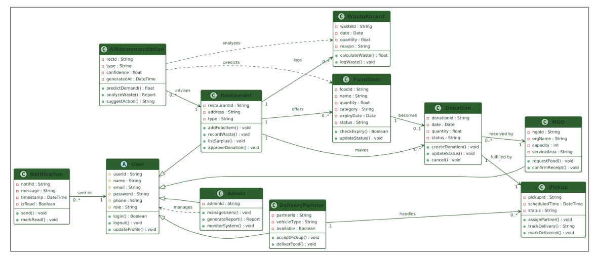
Figure 3.6 Domain class diagram with attributes, operations and multiplicities
3.2.2 Description and Terminology
Table 3.2 Domain modelling terminology
Term | Meaning | Seen in this project
Class | A description of a set of objects that share structure and behaviour. | Donation is a class; each request is an object
Object | A concrete instance of a class with its own attribute values. | donation1 : DN-1042
Attribute | A property that describes an instance of a class. | FoodItem.food : String
Operation | A behaviour an instance of a class can perform. | Donation.accept() : void
Association | A structural link between two classes. | Restaurant offers FoodItem
Multiplicity | How many instances of one class may be linked to an instance of the other. | 1 Restaurant to 0..* FoodItem
Dependency | A weak, “uses” relationship where one class relies on another without owning it. | AiRecommendation advises Restaurant
Stereotype | A keyword that refines what a class means. | AiRecommendation is an AI component
Object diagram | A snapshot of real instances and the links between them at one moment in time. | Figure 3.3

3.2.3 Project-Specific Explanation
The multiplicities in Figure 3.2 are the constraints that the business actually imposes. One Restaurant offers zero or more FoodItem objects, because it may not have surplus at all on a given day. One FoodItem becomes zero or one Donation, because two partners cannot claim the same batch. One Donation is received by exactly one NGO and is fulfilled by zero or one Pickup, since an accepted request may still be awaiting collection. One Delivery Partner handles zero or more pickups, and every Pickup is handled by exactly one partner. A WasteRecord is written for each unsalvaged batch and notifies the Admin, which is why Notification has a «sent to» dependency on User.
Figure 3.3 shows the same model as an object diagram at a single instant: the instance restaurant1 of Restaurant, named “Green Leaf Hotel”, has offered food1, a Veg Biryani of 15.0 kg expiring on 18 August at 22:00. The AI component has already produced rec1, an AiRecommendation of type Redistribute with a confidence of 0.92. food1 has become donation1, an approved donation of 15.0 kg, which was received by ngo1, “Helping Hands”, and is fulfilled by pickup1, scheduled for 18 August at 19:30 and handled by partner1, whose vehicle is available. notif1 tells the NGO that new surplus is available and has not yet been read. Reading the object diagram alongside the class diagram is what makes the multiplicities concrete: here every 1 is satisfied exactly once.
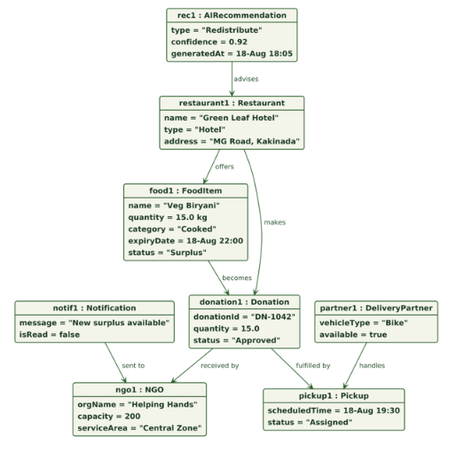
Figure 3.7 Object diagram — an instance snapshot of a donation in progress
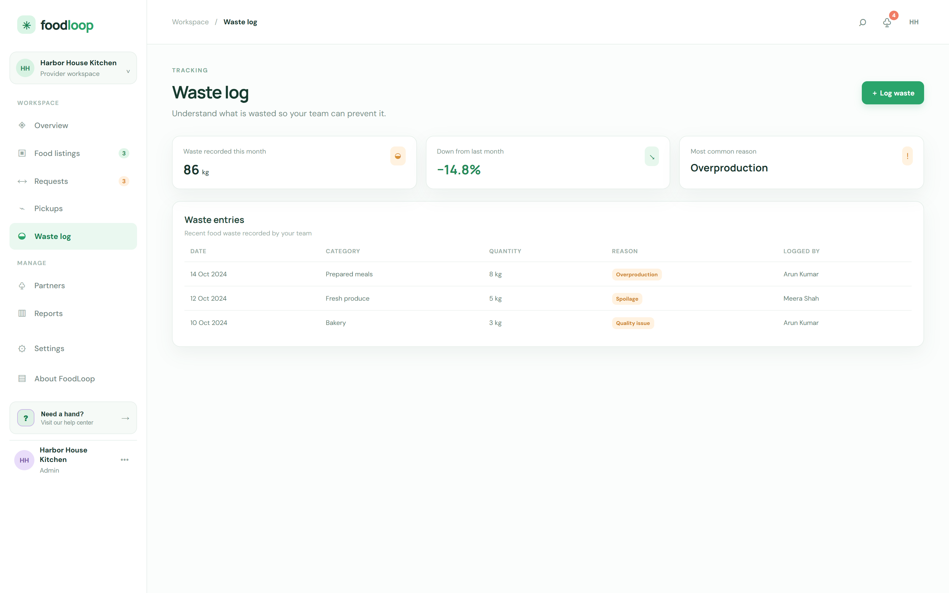
Figure 3.8 Waste log view — UC-09 Record Food Waste and UC-10 Analyse Food Waste, grouped by reason
Chapter 4
INTERACTION MODELLING
4.1 System Sequence Diagram
The system sequence diagram is the black-box view of one complete scenario. Only the system appears as a single lifeline; every internal object is hidden, which makes the diagram useful for agreeing business outcomes with the client before any design decision is made.
Figure 4.1 traces the central scenario of the project — a restaurant publishes surplus, an NGO asks for it, the provider decides, the food is collected and the impact is reported. The numbering is chronological and matches the event list in Table 2.10. The alternative fragment shows what happens when the partner declines, which is the branch that leaves the listing available for someone else.
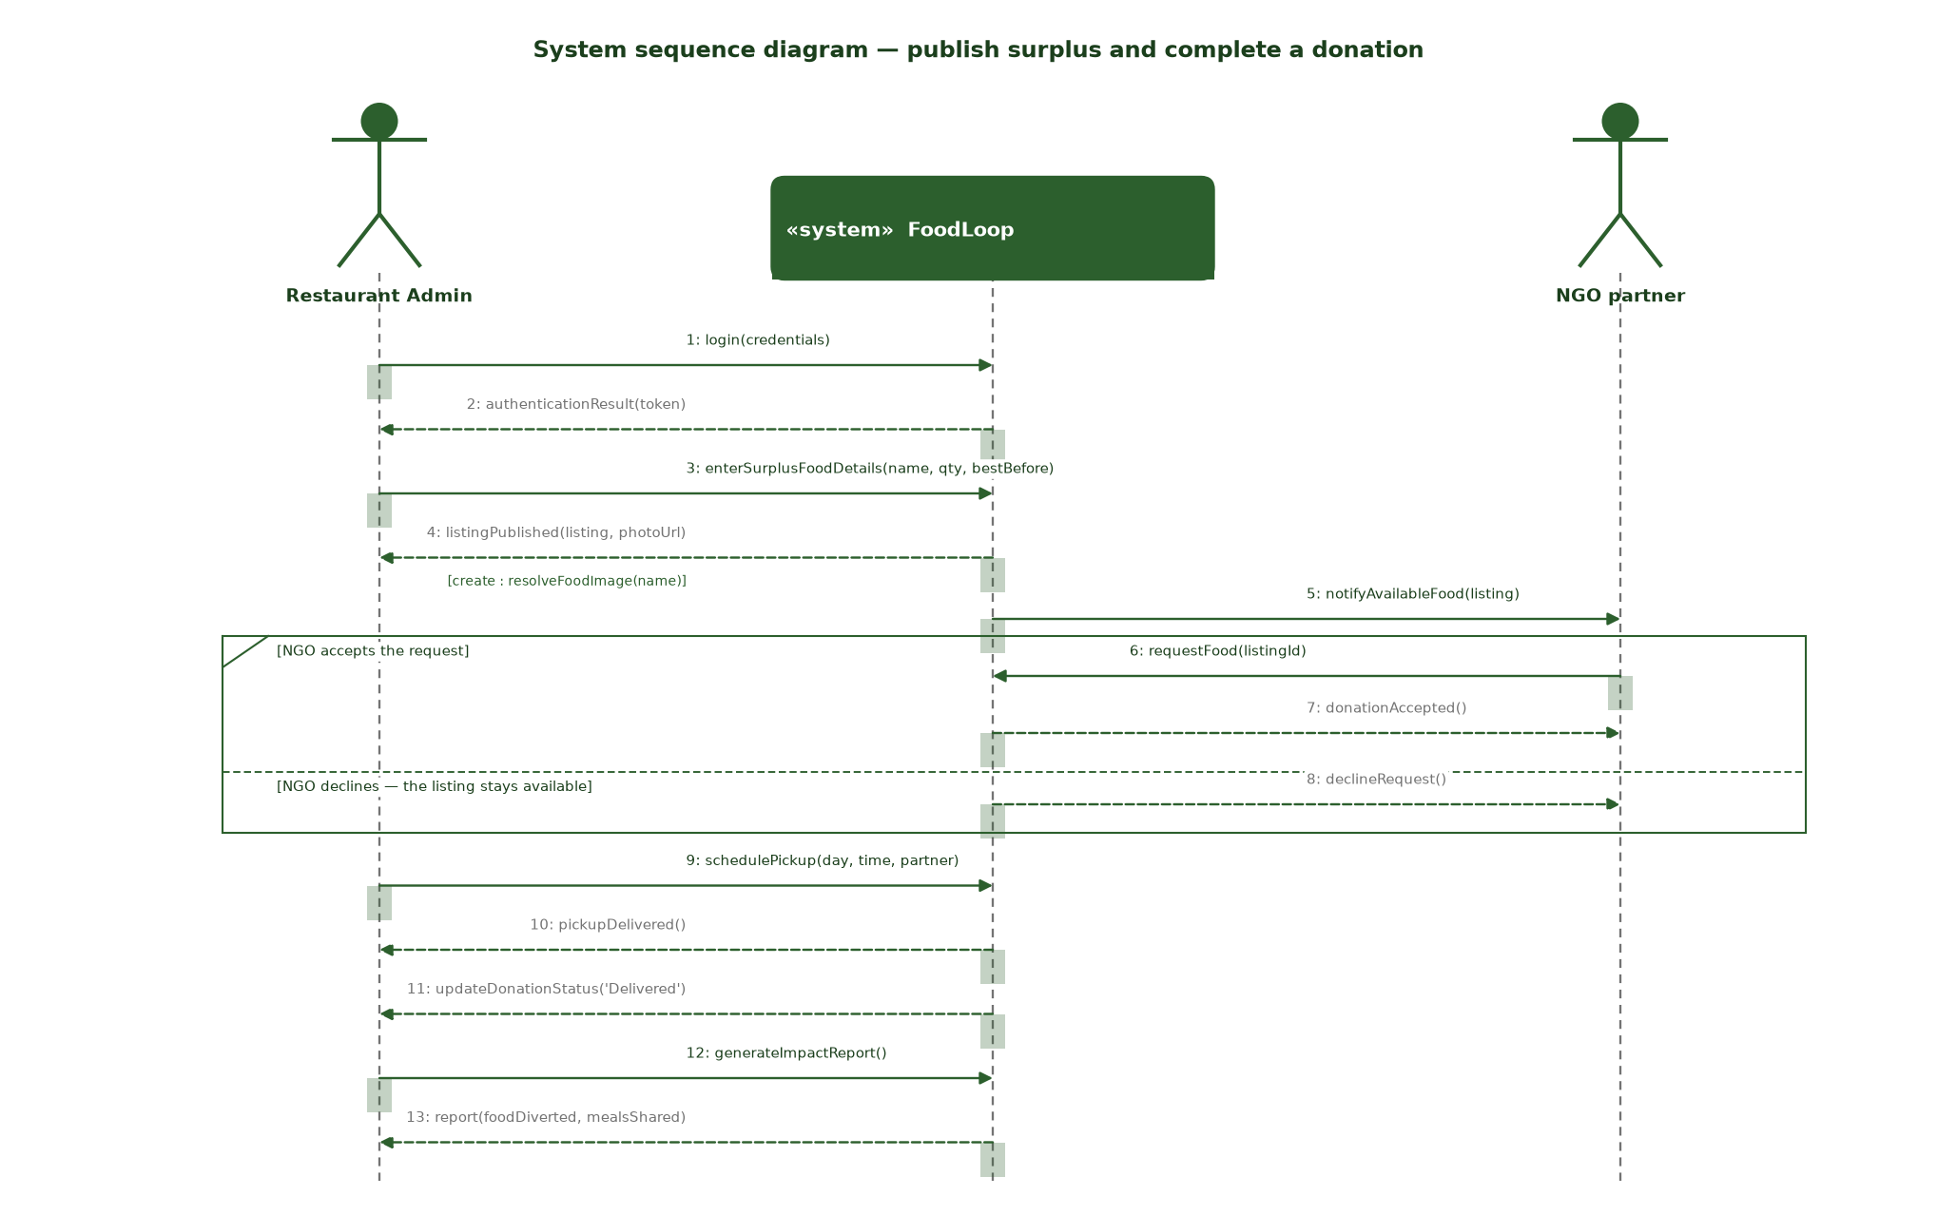
Figure 4.1 System sequence diagram for publishing surplus and completing a donation
Table 4.1 Messages of the system sequence diagram
# | Message | Direction | Event
1 | login(credentials) | Restaurant Admin → System | E-02
2 | authenticationResult(token) | System → Restaurant Admin | E-02
3 | enterSurplusFoodDetails(name, qty, bestBefore) | Restaurant Admin → System | E-03
4 | listingPublished(listing, photoUrl) | System → Restaurant Admin | E-03, E-04
5 | notifyAvailableFood(listing) | System → NGO | E-05, E-08
6 | requestFood(listingId) | NGO → System | E-05
7 | donationAccepted() | System → NGO | E-06
8 | declineRequest() | System → NGO | E-07
9 | schedulePickup(day, time, partner) | Restaurant Admin → System | E-09
10 | pickupDelivered() | System → Restaurant Admin | E-10
11 | updateDonationStatus('Delivered') | System → Restaurant Admin | E-10
12 | generateImpactReport() | Restaurant Admin → System | E-14
13 | report(foodDiverted, mealsShared) | System → Restaurant Admin | E-14

4.2 High-Level Sequence Diagram
The high-level sequence diagram opens the system boundary and names the components that actually exchange messages. It answers a different question from Figure 4.1: not what the system promises, but which parts of the implementation are responsible for keeping that promise.
Figure 4.2 shows the full path a listing takes. The browser submits to the REST API, which asks the AI engine for analysis and writes the record to the database, saves the recommendation, triggers the notification service and answers. The NGO then requests food through the same API, a pickup is scheduled with the delivery service, and the delivery status comes back to be written against the donation. The final response returns to the user, who sees a confirmation.
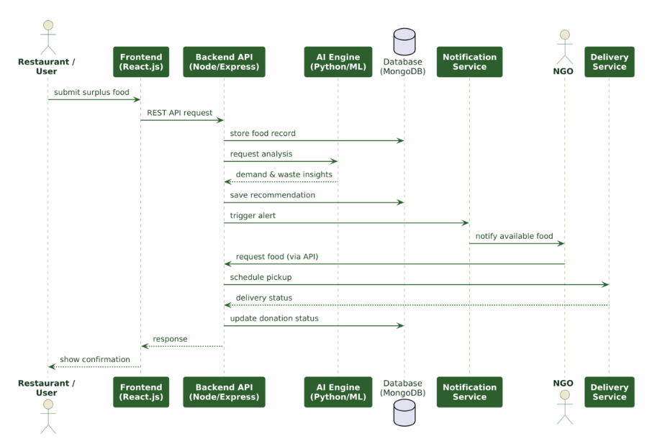
Figure 4.2 High-level sequence diagram showing the interaction between the major components
4.3 Detailed Sequence Diagram
The detailed sequence diagram descends into the internals of the system. Where Figure 4.2 treats the AI engine and the notification service as single participants, Figure 4.3 expands the system into the actors and internal objects that implement the scenario, and it makes the alternative path explicit.
Figure 4.3 shows the Restaurant logging in, entering the surplus details and receiving a recommendation with a confidence value from the AI engine. The system then notifies available food to the NGO. The alt fragment is the important part: if the restaurant approves, a pickup request is created and the delivery partner accepts, delivers and confirms the receipt, after which the status is marked Delivered. If the restaurant rejects, the NGO is told the food is unavailable and the listing returns to the pool. This is precisely the branch recorded as events E-06 and E-07 in Table 2.10.
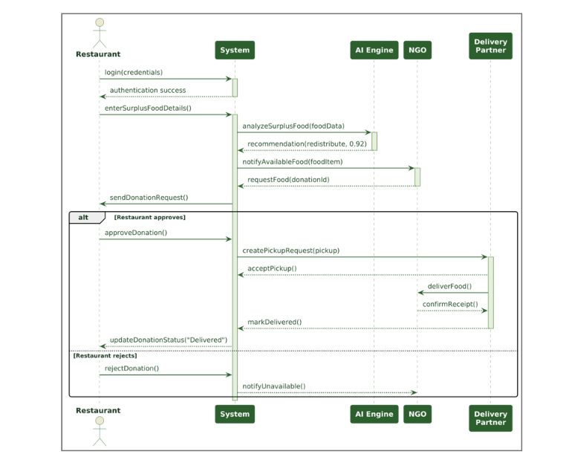
Figure 4.3 Detailed sequence diagram of the donation process, with the approve and reject branches
4.4 Communication Diagram
The communication diagram presents the same scenario as Figure 4.3 but organises it by object rather than by time. The links between object instances are the arrows; the order in which they are traversed is carried by the message numbers. It is the right diagram when the question is which objects collaborate, and it is a useful cross-check that no object is left without a collaborator.
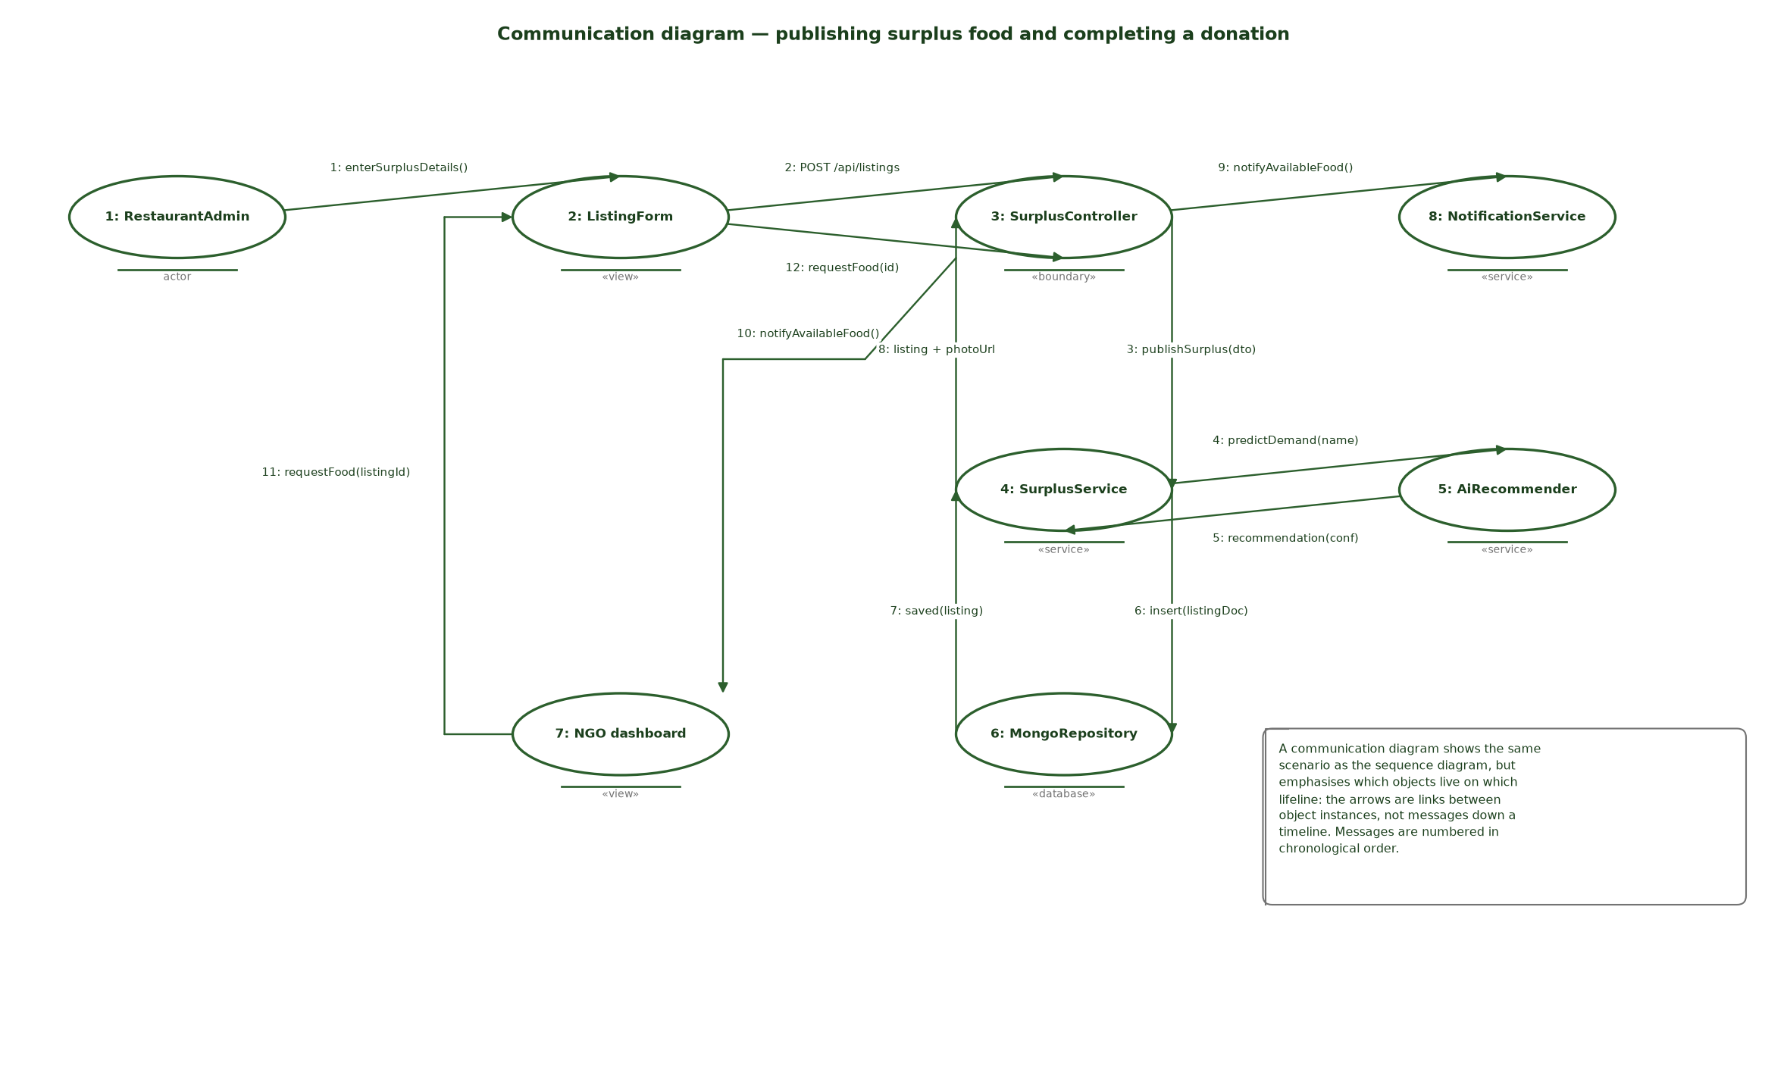
Figure 4.4 Communication diagram of the same scenario, showing the object links in chronological order
Chapter 5
DESIGN CLASS MODELLING
5.1 Design Class Diagram
The design class diagram refines the domain model into something that can be implemented. It adds the layers the implementation actually uses — presentation, application services, domain entities and persistence — and introduces two interfaces that let the layers be tested and replaced independently: IAuthService and IRepository.
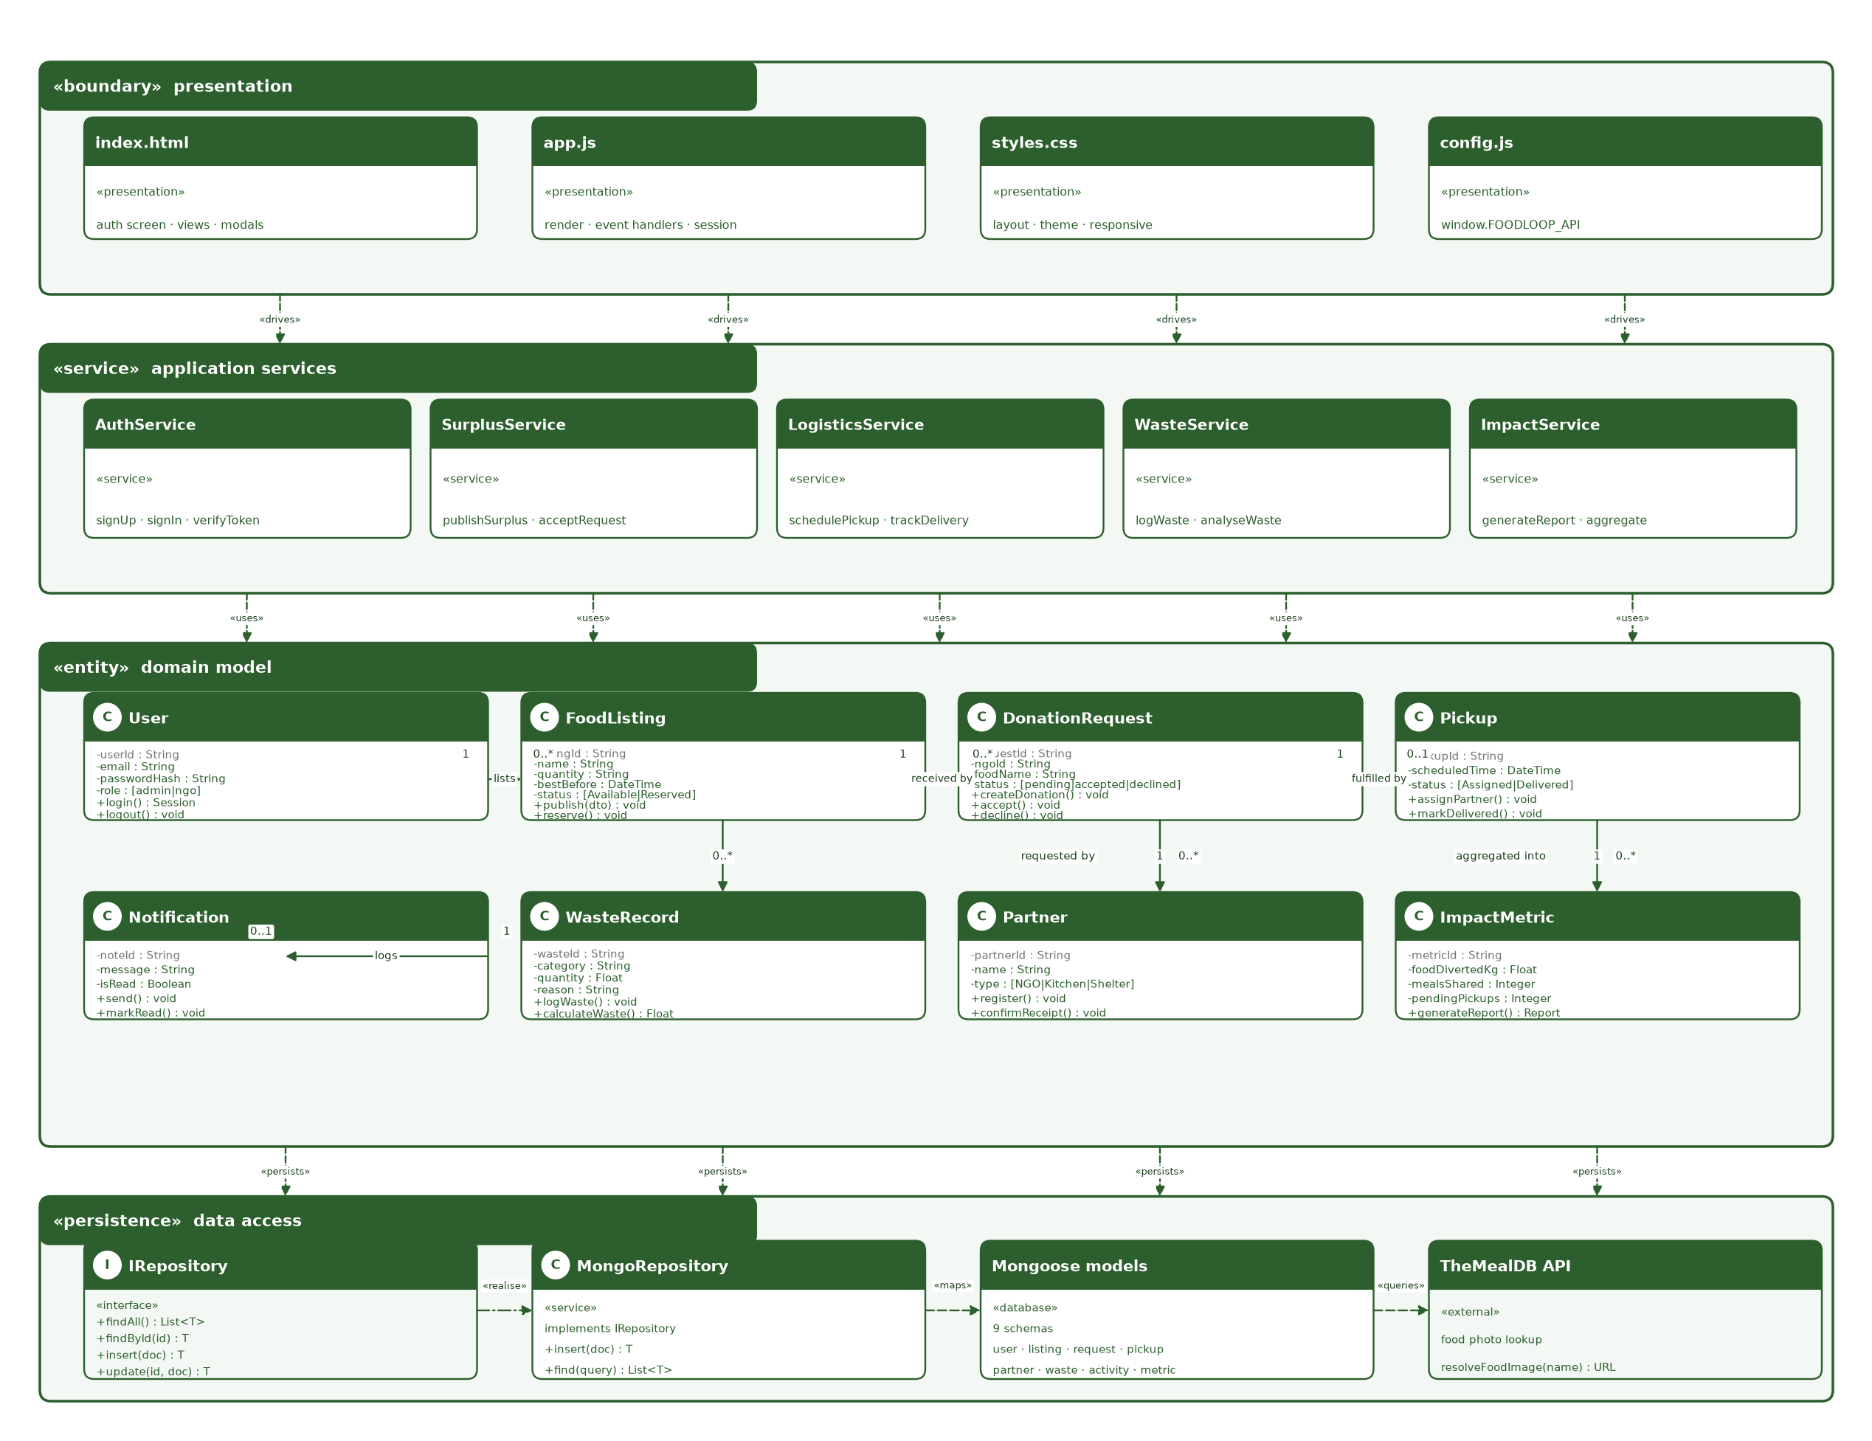
Figure 5.1 Design class diagram organised into presentation, service, entity and persistence layers
5.2 Classes, Attributes and Operations
Table 5.1 lists the attributes and operations of each design class. The attributes are private because no client code may reach into an entity directly; every change is made through one of the public operations, which is what keeps the status rules in one place.
Table 5.1 Design classes, attributes and operations
Class | Key attributes | Operations
User | userId, email, passwordHash, role, joinedOn | login(), logout(), updateProfile()
FoodListing | listingId, name, quantity, bestBefore, photoUrl, status | publish(dto), listSurplus(), reserve(), checkExpiry()
DonationRequest | requestId, ngoId, foodName, requestedAt, status | createDonation(), accept(), decline(), notifyFood()
Pickup | pickupId, scheduledTime, status, partnerId | assignPartner(), trackDelivery(), markDelivered()
Partner | partnerId, name, type, serviceArea, capacity | register(), requestFood(), confirmReceipt()
WasteRecord | wasteId, category, quantity, reason, loggedOn | logWaste(), calculateWaste()
Notification | noteId, message, isRead, timestamp | send(), markRead()
ImpactMetric | metricId, foodDivertedKg, mealsShared, pendingPickups, activePartners | generateReport(), aggregate()
ApiClient | baseUrl, token, timeoutMs | get(), post(), patch(), bootstrap(), poll()
AuthService | — (interface) | signUp(dto), signIn(dto), verifyToken(token)
IRepository | — (interface) | findAll(), findById(id), insert(doc), update(id, doc), remove(id)
MongoRepository | model | implements IRepository

The mapping back to the implementation is direct. FoodListing corresponds to the listingSchema and its Listing model; DonationRequest to requestSchema; WasteRecord to wasteSchema; Notification to activitySchema, which also backs the activity feed; ImpactMetric to metricSchema. ApiClient corresponds to the api() helper in app.js, and AuthService to the three /api routes that implement it.
5.3 Relationships and Multiplicity
Table 5.2 Relationships and multiplicity in the design model
From | Relationship | To | Mult. | Reading
User | lists | FoodListing | 1 : 0..* | One user publishes zero or many listings.
FoodListing | received by | DonationRequest | 1 : 0..* | One listing can attract several requests, but only one can be accepted.
DonationRequest | fulfilled by | Pickup | 1 : 0..1 | An accepted donation produces at most one pickup.
DonationRequest | requested by | Partner | 1 : 0..* | One partner raises many requests; each request names one partner.
Pickup | aggregated into | ImpactMetric | 1 : 0..* | Each completed pickup moves the impact counters.
FoodListing | produces | WasteRecord | 1 : 0..* | A listing that expires uncollected becomes a waste record.
WasteRecord | logs | Notification | 1 : 0..1 | Logging waste raises exactly one activity entry.

5.4 Interfaces, Dependencies and Generalization
Table 5.3 records the non-structural relationships. They matter because they are the seams along which the system can be changed without touching the rest of it.
Table 5.3 Interfaces, dependencies and generalisation
Relationship | Kind | From → To | Meaning and benefit
Realisation | «interface» | AuthService → ApiClient | The client side of authentication depends on the interface, not on the Express routes, so the transport can be replaced.
Realisation | «interface» | IRepository → MongoRepository | The persistence contract is separate from Mongoose, which is what makes NFR-04 (swappable storage) achievable.
Dependency | «uses» | Presentation → Application services | Views and controllers call services; they never touch entities or models directly.
Dependency | «uses» | Application services → Domain entities | Services orchestrate entities; entities hold no service references.
Dependency | «persists» | Domain entities → Persistence | Entities are written through repositories, not saved directly.
Dependency | «queries» | MongoRepository → TheMealDB API | Photograph resolution is an external call isolated inside the repository, so a failure cannot corrupt a listing.
Dependency | «drives» | Presentation → Presentation | index.html and app.js: the markup drives the controller layer.
Generalisation | Inheritance | User → Admin | An admin is a user with provider rights.
Generalisation | Inheritance | User → NGO | An NGO is a user with request rights and a restricted portal.

Chapter 6
BEHAVIOURAL MODELLING
6.1 Activity Diagram
The activity diagram models the workflow of the surplus redistribution process as a sequence of activities connected by control and data flow. It begins when a provider logs in and ends when the NGO confirms the receipt, and it shows the two decision points that give the process its shape: whether the submitted information is valid, and whether the food is suitable for donation at all.
The first diamond sends invalid input back to the provider with an error message, which is FR-20 and the retry loop in the implementation. The second diamond is the heart of the process. If the food is not suitable it is recorded as waste and the analytics are updated, and the flow ends. If it is suitable, a nearby NGO is found and notified; the flow then waits for a response, and a refusal sends the search back to another NGO rather than ending the process. Acceptance leads to arranging the pickup, assigning a delivery partner, delivering the food, updating the donation status and confirming the receipt.
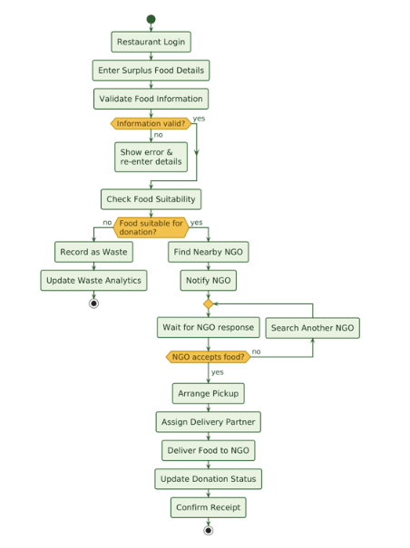
Figure 6.1 Activity diagram of the surplus food redistribution workflow
The dashboard in Figure 6.2 is the visible consequence of this workflow. The kilograms diverted, meals shared, pending pickups and active partners counters are all derived from the same records the activity diagram produces, and the recent activity list is the event stream in chronological order.
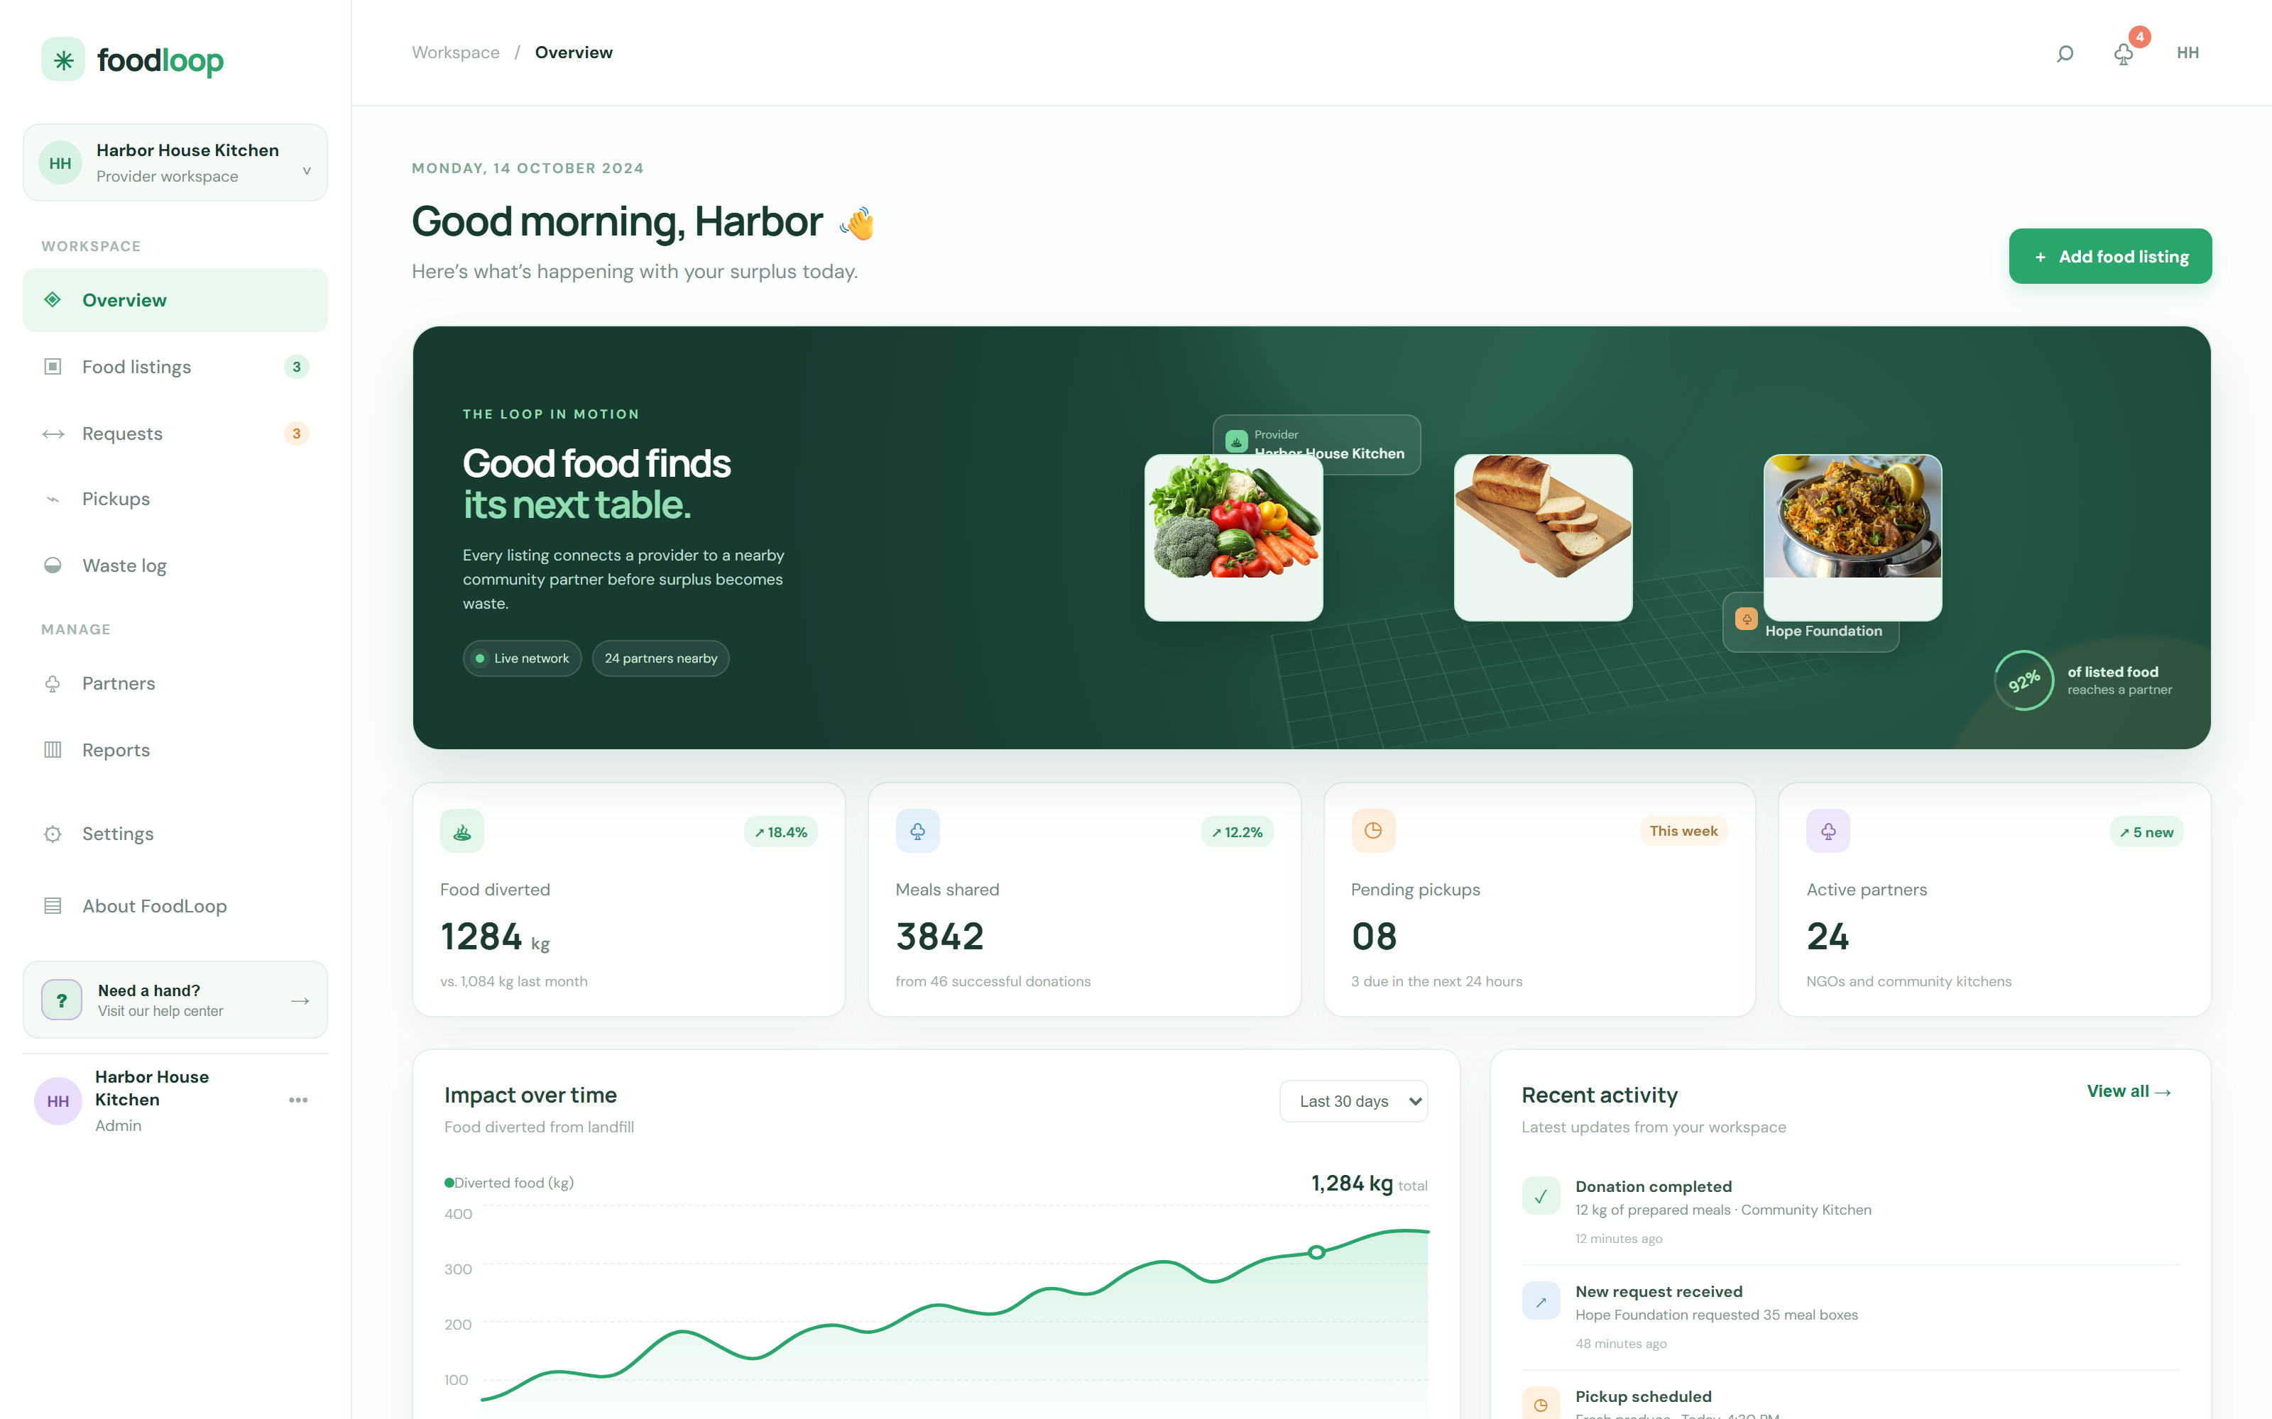
Figure 6.2 Overview dashboard — live impact counters and the recent activity feed
6.2 State Machine Diagram
Where the activity diagram describes the process, the state machine describes one object through that process. Figure 6.3 follows a single DonationRequest from creation to completion and shows exactly which transitions are legal.
A request is created in the pending state. The provider may accept it, which moves it to accepted and permits a delivery partner to be assigned, or decline it, which is terminal. An accepted request becomes a pickup and then a delivery, after which the partner confirms the receipt and the flow ends. Two guards protect the data: if the best-before time passes while the request is still accepted, the request moves to expired and the food is logged as waste; and the listing can always be withdrawn, returning the request to pending for the next batch.
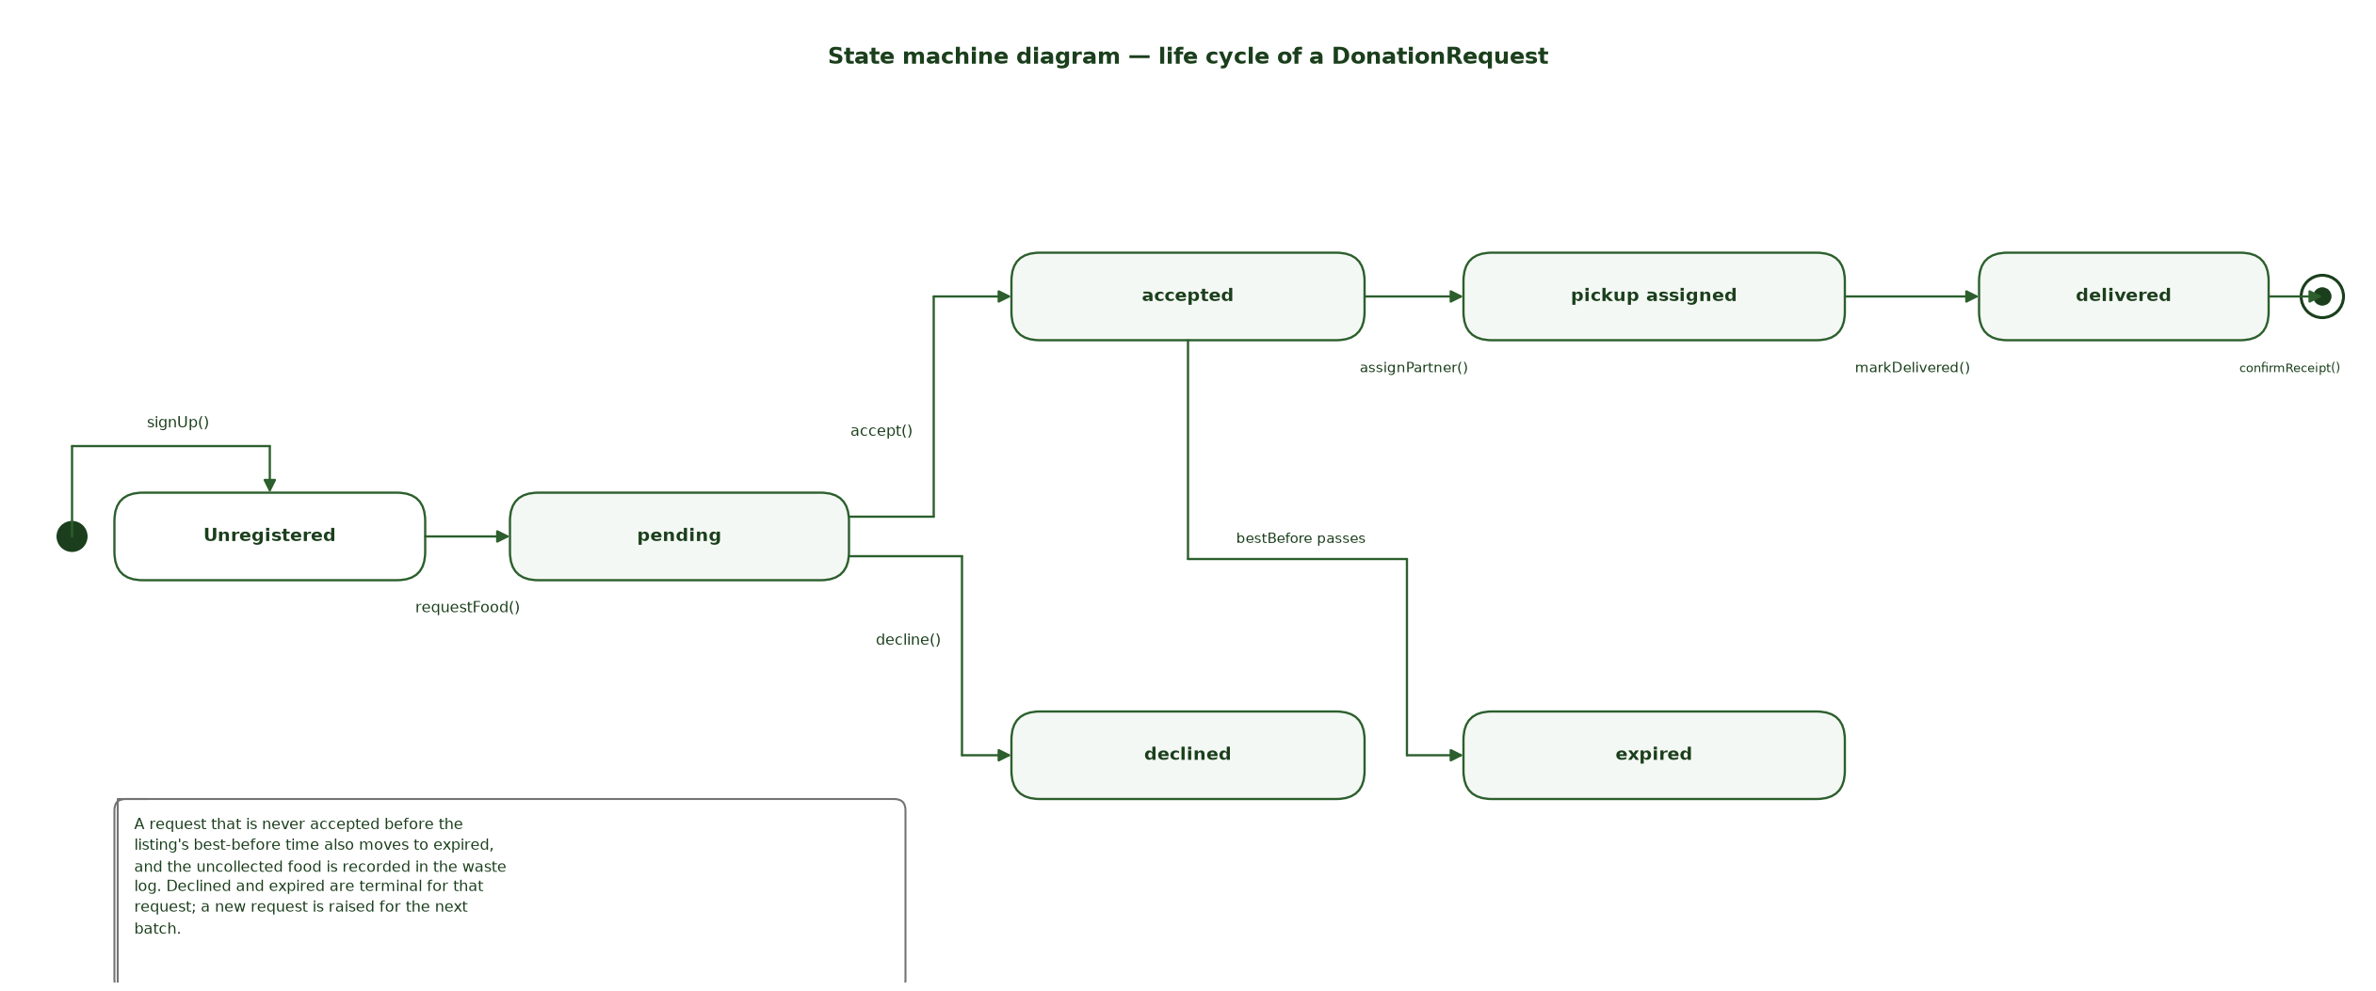
Figure 6.3 State machine diagram of the DonationRequest life cycle
Chapter 7
ARCHITECTURAL MODELLING
7.1 Package Diagram
The package diagram groups the classes of the system into logical subsystems and shows the dependencies between them. FoodLoop has a root package containing three client-side packages and two server-side packages. The dependency arrows all point downwards, which means no lower layer knows about a higher one.
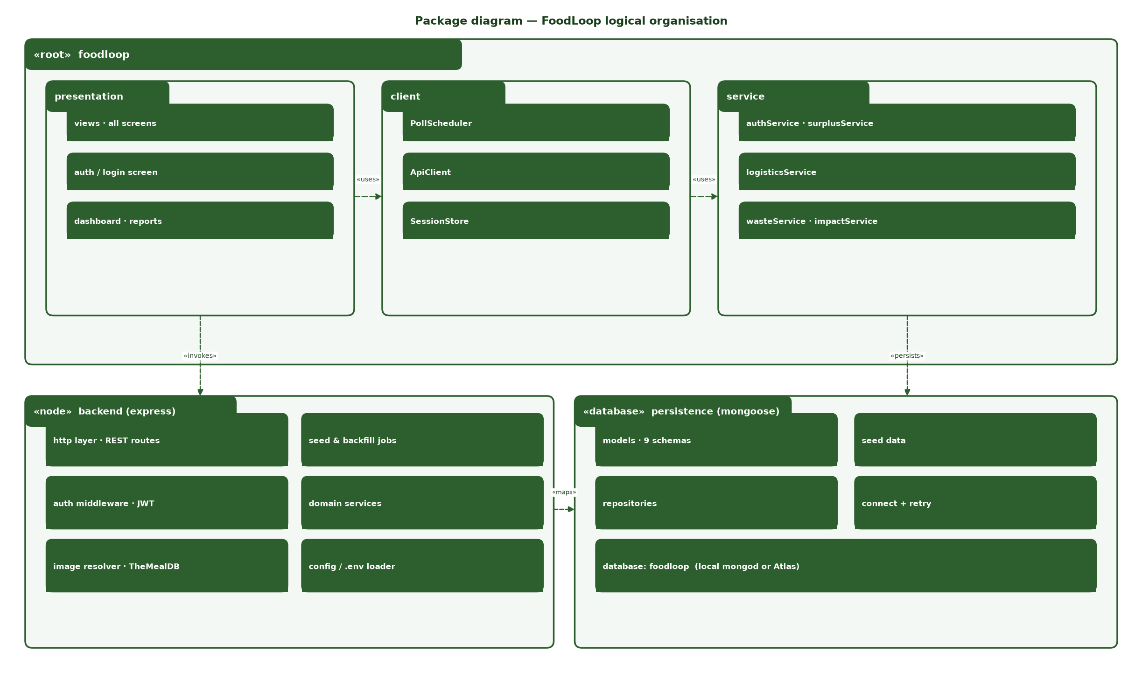
Figure 7.1 Package diagram of the FoodLoop logical structure
Table 7.1 Packages and their responsibilities
Package | Contents | Depends on
presentation | All screens, modals, forms and toasts | client
client | ApiClient, SessionStore, PollScheduler | backend «invokes»
service | authService, surplusService, logisticsService, wasteService, impactService | backend, persistence
backend (express) | HTTP routes, JWT middleware, ImageResolver, domain services, seed jobs, config loader | persistence «maps»
persistence (mongoose) | Nine models, repositories, seed data, connection and retry | —

7.2 Component Diagram
The component diagram replaces the logical packages with the deployable artefacts of the implementation. On the client, index.html and styles.css provide presentation, app.js acts as the controller and config.js supplies the API base URL. On the server, Express routes are grouped into controllers that delegate to domain services, and the Mongoose models and repositories form the only path to the database.
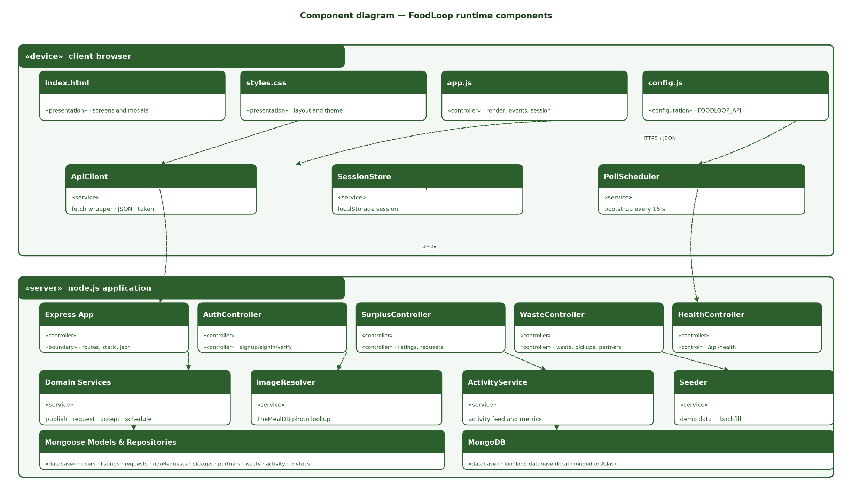
Figure 7.2 Component diagram of the FoodLoop runtime components
Figure 7.3 shows the client half of this diagram in use. The Add food listing modal is a presentation component driven by app.js, which collects the four fields and posts them to the surplus controller. It is also the clearest illustration of why FR-07 works: the modal promises the provider that a photograph is attached automatically, and the ImageResolver component on the server is what makes that promise true.
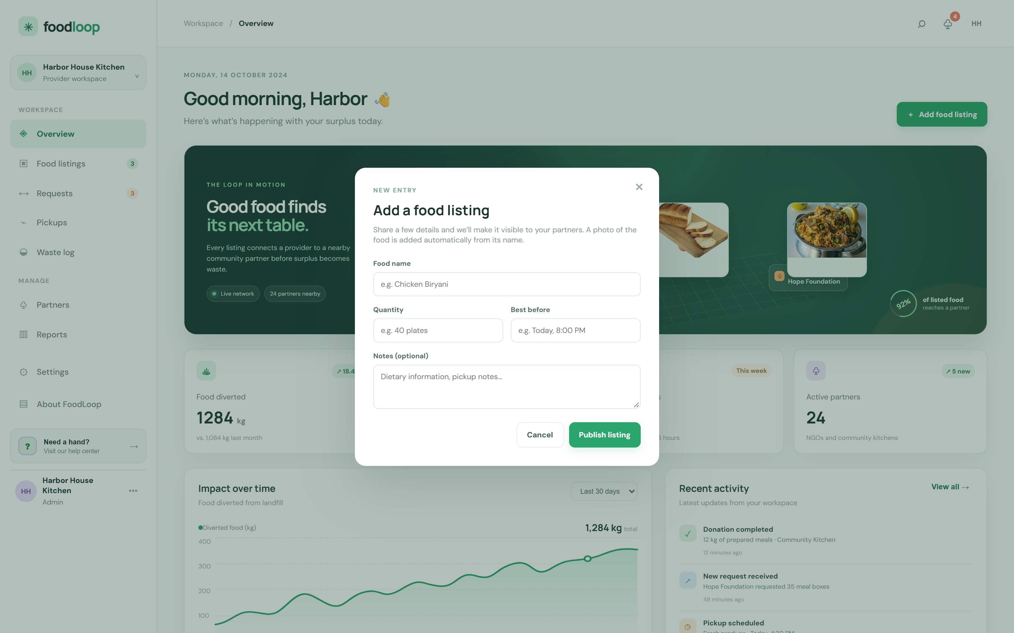
Figure 7.3 Add food listing modal — the presentation component that collects the data for UC-02
7.3 Deployment Diagram
The deployment diagram shows the physical runtime. A single Node.js process serves both the static page and the REST API on port 5000, so the browser talks to one origin and no CORS configuration is needed. The process connects to MongoDB over the local mongod service or a MongoDB Atlas cluster, and it calls TheMealDB over HTTPS to resolve food photographs.
Configuration is supplied through environment variables — PORT, MONGODB_URI and JWT_SECRET — which is what allows the same build to run on a laptop and on a hosted Node environment described by render.yaml. One constraint is worth recording: GitHub Pages can only serve the static page, so the deployed site needs a separately hosted HTTPS backend and window.FOODLOOP_API in config.js must point at it.
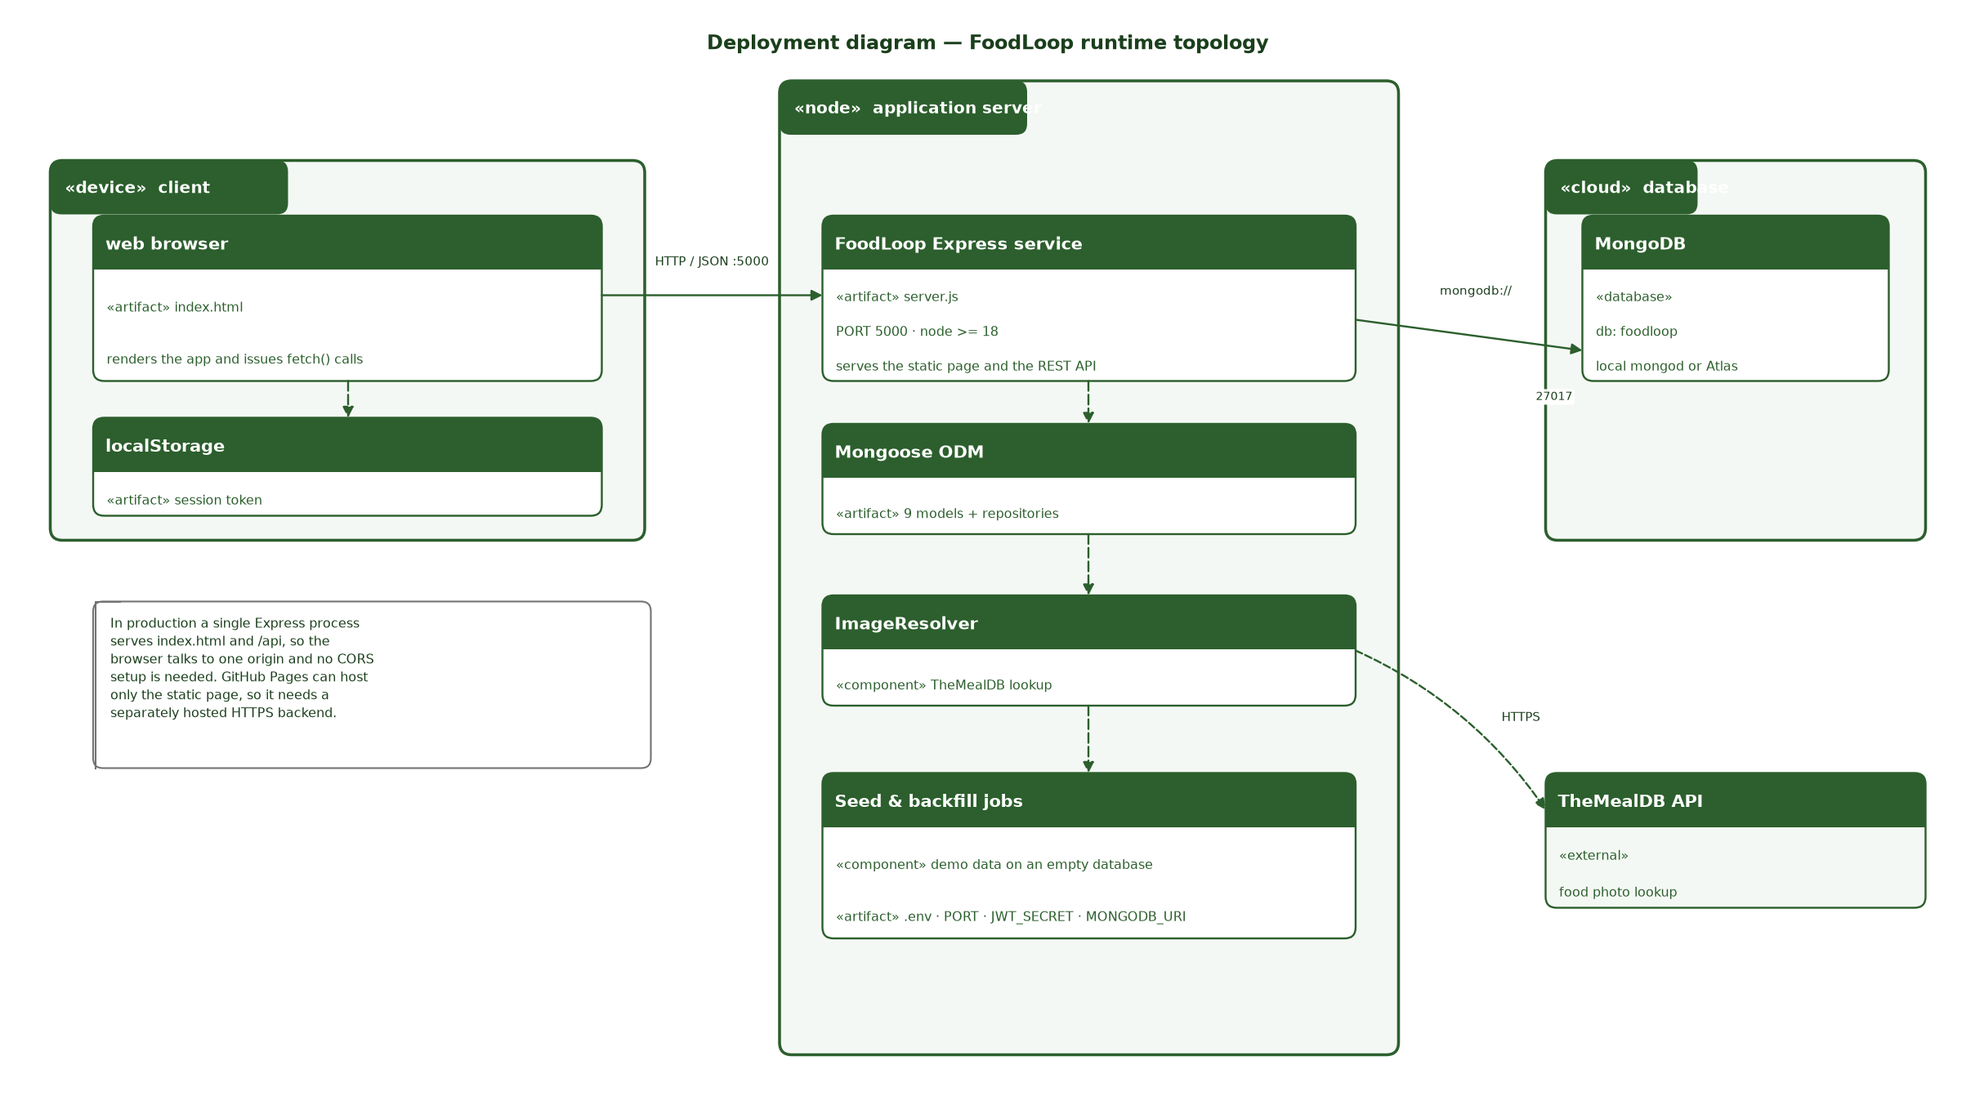
Figure 7.4 Deployment diagram of the FoodLoop runtime topology
Table 7.2 REST endpoints exposed by the server
Method | Endpoint | Purpose
POST | /api/signup | Register an admin or NGO account
POST | /api/signin | Authenticate and receive a JWT
GET | /api/verify | Validate a token and return the safe user
GET | /api/bootstrap | Return every collection in one call
GET | /api/health | Liveness probe that never touches the database
POST | /api/listings | Publish surplus food
POST | /api/requests | Raise a donation request
PATCH | /api/requests/:id | Accept or decline a request
POST | /api/waste | Record a waste entry
POST | /api/pickups | Schedule a pickup
POST | /api/partners | Add a community partner

Chapter 8
DATABASE DESIGN
8.1 Mapping Class Diagram to Relational Database
The class model is mapped onto a relational schema in the standard way. Each class becomes a table, each attribute becomes a column, and each association becomes either a foreign key or a junction table. Multiplicity decides which: a one-to-many association is mapped as a foreign key on the many side, while a many-to-many association needs a junction table.
Table 8.2 records the resulting constraints. Restaurant and FoodItem are merged into listings because in this domain a listing belongs to exactly one provider and the provider identity is already held in users. NGO becomes partners, extended with type, service area and capacity. Donation splits into requests, which holds the decision and the partner, and ngoRequests, which preserves the original item name so the audit trail survives a rename. AiRecommendation, Notification and ImpactMetric are stored as activity and metrics rather than as separate tables, because they are derived values that never need to be queried independently.
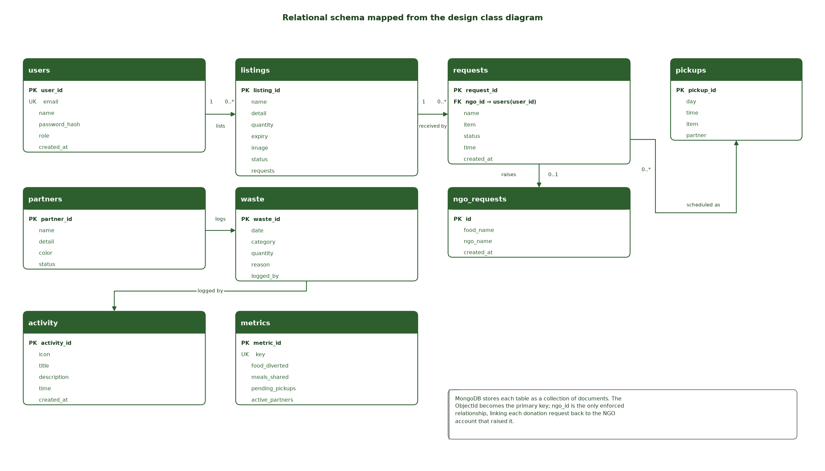
Figure 8.1 Relational schema mapped from the design class diagram
8.2 Database Tables
The implementation uses MongoDB, so each table below is a collection of documents and each column is a field. The database name is foodloop and it is reached at mongodb://127.0.0.1:27017 locally, or through MONGODB_URI when deployed.
Table 8.1 Database tables (MongoDB collections)
Table | Purpose | Key fields
users | Accounts of food providers and community partners. | name, email (unique), password (hashed), role, createdAt
listings | Surplus food published by a provider. | name, detail, quantity, expiry, image, status, requests, createdAt
requests | Donation requests and the provider's decision. | name, item, time, status, createdAt
ngoRequests | Audit trail of what each partner originally asked for. | foodName, ngoName, createdAt
pickups | Scheduled and completed collections. | day, time, item, partner
partners | Directory of NGOs, kitchens, shelters and food banks. | initials, name, detail, color, status
waste | Food that could not be rescued, with the reason why. | date, category, quantity, reason, loggedBy, createdAt
activity | Append-only event feed behind notifications. | icon, iconClass, title, description, time, createdAt
metrics | Single dashboard document holding the impact counters. | key, foodDiverted, mealsShared, pendingPickups, activePartners

8.3 Primary Keys and Foreign Keys
Table 8.2 Primary keys, foreign keys and constraints
Table | Primary key | Foreign keys | Constraints
users | _id (ObjectId) | — | email is unique; role ∈ {admin, ngo}; name, email, password, role are required
listings | _id (ObjectId) | user_id → users (logical) | name is required; status defaults to Available; image defaults to empty
requests | _id (ObjectId) | ngo_id → users.user_id | name and item are required; status ∈ {pending, accepted, declined}, default pending
ngoRequests | _id (ObjectId) | ngo_name → users.name (logical) | createdAt is stamped on insert
pickups | _id (ObjectId) | partner → partners.name (logical) | item is required; day defaults to Today
partners | _id (ObjectId) | — | name is required; status defaults to Connected
waste | _id (ObjectId) | logged_by → users.name (logical) | category, quantity and reason are required
activity | _id (ObjectId) | — | Append-only; createdAt is stamped on insert
metrics | _id (ObjectId) | — | key is unique and is used to find the dashboard document

In MongoDB the only enforced relationship is the explicit reference stored in a document; the remaining links are logical and are maintained by the application. That is an intentional trade-off for a document store: it keeps writes cheap and the schema flexible, at the cost of referential integrity that a relational engine would give for free.
8.4 CRUD Matrix
The CRUD matrix records, for every table, whether the system creates, reads, updates or deletes its rows. It is the quickest way to check that no table has been left without a lifecycle. Most collections are append-only by design: a donation request is never deleted, because its history is the evidence that the food was saved.
Table 8.3 CRUD matrix
Table | Create | Read | Update | Delete | Notes
users | POST /api/signup | POST /api/signin, GET /api/verify | — | — | Accounts are never modified after registration
listings | POST /api/listings | GET /api/bootstrap | Status change to Reserved on acceptance | — | Append-only history
requests | POST /api/requests | GET /api/bootstrap | PATCH /api/requests/:id | — | Only the status field is updated
ngoRequests | POST /api/requests | GET /api/bootstrap | — | — | Immutable audit record
pickups | POST /api/pickups | GET /api/bootstrap | Move to Completed on delivery | — | Append-only history
partners | POST /api/partners | GET /api/bootstrap | — | — | Append-only directory
waste | POST /api/waste | GET /api/bootstrap | — | — | Append-only log
activity | Created internally by every other route | GET /api/bootstrap | — | — | System-written only
metrics | Seeded once | GET /api/bootstrap | Recomputed on delivery | — | One document per key

Chapter 9
TOOLS AND TECHNOLOGIES USED
9.1 Overview of Tools and Technologies
The project deliberately uses a small, well-understood stack. Every choice below was made because it keeps the delivery simple enough to finish and document, and because each tool is widely available so that the work can be reproduced.
Table 9.1 Tools and technologies used
Layer | Technology | Version | Why it was chosen
Frontend | HTML5 | — | Semantic structure for the auth screen and the nine workspace views
Frontend | CSS3 | — | Grid and flexbox layout, custom properties for the theme, and a responsive breakpoint at 900 px
Frontend | JavaScript (ES2020) | — | No build step: the browser runs app.js directly, which keeps the prototype easy to deploy and to read
Frontend | Google Fonts — DM Sans, Manrope | — | Consistent typography without shipping font binaries
Backend | Node.js | ≥ 18 | One language on both sides of the wire, and native fetch
Backend | Express | 4.18 | Minimal routing and middleware for the fifteen REST endpoints
Backend | Mongoose ODM | 7.6 | Schema validation and typed models over MongoDB
Database | MongoDB | local or Atlas | Document model matches the listings and requests; free tier is sufficient for the prototype
Security | bcryptjs | 2.4 | Password hashing at cost 10
Security | jsonwebtoken | 9.0 | Stateless authentication tokens
External service | TheMealDB | free API | Supplies a real photograph for each named dish or ingredient
Deployment | GitHub Pages | — | Publishes the static page
Deployment | Render blueprint | render.yaml | Runs the same Node process for the API and the page on one origin
UML modelling | diagrams.net (draw.io) | — | Draws the use case, class, object, activity and sequence diagrams
Additional UML | Matplotlib | 3.11 | Scripted generation of the design class, communication, state machine, package, component, deployment and schema diagrams
Document automation | Python + python-docx | 3.13 / 1.2 | Generates this report from the university template so that the structure and page numbering stay consistent
Screenshots | Chrome headless via CDP | — | Captures the running application without installing a test runner

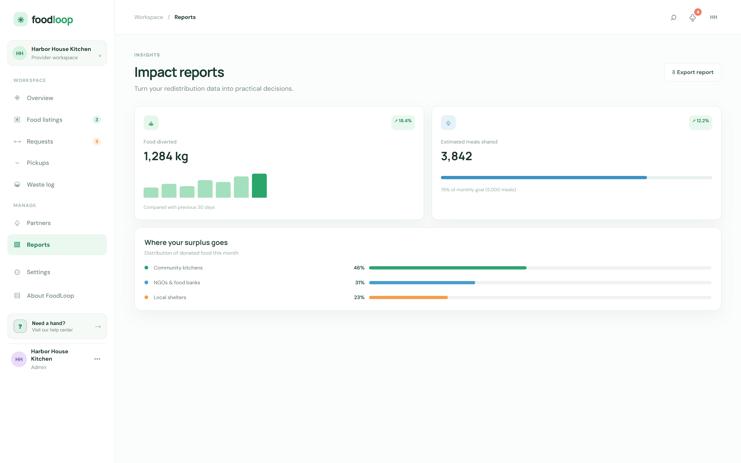
Figure 9.1 Impact reports view — UC-12 Generate Reports, rendered from the metrics and waste collections
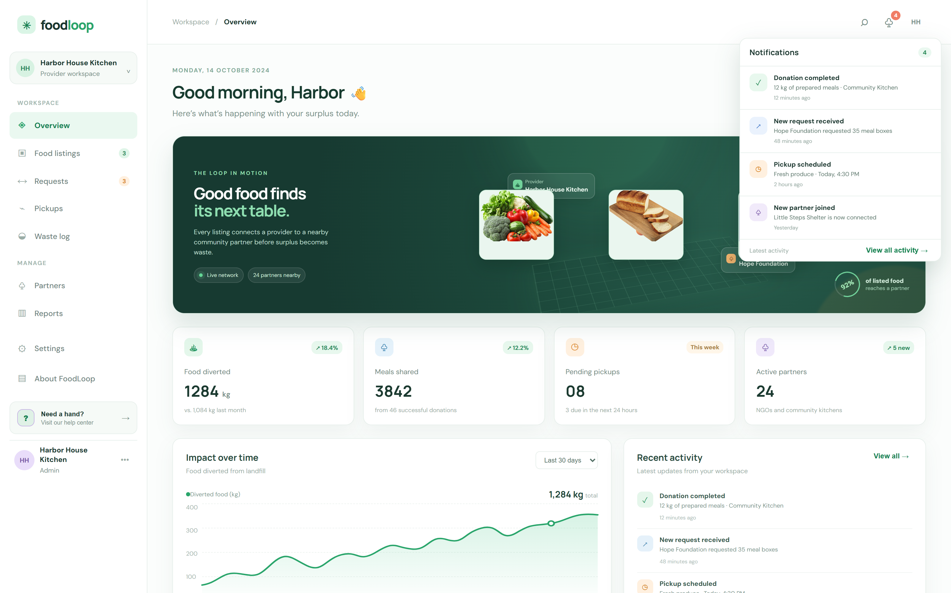
Figure 9.2 Notifications panel — UC-13 Receive Notifications, fed by the activity collection
9.2 UML Modelling Tool
The UML diagrams were produced with diagrams.net, an open-source graphical modelling tool that runs in the browser and needs no installation. It was chosen because the team already used it for modelling work, because it supports every UML 2.x diagram type required by this report, and because its files are plain XML that can be kept in version control alongside the source code.
9.3 Introduction to the Tool
diagrams.net — originally released as draw.io — is a web-based visual editor for user-interface mock-ups and UML diagrams. It runs entirely in the browser: diagrams are held in an in-memory model and saved either to the clipboard as XML or to a file on disk, so no server, account or internet connection is required once the page has loaded. It supports shape libraries for UML, including the actor, use case, class, object, package, component and node shapes used throughout this report, and it can export to PNG for inclusion in documentation.
For this project the tool was used for the six hand-drawn diagrams — the use case, class, object, activity, high-level sequence and detailed sequence diagrams. The remaining seven were generated from scripts with Matplotlib so that they stay consistent with one another and can be regenerated after a change, which matters because seven separate diagrams drawn by hand drift apart very quickly.
9.4 Features and Capabilities
Table 9.2 Features of the UML modelling tool used
Feature | How it was used in this project
Complete UML 2.x shape library | Actor, use case, class, object, package, component, note and node shapes for Figures 3.1 to 3.3 and 7.1 to 7.3
Relationship types | Association, dependency, realisation and generalisation arrows for the class and component models
Stereotype labels | «include», «extend», «interface», «system», «database» and «external» qualifiers
Multiplicity and role editing | The 1 : 0..* and 0..* : 1 labels on the class diagram
Grid and alignment guides | Consistent spacing across the use case and sequence diagrams
Layers and groups | The four architecture bands in the design class diagram
Free-form text and notes | Explanatory notes attached to the state machine and package diagrams
SVG and PNG export | PNG export of every diagram for inclusion in this report
Offline operation | Diagrams could be edited without an internet connection, which suited the laboratory sessions
XML source format | Diagrams could be version-controlled and reviewed like code

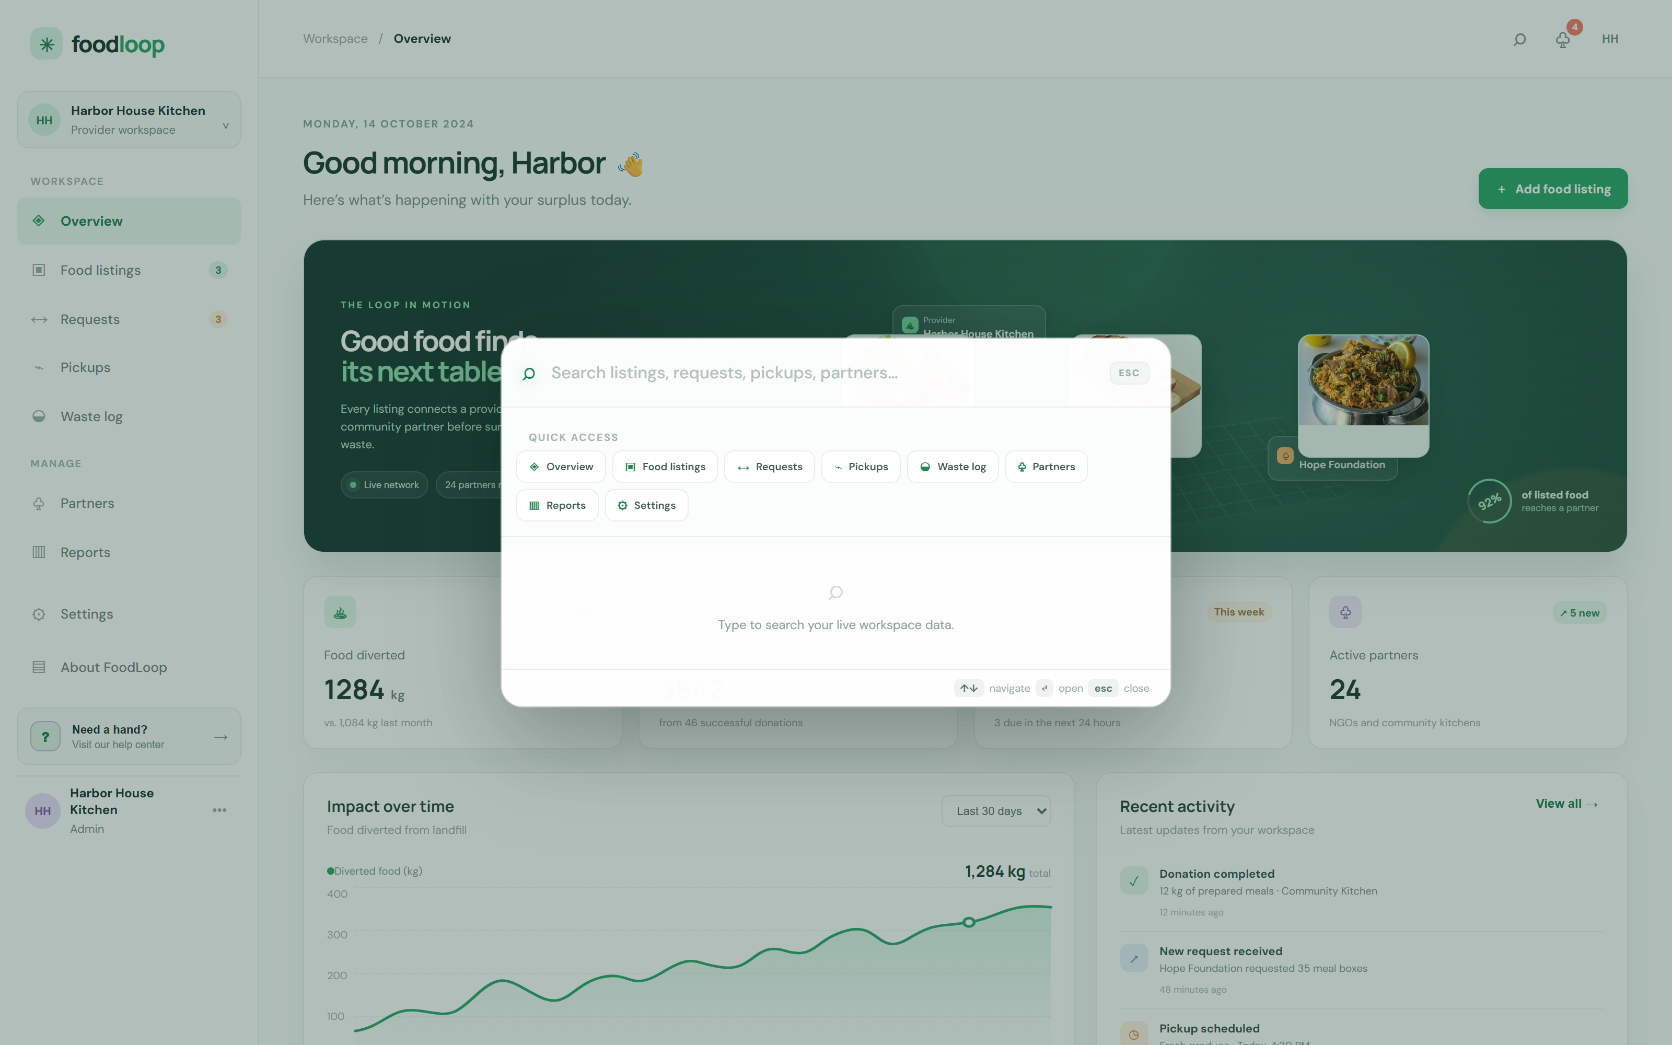
Figure 9.3 Global search command palette — FR-19, implemented as a presentation component driven by app.js
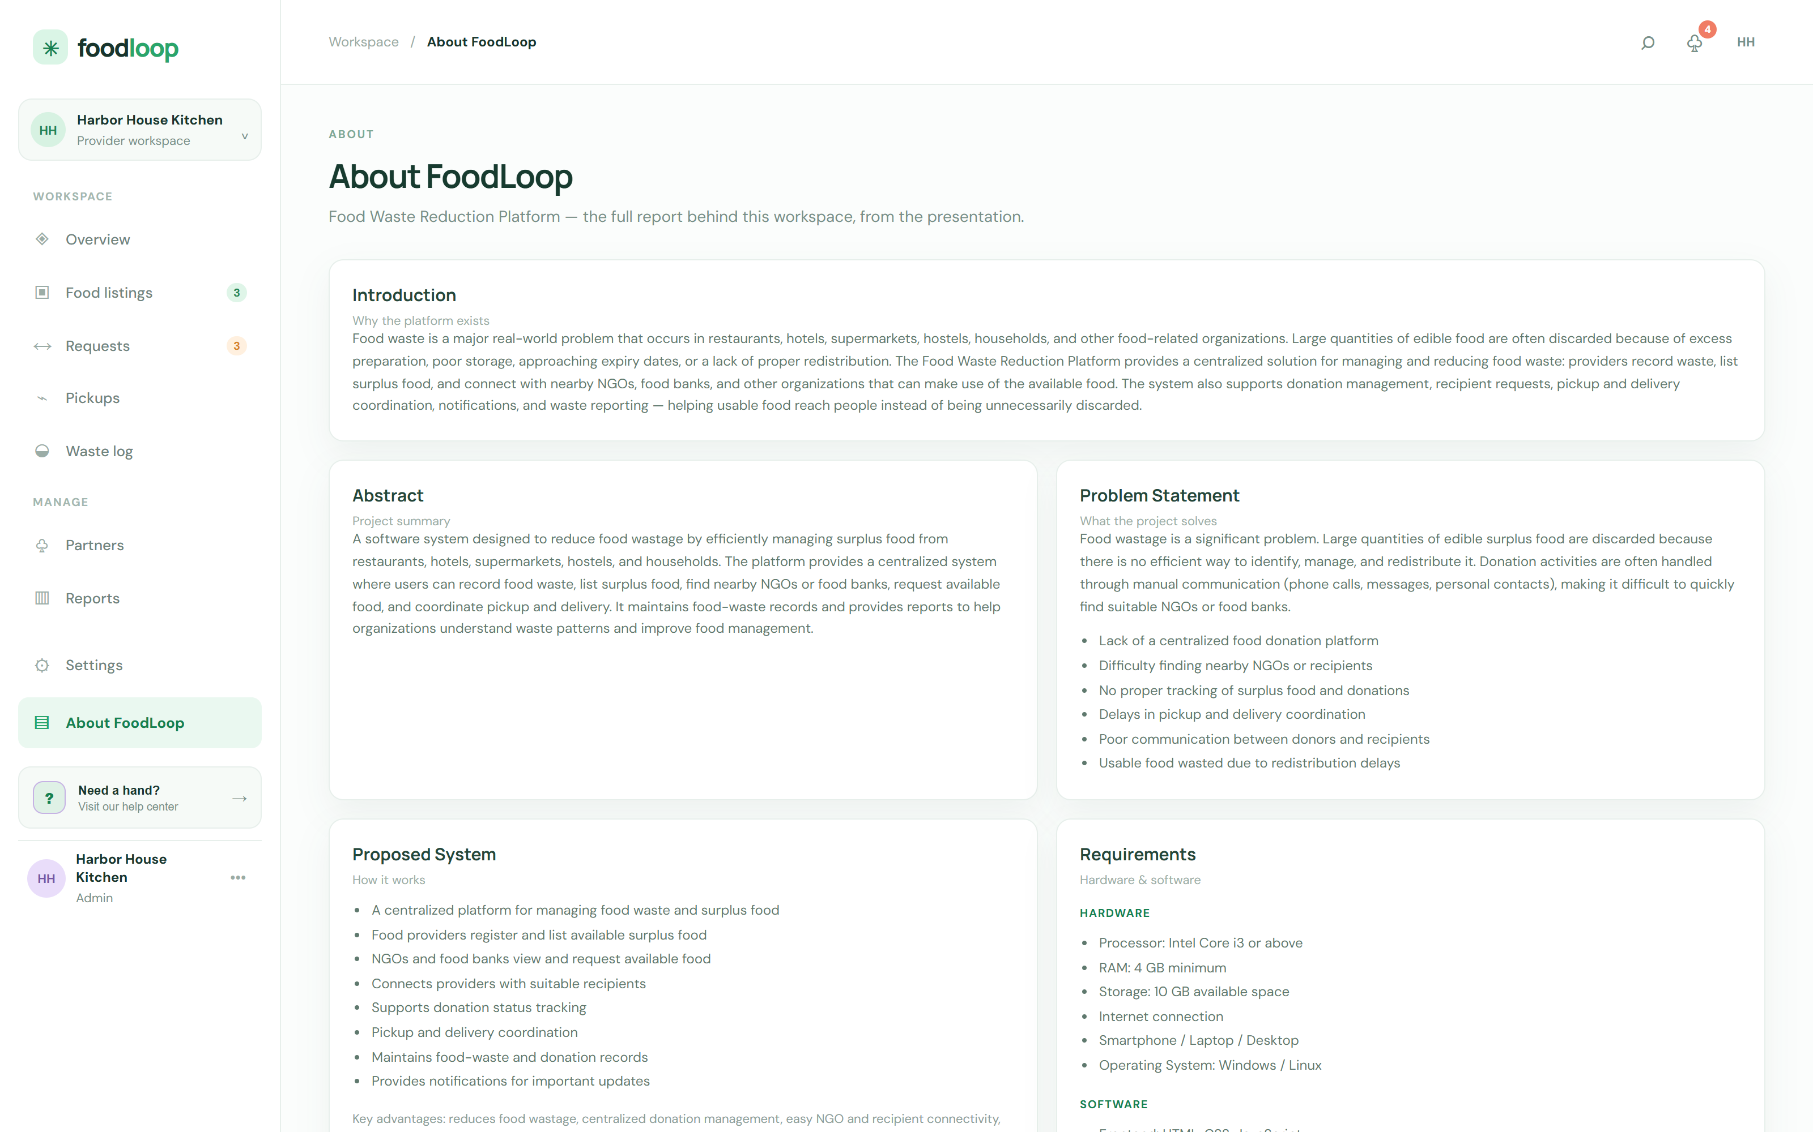
Figure 9.4 The About FoodLoop view, which embeds this project's own documentation and UML diagrams
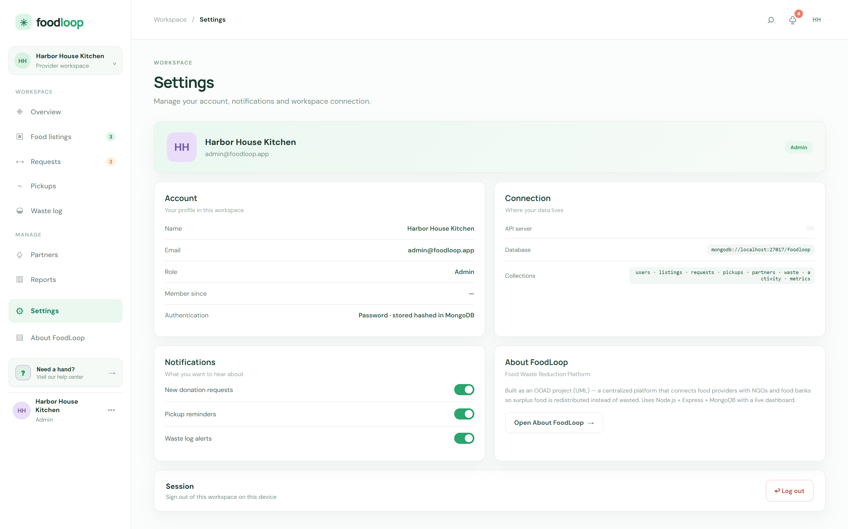
Figure 9.5 Settings view showing the account, the API and database connection, and notification preferences
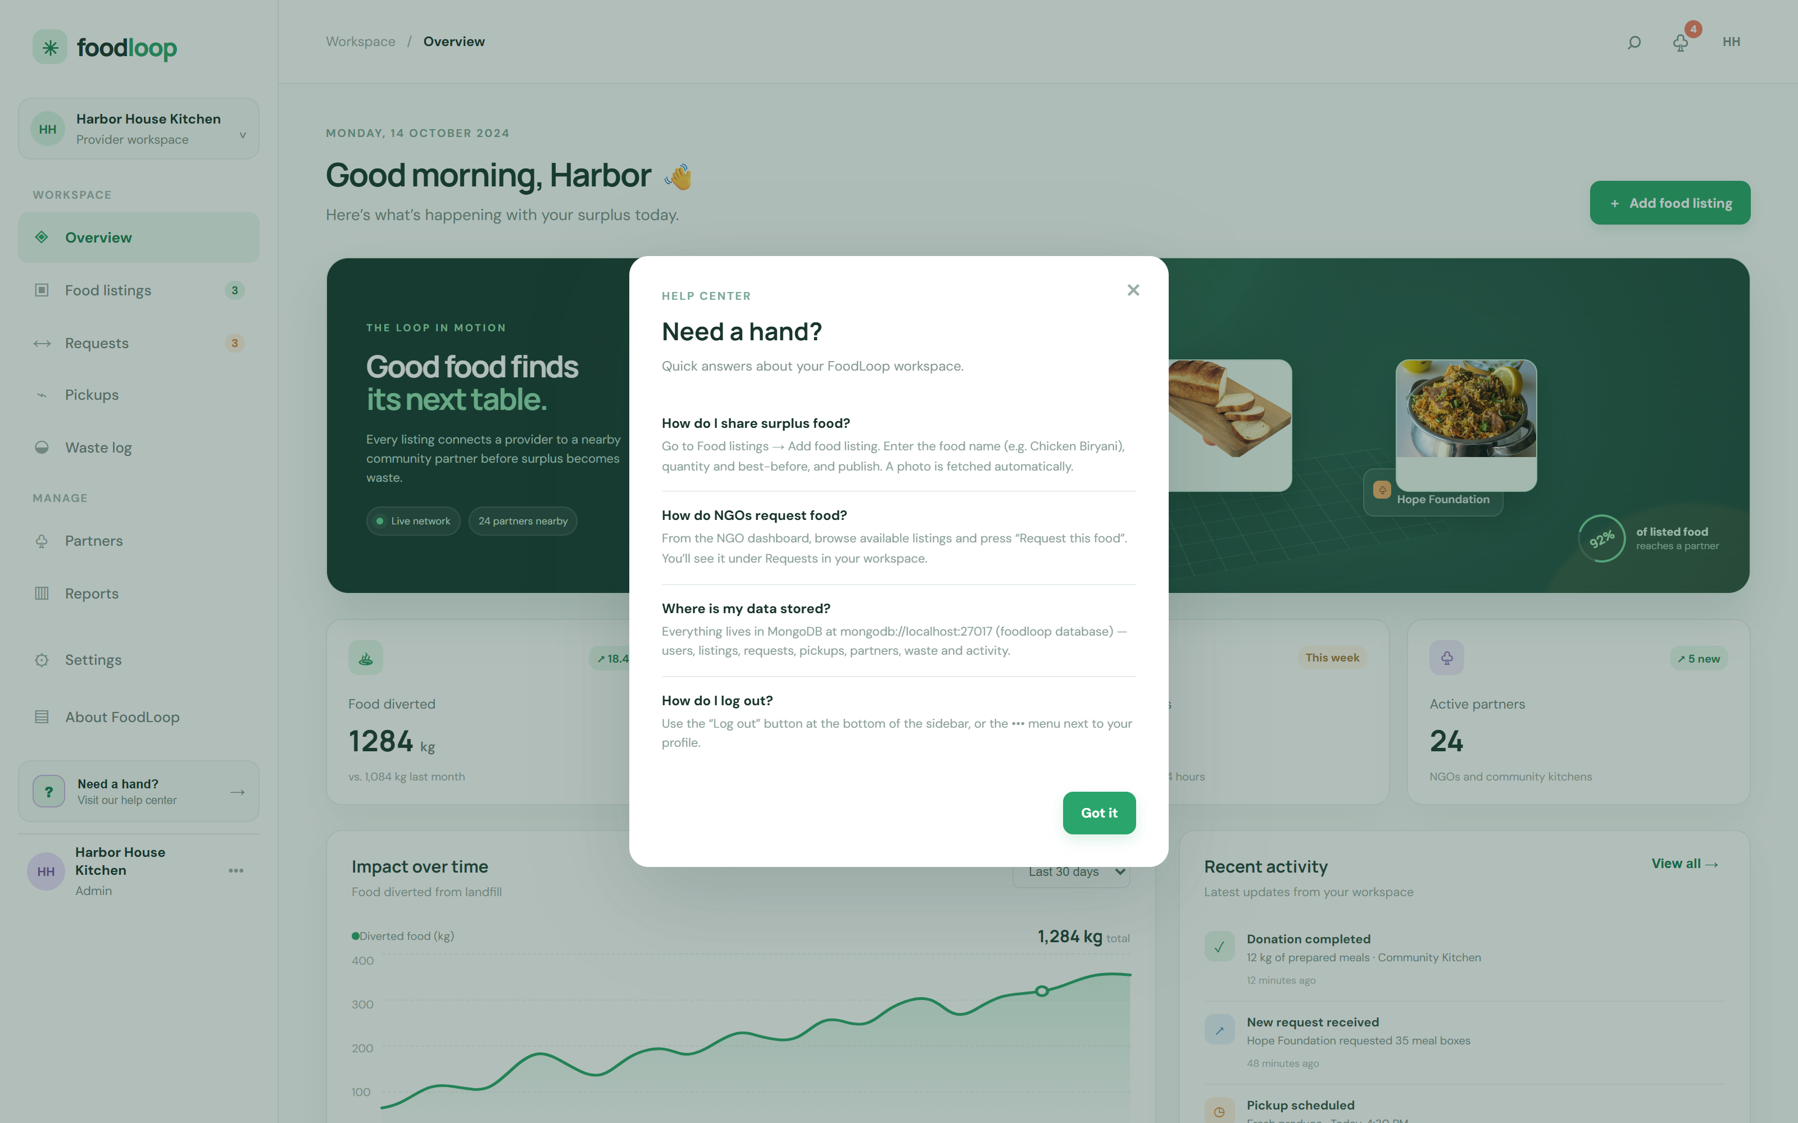
Figure 9.6 Help centre modal — the in-application guidance component
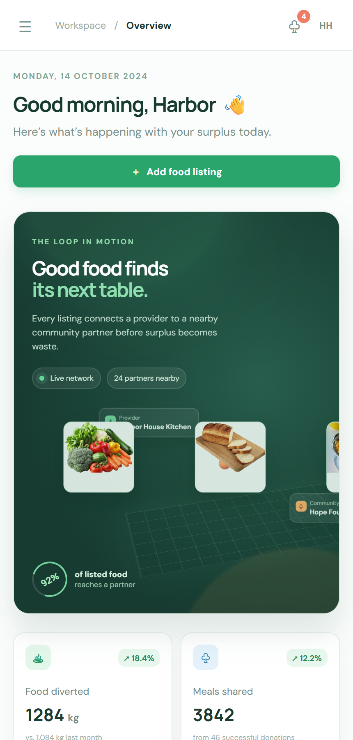
Figure 9.7 Responsive layout at 430 px, satisfying NFR-08
Chapter 10
CONCLUSION AND FUTURE SCOPE
10.1 Conclusion
FoodLoop was built to answer a simple question: why is edible food thrown away when somebody nearby would like it? The answer the project gives is a single shared record. A provider publishes what it has; every partner sees the same list with photographs, quantities and best-before times; a partner claims what it can collect; the provider accepts or declines; the pickup is scheduled and the delivery is recorded; and the kilogram that was saved appears on the dashboard.
The Object-Oriented Analysis and Design process produced the models that made this buildable rather than improvised. Sixteen functional and twelve non-functional requirements were traced to fourteen use cases and a fourteen-event table; the use case model fixed the vocabulary; the domain and design class diagrams fixed the structure and the persistence; the sequence, communication and state machine diagrams fixed the behaviour, including the two failure paths that are easy to forget; and the package, component and deployment diagrams fixed the architecture and the runtime topology. Chapter 8 then mapped that structure onto nine collections with an explicit CRUD matrix, so every class in the model has a storage home and every stored document has a class that justifies it.
The delivered prototype runs on Node.js, Express and MongoDB, protects accounts with bcrypt and JWT, keeps every view synchronised with a fifteen-second poll, and works from a phone in a food bank as well as from a desktop in a hotel office. Its value is not the sophistication of any single part but the fact that all of them agree with one another: the diagrams in this report describe the system that was built, and the screenshots in it were captured from that running system.
10.2 Limitations
The following limitations are known and were accepted deliberately at this stage of the project.
• Notifications and dashboard freshness depend on fifteen-second polling rather than server push, so a partner may see a change up to fifteen seconds late.
• Food photographs are fetched from TheMealDB, so a dish the service does not know falls back to an ingredient image and then to an emoji glyph.
• The AiRecommendation module is specified and stubbed but not trained; the demand prediction in Figures 4.3 and 6.1 is a design commitment rather than a working model.
• Pickups are recorded but not tracked in transit: there is no live location, no driver application and no proof of delivery.
• Impact figures are aggregated counters maintained by the application rather than computed from the donation history, so they do not yet reconcile automatically with the waste log.
• Only two roles exist. Delivery partners, food banks as a distinct role, and regulators are all outside the current scope.
• Authentication covers sign-up and sign-in; there is no password reset, no e-mail verification and no multi-factor authentication.
• Search filters the four main collections client-side, which is adequate for a few hundred records but would need server-side indexing at scale.
10.3 Future Enhancements
The following enhancements are planned, in the order in which they would deliver the most value.
Table 10.1 Planned enhancements
# | Enhancement | Addresses
1 | Server-sent events or WebSockets to replace polling, so a partner sees a new listing the moment it is published. | Limitation 1
2 | A trained demand-prediction model using the waste and listing history, exposed through the existing AiRecommender class. | Limitation 3
3 | A delivery-partner role with a driver view, live status transitions and a digital receipt with photograph proof. | Limitation 4, role scope
4 | Impact figures recomputed from the donation and waste history so the dashboard always reconciles with the logs. | Limitation 5
5 | Geolocation and distance matching so a partner is shown the food closest to it first, and a collection radius per partner. | FR-09
6 | Expiry alerts to providers and NGOs as a listing approaches its best-before time, with automatic re-listing after collection. | UC-06, UC-07
7 | A restaurant admin view for multi-branch providers, with per-kitchen waste comparison. | Scope
8 | Password reset, e-mail verification and optional multi-factor authentication. | Limitation 7
9 | Server-side search with indexes, plus filters on date range and waste reason. | Limitation 8
10 | Monthly impact reports in PDF with charts, shareable with partners and municipal bodies. | UC-12

Beyond these, the natural next step is to open the platform to partner organisations as tenants, so that each NGO manages only its own requests and capacity, and to publish the waste analytics as an anonymised dataset that a city can use to target interventions. The models in this report were built to allow both: the interfaces already isolate persistence and authentication, so adding tenancy is a change to two packages rather than to the system.

